Assignement 2

Question I :

Performance analysis aims to evaluate if the results of a manager are purely due to luck or if they are based upon his skills. Even if the efficient market theory deems that skillful active management is impossible, research by Shleifer (2000) shows that the market still presents some inefficiencies that can be exploited. His paper *Inefficient Markets: An Introduction to Behavioral Finance,* highlights thatnot all investors act rationally. Indeed, Behavioral biases, such as overconfidence, anchoring, and herd behavior, often influence investment decisions, leading to market inefficiencies that can be exploited with active management.

To that effect, return-based style analysis was developed by William Sharpe in 1992. It aims at determining the effective allocation or style of the investment solely using historical return data.

We start by modeling the portfolio return as the weighted sum of the returns from multiple factors (or asset classes, as described in the paper), representing the proportion allocated to each class, plus a residual term that captures the selection effect – returns that is not explained by the asset allocation and that can be attributed to the portfolio managers.

We can than estimate the effective program via a quadratic program:

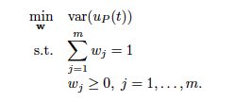

The program presents a twist on the conventional multiple regression as the weights are constrained to be non-negative and to add up to 1. This will ensures that the weights will reflect a full allocation across asset classes and that we obtain realistic weights, assuming no short position.

Using the following matrices,

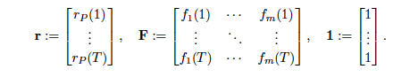

We can write the program as such:



Where expended objective function shows the difference between the actual portfolio returns and those implied by the estimated style.

This method will improve performance analysis by constructing a style that tracks the fund's performance more accurately than predefined benchmarks. However, this model shows some flaws as the weights are constant over time, which would be unrealistic for actively managed funds. More advanced versions of the model include regularization terms to allow for gradual changes in weights.