Design Document (Clinton Myhre, Seth Long, Geoffrey Sanders)

- Take the command line input of the form
plumber 1:”program-1” 2:”program-2” … n:”program-n” –e 1,2 1,3 …
and turn it into an adjacency matrix (the rows represent the program’s input and the columns represent the program’s output).
For each row and column that isn’t null (i.e. there exists an edge at that location), make a pipe and put both the read and write ends of that pipe in the appropriate place.
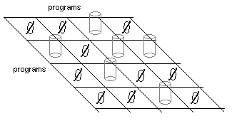
- Thread the Spreader and Collector functions n (n equals number of nodes in adj. matrix) times.
The Spreader function takes as arguments the file descriptor (fd) that it will read from and the column number of the adjacency matrix. It will go through that column of the adj. matrix and build an array of fd’s that it will write to. When the pipe that the Spreader is reading from is empty and closed, Spreader will close all of the fd’s in its array.
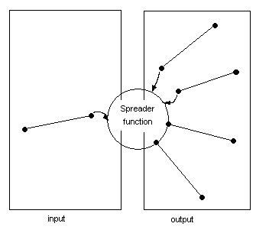
The Collector function takes as arguments the fd that it will write to and the row number of the adj. matrix. It will go through that row of the adj. matric and build an array of fd’s that it will read from. Using select it will either read a line from a pipe that contains data and write it to output, or read the whole content of one of the input pipes (until it is empty and closed) and write it to the output pipe. When all of the inputs are closed, close the output pipe.
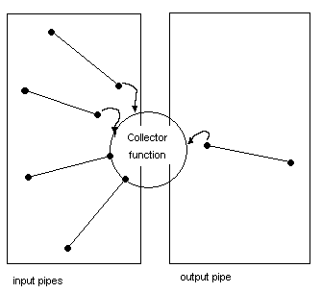
- fork the number of nodes times. Create two pipes, one from stdin to the output of a Collector thread, and the other from stdout to the input of a Spreader thread.
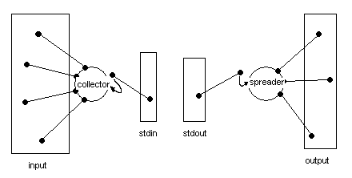
- exec the program.
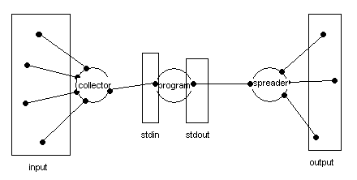
- The original instance of the process waits until all of the threads are dead, then cleans itself up and closes.

