Sam Mansfield

University of Iowa

GEOG:3050

Final Project Report

*Environmental Justice in Chicago*

**Goals and Specific Questions**

As climate change has worsened, a new type of social justice issue has occurred: Environmental Justice. As a society, we face many different burdens and benefits from both our communities, and our planets itself. The unproportionable distribution of these burdens is where the term environmental justice comes in. In the year 1982, in North Carolina, a predominantly African American neighborhood was elected to contain a landfill that would contain hazardous waste (energy.gov). This sparked outcry, and eventually lead to the environmental justice movement.

For this analysis, the city of Chicago was picked as the location. Growing up outside of the city has created this interest for me. I believe that there is a disparity among the 77 communities in the city, and how they are facing environmental burdens. Specifically, how the different demographic factors (income, poverty rates, rates of no high school diploma) correlate to the area of toxic release. The goal of this project and report is to discover if there is a correlation between the two. The specific questions I would like to answer are:

* Is there any disparity between the areas most affected by toxic release in the city of Chicago?
* Overall, are there specific groups of people or areas that are experiencing more environmental burdens than others?

I believe that these questions will be answered after a spatial and statistical analysis of the city of Chicago. Toxic release data will be very helpful for this project. This is because the data for this is available online and can be looked at in a mapping program in relation to the community demographics. Not only spatially, such as seeing which areas have the most points, but also by running regressions, to see how significant the correlation is. Overall, I believe that this project will answer the question of if there is or is not an environmental justice issue in Chicago.

**Data Collection and Descriptive Statistics**

For this project, there are many different types of data and layers that were used. Shapefiles, point features, and CSV data tables were all downloaded and imported into the project. I downloaded my Chicago community boundaries shapefile and my community data CSV file from the Chicago Data Portal (<https://data.cityofchicago.org/>). The TRI release data came from the EPA’s Toxic Release Inventory Explorer, where I chose the county that Chicago is in, and was given a report with all of points of high release, and the amount of release from the chemicals. Below is a look at the data that was used.

The shapefile of the Chicago communities was created by the Office of Tourism and was created by following the boundary lines of the 77 different communities. The community data CSV file that I downloaded was created using census data from the U.S Census Bureau, and contained six different socioeconomic health indicators, which I used three of (per capita income, percent of households below poverty, and percent of people who are unemployed). This data matched up with the shapefile nicely. The data that I received from the TRI explorer came from the facilities and industrial sites themselves, as they are required to report this information to the EPA. The chemicals included in these reports are those that cause cancer or other chronic human health effects, significant adverse acute human health effects, or significant adverse environmental effects.

There are a few limitations and assumptions to keep in mind when while working with this data. With the toxic release data, there is no information on the website that describes the unit of measurement. This is not the biggest deal, as you can assume that the larger number is the larger release. Another limitation is, how far does the toxic release go? After research on the internet, there doesn’t seem to be a clear answer, as it really depends on the type of chemical and how it was released. From the website, “On-site disposal or other releases include emissions to the air, discharges to bodies of water, disposal at the facility to land, and disposal in underground injection wells,” (TRI Explorer). Because of this, I made the release distance for communities within a distance parameter 5000 meters, which is a little larger than the largest estimate I could find.

The spatial extent of my data is Cook County, IL, which include all of the communities in the city. The temporal extent of the community data is 2012, which was the most recent data I could find. The temporal extent of the toxic release data is 2020.

This is the overall workflow model that my project followed. The workflow is not labeled with anything relating to the study area, as this model can be used for many different locations if the data for the location is able to be found. This model can lead to answering other questions or solving other problems. You can see the areas that need to be prioritized for change, or which communities are experiencing the most burdens, environmental or socioeconomic, as the data should include both. This workflow could assist in local governments, or even at the state level as well. Overall, this model would work well for case studies at other locations.

**Results**

For this project, my workflow model and script were ran using data from the city of Chicago. Below, are the results from the OLS regression and the Spatial Autocorrelation (Moran’s I), along with multiple maps visualizing the distribution of toxic release points in relation to the different demographic statistics of the communities.

**OLS: Moran’s I:**

**

**Moran’s I**

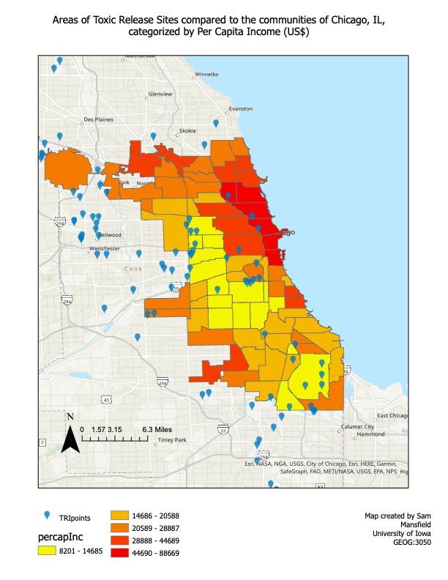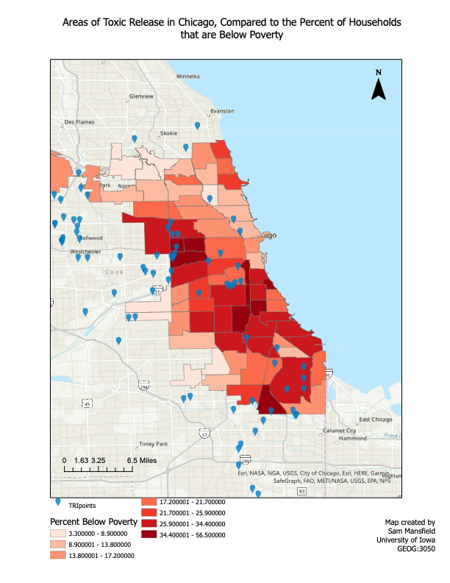

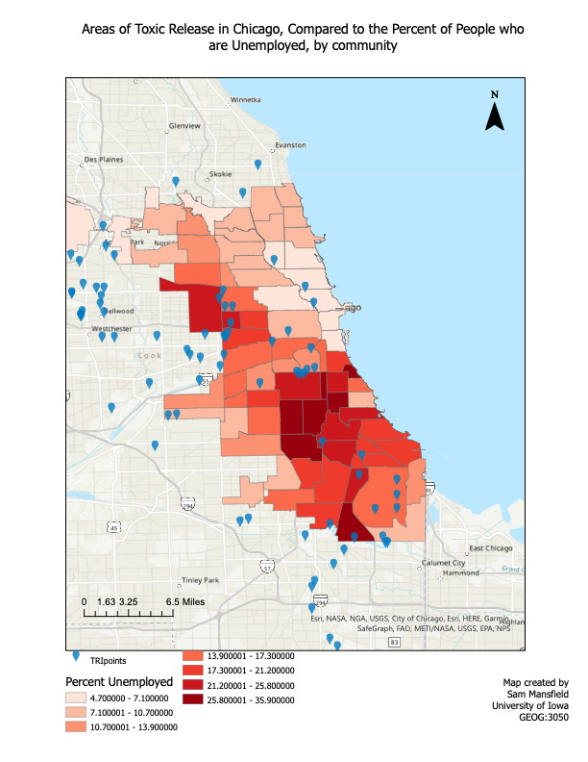

**Results (Cont.)**

The script worked well with the data that I used. With the Chicago data and shapefile, this script / workflow model started off by joining a community shapefile with demographic data, and then spatially joined to the points of the toxic release, which were made with the coordinates. After this, both an OLS and a Spatial Autocorrelation regression model was run. To join the points with the community, a field was created that showed the total onsite release that is in each community. As you can see, by looking visually at the maps when compared to the points of release, there are clusters that appear around areas that are lower down in the demographic data. Especially on the per capita income map, it is clear to see that the lower income areas have more points of release. The OLS regression showed that there was a significance with the relationship between households below poverty and total onsite release. The joint F statistic was significant, which means that the model was overall statically significant. You can trust this, because the Koenker statistic was not significant. We must keep in mind that the Jarque-Bera statistic came back significant, so the model may be biased. After running the Moran’s I model, the index tells us that there is an amount of clustering occurring, and the z-score was positive, which indicates significance. The p-value came back with all zeros. This means that we can accept it as statistically significant and accept our hypothesis that the way the toxic releases are dispersed is not random, and they are more clustered than what would be expected.

**Discussion and Conclusion**

After seeing the results of the regression and the visual mapping of the points, I believe that there is an unequal distribution of the areas of toxic release when compared to socioeconomic factors. While the OLS and Moran’s I confirm the results, the maps really show it. It is clear to see that the areas with a lower per capita income have more of these release points surrounding them or are within them. Unfortunately, this study did not include any ethnic or racial data, so it is hard to connect those for being reason. But the maps also show that areas with higher unemployment and higher poverty rates also experience the same types of clustering. I think the reason for this is because these companies that are releasing these toxins are choosing to do so in areas where the community is already vulnerable, because people will not be heard. By this, I mean the voices of these small, underfunded communities will not be loud enough to stop this development. In a wealthy area, the city would never allow for construction like this to occur, as it would be protested and listened to. I think this report shows that large companies and industrial complexes take advantage of lower income areas as a place to get away with harming the environment. To answer our original questions, there is a disparity between groups that are effects, and overall, the middle east regions and the areas in the south side of the city are also taking on more burdens than others. This is a serious concern, as these chemicals can cause adverse health and environmental effects.

This project did have some limitations. The data did not include racial distribution, so those factors were not able to be considered. Another limitation was the limited information about the TRI release information. Not knowing the unit of measurement, or the significance of exposure could result in some conclusions not being as accurate as possible, although I do believe these results are accurate. This project has use in other communities, such as a local government running the program to determine areas that need more focus on development and reducing harmful effects from toxic chemicals. Using different data could help somebody come to different conclusions as well. The point feature and the type of data used could be something completely different than the data used here. Therefore, this analysis could be beneficial in other settings. One lesson I learned through this project is how complex coding can me, and how the smallest error can result in a lot of problems. If I had more time, I think including other factors of environmental justice would have been interesting. Access to green spaces or organic foods is something that needs to be studied as well. I also think having a larger study area could help the regression, as having more points would lead to more solid results. Overall, I found this to be a successful project. I answered the questions that I aimed to, and I learned a lot about programming in the process.

*Citations*

“Environmental Justice History.” *Energy.gov*, https://www.energy.gov/lm/services/environmental-justice/environmental-justice-history#:~:text=The%20initial%20environmental%20justice%20spark,of%20toxic%20waste%20along%20roadways.

Data collected from:

Chicago Data Portal (<https://data.cityofchicago.org/>)

TRI Data and Tools (<https://www.epa.gov/toxics-release-inventory-tri-program/tri-data-and-tools>)