Final Project
Geo 5418
Henry Reissig
Austin Spatial Crime Analysis for 2004 and 2009

Introduction
Austin is a growing city. For the past decade, Austin and Central Texas as a whole has grown considerably. As with all cities, where there is growth, there is an increase in crime. Between 2004 and 2009, Austin has seen an increase of population of 11.8 percent (Austin City Connection) and combined crime in Austin increased 18.8 percent (City of Austin Police Department). These numbers though tell us nothing about how crime is distributed in Austin. Also, these numbers tell us nothing about what areas of Austin experienced and increase or decrease in crime between these two years. The component to be spatially modeled in this project is “crime reported” as indicated in the police department website. The project objective is to spatially analyze crime reported (as described above) in Austin for 2004 and 2009 by creating six maps showing the distribution of crime by census tract, the density of crime using an interpolation technique and the change in crime between 2004 and 2009.

Conceptual Model
The Austin Police Department tracts combined crime data by census tracts. Census tracts are regions defined by the Census Bureau and are used for demographic population data (US Census Bureau, 2010). Only Census Blocks are a smaller unit used for similar purposes. Census tracts are updated every ten years along with the census (US Census Bureau, 2010). As of 2009, this encompasses 182 census tracts within the city of Austin. With this number of census tracts, it seems possible to model the crime density within the city limits. Choropleth maps are ideal in representing data per census tract (Chang, 2010). Another way to represent the data is to create crime density maps based on the crime data per census tract. To do this, one must have the centroid coordinates for each census tract and crime per unit area for each tract. Once this is found, an interpolation method is used to find the crime density. Kriging was the interpolation method of choice. According to the lecture notes “Kriging is a geostatistical method for spatial interpolation that is composed of three components: spatial autocorrelation, a trend, and random errors. In this study, Fig 1 shows what options were used. The next section explains what was used.
Fig 1
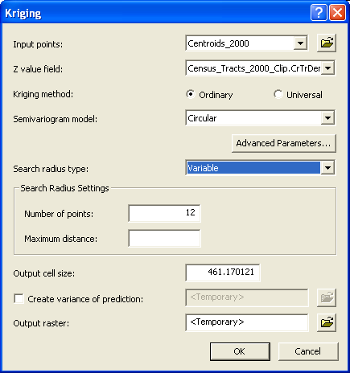

Similar studies have been done and much literature is on modeling crime density based on a variety of data. As far as modeling crime density based on census tracts, I was unable to find much literature on the subject. In “When, where, if, and but': qualifying GIS and the effect
of street lighting on crime and fear”, the authors go through spatial interpolation in showing how street lighting affects crime in England (Rachel Pain, 2006). In another study/demo, ESRI show how spatial interpolation among other tools can be used in crime analysis (Crime Analysis - GIS Solutions for Intelligence-Led Policing, 2008)

GIS-based Modeling Approach
In 2004, the estimated population in Austin, Texas was 692,102. By 2009, the estimated population was 774,037. This is an 11.8 percent increase (Austin City Connection). The combined crime increased 18.8 percent between 2004 and 2009 with the 2004 total reported of 135,020 and the 2009 total reported of 160,424 (City of Austin Police Department). The crime reported as described by the Austin Police Department web site is defined as such, “Data provided represents only calls for police service where a formal, written report was made and does not include other calls for police service that did not result in a written report” (City of Austin Police Department).
The crime data was gathered per census tract. It was decided that the “total crime” will be used. This encompassed everything from petty theft to murder because is it assumed that all crime is a concern for citizens. The census tract maps were then gathered from the Capital Area Council of Governments (Capital Area Council of Governments, 2010). The 2000 census tract map was used in this analysis. Crime data was then taken from the City of Austin Website. The data had total crime with census tract. Crime data was then converted to a database file. The crime by census tract data table was then joined with the 2000 census tract map by contract tract ID. The joined layer was then classified into graduated colors to visualize total crime per census tract for both the 2004 and 2009 data sets. Natural breaks were used in this classification (See Map 1 and Map 2 respectively).
Map1
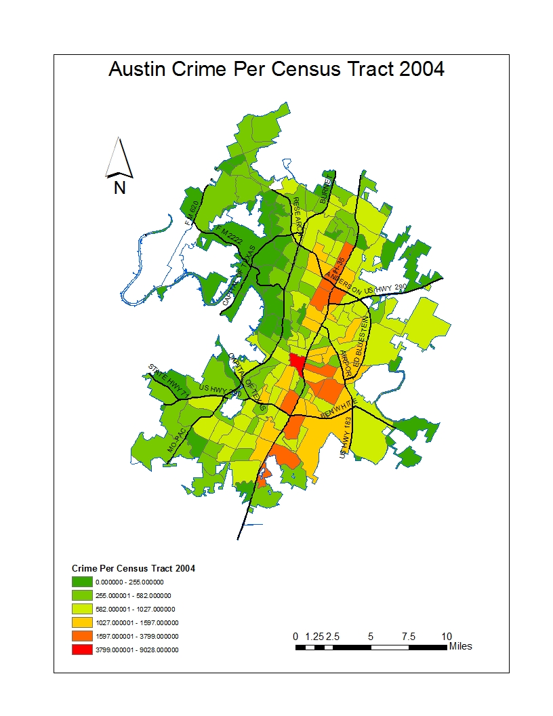

Map2
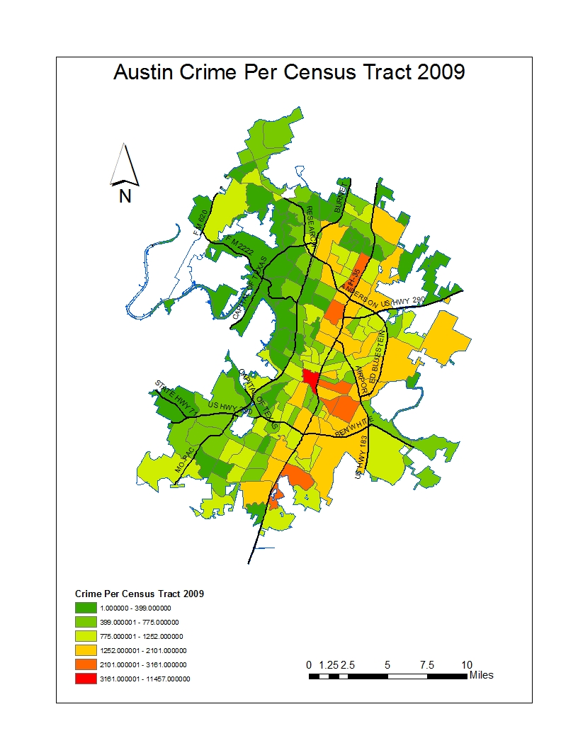
With the field calculator, the change in crime for each census tract between 2004 and 2009 was added in the attribute table. The already joined layer with the crime per census tract was then classified in graduated colors to visualize the change in crime per census tract. Manual breaks were used to separate census tracts with an increase in crime from census tracts with a decrease in crime (See Map 3).

Map 3
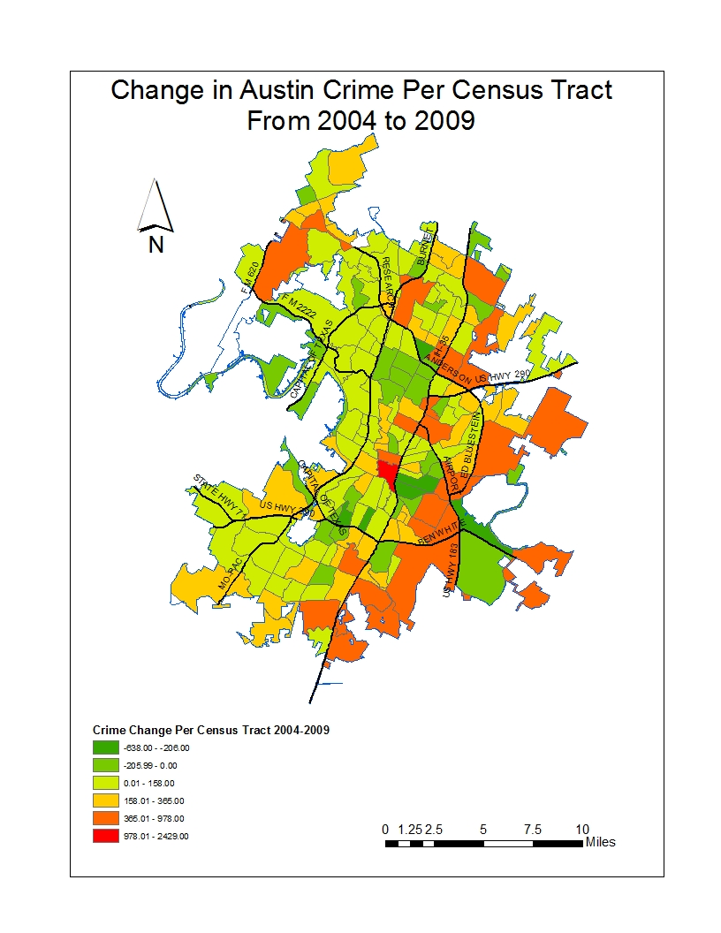

Before any interpolation analysis was done, the centroids and the areas of the tracts for the all the census tracts were found. Both centroids and areas were found using spatial analyst. With the area calculated, the population density was then found using the field calculator. The crime density was found per square mile using Kriging as the interpolation method of choice with the semivariogram model as “circular”, search radius type as “variable” and the number of points as “12”. This was done for both 2004 and 2009 (See Map 4 and Map 5 respectively).
Map 4
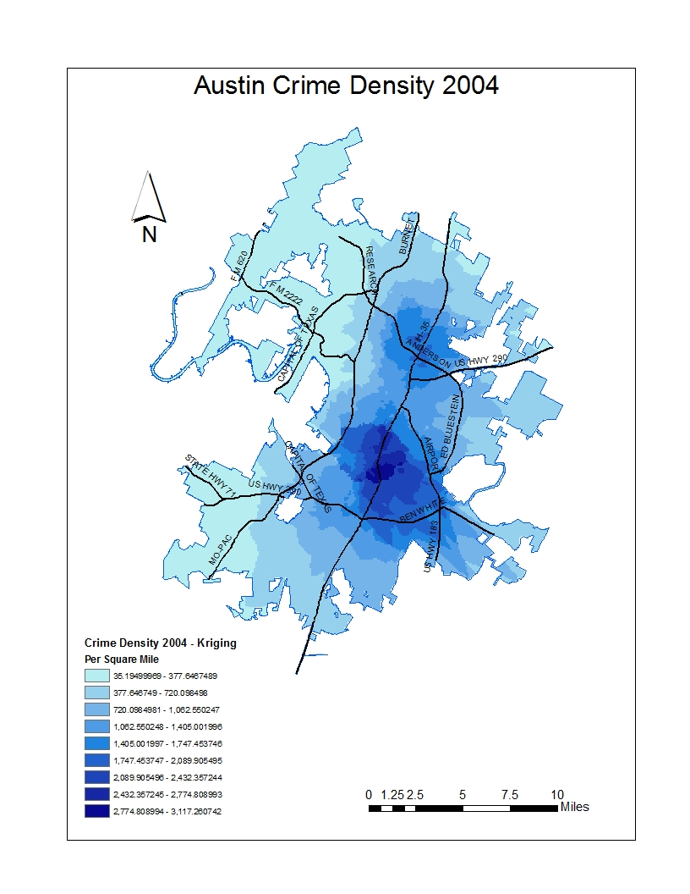

Map 5
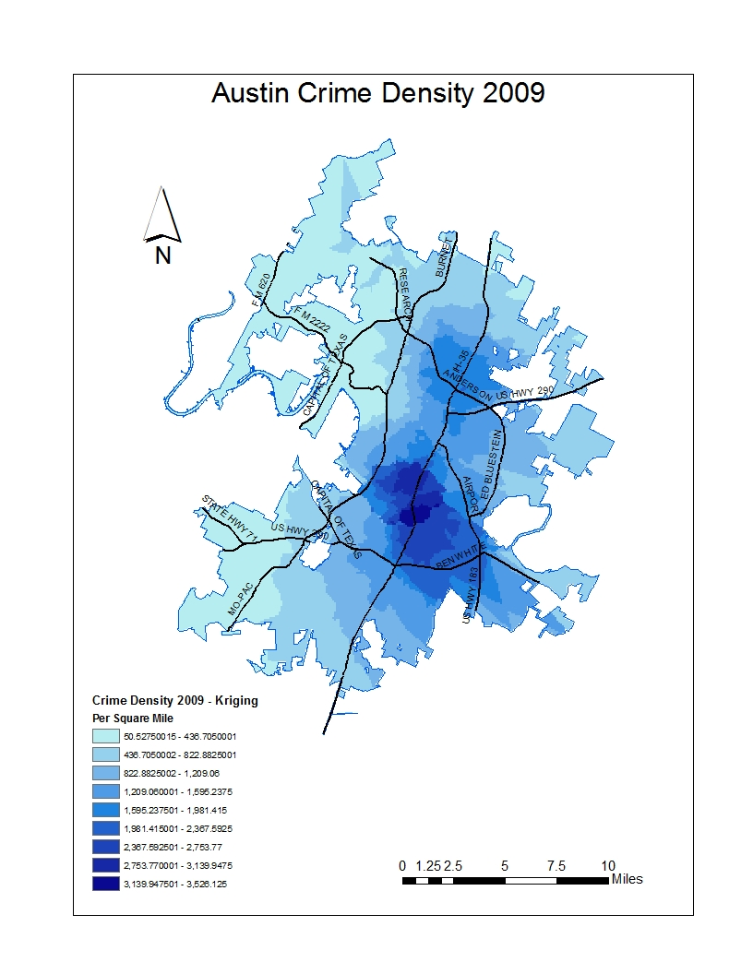
With the two raster maps of crime density, the change in crime density was then performed using the raster calculator in the spatial analyst toolset. The result was a raster showing the change in crime per square mile (See Map 6).

Map 6
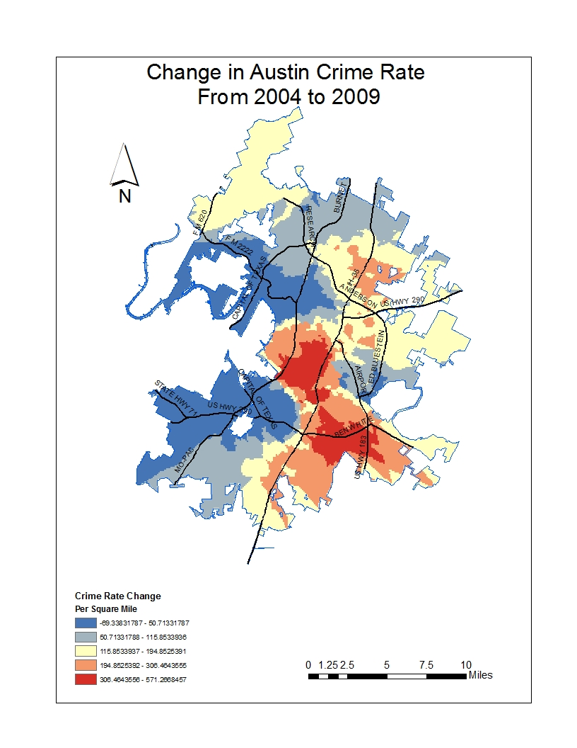

This process is shown graphically on Figure 1 “Data Flow Diagram Change in Austin Crime 2004-2009”.

Figure 2
Data Flow Diagram Change in Austin Crime 2004-2009
Centroids per census tract
Find Centroids per census tract
Census Tract Shape File for Austin
Clip Census Tract Sapefile to Austin City Limits
Census Tract 2000 Shapefile
City Limits Shape File
Crime Per Census Tract 2004
Crime Per Census Tract 2009
Interpolate with Kriging
Interpolate with Kriging
Crime Density Map 2009
Crime Density Map 2004
Subtract Crime Density (2009-2004)
Change in Crime 2004-2009
Classify based on total Crime for 2004 and 2009
Join Data File to Shape File by Census Tract ID
Total Crime Per Census Tract DB File
Move Data to Access DB and save as a DB File
Crime Per Census Tract In Excel
Manually Enter Data Into Excel for both 2004 and 2009
Crime Data Per Census Tract PDF
Issues during the study
The first problem occurred in collecting the crime statistics from the Austin Police Department web site. This data is in PDF format and it was not possible to export the data elsewhere. Therefore, it was necessary to manually type each of the census tracts and crime stats onto an Excel spreadsheet. The other issue I had was the kriging tool and masking. It was discovered that the kriging function used from the toolkit will not mask properly in spite of setting the mask. It was then discovered that the kriging tool used in the spatial analyst worked properly after hours of trying the other way. The values for area in the census tract attribute table did not correlate with visual inspection of the census tracts. It was therefore necessary to find the area through spatial analyst before it was used.
Conclusions
This study found that crime is not evenly distributed throughout the city both 2004 and 2009. Map 1 and Map 2 shows how crime was distributed by census tract. Map 4 and Map 5 shows this by crime density. These maps show how crime was distributed unevenly throughout the city. They show that the areas of highest crime for both years are in downtown, north-central, southeast and just east of downtown.
This study found that the increase in crime of 18.8 percent was not distributed evenly over the city of Austin. It was found that the areas of highest increase in crime between 2004 and 2009 are pretty much the same areas as the highest crime for each of these years. See Map 3 and Map 6 respectively. The exceptions to this are areas of extreme northwest. Map 3 and Map 6 shows different results for the extreme southwest, possibly because the interpolated census tract values of the southwest are on the edge and are located next to census tract experiencing a decrease in crime.
This study did not go into how any other factors correlate with the findings. For example, an analysis of the distribution of annual income would show a similar map of crime with the exception of downtown. Other factors that could be studied and compared with this analysis could be homeless population, education, percent home owners, and race among others.
This study was only meant to show general trends in the distribution of crime and the change in crime and should not be used for analysis on a street or neighbor level. This should be done by gathering individual crime incidents per neighborhood also found on the police website or by the neighborhood associations.

References
Austin City Connection. (n.d.). Retrieved April 2010, from Austin City Connection - The Official Web site of the City of Austin: http://www.ci.austin.tx.us/demographics/
Capital Area Council of Governments. (2010). Retrieved April 2010, from http://www.capcog.org/information-clearinghouse
(2010). In K.-t. Chang, Introduction to Geographic Information Systemes (p. 448). New York: McGraw Hill.
City of Austin Police Department. (n.d.). Retrieved April 2010, from Crime Listed by Census Tract: http://www.ci.austin.tx.us/police/censustract/censustract.cfm
Crime Analysis - GIS Solutions for Intelligence-Led Policing. (2008). Retrieved April 2010, from ESRI: http://www.esri.com/library/brochures/pdfs/crime-analysis.pdf
Rachel Pain, R. M. (2006). `When, where, if, and but': qualifying GIS and the effect. Environment and Planning A 2006, volume 38, pages , 2055-2074.
US Census Bureau. (2010). Retrieved April 2010, from http://www.census.gov/geo/www/cob/tr2000.html

