Literature Review
Issues and Strategies in the Conduit Function of Conservation Corridor Planning
Henry Reissig
Geography 5339

Introduction

This literature review concentrates on the conduit function of conservation corridors (Fig. 1). Conservation corridors will also be referred to as “wildlife corridors” and “greenways” maintaining whatever term is used in the article cited. Five major themes of literature were found on this topic: Biological Benefits, Design, Policy, Social/Community, and Research/GIScience.

The recent trend for planners is to deliver increasingly densely developed landscapes while simultaneously becoming more environmentally sustainable are leading urban planners to turn to conservation planning tools such as wildlife corridors (Evans 2007). Wildlife corridors are swaths of protected land that connects the core zones (large areas of protected land), allowing wildlife to move between zones (Nakamura and Short 2001). The primary function of greenways is to provide linkages to wildlife habitats (Linehan, Gross and Finn 1995). Greenways have been described as “networks of linked landscape elements that provide ecological, recreational and cultural benefits to the community” (Arendt 2004).

Biological Benefits

Human development has increasingly fragmented habitat with smaller and less connected patches of terrestrial habitat for a variety of wildlife, the result of this diminished habitat is a reduction of any ecosystem to maintain a higher diversity of plant, animal and aquatic species (Moskovits, et al. 2004). The general consensus among conservation biologists is that most current species have evolved in well-connected landscapes and landscape level connectivity has the potential to enhance population viability for many species (Henry, et al. 1999). Connectivity of habitat patches is important for movement of genes, individuals, populations, and species over multiple temporal and spatial scales. Habitat connectivity is especially important when habitat is rare, fragmented, or otherwise widely distributed (Minor and Urban 2008).

Design

There has been a shift of focus in greenway planning. Once considered a vegetative linear area for conservation purposes, greenways can be designed to balance both conservation and growth. Greenways have evolved into a resource that can meet the public’s needs for recreation, environmental protection, and alternative transportation (Conine, et al. 2004). The old way of approaching greenways is for the location to be in areas where developers don’t want to build such as: floodplains, wetlands, steep slopes, and water resources. This approach often does not consider the configuration, juxtaposition, and functional relationships between these as an essential component of an ecologically sound approach to development (Linehan, Gross and Finn 1995). Conservation literature contains few examples of corridors that been been protected, so planners have little to go on in implementing their plans. Key connections between conservation habitats will be lost unless they are explicitly protected. (Morrison and Boyce 2008).

Urbanization is considered to be the most important factor to species extinction rates. As a rule, urban land use should not be the dominant land use within one kilometer from any wetland, as it negatively affects the overall integrity of the avian community and especially affects the abundance and richness of obligate marsh-nesters. Also, it is recommended that all existing wetlands be conserved to mitigate against isolation effects and to preserve biodiversity (Smith and Chow-Fraser 2010). At a regional scale, urbanization is particularly important and should be considered as a critical threat to the designated linkages, especially to the identified critical areas (Gurrutxaga, Lozano and del Barrio 2010).

It is likely that many species will only persist if they are capable of adapting to future climatic conditions. Corridors can be created to help a variety of species migrate during this change. Identified dispersal chains for individual species through 2050, each chain consisting of temporally and spatially contiguous habitat intended to allow a species to shift its range in response to climate change. This model relies on several linked components including emissions scenarios, general circulation models, regional circulation models and model of climate envelopes (Williams, et al. 2005). Least cost modeling for focal species is the most widely used method for designing conservation corridors and linkages, however these linkages have been based on what is currently known about the species and land cover. With climate change, both of these will most definitely change with time. It is not effective on a small enough scale (square kilometer) to incorporate climate models into this approach. One solution is to design linkages for the continuity and interspersion of land facets, or recurring landscape units of relative activity rather than the temporary occupants of those arenas. C-means cluster analysis was performed on the data to define land facets with respect to four topographic variables (elevation, slope angle, solar insolation, and topographic position) (Brost and Beier 2012).

Roads can disrupt the flow of animals either physically by posing danger to animals when crossing and is a psychological barrier as well with the noise. However, a range of culverts, underpasses, and overpasses can be used by wildlife to successfully traverse these routes, especially if wildlife –proof fencing along the edge can somehow funnel the wildlife in the right direction away from danger (Hetherington, et al. 2008).

An explicit statement of its intended function is important to the proper design and management of a corridor. Six ecological functions define how corridors are used: habitat, conduit, filter, barrier, source, and sink. Planners should explicitly state the function(s) of the corridors when designing them. For example, a conduit to one species may be habitat to another and barrier to a third. Often times, greenways may look like wildlife corridors, but they are often too thin and rich in exotic plant species to enhance the movement of native wildlife. (Hess and Fischer 2001)

To maximize the effectiveness of corridors, planners need to look at large spatial scales, commonly referred to as watershed or area-wide planning because nature is not constrained simply by human made boundaries. Principles that planners need to follow: 1. Continuous corridors are better than fragmented corridors. 2. Wider corridors are better than narrow corridors. 3. Structurally-diverse corridors are better than those with simple structures. 4. Two or more corridor connections between patches are better than one. 5. Natural connectivity should be maintained or restored (Henry, et al. 1999).

Clustered housing is intended to create open space, but there is growing recognition that this design does little for connectivity between wildlife habitats (Freeman and Bell 2011). In Boulder County Colorado, Clustered housing was compared with dispersed housing developments to see how the two types of development compared to each other on the impact wildlife. Both types of housing development had significantly higher densities of non-native and human-commensal species and significantly lower densities of native and human-sensitive species than underdeveloped areas. More needs to be done in improving clustered housing development for it to be a viable ecological alternative design (Lenth, Knight and Gilgert 2006) (Fig. 3 and Fig.4).

After an investigation between patterns of threatened wildlife species and current land –use planning were investigated in Chiba City, Japan to design a sustainable land use plan. The following plans were recommended: core zones (large areas of protected land), wildlife corridors and urban reserves (preserved or restored natural habitat to serve as areas where urban residents can interact with nature and wildlife) (Nakamura and Short 2001).

In 1996, a coalition of organizations launched a new initiative in the Chicago region to harness and create a mosaic of natural areas connected by greenways and wildlife corridors. The plan contains 140 separate recommended actions that fall into six categories: land management, land protection, stream protection, research and monitoring, education and communication, local and regional development policies (Fig. 5). Expert groups from around the Chicago community convened and assessed available data presented to them and ranked natural community type against defined criteria. Four rankings – quantity, quality, biological importance and contribution to global conservation combined to make the final ranking. Through a similar process, the rivers, streams, and natural lakes were evaluated in the region (Moskovits, et al. 2004).

Economic/Finance

Planning efforts to date have not been responsive to the needs of wildlife and have continually been obscured by economic objectives (Linehan, Gross and Finn 1995). Often, the land that is most coveted for a corridor or system of corridors is extremely productive land for agriculture and human uses. Implementing corridors is a business decision based not solely on ecological information, but also on cost, opportunity cost, investment risk, and other feasibility considerations. Given the costs, opportunity costs, and risks of corridor implementation, conservationists must be disciplined to identify and focus implementation on connectivity needs that are the most essential (Morrison and Boyce 2008). Corridors are often very difficult and expensive to manage primarily because corridors have more edge so their habitat is more likely to be influenced by the surrounding matrix. In many cases, it is more economically feasible and ecologically better to buy corridor land in a piecemeal fashion that would connect protected areas in a network than to buy one large piece of land (Henry, et al. 1999). Publicly owned properties are preferable to privately held lands. Not only does this reduce the number of landowners one needs to deal with, it also reduces costs by keeping the number of tracts that would actually have to purchase by the municipality to a minimum (Conine, et al. 2004). Adapting existing structures of roadways for wildlife has been recommended over building costly structures specifically for wildlife (Hetherington, et al. 2008).

To encourage greenway corridors, communities should consider offering density incentives. An example could be creating an endowment fund to finance perpetual maintenance of the conservation areas when they are given to land trusts. Five ownership options exist under the “Growing Greener” approach: individual landowners and non-common open space, homeowners’ associations, land trusts, municipalities or other public agencies, combinations of the above (Arendt 2004).

Policy

Part of the problem of planning for open spaces is that conventional zoning regulation in the United State are designed a priori to open space planning, and often dictate the layout of development patterns that effectively mandate sprawl and hence fragmentation (Linehan, Gross and Finn 1995). In the United States, very little land-use planning and regulation occurs at the federal or state levels. So, it’s important to distinguish policies regarding conservation corridors in the United States versus the rest of the world (Arendt 2004). Urbanizing areas need a comprehensive, proactive plan that allows for both conservation and development (Freeman and Bell 2011). Regional and local conservation goals are not necessarily compatible. Regional planners don’t always look at the municipal scale and miss important ecological patterns and processes. The combination of local least cost surface analyses with regional least cost corridor analysis can enable a local jurisdiction to undertake conservation activities with better knowledge of how they apply at various spatial scales (Huber, et al. 2011). The concern for exurban development has led to an increase interest in planning tools that minimizes negative consequences such as: outright purchase of land or land easements by government or conservation groups, purchase of development rights, transferable development rights and urban growth boundaries. None of these can ensure that the conservation lands are designed to maintain landscape permeability for wildlife. Rewards and incentives are not enough for connectivity (Freeman and Bell 2011). Local land-use regulation can be written and implemented to pre-identify potential open space within each new residential subdivision in such a way that every development contributes a segment to the community’s conservation network envisioned in its comprehensive planning documents (Arendt 2004).

Effective land-use plans and policies that incorporate conservation principles, such as California’s Natural Communities Conservation Planning (NCCP), program are needed to support the retention of landscape permeability (Morrison and Boyce 2008). At the decision making level, the implementation of connectivity criteria between natural spaces will have to develop by integrating binding regulations into the regional planning. (Gurrutxaga, Lozano and del Barrio 2010). Steps to amend a zone ordinance for a greenway corridor implementation: replace existing zoning density with one that realistically fits the environmental constraints, provide a “non-common open space” option in addition to homeowner association land, require management plans for conservation plans and offer small density incentives (Fig. 3 and Fig. 4) (Arendt 2004). Once a plan is assembled, the draft of the recovery plan goes through a formal legal hearing. An example of this in the Chicago’s biodiversity recovery plan when the Northeastern Illinois Planning Commission and the Northwestern Indiana Regional Planning Commission along with several municipal agencies adopted the plan (Moskovits, et al. 2004).

Social and Community

Varying opinions on human interactions with corridors range from corridors created for human recreation and aesthetics as the main function to having corridors created for wildlife first with recreational opportunities as a byproduct (Hess and Fischer 2001). Often, wildlife corridors take on a quasi-object role that is neither natural nor manmade to gain support for a development that might otherwise not be approved (Evans 2007).
Corridors can provide social benefits such as increased recreational and education al opportunities, and improved aesthetics. The linear configurations of corridors are well suited for transit oriented sports such as hiking, walking, jogging, cycling and horseback riding. One Cabarrus County sponsored study performed to assess community needs as they relate to open space planning, a large number of residents voiced support for safe alternative transportation routes, particularly greenways. In fact, 72 percent of the participants supported such a proposal (Moskovits, et al. 2004). Corridors have educational benefits by providing educators with an excellent outdoor educational tool that provides access to an abundance of wildlife and plant species (Henry, et al. 1999). Connectivity to the community is a concern for planning greenways. Sometimes a formal process of adopting a plan can be an educational experience for the community. The Chicago recovery plan not only gained feedback from the public, but provided an education opportunity by raising the issue of biodiversity in the region. Connection to parks, schools, residential areas, employment centers, and retail establishments were first identified to be most in need to connectivity (Moskovits, et al. 2004). An incentive for community support of conservation corridors is to add public access to trail corridors that may traverse a proposed subdivision or donation of subdivision open space to the municipality for public recreation purposes (Arendt 2004). The community can also get involved in maintaining the green space. An urban watch group can collect data to examine environmental factors that influence the native diversity in urban green space. Urban planners, park districts, site managers, and landowners will have access to these data and will apply them in the management of sites to improve or create urban spaces. Three ways to get the public directly involved in monitoring the green areas called “Urban Watch”: record the presences and distribution of group of organisms – plants, animals, fungi – in urban environment, examine environmental factors that influence the biodiversity in urban ecosystems and analyze and compile the information in a way that is readily usable by urban planners and park managers (Moskovits, et al. 2004).

Research and GIScience

When planning for green spaces with Geographic Information Systems (G IS) as a tool, you first need to perform a habitat assessment by gathering data on basin, hydro, land use, and a species inventory. You then end up with information to feed into a network analysis (through a GIS of choice) (Fig. 5).

The most common method for assessing the interaction between pairs of nodes is the gravity model (Sklar and Constanza 1991). The gravity model states that the greater the size (or other quantity attribute), closer the distance, and the less degree of ‘friction’, the greater the level of interaction. In connectivity analysis, the gravity model can be used to measure the level of interaction between nodes which represent potential gateway links. After a cost surface is created, least cost path is then created with a GIS. When the ‘cost to builder is to be minimized, the network will be a branched network, or a minimum spanning tree. Alternative paths can be created by changing the cost criteria (Linehan, Gross and Finn 1995).

Graph or network theory is a set of nodes and edges, where nodes represent individual elements in a network and edges represent connectivity between the nodes. The definition and measurement of connectivity has been controversial because connectivity can be measured either at the patch scale or at the landscape scale and can be defined either structurally or functionally. Graph theory may be well suited for selecting habitat reserves. The importance of considering landscape connectivity when designing reserves is becoming widely acknowledged (Fig. 2) and (Table 1) (Minor and Urban 2008).

Drawing on the body of knowledge from landscape ecology, conservation biology, network theory and land landscape planning, it is found that a network of wildlife reserves and corridors should serve as a theoretical framework of a comprehensive greenway system (Linehan, Gross and Finn 1995). Network analysis is an appropriate approach to greenway planning, as it provides a method of systematizing the relationship between elements that can serve as greenway nodes as well as accounting for the conditions of the potential links. Wildlife movement is not limited to formally managed reserves and corridors, but occurs across a gradient of land uses in the human landscape. These results are based on the concept that wildlife originates movement anywhere in the habitat and move in a least costly direction. A least cost surface of possible wildlife movement is generated from this analysis (Table 2) (Huber, Shilling, et al., Municipal and regional habitat connectivity planning 2011).

Conservation Zoning and Cluster Zoning were compared in a case study to assess the efficacy of these two approaches to development. A landscape permeability model for wood frogs was used. Geographic Information S exurban systems (GIS) model to simulate the location of houses and open space in Conservation and Cluster Subdivisions. A landscape permeability model was used to compare the ability of the two zoning approaches to provide an interconnected network of habitat for the focal species. It was found that Conservation Zoning and no buffers, the metric are generally better than under Cluster Zoning (Table 3) (Freeman and Bell, Conservation versus cluster subdivisions and implications for habitat connectivity 2011).

Cost surfaces are a valuable tool in designing and studying conservation corridors. Issues can arise in selecting cost surface variables and scoring and weighting them.
A study recommends designing linkages to serve multiple (rather than one) focal species likely so that a collection of species can benefit from this linkage (Beier, Majka and Spencer 2008). As an example, researchers used a spatial modeling methodology to complete the existing Natura 2000 network in the Basque Country with elements of ecological connectivity. A cost surface was created for a targeted dominant species in the area. Least cost paths were then used to identify zones of probable connection between reserves. The final network is made of core areas, link corridors, link areas and buffer zones, all having an explicit spatial allocation (Figs. 7-10) (Gurrutxaga, Lozano and del Barrio 2010).

Conclusions
This literature review found five major themes: Biological Benefits, Design, Policy, Social/Community, and Research/GIScience. This literature showed a wealth of knowledge on each of the major themes, however there seems to be conflicting opinions on what conservation corridors function should be for humans first and wildlife second, or the other way around. The challenges ahead are more in the public scale on how to actually acquire the necessary lands to create adequate linkages.

Bibliography

Arendt, R. 2004. Linked landscapes - Creating greenway corridors through conservation subdivision design strategies in the northeastern and central United States. Landscape and Urban Planning 68: 241-69.
Beier, P., Daniel R. M., and W. D. Spencer. 2008. Forks in the Road: Choices in Procedures for Designing Wildland Linkages. Conservation Biology 22 (4): 836-51.
Brost, B. M., and P Beier. 2012. Use of land facets to design linkages for climate change. Ecological Applications 22 (1): 87-103.
Conine, A., W. Xiang, J. Young, and D. Whitley. 2004. Planning for multi-purpose greenways in Concord, North Carolina." Landscape and Urban Planning 68: 271-87.
Evans, J. P. 2007. Wildlife Corridors - An Urban Polical Ecology. Local Environment 12 (2): 129-152.
Freeman, R. C., and K. P. Bell. 2011. Conservation versus cluster subdivisions and implications for habitat connectivity. Landscape and Urban Planning 101: 30-42.
Gurrutxaga, M. , P. J. Lozano, and G. del Barrio. 2010. GIS - based approach for incorporating the conectivity of ecological networks into regional planning. Journal for Nature Conservation 18:318-26.
Henry, A. C., D. A. Hosack, C. W. Johnson, D. Rol, and G. Bentrup. 1999. Conservation corridors in the United States: Benefits and planning guidelines. Journal of Soil and Water Conservation 54 (4):645-50.
Hess, George R., and Richard A. Fischer. 2001. Communicating clearly about consevation corridors. Landscape and Urban Planning 55: 195-208.
Hetherington, D. A., D. R. Miller, C. D. Macleod, and M. L. Gorman. 2008. A potential habitat network for the Eurasian lynx Lynx lynx. Mammal Review 38 (4): 285-303.
Huber, P. R., F. Shilling, J. H. Thorne, and S. E. Greco. 2011. Municipal and regional habitat connectivity planning. Landscape and Urban Planning 105: 15-26.
Lenth, B. A., R. L. Knight, and W. C. Gilgert. 2006. Conservation Value of Clustered Housing Developments. Conservation Biology: 20 (5) 1445-46.
Linehan, J., M. Gross, and J. Finn. 1995. Greenway planning: developing a landscape ecological network approach. Landscape and Urban Planning 33: 179-93.
Minor, Emily S., and D. L. Urban. 2008. A Graph-Theory Framework for Evaluating Landscape Connectivity and Conservation Planning. Conservation Biology 22: 297-307.
Morrison, S. A., and W. M. Boyce. 2008. Conserving Connectivity: Some Lessons from Mountain Lion in Southern California. Conservation Biology 23 (2):275-285.
Moskovits, D. K., C. Fialkowski, G. M. Mueller, T. A. Sullivan, J. Rogner, and E. McCance. 2004. Chicago Wilderness - A New Force in Urban Conservation. Annals of New York Academy of Sciences 1023: 215-236.
Nakamura, T., and K. Short. 2001. Land-use planning and distribution of threatened wildlife in a city of Japan. Landcape and Urban Planning 53: 1-15.
Sklar, F., and R. Constanza. 1991. The development of spatial models for landscape ecology: a review and prognosis. Landscape Ecology, 239-287.
Smith, L. A., and P. Chow-Fraser.2010. Impacts of Adjacent Land Use and Isolation on Marsh Bird Communities. Environmental Management 45: 1040-1051.
Williams, Paul, et al. 2005. Planning for climate change: identifying minimum-dispersal corridors for the Cap Proteaceae. Conservation Biology 19 (4):1063-1074.

Appendix

Tables

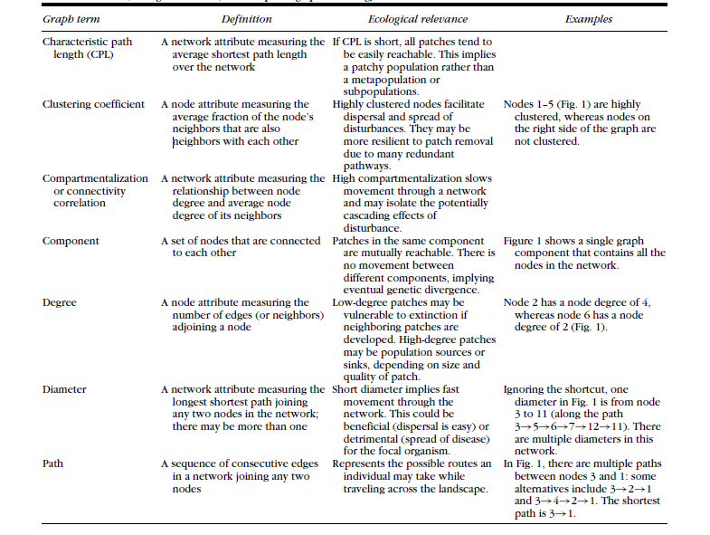
Table 1 – Definitions, ecological relevance, and examples of graph terminology used (Minor and Urban 2008)

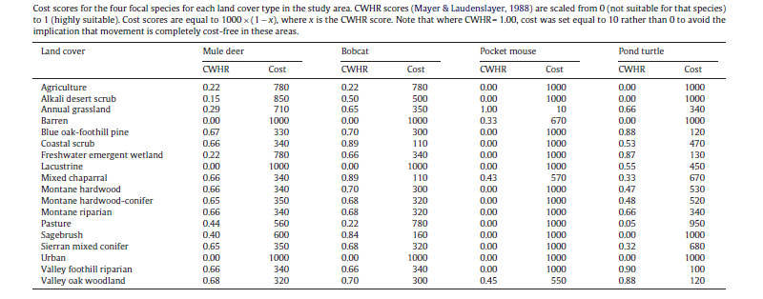
Table 2
(Huber, Shilling, et al., Municipal and regional habitat connectivity planning 2011).

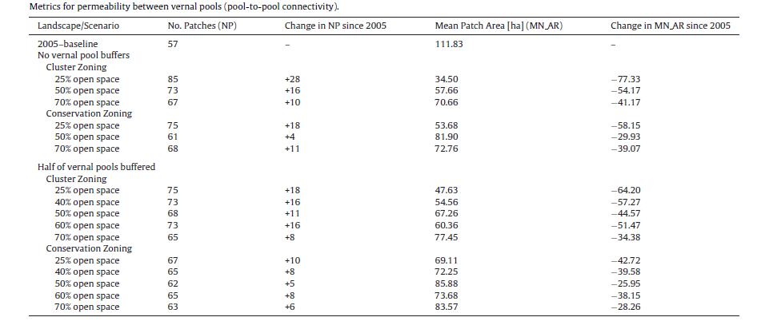

Table 3
(Freeman and Bell, Conservation versus cluster subdivisions and implications for habitat connectivity 2011)

Figures
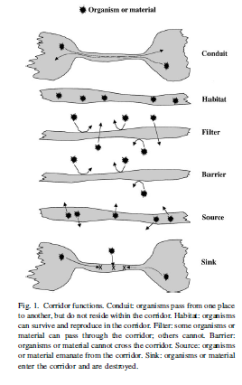
Fig. 1
(Hess and Fischer 2001)
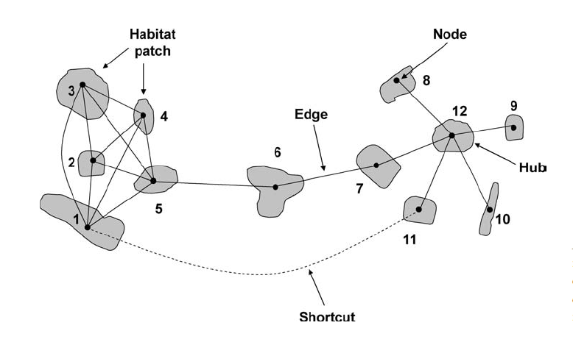
Fig.2. Illustration of some network terms. See example column in Table 1 for an explanation of habitat patch numbers (Minor and Urban 2008)

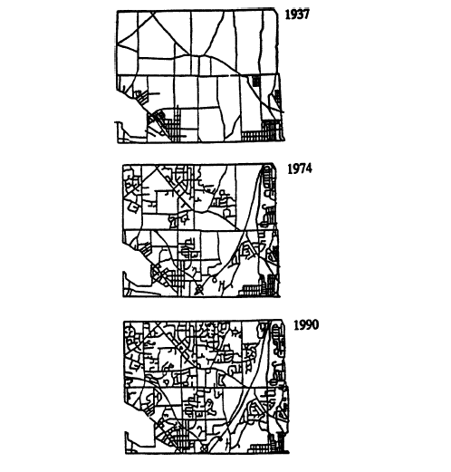

Fig.3. The pattern of “wall-to-wall subdivisions” that evolves over time with zoning and subdivision ordinances which require developers to provide nothing more than house-lots and streets (Arendt 2004).

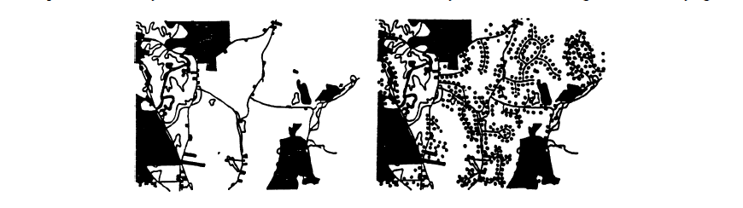
Fig.4. A matching pair of graphics, taken from an actual “build-out map”, showing existing conditions (mostly undeveloped land) contrasted with the potential development pattern of “checkerboard suburbia” created through conventional zoning and subdivision regulations (Arendt 2004).

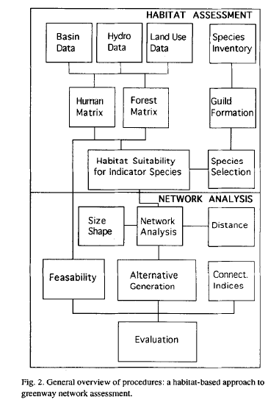
Fig. 5 (Linehan, Gross and Finn 1995)
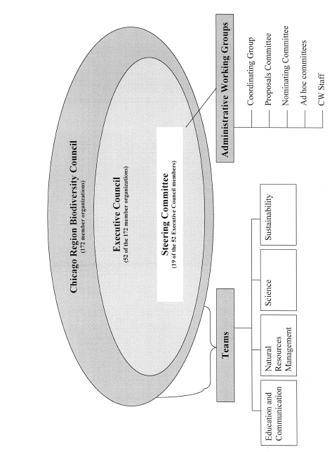

Fig.5. Chicago Wilderness Organizational Chart (Moskovits, et al. 2004)

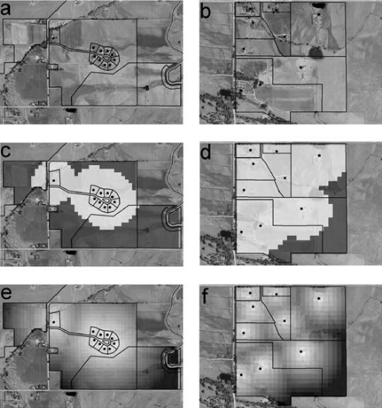

Fig 6. Discreet distance analysis of (a) clustered development with a total area of 85 ha, 10 houses, and 80 ha of protected outlots and (b) dispersed development with a total area of 60 ha and 9 houses. When each house in the development is buffered by a hypothetical 200-m zone of influence the (c) clustered development retains 49 ha (58% of the total area) outside the zone of influence, whereas the (d) dispersed development retains only 13 ha (22% of the total area) outside the zone of influence. In (e) and ( f ) distance from the nearest house is reflected as a continuous surface (Lenth, Knight and Gilgert 2006).

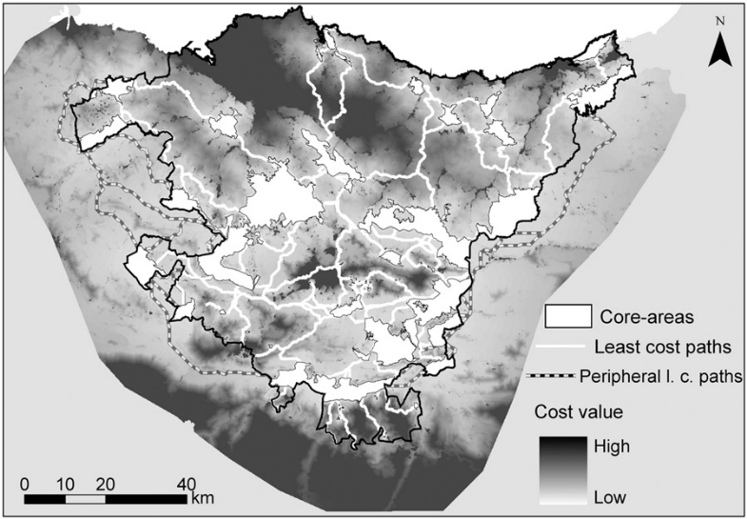

Fig.7. Map of cost surface and location of least cost paths between core areas.
(Gurrutxaga, Lozano and del Barrio 2010).

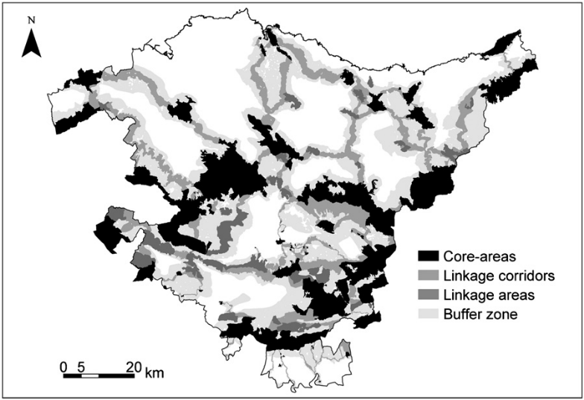
Fig. 8. Map of ecological networks structural elements
(Gurrutxaga, Lozano and del Barrio 2010).

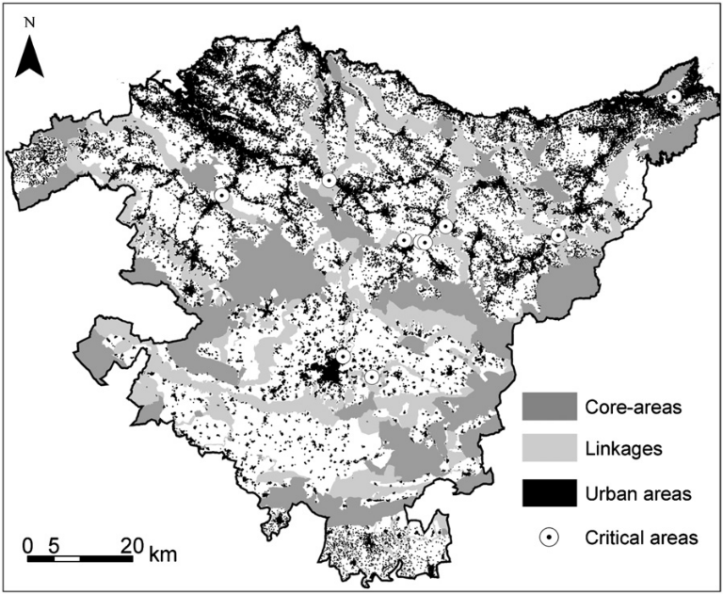
Fig. 9. Location map of critical areas of corridors due to urban land.
(Gurrutxaga, Lozano and del Barrio 2010).

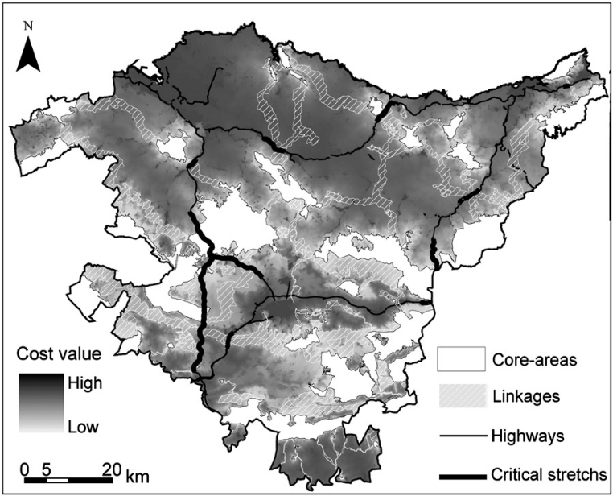
Fig. 10. Location map of critical highway stretches.
(Gurrutxaga, Lozano and del Barrio 2010).

