Part 4 - Report Outline
Design Rationale
Figure 1 – Current View of Location

Project’s impact on the community and environment
Concept Statement
The intent of our design is to build a mixed-used residential-retail transit-oriented development that is a true centerpiece of the community. The site will include a mix of residences, shops, office space that is primarily targeted at residents, a rail station, an on-site child care center as well as landscaping that includes a community garden, rainwater capture and xeriscaping.
Programming (current and future uses)
Mixed User Development with the following characteristics: residential living with an affordable housing component, retail, restaurants, transit oriented development (TOD), on-site childcare, playgrounds, small scale community gardens, and office space.
Contextual features
The site has been designed to give the residents an integrated development to live, work, raise a family and play, yet this development has also been to designed to not only minimally impact the surrounding neighborhood, but actually enhancing it. Below will show you how this is done. Figure 1 gives the basics on the site and what it is comprised of.
Figure 1
Current Transportation, Zoning, Utilities, Area, and Cost of the three Lots
Criteria Detail | Austin Energy Site | Walker Tire | B&B Transmission | Totals
Access/Transportation | Yes | Yes | Yes | Yes
Bus | Yes | Yes | Yes | Yes
Rail | Yes | Yes | Yes | Yes
Automobile | Yes | Yes | Yes | Yes
Utilities | Yes | Yes | Yes | Yes
Zoning | F1 | F1 | F1 | F1
Total Area (Sq. Ft) | 244,023 | 104,108 | 11,800 | 359,931
Acquisition Costs | $3,174,721 | $1,537,330 | $251,465 | $4,963,516

Design with Nature
This site is located in north-central Austin, in which is in Central Texas, in the Hill Country region. Currently, the site has no vegetation on it. Our plan includes xeriscaping it with native plants to encourage local flora and fauna to flourish on site. Additionally, we plan to plant a community-type garden that will be primarily tended to by residents and students at the child care center, and used by the child care center’s chef to prepare lunches for the children in attendance. Additionally, the rainwater harvesting techniques will be utilized to capture rainfall that can be used in the gardens and other green areas.
Approach to Open Space
Besides the community garden, other open areas include picnic benches and barbeque pits to be used for residents and whenever community events take place. A small covered patio will shield the residents from the sun or rain. A walking trail will surround the interior of the complex and give a convenient way to move around the complex.

Design with Culture

The cultural aspects of the site are diverse. The land is currently owned primarily by The City of Austin, specifically, Austin Energy, as well as three small business owners along Lamar Boulevard. The land is currently zoned by the State of Texas as F1 and locally as TOD (Transit-Oriented Development), which is the zoning that would be required for this type of development. Demographic characteristics of the neighborhood are addressed in the next section (Community).

Community
This project will fit well into the neighborhood. The area is already a mix of residential and retail and has an adjacent transit-oriented development that is currently sitting at 98% occupancy. There is not another child care center in the immediate vicinity of this property, so this will entice residents to the site.

Figure 2 - Site Location and Site Area defined by one mile radius

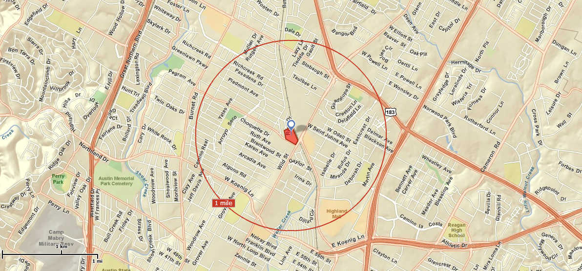
As of 2000, the data shows that the one mile radius surrounding the proposed site compared to the rest of Austin is older, whiter, more educated, yet with fewer younger families with children. This has probably changed in the last ten years with an influx of a younger generation at Midtown Commons at Crestview and the Regulating Plan for Lamar as discussed earlier. This also means that this area may lack the child care needs with this growing population. It does show a higher rate of users taking public transportation. However, the population in the one mile radius around the site has roughly the same number of cars per household as the rest of Austin.

Table 1 - Demographic Characteristics between Site Area and Austin
Category | Site Area (2000)  (within one mile radius) | Austin (2000)
General
Population | 15,025 | 656,562
Percent White | 73.7% | 65.4%
Population age 0-9 | 11.2% | 13.4%
Age 65+ | 11.2% | 6.7%
College Graduate  (undergrad and grad) | 40.4% | 33.6%
College Students | 10.0% | 12.8%
Real Estate Facts
Owner Occupied Housing Units | 43.7% | 43.0%
Renter Occupied Housing Units | 53.8% | 52.9%
Vacant Housing Units | 2.5% | 4.0%
Household Facts
In Family Households | 64.6% | 70.3 %
Enrolled in Nursery/Kindergarten | 2.7% | 3.3%
Females in Labor Force | 32.1% | 31.9%
Males in Labor Force | 40.3% | 40.0%
Employed Females 16+ with children under 6 | 4.5% | 4.8%
Married Couple Households  -with Related Children | 13.6% | 19.4%
Other Family (No Spouse Present)  -with Related Children | 8.3% | 9.7%
Median Household Income | $36,377 | $43,074
Per Capita Income | 19,428 | $24,163
Transportation Habits
Workers 16+ Taking Public Transportation | 5.2% | 4.5%
Average Travel Time to Work (min) | 19.9 | 22.4
Average Number of Vehicles Available | 1.5 | 1.6

There is already a plan in place for this type of development at this site, per the “REGULATING PLAN for the Lamar Blvd./Justin Lane TOD Station Area Plan (SAP)”.

Design places for people
This development will accommodate almost every aspect of a person’s life.

Site conditions
The physical address of the main parcel is 6906 Ryan Drive, Austin, Texas, 78757 and the latitude and longitude are 30.3379°N 97.7217°W. The site is entirely flat and sits at an elevation of 735 feet (224 meters). Average number of sunny days in Austin is 115 and the average annual wind speed is 8.9 mph.
Location Specific Conditions | Site characteristic of condition
Sun and Wind Exposure | Nothing in this location makes it different than that rest of Austin when it comes to sun and wind exposure.
Lot size and shape | 359,931 sf, irregular 5 sided shape
Location in relation to transportation systems | Located next to Metro Rail station and bus stop
Significant vegetation, topography | No significant vegetation, Flat
Prominent Vistas/Views or Landmarks | None
Building scale and character | Mixed use for residences, retail combined with open areas.

Approach to open space
As shown on the site plan, there will be plenty of open space for the residents and visitors. First, there will be community gardens for residents to plant their own vegetables and present an opportunity to supply the children with organic food grown on the site and for the children to see firsthand where their food comes from. Second, a open area with picnic benches and barbeque pits to be used for residents and whenever community events take place. Surrounding these natural open areas is xeriscaped native specie plants, trees, and shrubs that are watered by both reused rain water and conventional irrigation.

Circulation
Entrances will be on both Lamar Blvd. and Justin Ln. This will place the in and out traffic as far away from the adjacent residential neighborhoods as possible. Traffic will increase on Justin Ln. connecting Burnet Rd. and Lamar Blvd. It is inevitable that traffic will increase on Justin Ln. from residents’ coming from and going to Burnet Rd (see figure 2). Traffic will increase on Lamar as well. Circulation within the site will be confined to areas near retail and to and from the residential parking area plus traffic going to and from the rail station.

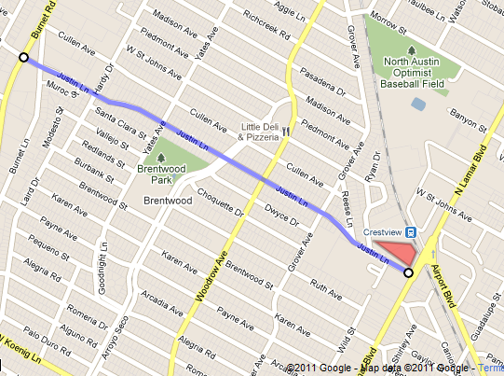
Figure 2
Building envelopes/pods
As show on Figure 3, the building envelopes/pods are located near the Justin Ln. and Ryan Dr. This will minimize the noise from traffic on Lamar Blvd. and the rail road tracts. The retail space is located near Lamar to minimize traffic from Lamar from going through the development. The rail station will accommodate the pedestrian and automobile traffic coming into the development.

Building Envelopes/Pods - Figure 3
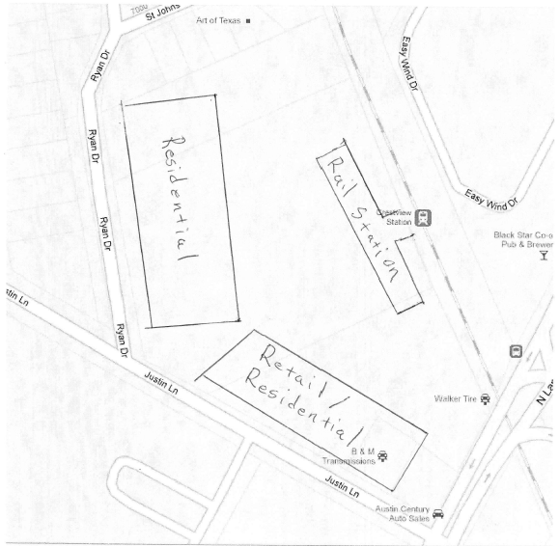

Utilities
The infrastructure is in place for a development of this type to take place here. There is already water, sewer and electricity accessible at the site, as well as good adjacent transportation connectivity.
Views
The views from each direction can be summarized by the table below. The directions are reference in the direction of the boundary of the property. The surrounding area is relatively flat, so these views are from the edge of the property or can be from a higher floor in the interior of the property.
Views - Figure 4
Direction | View
Residences on St. Johns | The back yards of the residences on St. Johns.
Ryan St. | The street and the fronts of the houses on that street.
Justin Ln. | The street and apartment complexes on the street and a Walgreens at the corner of Lamar.
Lamar Blvd. | The street and retail on it.

Bibliography
http://www.currentresults.com/Weather/Texas/annual-days-of-sunshine.php
http://lwf.ncdc.noaa.gov/oa/climate/online/ccd/avgwind.html

