The Environmental and Legal Aspects of Hydraulic Fracturing
Henry Reissig
Geography 5314 – Environmental Law
November 27, 2012

The Rise of the Hydraulic Fracturing Industry

Natural gas plays a key role in providing the United States (US) independence in energy resources. The US has vast reserves of natural gas. Much of this is shale gas that is trapped in shale formations called “plays”. Shale is a fine grained sedimentary rock that can be rich in petroleum and natural gas. Shale plays are quite abundant in the US (see fig. 1). For the past decade, the Barnett Shale play in north Texas has been a top producer of natural gas and much of the extraction techniques have been developed and perfected in this play. Other important shale plays are the Marcellus in the eastern United States, the Bakken in North Dakota and the Eagle Ford in south Texas. As of 2011, 94 percent of the natural gas was produced domestically.

Many of these reserves have only recently been accessible due to advances in extraction techniques called “unconventional extraction methods”. These unconventional methods are the key technologies used in extracting natural gas out of natural shale formations and has allowed access to large volumes of shale gas that was previously uneconomical to produce. Shale gas development is considered “unconventional” because of four technologies recently combined to make gas production from shale technically and economically feasible. None of these four are brand new techniques, but the combination of all these together is what makes the hydraulic fracturing process unconventional. These four technologies are: directional drilling, high hydraulic fracturing fluid volumes, slickwater, and multi-well pads. Directional drilling is the technology that allows the drilling bit to be controlled to go any direction the operator wants to achieve maximum coverage of the shale layer. High hydraulic fracturing fluid volumes is needed to penetrate the induced and naturally occurring fracturing layers deep into the earth to release as much gas as possible from the shale layer. Slickwater allows the hydraulic fracturing process to inject high volumes of fluid in long distances (as long as 2 miles) through a small diameter pipe (4-5”) in a relatively brief period of time at relatively high pressures. Multi-well pads are needed to maximize the reach from one pad to access as much of the gas inventory as possible using the land and capital as efficiently as possible. Risks are much higher using unconventional extraction methods because of the larger quantities of materials going into the process and the higher industrial power to perform the process.

The U.S. Energy Information Administration estimates that the U.S. natural gas production in the next 15 years will increase by 29 percent to where the estimated natural gas production in 2025 will be 27.9 trillion cubic feet (cf). Almost all of this is due to the projected growth in shale gas production that will go from 23 percent of the total gas production in 2010 to an estimated 49 percent 2035 (see fig. 2). This has also put Texas at the forefront of the environmental issues pertaining to the hydraulic fracturing. With the stakes so high to tap into these resources the concern on the effects of the environment have also increased the need to create laws and regulations that address these concerns and that will keep up with the exploding growth of the industry. This paper will cover the hydraulic fracturing process in general, then cover the environmental impact of the hydraulic fracturing process and then finally cover the federal and Texas laws and regulations pertaining to the hydraulic fracturing process.

The Hydraulic Fracturing Process

The hydraulic fracturing process begins with the following steps (see fig. 3):
1. A drilling bit or drill string starts drilling a hole in the ground. The hole may initially be around 18 inches in diameter, but will reduce in size as the hole gets deeper to around 5 or 6 inches in diameter. During this time, it’s an open hole where the hole is in contact with the atmosphere. Compressed air or drilling mud is pumped down the pipe and cuttings from the hole are ejected.
2. The drilling eventually penetrates the water table. The drilling will continue under the deepest part of the water table. To isolate the fresh water zone, the surface casing is inserted into the drilled hole.
3. Cement is poured down the casing sealing off the well bore from the fresh water preventing contamination. The quality of the cement is crucial in this step because this will help ensure the separation of the contents of the pipe from the underground water source.
4. Drilling continues to 500 feet above the planned horizontal section. The curve will begin with approximately a 0.5 mile radius turn to the horizontal position called “the lateral”.
5. Drilling proceeds down the lateral until the target length is reached. The annulus (space between the casing and the wall) is filled with cement by sending the cement through the production casing. The annulus is about an inch thick and the integrity of cement is especially important here. Known issues have been bonding issues between the cement and the casing and the general quality of the cement itself. The integrity of the annulus is important in keeping methane or hydraulic fracturing fluid migration from happening. At this point in the drilling is completed and the drilling company has the option to wait for the next step to take place. Some of the many reasons to wait could be too low of gas prices, lack of infrastructure to process it, no gathering lines to take it to the transmission lines, lack of place to put the wastewater.
6. A perforating gun is inserted down the entire length of the casing and then, along the horizontal section, shoots small holes through casing and cement and into the shale formation. Small fractures travel to naturally existing fractures and joints in the shale joining the well with the rest of the shale formation.
7. Hydraulic fracturing fluid is created by mixing water with sand and a variety of other chemicals (discussed in more detail later in the paper) and pumped into the well bore under high pressure, forcing the rock to fracture. This is done throughout the horizontal distance of the well and is repeated in roughly 1,000 foot segments. Millions of gallons of water are used in this process and the total amount depends on many factors such as rock type.

The Environmental Aspects of Hydraulic Fracturing

Numerous environmental issues can be addressed regarding hydraulic fracturing. The hydraulic fracturing process affects air, water and land. Another concern is the increase in seismic activity around areas affected by hydraulic fracturing.

Effects on Drinking Water
The number one concern about the possible environmental risks associated with hydraulic fracturing is the potential impact on drinking water resources. The water table can be affected at any step in the process, but it is especially vulnerable during drilling process as it goes through the water table. In step 2 of the process where drilling goes through the water table, some of the drilling mud or compressed air will get into water table. This is unavoidable. Before the protective casing is set, anything going into the hole will end up in the fresh water table.

During and after drilling the well, there is a vulnerable connection to deeper layers as far down as 7000 feet. With direct access to the deep layers of the earth, ground water can be susceptible to contamination from Volatile Organic Compounds (VOCs) and Naturally Occurring Radioactive Material (NORM). Some of these are: methane, radium, radon, chromium, lead, arsenic, barium, benzene, bromide, sodium chloride, H₂S, 2-butoxyethanol, (2-BE), 4 Nitroquinoline-t-oxide (4-NQO) and other pollutants (see fig. 4).

The hydraulic fracturing process uses a very large amount of water. Conventional drilling uses around 100,000 gallons of water whereas unconventional drilling using hydraulic fracturing can use several million gallons per well.

Casing and Cement Failures
Casing and cement failures are a major concern for the short and long term outlook of a gas well. Gas, drilling fluid, brine migrating up through well structure is a chronic problem in the oil and gas industry mostly due to casing and cement failures. Possible issues with these failures are the following (see fig. 5 and fig. 6): (a) migration along the contact between the cement and the rock, (b) migration along the contact between the cement and the casing (loss of bond), (c) diffusion of fluids through poor quality cement, (d) fracture of the cement, (c) rupture of the casing, (d) cement well plug fail.

Hydraulic fracturing Process and Air Quality
Air is heavily affected by hydraulic fracturing process. The hydraulic fracturing process produces a large amount of exhaust from heavy machinery. Pumps are used in all steps of the hydraulic fracturing fluid process. Pumps are used in bringing high volumes of fluids by trucks, storing these high volumes in tanks or pits and an extraordinarily high amount of pumping power is used in the actual hydraulic fracturing process. It’s not unusual to use 40,000 aggregate horsepower in one hydraulic fracturing job.

A lot of gas is leaked into the atmosphere during the entire process. Looking at the whole life cycle of natural gas, two to six percent is leaked into the atmosphere. The term “life cycle” refers to five steps: (1) getting to the gas, (2) bringing the gas to the surface, (3) processing the gas, (4) transporting the gas and (5) burning the gas. Methane is 20 to 100 times more potent of a greenhouse gas than carbon dioxide. By 2025 it could potentially reach 1.6 trillion cf leaked into the atmosphere based on the predicted production. This could be a major contributor to climate change.

The land is affected more by unconventional extraction than traditional extraction because in a conventional extraction job using vertical drilling, only one well is needed per pad because the resource to be extracted tends to be pooled up in one spot and if the spot is missed or is depleted, the whole pad would have to be moved to a location to where the resource is found again. In unconventional extraction such as hydraulic fracturing, the gas extracted is contained in the shale located everywhere, so the new process of directional drilling creates multi well pads (see fig. 7). As many as eight wells can be used per pad.

A prime example of this is the Dallas Fort Worth International Airport who leased its land (~18,000 acres) to Chesapeake Energy for $185 million with 25 percent of all royalties written in the contract. The map on Figure 8 shows the DFW airport where the red dots represent the pads (53) and the red lines represents the wells. This shows the extent of the coverage that unconventional extraction has on land.

Hydraulic fracturing Fluid and its Environmental Impact
The water must be lubricated, so chemists created chemicals to add to the water to reduce friction of the water passing through the casing and between the water molecules themselves. The hydraulic fracturing fluids going into the well consists of the following minimum ingredients: proppants, biocides, fluid loss additives, anti-corrosives, friction reducers and acid. Proppants are particles like sand that are transported into the fractures to keep them open after fracturing pressure release. Biocides kill bacteria that harm the gelling agents that are used to increase the viscosity of the fluid. Fluid loss additives decrease leakoff of the fracturing fluid into the rock. Anti-Corrosives protect metallic elements in the well. Friction reducers allow for higher pressures and better flow rates. Acid is used to clean out perforations, well and fractures in the shale. Diesel fuel has also been used as part of the hydraulic fracturing fluid, but it’s a known carcinogen and many citizens and environmental groups want to ban it from the allowed list of chemicals.

When the fracturing process is completed, the hydraulic fracturing pressure is released and much of the fracturing fluid backflows to the well head. This is followed by produced “water” for much of the life of the well. The backflow will contain saline, heavy metals, fluid additives and NORM. To clarify the terms, “flow back fluid” is the fluid that comes out “soon” after the hydraulic fracturing fluid is injected and “produced water” is the fluid that comes up “with time” during the life of the well. This cutoff time is important, but is not standardized. The reason it’s important is because the disposal methods and standards can vary between what it considered “flow back” and what is considered “produced water”. This can be a problem because proper disposal requires proper knowledge of the contents of the fluid whether it’s considered “flow back fluid” or “produced water”.

The industry states that it’s improbable that gas, hydraulic fracturing fluid and produced “water” will migrate up from the hydraulic fractured formation though disagreement persists with affected citizens and some environmental advocates. In Texas, well operators are required to provide actual fracturing data in detail and resulting production results after well stimulation treatment is complete. The hydraulic fracturing process is monitored to check to see if the fractures created in the process are limited to the targeted formation.

After the hydraulic fracturing fluid comes back up, it initially stays on site in collection ponds or tanks. Tank storage is far preferred over collection ponds because of the contact it has with the environment. Evaporation of the fluid will contribute to poor air quality and risk from flooding and liner leakage in the pond can be avoided using tanks. After storage on the site, the fluid then is disposed of mostly in injection wells.

Seismic Activity
According to the United State Geologic Survey (USGS), seismic activity has been increasing in the U.S. midcontinent for the past few years, but seismic activity has been attributed mostly to injection wells rather than the hydraulic fracturing process itself.

Federal and State Laws and Regulations of Hydraulic Fracturing

Study on Regulations and Enforcement Regarding Shale Gas Development
The Energy Institute at the University of Texas surveyed federal and state laws and regulations related to shale gas development in 16 shale gas production states. This analysis covered all phases of shale gas production: exploration, well siting, drilling and fracturing, production, well plugging and site closure. This group also examined several federal exemptions. The key findings were the following: (a) Primary regulatory authority is in the states control and many federal requirements have been delegated to the states. (b) Most state oil and gas regulations were written well before shale gas development began. (c) Some states have revised regulations pertaining to shale gas development. Three main areas are: disclosure of hydraulic fracturing chemicals used in the process, proper casing of wells to prevent ground water contamination, and management of wastewater from flow back and produced water. (Note: These thee areas will be examined for Texas below) (d) Spotty regulation remains for well casing and cementing, water withdrawal and usage, and waste storage and disposal (e) Urgent issues, such as spill prevention which may pose a greater danger than hydraulic fracturing itself and more needs to be done to address this.

The Energy Institute also reviewed the capabilities that state agencies have in enforcing regulations regarding the shale gas development. This study reviewed the staff responsible including the staff responsible for the inspection and the attorneys supporting them. The key findings were: (a) Enforcement capacity varies greatly by state particularly the variation in the staff to inspection ratio. (b) Most violations are the same type associated with traditional oil and gas production rather than for shale gas production including hydraulic fracturing. (c) Surface incidents are reported much more than subsurface containment releases possible possibly because surface incidents are easier to observe.
Federal Regulations and Exemptions
The Environmental Protection Agency (EPA) states that its focus and obligations under the law are to provide oversight, guidance, and rulemaking (where appropriate) that protect the air and water where Americans live, work and play. All states must abide by the federal environmental laws, but the oil and gas industry has several exemptions from federal environmental laws to exploration and development. Some of these exemptions are the (a) Comprehensive Environmental, Response, Compensation and Liability Act (b) Resource Conservation and Recovery Act, (c) Safe Drinking Water Act, (d) Clean Water Act, (e) Clean Air Act, (f) National Environmental Policy Act, (g) Toxic Release Inventory under the Emergency Planning and Community Right-to-Know Act.

Pre and post Ground Water Testing
A baseline assessment program for all nearby water wells in the vicinity of the hydraulic fracturing job is recommended by the American Petroleum Institute guidance (API-HF1) before and after any hydraulic fracturing operations in new area. Colorado requires testing of certain wells in the vicinity of the hydraulic fracturing operations to go through testing before and after hydraulic fracturing jobs. Pennsylvania puts the burden of proof on any oil and gas company that they have not caused the deterioration of ground water used for drinking water near a hydraulic fracturing job.

Roles of the Railroad Commission of Texas and the TCEQ
The Texas Railroad commission (TRC) is a state agency that regulates the oil and gas industry in Texas. Other areas the TRC regulates are: gas utilities, pipeline safety, liquefied petroleum gas safety, and surface coal and uranium mining. As far as the shale development is concerned, the TRC issues permits for gas wells and monitors well drilling, completion, production, and plugging operations. Many of the rules for shale development can be found in the Texas Administrative Code (TAC) Title 16 (Economic Regulation), Part 1 (Railroad Commission of Texas), Chapter 3 (Oil and Gas Division). The rules below will all be in Chapter 3. The Texas Commission on Environmental Quality (TCEQ) is the Texas environmental regulatory and enforcement agency. It’s oversight of the oil and gas industry is limited though. For example, according to TCEQ, groundwater is not regulated by the TCEQ, but rather the groundwater conservation districts. Surface water used for oil production activities is regulated under the TCEQ which allows surface water to be used for “mining purposes” by the oil and gas industry.

Disclosure of Hydraulic Fracturing Chemicals in Texas
As shown in the hydraulic fracturing process section, there is always a chance that hydraulic fracturing fluid can come into contact with humans in various ways. It can leak through faulty casing into the ground water table, it can sit in holding ponds for extended times evaporating into the atmosphere and it will continuously come out of wells heads mostly during the hydraulic fracturing operation as “hydraulic fracturing fluid” or as “produced water in a continuous, but lesser degree. Hydraulic fracturing fluid will eventually be shot down injection wells further exposing it to underground water and causing some seismic activity. With all this exposure to hydraulic fracturing fluid, public concern is at an all-time high on exactly what exactly constitutes hydraulic fracturing fluid. In response to this concern Texas Governor Rick Perry signed a disclosure law requiring the composition of fluids used in hydraulic fracturing be disclosed on July 15, 2011. 16 Tex. Admin. Code § 3.29 (Hydraulic Fracturing Chemical Disclosure Requirements) covers this new law. The composition of hydraulic fracturing fluid varies from well to well and from one drilling company to another. Under this law, operators will be required to report the makeup of fluids to the TRC through fracfocus.org. Fracfocus.org is a website sponsored by the Ground Water Protection Council and the interstate Oil and Gas Compact Commission. When in the site, the user will select the state, county, the name of the well in the county, and the operator of that well. Forms G-1 (Gas Well Back Pressure Test, Completion or Recompletion Report, and Log) includes a section on the back to list what and how much slick water fluid and sand is injected.

Proper casing of wells to prevent ground water contamination in Texas
The RRC requires wells to have several layers of steel casing and cement to protect groundwater. These are covered in 16 Tex. Admin. Code § 3.13. The RRC requires three protection layers of casing to protect the ground water. The first protection layer is the outside layer in contact with the water. It is encased in cement that reaches from the ground surface to below the deepest usable quality groundwater level. The surface casing acts as a protective sleeve as the drilling goes even deeper. The second protection layer is the production casing that goes the entire depth of the well and is permanently cemented into place. The third layer is the tubing where the oil or gas goes through. Gauges at the surface are required by the RRC to monitor these wellbore casings so problems occurring down the well can be found. (See fig. 9).

The management of wastewater from flow back and produced water in Texas
According to the RRC, both hydraulic flow back fluid and produced water must be disposed of “in a manner that will not cause or allow pollution of surface or subsurface waters.” Most of these fluids or either recycled or disposed of by injection into “geologically confined underground formations through injection wells permitted through the RRC EPA-delegated Underground Injection Control (UIC) program under the federal Safe Drinking Water Act.” Two Rules also cover some of these issues: 16 Tex. Admin. Code § 3.57 (Reclaiming Tank Bottoms, Other Hydrocarbon Wastes, and Other Waste Materials) and 15 Tex. Admin. Code §3.98 (Standards for Management of Hazardous Oil and Gas Waste).

Conclusion

Shale gas development is here to stay and it’s going to continue to grow for years to come as long as profits are made and the need is there. With the new unconventional extraction methods, the United States is already a major exporter of fossil fuels. Natural gas has been touted as a clean alternative to other fossil fuels and its usage as a transportation fuel has wide support from Republicans and Democrats alike. This comes at a price though. It’s not enough to see how clean it burns. You must also look at the whole life cycle in how it is produced. With much concern over the hydraulic fracturing process itself, it’s the endemic processes such as exhaust from pumps and fluid outgassing, along with the incidentals such as spills, casing failures, gas leaks, and holding pond leaks that can take a toll on the environment the most. The unconventional gas extraction methods increase the frequency and density of the problem throughout the affected areas. Oil and gas operators will what it takes to stay in business, so the field needs to leveled with clear and consistent rules for them to follow. Laws need to be updated to include the new processes including hydraulic fracturing to ensure that this economic success does not include an environmental disaster. Only 16 Tex. Admin. Code § 3.29 (Hydraulic Fracturing Chemical Disclosure Requirements) specifically addresses hydraulic fracturing in particular.

Appendix A - Illustrations

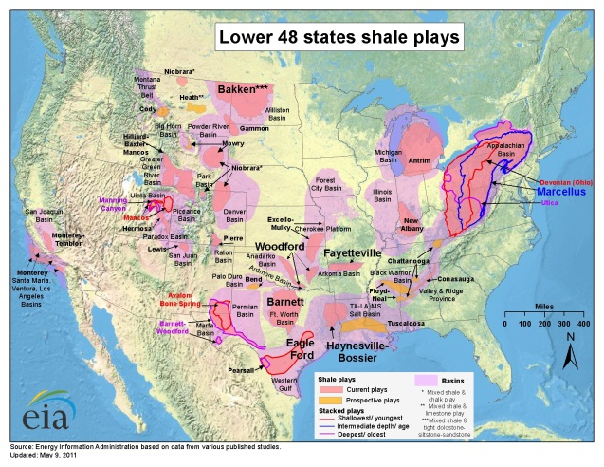
Figure 1
Shale Plays in the Continental United States
Source: http://www.eia.gov/pub/oil_gas/natural_gas/analysis_publications/maps/maps.htm

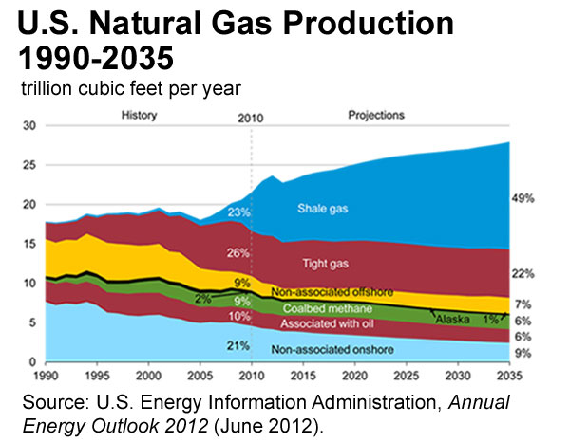

Figure 2
Projected U.S. Gas Production 1990-2035 broken down by resource type
Source: http://www.eia.gov/energy_in_brief/about_shale_gas.cfm

Appendix A – Illustrations cont.

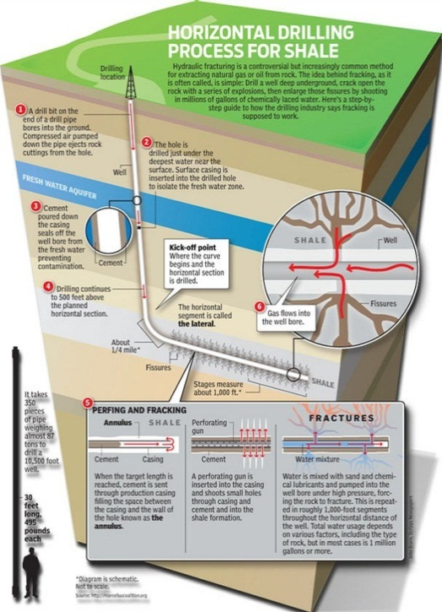

Figure 3
Horizontal Drilling Process for Shale
Source: http://www.gosanangelo.com/photos/2011/jun/27/48296/

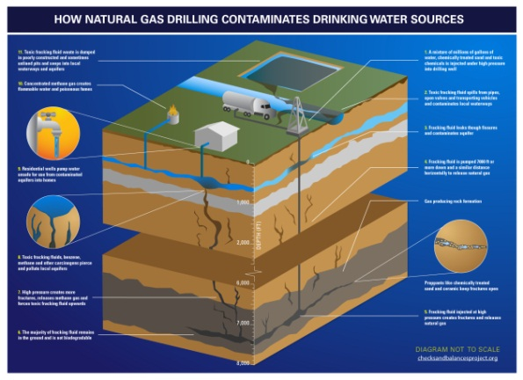

Figure 4
How Natural Gas Drilling Contaminates Drinking Water Resources
Source: http://checksandbalancesproject.org/2011/05/06/gas-patch-scientists-explain-how-hydraulic-fracturing-can-permanently-contaminate-public-water-supplies/

Appendix A – Illustrations cont.

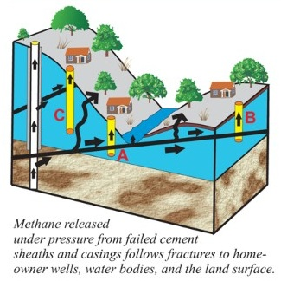
Figure 5
Illustration of possible issues regarding from failed cement on castings
Source: http://www.napalmcreek.com/how-safe-is-hydraulic fracturing.php

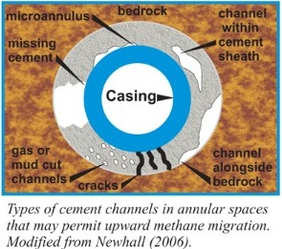

Figure 6
Cross section of possible cement issues with casing.
Source: http://www.napalmcreek.com/how-safe-is-hydraulic fracturing.php

Appendix A – Illustrations cont.

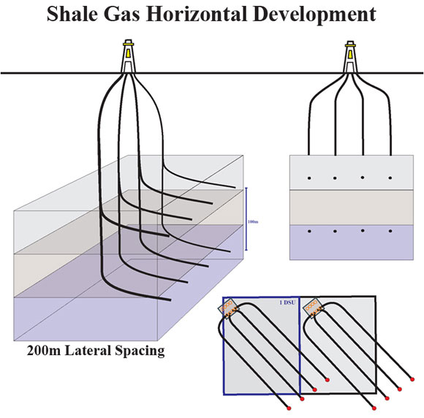
Figure 7
Multiple wells per pad illustrated
Source: http://www.neb.gc.ca/clf-nsi/rnrgynfmtn/nrgyrprt/ntrlgs/prmrndrstndngshlgs2009/prmrndrstndngshlgs2009-eng.html

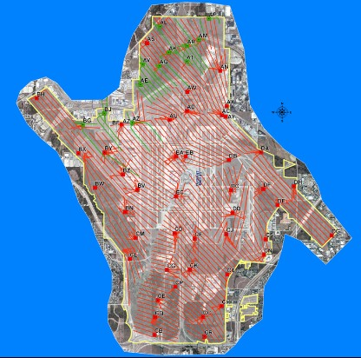

Figure 8
Map of wells located at the DFW airport
Source: http://www.napalmcreek.com/how-safe-is-hydraulic fracturing.php
Appendix A – Illustrations cont.

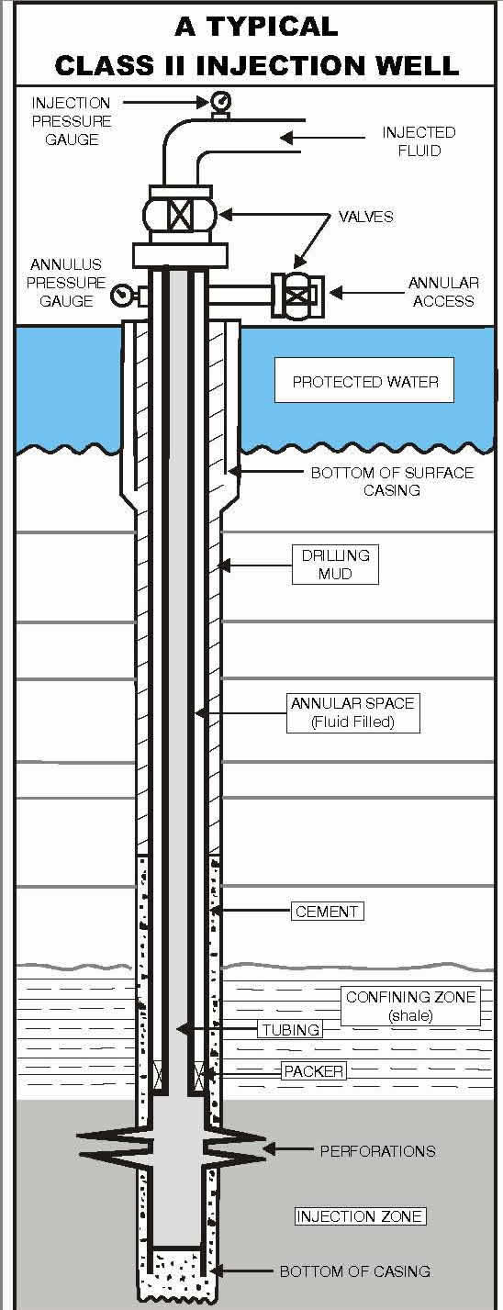

Figure 9
Areas of importance pertaining to casing cement integrity
Source: http://www.rrc.state.tx.us/about/faqs/images/injectionwelllg.jpg

Bibliography

Anthony Ingraffea, PhD, P.E. "How Safe is Fracking? Four Myths About Hydrofracking." Napalm Creek Oracle. 2011. http://www.napalmcreek.com/how-safe-is-fracking.php (accessed Nov. 2012).
DeepResource: Observing the world of geopolitics, energy, and other resources – “Dr. Ingraffea Facts on Hydraulic fracturing”. 2010. http://deepresource.wordpress.com/2012/10/03/dr-ingraffea-facts-on-hydraulic fracturing (accessed 11 2012).
Energy Institute at the University of Texas - Regulation of Shale Gas Development and Enforcement of State Regulations. 2011. http://energy.utexas.edu/index.php?Itemid=160&id=151&option=com_content&view=article (accessed Nov. 2012).
EPA.gov Natural Gas Extraction - Hydraulic Fracturing. November 20, 2012. http://www.epa.gov/hydraulicfracture/ (accessed Nov. 20, 2012).
Frac Focus - Groundwater Protection & Water Usage. 2012. http://fracfocus.org/groundwater-protection (accessed Nov. 2012).
Frac Focus - Regulations by State. 2012. http://fracfocus.org/regulations-state (accessed Nov. 2012).
"Natural Gas Extraction - Hydraulic Fracturing." Environmental Protection Agency. Oct. 2, 2012. http://www.epa.gov/hydraulicfracture/ (accessed Nov. 2012).
"Plan to Sudy the Potential Impacts of Hydraulic Fracturing on Drinking Water Resources." Environmental Protection Agency. 2011. http://www.epa.gov/hfstudy/HF_Study__Plan_110211_FINAL_508.pdf (accessed Nov. 2012).
Railroad Commision of Texas - Hydraulic Fracturing Frequently Asked Questions. 2012. http://www.rrc.state.tx.us/about/faqs/hydraulicfracturing.php#frac15 (accessed Nov. 2012).
Renee Lewis Kosnik, MSEL, JD, Research Director, Oil and Gas Accountability Project. "The Oil and Gas Industry’s Exclusions and Exemptions to Major Environmental Statutes." Natural Gas Subcommittee of the Secretary of Energy Advisory Board. Oct. 2007. http://www.shalegas.energy.gov/resources/060211_earthworks_petroleumexemptions.pdf (accessed Nov. 2012).
Stephen Rassenfoss, JPT/ JPT Online Staff Writer. "From Flowback to Fracturing: Water Recycling Grows in the Marcellus Shale." Society of Petroleum Engineers. Jul. 2011. http://www.spe.org/jpt/print/archives/2011/07/12Marcellus.pdf (accessed Nov. 2012).
"Texas Administraive Code, Title 16, Part 1, Chapter 3." Office of the Secretary of State. 2012. http://info.sos.state.tx.us/pls/pub/readtac$ext.ViewTAC?tac_view=4&ti=16&pt=1&ch=3&rl=Y (accessed Nov. 2012).
"Texas in Vanguard of Nationwide Oil and Gas Energy Boom." Texas Commission on Environmental Quality. Aug. 2012. http://www.tceq.texas.gov/assets/public/comm_exec/pubs/pd/020/2012/Outlook-August-2012-x.pdf (accessed Nov. 2012).
The Process of Shale Extraction. n.d. http://www.energyfromshale.org/shale-extraction-process (accessed Nov. 2012).

