Travis County Congressional Districts

Project Description:
Travis county is split (shared) between five congressional districts: 10th (Michael McCaul-R), 17th (Bill Flores-R), 21st (Lamar Smith-R), 31st (John Carter-R), and 35th (Lloyd Doggett-D). This means that Travis County is represented as 80 percent republican (not by area, but by representation). Does this adequately represent Travis County? Intuition tells us that this is not true. A deeper look will tell us exactly how far off this is.
This project will analyze congressional districts to see how representative they are to the communities within these districts. The research question is: Are there significant differences between the racial breakdown and voting habits of the entire districts in question with the portion of the districts within Travis county? If the answer is “Yes”, the statistics will quantify by how much and it is and could suggested that Gerrymandering is taking place within Travis county.
The racial breakdown of the congressional districts will be found by analyzing the census blocks contained within the districts and the voting habits will be found from the results of the 2016 presidential election for each county or voting precinct. The final result will be presented through tables, charts, and maps.

Project Goal:
By comparing the racial breakdown and voting records between the congressional districts within Travis county versus the rest of the congressional district outside of Travis county, study’s goal is to test to see if the part within Travis county is consistent with the rest of the district or if there is a measurable difference. A measurable difference will indicate possible gerrymandering taking place.

Deliverables:
A map series with supporting tables and charts depicting a comparison between demographics for congressional districts within Travis county versus the demographics in the rest of the district and a similar set depicting the voting characteristics of both.
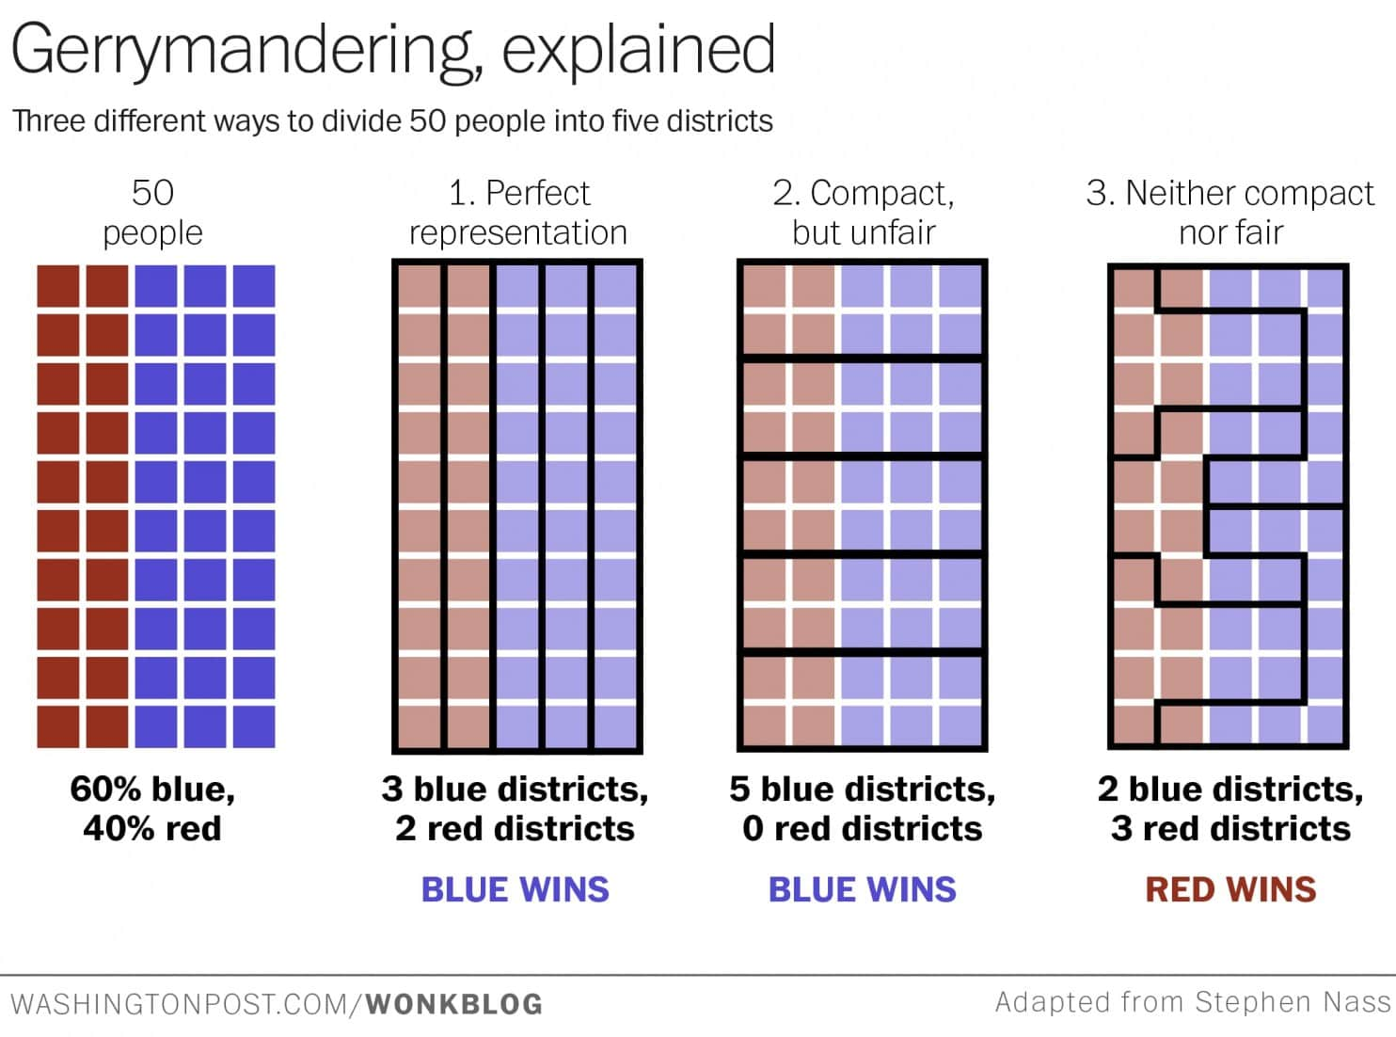

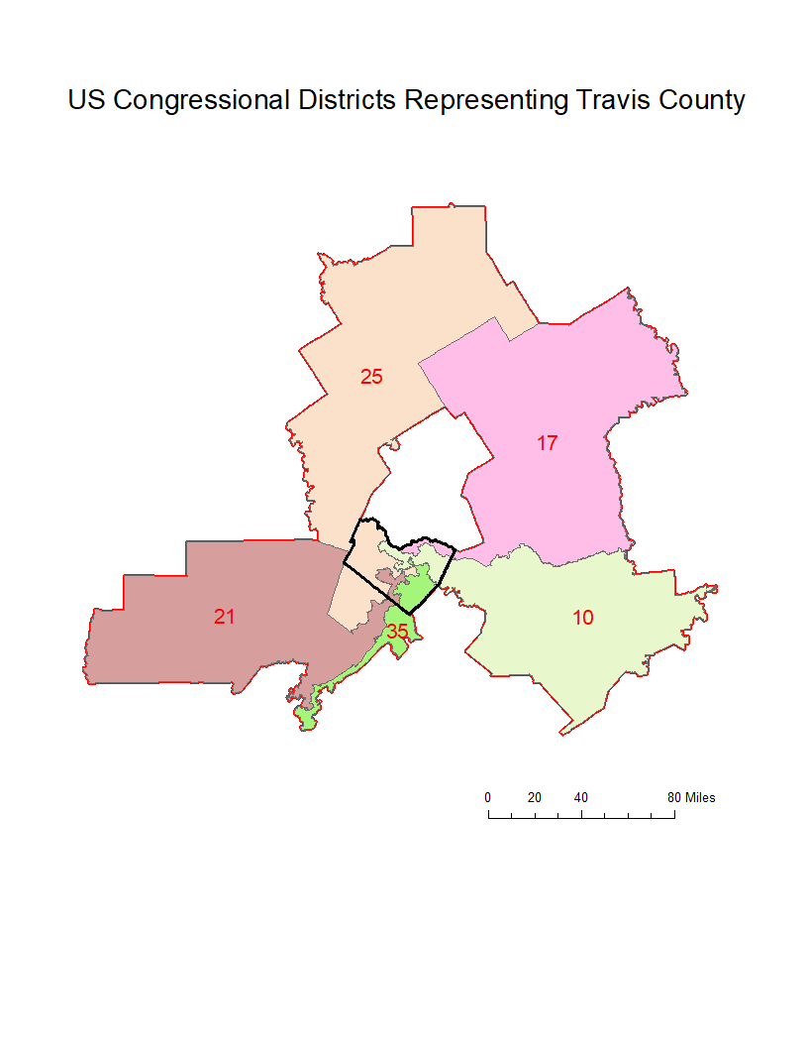

District | Representation | Area (Sq. Mi) | Perimeter (Mi) | Circularity
10 | Michael McCaul-R | 5143.7 | 632.3 | 2.49
17 | Bill Flores-R | 7768.8 | 693.3 | 2.21
21 | Lamar Smith-R | 5956.8 | 617.9 | 2.26
25 | John Carter-R | 7744.4 | 774.5 | 2.48
35 | Lloyd Doggett-D | 601.5 | 367.4 | 4.23

