AGEJLE-OS Community-engaged OS mapping

Contact: Nathan Morrow, PhD. Nmorrow@tulane.edu

The Advancing Gulf Coast EJ Leadership & Engagement in Open Science (AGEJLE-OS) project provides a recent, applied example of how community–academic partnerships can operationalize open science in community-engaged contexts. AGEJLE-OS supported community-engaged organizations and academic partners across the Gulf South to engage with NASA Earth science data, adopt open-science practices, and translate data into locally relevant research and planning activities. The project employed a two-tier collaboration model in which Open Science Champions received targeted training and support and, in turn, facilitated broader engagement through convenings, proposal development, and curriculum development. This approach moved beyond awareness-raising to practical application, emphasizing Earth Science to Action and community-defined research priorities.

AGEJLE-OS activities contributed to an applied synthesis of literature on community-engaged open science, community-engaged research, and the use of Earth observation data for decision support. The literature review curated under the project focused on participatory research methods, cumulative environmental risk assessment, data accessibility, and governance of community–academic collaborations. This review was used directly to support proposal development, curriculum design, and convening discussions, ensuring that scholarly insights were connected to practical implementation needs of local organizations. The resulting materials are archived openly and intended for reuse by both community practitioners and researchers.

A central objective of AGEJLE-OS was to translate ecosystem mapping of organizations, institutions, and data resources into concrete research and action pathways. Mapping outputs informed the development of multiple community-led, academically supported proposals addressing cumulative environmental exposures, extreme heat and air quality, coastal resilience, and fenceline community monitoring. These proposal pathways demonstrate how networked capacity, when paired with open data and technical support, can move from descriptive mapping to actionable research agendas aligned with federal funding opportunities. The proposal outcomes illustrate the role of open science as an enabling mechanism for locally grounded community-engaged research.

The organizations identified in this mapping exercise vary in their levels of engagement with open data, citizen science, and community monitoring. Through AGEJLE-OS, several Gulf South organizations expanded their use of openly available Earth observation data, adopted transparent data practices, and strengthened partnerships with academic institutions. This included the use of open repositories for sharing materials, participation in open-science training, and incorporation of NASA Earth science data into community-defined research and planning efforts. These experiences highlight both the opportunities and capacity constraints associated with open-science engagement in community settings.

This work was supported by NASA through the Transform to Open Science (TOPS) initiative (Grant No. 22-TWSC22-0090). The views expressed are those of the authors and do not necessarily reflect the views of NASA.

List of authors working on Community-engaged science from Literature review

- Dr. Andrew M. Parker is a Senior Behavioral Scientist at Behavioral and Policy Sciences, RAND Corporation, Santa Monica, California, USA.
- Anthony H. Speier. PhD. LSUHSC Department of Psychiatry, Louisiana State University Health Sciences Center New Orleans
- Bernard Goldstein Professor Emeritus and Dean Emeritus at University of Pittsburgh Graduate School of Public Health, Pittsburgh, Pennsylvania, United States
- Beth Rosenberg, Tufts University School of Medicine, Boston, MA, USA.
- Catherine E. McKinley. Tulane University School of Social Work, New Orleans, LA
- Christine A. Beve, North Carolina Institute for Public Health, Gillings School of Global Public Health, University of North Carolina at Chapel Hill, Chapel Hill, North Carolina, USA
- Darya Minovi (Policy Analyst), the Center for Progressive Reform, Washington, District of Columbia, USA. Center for Progressive Reform, 1250 Connecticut Ave NW, Suite 700, Washington, DC 20036, USA E-mail Address: dminovi@progressivereform.org
- Dr. Eric Baumgartner, Pediatric specialist. LSU
- Francis Adeola, Professor, Department of Sociology, University of New Orleans, United States.
- Howard J. Osofsky, M.D., Ph.D. Kathleen and John Bricker Chair and Professor of Psychiatry 504-568-6004 email: hosofs@lsuhsc.edu
- Jennifer Langhinrichsen-rohling, PHD, Professor. College of Liberal Arts and Sciences. University of North Carolina (UNC Charlotte) Phone: 704-687-1350 email: jlanghin@uncc.edu
- Jennifer M. Lilly Fordham University
- Jessica L. Liddell. Tulane University School of Social Work, New Orleans, LA
- John Sullivan, University of Texas Medical Branch/National Institute of Environmental Health Sciences, Galveston, TX, USA.
- Dr. Joshua Ozymy, Department of Social Science, Texas A&M University Corpus Christi, 6300 Ocean Drive, Corpus Christi, TX 78412, USA, E-mail Address: joshua.ozymy@tamucc.edu
- Joy Osofsky, PhD. Professor of Pediatrics. LSUHSC School of Medicine. Professor of Pediatrics, Psychiatry, and Public Health Head, Division of Pediatric Mental Health. Department of Pediatrics. Louisiana State University Health Sciences Center New Orleans. Children s Hospital 200 Henry Clay Ave, New Orleans, LA 70118. Phone: (504) 296-9011 Fax: (504)
568-6006
- Katelyn Parady, Justice at Work, Boston, MA, USA
- Katherine Kirkland, Executive Director at Association of Occupational and Environmental Clinics. The George Washington University

- Leah Drakeford is a Graduate Student at Department of Sociology, Louisiana State University, Baton Rouge, Louisiana, USA.
- Lisanne F. Brown. PhD. Principal Associate, Health & Environment, Ph.D., epidemiology and program evaluation, Tulane University School of Public Health & Tropical Medicine (SPHTM)
- Dr. Margaret M. Weden, Economics, Sociology and Statistics, RAND Corporation, 1776 Main Street, Santa Monica, CA 90401, USA. Social Scientist at Economics, Sociology and Statistics, RAND Corporation, Santa Monica, California, USA. E-mail Address: mweden@rand.org
- Dr. Melissa L. Jarrell is a Dean at University College, Professor of Criminal Justice, Texas A&M University Corpus Christi, Corpus Christi, Texas, USA.
- National Prison Project of the American Civil Liberties Union
- Nnenia M. Campbell, Department of Sociology, University of Colorado Boulder, Boulder, Colorado, USA Correspondence: nnenia.campbell@colorado.edu
- Dr. Rajeev Ramchand is a Senior Behavioral Scientist at Behavioral and Policy Sciences, RAND Corporation, Santa Monica, California, USA.
- Stephen Bradberry. Executive Director Alliance Institute.
- Steven Picou, Professor of Sociology, Department of Sociology, Anthropology and Social Work, and Director, Coastal Resource and Resiliency Center, University of South Alabama, United States.
- Tonya Cross Hansel, Ph.D., LMSW Tulane School of Social Work. 127 Elk Place, Mailcode #8906 New Orleans, LA 70112-2627 Tcross1@tulane.edu
- Dr. Vanessa Parks is a Post-doctoral Research Associate at the Center for Population Studies, University of Mississippi, Oxford, Mississippi, USA.
- Dr. Kimberly Terrell, Environmental Law Clinic, Tulane University, 6329 Freret St, New Orleans, LA 70118, USA
- Dr. Wesley James, Department of Sociology, University of Memphis, Memphis, Tennessee, USA.
- Gianna St Julien, Environmental Law Clinic, Tulane University, 6329 Freret St, New Orleans, LA 70118, USA

List of authors working on Open Science from Literature review

- Abel Lin, National Center for Microscopy and Imaging Research, Center for Research in Biological Systems and the Department of Neurosciences, University of California San Diego, La Jolla, California, USA
- Alexander Abuabara is a Doctoral Candidate at Texas A & M University, College Station, Texas, USA.
- Amanda Phillips-Savoy, Department of Family Medicine, Louisiana State University at Lafayette, Lafayette, LA 70504, USA aphil1@lsuhsc.edu LSUHSC-University Hospitals and Clinics, New Orleans, LA, USA
- Amber Anthony, Sealy Center for Environmental Health and Medicine, The University of Texas Medical Branch at Galveston, Galveston, TX 77555, USA alanthon@utmb.edu (A.A.)
- Dr. Andrea Roberts is an Assistant Professor in the College of Architecture at Texas A & M University, College Station, Texas, USA.
- Asim Khan, Department of Preventive Medicine and Community Health, The University of Texas Medical Branch at Galveston, Galveston, TX 77555, USA asimhkhan1984@gmail.com
- Bayou Interfaith Shared Community Organizing, and Dustin Nguyen-Vietnamese Community
- Bishop James Black, Center for Environmental and Economic Justice, Biloxi, MS 39531, USA Jamb1891@BellSouth.net (B.J.B.)
- Bret Howrey, Department of Family Medicine, The University of Texas Medical Branch at Galveston, Galveston, TX 77555, USA bthowrey@utmb.edu
- Chantele Singleton, Sealy Center for Environmental Health and Medicine, The University of Texas Medical Branch at Galveston, Galveston, TX 77555, USA csinglet@utmb.edu (C.S.)
- Cornelis Elferink, Center of Excellence in Environmental Toxicology, University of Pennsylvania, Philadelphia, PA, USA Sealy Center for Environmental Health and Medicine, The University of Texas Medical Branch at Galveston, Galveston, TX 77555, USA coelferi@utmb.edu (C.E.) Department of Pharmacology and Toxicology, The University of Texas Medical Branch at Galveston, Galveston, TX 77555, USA
- Dan Jackson, University of Pennsylvania, Philadelphia, PA, USA
- Daniel Jackson, Center of Excellence in Environmental Toxicology, Perelman School of Medicine, The University of Pennsylvania, Philadelphia, PA 19104, USA pjacks@upenn.edu (D.J.)
- Dustin Nguyen, Mississippi Vietnamese Fishing Community, Gulfport, MS, USA dustin_ing@yahoo.com
- Ghulam A. Shakeel Ansari, Department of Pathology, The University of Texas Medical Branch at Galveston, Galveston, TX 77555, USA sansari@utmb.edu (G.A.S.A.) Center of Excellence in Environmental Toxicology, University of Pennsylvania, Philadelphia, PA, USA

- Gilbert Rowe, Texas A&M University at Galveston Galveston, TX 77554, USA roweg@tamug.edu 11
- Harshica Fernando, Prairie View A & M University, TX, USA Department of Pathology, The University of Texas Medical Branch at Galveston, Galveston, TX 77555, USA hafernan@utmb.edu (H.F.)
- Hiram Sarabia, Urban Studies and Planning Program
- Ilya Zaslavsky, San Diego Supercomputer Center, University of California San Diego, La Jolla, California, USA
- James Gee, Department of Family Medicine, Lafayette General Hospital, Lafayette, LA 70503, USA jhgee7@att.net
- Jennifer Blanks, Texas A & M University, 400 Bizzell Street, College Station, TX 77843, USA, E-mail Address: jenrblanks@gmail.com
- John Prochaska Department of Preventive Medicine and Community Health, The University of Texas Medical Branch at Galveston, Galveston, TX 77555, USA joprocha@utmb.edu (J.P.) Center of Excellence in Environmental Toxicology, University of Pennsylvania, Philadelphia, PA, USA
- John Sullivan, University of Texas Medical Branch / Sealy Center for Environmental Health & Medicine, Galveston, TX, USA
- Joi Tate, Center for Environmental and Economic Justice, Biloxi, MS 39531, USA joi830@yahoo.com (J.T.)
- Joseph J Shearer, Department of Preventive Medicine and Community Health, The University of Texas Medical Branch at Galveston, Galveston, TX 77555, USA jjsheare@utmb.edu
- Joy Semien is a Doctoral Candidate at Texas A & M University, College Station, Texas, USA.
- Keith Pezzoli, Urban Studies and Planning Program
- Louisiana Environmental Action Network, United Houma Nation
- Marie Lynn Miranda, Nicholas School of the Environment and Earth Sciences, Duke University, Durham, North Carolina, USA
- Marilyn Howarth, Center of Excellence in Environmental Toxicology, Perelman School of Medicine, The University of Pennsylvania, Philadelphia, PA 19104, USA howarthm@uphs.upenn.edu (M.H.)
- Mark Ellisman, National Center for Microscopy and Imaging Research, Center for Research in Biological Systems and the Department of Neurosciences, University of California San Diego, La Jolla, California, USA
- Marylee Orr, Louisiana Environmental Action Network, Baton Rouge, LA, USA
- Reynold A. Panettieri, Jr. Center of Excellence in Environmental Toxicology, Perelman School of Medicine, The University of Pennsylvania, Philadelphia, PA 19104, USA pjacks@upenn.edu (D.J.)

howarthm@uphs.upenn.edu (M.H.) Perelman School of Medicine, Rutgers University, the State University of New Jersey, New Brunswick, NJ 08901, USA rap@mail.med.upenn.edu
- Sharon Croisant, University of Texas Medical Branch, Galveston, TX, USA
- Trevor M. Penning, University of Pennsylvania, Philadelphia, PA, USA
- Robert Tukey, Department of Pharmacology, 3Department of Chemistry and Biochemistry,
- Wilma Subra, Subra Company, New Iberia, Louisiana, USA
- William A. Suk, National Institute of Environmental Health Sciences, National Institutes of Health, Department of Health and Human Services, Research Triangle Park, North Carolina, USA
- Yu-li Lin, Department of Preventive Medicine and Community Health, The University of Texas Medical Branch at Galveston, Galveston, TX 77555, USA y1ulin@utmb.edu (Y.L.)

List of higher education institutions in Louisiana

Baton Rouge Community College
LaSPACE Consortium Affiliate Institutional Coordinator: Sandra Guzman
guzmans@mybrcc.edu 225-216-8213

Delgado Community College
LaSPACE Consortium Affiliate Institutional Coordinator: Raymond Duplessis
rduple@dcc.edu 504-671-6419

Dillard University
LaSPACE Consortium Affiliate Institutional Coordinator: Abdalla Darwish
adarwish@dillard.edu 504-816-4840

Grambling State University
LaSPACE Consortium Affiliate Institutional Coordinator: Matthew F.
Ware waremf@gram.edu 318-274-2391

Louisiana State University
LaSPACE Consortium Affiliate Institutional Coordinator: Louisiana State University and A&M College (LSU) Stephen D. Beck sdbeck@lsu.edu
225-578-5833

Community-engaged Peer-reviewed Author
Leah Drakeford, Graduate Student at Department of Sociology, Louisiana State University, Baton Rouge, Louisiana, USA.

Louisiana State University Agricultural Center (LSU-Ag)
LaSPACE Consortium Affiliate Institutional Coordinator:
Wade Baumgartner wbaumgartner@agcenter.lsu.edu 225-578-7742

Louisiana State University Health Sciences (LSUHSC)
LaSPACE Consortium Affiliate Institutional Coordinator:
Diana Cruz-Topete diana.cruz@lsuhs.edu 318-675-4213

Community-engaged Peer-reviewed Author
Anthony H. Speier. PhD. LSUHSC Department of Psychiatry, Louisiana State University Health Sciences Center New Orleans
Joy Osofsky, PhD. Professor of Pediatrics. LSUHSC School of Medicine. Professor of Pediatrics, Psychiatry, and Public Health Head, Division of Pediatric Mental Health. Department of Pediatrics. Louisiana State University Health Sciences Center New Orleans. Children s Hospital 200 Henry Clay Ave, New Orleans, LA 70118. Phone: (504) 296-9011 Fax: (504)
568-6006

Louisiana State University of Shreveport (LSUS)
LaSPACE Consortium Affiliate Institutional Coordinator:
Urska Cvek urska.cvek@lsus.edu 318-795-4266

Louisiana State University at Lafayette
Open-Sci Peer-reviewed Author
Amanda Phillips-Savoy, Department of Family Medicine, Louisiana State University at Lafayette, Lafayette, LA 70504, USA aphil1@lsuhsc.edu LSUHSC-University Hospitals and Clinics, New Orleans, LA, USA

Louisiana Tech University (LaTech)
LaSPACE Consortium Affiliate Institutional Coordinator:
Mary Caldorera-Moore mcmoore@latech.edu 318-257-2207

Southern University at New Orleans
LaSPACE Consortium Affiliate Institutional Coordinator:
Illya Tietzel itietzel@suno.edu 504-286-5111

Loyola University New Orleans
LaSPACE Consortium Affiliate Institutional Coordinator:
Martin McHugh mmchugh@loyno.edu 504-865-2451

McNeese State University
LaSPACE Consortium Affiliate Institutional Coordinator:
Ning Zhang nzhang@mcneese.edu 337-475-5873

Nicholls State University
LaSPACE Consortium Affiliate Institutional Coordinator: Matt Marlow matthew.marlow@nicholls.edu
985-448-4576

Northshore Technical Community College (NTCC) LaSPACE Consortium Affiliate Institutional Coordinator: Chuck Crabtree charlescrabtree@northshorecollege.edu
985-545-1231

Northwestern State University LaSPACE Consortium Affiliate Institutional Coordinator: Anna Dugas dugasa@nsula.edu
318-357-5519

Nunez Community College
LaSPACE Consortium Affiliate Institutional Coordinator: Andreas Pashos apashos@nunez.edu
504-278-6287

River Parishes Community College Gonzales LaSPACE Consortium Affiliate Institutional Coordinator: Esperanza Zenon ezenon@rpcc.edu
225-743-8713

Southeastern Louisiana University (SELU) LaSPACE Consortium Affiliate Institutional Coordinator: Gerard Blanchard gerard.blanchard@selu.edu
985-549-2159

Southern University and A&M College LaSPACE Consortium Affiliate Institutional Coordinator: Michael Stubblefield michael_stubblefield@subr.edu
225-771-5231

Tulane University
LaSPACE Consortium Affiliate Institutional Coordinator: Mark J. Fink fink@tulane.edu
504-862-3568

University of Louisiana at Monroe (ULM)
Ken Leppert
LaSPACE Consortium Affiliate Institutional Coordinator: leppert@ulm.edu
318-342-1918

University of Louisiana at Lafayette LaSPACE Consortium Affiliate Institutional Coordinator: Afef Fekih afef.fekih@louisiana.edu
337-482-5333

The University of New Orleans (UNO)
LaSPACE Consortium Affiliate Institutional Coordinator:
Matthew Tarr mtarr@uno.edu 504-280-6836

avier University of Louisiana
LaSPACE Consortium Affiliate Institutional Coordinator:
Ashwith K. Chilvery achilver@xula.edu 504-520-5149

Blue Cliff College - Alexandria Bossier Parish Community College
Central Louisiana Technical Community College Centenary College of Louisiana
Delta College of Arts & Technology, Inc. Franciscan Missionaries of Our Lady University Herzing University - New Orleans
Louisiana Delta Community College Louisiana State University of Alexandria
Louisiana State University Health Sciences Center New Orleans Louisiana State University Eunice Louisiana State University Health Shreveport Louisiana Christian University
Liew Family International Student Center McCann School of Business & Technology Remington College Shreveport Campus Remington College Lafayette Campus Remington College Mobile Campus
Saint Joseph Seminary College

South Louisiana Community College - Lafayette Ca SOWELA Technical Community College
University of Holy Cross

Map (link) to LEAN project map of EJ communities in LA
Louisiana Environmental Action Network (LEAN) is a community based not-for-profit organization to resolve the unique environmental issues in Louisiana through education, empowerment, advocacy, and support. LEAN is an excellent Open Science source that provides the necessary tools and services to individuals and communities facing environmental problems. The highlight project called “Community Atlas” aims to explore Louisiana's current and past environmental challenges. ON this website, there are collections of news articles, videos, photographs, oral histories, public comments, legal actions, and other media. The Louisiana’s history represents the struggles of the community-engaged movement in Louisiana and United States.

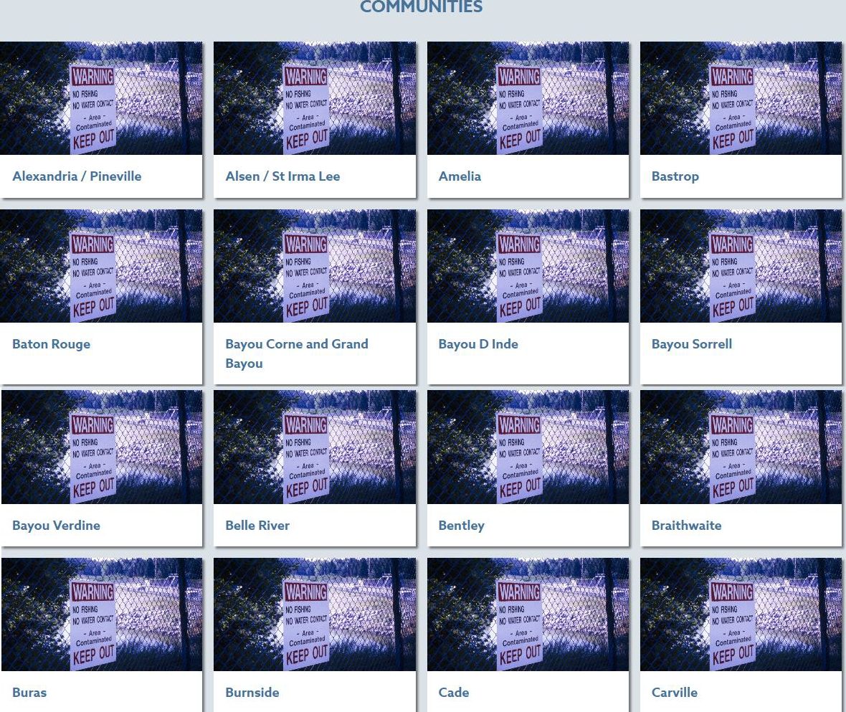
Source: https://leanweb.org/community-atlas

Other maps of environmental disparities in LA

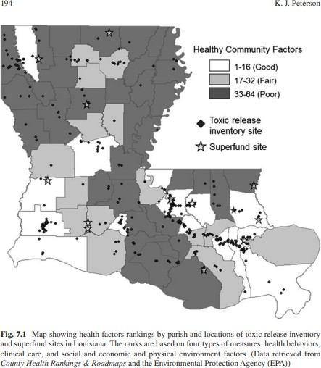

https://www.researchgate.net/figure/Map-showing-health-factors-rankings-by-parish-and-locations-of-t oxic-release-inventory_fig1_337225536

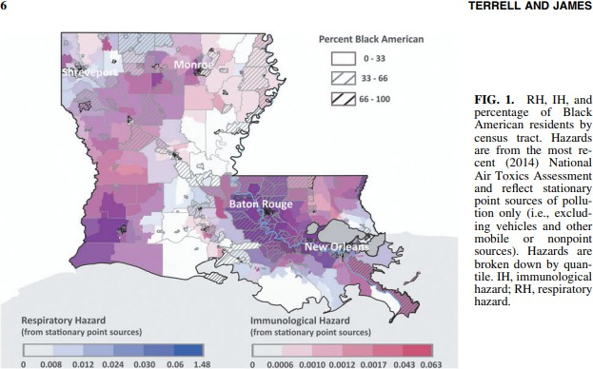

https://www.liebertpub.com/doi/epub/10.1089/env.2020.0021

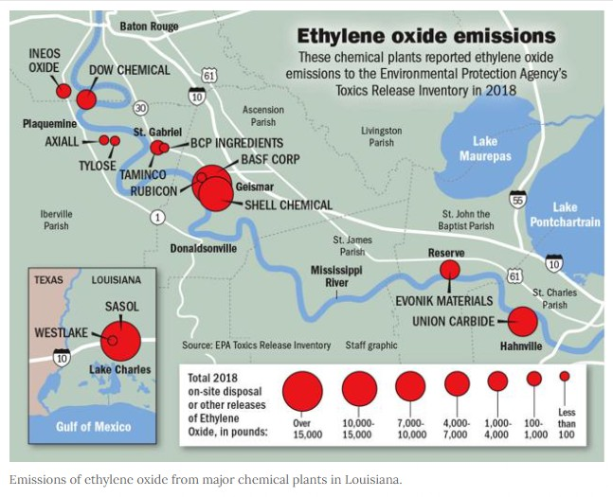

https://www.nola.com/news/environment/article_852d98d0-3d81-11ec-a61f-0bf8e82339a8.html

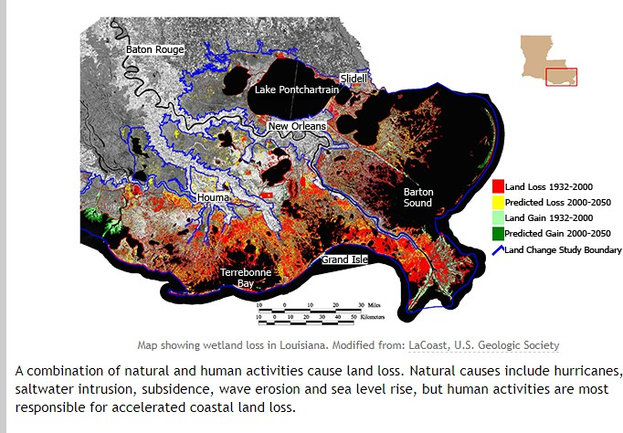
https://www2.southeastern.edu/orgs/oilspill/wetlands.html

Louisiana Local and State data sources (Courtesy of Tulane Libraries)
Howard-Tilton Memorial Libraries https://library.tulane.edu/html

Rudolph Matas Library of the Health Sciences https://library.tulane.edu/matas

Louisiana Department of Environmental Quality https://www.deq.louisiana.gov/page/tlc-air-monitoring

Air Now https://www.airnow.gov/

EPA Consumer Confidence Reports (CCR) https://ordspub.epa.gov/ords/safewater/f?p=136:102::::::

Louisiana Healthy Communities Coalition http://healthylouisiana.org/

Louisiana Department of Health https://ldh.la.gov/

Climate and Economic Justice Screening Tool https://screeningtool.geoplatform.gov/en/#3/33.47/-97.5

Searchable literature database-based on AGEJLE-OS aims

Global Health:
https://ovidsp.dc2.ovid.com/ovid-b/ovidweb.cgi?QS2=434f4e1a73d37e8cd9587e31747c59e325a3fe5b1994993b3af97a9b48f5d 2a1dc8e430d40b3da25dc118026d1b38b5e12de7819110f07ed03c3dfdb8511fc2b931a6fcd6c6 ca92e2040f0128cd9a5fa32a3e4976bef83c108176123f4dfaa48e895107b6afd952852d280018c 0c0434a034e43449b2dd5ff229902420f0a8781e78285b80b742073501a93722887a65fb5e8fc2
d148d48c20ddfecfad0d8178c414c91a33c9045f9b0a9b606cc6cacb141b4781c6a89cdc34bb92 5e1e013afa09c5caff5bec4dd955901d3c07cec1de0407c48f99fb9576cfaf0bc2fc0654fb522c1d5 019b46c85b36bedc39f3ab1fc4ade955bdbe786b656e9d190692293c43ad10dc5d8cca1bdd6db 3648fd893826deb8cd9c4e1bee3357be3ae50a4248f373d09dcccbf8bff7a072b0bf13a2b780

PubMed:
https://pubmed.ncbi.nlm.nih.gov/?myncbishare=tulanelib&otool=tulanelib

EBSCO:
https://search.ebscohost.com/WebAuth/Community.aspx?custid=s8978822&groupid=main&ref
=https%3a%2f%2flibrary.tulane.edu%2f&shibtoken=A2VQwHhv55eGSBqpeVfaeA8gf7-qEqnxiwpIBTPDyyovd5YdKLD4SUUOQ2o7OhacCkE3fkWmFfK0OErU5MPniheZ9H6swn1yh_ CZ4vCHIEzl-VjsIUFxQjBgFg_shjI6d7PnTyJ8btlafkvY_fQLPq9lza-IC84FwqpOYUBR-x6nKinKVvi5RUxZr4H9jqV2Ez6LxRJCHWE1LbGlIPzTJP8NvmRK5ghH3nnCjk-DMPgIjfz0766utsIAJseLRYEqNrnNm_dCEQjg6pZ9ZBs2Xh7-P91Tn1MnoSu1O58vq_d2hBlFqpP2CNnKpHRG77nWBuRahiof7fuwK9ofy_Sp7WRGS8vsXU GLA8d4q1OZEFUlsMjBa2vf0f--DzybgDxMlNmU6mn8YF5A80Qn70QbCxuMdS91eRIod3eDctPxXwxXySBnmSGO-PvljVMk1MJ8Cm4wX93cnXg9OXL7WUMPeH68VTLK&authtype=shibboleth&stsug=AmX0PfDj MMmapI8gc0lEAtBjS8k6D9JO_io8VnQkcdjNSA0A5fJcxQtxUvZMF6e5XNsaBG3sQ1iAj341_G zqVN-9R-mzjlDB-5EDlJ86AVnUumJStFHvGs_4V7jJXPFqYiNO2zfQQlsWVLd5woDzK0qYTw1OcIY17pY_6Gw-442hGgU&IsAdminMobile=N&encid=22D731163C7635873746355632253C473583390377C3
76C377C376C373C376C370C331&selectServicesToken=A2U7bZajh87tLmlIfmhPsq6uGBluQ KnxiwpIBTPDyyqfGF-mk8iydll6NMcoTq9fMum67guziX9qgmtID7hh7bcyxhrULexJKu9Q8m42wzBwB5eHcvCVagcuH ddmXVVle4OxCr_UQbhsA3YTF3HtPtOG8kYtXXLbrobRkr1UWo8ooHjbLcjIC-jJtMlMwm991BYxRIipZZ6dMbqPV8lhs5XspS1lL6Y5Ynw5ubKfBXjAbiO-HFehsK0oOwzV6C_izaS0hzRwl9_EcZ_Cj_jAwGHs8_Wrrz4sTyuR

Pro Quest:
https://www.proquest.com/advanced?accountid=14437&forcedol=true&forcedol=true

Web of Science:
https://www.webofscience.com/wos/woscc/basic-search

List of Community-engaged organizations in Louisiana

Name Contact info
Type of work being done

350 New Orleans info@350neworleans.org Global Climate Work

A Community Voice
Beth Butler (bethbutler.south@gmail.com) https://www.acommunityvoice.org/
2221 St. Claude Avenue New Orleans, La 70117 Community Advocacy

Advocates for Environmental Human Rights
nwalker@ehumanrights.org 504-799-3060
http://www.ehumanrights.org/ourwork.html Human Rights

Bridge the Gulf bridge
Michael Tritico (thegulfproject@gmail.com) https://bridgethegulfproject.org
Equity, EJ, Climate

Center for Constitutional Rights

https://ccrjustice.org/
666 Broad Way 7th Floor, NYC, New York, 10012 Constitutional Rights

Climate Reality
https://www.climaterealityproject.org/
555 11th Street NW, Suite 601, Washington DC 20004 Climate Change

Coalition to Restore Coastal Louisiana coalition@crcl.org https://www.crcl.org/70802
3801 Canal St. Suite 400, New Orleans LA 70119

Coalition Against Death Alley
Gregory Manning (gmanning1973@yahoo.com) https://www.enddeathalley.org/our-coalition Environmental Justic in Death Alley

Concerned Citizens of Mossville
Carolyn Peters (carolynpeters2014@gmail.com) https://ej4all.org/mossville
4407 Fisher St., West Lake LA, 70669

Concerned Citizens of St. John Parish
Robert Taylor (btcnola@gmail.com)
Mary Hampton (marychampton@gmail.com) https://www.ccosj.com/

Reserve, Community-engaged and Chemical Policy Reform

Concerned Citizens of St. John the Baptist Parish
Robert Taylor (btcnola@gmail.com)
Mary Hampton (marychampton@gmail.com)

Deep South Center for Community-engaged
Dr.Beverly Wright, Executive Director (beverlyw@dscej.org) 504-272-0956
https://www.dscej.org/70127
9801 Lake Forest Blvd, New Orleans, LA 70127 Community-engaged

Earth Justice
Corinne Van Dalen (cvandalen@earthjustice.org)
Cyndhia Ramatchandirane (cramatch@earthjustice.org) https://earthjustice.org/about?
gclid=Cj0KCQjwkOqZBhDNARIsAACsbfJH4sScKbl17DZhQGIMqYH67YPHy3 Mjb82t-brZPhzRLd2NHCUMAGQaAgHHEALw_wcB
50 California St., Ste. 500, San Francisco, CA 94111

Foundation for Louisiana
225-326-7016
https://www.foundationforlouisiana.org/70116
2022 St. Bernard Ave, Suite 122b, New Orleans, LA 70116 Criminal Justice, Justice Reformer, Gender & Race Justice

Greater New Orleans Interfaith Climate Coalition
https://gnoicc.org/

Climate Change and Education

Green Army
General Russel Honore (russelhonore@gmail.com) Jacques Morial (jacquesmorial@gmail.com)
Joel Gheesling (jgheesling@kepplerspeakers.com) relief efforts
703.516.4818

Gulf Coast Environmental and Health Coalition
https://gcehc.webs.com/ Environmental advocacy

Gulf Coast Joint Venture barry_wilson@fws.gov 337-262-7015
www.gcjv.org
700 Cajundome Blvd, Lafayette, LA 70506 Conservation

Healthy Gulf
cyn@healthygulf.org
Naomi Yoder (naomi@healthygulf.org)
Michael Esealuka (michaelesealuka@healthygulf.org) 5045251528 #202
www.healthygulf.org/70112 climate, conservation, water

Inclusive Louisiana Gail Leboeuf (gleboeuf27@gmail.com)
https://inclusivelouisiana.org/ community-engaged, industrial pollution
Louisiana Bucket Brigade info@labucketbrigade.org 504-484-3433

https://labucketbrigade.org/70119
Anne Rolfes (anne@labucketbrigade.org) Shreyas Vasudevan (shreyas@labucketbrigade.org)

Luisiana Environmental Action Network (Cancer Alley) Marylee Orr, Executive Director (marylee@leanweb.org) 225-928-1315
225-922-9247
https://leanweb.org/70896
P.O. Box 66323, Baton Rouge, LA 70896 Community-engaged and community relations

Lowlander krajeskipeterson@msn.com https://www.lowlandercenter.org/71449 51 Point Dr., Many, LA 71449
ecological and environmental conservation

Moving Forward Gulf Coast
info@movingforwardgc.org

985-643-6186
http://katrinareader.org/moving-forward-gulf-coast Gulf Coast restoration

NAACP Gulf Coast Advocacy Center
225-334-9909
https://naacp.org/issues/advocacy-litigation70806 3313 Government St, Baton Rouge, LA 70806 Advocacy

Pontchartrain Conservancy info@scienceforourcoast.org 504-836-2215
https://scienceforourcoast.org/70124
P.O. Box 6965, Metairie, LA 70009 Conservation

Public Lab staff@publiclab.org 504-358-0647
www.publiclab.org/70117
3014 Dauphine St, Suite 100 PMB 93499, New Orleans, LA 70117 Community-engaged

RESTORE
Michael Tritico michaeltritico@yahoo.com

RISE St. James
Sharon Lavigne (sharonclavigne@gmail.com) https://risestjames.org/
2150 Allston Way, Suite 460, Berkeley, CA 94704 Community-engaged

Sierra Club
Darryl Malek-Wiley
darryl.malek-wiley@sierraclub.org https://www.sierraclub.org/about-sierra-club
2101 Webster St Suite 1300, Oakland, CA 94612 Community-engaged and protection

Southwings
5500 Prytania Street #532, New Orleans, LA 70115 Conservation

The Descendants Project/Stop the Wallace Grain Elevator
Jo Banner (jo@thedescendantsproject.org) Preservation

Together Louisiana
https://www.togetherla.org/
2721 S. Broad St., New Orleans, LA 70125 Community engagement, development, and leadership

Tulane Environmental Law Clinic
Dr. Kimberly Terrell https://law.tulane.edu/clinics/environmental John Giffen Weinmann Hall,
6329 Freret St, New Orleans, LA 70118

VAYLA
Ellen Lu (ellen@vayla-no.org) Zachary Lang (zachary@vayla-no.org) Kim Dunn, Technical Training Director,
kimd@dscej.org) 13235 Chef Menteur Hwy., Suite A, New Orleans, LA 70129 Environmental and reproductive justice
https://vayla-no.org/

List of Open Science organizations in Louisiana

Coastal Environments Incorporated bmanly@coastalenv.com (Beth Manly, President) 225-383-7455
Bryan Haley, Project Manager Remote-sensing and GIS Specialist (bhaley@coastalenv.com) 504-516-2434
www.coastalenv.com
70802 (Coporate oﬃce), 70122 (NOLA oﬃce), 77004 (Houston oﬃce), 78401 (Corpus Christi office), 39530 (Biloxi office)

Gulf Coast Safety & Training Group admin@gcstg.com https://gcstg.com/70508

Center for Gulf Coast Environmental Health Research,
Leadership and Strategic Initiatives Tulane University
Jasmine Fournie (jfournie@tulane.edu) http://www.gulfcoastenvironmentalhealth.com/70124

Greater New Orleans Foundation
holly@gnof.org 504-598-4663
https://www.gnof.org/what-we-do/program-areas/environment/gulf-coast/70130

I See Change
Julia Kumari Drapkin, CEO community@isschange.org Community Climate & Weather Journal

Public Lab Staff@publiclab.org 504-358-0647
http://publiclab.org/wiki/plots-staff

Out of State Community-engaged organizations that work in Louisiana

Georgetown Community-engaged Program
Georgetown University
Gaël Giraud, Founder/Director (berkleycenter@georgetown.edu) Carrick Reddin, Collaborator

UC Berkeley University Department of Sociology Dr. Arlie R. Hochschild (ahochsch@berkeley.edu) Professor Emerita
Writer: Strangers in Their Own Land: Anger and Mourning on the American Right https:// sociology.berkeley.edu/professor-emeritus/arlie-r-hochschild
510-642-4766

Out of State Open Science organizations that work in Louisiana

Name Contact info

Sky Truth hello@skutruth.org 304-885-4581
skytruth.org/35443
PO BOX 3283, Sheperdstown, WV

Gulf Coast Preservation Society
info@gulfpreserve.org 941-554-7606
http://gulfpreserve.org/33921
PO Box 733, Boca Grande, FL 33921

Conservation Foundation of the Gulf Coast
info@conservationfoundation.com 941-918-2100
https://www.conservationfoundation.com/34229
P.O. Box 902
400 Palmetto Ave, Osprey, FL 34229-0902

Center for Interdisciplinary Geospatial Information Technologies
Delta State University
Talbot J. Brooks, Director (tbrooks@deltastate.edu)

Surfrider Foundation

info@surfrider.org https://www.surfrider.org/ Headquarters in San Clemente, CA

Oxfam America info@oxfamamerica.com https://www.oxfamamerica.org/
Headquarters in Boston and Washington D.C.

Texas Community-engaged Advocacy Services Juan Parras, Founder/Director (parras.juan@gmail.com) https://www.tejasbarrios.org/77011

Citizens League for Environmental Action
Jane Dale Owen, President (janedowen@aol.com) https://cechouston.org/2006/03/16/citizens%E2%80%99-league-for-environmental-action-now

Boat People SOS - Gulf Coast
info@bpsos.org
228-436-9999 (Biloxi) / 251-824-7016 (Bayou La Batre) https://www.bpsos.org/bpsos-gulf-coast
39530 (Biloxi) / 36509 (Bayou La Batre)

Coastal Environments Incorporated bmanly@coastalenv.com (Beth Manly, President) 225-383-7455
Bryan Haley, Project Manager Remote-sensing and GIS Specialist (bhaley@coastalenv.com) 504-516-2434

www.coastalenv.com
70802 (Coporate office), 70122 (NOLA office), 77004 (Houston office), 78401 (Corpus Christi office), 39530 (Biloxi office)

Government sponsored data collection initiatives

-Tulane Community-engaged Curriculum for K-12 initiative

https://news.tulane.edu/pr/tulane-receives-12-million-grant-create-environmental-justice-curriculum-louisiana-k-12-schools

-Louisiana Private Well Initiative Program https://ldh.la.gov/assets/oph/Center-EH/envepi/PWI/Documents/ Final_Progress_Report_PWI_II.pdf

-Louisiana Ambient air monitoring program
Ambient Air Monitoring Program | Louisiana Department of Environmental Quality

-Louisiana Department of Health (Your drinking water and you) training manual 20040121 (louisiana.gov)

-EPA Volunteer monitoring Starting Out in Volunteer Monitoring (epa.gov)

List of Open Sci organizations in Louisiana

Gulf Coast Safety & Training Group admin@gcstg.com https://gcstg.com/70508

Center for Gulf Coast Environmental Health Research,
Leadership and Strategic Initiatives Tulane University
Jasmine Fournie (jfournie@tulane.edu) http://www.gulfcoastenvironmentalhealth.com/70124

Public Lab Staff@publiclab.org 504-358-0647
http://publiclab.org/wiki/plots-staff

Louisiana Bucket Brigade info@labucketbrigade.org 504-484-3433
https://labucketbrigade.org/70119
Anne Rolfes (anne@labucketbrigade.org)
Shreyas Vasudevan (shreyas@labucketbrigade.org)

- Recognized Indigenous Tribes of Louisiana

The state-recognized tribes of Louisiana, The Addai Caddo Tribe
the Biloxi-Chitimacha Confederation of Muskogee The Choctaw-Apache Community of Ebarb
The Clifton Choctaw,

The Four Winds Tribe Louisiana Cherokee Confederacy The Grand Caillou/Dulac Band The Isle de Jean Charles Band
The Louisiana Choctaw Tribe The Pointe-Au-Chien Indian Tribe The United Houma Nation.

The Federally recognized

The Chitimacha Tribe of Louisiana The Coushatta Tribe of Louisiana
The Jena Band of Choctaw Indians The Tunica-Biloxi Indian Tribe

Note:

- The Coushatta Tribe of Louisiana, Jena Band of Choctaw Indians, and Tunica-Biloxi Indian Tribe of Louisiana are headquartered in the towns of Elton, Jena, and Marksville, respectively

- In New Orleans, approximately 2700 people identify as having American Indian/Alaska Native background, comprising 0.7% of the city’s population. About 1.3% of Louisiana.

- New Orleans sits on the originally were the Chitimacha, with the Atakapa, Caddo, Choctaw, Houma, Natchez, and Tunica inhabiting throughout the state.
- The Chitimacha Tribe of Louisiana is the only Louisiana tribe to still live on a section of their original homeland, with a reservation located near the town of Charenton.

References:

- https://www.ala.org/aboutala/offices/nola-tribes

- https://www.nps.gov/jela/learn/historyculture/native-americans-in-louisiana.htm#:~:text=Today%2C%20there%20are%20four%20federally,by%20the%20state% 20of%20Louisiana.

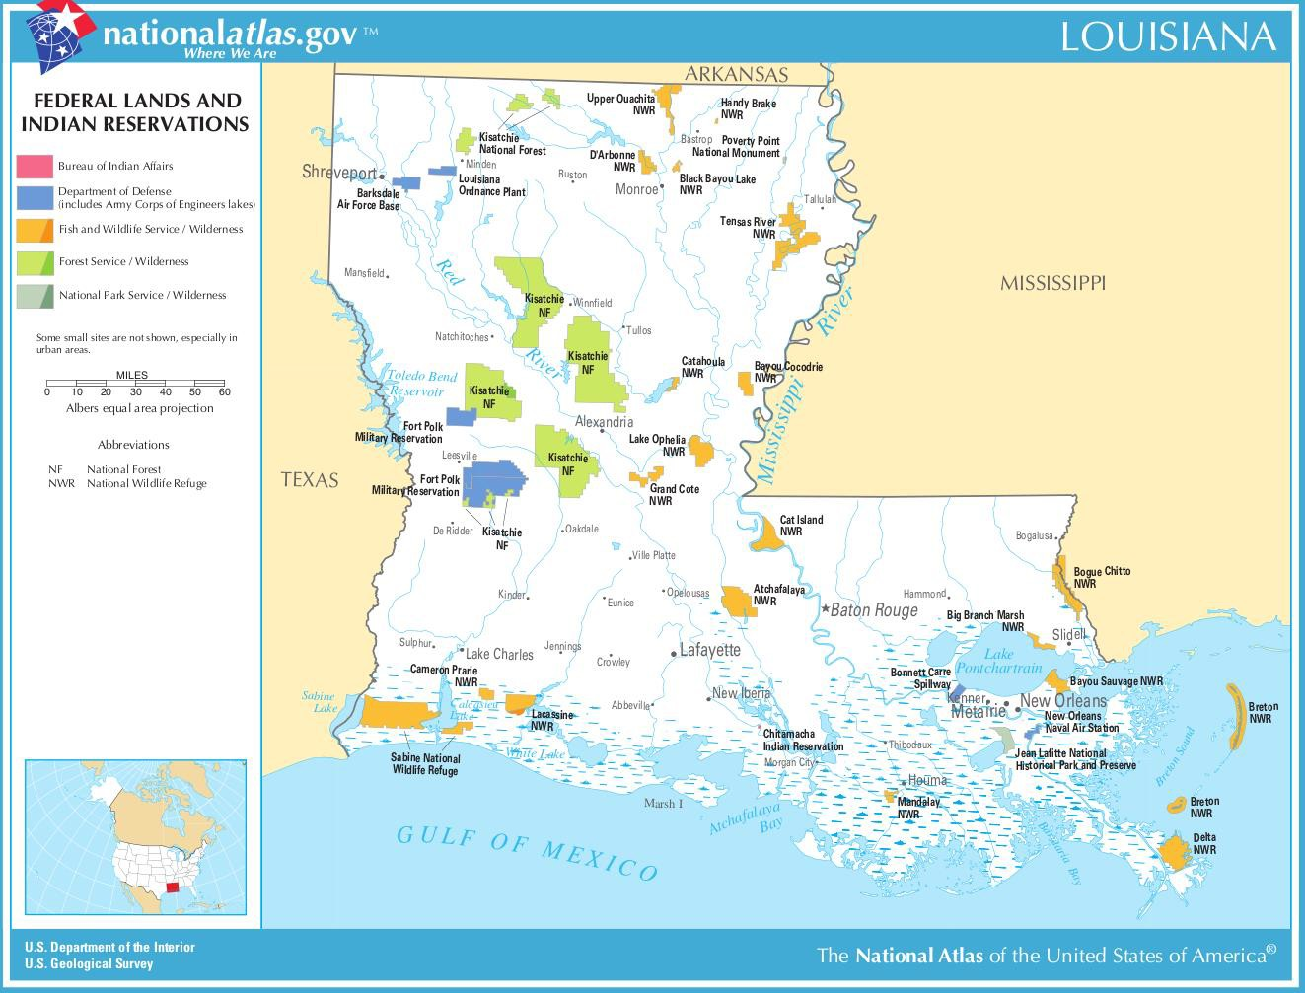

Source: https://www.aaanativearts.com/native-amerian-tribes-by-state/louisiana-indian-tribes
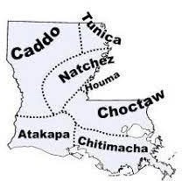

Source: http://www.native-languages.org/louisiana.htm

