Ch3: Generalized inverse uncertainty, individual activity
Hang Chen

Question 1

The trace of Rm = 7 < 9, so it is not close to the identity matrix. The model resolution matrix is shown as figure below. From the Rm, we can find that the last model parameter can be recovered perfectly. Then m1,m2, m4 and m5 have better resolution than the others.

Question 2
The trace of Rd = 7 < 8, which means that Rd is not close to identity matrix. From the Rd, we find that the last two elements are 1, which means that the last data could be perfectly predicted and that is why the last two data points were recovered exactly in the generalized inverse individual activity. The other six data points are slightly biased.

Question 3
The norm of Bias matrix is 1. I minus the R_{m} −I and −V₀V^{T}, and the result is shown in the right below figure. The difference between them is about scale 10 ⁻¹⁶, and we can consider them as the same. From the left bias matrix, I found it is just opposite to the model resolution matrix. The bias in last parameter is 0 and the other is not zero which means that the other parameters are kind of biased.
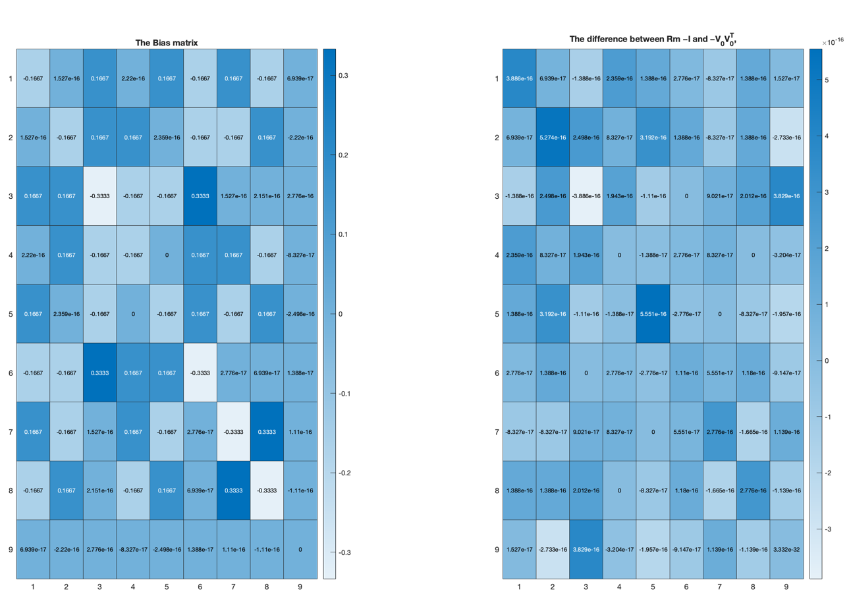
Question 4
The original model and recovered model are shown as below. From the recovered model the second, fourth and the last parameters are close to zero and thus close to the true model. The others are more or less away from the true model. The limited data resolution causes information about the central block slowness to smear into some, but not all, of the adjacent blocks even for noise-free data (as discussed in textbook).

Question 5
The condition numbers for G and G† are 2.2298e+16 and. 1.6815e+16 respectively. The condition number means the biggest singular value over the smallest singular value. The huge condition number means G and G† have very small singular value which makes the parameters estimation unstable.

Codes:

clear
clc

% define the G
s2=sqrt(2);
G = [1,0,0,1,0,0,1,0,0;
0,1,0,0,1,0,0,1,0;
0,0,1,0,0,1,0,0,1;
1,1,1,0,0,0,0,0,0;
0,0,0,1,1,1,0,0,0;
0,0,0,0,0,0,1,1,1;
s2,0,0,0,s2,0,0,0,s2;
0,0,0,0,0,0,0,0,s2];

[U,S,V] = svd(G);

p=rank(G);

%% question 1

Vp=V(:,1:p);
Rm=Vp*Vp';
% find the trace
trace(Rm)

figure
colormap('gray')
imagesc(reshape(diag(Rm),3,3))
set(colorbar,'Fontsize',18);
set(gca,'xtick',[1,2,3,4,5,6,7,8,9]);
set(gca,'ytick',[1,2,3,4,5,6,7,8,9]);
xlabel('j')
ylabel('i')
%% question 2
Up=U(:,1:p);
Rd=Up*Up';

figure
plot(diag(Rd))
ylabel('Data resolution')
xlabel('Points')
set(gca,'fontsize',14)

%find the trace
trace(Rd)

%% Question 3

Bias = Rm - eye(size(Rm))

Bias1 = -V(:,p+1:end)*V(:,p+1:end)'

figure
subplot(1,2,1)
heatmap(Bias)
title ('The Bias matrix')
subplot(1,2,2)
heatmap(Bias - Bias1)
title ('The difference between Rm −I and −V_0V^T_0,')
% get norm
norm(Bias)
norm(Bias1)

%% Question 4

spikemodel = reshape([0,0,0;0,1,0;0,0,0],9,1);

dtest = G*spikemodel;

Up = U(:,1:p);
temp = diag(S);
Sp = diag(temp(1:p));
Vp = V(:,1:p);
m = Vp*Sp^-1*Up'*dtest;

figure
subplot(1,2,1)
imagesc(reshape(spikemodel,3,3))
set(colorbar,'Fontsize',18);
set(gca,'xtick',[1,2,3,4,5,6,7,8,9]);
set(gca,'ytick',[1,2,3,4,5,6,7,8,9]);
xlabel('j')
ylabel('i')
title('Original model')
colormap('gray')
subplot(1,2,2)
colormap('gray')
imagesc(reshape(m,3,3))
set(colorbar,'Fontsize',18);
set(gca,'xtick',[1,2,3,4,5,6,7,8,9]);
set(gca,'ytick',[1,2,3,4,5,6,7,8,9]);
xlabel('j')
ylabel('i')
title('Estimated model')
%% question 5
% condiction of G
cond(G)

% condiction of G'
cond(Vp*Sp^-1*Up')

