Installation instructions:

1. Open QGIS and go to: Scripts >> Tools >> Add script from file (To activate the Processing Toolbox go to Menu >> Processing >> Toolbox or press Ctrl + Alt + T)
3. Navigate to the script folder and select SwathProfile.py
4. The new script will be now accessible in User scripts. Double click to launch it.
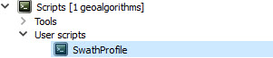
5. To add the help file, copy SwathProfile.py.help to UserFolder/.qgis2/processing/script
6. Run SwathProfile algorithm with sample data, it should include documentation

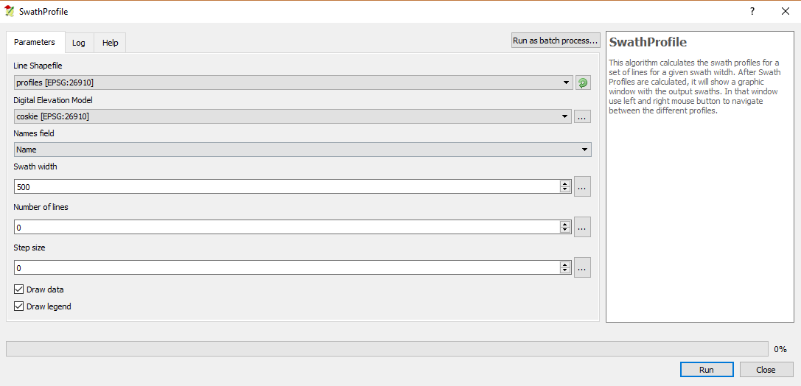
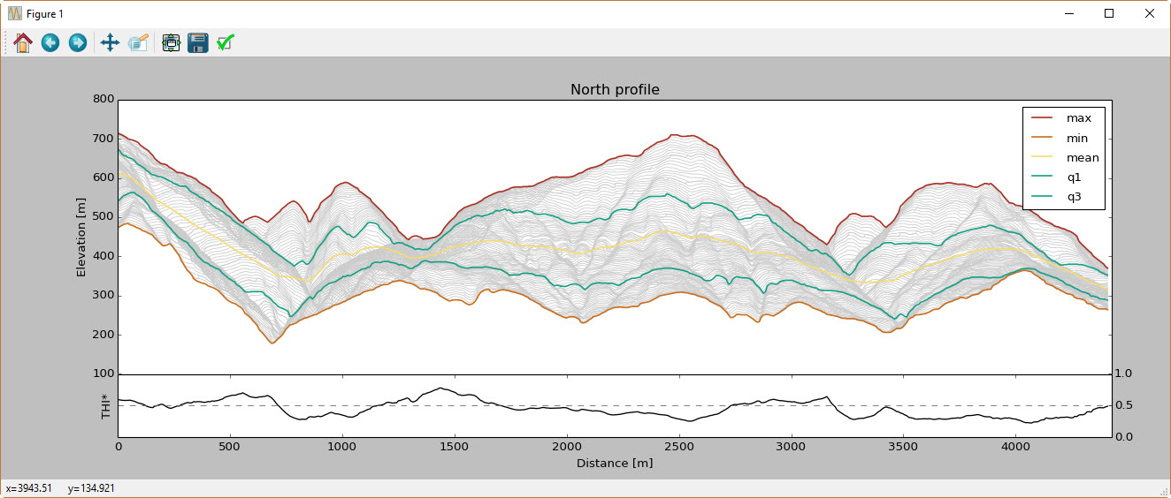
5. Use left and right buttons to change between profiles in the graphic window

