# 121 -Best time to buy and sell stock ---- Think about tracking minium , maximum while traversing ( kandane Track min and max)

#918. Maximum Sum Circular Subarray—totalsum – minsum give the sum of subarray which is max .
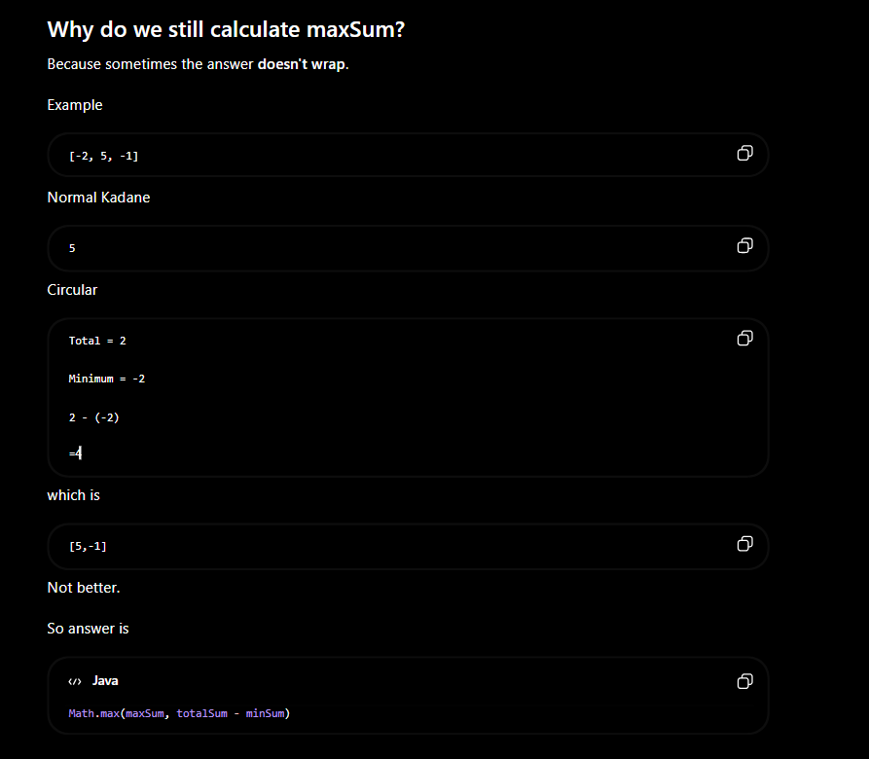

724. Find Pivot Index
Instead of doing prefix sum , do rightsum= totalsum – leftsum – nums[i];

ROTATE ARRAY:

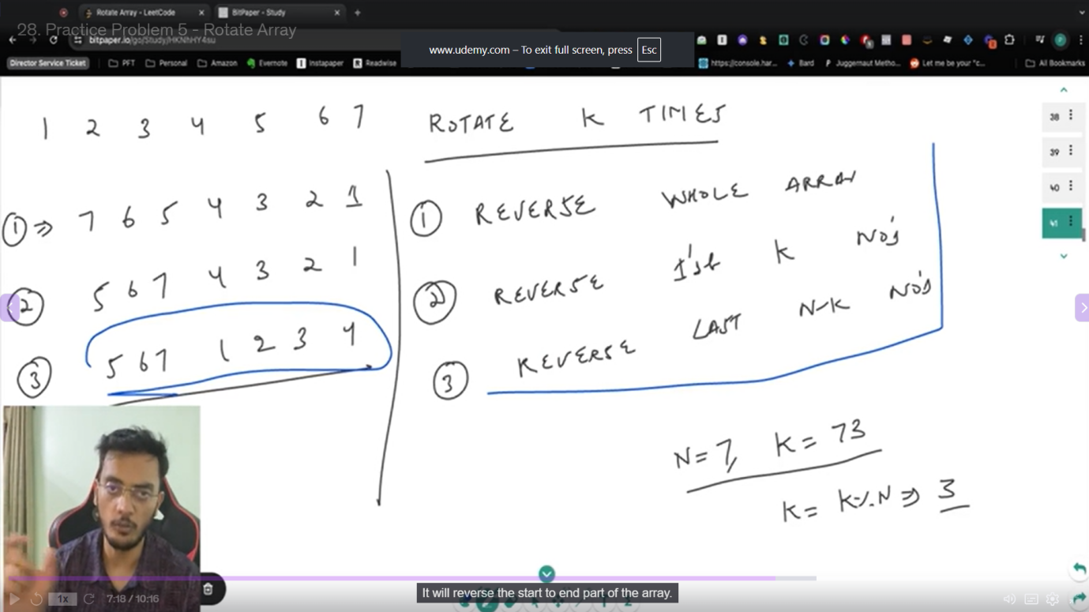

Right rotate : (i+k)%n
Left roate : (i-k+n)%n
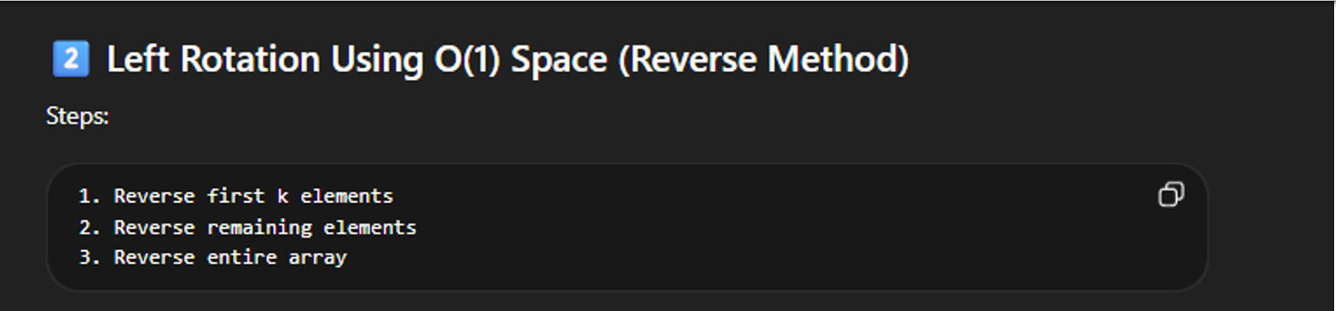
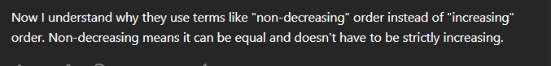

- To check if the array is rotated and sorted … nums[i] > nums[(i+1)%n] at most one time or at all
Two pointer :
- Use when we need a pair
Its work effienttly is most sorted array problem

- Character.isLetterOrDigit(leftchar)---to check whether the char is letter or digit
TRAPPIN RAIN WATER :
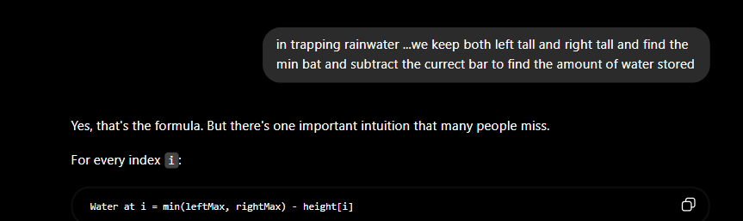

# sort colours ----
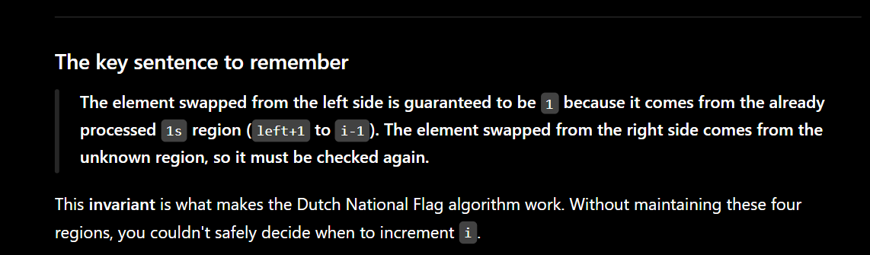

80. Remove Duplicates from Sorted Array II--- here as per partition method the left doesn’t have to start from the beginning …..

