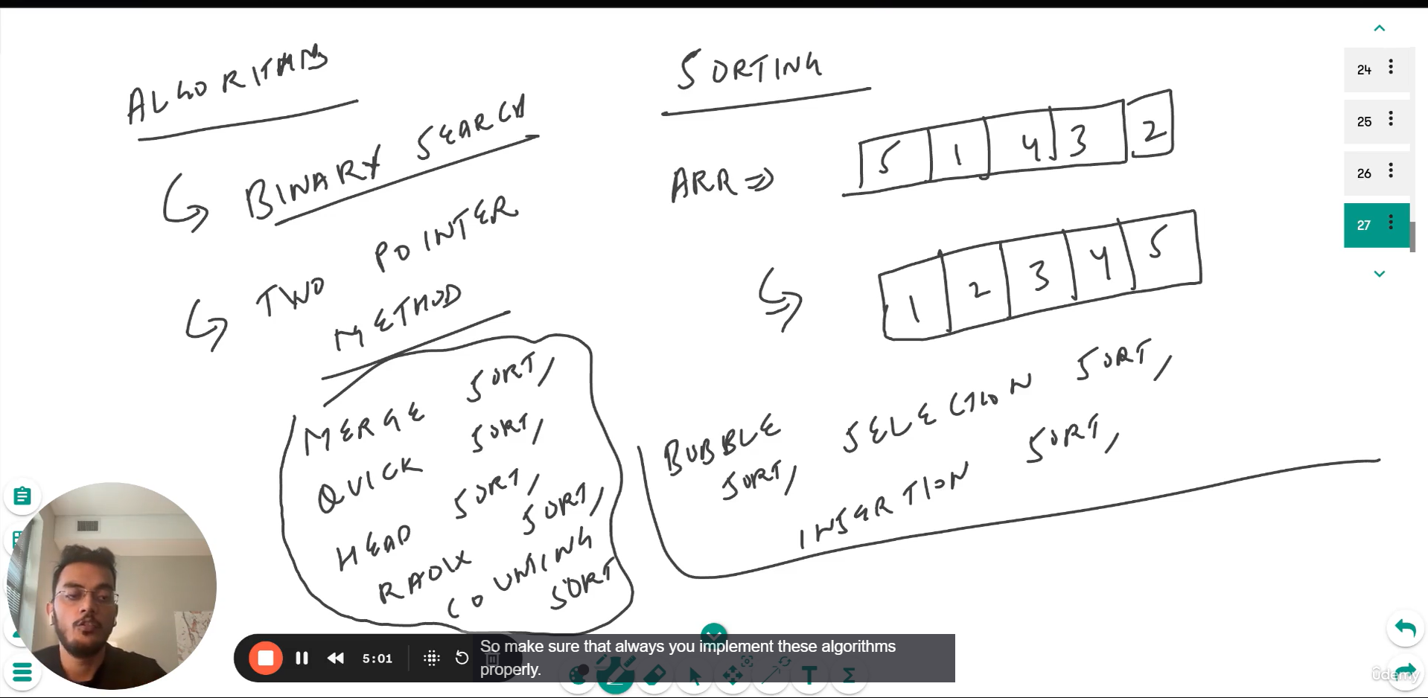

SORTING IS IMPORTANT AS IT HELP AND WORK ONLY WHEN THE ARRAY IS SORTED FOR MANY ALGORITHM …
SOMETIMES SORTING THE GIVEN INPUT ARRAY MAKE THE PROBLEM EASIER;

