1)Venture capital-money invested by another compony for the growth of our company , especially in a mind set of getting high return value if our business success.( sequoia)
VC mostly for startup company only.

2)TOTAL ADDRESSABLE MARKET represents the maximum revenue possible if the company captured the entire global market…..eg:

Imagine there's a company that makes fitness trackers. The Total Addressable Market (TAM) would be the total revenue the company could earn if every single person in the world who needs a fitness tracker bought one.
- For instance, if there are 500 million potential customers globally who might want a fitness tracker, and each tracker costs ₹5,000, then:
  - TAM = 500 million × ₹5,000 = ₹2.5 trillion.

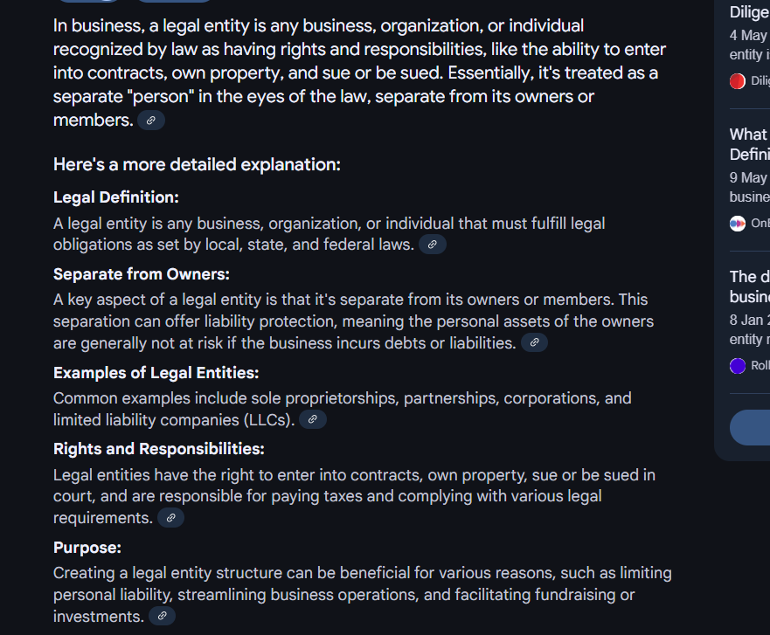

‘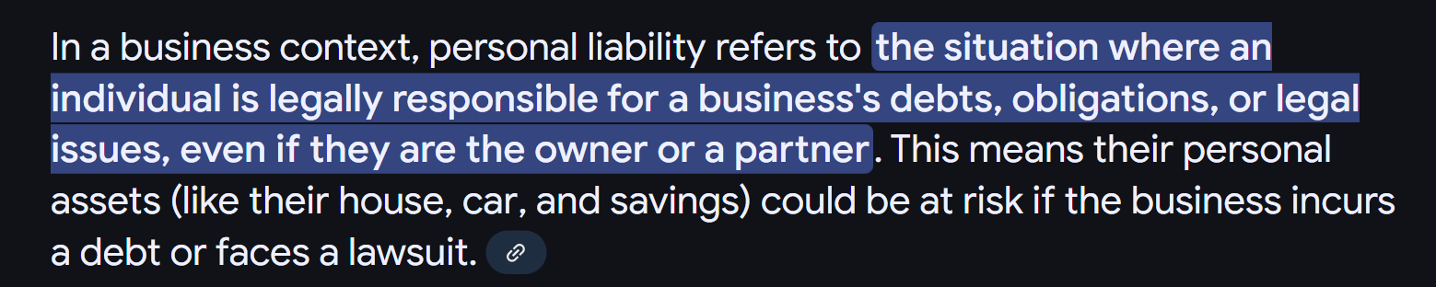

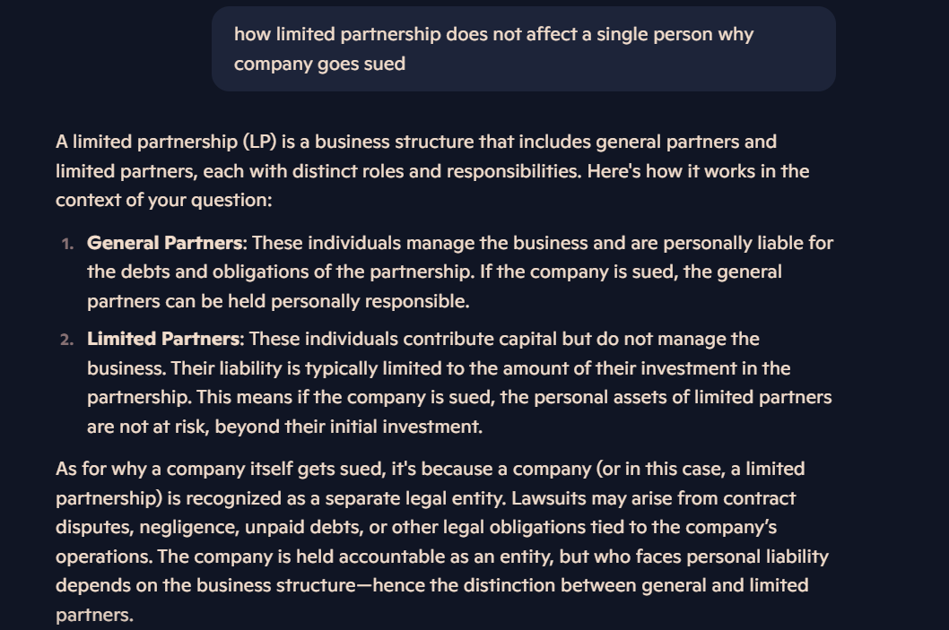

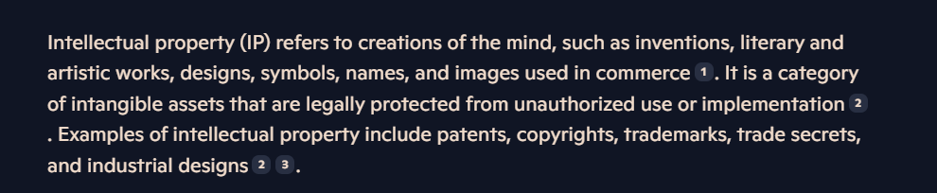

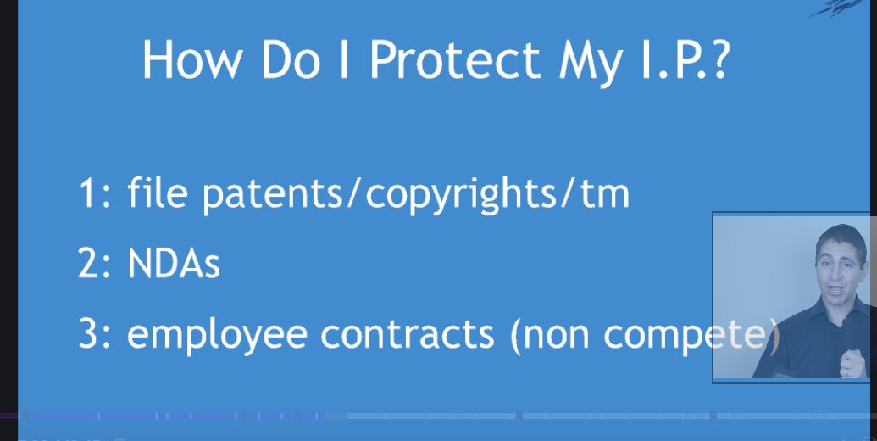

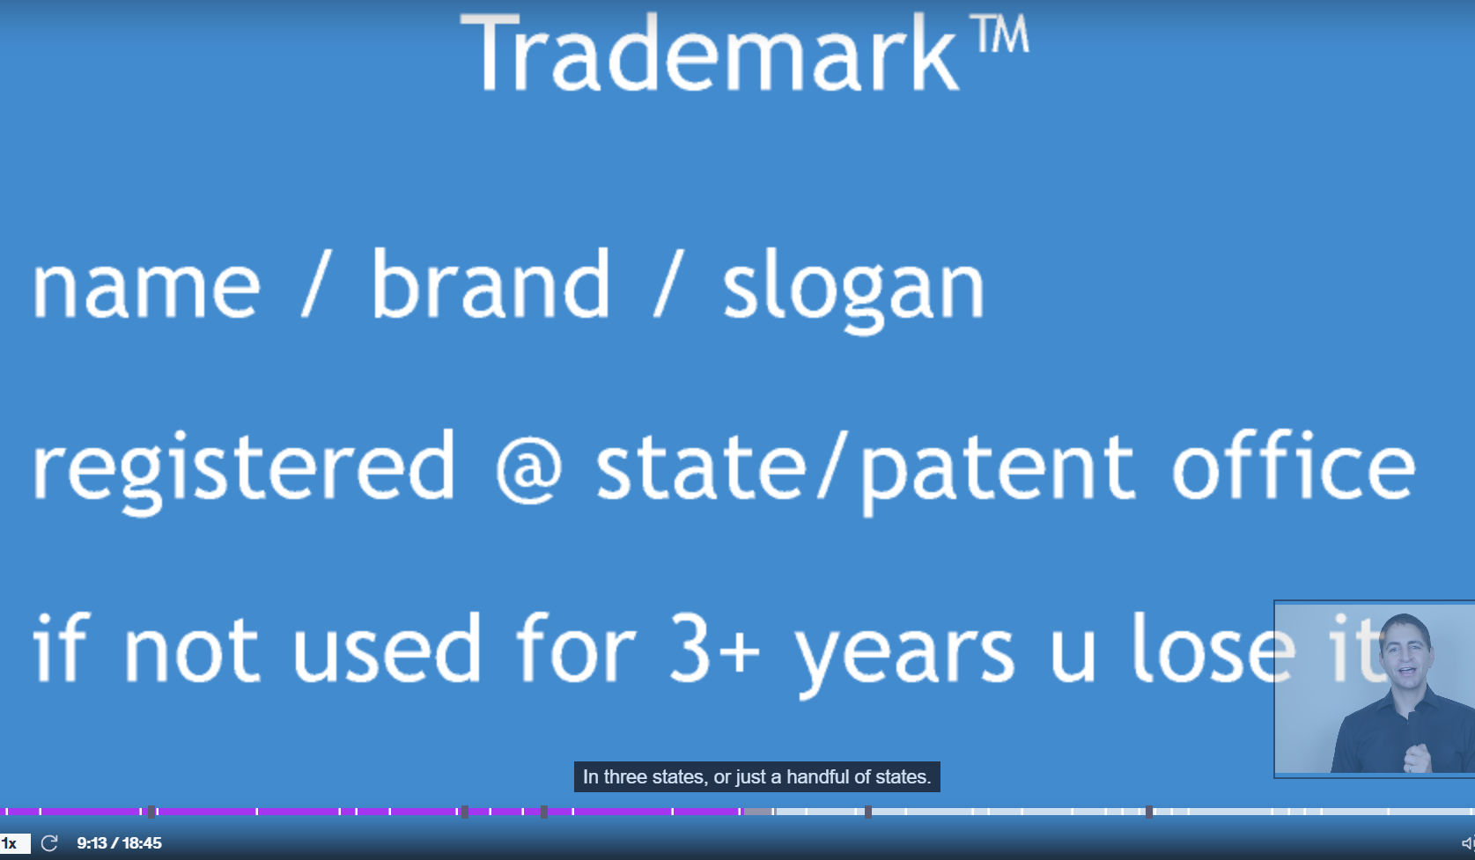

TM-> its says the company trade marks is protected only for few states

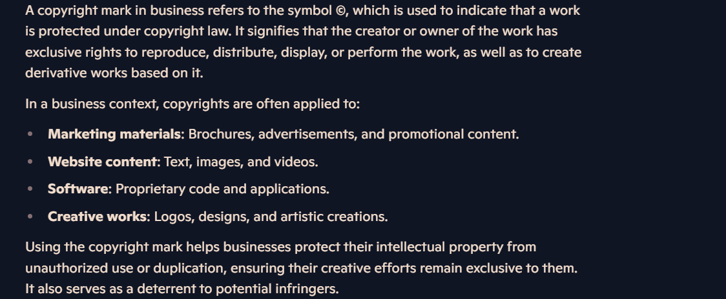

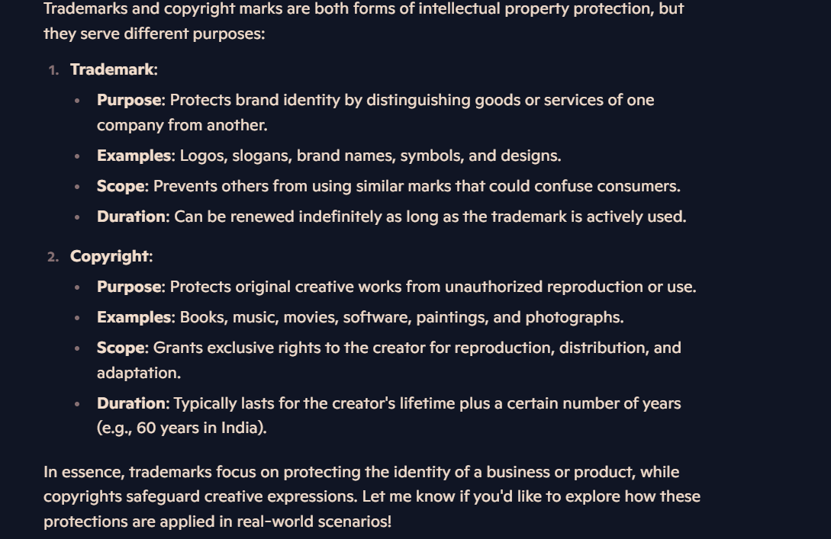

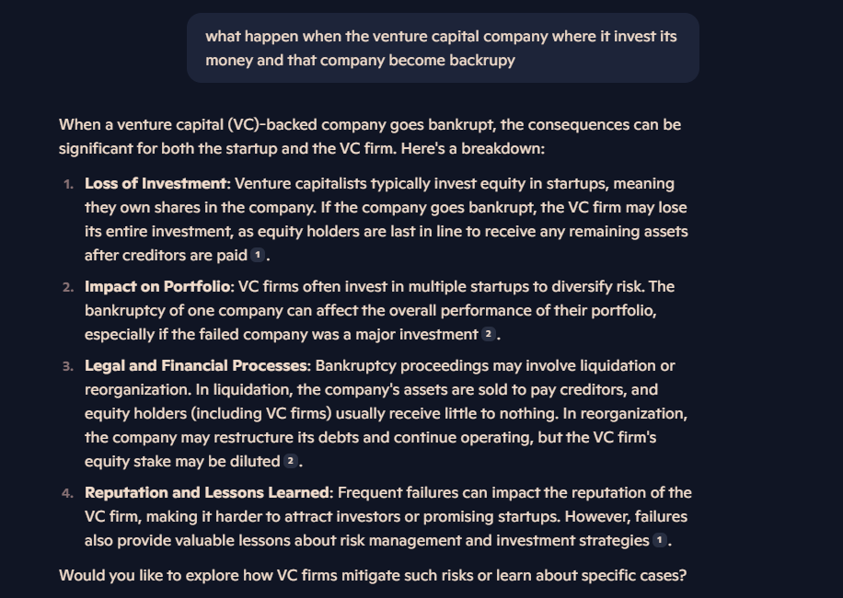

UNICORN -> a company that became worth of 1 billion dollar after getting invested by venture capital;

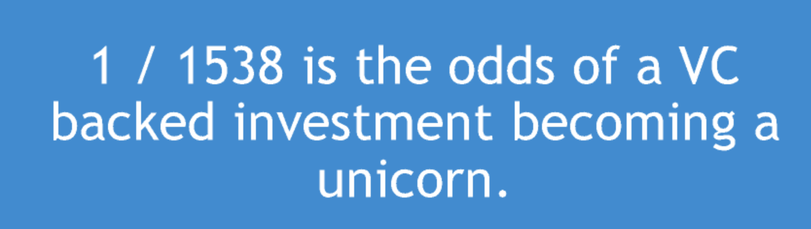

SEQUIO-> a VC firm that have 5% investment on unicorn company;

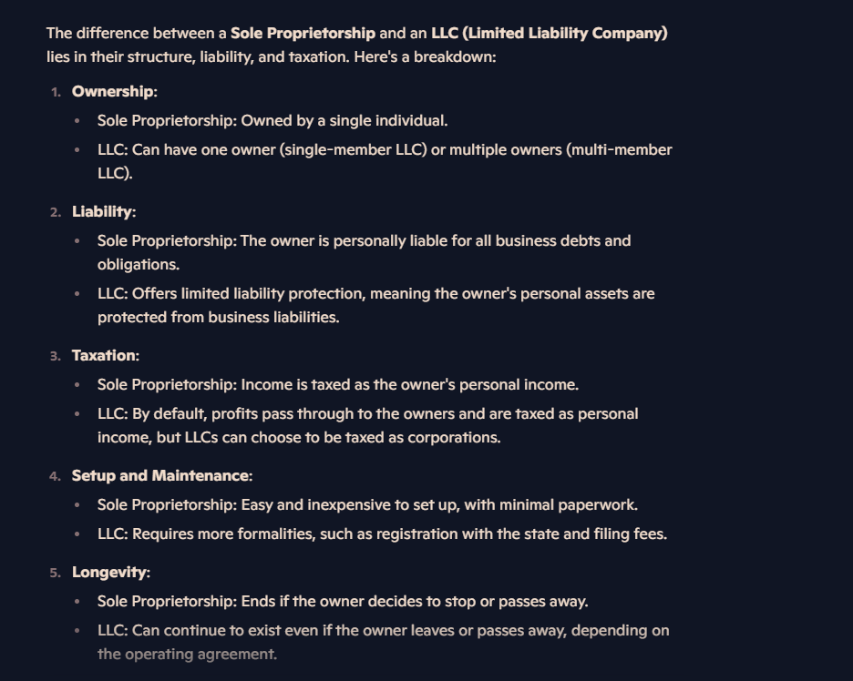

BUSINESS PRESENTATION:

- Make the lines of words in slide very less( THREE BULLET POINT MAX PER SLIDES).
- Present with passion
- Have a slogan
- Speak in simple language
- Have humour and make a point straight
- Have a background picture
- Make eye contact with everyone
- Move /walk on stage if possible
- GO OFF SCRIPT BY SPEAKING ON PASSION..

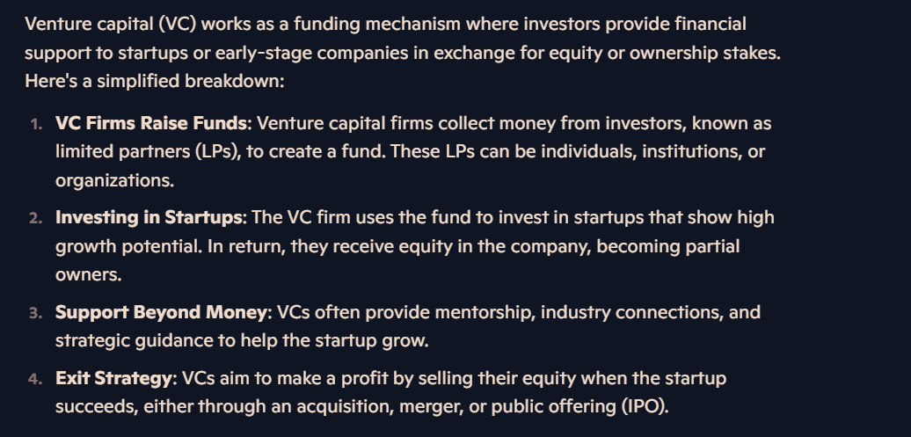

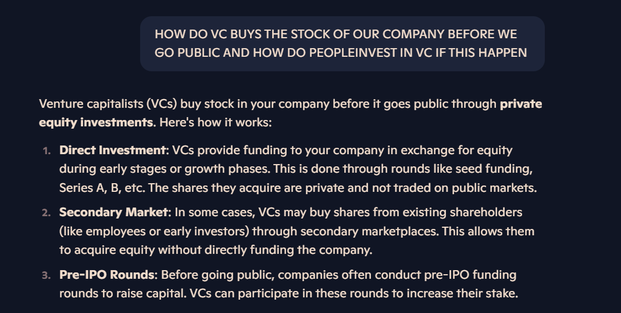

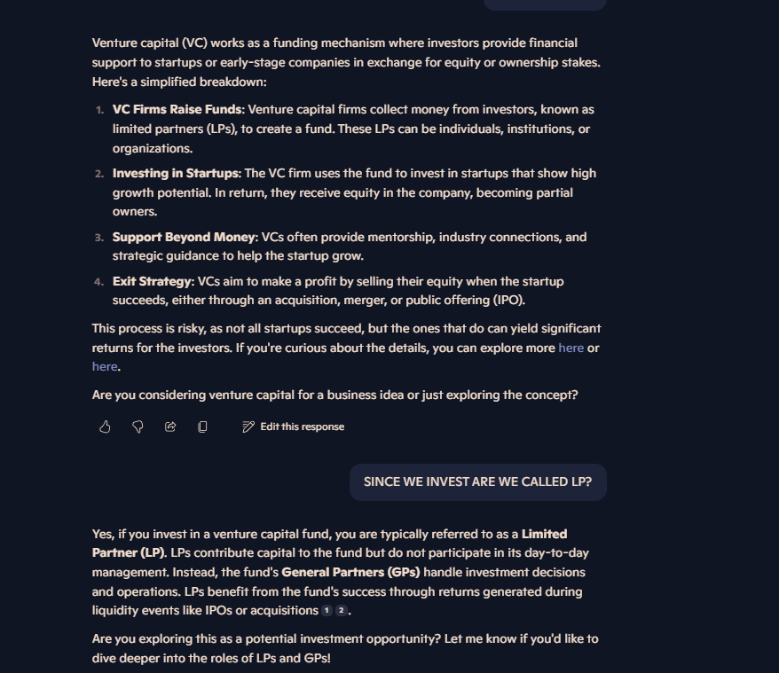

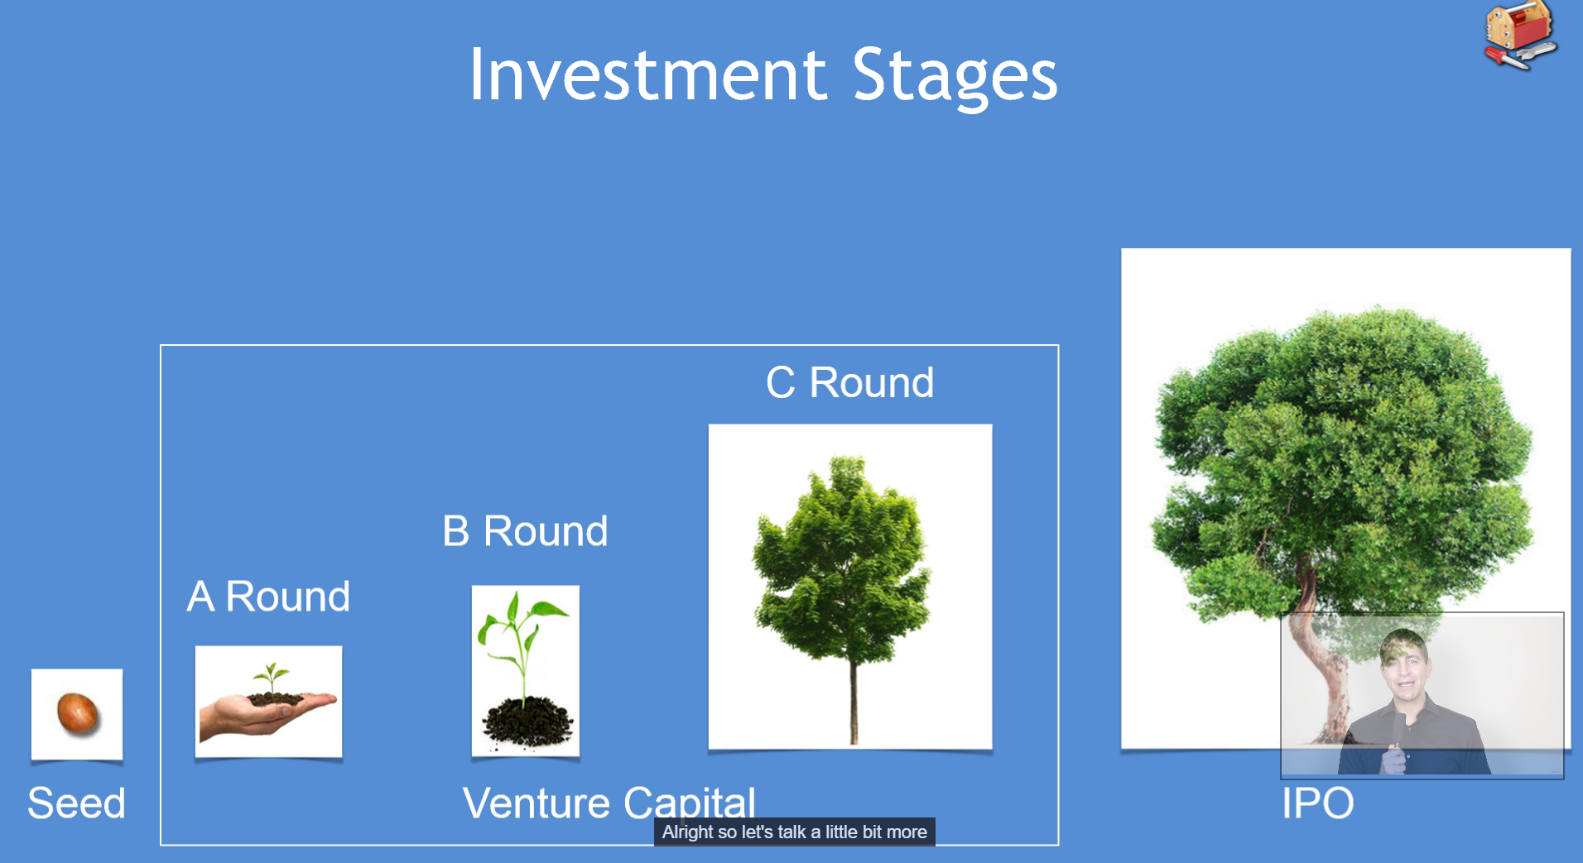

ROUND A------SEQUIO
ROUND C --- BANK DEBT OR ANOTHER VC
FROM START TO IPO ITS TAKE 7 YEARS FOR GREAT COMPANY ;

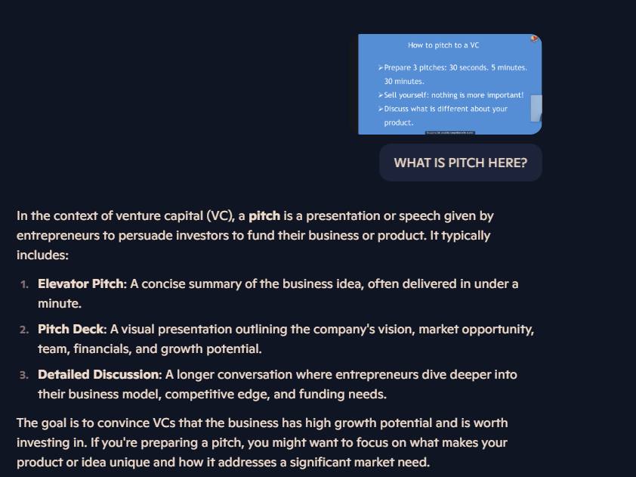

- MOST OF THE VC AND TECHNOLOGY EMERGED BECAUSE OF COLD WAR AND US BEGIN TERRIFIED OF RUSSIA, LIKE NASA FUNDED MICROCHIP TO SEND MAN TO MOON BEFORE RUSSIA , US GOVT FUNDED WEB TO COMMUNICATE IF NUCLEAR HIT ….ETC
- 