Documentation of the SHEMAT-Suite Files
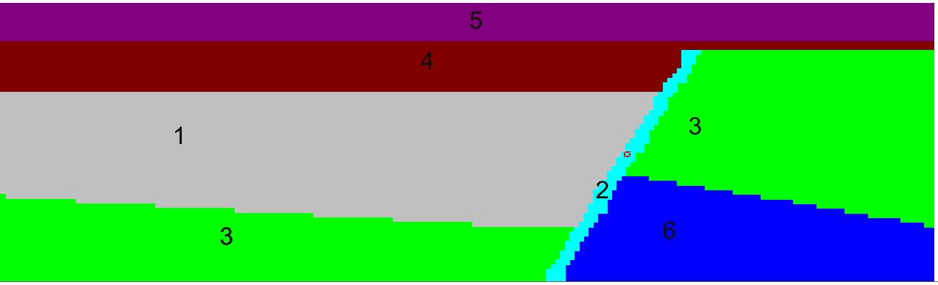

Geology simplified from Perth Basin
Includes a layered structure with a fault (fault = unit 2)

File group oed_open*:
High permeability in the fault. RUNMODE 1 (forward with data).
This forward model is used to create the synthetic data for the inversion.

Data is given under
# data , records=39
23.7769395446154 0.5 180 1 59 2 1
…..
Value(temperature in this case) error i j k (Position) 2=temperature 1=flag
-----
Is used to obtain at end of run the calculated temperatures at the given i j k positions.

Output in file oed_open_final.dat: (obs! The data points in oed_open differ, since they have been corrected later, to look better!)

File group oed_inv*:
Inversion run (RUNMODE:2)

Data is given by using the calculated temperatures from file oed_open_final.dat with 0,5 K white noise added. It is included in the input file oed_inv under # data

Unit (layer) for inversion is defined by
# enable unit
0 0 0 0 1 0
i.e. the 5th layer contains the parameter to invert for.
(It is also possible to define more units with properties to invert for.)

The property (parameter) to invert for is defined by
# enable property
0 0 0 2 0 0 0 0 0 0 0 0 0 0 0 0 0
i.e. the 4th property is inverted for (permeability), 2:inverted for log(property), 1: property
(It is also possible to enable more than one property to invert for.)

Obs! The property specification under #units in file oed_inv for the property to invert for has to be different from that for the calculation of the synthetic data (in a synthetic case).

# errors
0.0 0.0 0.0 6.0 0.0 0.0 0.0 0.0 0.0 0.0 0.0 0.0 0.0 0.0 0.0 0.0 0.0
….
Gives the error of the property to invert for (4th property (=permeability); 6 is log error). (Obs! In input file specified for each unit, but only used for unit (layer) 5.)
(It is possible to invert for different properties in different units by specifying errors.ne.0 for those to be inverted for.)

# inverse (controls the inversion)
1 (inversion on)
5 0.0001 1.0 5 non linear iterations 0.0001 stop criteria, 1. damping
0 0 0: activates output of covarinaces (might not work)
1 1: output at each step of iteration

The result of the inversion is given in oed_inv_P_final.dat

-----

