ASSIGNMENT – 2

JAVA PROGRAMMING

User-Defined Exception Handling
Name: Geona Alis J
Register No.: 192511088
Course Code: CSA0926
CO Reference: CO2
Assignment Set: Direct-Descriptive
Question No: Q11
Submission Date: 10/08/2026

1. PROBLEM UNDERSTANDING

The objective of this program is to demonstrate the use of a user-defined exception in Java.
A custom exception named InvalidAgeException is created by extending the built-in Exception class. The program validates a person's age and considers an age below 0 or above 120 as invalid.
When an invalid age is entered, the custom exception is thrown and caught using a try-catch block. An appropriate error message is then displayed to the user.

2. APPROACH / DESIGN
The program follows these steps:
① Create a custom exception class called InvalidAgeException.
② Extend the Java Exception class to create the user-defined exception.
③ Create a validateAge() method to check whether the entered age is valid.
④ If the age is less than 0 or greater than 120, throw InvalidAgeException.
⑤ Use a try-catch block in the main() method to handle the exception.
⑥ Display a suitable message for both valid and invalid inputs.

✧ Validation Rule ✧
Valid Age → 0 ≤ Age ≤ 120
Invalid Age → Age < 0 OR Age > 120

3. SOURCE CODE
import java.util.Scanner;

class InvalidAgeException extends Exception {
public InvalidAgeException(String message) {
super(message);
}
}

public class Main {

static void validateAge(int age) throws InvalidAgeException {
if (age < 0 || age > 120) {
throw new InvalidAgeException(
"Invalid age: Age must be between 0 and 120."
);
}

System.out.println("Valid age: " + age);
}

public static void main(String[] args) {
Scanner sc = new Scanner(System.in);

System.out.print("Enter age: ");
int age = sc.nextInt();

try {
validateAge(age);
} catch (InvalidAgeException e) {
System.out.println(e.getMessage());
}

sc.close();
}
}

✦ Concepts Demonstrated ✦
extends Exception → Creates a custom exception
throw → Throws the exception
throws → Declares the exception
try-catch → Handles the exception
Scanner → Accepts user input

4. TEST CASES

Test Case | Input | Expected Result | Status
TC 01 | 20 | Valid age: 20 | ✓ Pass
TC 02 | -5 | Invalid age message | ✓ Pass
TC 03 | 150 | Invalid age message | ✓ Pass

TEST CASE 01 — NORMAL INPUT
Input
20
Output
Enter age: 20
Valid age: 20
Result: ✓ The program accepts the valid age successfully.

TEST CASE 02 — NEGATIVE AGE
Input
-5
Output
Enter age: -5
Invalid age: Age must be between 0 and 120.
Result: ✓ InvalidAgeException is thrown and handled correctly.

TEST CASE 03 — UNREALISTICALLY HIGH AGE
Input
150
Output
Enter age: 150
Invalid age: Age must be between 0 and 120.
Result: ✓ InvalidAgeException is thrown and handled correctly.

5. EXECUTION SCREENSHOTS

◈ Screenshot – Test Case 01

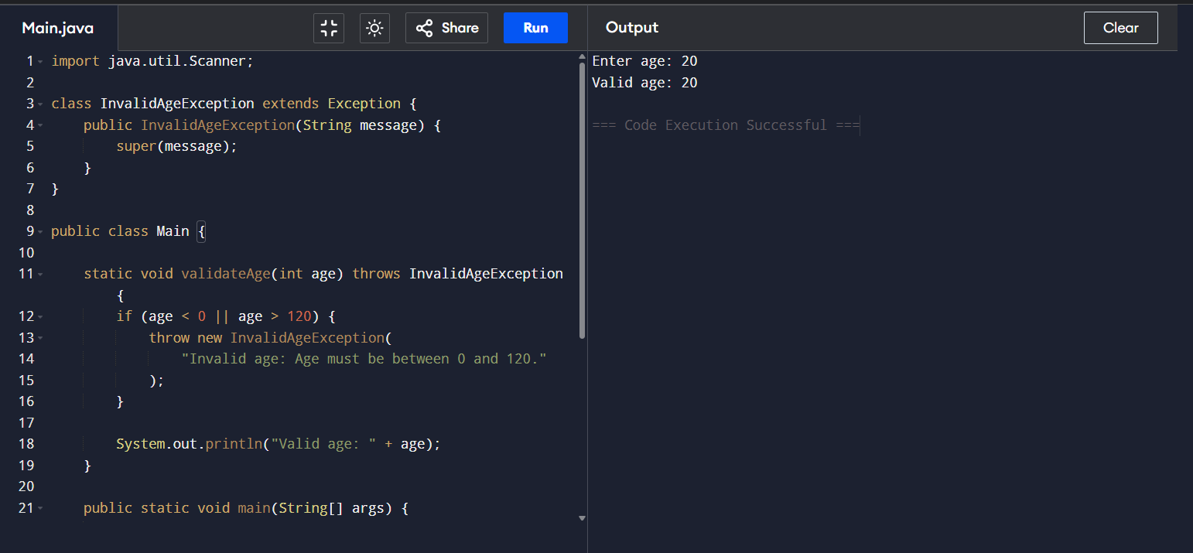
Input: 20

◈ Screenshot – Test Case 02
Input: -5
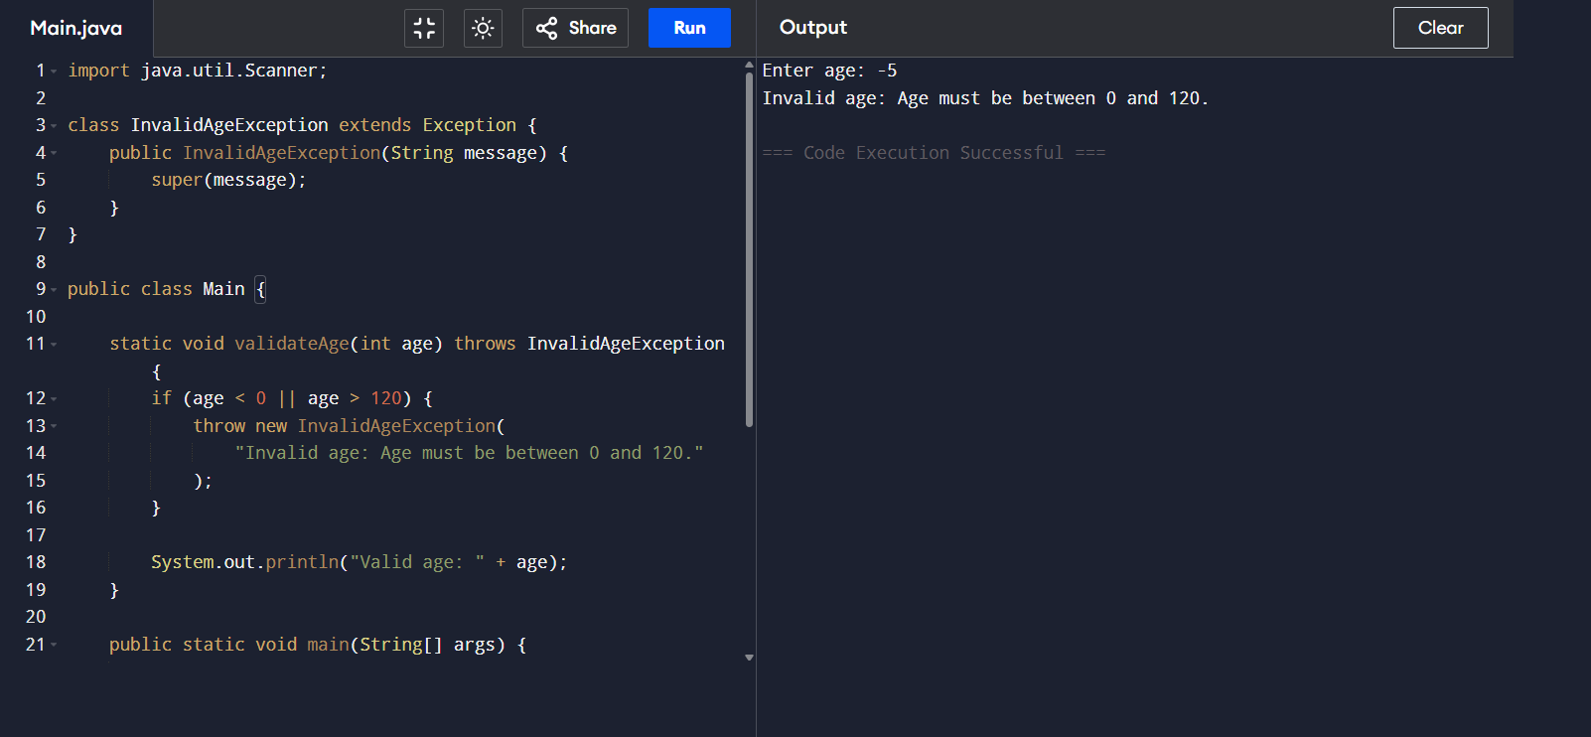

◈ Screenshot – Test Case 03
Input: 150
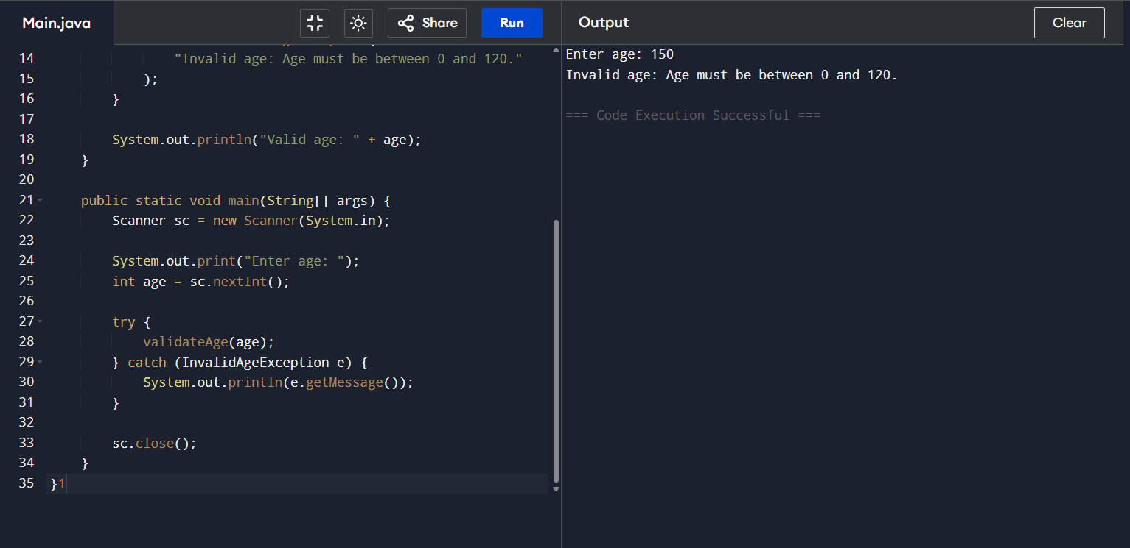

6. RESULT
The Java program was successfully implemented using a user-defined exception named InvalidAgeException.
The program correctly validates the entered age and throws the custom exception when the age is negative or greater than 120. The exception is successfully caught using the try-catch mechanism and the appropriate message is displayed.

★ RESULT: PROGRAM EXECUTED SUCCESSFULLY ★

7. REFLECTION

Through this assignment, I learned how to create and implement a custom exception in Java. I understood the purpose of throw, throws, and try-catch in exception handling.
The main challenge was understanding how a user-defined exception is created and communicated between methods. By implementing the InvalidAgeException class separately, I was able to handle invalid input in a structured and meaningful way.
This program helped me understand how exception handling can make Java programs more reliable, readable, and user-friendly.

8. DECLARATION
I hereby declare that this assignment is my own work. Any AI or external tool assistance used during the preparation of this assignment has been appropriately disclosed.
Student Name: Geona Alis J
Register No.: 192511088
Signature: Geona
Date: 10/08/2026

