EXPERIMENT-12
Demonstrate virtualization by Installing Type-2 Hypervisor in your device, create and configure VM image with a Host Operating system (Either Windows/Linux).

Aim
To demonstrate virtualization by installing a Type-2 Hypervisor (Oracle VirtualBox/VMware Workstation), creating a Virtual Machine (VM), and installing a guest operating system (Windows/Linux) on the host computer.

Procedure
- Download and install a Type-2 Hypervisor (e.g., Oracle VirtualBox or VMware Workstation) on the host operating system.
- Launch the hypervisor application after installation.
- Click New to create a new Virtual Machine (VM).
- Enter the VM name, select the Operating System type (Windows/Linux), and choose the appropriate version.
- Allocate the required RAM (e.g., 2 GB or more) to the VM.
- Create a Virtual Hard Disk (VDI/VMDK) and assign the required storage (e.g., 20 GB).
- Open Settings and attach the guest OS ISO image to the virtual optical drive.
- Start the VM and follow the installation steps to install the guest operating system.
- After installation, install Guest Additions/VMware Tools for improved performance and device support.
- Verify that the virtual machine boots successfully and the guest operating system runs properly.

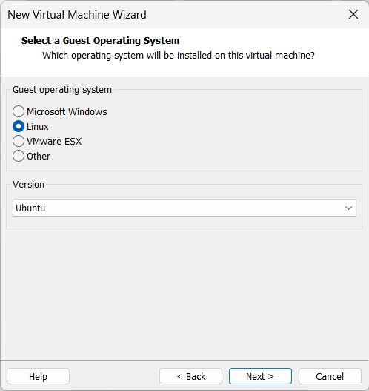

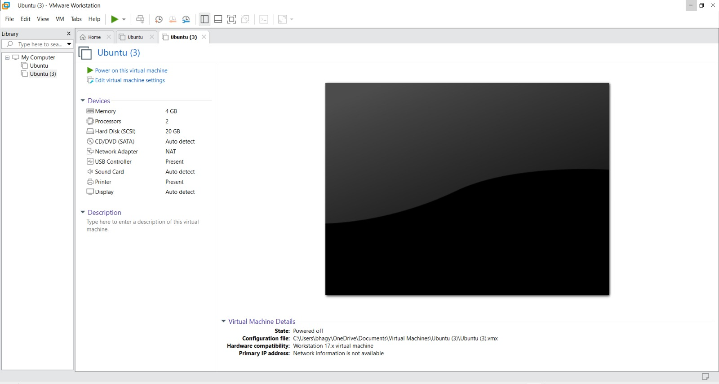

Result
The Type-2 Hypervisor was successfully installed, a Virtual Machine was created and configured, and the guest operating system (Windows/Linux) was installed and executed successfully.

