EXPERIMENT-13
Create a Virtual Machine with 1 CPU, 2GB RAM and 15GB storage disk using a Type 2 Virtualization Software

Aim
To create a Virtual Machine (VM) with 1 CPU, 2 GB RAM, and 15 GB virtual hard disk using a Type-2 Virtualization Software (such as Oracle VirtualBox or VMware Workstation).

Procedure
- Install a Type-2 Hypervisor (Oracle VirtualBox or VMware Workstation) on the host computer.
- Open the virtualization software and click New to create a new virtual machine.
- Enter the name of the virtual machine and select the Operating System type and version (Windows/Linux).
- Allocate 2 GB (2048 MB) RAM to the virtual machine.
- Set the CPU allocation to 1 processor (1 CPU) in the processor settings.
- Create a new virtual hard disk and set its size to 15 GB.
- Choose the disk format (VDI/VMDK) and select Dynamically Allocated or Fixed Size as required.
- Attach the operating system ISO image to the virtual machine through the Storage settings.
- Review the configuration and click Finish to create the virtual machine.
- Start the virtual machine and verify that it is configured with 1 CPU, 2 GB RAM, and a 15 GB virtual disk.
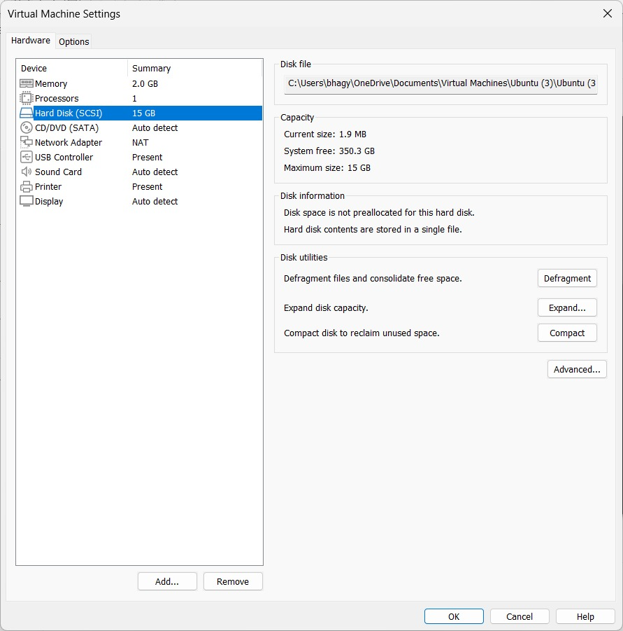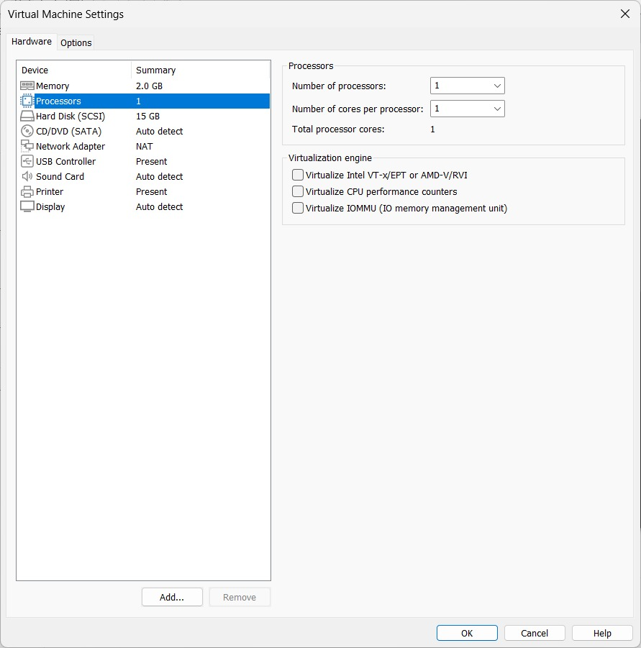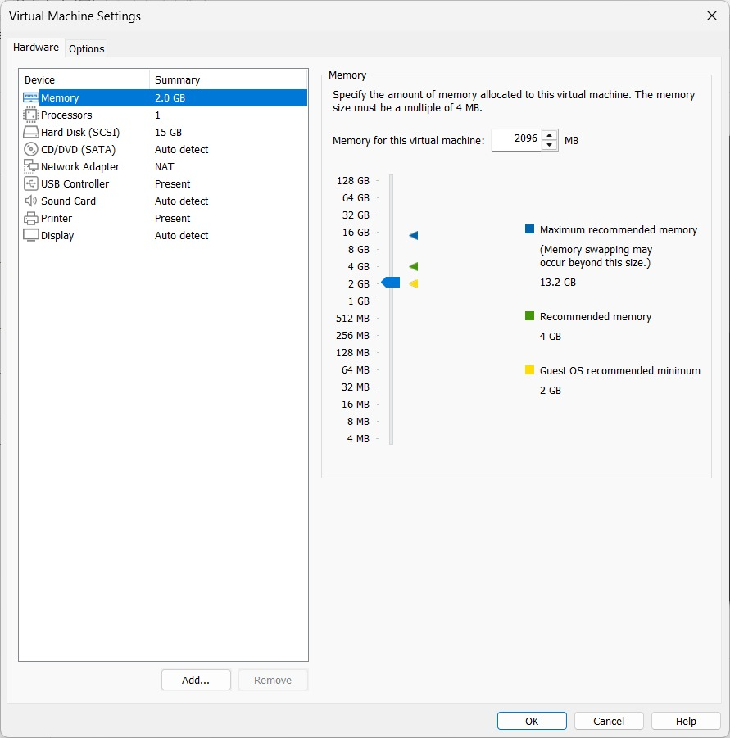

Result
A Virtual Machine was successfully created using a Type-2 Virtualization Software with 1 CPU, 2 GB RAM, and a 15 GB virtual hard disk, ready for operating system installation and use.

