CSA1503-Cloud computing and big data analytics
Experiment-1
Create a simple cloud software application for Car Booking Reservation System using any Cloud Service Provider to demonstrate SaaS include the necessary fields such as search for cabs, from, to, rental , out station, Package type, hours/Days etc.
INPUT
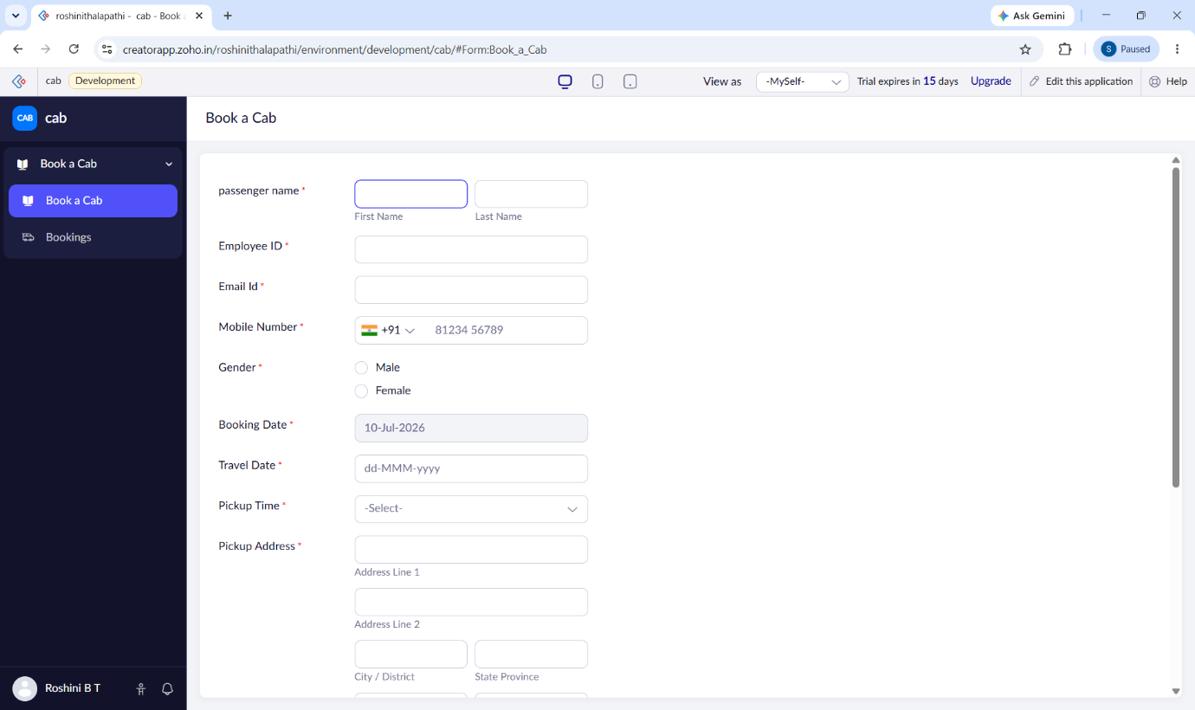

OUTPUT
