SAVEETHA SCHOOL OF ENGINEERING
SAVEETHA INSTITUTE OF MEDICAL AND TECHNICAL SCIENCES
CSA1505- CLOUD COMPUTING AND BIG DATA ANALYTICS
1. Create a simple cloud software application for Flight Reservation System using any Cloud Service Provider to demonstrate SaaS include the necessary fields such as one way, round trip, From, to, Departure, Departure, Travelers & Class, Fare Type, International and Domestic Flights etc.
INPUT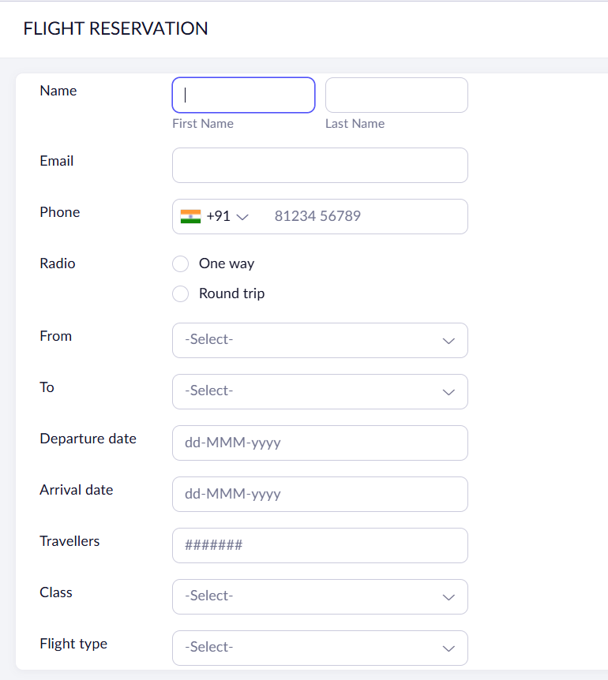
OUTPUT
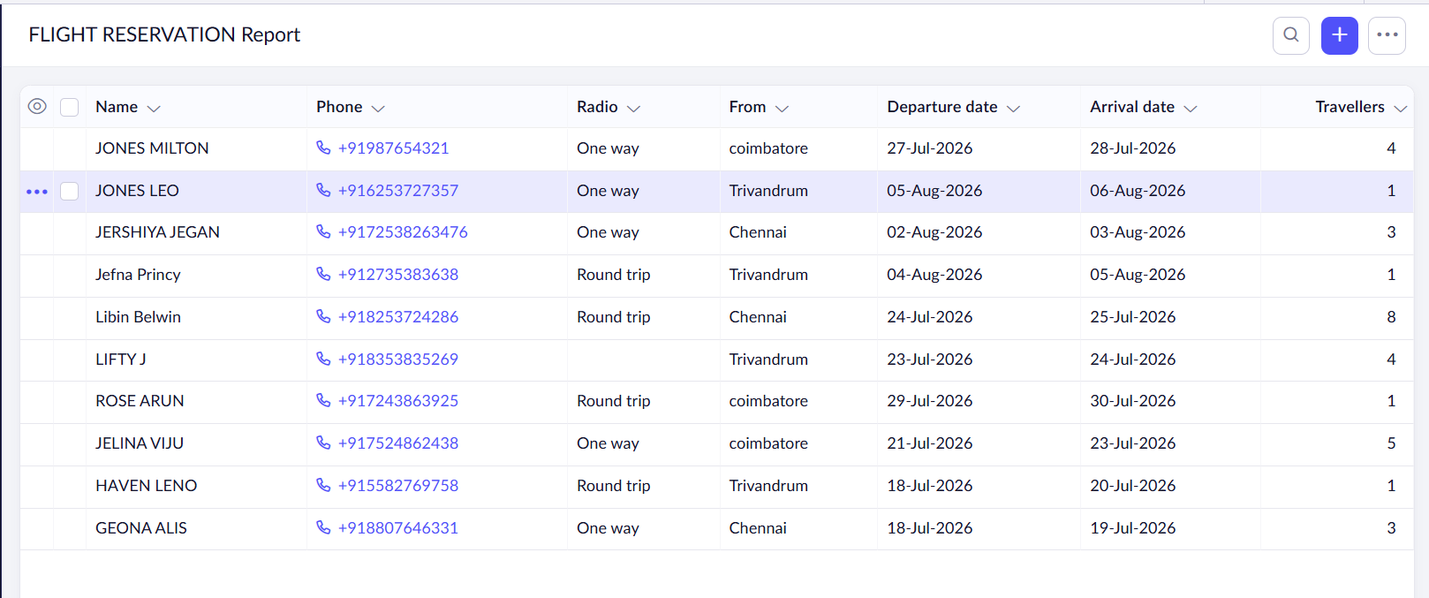
OVERVIEW
