SAVEETHA SCHOOL OF ENGINEERING SAVEETHA INSTITUTE OF MEDICAL AND TECHNICAL SCIENCES INSTITUTE OF CSE
CSA15- CLOUD COMPUTING AND BIG DATA ANALYTICS

2. Create a simple cloud software application for Property Buying & Rental process (In Chennai city) using any Cloud Service Provider to demonstrate SaaS include the necessary fields such as Buy, Rent, commercial, Rental Agreement , Rental Agreement, Area, place, Range, property value etc.

Aim
To create a simple cloud-based Property Buying & Rental application for Chennai city using a Cloud Service Provider (such as Google AppSheet, Microsoft Power Apps, or Salesforce) to demonstrate the Software as a Service (SaaS) model. The application should include features for property buying, renting, commercial properties, rental agreements, area, place, price range, and property value.

Procedure
- Open a cloud service provider such as Google AppSheet or Microsoft Power Apps.
- Sign in using your Google or Microsoft account.
- Create a new application using a blank template or from Google Sheets.
- Create a table with the following fields:
  - Property ID
  - Owner Name
  - Property Type (Buy/Rent/Commercial)
  - Area (in sq. ft.)
  - Place (Example: T. Nagar, Anna Nagar, Adyar, Velachery)
  - Price Range
  - Property Value
  - Rental Amount
  - Rental Agreement (Yes/No)
  - Contact Number
  - Property Status (Available/Sold/Rented)
- Design the input form to allow users to enter property details.
- Add search and filter options based on:
  - Buy
  - Rent
  - Commercial
  - Area
  - Place
  - Price Range
- Save the application to the cloud platform.
- Publish or deploy the application so that users can access it through a web browser or mobile device.
- Test the application by adding sample property records and verifying that users can search and view the required information.
- Verify that the application stores and retrieves data successfully from the cloud, demonstrating the SaaS model.
INPUT
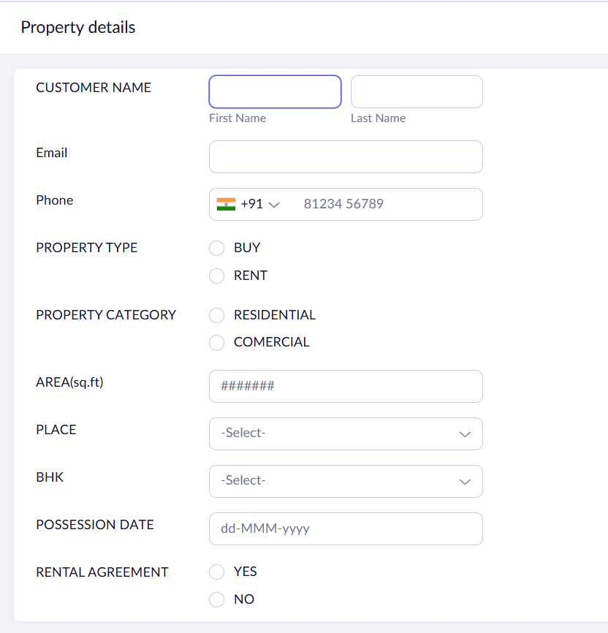
OVERVIEW:
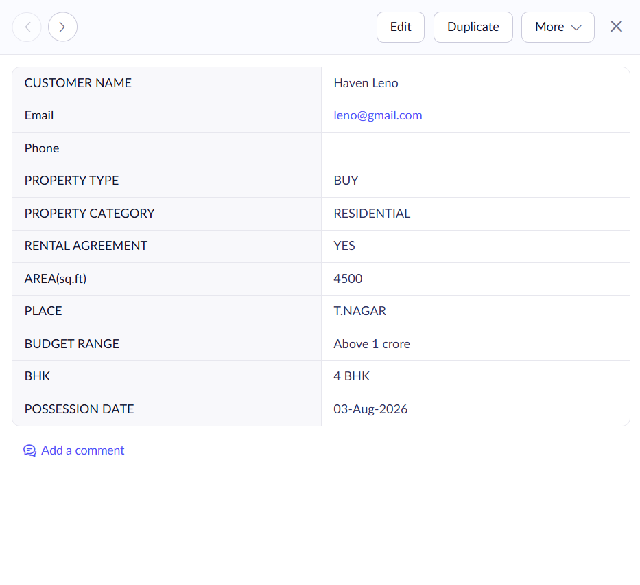
OUTPUT:


Required Fields
- Property ID
- Owner Name
- Buy
- Rent
- Commercial
- Rental Agreement
- Area (sq. ft.)
- Place (Chennai Location)
- Price Range
- Property Value
- Rental Amount
- Contact Number
- Property Status

Result
A simple cloud-based Property Buying & Rental application for Chennai city was successfully created using a Cloud Service Provider. The application allows users to manage and search properties for buying, renting, and commercial purposes, thereby demonstrating the Software as a Service (SaaS) cloud computing model.

