Geon Soo Park

HCDE 310

11.7.2016

Homework 6 Write-up

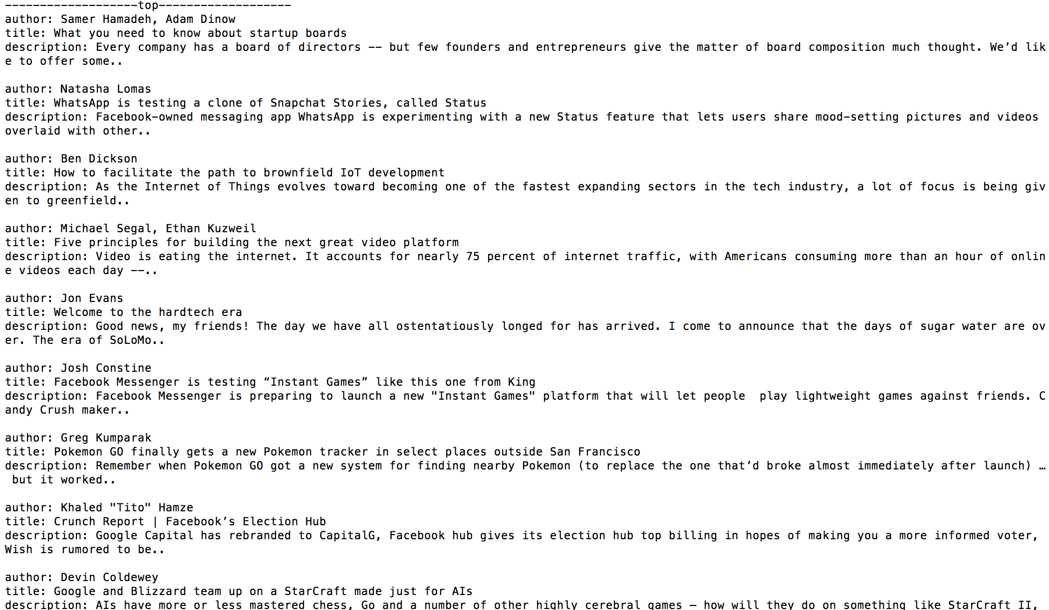My application takes Wall Street Journal API and it gives information of the article (author name, title, and brief description). It sorts by the information of article such as ‘popular’, ‘latest’, or ‘top’. Then, depends on the sorted category (‘latest’, ‘top’, or ‘popular), it gives the information of the article. See the image below: