VESPA(Velocity Spectral Analysis) Tutorial

by Xuping Feng
@NJU
June 30, 2017

This tutorial is to let readers simply understand how my program works and hope you get something new with it. Especially, here, this program comes with NO WARRANTY, to the extent permitted by law.

1. Parameters of this program
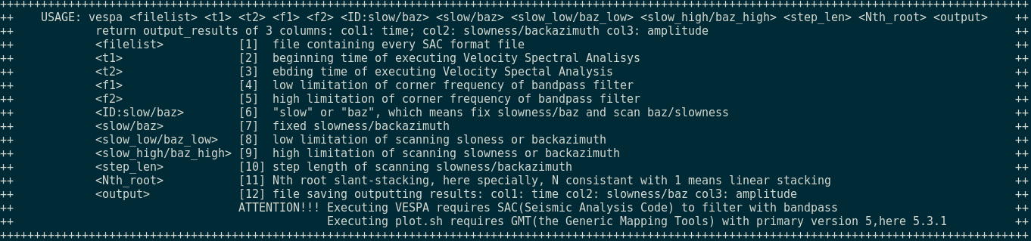
2. An example of executing this programm
First the information of this earthquake event is given as blow, see fig 1.
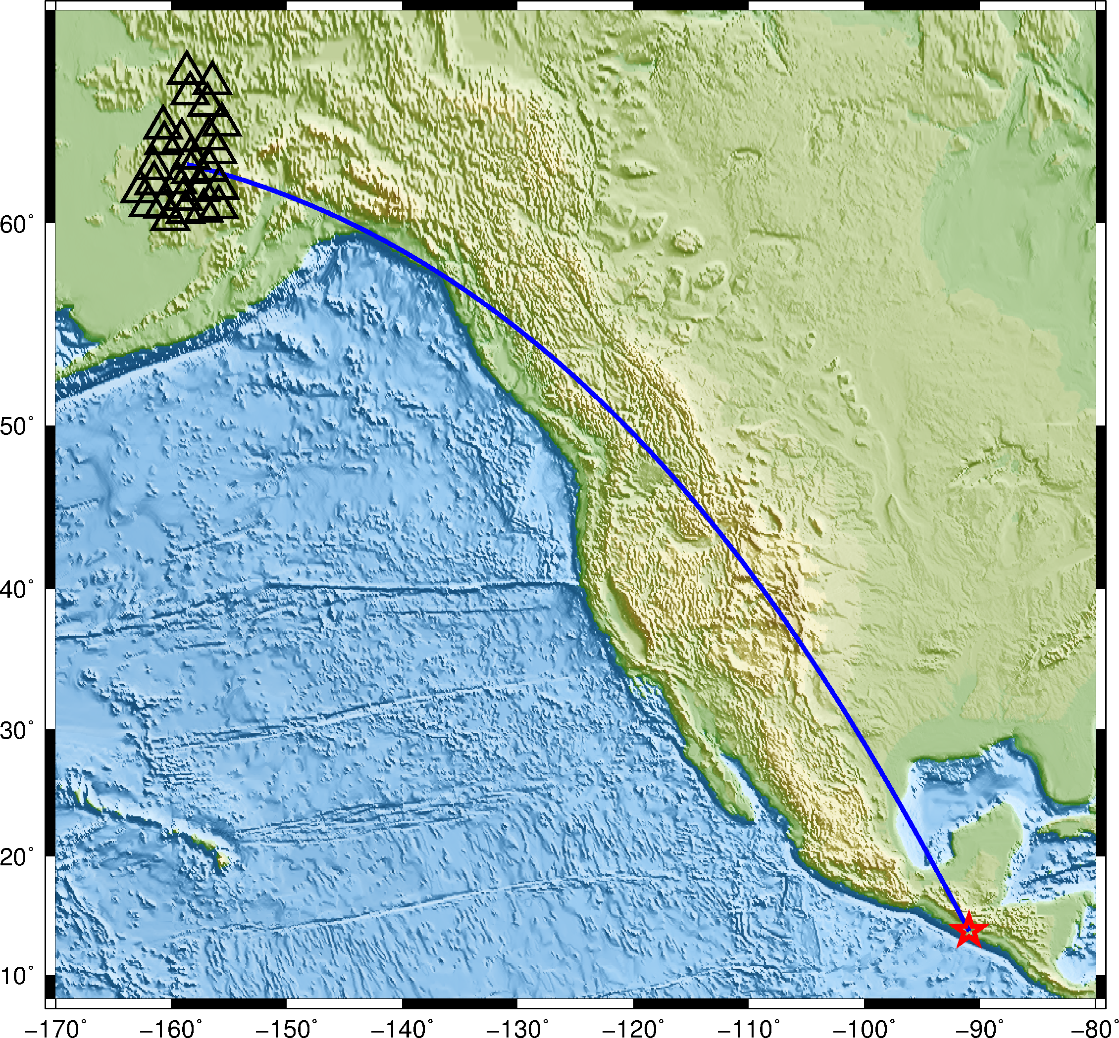

Actually, the epicenter of this event locates in the place which is near coast of Guatemala, 13.7527°N, -90.9488°W, and the seismic array used in this example is installed in Alaska,US. The great circle arc is about 67.62°, back-azimuth 103.563°, and referenced depth of hypocenter is 46.82 km. We calculate synthetic values, here, travel times , Ray Parameters and corresponding seismic phase names using Taup solftware (by USC) shown as blow,
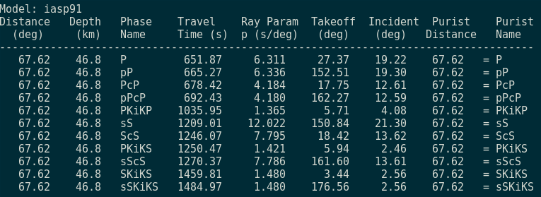

These raw seimsic data (actually, filtered with 0.05 ~ 0.15 Hz)of this array are plotted as the following figure shows,
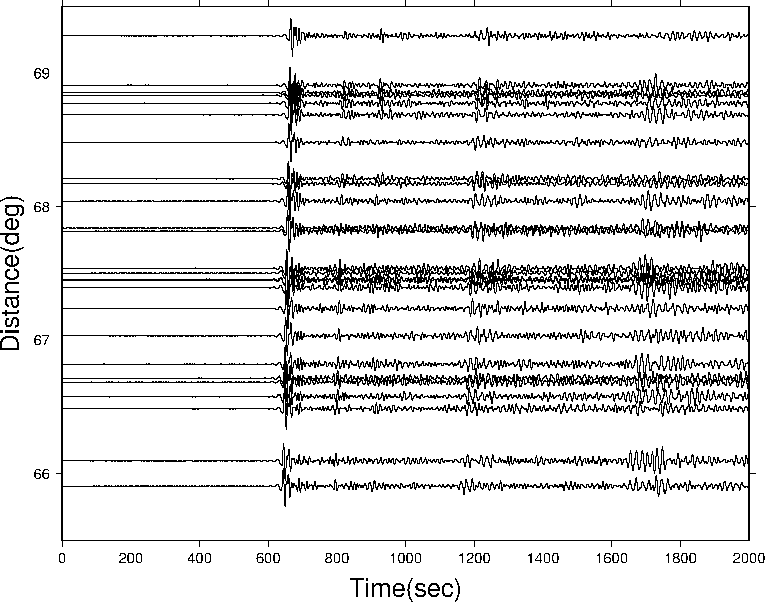
2.1 Get proper back-azimuth and rough slowness with Beam forming
method
Here we first find the back-azimuth and rough slowness using Beam
forming method, to know more matials and see “ARRAY SEISMOLOGY: METHODS AND APPLICATIONS” by Sebastian Rost and Christine Thomas, 2004, Reviews of Geophysics. Result is shown by following figure,

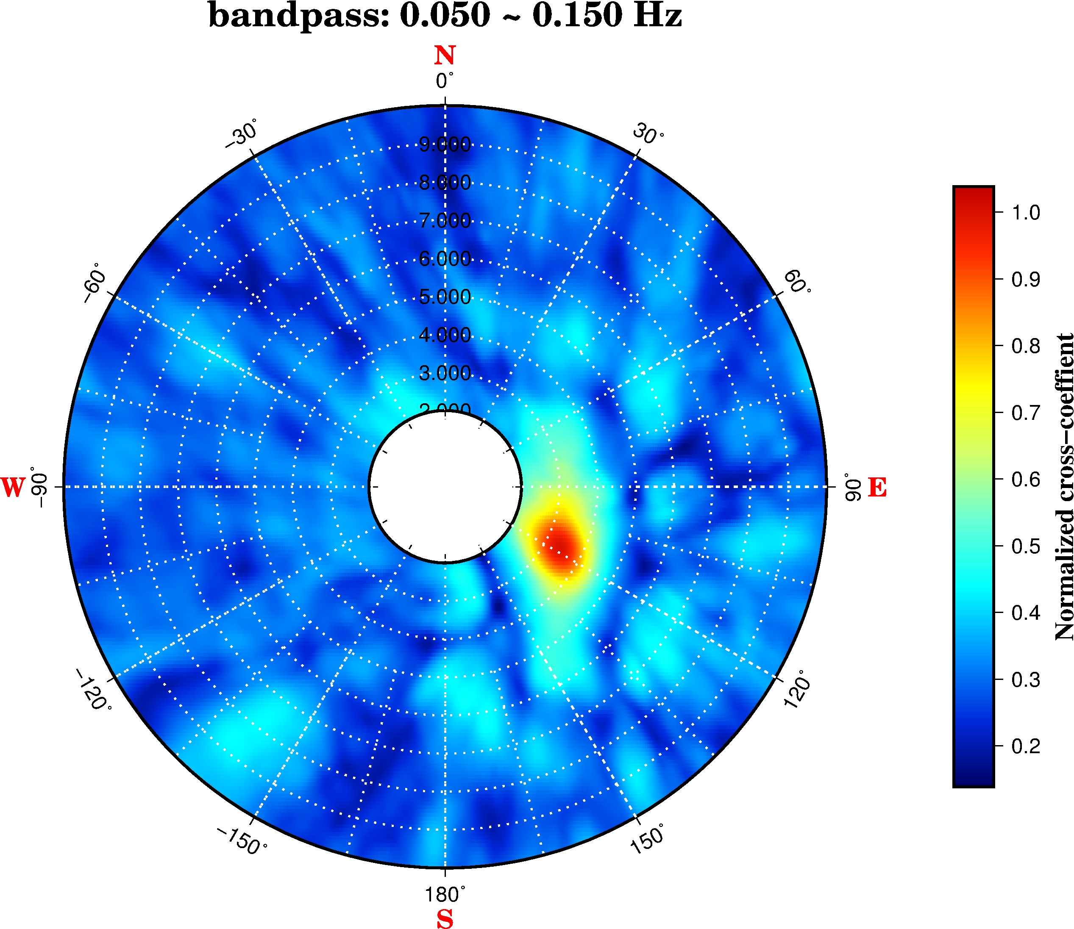
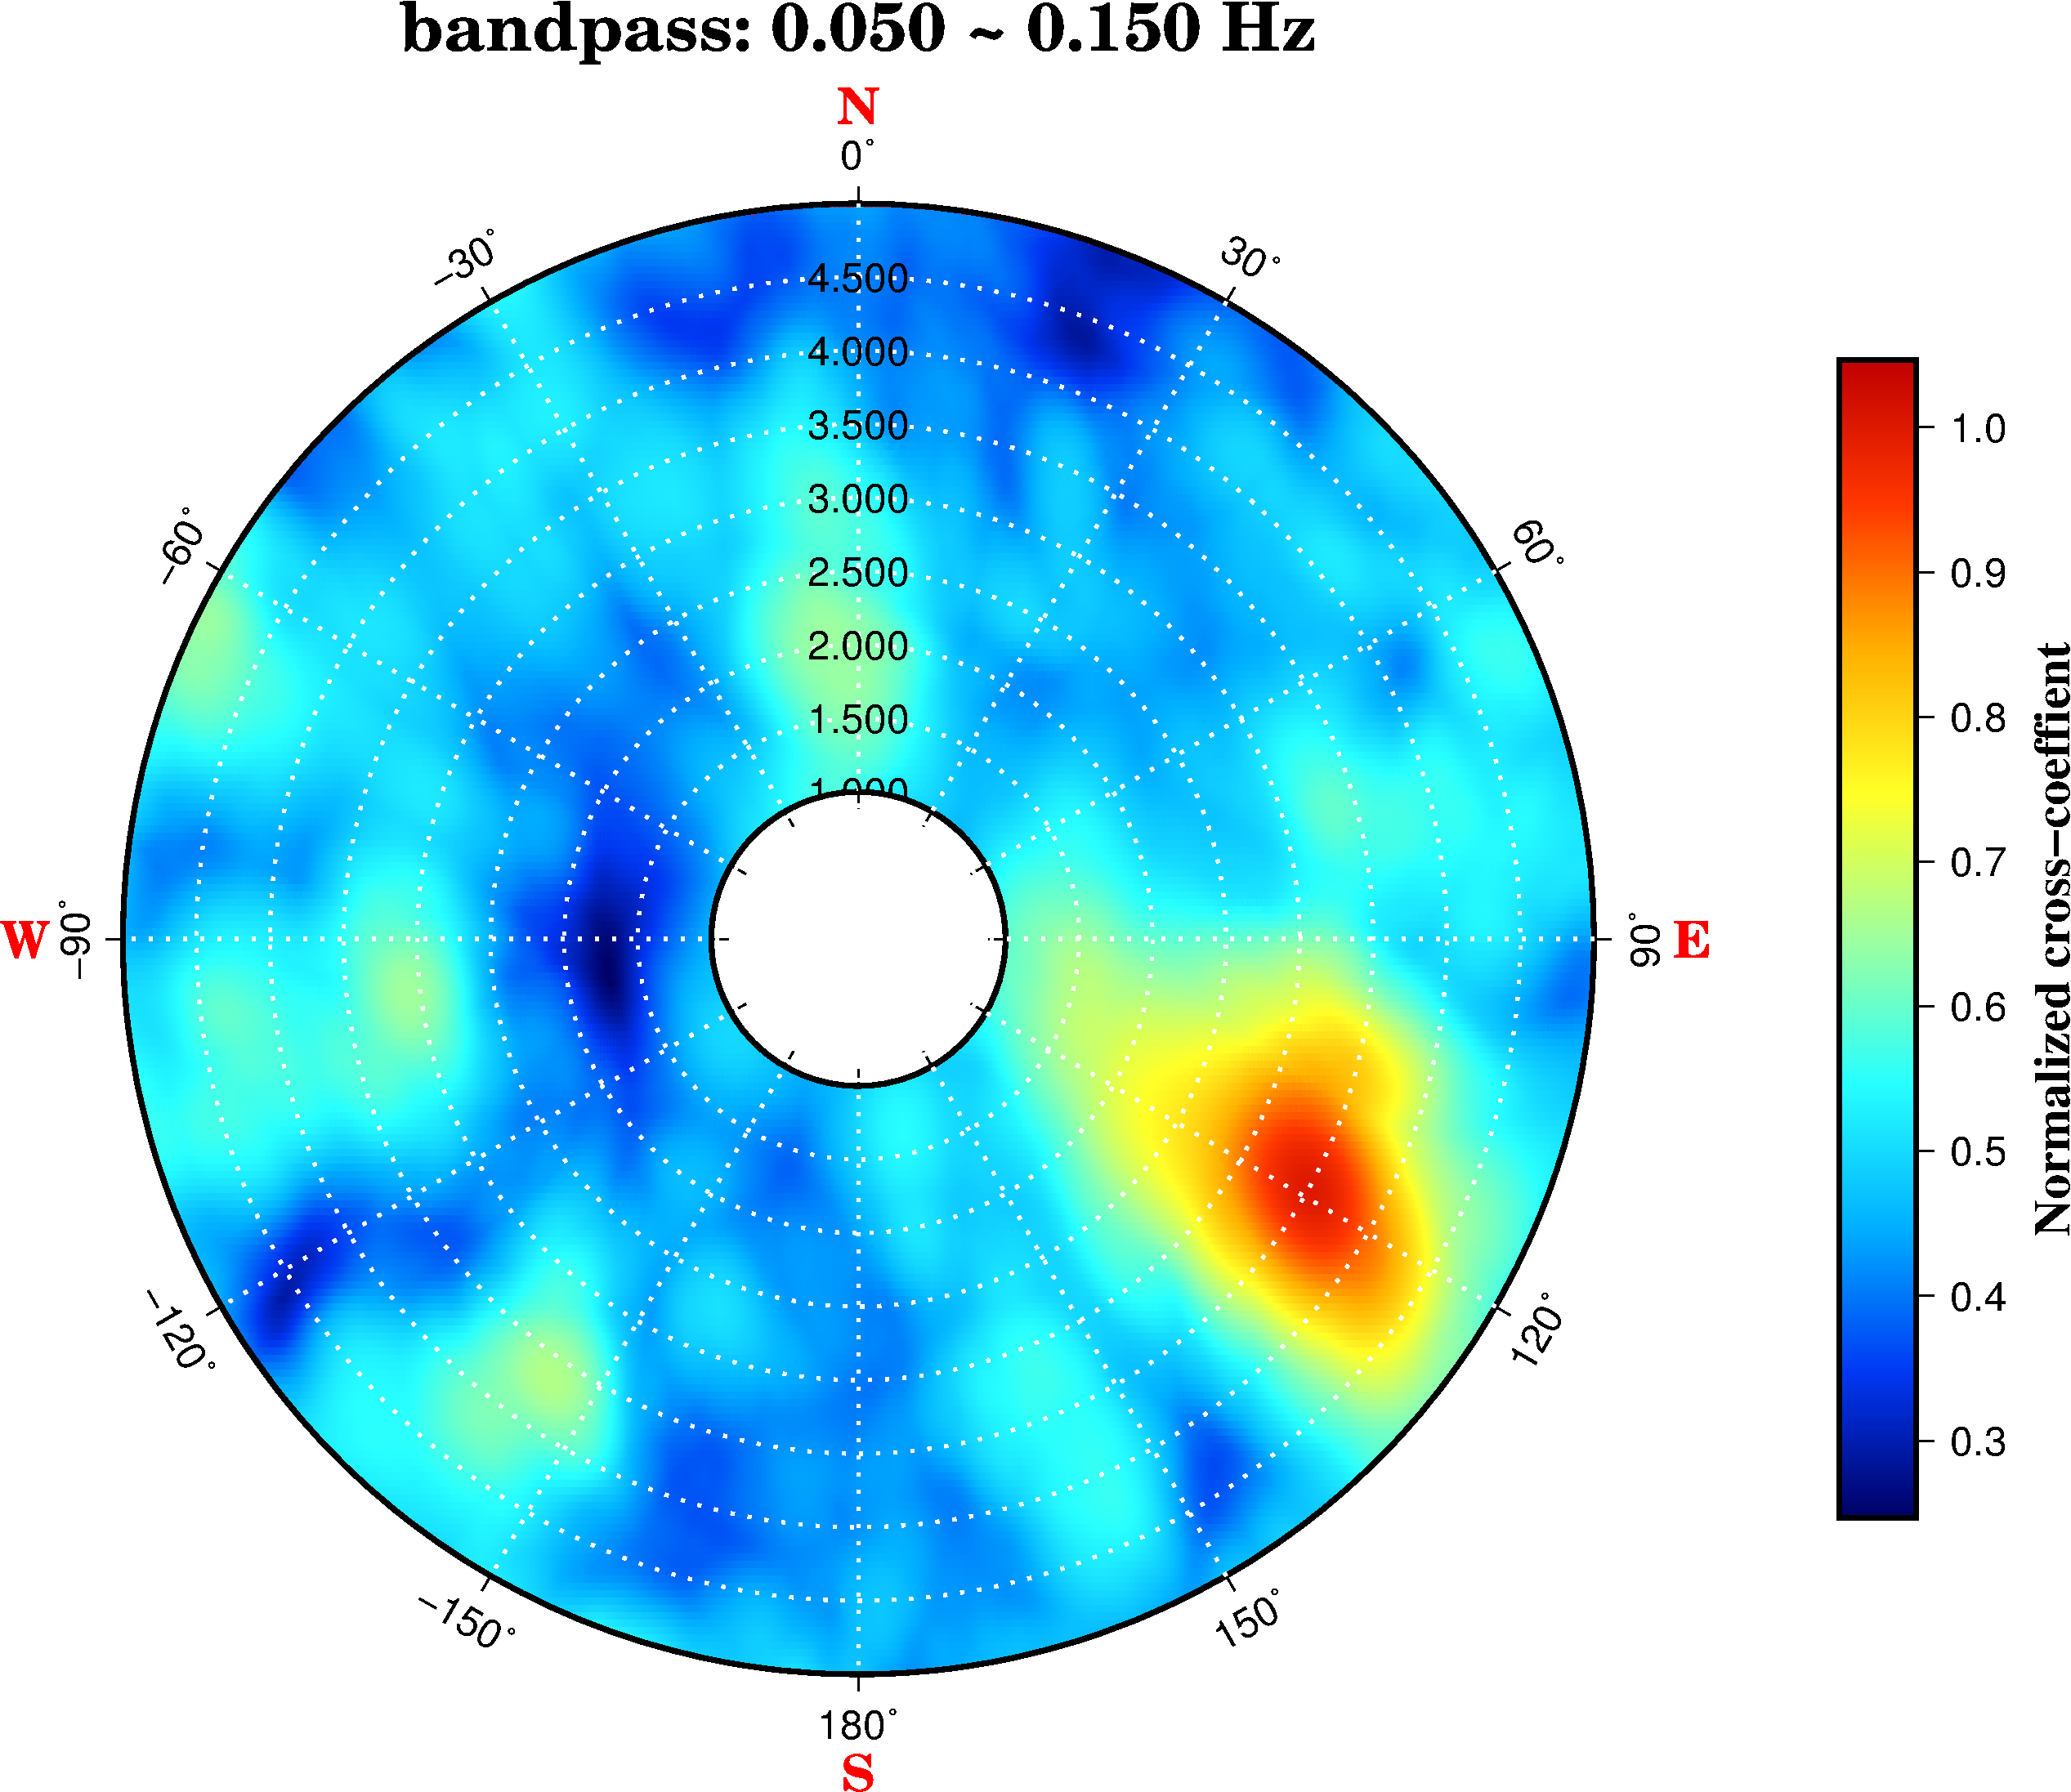

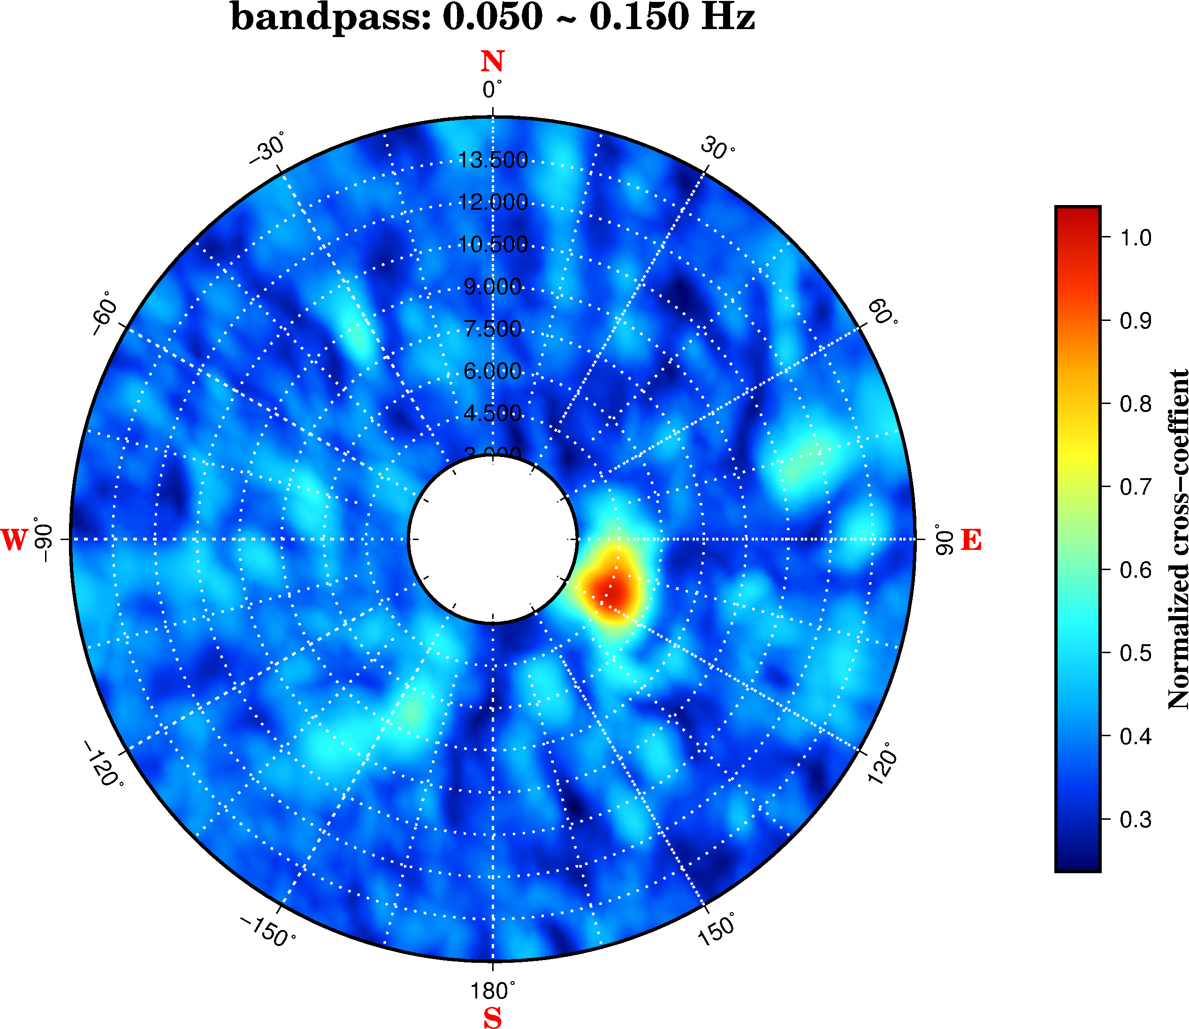
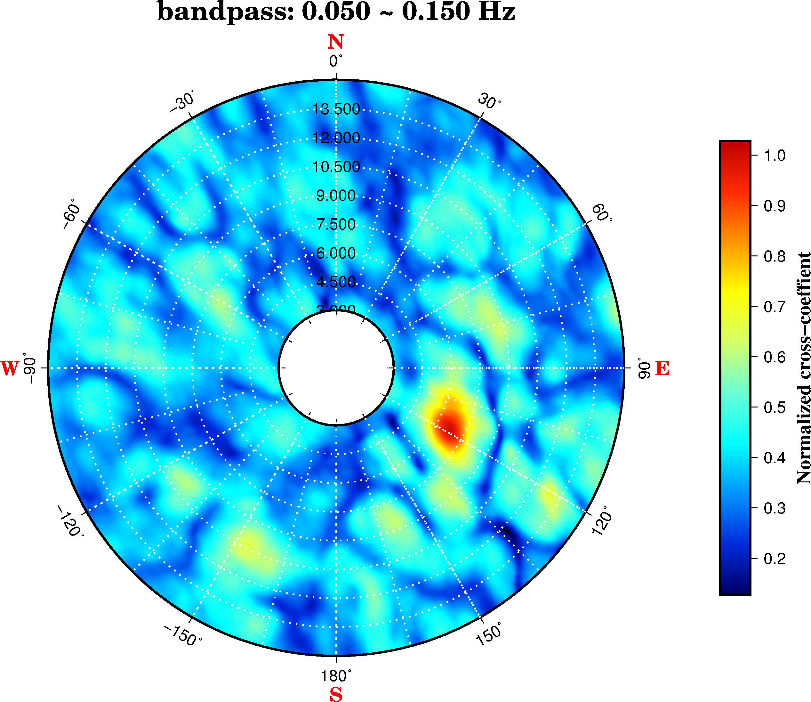

As the result of executing beam forming revealed(time windows are 600~700s, 700~800s, 700~1000s and 1150~1250s, respectively, the proper back-azimuth is 118°.

2.2 Fix back-azimuth 118° and scan slowness

Now we scan the slowness with fixed back-azimuth 118° and see firgures blow,
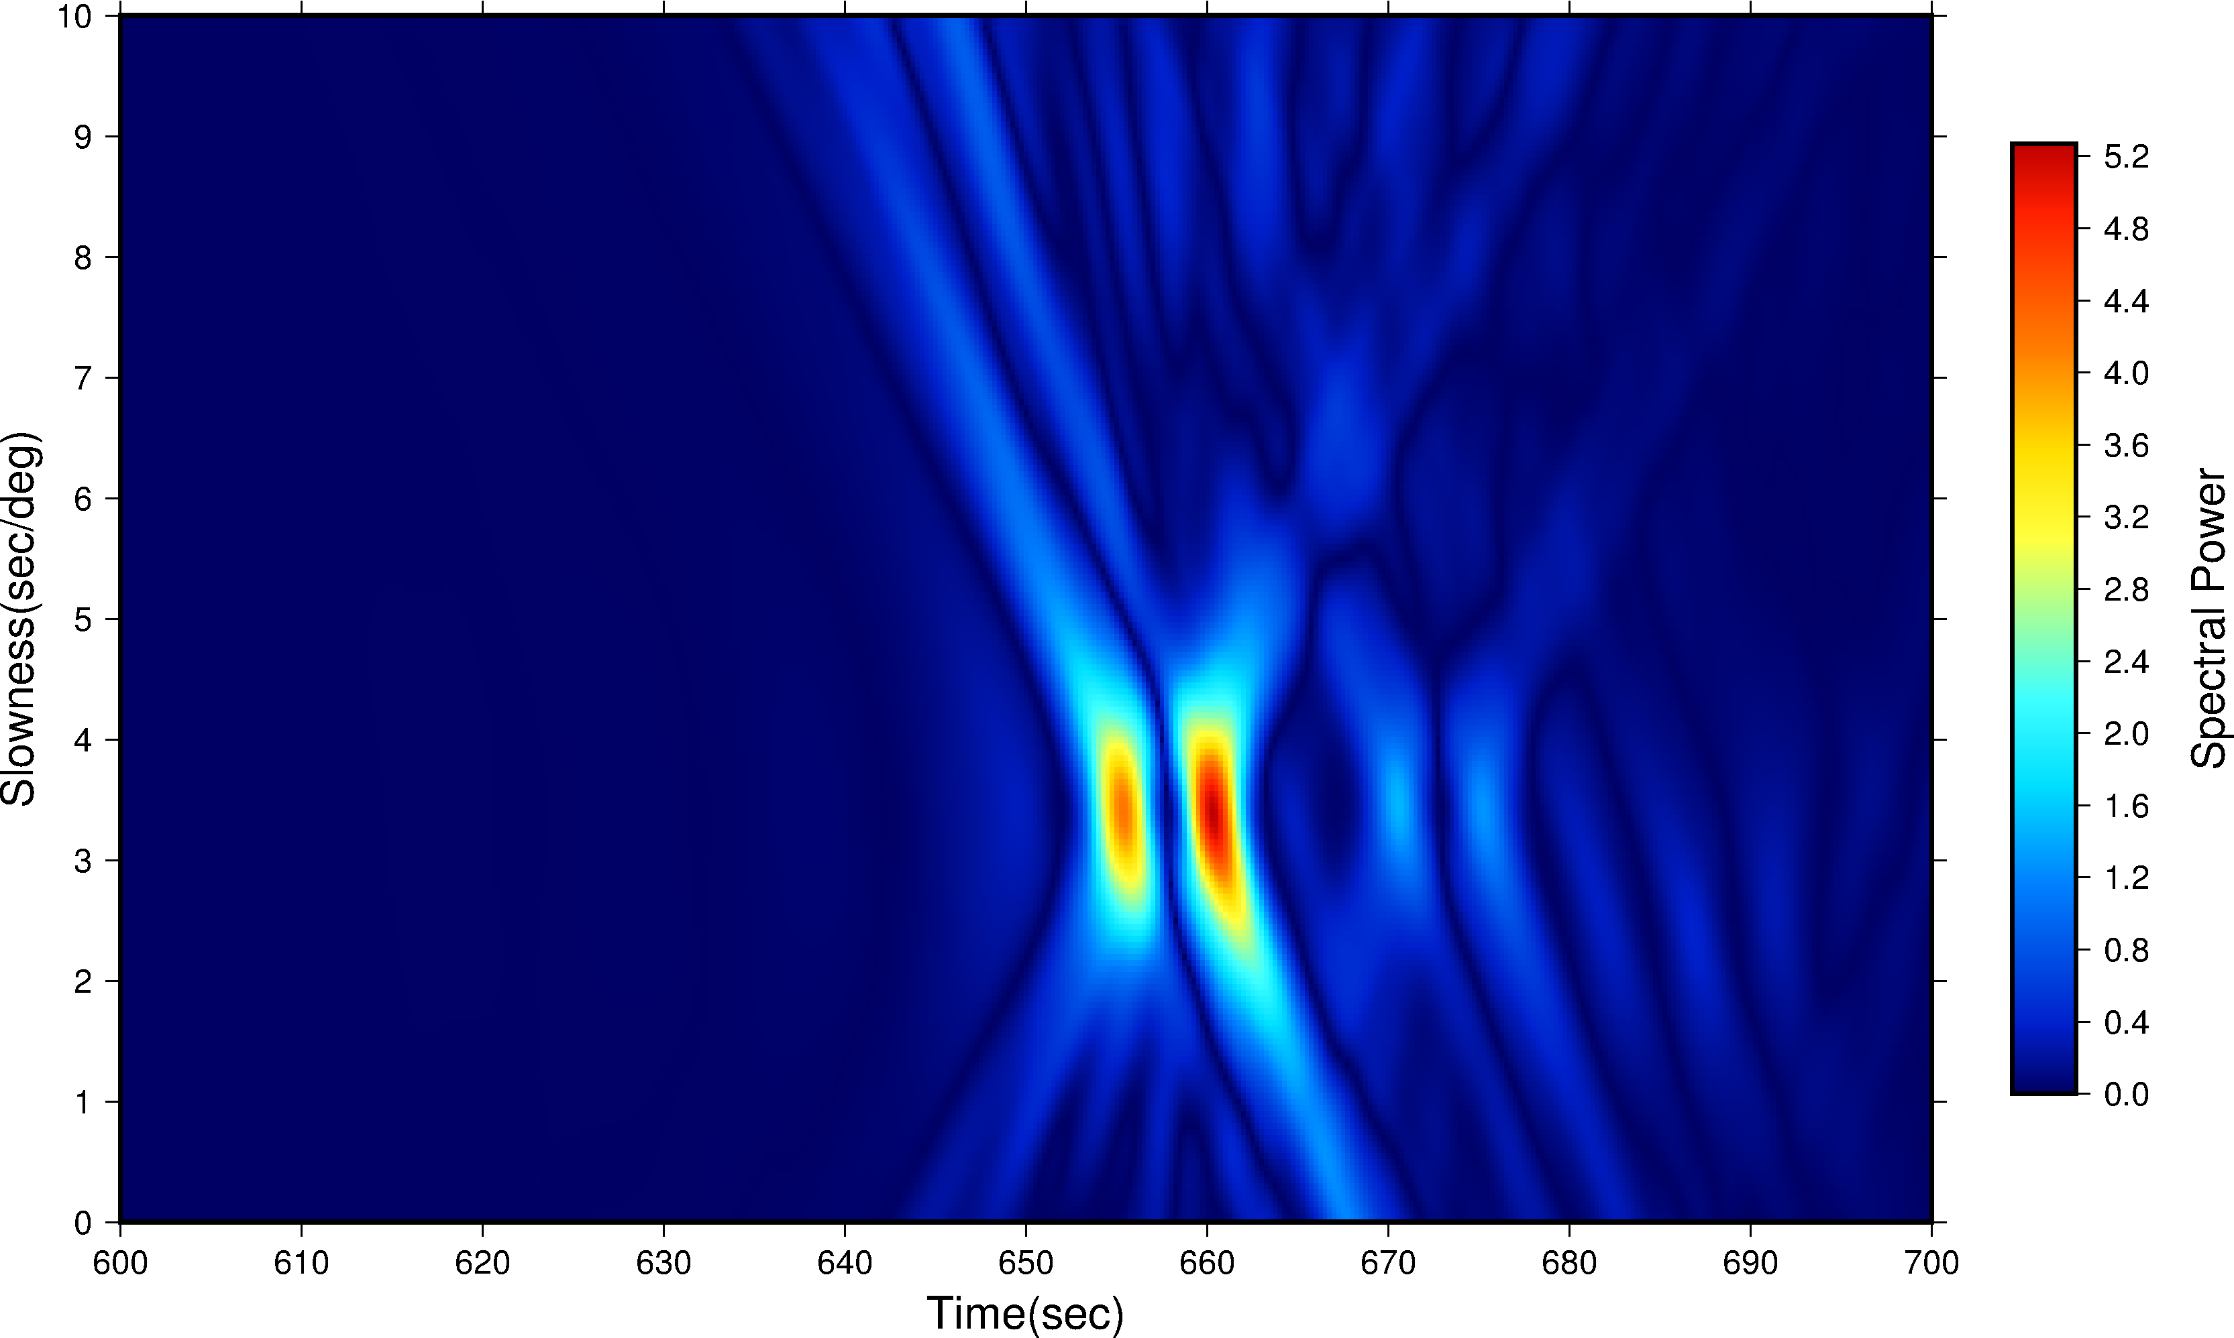
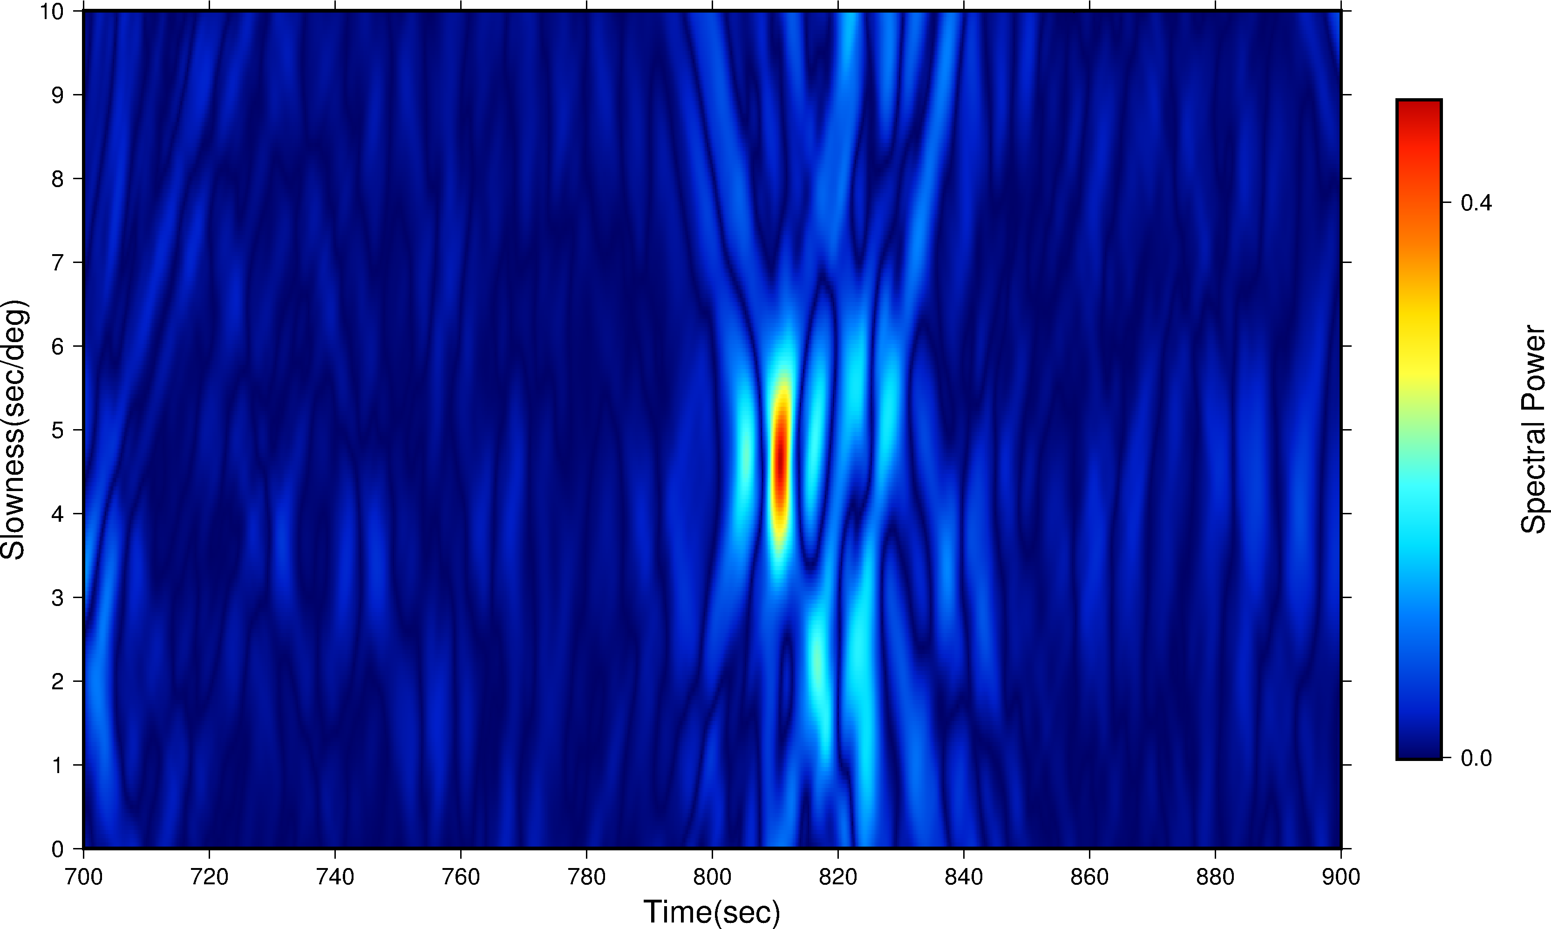

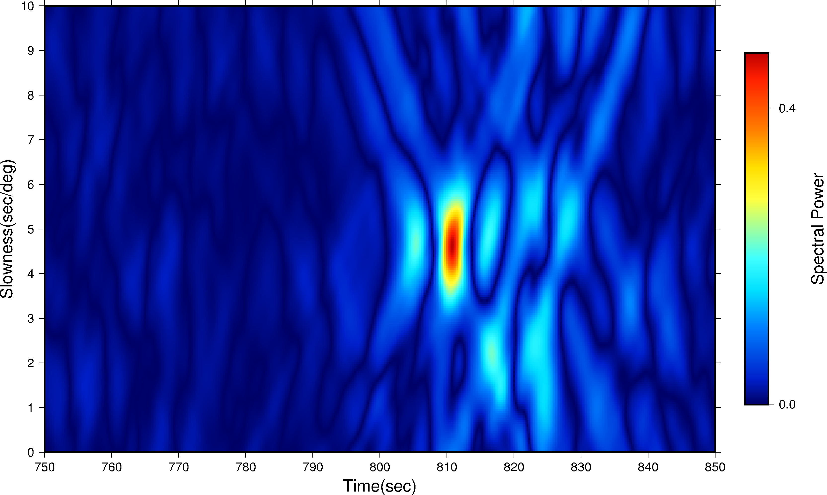
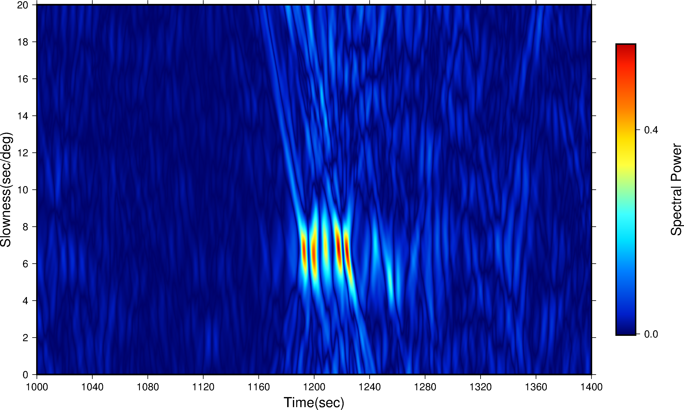

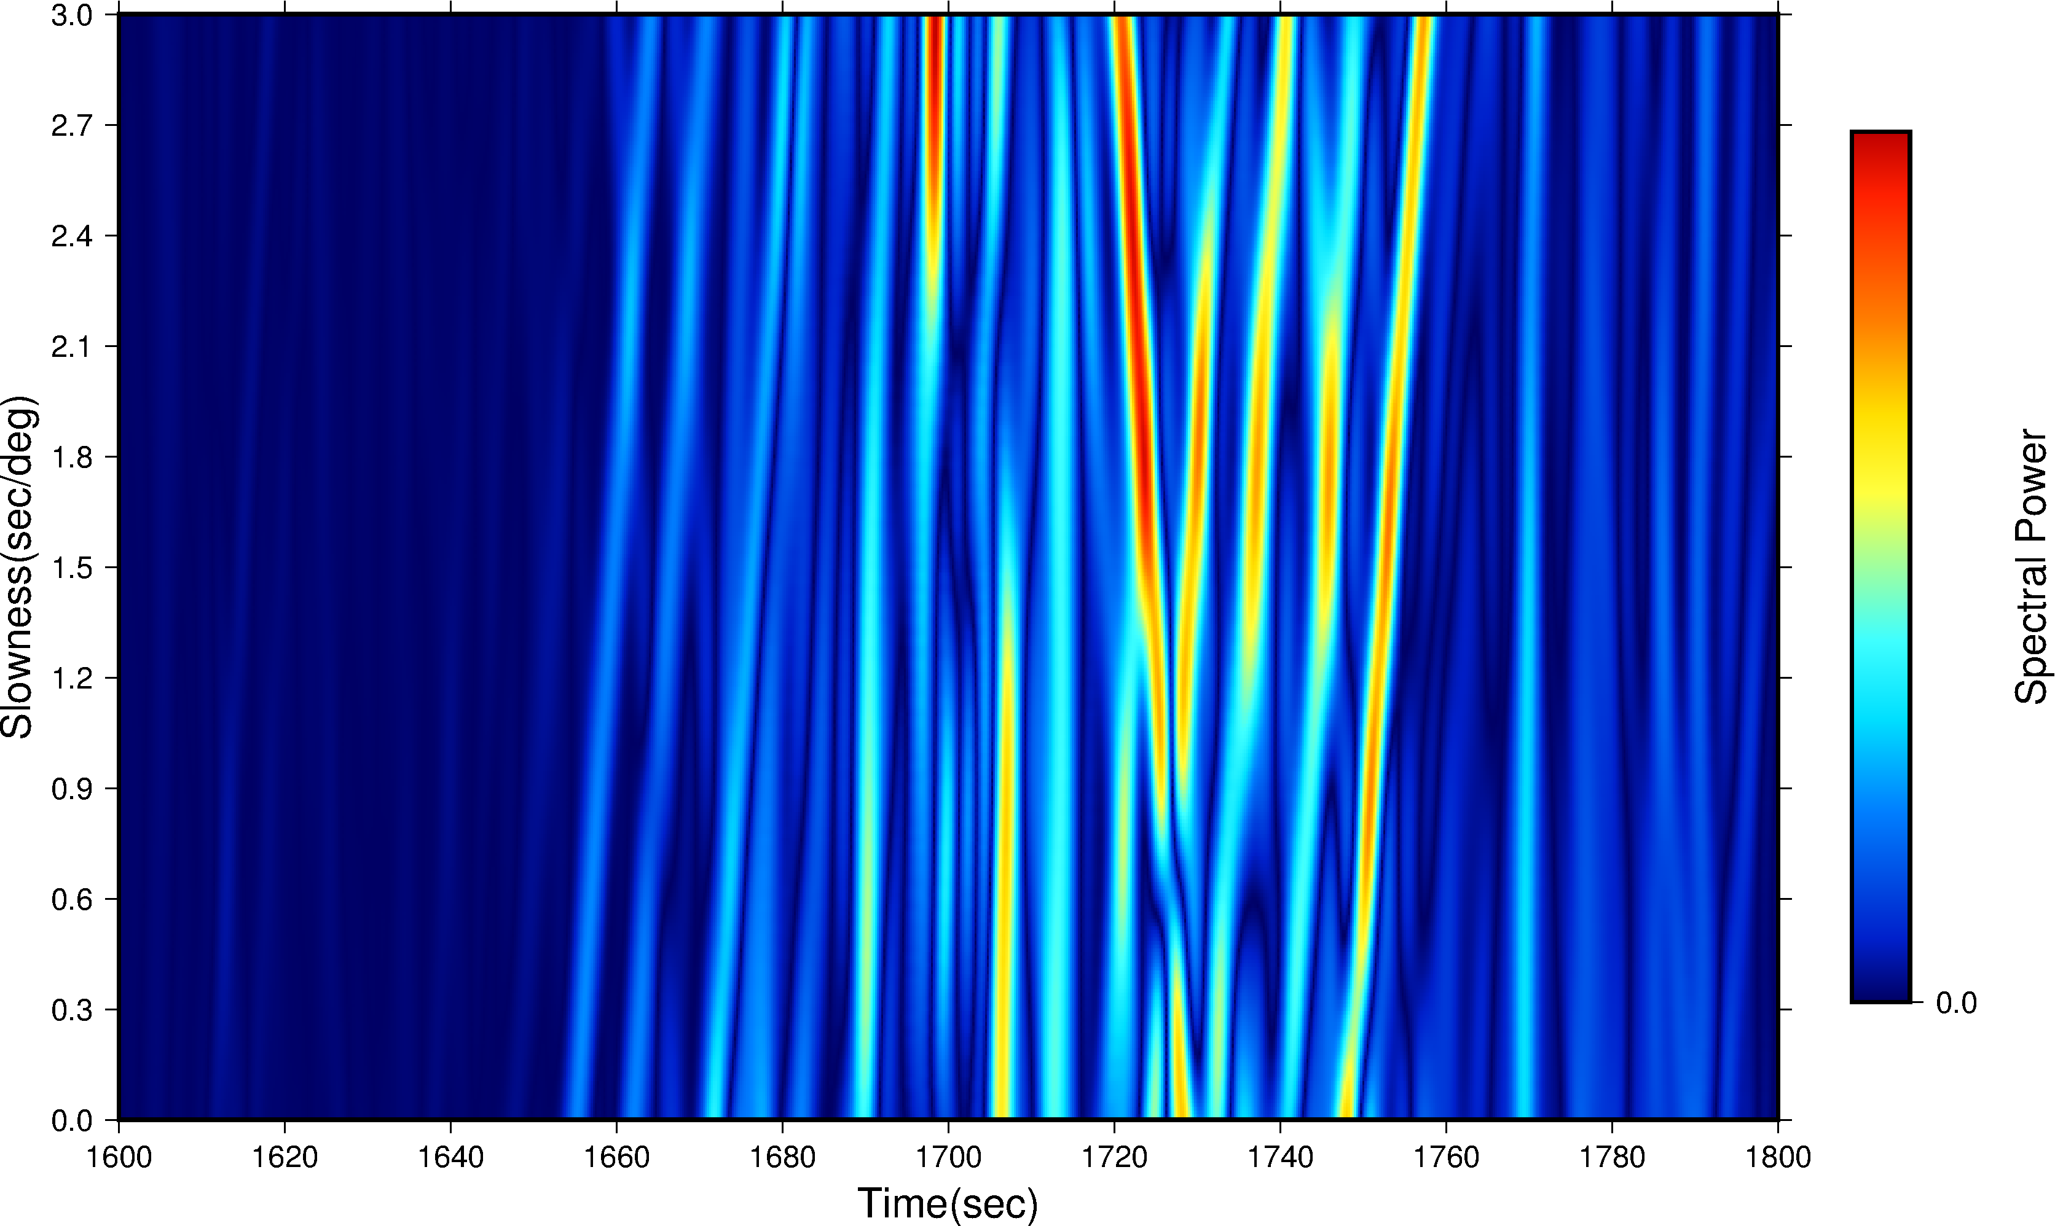

2.3 Fix slowness and scan back-azimuth

Now we scan back-azimuth with fixed slowness, see results below,


