项目名称：瓮福协同供应链项目
文档编号：NC-M222-M-SCM-02


瓮福集团管理信息化系统项目
供应链解决方案
计量接口（火车）


用友软件股份有限公司
2010年12月
此文档为保密文档，未经用友软件股份有限公司书面同意，不得向任何单位或个人提供、转让本文档中的任何内容，用友软件股份有限公司将保留对泄漏文档内容的起诉权

长沙衡器磅房计量数据交换解决方案

概述
此插件是为了实现物资过磅计量在NC供应链产品的接口方案，主要针对火车运输过磅计量的业务，解决NC系统与外部计量软件系统的数据传递。
主要业务流程如下图所示：
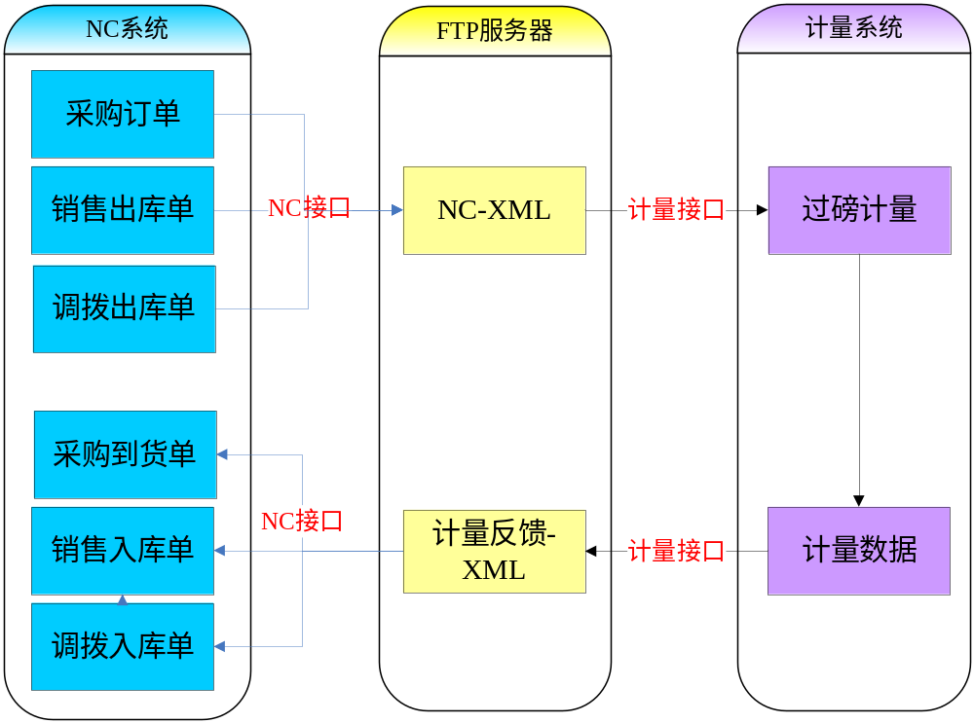

功能实现方案描述

采购订单数据交换

NC系统发送数据
NC系统以手动导出的方式，导出采购订单数据，包括单据编号、物料编码、客商编码、客商名称、数量、收货单位、XML文件的方式上传到FTP服务器，供计量系统调用。（XML数据格式详见NC发送采购订单格式）

过磅计量系统处理数据
过磅计量系统在过磅完成后，登记货物对应的订单编号、存货编码、毛重、皮重、净重、扣重、过磅员、过磅时间、复磅时间数据，可针对不同订单生成XML格式数据文件，上传到FTP服务器，供NC系统调用。（XML数据格式详见NC接收到货单格式）

NC系统自动导入数据
NC系统部署一个后台任务，自动监听计量系统返回的含计量数据的XML文件,并根据订单号反查订单信息，在校验无误后，生成到货单，存入数据库中。

销售出库单数据交换

NC系统发送数据
NC系统中，以手工导出的方式导出销售出库单数据到XML文件，并上传到FTP服务器。（XML数据格式详见NC发送销售发货单数据格式）

过磅计量系统处理数据
过磅计量系统远程连接FTP的方式，读取指定路径下的XML数据文件，得到销售出库单信息。过磅系统采集数据后，按照XML格式生成含计量数据的XML文件，并上传到FTP服务器。（XML数据格式详见NC接收销售发货单数据格式）

NC系统自动导入数据
NC系统部署一个后台任务，自动监听计量系统返回的XML文件。在校验无误后，返写出库单，并存入数据库。

调拨出入库计量数据交换

NC发送调拨出库单
国贸公司调拨货品出库时，录入调拨出库单，含出库单号、物料、收货单位、数量、计量单位等信息，生成XML数据格式文件，上传到FTP服务器。（NC发送调拨出库单数据格式）

磅房计量处理数据
磅房计量站在火车过磅后，记录过磅信息，并根据FTP服务器上的文件格式，生成XML过磅xml文件，上传FTP服务器。（NC接收调拨入库单数据格式）

NC接收生成调拨入库单
NC系统自动监听FTP服务器，接收磅房计量站发送到XML数据格式文件，解析后自动生成调拨入库单。

数据格式定义

采购订单数据交换数据格式
表头及磅单文件头说明：
<ufinterface account="1" billtype="1" filename="文件名称" isexchange="Y" roottag="bill" replace="Y" receiver="jlxt" sender="0101" proc="add" subbilltype="1">
account 表示有几个榜单数据，即<subbill/>的数量
billtype 单据类型，1为订单，2为销售出库单，3为调拨出库单
filename 文件名称，避免重复
isexchange NC中使用，默认为Y
roottag 根节点名称，默认为bill
replace NC中使用，默认为Y
receiver 文件接收方
sender 文件发送方，NC发送订单时为NC中公司主键，接收时为计量系统
proc 操作类型，默认为add
subbilltype 子单据类型
反写规则:
1 订单的sender = 到货单的receiver
2 订单的receiver = 到货单sender
3 订单的billtype = 到货单的billtype
4 订单中的filename = 订单编号.xml;
5 磅单中的filename = 磅单号.xml(建议以磅单号命名，避免出现重复)
6 订单到subbilltype = 到货单的subbilltype

NC发送采购订单格式
<?xml version="1.0" encoding='UTF-8'?>
<ufinterface account="2" billtype="1" filename="订单编号.xml" isexchange="Y" roottag="bill" replace="Y" receiver="jlxt" sender="0101" proc="add" subbilltype="1">
<!--订单的sender = 到货单的receiver;订单的receiver = 到货单sender;订单的billtype = 到货单的billtype;订单到subbilltype = 到货单的subbilltype;-->
<bill>
<bill_head>
<billcode>订单编号</billcode>
<custcode>供应商编码</custcode>
<custname>供应商名称</custname>
<billstate>单据状态</billstate><!--0 关闭 1 开启-->
</bill_head>

<bill_body>
<subbill>
<storecode>存货编码1</storecode>
<account>数量1</storeaccount>
<measname>计量单位1</measname>
<wagonboxcode>车号1</wagonboxcode>
<receivedeptcode>收货单位编码1</receivedeptcode>
<receivedeptname>收货单位名称1</receivedeptname>
</subbill>

<subbill>
<storecode>存货编码2</storecode>
<account>数量2</storeaccount>
<measname>计量单位2</measname>
<wagonboxcode>车号2</wagonboxcode>
<receivedeptcode>收货单位编码2</receivedeptcode>
<receivedeptname>收货单位名称2</receivedeptname>
</subbill>
......
</bill_body>
</bill>
</ufinterface>

NC接收到货单格式
<?xml version="1.0" encoding="UTF-8"?>
<ufinterface account="2" billtype="1" filename="文件名称" isexchange="Y" roottag="bill" replace="Y" receiver="0101" sender="jlxt" proc="add" subbilltype="">
<!--订单的sender = 到货单的receiver;订单的receiver = 到货单sender;订单的billtype = 到货单的billtype;订单到subbilltype = 到货单的subbilltype;-->

<bill>
<bill_head>
<sendtime>发送时间(yyyy-mm-dd hh-mi-ss)</sendtime>
<sendpsn>发送人</sendpsn>
</bill_head>

<bill_body>
<billinfo billcode ="订单编号1">
<subbill>
<storecode>存货编码1</storecode>
<measname>计量单位1</measname>
<grossweight>毛重1</grossweight>
<tareweight>皮重1</tareweight>
<netweight>净重1</netweight>
<deductweight>扣重1</deductweight>
<ponderationpsn1>过磅员1</ponderationpsn1>
<ponderationpsn2>过磅员2</ponderationpsn2>
<weightcode>磅单号1</ weightcode>
<wagonboxcode>车皮号1</wagonboxcode>
<ponderationtime>过磅时间1(yyyy-mm-dd hh-mi-ss)</ponderationtime>
<reponderationtime>复磅时间1(yyyy-mm-dd hh-mi-ss)</reponderationtime>
</subbill>

<subbill>
<storecode>存货编码2</storecode>
<measname>计量单位2</measname>
<grossweight>毛重2</grossweight>
<tareweight>皮重2</tareweight>
<netweight>净重2</netweight>
<deductweight>扣重2</deductweight>
<ponderationpsn1>过磅员1</ponderationpsn1>
<ponderationpsn2>过磅员2</ponderationpsn2>
<weightcode>磅单号2</ weightcode >
<wagonboxcode>车皮号2</wagonboxcode>
<ponderationtime>过磅时间2(yyyy-mm-dd hh-mi-ss)</ponderationtime>
<reponderationtime>复磅时间2(yyyy-mm-dd hh-mi-ss)</reponderationtime>
</subbill>
</billinfo>
<billinfo billcode ="订单编号2">
...
</billinfo>
</bill_body>
</bill>
</ufinterface>

销售出库单交换数据格式

NC发送销售出库单数据格式
<?xml version="1.0" encoding='UTF-8'?>
<ufinterface account="2" billtype="2" filename="销售出库单单号.xml" isexchange="Y" roottag="bill" replace="Y" receiver="jlxt" sender="0101" proc="add" subbilltype="2">
<!--发送的sender = 回写的receiver;发送到receiver = 回写的sender;发送的billtype = 回写的billtype;发送到subbilltype = 回写的subbilltype;-->
<bill>
<bill_head>
<bill_head>
<billcode>销售出库单单号</billcode>
<custcode>供应商编码</custcode>
<custname>供应商名称</custname>
<billstate>单据状态</billstate><!---0 关闭 1 开启-->
</bill_head>

<bill_body>
<subbill>
<storecode>存货编码1</storecode>
<account>数量1</storeaccount>
<measname>计量单位1</measname>
<wagonboxcode>车皮号1</wagonboxcode>
<receivedeptcode>收货单位编码1</receivedeptcode>
<receivedeptname>收货单位名称1</receivedeptname>
</subbill>
<subbill>
<storecode>存货编码2</storecode>
<account>数量2</storeaccount>
<measname>计量单位2</measname>
<wagonboxcode>车皮号2</wagonboxcode>
<receivedeptcode>收货单位编码2</receivedeptcode>
<receivedeptname>收货单位名称2</receivedeptname>
</subbill>
……
</bill_body>
</bill>
</ufinterface>

NC接收销售出库单数据格式
<?xml version="1.0" encoding='UTF-8'?>
<ufinterface account="2" billtype="2" filename="文件名称" isexchange="Y" roottag="bill" replace="Y" receiver="0101" sender="jlxt" proc="add" subbilltype="2">
<!--发送的sender = 回写的receiver;发送到receiver = 回写的sender;发送的billtype = 回写的billtype;发送到subbilltype = 回写的subbilltype;-->
<bill>
<bill_head>
<sendtime>发送时间(yyyy-mm-dd hh-mi-ss)</sendtime>
<sendpsn>发送人</sendpsn>
</bill_head>

<bill_body>
<billinfo billcode ="销售出库单单号">
<subbill>
<storecode>存货编码1</storecode>
<weightcode>磅单号1</ weightcode>
<measname>计量单位1</measname>
<grossweight>毛重1</grossweight>
<tareweight>皮重1</tareweight>
<netweight>净重1</netweight>
<deductweight>扣重1</deductweight>
<wagonboxcode>车皮号1</wagonboxcode>
<ponderationpsn1>过磅员1</ponderationpsn1>
<ponderationpsn2>过磅员2</ponderationpsn2>
<ponderationtime>过磅时间1(yyyy-mm-dd hh-mi-ss)</ponderationtime>
<reponderationtime>复磅时间1(yyyy-mm-dd hh-mi-ss)</reponderationtime>
</subbill>

<subbill>
<storecode>存货编码2</storecode>
<weightcode>磅单号2</weightcode>
<measname>计量单位2</measname>
<grossweight>毛重2</grossweight>
<tareweight>皮重2</tareweight>
<netweight>净重2</netweight>
<deductweight>扣重2</deductweight>
<wagonboxcode>车皮号2</wagonboxcode>
<ponderationpsn1>过磅员1</ponderationpsn1>
<ponderationpsn2>过磅员2</ponderationpsn2>
<ponderationtime>过磅时间2(yyyy-mm-dd hh-mi-ss)</ponderationtime>
<reponderationtime>复磅时间2(yyyy-mm-dd hh-mi-ss)</reponderationtime>
</subbill>
</billinfo>
<billinfo billcode ="销售出库单单号2">
……
</billinfo>

</bill_body>
</bill>
</ufinterface>

调拨出入库单交换数据格式

NC发送调拨出库单数据格式
<?xml version="1.0" encoding='UTF-8'?>
<ufinterface account="2" billtype="3" filename="调拨出库单号.xml" isexchange="Y" roottag="bill" replace="Y" receiver="jlxt" sender="0101" proc="add" subbilltype="3">
<!--出库单的sender = 入库单的receiver;出库单的receiver = 入库单sender;出库单的billtype = 入库单的billtype;出库单到subbilltype = 入库单的subbilltype;-->
<bill>
<bill_head>
<billcode>调拨出库单号</billcode>
<custcode>供应商编码</custcode>
<custname>供应商名称</custname>
<billstate>单据状态</billstate><!--0 关闭 1 开启-->
</bill_head>

<bill_body>
<subbill>
<storecode>存货编码1</storecode>
<account>数量1</storeaccount>
<measname>计量单位1</measname>
<wagonboxcode>车皮号1</wagonboxcode>
<receivedeptcode>收货单位编码1</receivedeptcode>
<receivedeptname>收货单位名称1</receivedeptname>
</subbill>

<subbill>
<storecode>存货编码2</storecode>
<account>数量2</storeaccount>
<measname>计量单位2</measname>
<wagonboxcode>车皮号2</wagonboxcode>
<receivedeptcode>收货单位编码2</receivedeptcode>
<receivedeptname>收货单位名称2</receivedeptname>
</subbill>
......
</bill_body>
</bill>
</ufinterface>

NC接收调拨入库单数据格式
<?xml version="1.0" encoding="UTF-8"?>
<ufinterface account="2" billtype="3" filename="文件名称" isexchange="Y" roottag="bill" replace="Y" receiver="0101" sender="jlxt" proc="add" subbilltype="3">
<!--订单的sender = 到货单的receiver;订单的receiver = 到货单sender;订单的billtype = 到货单的billtype;订单到subbilltype = 到货单的subbilltype;-->
<bill>
<bill_head>
<sendtime>发送时间(yyyy-mm-dd hh-mi-ss)</sendtime>
<sendpsn>发送人</sendpsn>
</bill_head>

<bill_body>
<billinfo billcode ="调拨出库单号1">
<subbill>
<storecode>存货编码1</storecode>
<weightcode>磅单号1</weightcode>
<measname>计量单位1</measname>
<grossweight>毛重1</grossweight>
<tareweight>皮重1</tareweight>
<netweight>净重1</netweight>
<deductweight>扣重1</deductweight>
<ponderationpsn1>过磅员1</ponderationpsn1>
<ponderationpsn2>过磅员2</ponderationpsn2>
<wagonboxcode>车皮号1</wagonboxcode>
<ponderationtime>过磅时间1(yyyy-mm-dd hh-mi-ss)</ponderationtime>
<reponderationtime>复磅时间1(yyyy-mm-dd hh-mi-ss)</reponderationtime>
</subbill>

<subbill>
<storecode>存货编码2</storecode>
<weightcode>磅单号2</ weightcode >
<measname>计量单位2</measname>
<grossweight>毛重2</grossweight>
<tareweight>皮重2</tareweight>
<netweight>净重2</netweight>
<deductweight>扣重2</deductweight>
<ponderationpsn1>过磅员1</ponderationpsn1>
<ponderationpsn2>过磅员2</ponderationpsn2>
<wagonboxcode>车皮号2</wagonboxcode>
<ponderationtime>过磅时间2(yyyy-mm-dd hh-mi-ss)</ponderationtime>
<reponderationtime>复磅时间2(yyyy-mm-dd hh-mi-ss)</reponderationtime>
</subbill>
......
</billinfo>
<billinfo billcode ="调拨出库单号2">
......
</billinfo>
</bill_body>
</bill>
</ufinterface>

数据统一

存货编码的统一
由长沙衡器进行初始化处理。

计量单位的统一
NC计量单位、磅房计量单位之间的换算以xml配置文件的格式进行统一。具体xml格式如下：
<?xml version="1.0" encoding='UTF-8'?>
<measure_config version="201012210001">
<measure>
<nc_measure>NC计量单位名称1</nc_measure>
<wh_measure>磅房计量单位名称1</wh_measure>
<measure_rate>NC计量单位1 / 磅房计量单位1</measure_rate>
</measure>

<measure>
<nc_measure>NC计量单位名称2</nc_measure>
<wh_measure>磅房计量单位名称2</wh_measure>
<measure_rate>NC计量单位2 / 磅房计量单位2</measure_rate>
</measure>
……
</measure_config>

说明：该文件作为程序配置文件进行处理，放置于FTP服务器，手工进行维护

