LDAPAdmin Application
Private Web Service (REST Api)
Functional Test
(DRAFT DOCUMENT)

Table of Contents
1Introduction 2
2Start up LdapAdmin 2
3Users Service 2
3.1Create 2
3.2Read the user data 3
3.3Update the user data 3
3.4Read the complete user list 5
3.5Delete User 5
4Groups Services 6
4.1Create Group 6
4.2Read Groups 7
4.3Update Group 8
4.4Delete Group 8
5Group of Users 10
5.1Update group of users 10

Introduction

This document present a set of functional test cases based on the requirement document for LdapAdmin application, published at:
https://github.com/pgiraud/georchestra/blob/ldapadmin/ldapadmin/CLIENT_SERVER_INTERFACE.md

Start up LdapAdmin

$ cd ldapadmin
$ ../mvn install -Dmaven.test.skip
$ ../mvn -Ptemplate jetty:run

Users Service

Create
Create the file adduser.json with the following content
{
"facsimileTelephoneNumber": "444555666",
"givenName": "Mario",
"l": "Madrid",
"mail": "mario.ortiz@gmail.com",
"postOfficeBox": "post Offic eBox 1",
"postalCode": "5000",
"sn": "ortiz",
"street": "Gran Via Numero 5",
"telephoneNumber": "111222333"
}

Open a console to executes the following command:

curl -H "Content-Type: text/xml" -d @adduser.json --request POST http://localhost:8080/ldapadmin/private/users

You will get the following output

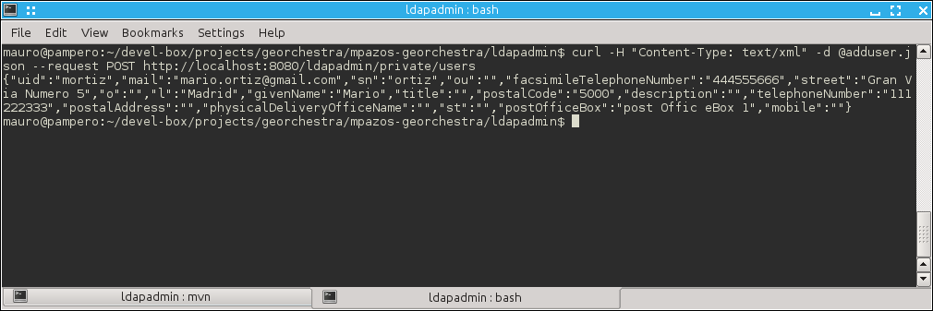

Read the user data

Using the uid: mortiz, execute the following command, to retrieve the user's data created in the previous section.
curl -H "Content-Type: text/xml" --request GET http://localhost:8080/ldapadmin/private/users/mortiz
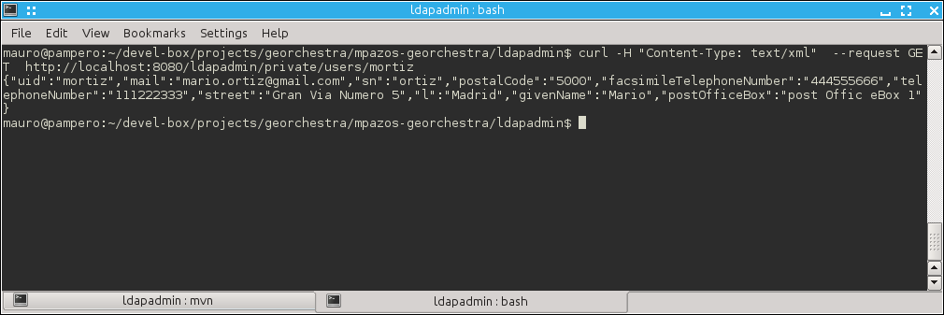

Update the user data
To update mortiz user, create a file updateuser.json
{
"facsimileTelephoneNumber": "12345",
"givenName": "Mario",
"l": "Cordoba",
"mail": "mortiz@gmail.com",
"postOfficeBox": "post Offic eBox 11",
"postalCode": "1000",
"sn": "Ortiz",
"street": "pacifico 50",
"telephoneNumber": "6789"
}

Then, execute the following command:

curl -H "Content-Type: text/xml" -d @updateuser.json --request PUT http://localhost:8080/ldapadmin/private/users/mortiz

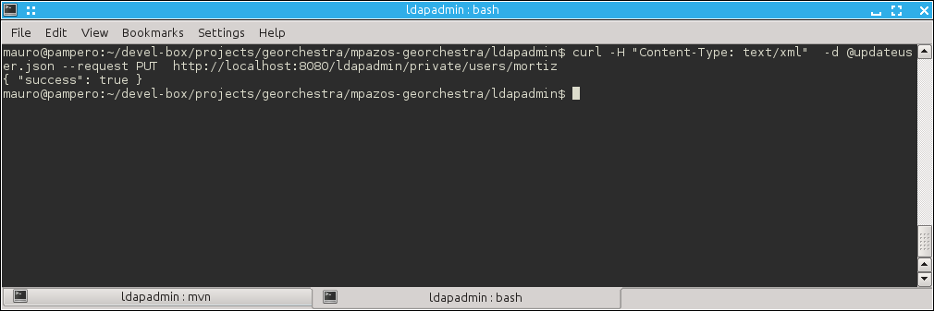
To checks the changes execute the read command as was explained before.

curl -H "Content-Type: text/xml" --request GET http://localhost:8080/ldapadmin/private/users/mortiz

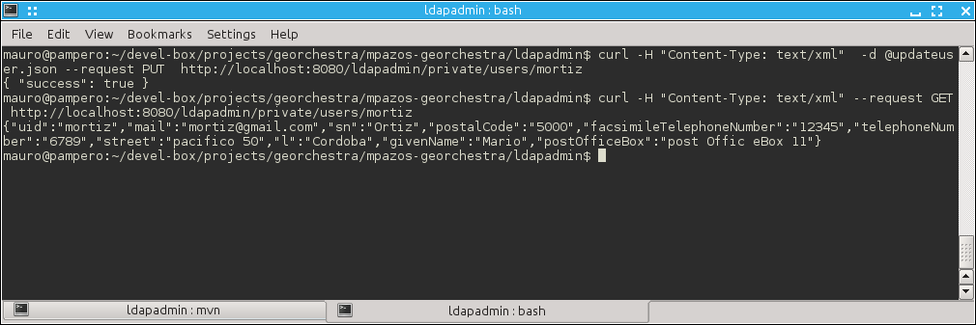

Read the complete user list
curl -H "Content-Type: text/xml" --request GET http://localhost:8080/ldapadmin/private/users

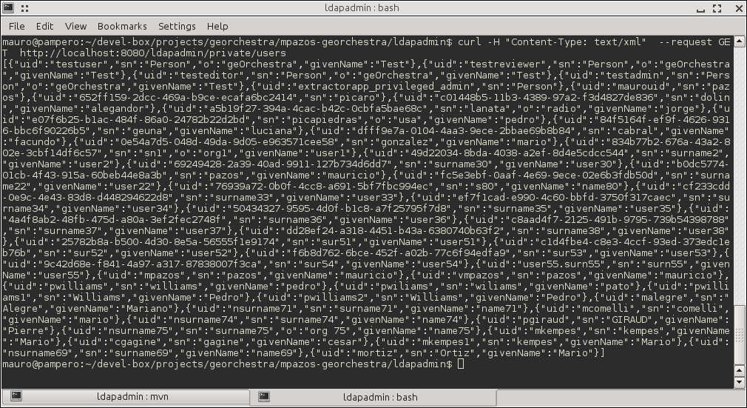

[..,{"uid":"mkempes1","sn":"kempes","givenName":"Mario"},{"uid":"nsurname69","sn":"surname69","givenName":"name69"},{"uid":"mortiz","sn":"Ortiz","givenName":"Mario"}]

As you can see the user created is the last one.

Delete User

To remove mortiz user execute:
curl -H "Content-Type: text/xml" --request DELETE http://localhost:8080/ldapadmin/private/users/mortiz

As is shown in the following screenshot.

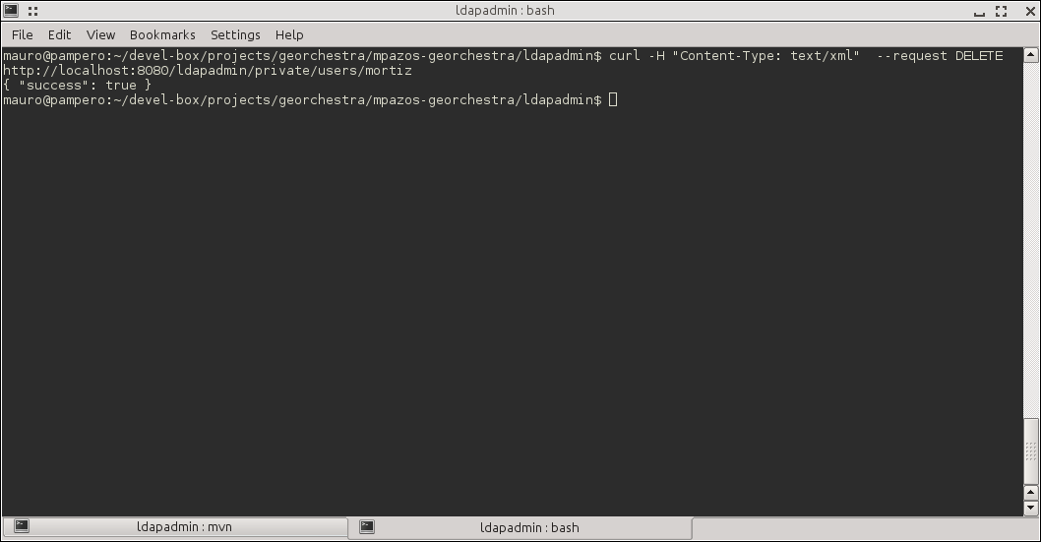
Checks that mortiz is not present in the ldap structure reading the list of users:
curl -H "Content-Type: text/xml" --request GET http://localhost:8080/ldapadmin/private/users

Groups Services

Create Group
Create the file addgroup.json with the following content:
{
"cn": "group40",
"description": "description 40"
}

Now, execute the following command:

curl -H "Content-Type: text/xml" -d @addgroup.json --request POST http://localhost:8080/ldapadmin/private/groups

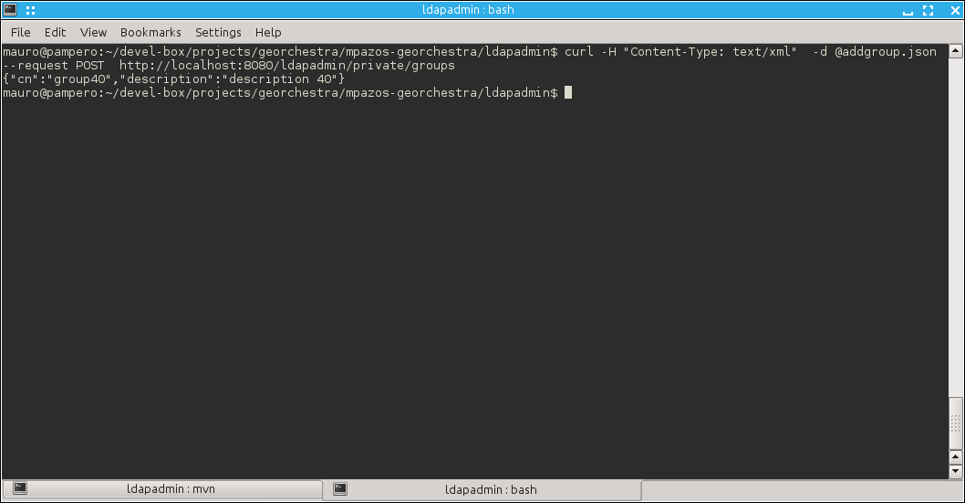

Read Groups
Execute the following command to list the groups present in the LDAP store. You will see the group40 inserted in the last operation.
curl -H "Content-Type: text/xml" --request GET http://localhost:8080/ldapadmin/private/groups

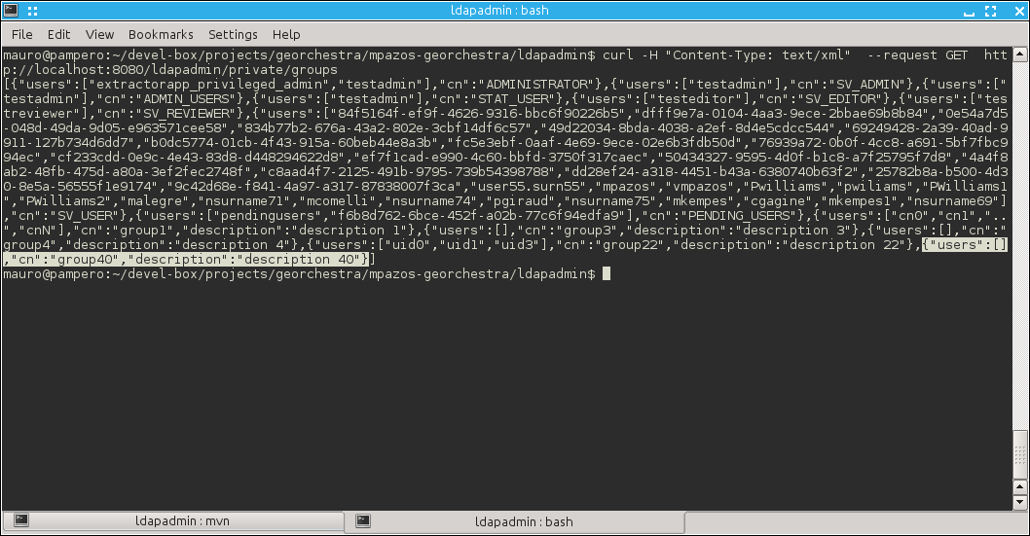

Update Group

To modify the group data, create the file updategroup.json with the following content:
{
"cn": "group44",
"description": "description 44"
}

To update the group40 execute this command:
curl -H "Content-Type: text/xml" -d @updategroup.json --request PUT http://localhost:8080/ldapadmin/private/groups/group40

Then check that the group 40 was changed using the read comand.

curl -H "Content-Type: text/xml" --request GET http://localhost:8080/ldapadmin/private/groups

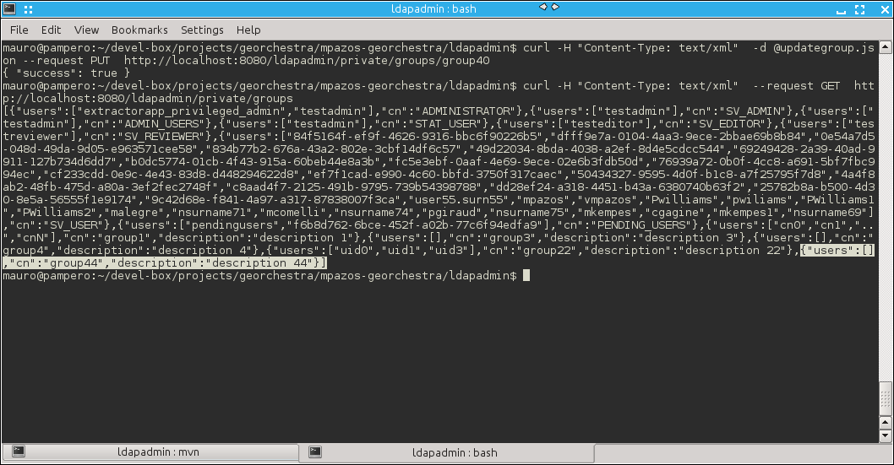

Delete Group
To remove the group44 execute:
curl -H "Content-Type: text/xml" --request DELETE http://localhost:8080/ldapadmin/private/groups/group44
Check the result inspecting the group list.
curl -H "Content-Type: text/xml" --request GET http://localhost:8080/ldapadmin/private/groups

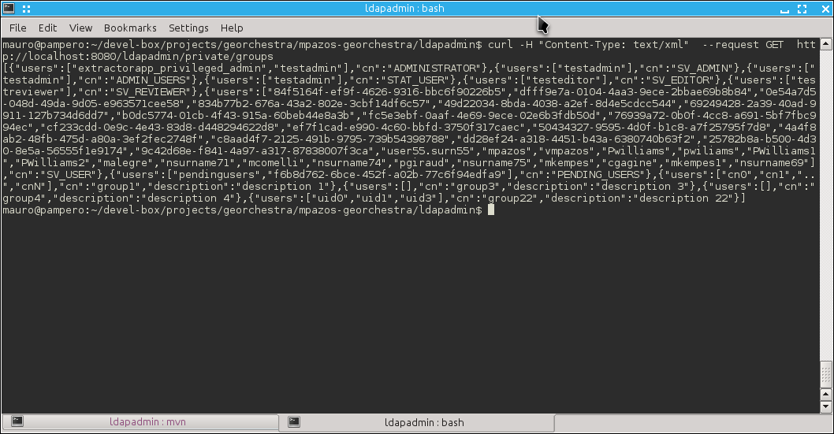

Group of Users

Update group of users
To test this feature I will create the group45 and group46 using the following commands.
As was shown in 4.1, it is needed a couple of file with the group data.
The file group45.json contains
{
"cn": "group45",
"description": "description 45"
}
The file group46.json contains
{
"cn": "group46",
"description": "description 46"
}
Then execute the create commands

curl -H "Content-Type: text/xml" -d @group45.json --request POST http://localhost:8080/ldapadmin/private/groups

curl -H "Content-Type: text/xml" -d @group46.json --request POST http://localhost:8080/ldapadmin/private/groups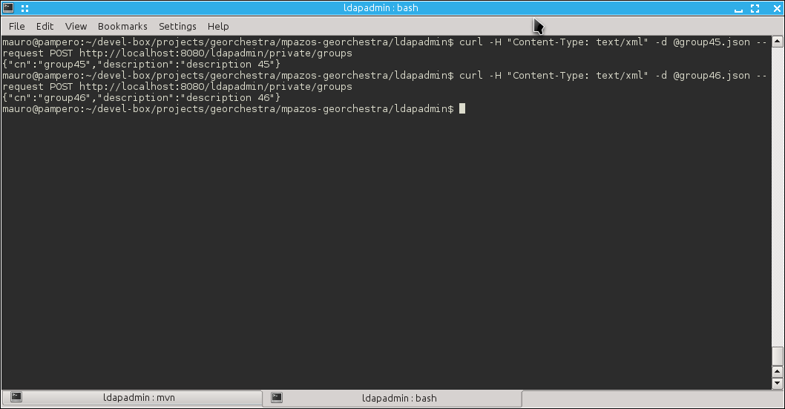

First, we will add some users in the group45. It is necessary to create the file updateuserlist.json file with the content:
{
"users": ["uid0","uid1","uid3"],
"PUT": ["group45"],
"DELETE": []
}

Then execute

curl -H "Content-Type: text/xml" -d @updateuserlist.json --request POST http://localhost:8080/ldapadmin/private/groups_users

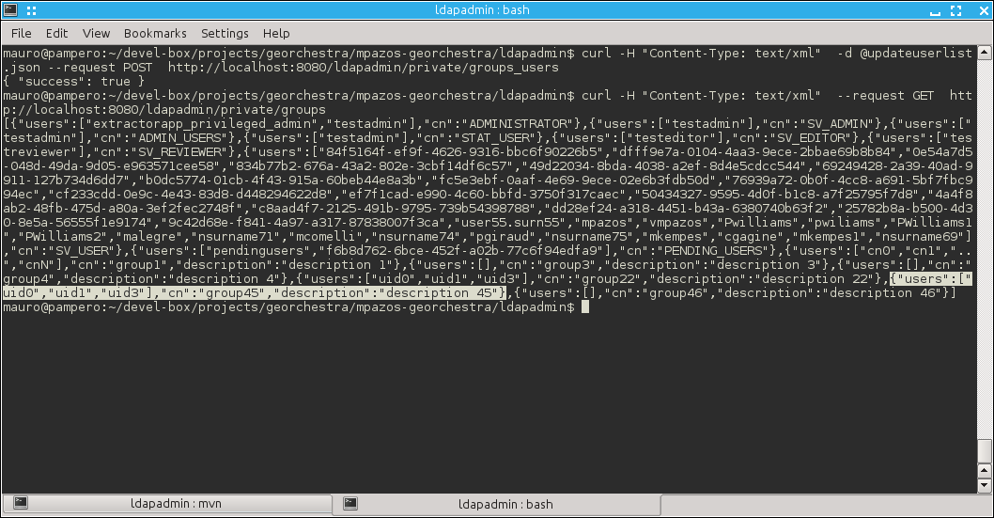
Now, that we have 3 users in the group45 we will delete the uid0 from the group45 and finally we will put it in the group46. To do that, create the following modify the updateuserlist.json file with the following data:

{
"users": ["uid0"],
"PUT": ["group46"],
"DELETE": [group45]
}

The execute the update command as was done previously.

curl -H "Content-Type: text/xml" -d @updateuserlist.json --request POST http://localhost:8080/ldapadmin/private/groups_users

Check the result listing the groups as is shown in the sreenshot.

