This homework consists of three parts, namely, design, project plan, and coding convention.

- Design. The template for design is given (see the following pages).
  - You can find explanations regarding each section in the template
  - The UML tool is required to use. Rational Rose/Architect is available at the public lab.
- Project plan. Microsoft Project is required to use for the project plan.
- Coding Convention. You can choose to compose your own coding convention or use existing coding convention (e.g., Sun has coding convention for Java). No matter which way you go, please submit your coding convention document together with the design document.
  - Coding convention is not merely a document. You should stick to it. At the end of this semester, there will be a student peer code-review session. Keep in mind that all the assignments in this semester are competition-based. The teams will be ranked according their performance. The best team will receive the best grade.
  - The student peer code-review questions are given. Hence, when you start to write code, you know what will be evaluated.
https://docs.microsoft.com/en-us/dotnet/csharp/programming-guide/inside-a-program/coding-conventions
https://source.android.com/setup/contribute/code-style

FourWheelFitbit
Software Design Specification
Version 1.6

Prepared by Geordi Dosher, Jon Hyde, and Jacob Theobald

Revisions
Version | Primary Author(s) | Description of Version | Date Completed
V 1.0 | Jacob Theobald | Sections 1, 2, & 3 | 11/12/18
V 1.1 | Jon Hyde | Section 5 | 11/13/18
V 1.2 | Jacob Theobald | Sequence Diagrams and section 4 | 11/13/18
V 1.3 | George Dosher | Section 6 | 11/13/18
V 1.4 | Jacob Theobald | Refinement of sections 3 and 4 | 11/14/18
V 1.5 | Jon Hyde | Update Section 5, 7 | 11/15/18
V 1.6 | George Dosher | Update Section 5.2, 5.5 | 11/15/18
V 1.7 | Jon Hyde | Update Section 7 | 11/17/18
V 1.8 | Jacob Theobald | Add subsections to section 4 and update sequence diagrams | 11/17/18
Contents
1 Introduction 1
1.1 System Overview 1
1.2 Supporting Materials 1
1.3 Definitions and Acronyms 1
2 Design Considerations 3
2.1 Assumptions 3
2.2 Constraints 3
2.3 Goals and Guidelines 3
3 Architecture 4
3.1 Overview 4
3.2 Strategies 4
3.2.1 Technical Environment 4
3.2.2 Maintainability 4
3.2.3 Performance 4
3.3 Software Specification 5
3.4 Hardware Specification 5
4 System Level Design 6
4.1 Hierarchy Chart Of Components 6
4.1.1 Model 6
4.1.2 View 6
4.1.3 Controller 6
4.1.4 Analysis Layer 7
4.1.5 Android Phone Application 7
4.2 Sequence Diagrams And Descriptions 7
5 Object Level Design 9
5.1 Model – MVC Design Pattern 9
5.1.1 Class Algorithm of Model 10
5.2 View (Website) – MVC Design Pattern 10
5.2.1 Class HomePage 11
5.3 Controller – MVC and Façade Design Pattern 11
5.3.1 Class ApplicationController of Controller 12
5.4 WheelchairMovementAnalyzer – Façade Pattern 13
The WheelchairMovementAnalyzer class is responsible for analyzing the user data received from the ApplicationController class. It takes the DataTable and analyzes it and returns the moving and stationary time along with a breakdown of the times when moving or stationary. 13
5.4.1 Class WheelchairMovementAnalyzer 13
5.5 Android App 13
5.5.1 RecordingActivity – View of MVC 14
5.5.2 ResultsActivity – View of MVC 14
6 User Interface Design 16
6.1 User Interface Design Overview 16
6.2 User Interface Navigation Hierarchy 16
6.2.1 Website User Interface 16
6.2.2 Android App User Interface 17
7 Requirements Traceability Matrix 18
8 Appendices 20

Introduction
The Software Design Specification details the structure and outline of how the software for FourWheelFitbit will be built. The document includes both written details as well as several diagrams to illustrate the design considerations, architecture, system level design, object level design, and user interface design of the software.
The intended audience is developers and other technical stakeholders.

System Overview
The Software Design Specification outlines the systems by which a user of a wheelchair or a client with preformatted data may interact with and upload to the FourWheelFitbit system to analyze accelerometer and gyroscope data. Additionally, it outlines the user interfaces and system constraints.

Supporting Materials
For further information see the Software Design Specification document, as well as the requirements that have been laid out by Dr. Fu for his Software Engineering I course.

Definitions and Acronyms

Term | Description
MVC | Model, View Controller – a widely used design pattern often used for applications involving user interfaces
CSV | Comma or Character Separated Values – a file format type used for tabular data.
API | Application Programming Interface. A set of rules detailing how different software components interact with each other.
.NET | A software development framework developed by Microsoft. The software is primarily used to make websites and apps. Software is written in the C# programming language
.txt | A text file
IDE | Integrated Development Environment – is a software application that provides comprehensive facilities to computer programmers for software development.
OS | Operating System
SDK | Software Development Kit – set of software development tools that allows the creation of applications for a certain software package, framework, hardware platform, computer system, game console, operating system, or similar development platform.
API | Application Programming Interface – a set of methods accessible outside of the program that specifies how the program should interact
HTTP POST | A web transfer protocol method that requests that a web server accepts the data enclosed in the body of the request message

Design Considerations

Assumptions
Assumptions:
User smart phone recording or uploaded data will be from a moving wheelchair and will be a correctly formatted .CSV file.
Dependencies:
The user must have access to one of the following:
- Internet connected Android smartphone capable of recording accelerometer and other sensor data.
- An internet connected device with a browser capable of uploading .CSV files.

Constraints
The user must have internet access. If using a smartphone, the phone must use the Android operating system and be capable of recording sensor data.

Goals and Guidelines
The goal of this system is for ease of use and ease of maintainability. The crux of this is KISS, or Keep It Simple Stupid design philosophy. The software will be based around the common MVC design pattern using well documented .NET API protocols such that the program is straightforward and easy to read.
The user should have no trouble understanding what to do or how to do it within the phone Application or browser-based user interfaces.

Architecture

Overview
The architecture of FourWheelFitbit is based around an N-Tiered MVC design pattern. On the client side, web-based browsers and an Android smart phone application will allow users to upload data for analysis and view the results.
Server side is home to the controller, which presents out web-API to the views, as well as the data model, and the algorithm layer which is responsible for the data analysis.
By using this design pattern as the basis of our architecture, we are allowed great freedom and flexibility to each subsystem with minimal impact to the other systems.

Strategies

Technical Environment
The host and client will require internet access. Phone users will be required to use the Android smartphone operating system.

Maintainability
Due to the use of the MVC design pattern, FourWheelFitbit is an extremely flexible application. The use of web-based APIs allows for any number of changes and expansions to the front-end, such as different smart phone operating systems (iOS) or tablet access through the web.
Additionally, modifications to the analysis algorithm can be made without affecting current front-end clients and users.

Performance
The software should be capable of analyzing and returning data within a reasonable timeframe. Exact figures are difficult to pin down as there a numerous variables, such as internet speed and the size of the data to be analyzed.
A 30mbps internet connection and an input file or string of no more than 4,000 values should be able to be uploaded, analyzed, and returned in under 10 seconds.
Service uptime should be on par with the Microsoft Azure server uptime.

Software Specification
OS: Windows or MacOS capable of supporting Visual Studio and .NETcore projects
IDE: Visual Studio (2015 or newer)
SDK: .NETcore 4.5
Version Control: GitHub

Hardware Specification
- Clients
  - Smartphone with Android operating system
  - PCs, laptops, handheld devices, cell phones
- Servers
  - Microsoft Azure
- Network
  - Standard Internet connection

System Level Design
FourWheelFitbit is based on the MVC or Model-View-Controller design pattern and the Interface design pattern. Additionally we have an Analysis Layer such that this project is n-Tiered (with 4 total tiers). These were selected as each subcomponent of the system fit neatly into these patterns:
Model: The data structure of the recorded wheelchair movement data to be analyzed
View: Web-browser and Android smartphone application
Controller: The controller is also responsible for the Interface portion of the design pattern. It presents the web-APIs available for the views to use.
4th Tier: The algorithm class itself, which is responsible for the analysis of the data model.

Hierarchy Chart Of Components

Model
The model is a DataTable type that is created using the data supplied by the user. The input data is sent through the views (either directly recorded from an Android app or uploaded via web-browser). This class is responsible for creating a data class from the input data suitable to be analyzed.

View
View: The view is comprised of two separate components – the Android Application and the website. The Android view will allow the user to record data, send it to the program, and view the results. The Website will allow the user to upload a .CSV file containing previously recorded data for analysis and view the results.

Controller
Controller: The controller is responsible for the Interface design pattern – it presents an API accessible to views and controls access to the subsystems, namely the model and the algorithm analysis layer. The API accepts HTTP POST calls from the views containing input data and is responsible for delegating the analysis responsibilities to the subsystems and returning the results.

Analysis Layer
Analysis Layer: This subsystem is responsible for analyzing the data model and returning the results to the controller.

Android Phone Application
The views class is supported heavily by an Android application. The application will act as a boundary layer by which a user can record, upload, and view analysis results directly from their Android smartphone.

Other hierarchies were considered, such as combining the Analysis Layer and the Model layer; however this violates the single responsibility principle and would make the code harder to maintain.

Sequence Diagrams And Descriptions

Sequence diagram for a web browser user:

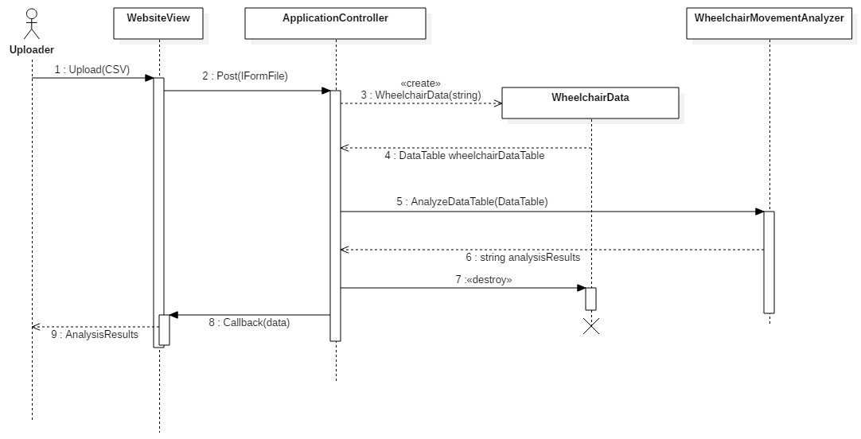

Sequence diagram for a phone application user:

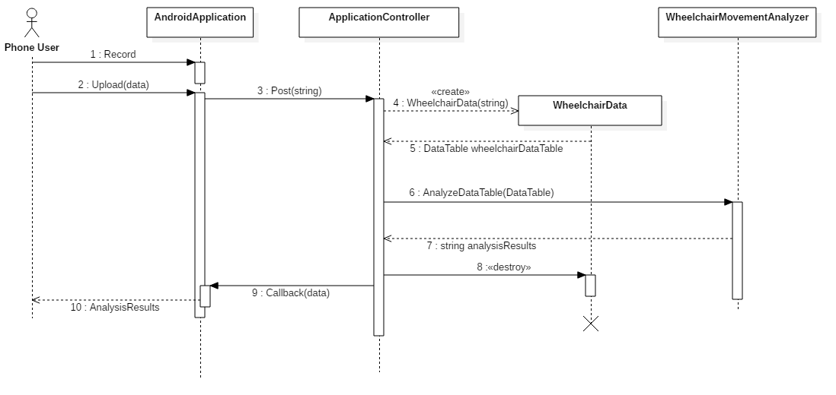

Object Level Design

Model – MVC Design Pattern
The MVC design pattern is an architectural design pattern. It divides the application into three interconnected parts the Model, View, & Controller. The model is the central component that directly manages data and logic of the application. The model package is responsible for the data of the application. It receives user input from the controller. The model contains the class responsible for analyzing the data uploaded by the user. The WheelchairData class is the Model in the MVC design pattern.
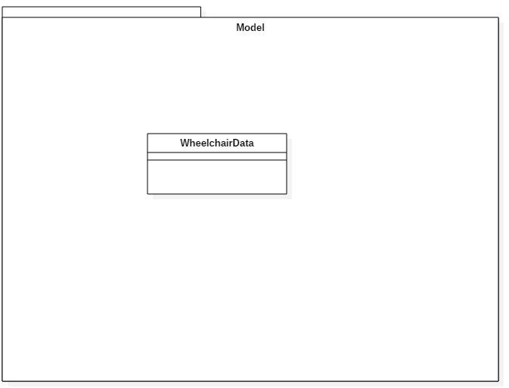

Class Algorithm of Model
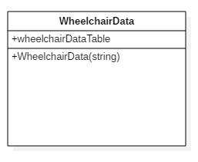

- The WheelchairData class is responsible for processing the input from the ApplicationController and formatting it in a DataTable.

View (Website) – MVC Design Pattern
The view component of MVC design pattern handles the visual representation of the data contained within model. The view contains the class that are responsible for displaying information to the user of the website. The HomePage class acts as the View in the MVC design pattern.
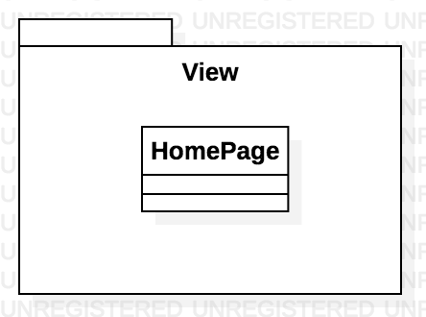

Class HomePage
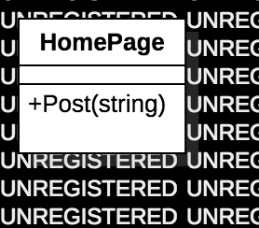
The HomePage is what gets data from the user and displays the data output from our algorithm. It’s not a class per se, but it is a html page with JavaScript code handling the sending/receiving logic. The page’s functionality comes from a post method which sends the data from the .csv file to the backend to be processed by the controller. The analyzed data will then be returned to this method to be displayed on the screen.

Controller – MVC and Façade Design Pattern
The controller of the MVC design pattern acts on both the model and view to control the data flow and keep view and model separate. The controller is responsible for handling user input, it takes input from the user and passes it along to the model to be formatted, once formatted it passes the data to the WheelchairMovementAnalysis class to be analyzed. It contains classes that process input from the user’s mouse or touchscreen. The ApplicationConroller class is a sub class of the built in Controller class of ASPNetCore framework. The ApplicationController class acts as the Façade in the Façade design pattern and the Controller in the MVC design pattern. The façade design pattern is a structural design pattern that hides the internal complexity from the client. The client sees one simple interface which takes input from the client and delegates it to the various sub-systems.
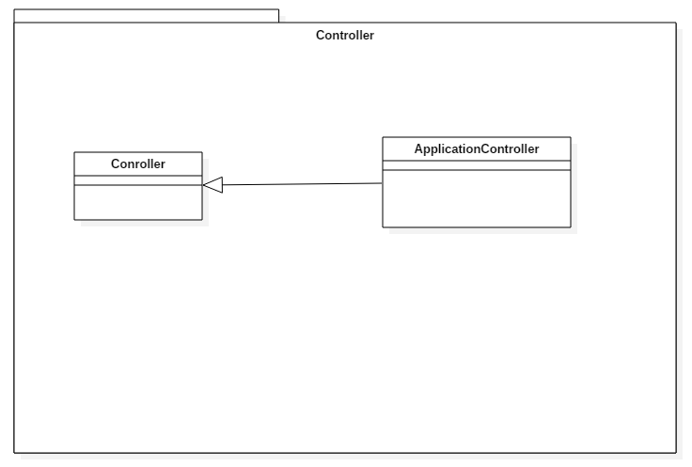

Class ApplicationController of Controller
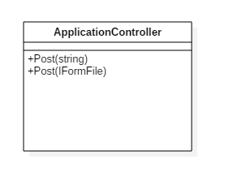

- The ApplicationController extends the .NET web api base controller class
- The ApplicationController class is responsible for allowing web and app users to upload data for it to be analyzed.
- The ApplicationController class interacts with the WheelchairData class in Model and the WheelchairMovementAnalyzer class.

WheelchairMovementAnalyzer – Façade Pattern

The WheelchairMovementAnalyzer class is responsible for analyzing the user data received from the ApplicationController class. It takes the DataTable and analyzes it and returns the moving and stationary time along with a breakdown of the times when moving or stationary.

Class WheelchairMovementAnalyzer
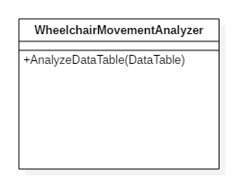
- The WheelchairMovementAnalyzer class is responsible for analyzing the user data to provide a summary of time spent moving, stationary, and breakdown of the times in motion and stationary.

Android App
The Android app has two main classes to control its functionality. Each class is its own screen. In the Android system, a screen is called an Activity. The RecordingActivity holds the logic and UI for recording sensor data and uploading it to the server. The ResultsActivity receives the data from the web service and displays the statistics to the user.
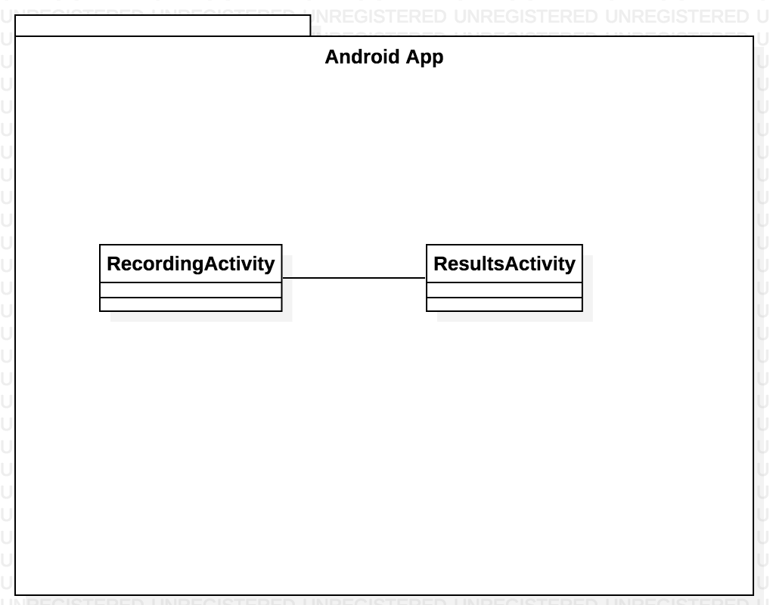

RecordingActivity – View of MVC
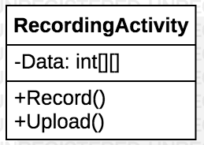
The RecordingActivty is the main screen of the Android app and contains most of the functionality. If has two main responsibilities: recording data from the accelerometer and clock, and then uploading that data to the server to be processed. When it receives that data, this activity will start a ResultsActivity to view the data.

ResultsActivity – View of MVC
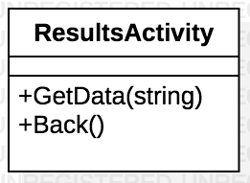
The ResultsActivity has one job, and that is to display the results returned from the web service. The RecordingActivity will pass it the data using the GetData(string) function, passing it json data as a string. The ResultsActivity will then decode the data and display it on the screen. There is also a back button, allowing the user the ability to go back to recording mode.

User Interface Design

User Interface Design Overview
FourWheelFitBit has two different user interfaces. You can use the app both on the computer with a web browser like Google Chrome or with an Android phone using our app. Both the web and phone interface allow the uploading of wheelchair sensor data and the viewing of the analysis results. The phone adds the additional functionality of being able to record the data to be uploaded.

User Interface Navigation Hierarchy

Website User Interface
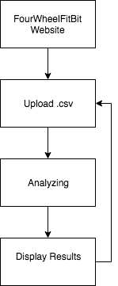
The user interface for the website is fairly straightforward. The starting page gives the user the ability to upload a .csv file. After the user has uploaded the file, the page display1s an animation telling the user the data is currently being analyzed. After the results have been returned, they will be displayed on the screen. The user will also have the option to upload a new .csv file to be analyzed.

Android App User Interface
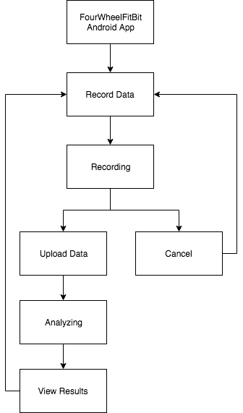

The user interface for the phone app has a few more features, as users are able to both record data and view analysis results. When first opening the app, the user will have one available action: record. When the user presses the record button, the phone will start to record sensor data and the phone screen will indicate that recording is taking place and give the user the option to stop recording. When the recording is stopped, the user can either cancel and discard the information (taking him back to the initial screen), or he can upload the results to be analyzed. If he selects to have the results analyzed a screen will appear notifying him that analysis is taking place while the data is being uploaded, analyzed, and downloaded to the phone. Once this process is completed, the results will be displayed on the phone and the user will have the option to record again.

Requirements Traceability Matrix
The Requirements Traceability Matrix indicates traceability from the software requirements document to the design elements documented.
Requirements Traceability Matrix
 | DS1 | DS2 | DS3 | DS4 | DS5 | DS6 | DS7
FR1 |  |  |  |  | X
FR2 |  |  |  |  |  |  | X
FR3 |  |  |  |  | X
FR4 |  |  |  | X
FR5 |  | X
FR6 | X
FR7 |  |  | X

Functional Requirements
Value | Functional Requirement
FR1 | Phone - Record smartphone sensor data
FR2 | Phone - Upload data to analysis tool
FR3 | Phone - Save sensor data
FR4 | Phone - View analysis results
FR5 | Phone – Convert data to CSV
FR6 | Website - Upload CSV Data
FR7 | Print to screen mobility analysis results

Design Specifications
Value | Function | Class
DS1 | Post(IFormFile file) | ApplicationController
DS2 | Post(string inputData) | ApplicationController
DS3 | Post(IFormFile file) | ApplicationController
DS4 | GetData(string results) | ResultsActivity
DS5 | Record() | RecordingActivity
DS7 | Upload() | RecordingActivity

Appendices
.

