What Causes these Phenomena?

A lightning strike:

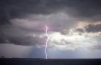 | 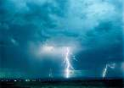 | 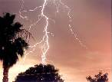
Q1: What is lightning?
Q2: What causes lightning?

Sticking a balloon to a wall:

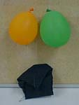 | 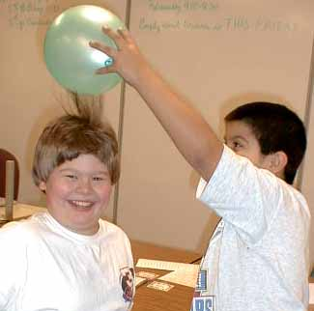 | 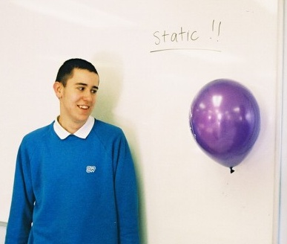
Q3: How can you stick a balloon to a wall?
Q4: Why does it stay there?

The Van der Graaf Generator:

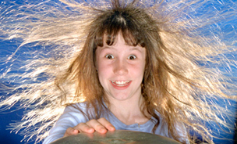 | 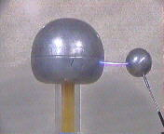 | 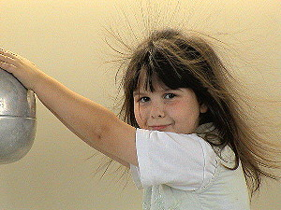

Q5: Why do the girls’ hair stand all on end?
Q6: What is the line connecting the two hemispheres in the picture in the centre?

