Uses and Dangers of Static Electricity
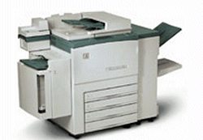
Question One:
The picture shows a photocopier.

Explain how the photocopier works by matching the statements P, Q, R or S from the list with each of the boxes 1 – 4 in the flow diagram.
P an image of the original is projected onto the plate
Q black powder is transferred from plate to paper
R the copy plate is electrically charged
S the parts which are still charged attracted black powder
1
2
light falls on the plate and some electric charge leaks away
3
4
[4]
Question Two:
Explain the following.
- If you walk on a nylon carpet and then touch a metal radiator you may get a shock.
.........................................................................................................................................................................................[2]
- Getting out of a car seat can give you a shock.
.........................................................................................................................................................................................[2]
- Taking off a pullover can produce lots of crackles and tiny sparks.
.........................................................................................................................................................................................[2]
Question Three:
In hot weather, a car on the move becomes charged unless it is fitted with a conducting strip trailing from its chassis.
- Why does the conducting strip need to touch the ground?
........................................................................................................................................................................................................................................................................................[1]
- Without a conducting strip fitted, anyone touching the car would receive an electric shock. Why?
........................................................................................................................................................................................................................................................................................[1]
- Why is a car fitted with a conducting strip unlikely to become charged when it is raining?
........................................................................................................................................................................................................................................................................................[2]
Question Four:
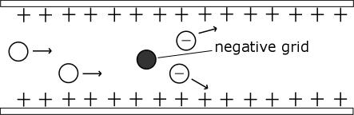
Dust extractor in power station chimneys are very effective at stopping ash being carried by flue gases into the atmosphere. The flue gases are passed through a negatively charged wire grid. The grid is fixed inside an earthed metal tube. Particles of ash passing through the grid become negatively charged from the grid. The diagram shows the idea.

Why are the particles attracted to the metal tube?
........................................................................................................................................................................................................................................................................................[2]

