Static Electricity

Question One:
A cloth is used to rub a thin polythene strip. This makes the polythene negatively charged. The same cloth is held near to the strip. Which two of these statements are correct?
- the strip lost positive electrons when it was rubbed
- the strip gained negative electrons when rubbed
- the cloth repels the strip
- the cloth gains electrons when it rubs the strip
- the cloth has become positively charged

Question Two:
The diagram shows two charged plastic strips held close together.
Which two following statements are true?

- the strips attract each other
- the strips repel each other
- when one strip is turned the other way round, the strips will attract each other
- when one strip is turned the other way round, the strips will repel each other
- when both strips are turned the other way round, the strips will attract each other

Question Three:
The diagram shows two metal balls, P and Q, hanging from the nylon threads. P is repelled by and Q is attracted to a negatively charged rod.

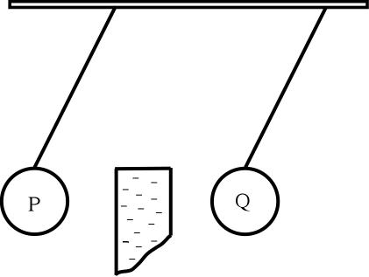
Which two statements are true?
- P is negatively charged
- P is positively charged
- P is uncharged
- Q is negatively charged
- Q is positively charged

Question Four:
A plastic ruler is rubbed on a duster. The ruler becomes negatively charged.
Which two statements are true?
- the duster has also become negatively charged
- the duster had gained electrons
- the duster has lost electrons
- the ruler has gained electrons
- the ruler has lost electrons
Question Five:
When an aircraft lands it is often electrically charged.

4.1 How has the aircraft become electrically charged?
- By exposure to strong sunlight above the clouds
- By friction with the air
- By leakage of charge from the aircrafts instruments
- By the radio waves used to contact Air Traffic Control

4.2 The charge on the aircraft can be large, why is this dangerous?
- A spark from the charged aircraft could cause and explosion while refuelling
- Dust from the runway could be attracted to the aircraft
- Radio contact with the ground staff could become difficult
- The passengers could get an electric shock

4.3 When the aircraft has landed it has to be electrically discharged. What is the safest way to do this?
- Invite passengers to leave the aircraft by means of a metal slide
- Keep the aircraft stationary on the runway for 10 minutes
- Open the aircraft doors
- Use a cable to attach the aircraft to a copper rob buried in the ground

4.4 Static electric charges can be useful as well as causing problems. Which of these devices make use of electrostatic charges?
- A circuit breaker
- An electric motor
- A filament lamp
- A smoke precipitator

Question Six:
A Van de Graaf machine is used to produce very high voltages. When the machine is switched on a charge collects on the dome.


5.1 A girl stands on a thick plastic block and she touches the dome. When the machine is switched on her hairs stand on end.
Her hairs stand on end because…
- each hair has the same charge, that is the same as the charge on her head.
- each hair has the same charge that is opposite to the charge on her head.
- the hairs have opposite charges to each other.
- the hairs are charged by her head has no charge.

5.2 Why must the girl stand on the plastic block?
- So that the charge on the dome does not become to great
- To stop both her head and the dome from discharging
- Plastic is a good conductor of static electricity
- So that her voltage does not become to great

5.3 A strip of paper is held close to the charged dome. The strip is attracted to the dome.
What can you say about the strip of paper?
- It might have the same charge as the dome or it might be neutral
- It might have the opposite charge to the dome or it might be neutral
- It has the same charge as the dome
- It has the opposite charge to the dome

5.4 The charge on the dome is positive. The dome can be discharged by connecting it to earth.
Which of these happens as the dome is discharging?
- Positive charges flow from the dome to the earth
- Positive charges flow from the earth to the dome
- Negative charges flow from the dome to the earth
- Negative charges flow from the earth to the dome

