**IACA 2019: Application of Social Network Analysis**

Philadelphia Police Department; George Kikuchi ([george.kikuchi@phila.gov](mailto:george.kikuchi@phila.gov)

**Sample web app;** this website shows an example app that we will build. Try searching for some random person IDs (all numeric) and click Update Chart. <https://bit.ly/2L6fKzh> or <https://george-kikuchi.shinyapps.io/sna_sample_app/>

**Using your own data…**

Notably, the app and data stays within your agency’s network (**none of your data go to the Internet**). There are data specs towards the end of the tutorial.

**Using the app**

This process will include initial setups of installing R, RStudio, and associated libraries, in addition to running the app. If you already have R 3.6.1 version and RStudio installed, you can skip to Step 3.

1. Install R (can be skipped if you already have R 3.6.1)

* Go to <https://cran.r-project.org/> , select Download R for Windows (or whatever is your OS), and click “install R for the first time”

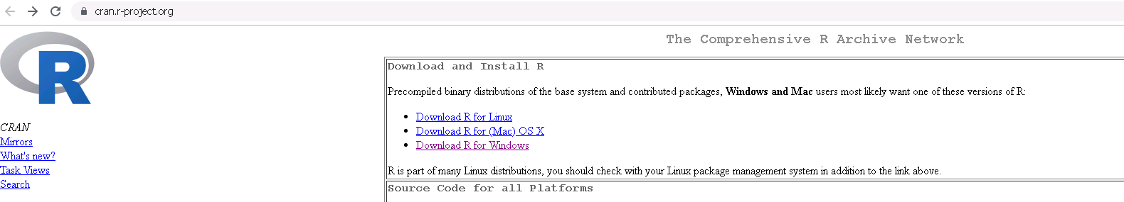 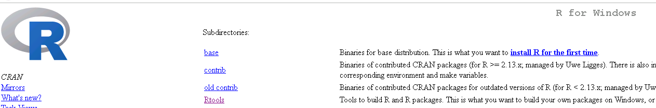

* Accepting all the default settings during the installation process is typically fine

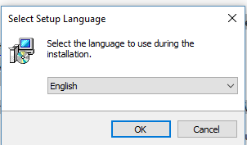 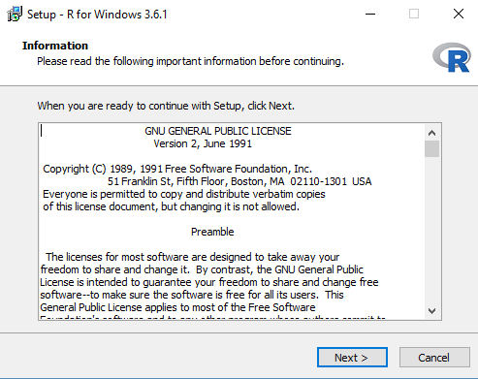 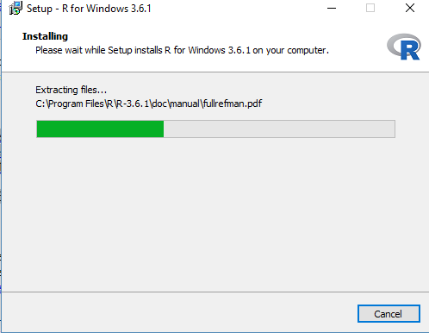 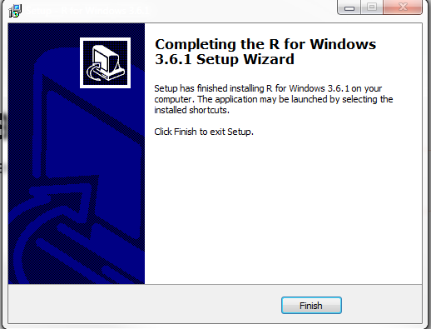

1. Once R finishes installation, install RStudio (can be skipped if you already have RStudio)
   * Go to <https://rstudio.com/products/rstudio/download/#download> and click the latest version of RStudio installer for your OS (e.g., Windows 10/8/7/ 64-bit)
     + if you are on a 32 bit system, you will likely have to use an older version of RStudio (not tested for this app)
   * Accepting all the default settings during the installation process is typically fine

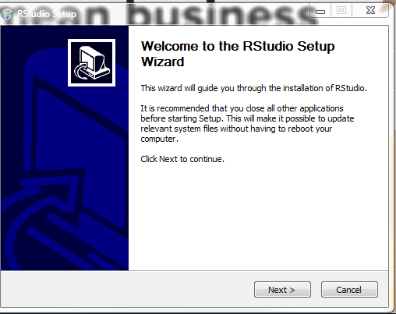 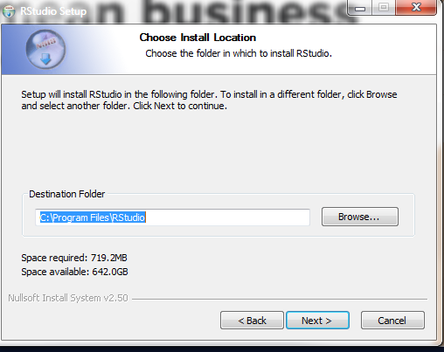 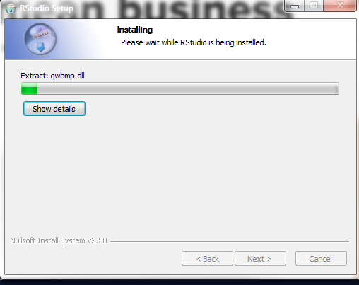 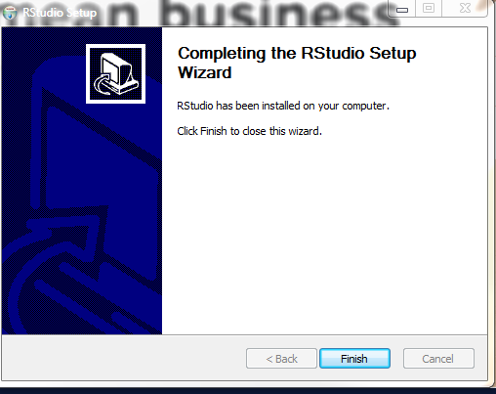

1. Once the installation of both R and RStudio is complete, go to your desktop and **iaca_sna** 🡪 sna_Excel_upload 🡪 and double-click  **sna_Excel_upload.Rproj**
2. There are 3-4 panels inside of RStudio. One of the panels (**most likely the right bottom one**) shows a list of files inside of the sna_Excel_upload folder. Click **_RunThisOnceForWorkshop.R**

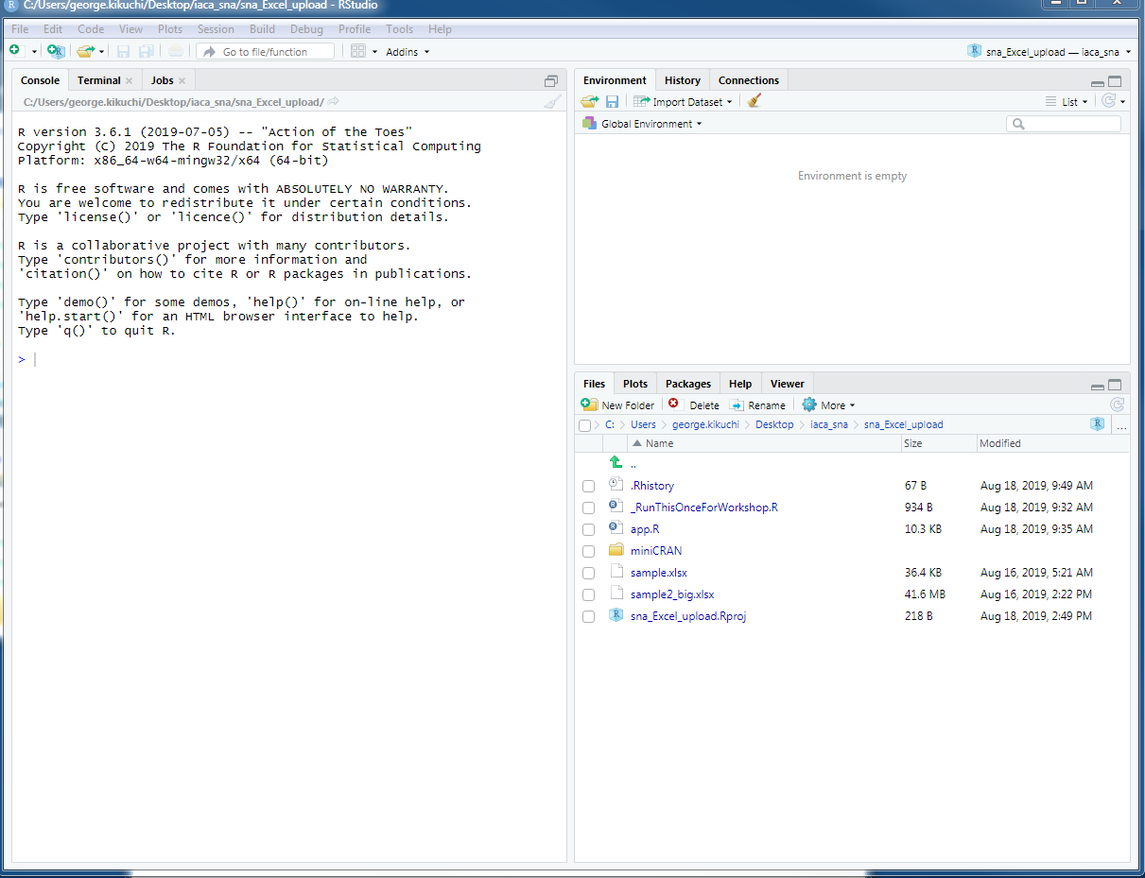

1. Once **_RunThisOnceForWorkshop.R** is opened (most likely in the top left panel), highlight all lines of this code and click **Run** towards the top right of this panel.

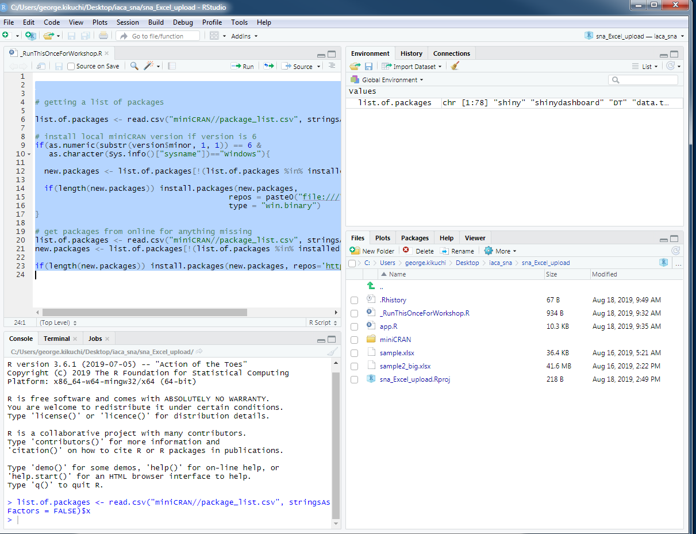

1. Depending on your right to your machine, you may be asked about using a personal library. if you see a message like this, click Yes.

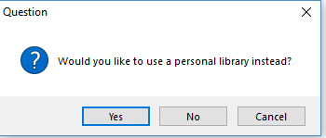

1. Most of the libraries should be fairly quick to install as they are saved in the USB folder. However, there can still be some libraries that will have to be installed from the Internet. Be patient in this process; these libraries just need to be installed once.

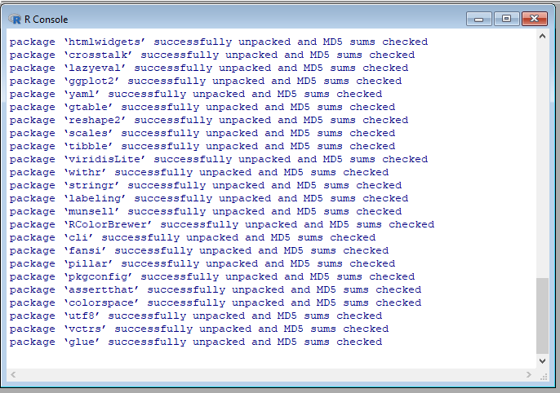

1. Once the installation of libraries is finished, click **app.R** from the list of files panel (most likely bottom left)

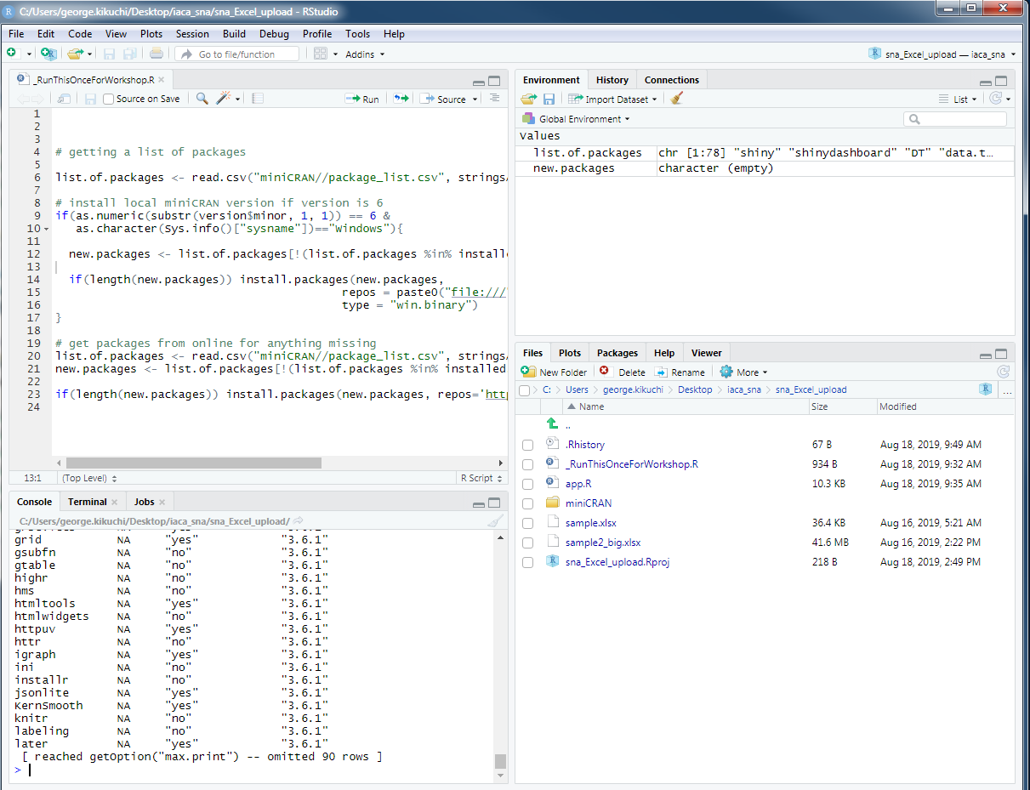

1. Once you have opened app.R, click the **Run App** button (top right of the script panel)

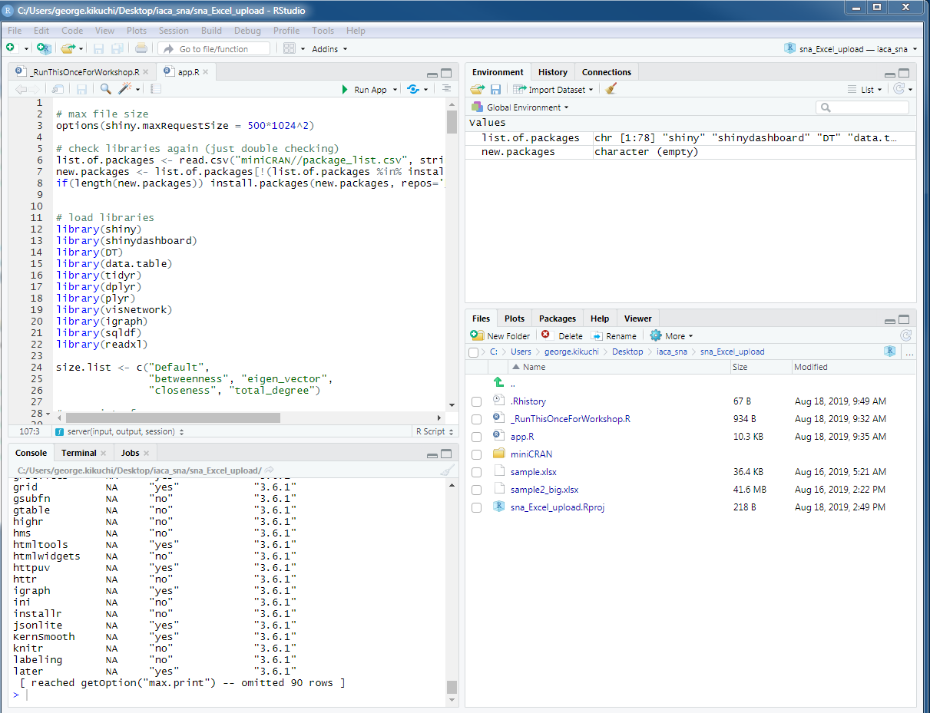

1. A browser such as Chrome (or RStudio browser) should open, with a pop-up menu asking for an Excel file. If you see an RStudio browser and wish to change to your default browser, you can click Open in Browser button too.

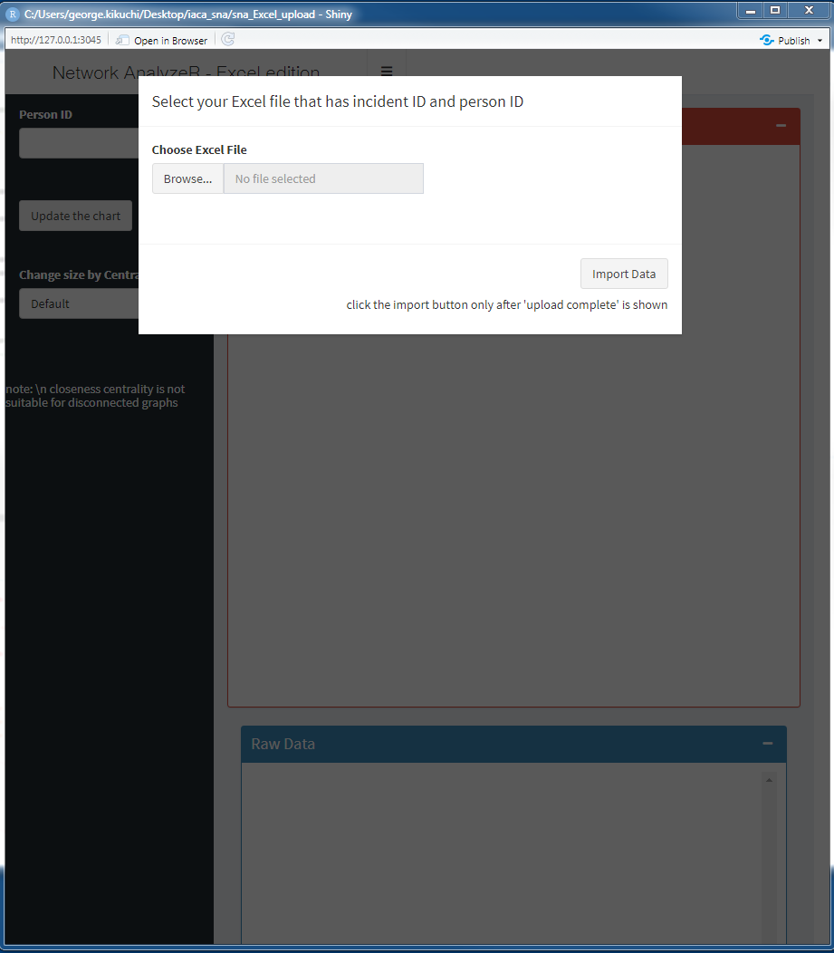

1. Click “**Browse**” and select **sample.xlsx** from **iaca_sna** (USB) folder 🡪 **sna_Excel_upload** folder on your desktop.
2. 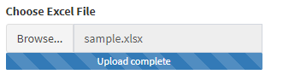Click Import Data (**wait till** the blue progress bar shows **Upload Complete**)
3. Type a **person ID** in the search box (this may be a bit slow for a big data; be patient). Click **Update the chart**.

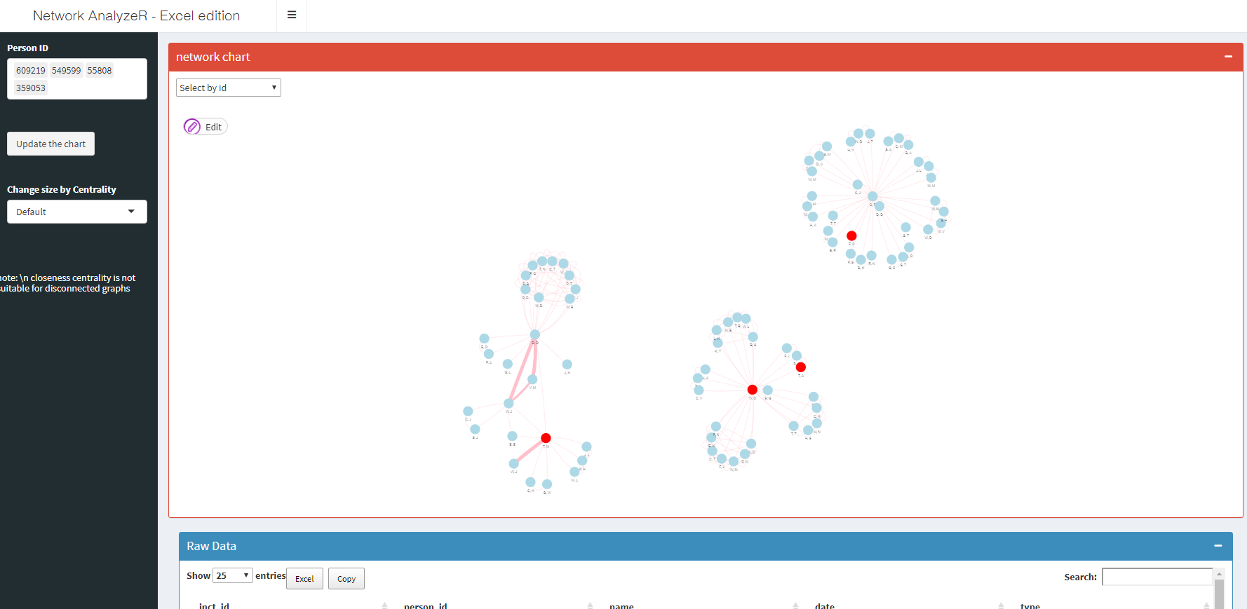

1. When using your own data (e.g., arrest record data dump from your agency’s RMS), you will need to format the Excel table as follows. Column names need to be exactly like these; **inct_id, person_id, name, date, type**. You can include more columns, but these are the required columns. A future version of this app script may introduce more flexibility, but these are the required input fields at least at the moment.

