**73%**

**Complete the following test. You may use your textbook, labs, and lecture notes. All code submitted must be your original work. Code must be committed and pushed to your GitHub repository to receive credit. Share your GitHub with your instructor.**

**HOT3**

For this test, you will continue working with the Sales Order database application. You can choose to build on top of HOT2 or start from scratch.

Create or Update the SalesOrders database to include the following three tables:

* A Products table (Seed data can be found in the “new” 05-SOProductsUpdated.SQL file with 40 products). **4pts**
  + Update the original seed data that contained 5 products to the new seed data with 40 products.
* A Categories table – same data from the previous test - **4pts**
* A (new) Customers table – Seed data provided in the attached 02-SOCustomers.SQL file -**4pts**
  + Currently no relationship to Products or Categories
* Add a new Area to the site. Create an Admin area to allow Update/Delete/Edit functionality on all 3 database tables. This functionality should only be found under the Admin URLs. The default URLs (non admin) should only be able to List the 3 tables worth of data. - **10pts**
* The nav bar provides links to the various URLs of the site – **4pts**
* Use attribute routing to shorten some of the URLs - **9pts -2pts**
  + Request URL Controller/Action

=====================================================

* + - / Product/Index
    - /products Product/List
    - /product/{id} Product/Details/id
    - /categories Category/List
    - /customers Customer/List
* Using the products table, include the following website features:
  + Show all Products. **5pts**
  + Show an individual product (including image). **5pts**
  + New Products can be added. **5pts**
  + Existing Products can be updated. **5pts**
  + Existing Products can be deleted. **5pts**

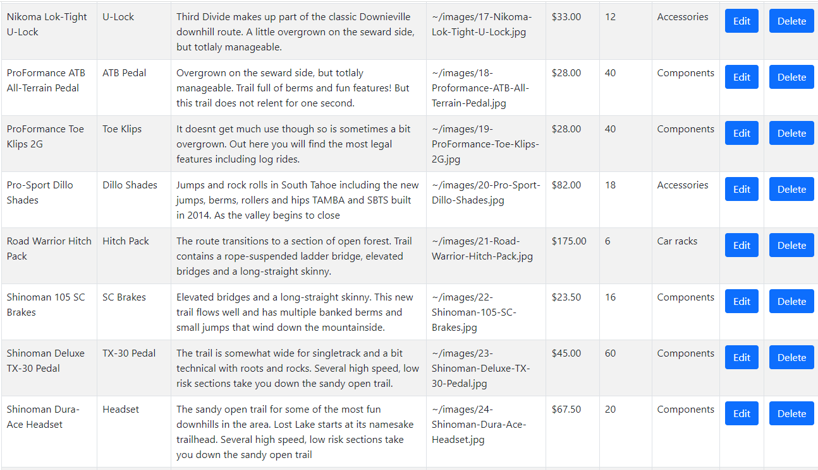

**Portion of Products List**

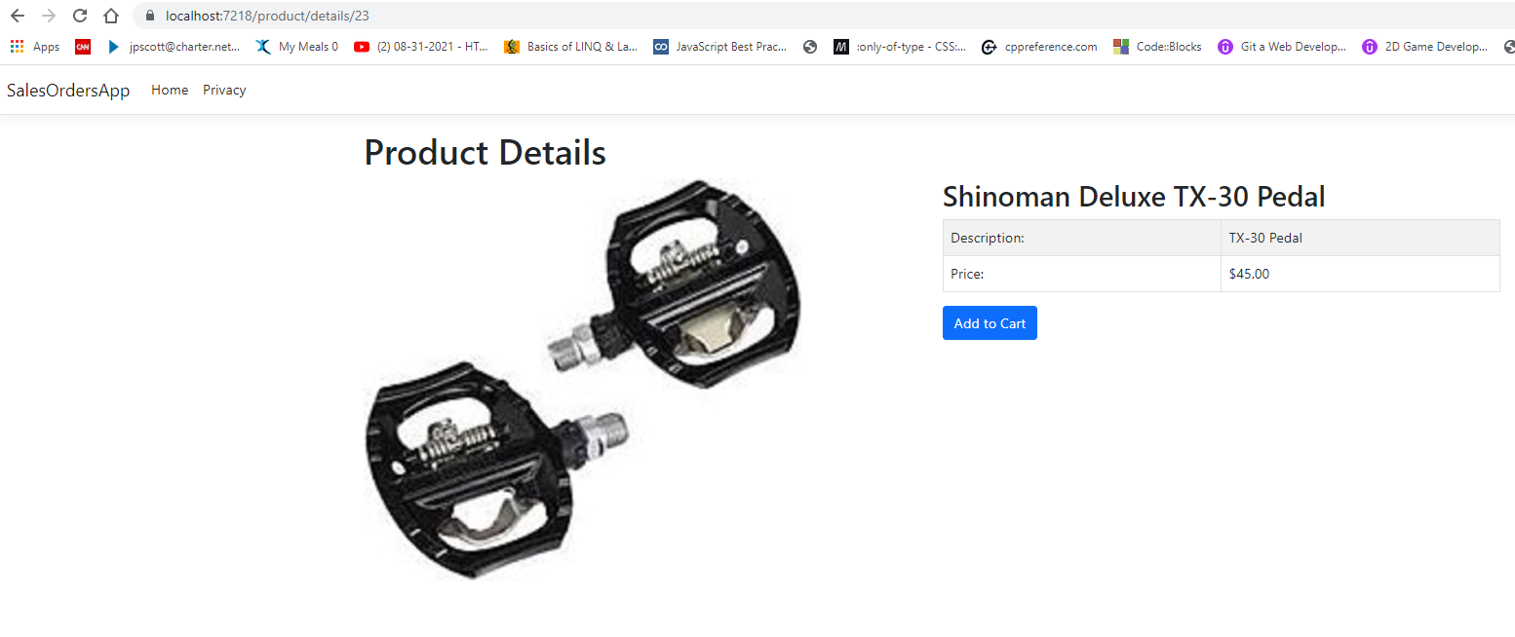

**Product DETAILS SCREEN Example**

* Using the categories table, include the following website features:
  + Show all Categories. **5 points.**
  + New Categories can be added. **5 points.**
  + Existing Categories can be updated. This may have Products table conflicts. **5 points.**
  + Existing Categories can be deleted. This may have Products table conflicts. **5 points.**

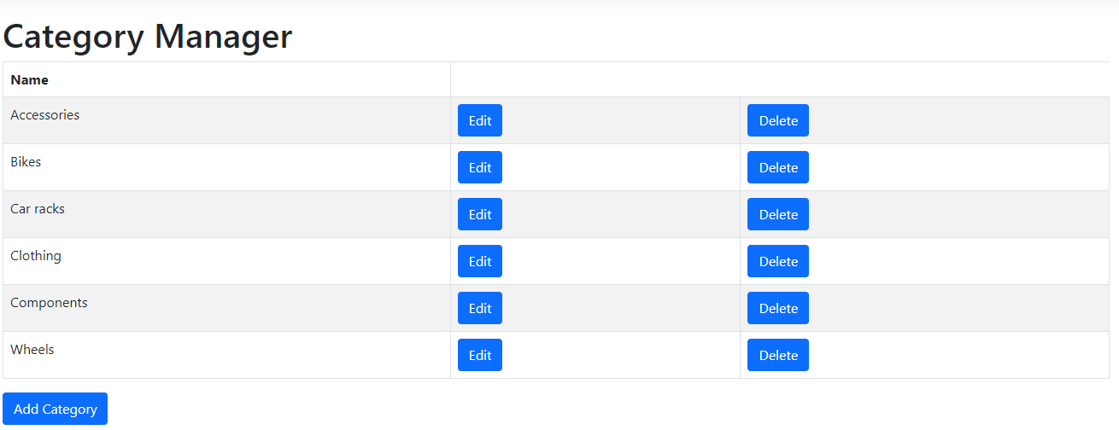

**Category START SCREEN**

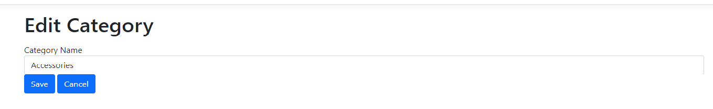

**Category EDIT SCREEN**

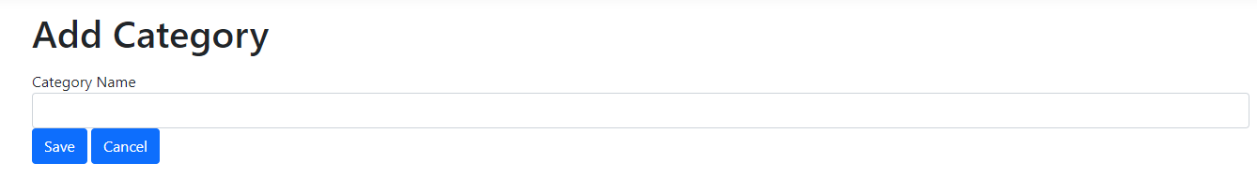

**Category ADD SCREEN**

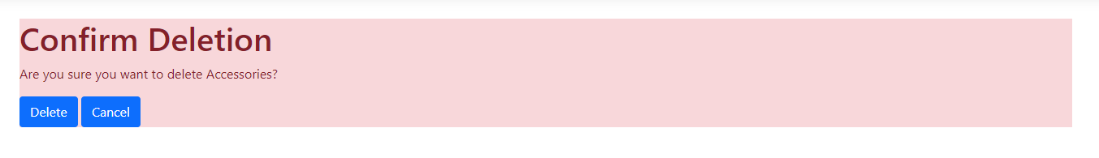

**Category DELETE SCREEN**

* Using the customers table, include the following website features:
  + Show all Customers. **5 points.**
  + New Customers can be added. **5 points.**
  + Existing Customers can be updated. **5 points.**
  + Existing Customers can be deleted. **5 points.**

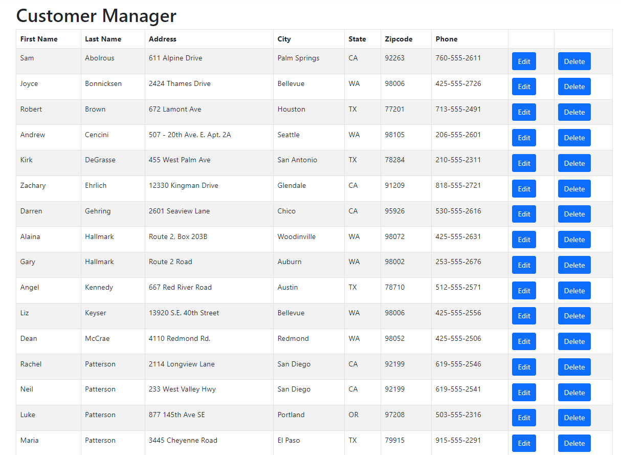

**Portion of Customers START SCREEN**

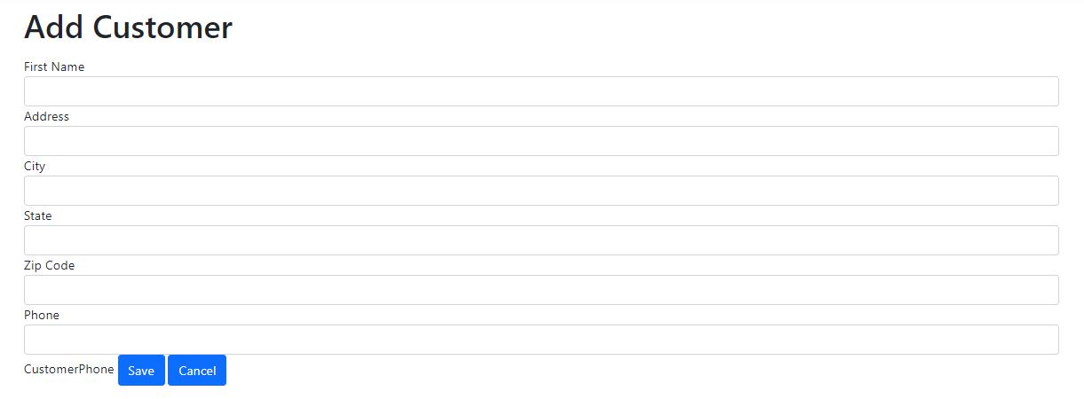

**Customers ADD SCREEN**

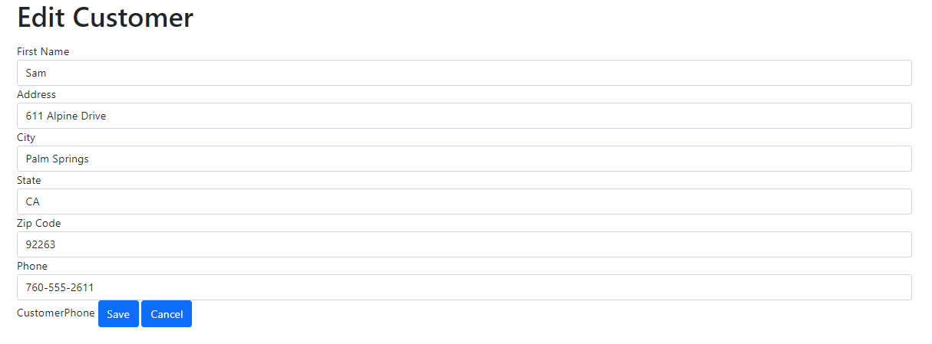

**Customers EDIT SCREEN**

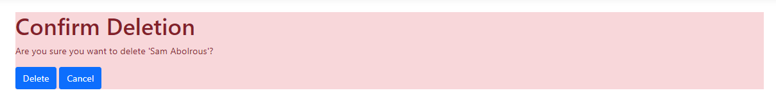

**Customers DELETE SCREEN**