Assignment 8.1

1) When to use (Rapid Application Development) RAD model. When not to use (Rapid Application Development) RAD model

RAD is used:

- Whenever a system can be modularised to be delivered in incremental manner.
- If there is high availabilty of designers for modeling.
- If the budget permits the use of automated code generating tools.
- If there are domain experts available for relevant business knowledge.
- Where the requirements change during the course of project and working prototypes are presented in small iterations of 2-3 months.

RAD is not used
- When project duration for development is longer.
- When there is no highly skilled designers and domain experts
- When the budget for a project is small.

2) Define an ER diagram of a software Organization with all the relationship model that was discussed in the classroom
Age
E.ID
LName
DName
Sex
D.ID
Location
FName

Salary
workfor
EMPLOYEE
DEPARTMENT

workon

controls

Request for

CLIENT
PROJECT

P.ID
Location
Address
C.ID
PName
Phone
Name

3) Describe the Entity Relationships for the following diagram

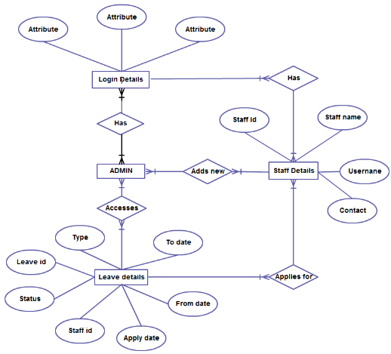

Above diagram have 4 entities:
- Leave details
- admin
- staff details
- login details

the above ER diagram describes:

LOGIN DETAILS:
- each staff and admin has their own login details
- one or more admin can login using their own login details into admin details
- one or more staff can login using their own login details into staff details

STAFF

- staff id is the primary key
- each staff have staff name, username, contact, staff id
- one or more staff can apply to one leave detail

ADMIN

- Each admin has access to leave details
- one or more admin has access to one leave details
- admin have many to many relation to other entities
- each admin can add new staff

LEAVE DETAILS
- it has following attributes: type, to date, apply date, status, staff id, leave id, apply date
- admin has access to leave details

