**Modelling Logic**

**BY**

**MAN FU LEI**

# Modelling Logic with Structure English

The modelling logic is drawn according to level-1 diagram:

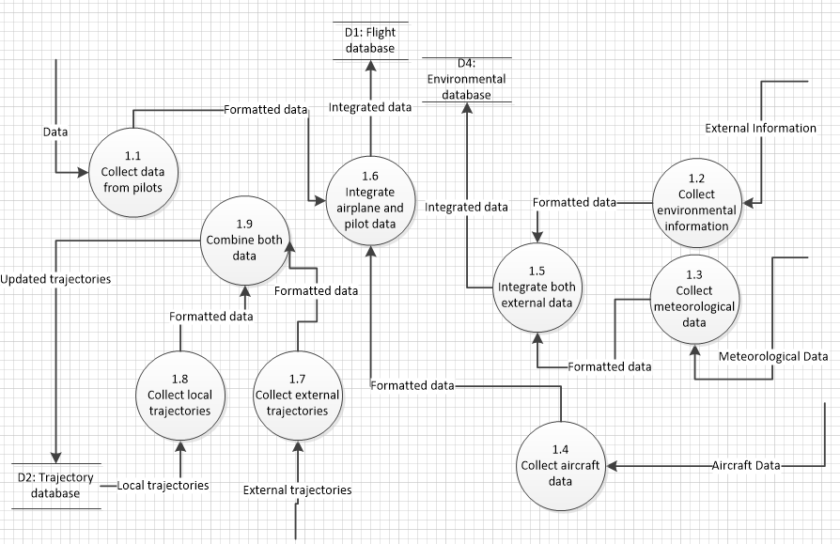

This is like the following table:

|  |
| --- |
| Process 1.1: Collect Data from Pilots  DO  READ next Input-from-pilot  STORE Input-from-pilot into register%r1  COPY register%r1 to register%r2  ADD 1 to Number-of-input  UNTIL End-of-input |
| Process 1.2: Collect Environmental Information  DO  READ next Input-from-devices  STORE Input-from-devices into register%r3  COPY register%r3 to register%r4  ADD 1 to Number-of-input  UNTIL End-of-input |
| Process 1.3: Collect Meteorological Data  DO  READ next Input-from-sensor  STORE Input-from-sensor into register%r5  COPY register%r5 to register%r6  ADD 1 to Number-of-input  UNTIL End-of-input |
| Process 1.4: Collect Aircraft Data  DO  READ next Input-from-aircraft  STORE Input-from-aircraft into register%r7  COPY register%r7 to register%r8  ADD 1 to Number-of-input  UNTIL End-of-input |
| Process 1.5: Integrate Both External Data  DO  READ next register%r4  READ next register%r6  ADD register%r4, register%r6 to register%r21  FIND matching type-of-record  BEGIN IF  If found-record is older than register%r21  STORE register%r21 into location-of-found-record  ADD 1 to Identifier-in-record  END IF  UNTIL End-of-file |
| Process 1.6: Integrate Airplane and Pilot Data  DO  READ next register%r2  READ next register%r8  ADD register%r2, register%r8 to register%r22  FIND matching type-of-record  BEGIN IF  If found-record is older than register%r22  STORE register%r22 into location-of-found-record  ADD 1 to Identifier-in-record  END IF  UNTIL End-of-file |
| Process 1.7: Collect External Trajectories  DO  BEGIN IF  If data-from-other-airports is newer than data-from-local-drive-1  THEN COPY data-from-other-airports into register%r9  STORE register%r9 into local-drive-1  END IF  UNTIL End-of-system |
| Process 1.8: Collect Local Trajectories  DO  READ next local-data-record  STORE local-data-record into register%r10  ADD 1 to Number-of-input  UNTIL End-of-system |
| Process 1.9: Combine Both Trajectory Data  DO  READ next local-drive-1  READ next register%r10  ADD local-drive-1, register%r10 to register%r23  FIND matching type-of-record  BEGIN IF  If found-record is older than register%r23  If local-drive is not full  STORE register%r23 into location-of-found-record  ADD 1 to Identifier-in-record  END IF  UNTIL End-of-file |

# Modelling Logic with Decision Tables

The table uses the above process 1.9 and is like following:

|  |  |  |  |  |  |  |  |
| --- | --- | --- | --- | --- | --- | --- | --- |
| **Condition stubs** | **Conditions/ Courses of Action** | **Rules** | | | | | |
| **1** | **2** | **3** | **4** | **5** | **6** |
| Record compared to %r23 is | Older | Same | Newer | Older | Same | Newer |
| Local drive is full | Yes | Yes | Yes | No | No | No |
|  |  |  |  |  |  |  |  |
| **Action stubs** | Replace the old record | X |  |  | X |  |  |
| Discard any change |  | X | X |  | X | X |
| Apply for new space | X |  |  |  |  |  |
| Renew the identifier | X |  |  | X |  |  |
| Logs the event | X | X | X | X | X | X |

The reduced decision table is like following:

|  |  |  |  |  |
| --- | --- | --- | --- | --- |
| **Condition stubs** | **Conditions/ Courses of Action** | **Rules** | | |
| **1** | **2** | **3** | |
| Record compared to %r23 is | Older | Older | Not older | |
| Local drive is full | Yes | No | - | |
|  |  |  |  |  | |
| **Action stubs** | Replace the old record | X | X |  | |
| Discard any change |  |  | X | |
| Apply for new space | X |  |  | |
| Renew the identifier | X | X |  | |
| Logs the event | X | X | X | |

# List of References

Joseph, S.V. & Joey, F.G. & Jeffrey, A.H. (2011) *Essentials of systems analysis and design 5th ed*. USA: Prentice Hall.