**Web Programming Project**

1. **Introduction**
   1. **Topic**

The topic of my website is to introduce the constitution of Australia. It includes six webpages:

* Index.htm: This is the main page which includes an inline frame that the other five pages will be loaded on.
* C.htm: The page introducing the constitution. It is organized by the chapters inside the constitution.
* HOR.htm: The page introducing the House of Representatives. It is organized by the different functions of the House.
* S.htm: The page introducing the Senate. It is also organized by its different functions.
* HC.htm: The page introducing the high court. It is organized by different aspects such as history and building style.
* EG.htm: The page introducing the executive government. It is organized by different departments in the government. The functions of respective departments will be introduced concisely.
  1. **Purpose**

The purpose of designing this website is to finish the project assigned by the tutor. In order to comply with the law of copyright as well as organize the websites in an easy way, the author chose a topic that is thought to cause no argument on business interest. By choosing this topic, one can also learn about the knowledge of political stipulations of Australia without wasting his time and money studying here.

* 1. **Display Requirement**

The minimum resolution for displaying the website correctly is 1280 x 600. Recommended resolution is 1366 x 768. All webpages are tested on Microsoft Internet Explorer 10 and Google Chrome 26. In Firefox 19 it doesn’t play the sound. Google Chrome doesn’t support the “window.parent.function()” so the recommended browser is Internet Explorer 10.

1. **Layout**

The overall layout is using the index.htm as a main frame and loading the other five subpages into the inline frame with five indicative icons aligning on the left. All images are in images folder. Only one style sheet is used which is named style .css put into the styles folder. Images the style.css references will be put in that folder too. All the <a> references don’t have the underline effect unless specified and default color is black. Each subpage has a piece of background music which will play for less than 20 seconds. The volume of each is controlled by script on loading however the control panel will display and let user choose whether to listen to it again or stop it. The items in the list in each subpage are the beginning of every chapter by clicking which the user can go to the corresponding chapter. The site map is the same in every subpage which has five areas that are clickable pointing to the five subpages. The areas are rectangular. There is a #copyright division at the bottom of every subpage declaring the copyright of the webpages which also includes an E-mail link to the author.

In every subpage there is a menu division #menu whose background color is: #334420. “dmenu” is the one adjusted for double-lined menu items. “dmenu” and “menu” has the same background color as #menu’s. Their font color is: #709394 both in link and hover mode. Menu items will be displayed in block with the effect that when mouse is on the background color is: #fff and the padding will change as: padding-top: 9px (dmenu) and 15px (menu). Slight adjustment will be done to make them look decent. All images are without border. Every #header’s color is transparent. The mouse-on effect on the list is: color: #fff. The list style is square and color of the square is: #814. The title of every table uses p.caption whose color is: #201314 and size is 16pt bolded and aligned center.

The E-mail link uses a decoration of underline and its original color is: #fff. Its mouse-on effect is change the color as red.

The music files are placed into the music folder. The background music for every subpage is:

* pal3.mp3
* pal31.mp3
* pal32.mp3
* pal33.mp3
* pal34.mp3
  1. **Index.htm**

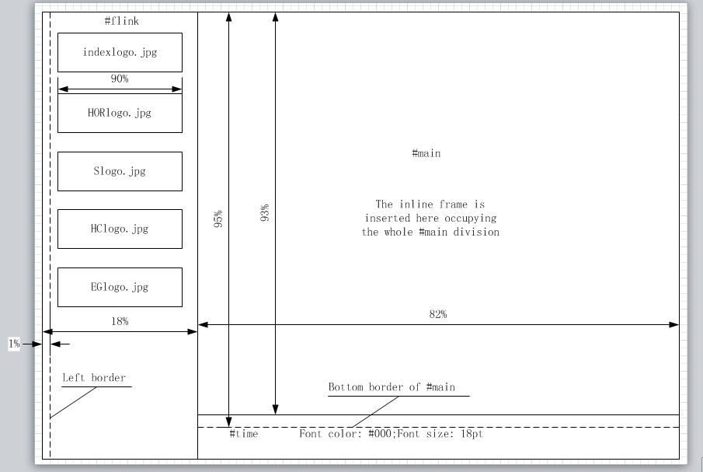

The background image will use: background.jpg using size of 500%. Font color is: #fff. The border of the inline frame is 0. The clock will be aligned to the left border of the division.

When moving the mouse onto the pictures on the #flink division, they will change to other pictures which will have an effect of being lighted. Every picture corresponds to a subpage which will be displayed in the #main division. When the page is displayed, its thumb picture will keep lighted. In the #time division, a digital clock will be displayed updating every second.

The following will list the subpages in the order of the time they were written.

* 1. **C.htm**

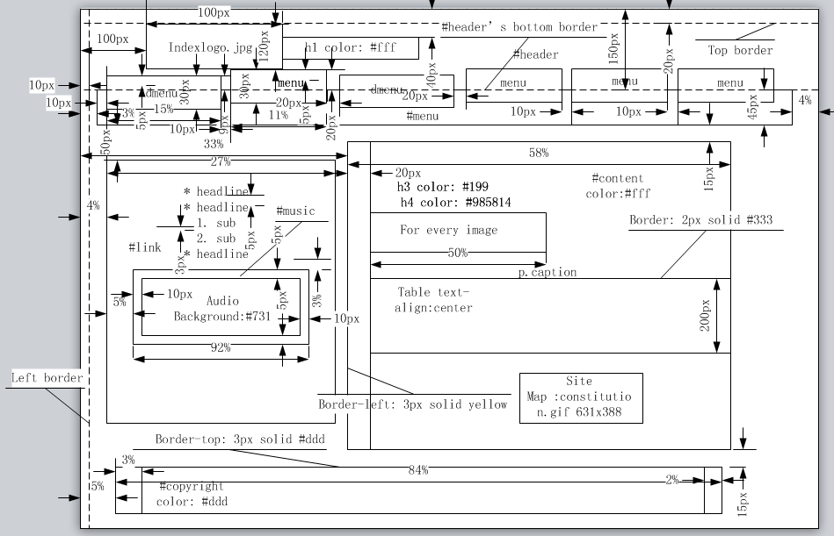

The background image is: background.jpg with size of 500% not repeated. Font color is: #fff.

Headline’s font-size is: 16pt and font-color: #709394. The list style is square and color of the square is: #814. The font size for “sub” is 14pt and color is: #520 which is also the color of the numbers in numbered list.

There is a table inside which is like the following:

|  |  |  |  |
| --- | --- | --- | --- |
| th border:1px solid #666 | th color:#111 | th background-color:#099 | th |
| td border:1px solid #666 | td color:#111 | td background-color:#699 | td |
| td.stagger background-color:#399 | td.stagger | td.stagger | td.stagger |
| td | td | td | td |
| td.stagger | td.stagger | td.stagger | td.stagger |
| td | td | td | td |

In the #content it uses the following pictures:

* ParliamentHouse.jpg
* Senate.jpg
* HouseOfRepresentative.jpg
* oath.jpg
* Power.jpg
* GovernmentHouse.jpg
* HighCourt.jpg
* states.gif
* void.jpg
  1. **HOR.htm**

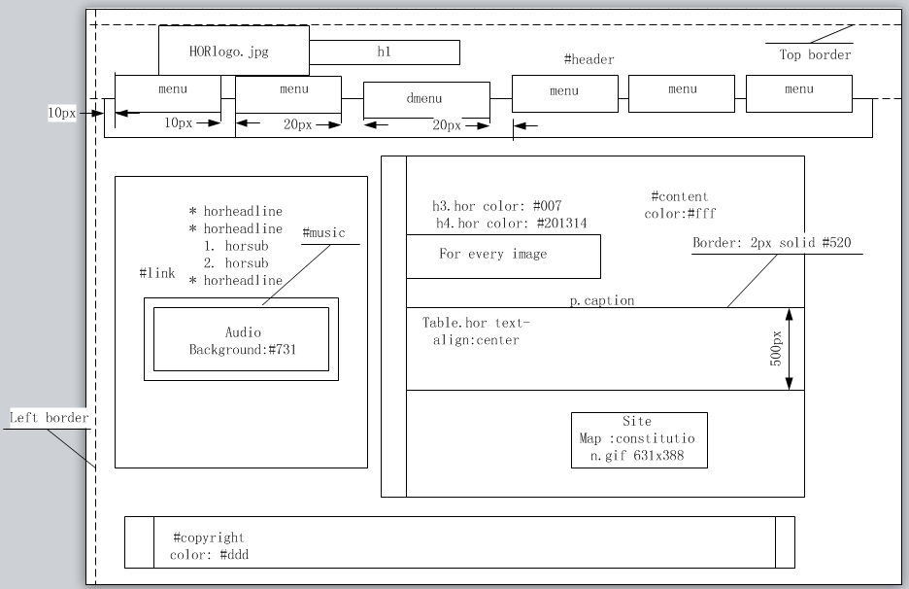

The background image is: HORBackGround.jpg with size of 1100% not repeated.

Headline’s font-size is: 16pt and font-color: # 192168. The font size for “horsub” is 14pt and color is: #201314 which is also the color of the numbers in numbered list.

There is a table inside which is like the following:

|  |  |  |  |
| --- | --- | --- | --- |
| th border:1px solid #666 | th color:#111 | th background-color:#099 | th |
| td border:1px solid #666  background-color:#699  color:#111 | td | td | td |
| td.horstagger | td.horstagger |
| td | td |
| td.horstagger | td.horstagger |
| td.horstagger background-color:#985 | | td.horstagger |
| td | | td |
| td | td.horstagger | | td.horstagger |
| td | td | td |
| td.horstagger | td.horstagger |
| td.horstagger | td | td |
| td.horstagger | td.horstagger |
| td | td | td |
| td.horstagger | td.horstagger |
| td | | td |
| td.horstagger | | td.horstagger |

In the #content it uses the following pictures:

* HouseOfRepresentatives.jpg
* MembersOftheHouse.jpg
* AustraliaAct.jpg
* RaisingHand.jpg
* 100.jpg
* HORSitting.jpg
* protest.jpg
* chamber.jpg
* SpeakerChair.jpg
* flags.jpg
  1. **S.htm**

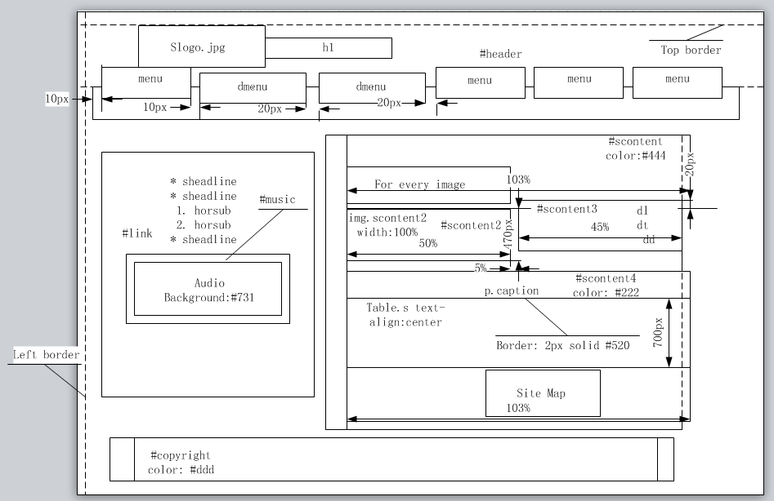

The background image is: SBackGround.jpg with size of 1450% not repeated.

Headline’s font-size is: 16pt and font-color: # 142857. The font size for “horsub” is 14pt and color is: #201314 which is also the color of the numbers in numbered list.

There is a table inside which is like the following:

|  |  |  |  |
| --- | --- | --- | --- |
| th border:1px solid #666; color:#111; background-color:#099 | | | th |
| td border:1px solid #666  background-color:#699  color:#111 | td | td | td |
| td.horstagger | td.horstagger |
| td | td |
| td.horstagger background-color:#985 | td.horstagger | td.horstagger |
| td | td |
| td.horstagger | td.horstagger |
| td | td | td |
| td.horstagger | | td.horstagger |
| td | td | td | td |
| td.horstagger | td.horstagger |
| td | td |
| td.horstagger | td.horstagger | td.horstagger |
| td | td |
| td.horstagger | td.horstagger |
| td | | td |
| td.horstagger | | td.horstagger |
| td | td | td |
| td.horstagger | td.horstagger | td.horstagger |
| td | | td |

In #scontent3 it uses dictionary list to explain the image in #scontent2. The color of dt is: #111 bolded and that of dd is: #222.

In #scontent1 and #scontent4 it uses the following pictures:

* AustralianSenate.jpg
* powers.jpg
* SenateCom.jpg
* scale.jpg
* SenateSeat.jpg
* quorum.jpg
* community.jpg
* committee.jpg
* ScrutinizeLaw.jpg
* burn100.gif
  1. **HC.htm**

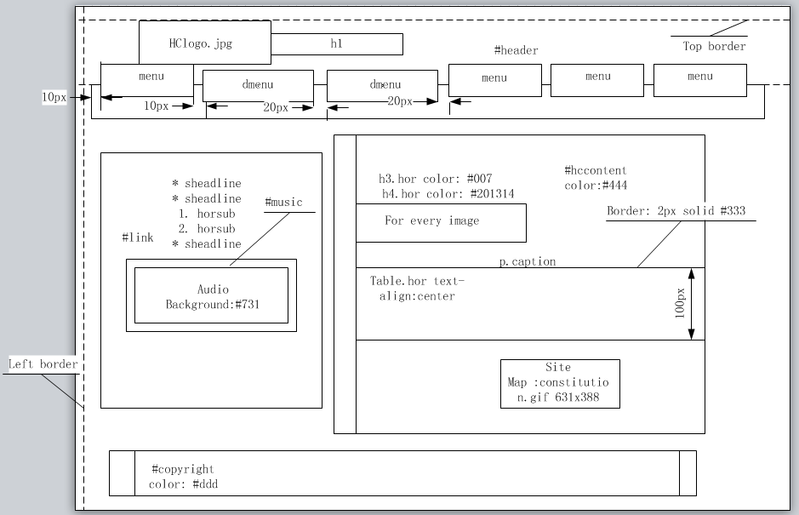

The background image is: HCBackGround.jpg with size of 1400% not repeated.

Headline’s font-size is: 16pt and font-color: # 142857. The font size for “horsub” is 14pt and color is: #201314 which is also the color of the numbers in numbered list.

There is a table inside which is like the following:

|  |  |  |  |  |  |  |  |
| --- | --- | --- | --- | --- | --- | --- | --- |
| th | td | td.horstagger | td | td.horstagger | td | td.horstagger | td |
| th | td | td.horstagger | td | td.horstagger | td | td.horstagger | td |

In #hccontent it uses the following pictures:

* role.jpg
* OpeningCeremony.jpg
* 1929.jpg
* HCA.jpg
* CourtBuilding.jpg
* CourtSitting.jpg
* CourtOperation.jpg
* Courtview.jpg
* CourtInternal.jpg
* CourtInCon.jpg
* PublicHall.jpg
* c1.jpg
* c2.jpg
* c3.jpg
  1. **EG.htm**

It uses the same layout and color scheme as well as font size as those of HC.htm. The background image is: EGBackGround.jpg with size of 1500% not repeated. Its logo file is: EGlogo.jpg.

In #hccontent it uses the following pictures:

* agd.jpg
* aff.jpg
* bcde.jpg
* ccee.jpg
* d.jpg
* eewr.jpg
* fhcsia.jpg
* fd.jpg
* fat.jpg
* ha.jpg
* hs.jpg
* ic.jpg
* it.jpg
* iisrte.jpg
* ralgas.jpg
* ret.jpg
* sewpc.jpg
* pmc.jpg
* va.jpg
* t.jpg
  1. **Miscellaneous**

There are three blocks inside each subpage whose locations are fixed according to the subpage.

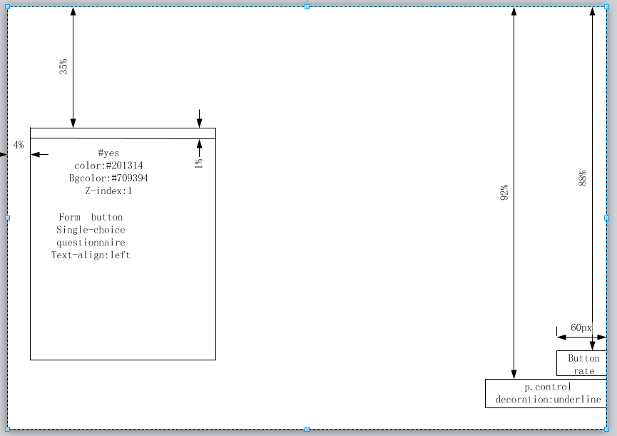

The #yes division is invisible when the page is loaded. When users click on the “rate” button, the #yes division will become visible and let user choose how he feels upon the page. If he doesn’t choose, the division will display there annoying the user. If he clicks the “submit” button without choosing any options, it will alert corresponding prompt. When the user chooses the second form and submits it, the division will be gone and the “rate” button is gone too. The “submit” button will be disabled after useful submission.

The p.control is a link that will bring the user back to top every time it is clicked. It will maintain the color as #fff when mouse is on.