SWARMCHESTRATE · OPTIMUSDB · IDENTITY

optimusIssuer — Design, Security and Operations
The credential issuance service for the OptimusDB swarm: its architecture, the two-tier key model, the key ceremony, the API and operator interface, deployment, operations and federation.
Document | optimusIssuer Design, Security and Operations
Version | 1.0 — for review
Status | Draft
Date | 17 September 2026
Project | Swarmchestrate, EU Horizon Europe Grant Agreement 101135012
Institution | Institute of Communication and Computer Systems (ICCS)
Component | optimusIssuer 1.0.0 — Go 1.21, React 18
Relates to | OptimusDB Decentralized AAA Design Specification v1.0

Contents
1 | Purpose and summary
2 | Placement
3 | Architecture
4 | The credential model, as this service implements it
5 | Key architecture
6 | Security
7 | API reference
8 | The operator interface
9 | The key ceremony
10 | Deployment
11 | Operations
12 | Federation
13 | Development and testing
A | Configuration reference
B | Store records
C | issuerctl reference
D | Repository layout
E | Glossary

1 Purpose and summary
OptimusDB agents authenticate callers by verifying W3C Verifiable Credentials locally. No authority is contacted when a request arrives: the agent decodes a public key out of the caller's identifier, checks two signatures and consults a trust list it already holds. That is what allows an agent to keep working while partitioned from everything else.
Something, however, has to sign those credentials. optimusIssuer is that something — a small Go service with a React interface, holding one Ed25519 key and a set of policies about what it will grant. It is deliberately the only component that touches issuer private key material, and deliberately the only one that is not required for an agent to verify anything.

1.1 What it is
Property | Value
Form | One Kubernetes Deployment, one replica
Language | Go 1.21 backend, React 18 single-page interface
Interface delivery | Built by Vite and embedded into the Go binary; the runtime image is one static executable
Persistence | None of its own. Records are written to OptimusDB stores
Operator authentication | Keycloak OIDC, the existing optimusddc realm
On the agent request path | No. Agents never contact it
Availability requirement | Only for onboarding. Existing credentials are unaffected by an outage
Table 1.1 — optimusIssuer at a glance

1.2 Why it exists as a separate project
Three reasons, in order of weight.
It is the only component holding a signing key, so its blast radius differs from everything else in the deployment. Keeping it in its own repository, its own namespace and its own release cycle makes that boundary explicit rather than implied.
Its availability requirements are the opposite of the agents'. An agent must verify while partitioned; an issuer is expected to be reachable only when somebody is onboarding. Bundling the two would import the issuer's uptime expectations into the agent, or the agent's isolation constraints into the issuer, and neither is desirable.
It is optional. A deployment that issues credentials from a laptop with the command-line tool needs no service at all, and the design of OptimusDB does not assume one exists. Making it a separate project keeps that true.

1.3 What it deliberately does not do
It does not issue automatically. Every credential passes through a human decision. Whether to trust a party is not a judgement a program should make on its own, and an automatic issuer with a network-reachable key is a substantially larger target than one that requires an operator to click approve.
It is not on the request path. This is worth stating twice because it is the property that keeps the wider design honest: if verification ever came to depend on this service being reachable, the system would have reacquired the central authority the credential model was chosen to avoid.
It keeps no database. Requests, issued-credential records, trusted issuers and revocations all live in OptimusDB stores, which replicate and are captured by the existing export. The service is stateless and can be rescheduled without losing anything.
The one genuine trade-off
Putting a signing key in a container means a cluster compromise becomes the ability to mint arbitrary credentials — exactly what an offline key protects against. Section 5 describes the two-tier key model that bounds this, and section 9 the ceremony that establishes it. If that trade is unacceptable for a given deployment, the command-line tool provides the same issuance without the service.

2 Placement
optimusIssuer sits beside the OptimusDB deployment rather than inside it, in its own namespace, reachable through the existing ingress at a distinct path.
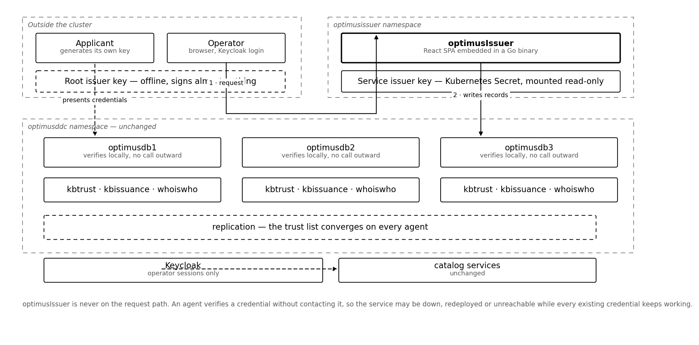
Figure 2.1 — Where optimusIssuer sits. It writes records into the agents' stores and is never called by them.

2.1 Relationships
Component | Relationship | Direction
OptimusDB agents | Writes requests, issuance records, trusted issuers and revocations through the existing command API | issuer → agent only
Keycloak | Verifies operator access tokens against the realm's public keys | issuer → Keycloak, cached
Traefik | Serves the interface and API under /issuer | ingress → issuer
Applicants | Submit credential requests; receive a signed credential file | applicant → issuer
OptimusDDC | None. The catalog front end does not interact with this service | —
Table 2.1 — What optimusIssuer talks to
The direction of the first row matters. No agent ever calls optimusIssuer, which is why an agent can verify credentials during an outage of this service, and why a NetworkPolicy can forbid inbound traffic to it from the agents' namespace entirely.

2.2 Where records live
Store | Records written | Why there
kbtrust | Trusted issuer entries, revocations | Consulted by agents during verification; already replicated
kbissuance | Credential requests, issuance records | New store, created on first use by the dynamic store registry
whoiswho | Optional descriptive identity records | Makes audit rows legible; never consulted during verification

Because all three are ordinary OptimusDB document stores, they replicate to every agent and are captured by the existing export and import. optimusIssuer can be destroyed and rebuilt without losing any record of what it has done.

3 Architecture

3.1 Process structure
optimusIssuer (one container, one process)
┌────────────────────────────────────────────────┐
│ chi router │
│ / → embedded React SPA │
│ /api/v1/issuer → public | operator | admin │
├────────────────────────────────────────────────┤
│ api.Service policy, orchestration │
│ credential sign, verify │
│ canonical JCS, SHA-256 │
│ did did:key encode and decode │
│ keys key loading, permission checks │
│ auth Keycloak token verification │
│ store OptimusDB command API client │
│ audit bounded in-memory ring │
└────────────────────────────────────────────────┘
Listing 3.1 — Package layout

3.2 Why the interface is embedded
The React application is built by Vite and embedded into the Go binary with the embed directive. The runtime image therefore contains one static executable and nothing else: no node runtime, no nginx, no second container in the pod.
This is a security decision as much as an operational one. The component holding the signing key should have the smallest possible surface, and a web server process with its own release cadence and CVE stream is surface that buys nothing here.

3.3 Three privilege tiers
Tier | Requirement | Endpoints
Public | None | health, info, submit a request
Operator | Keycloak role issuer:operator | list, approve, reject, issue, revoke, read the trust list, audit
Admin | Keycloak role issuer:admin | modify the trust list
Table 3.1 — Privilege tiers
Request submission is unauthenticated on purpose. The payload carries no secret — the only key-derived field is a public identifier — and requiring a credential in order to ask for a credential would make onboarding circular.
Modifying the trust list is separated from ordinary issuance because it is categorically different. Issuing a credential grants capabilities to one party; adding a trusted issuer delegates the ability to grant capabilities to anyone. The two should not sit behind the same role.

3.4 Statelessness
The only state held in the process is the private key in memory, a cached Keycloak key set and a bounded audit ring for the interface. Everything durable is written to OptimusDB. A restart loses the audit ring, which is a convenience view; the durable issuance record is in kbissuance.
One replica is specified deliberately. A second would place another copy of the key in memory for no availability gain, since the service is not on the request path and an onboarding delayed by a restart costs nothing.

4 The credential model, as this service implements it
The formats are those of the wider AAA design; this section covers what optimusIssuer does with them.

4.1 What is signed
{
"@context": ["https://www.w3.org/2018/credentials/v1",
"https://swarmchestrate.eu/contexts/optimusdb/v1"],
"id": "urn:uuid:vc-7d3f2a91c4e80b65",
"type": ["VerifiableCredential", "OptimusDBCapability"],
"issuer": "did:key:z6MkhaXgBZDvotDkL5257faizti...",
"issuanceDate": "2026-09-17T09:05:00Z",
"expirationDate": "2026-12-16T09:05:00Z",
"credentialSubject": {
"id": "did:key:z6MkfMyApp9kWq2fT7nB4pL8sYdX1aH6uJ0eC5rNmQvT",
"name": "Attica Solar Ingest",
"organisation": "ICCS",
"capabilities": [
{ "action": "crudput", "store": "kbmetadata" },
{ "action": "crudget", "store": "kbmetadata" }
]
},
"proof": {
"type": "Ed25519Signature2020",
"created": "2026-09-17T09:05:00Z",
"proofPurpose": "assertionMethod",
"verificationMethod": "did:key:z6MkhaXg...#z6MkhaXg...",
"proofValue": "z3MvGcVxzR8kWq2fT9nB4pL7sYdX1aH6uJ0eC5rNmQ..."
}
}
Listing 4.1 — A credential as issued

4.2 The signing operation
- Build the credential with proofValue empty. The remaining proof fields — type, created, purpose, verification method — are inside the signed payload, so none of them can be altered afterwards.
- Canonicalise with JCS, RFC 8785: object keys sorted by UTF-16 code unit, no insignificant whitespace, ECMAScript number formatting.
- Hash the canonical bytes with SHA-256.
- Sign the digest with Ed25519.
- Encode the 64-byte signature as base58btc multibase and place it in proofValue.

4.3 Self-verification
Immediately after signing, the service verifies its own output using the same verification function an agent runs. If that check fails the credential is discarded and an error is returned rather than a credential.
Why this is not redundant
The single most likely defect in this system is a canonicalisation mismatch between issuer and verifier. Its symptom is a signature that fails to verify, which sends people to look at key handling rather than at serialisation. Verifying at issuance moves that failure to the moment the code is exercised, with a message that names the cause.

4.4 Capabilities, not roles
The grant carried by a credential is a list of action and store pairs. A role would be a name meaningful only by reference to a table held elsewhere, which implies a service that holds it; a capability carries the grant itself, so a verifier needs nothing beyond the credential and a public key.
Field | Matching | Wildcard
action | Exact string match against the operation the agent is performing | * matches any action
store | Exact match against the target store; not a prefix match | * matches any store

Wildcards are honoured but treated as exceptional throughout: highlighted in the interface, recorded distinctly in the audit trail, and optionally requiring a second operator. A credential granting a wildcard on both fields is equivalent to unrestricted access and should be rare enough to be individually justified.

4.5 Validity
Credential type | Recommended validity | Rationale
Operator | 30 days | High privilege; short window limits the value of a leak
Application | 90 days | Long enough to avoid churn, short enough that revocation is rarely needed
Long-lived provider or agent | 365 days | Stable parties; the service caps this by default
Table 4.1 — Recommended lifetimes
The service refuses to sign beyond its configured maximum, which is a deliberate guard against an operator setting a large number to avoid future work. Expiry is the primary revocation mechanism in this design, so long lifetimes shift weight onto the revocation list, which is the mechanism with the worse latency.

5 Key architecture

5.1 The problem with one key
The wider AAA design assumes the issuer key is offline, because a key inside the cluster means that compromising the cluster yields the ability to mint any credential. Running optimusIssuer as a service contradicts that assumption directly, and pretending otherwise would be the weakest part of this document.
The resolution is not to put the key back on a laptop and abandon the service, but to use two keys with very different exposure.
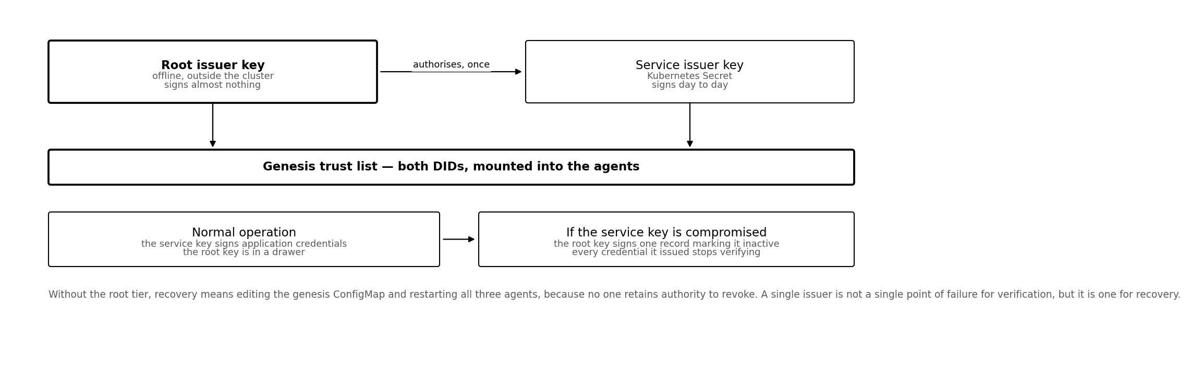
Figure 5.1 — Two keys, two exposures. The root key authorises the service key and is then put away.

5.2 The two tiers
 | Root issuer | Service issuer
Location | Offline, outside the cluster | Kubernetes Secret, mounted read-only
Signs | One trust-list entry, plus emergency revocations | Day-to-day application credentials
Used | Once at bootstrap; rarely thereafter | Continuously
Exposure | Physical only | Anything that reads the Secret or the process memory
If compromised | No recovery inside the system | The root key marks it inactive
Rotation | Requires a new genesis list and an agent restart | A Secret update and a pod restart
Table 5.1 — The two issuer keys compared

5.3 What the root key buys
If the service key is compromised, the root key signs a single record setting that issuer's status to inactive. The record replicates through kbtrust and every agent stops accepting every credential the service key ever signed — without redeploying anything, restarting anything or editing a ConfigMap.
Without the root tier, the same recovery means producing a new genesis list, applying it to the agents' namespace and restarting all three agents, because no key remains with authority to revoke. A single issuer is not a single point of failure for verification, but it is one for recovery, and recovery is when a single point of failure hurts most.

5.4 Key file format and handling
{
"did": "did:key:z6MkhaXgBZDvotDkL5257faiztiGiC2QtKLGpbnnEGta2doK",
"keyType": "Ed25519",
"created": "2026-09-17T09:00:00Z",
"label": "optimusIssuer service key",
"privateKeyMultibase": "z3u2en7t5LR2WtQH5PfFqMqCHqGSVGXLnkYmbEpJXVnAAgSPM"
}
Listing 5.1 — A key file. Only privateKeyMultibase is secret.
The service refuses to start if the file is readable by group or others. An issuer key with loose permissions is equivalent to a published key, and the failure is otherwise silent — nothing goes wrong until someone notices credentials they did not authorise.
The key is mounted as a file rather than supplied as an environment variable. Environment variables appear in a pod description, in crash dumps and in the environment of any child process, and none of those exposures is obvious when the deployment is written.

5.5 Rotation

5.5.1 Rotating the service key
- Generate a new service key with issuerctl on the machine holding the root key.
- Sign a trust-list record for the new DID, status active, using the root key.
- Write that record through any agent; it replicates.
- Replace the Kubernetes Secret and restart the Deployment.
- Sign a record setting the previous service DID to inactive.
- Reissue credentials still in use before their expiry, or accept that they stop verifying at step 5.
Step 6 is the one that requires planning. Marking the old issuer inactive invalidates every credential it signed, so either reissue first or schedule the change to coincide with a natural expiry window.

5.5.2 Rotating the root key
Rarely required and more intrusive. A new genesis list must be produced and applied to the agents, and every agent restarted to read it. Because the genesis list is only consulted when kbtrust holds no trusted issuer records, an existing deployment will also need the new root recorded through the normal path before the old one is deactivated.

6 Security

6.1 Threat surface
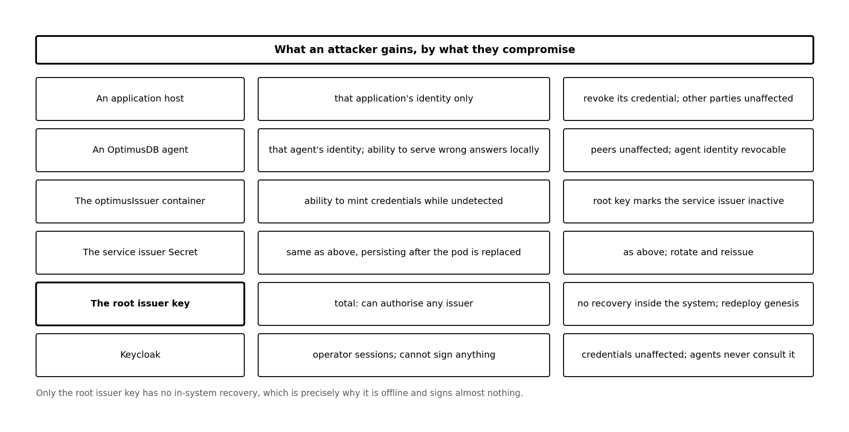
Figure 6.1 — What an attacker gains from each compromise, and what limits it.

6.2 Controls in the implementation
Control | Implementation
Key never in an environment variable | Mounted as a file at /etc/issuer/key, mode 0400
Refuses loose file permissions | keys.Load rejects any mode with group or other bits set
Non-root, read-only root filesystem | runAsUser 10001, readOnlyRootFilesystem, all capabilities dropped
Restricted egress | NetworkPolicy allows only the agents, Keycloak and DNS
No inbound from the agents | NetworkPolicy ingress permits only the ingress controller namespace
Single replica | One copy of the key in memory; Recreate strategy
Self-verification at issuance | Every credential verified with the agent's code before it is returned
Two-operator control for wildcards | Configurable; refuses single-operator approval of a wildcard capability
Policy ceiling on validity | The service will not sign beyond its configured maximum
Action allow-list | Optional bound on what this issuer may grant at all
Audit of every decision | Written to the process log and to kbissuance
Table 6.1 — Implemented controls

6.3 Residual risks
- An operator with the admin role can add a trusted issuer, which delegates the ability to grant capabilities. This is by design and is why the role is separated; it is mitigated by audit rather than by prevention.
- A compromise of the running container exposes the service key in memory even with the file mounted read-only. The two-tier model bounds the consequence but does not prevent the exposure.
- Revocation is not immediate. An attacker who mints credentials and is detected within minutes still has a window in which those credentials verify.
- The interface is served by the same process that holds the key. A defect in the static file handler is therefore a defect in the key-holding process. The handler is small and serves only embedded files, which is the mitigation.
- Keycloak compromise yields operator sessions. An attacker who can mint operator tokens can approve issuance. This is the one place where the centralised component still matters, and it argues for the second-approval control.

6.4 What is explicitly not claimed
This service does not make the system resistant to an attacker who controls the cluster. It makes such an attacker's actions visible and bounded: visible because every issuance is recorded in a replicated store, and bounded because the root key can withdraw the service issuer's authority wholesale.
Nor does it remove the need to trust the party operating it. The design distributes the trust root across a list rather than eliminating it, and whoever holds the root key holds real power. Section 11 discusses what federation changes about that.

7 API reference
Base path /api/v1/issuer. All responses are JSON. Errors carry an error field with a message intended to be actionable.

7.1 Public

GET /health
200 OK
{
"status": "ok",
"issuer_did": "did:key:z6MkhaXg...",
"agent": "reachable",
"time": "2026-09-17T09:00:00Z"
}
503 Service Unavailable — the agent is unreachable; issuance will fail

GET /info
200 OK
{
"issuer_did": "did:key:z6MkhaXg...",
"max_validity_days": 365,
"default_validity_days": 90,
"allowed_actions": []
}

POST /requests
POST /api/v1/issuer/requests
Content-Type: application/json
{
"subject_did": "did:key:z6MkfMyApp9kWq2fT7nB4pL8sYdX1aH6uJ0eC5rNmQvT",
"name": "Attica Solar Ingest",
"organisation": "ICCS",
"contact": "ops@iccs.example",
"deployment": "epm-server, /opt/myapp",
"justification": "Publishes dataset descriptors nightly",
"requested_capabilities": [
{ "action": "crudput", "store": "kbmetadata" },
{ "action": "crudget", "store": "kbmetadata" }
],
"requested_validity_days": 90
}
202 Accepted
{
"request_id": "req-4f2b9c1e",
"status": "pending_approval",
"message": "An operator must approve this request before a credential is
signed. Nothing has been granted."
}
Listing 7.1 — Submitting a request

7.2 Operator
Method and path | Purpose | Notes
GET /requests | The approval queue | Filter with ?status=pending
POST /requests/{id}/approve | Approve and sign | Body carries the capabilities actually granted
POST /requests/{id}/reject | Reject | Body carries a reason, recorded
POST /credentials | Issue outside the queue | Same body shape as approve
GET /credentials | Everything issued | Includes status and expiry
POST /credentials/{id}/revoke | Revoke | Returns a note that this is not immediate
GET /trust | Read the trust list | From kbtrust
GET /audit | Recent actions | In-memory ring; lost on restart

POST /api/v1/issuer/requests/req-4f2b9c1e/approve
Authorization: Bearer <keycloak token>
{
"subject_did": "did:key:z6MkfMyApp9kWq2...",
"name": "Attica Solar Ingest",
"capabilities": [
{ "action": "crudget", "store": "kbmetadata" }
],
"validity_days": 90
}
201 Created — the full signed credential
Listing 7.2 — Approving, with the capability set narrowed from what was requested
The capabilities in the approval body are authoritative, not those in the request. A request is a proposal; an operator who narrows it must not be overridden by what the applicant asked for.

7.3 Admin
POST /api/v1/issuer/trust
Authorization: Bearer <keycloak token, issuer:admin>
{
"_id": "did:key:zSZTAKI...",
"name": "SZTAKI Issuing Authority",
"may_issue": ["OptimusDBCapability"],
"max_delegation_depth": 2,
"status": "active"
}
Listing 7.3 — Adding a partner as a trusted issuer
The most consequential call in this API
Adding a trusted issuer delegates the ability to grant capabilities in this swarm to another party, permanently until deactivated. Every agent will accept credentials that party signs. It requires the admin role, is confirmed in the interface with an explicit warning, and is always audited.

7.4 Error responses
Status | Condition
400 | Malformed body, invalid DID, empty capability set, validity beyond the policy ceiling
401 | Missing or invalid operator token
403 | Valid token without the required role
409 | A wildcard capability requiring a second approval
500 | Signing or store write failed; the message names which
503 | The agent is unreachable, so records cannot be written

8 The operator interface

8.1 Views
View | Purpose | Notable behaviour
Requests | The approval queue | Opens a capability editor pre-filled with the request, for narrowing
Issue | Direct issuance | For onboarding by hand, or reissuing after expiry
Credentials | Everything issued | Highlights anything expiring within two weeks
Trust list | Issuers the swarm accepts | Adding one is behind an explicit confirmation
Audit | Actions in this process | In-memory; the durable record is in kbissuance
Table 8.1 — Interface views

8.2 Decisions built into the interface
The capability editor offers the known actions and stores as suggestions but accepts free text, because a deployment may define its own actions and a closed list would silently prevent that.
Wildcards are visually distinguished wherever they appear, and a count is shown with a note recommending the narrowest set that works. This is the only place in the system where an operator can accidentally grant far more than intended, and it is worth the friction.
Approving pre-fills the editor with what was requested rather than with nothing. An empty form invites an operator to grant broadly to avoid iterating; a pre-filled one invites narrowing.
The credential is offered as a download and also shown in full. Showing it matters because an operator should be able to see what was signed without a separate tool.

8.3 Operator authentication
Operators log in through Keycloak against the existing optimusddc realm. This is the one place in the wider design where a browser session is the right mechanism: a human approving an issuance is better served by an interactive login than by a key file, and Keycloak is already deployed.
Two realm roles are required: issuer:operator for the queue and issuance, issuer:admin for the trust list. With no Keycloak configured the service runs with authentication disabled and logs a warning on every start; that mode exists for development and should never reach a deployment.

9 The key ceremony
The ceremony establishes the two issuer keys and the genesis trust list. It is performed once, and its output determines who may grant capabilities in this swarm for as long as the deployment lives. It deserves more formality than a command run on a laptop between meetings.
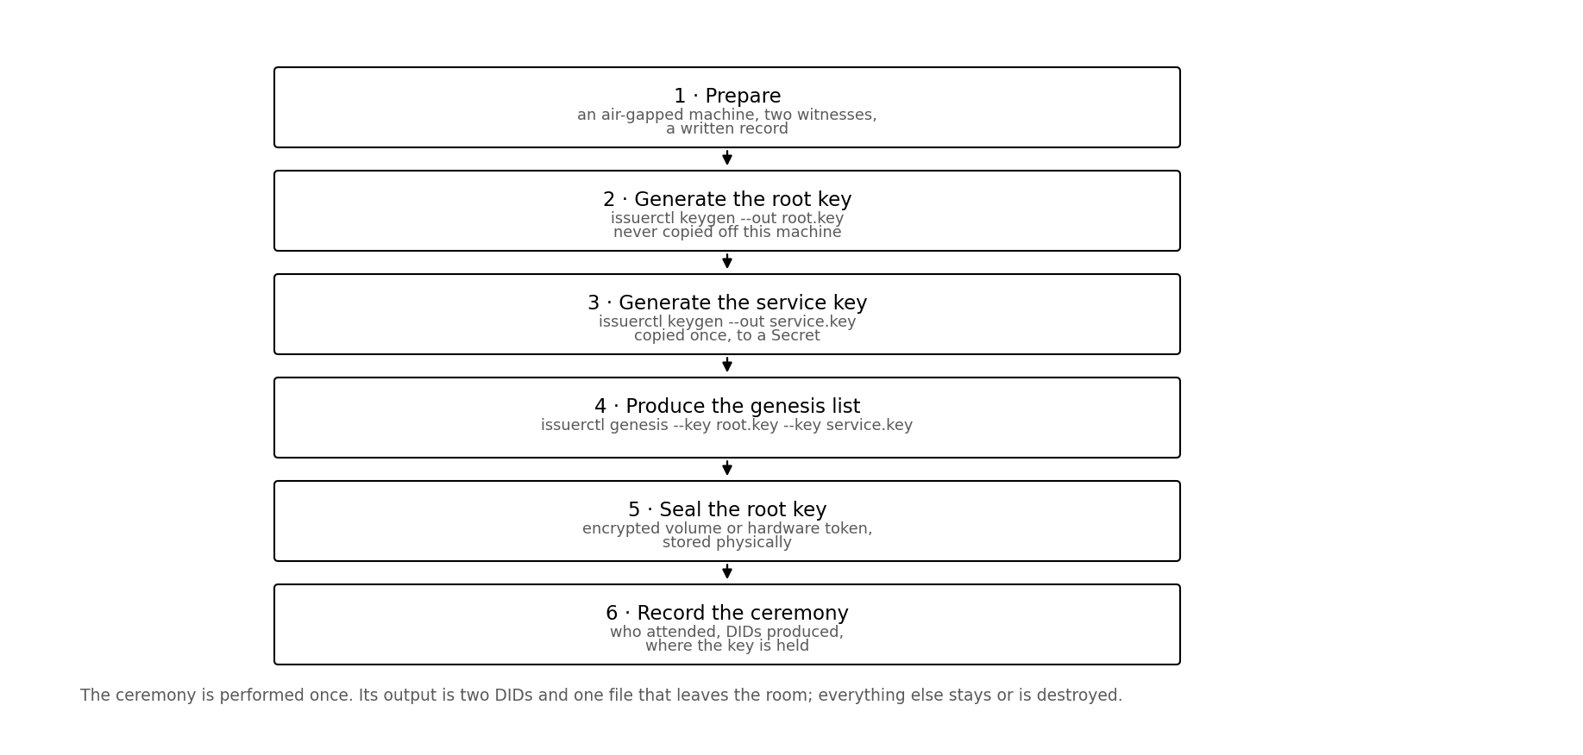
Figure 9.1 — The ceremony. Performed once; two DIDs and one file leave the room.

9.1 Preparation
Item | Requirement
Machine | Freshly booted, not joined to the cluster, network disconnected for steps 2 and 3
Witnesses | At least one besides the operator, named in the record
Storage for the root key | An encrypted volume or a hardware token, prepared beforehand
Record | A written document, completed during the ceremony, not afterwards
Binary | issuerctl, built from a known commit, its hash recorded
Table 9.1 — Before starting

9.2 Steps

Step 1 — Verify the tool
sha256sum ./issuerctl
git rev-parse HEAD # record both in the ceremony document

Step 2 — Generate the root key
./issuerctl keygen --out root.key --label "ICCS Root Issuer"
DID: did:key:z6MkhaXgBZDvotDkL5257faiztiGiC2QtKLGpbnnEGta2doK
key: root.key (mode 0600)

Read the DID aloud and have a witness confirm it against the screen. It will be transcribed into the genesis list and a transcription error is easier to catch now than after deployment.

Step 3 — Generate the service key
./issuerctl keygen --out service.key --label "optimusIssuer service key"
DID: did:key:z6MkrServiceKeyDIDHere...

Step 4 — Produce the genesis list
./issuerctl genesis \
--key root.key --name "ICCS Root Issuer (offline)" \
--key service.key --name "optimusIssuer service" \
--out issuers.json

This file is the only output that leaves the room in electronic form. It contains two public identifiers and no secret, so it may be copied freely and committed to the deployment repository.

Step 5 — Seal the root key
Move root.key to the prepared encrypted volume or hardware token. Delete every other copy with a tool that overwrites, not merely unlinks. Do not reconnect the network until this step is complete.
shred -u root.key # after copying to sealed storage

Step 6 — Transfer the service key
Reconnect, create the Kubernetes Secret, and destroy the local copy:
kubectl -n optimusissuer create secret generic issuer-key \
--from-file=issuer.key=./service.key \
--dry-run=client -o yaml > secret.yaml
kubectl apply -f secret.yaml
shred -u secret.yaml service.key

Step 7 — Record the ceremony
Field | Recorded
Date, time, location | When and where
Participants | Operator and witnesses, by name
Tool version | Commit hash and binary checksum
Root DID | In full
Service DID | In full
Root key storage | What medium, held by whom, where physically
Destruction confirmed | That all other copies were overwritten, witnessed
Signatures | Operator and witnesses
Table 9.2 — The ceremony record
Why the record matters more than it seems
The genesis list is the one assertion in this system that is not derived from anything else. A reviewer asking why these particular issuers are trusted should be able to read an answer, rather than being told it was configured at some point by someone. The record is what turns an axiom into an auditable decision.

9.3 Afterwards
The root key is brought out only to authorise a new service key, to deactivate a compromised one, or to add a partner issuer if that authority is not delegated. Each such use should be recorded in the same document.

10 Deployment
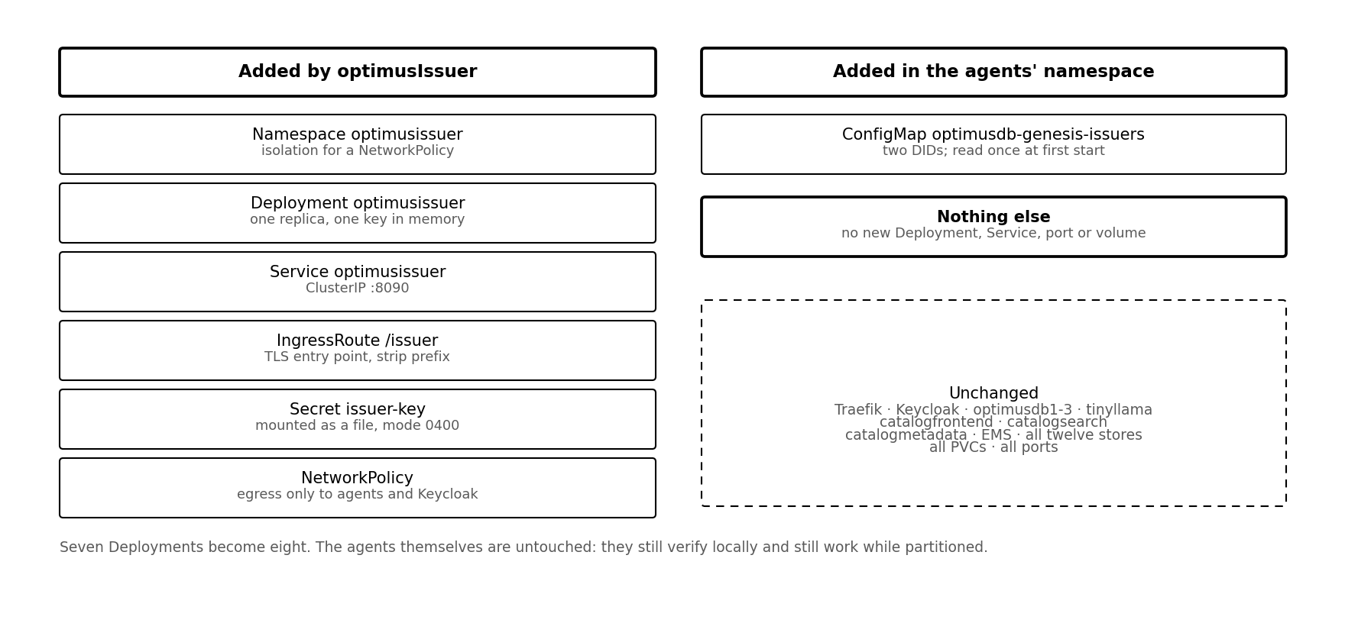
Figure 10.1 — What is added. Seven Deployments become eight; the agents are untouched.

10.1 Objects
Object | Namespace | Purpose
Namespace optimusissuer | — | Isolation, so a NetworkPolicy can be scoped
Deployment optimusissuer | optimusissuer | One replica, Recreate strategy
Service optimusissuer | optimusissuer | ClusterIP on 8090
Middleware issuer-stripprefix | optimusissuer | Removes /issuer before forwarding
IngressRoute optimusissuer | optimusissuer | PathPrefix /issuer on the TLS entry point
Secret issuer-key | optimusissuer | The service key, mounted as a file, mode 0400
NetworkPolicy optimusissuer | optimusissuer | Egress to agents, Keycloak and DNS only
ConfigMap optimusdb-genesis-issuers | optimusddc | The genesis trust list, read by the agents
Table 10.1 — Kubernetes objects
Only the last row is in the agents' namespace, and it is read by the agents rather than by this service.

10.2 Installing
kubectl apply -f deploy/01-namespace.yaml
# the Secret is produced during the ceremony, not stored in the repository
kubectl apply -f secret.yaml && shred -u secret.yaml
kubectl apply -f deploy/03-deployment.yaml
kubectl apply -f deploy/04-ingressroute.yaml
kubectl apply -f deploy/05-networkpolicy.yaml
# into the agents namespace
kubectl apply -f deploy/06-genesis-configmap.yaml

10.3 Verifying the installation
# the service knows its own identity
curl -s https://HOST/issuer/api/v1/issuer/health | jq
# the DID matches the one from the ceremony
curl -s https://HOST/issuer/api/v1/issuer/info | jq -r .issuer_did
# the agents hold the genesis list
curl -s -X POST https://HOST/optimusdb1/swarmkb/command \
-H "Content-Type: application/json" \
-d '{"method":{"cmd":"crudget"},"dstype":"kbtrust",
"criteria":[{"record_type":"trusted_issuer"}]}' | jq

The third check is the one that matters. If the agents do not hold the trust list, credentials will be signed correctly and rejected at verification, with an error naming the issuer rather than the signature.

10.4 Resource impact
Resource | Request | Limit | Note
CPU | 50m | 500m | A signature is tens of microseconds; the load is human-paced
Memory | 64Mi | 256Mi | The binary, the embedded interface and a small audit ring
Storage | none | none | No persistent volume; records go to OptimusDB

11 Operations

11.1 Onboarding an application
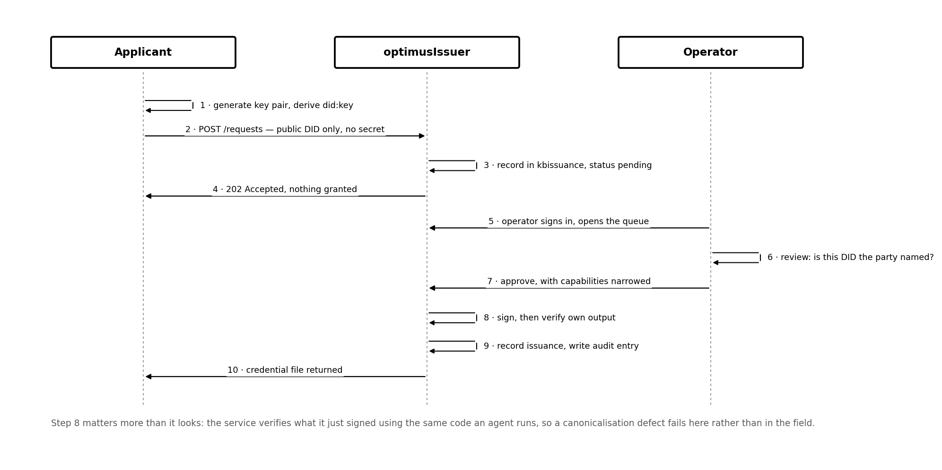
Figure 11.1 — Request to credential. The agents are not involved until the application first uses what it receives.
- The applicant generates a key pair on its own machine and sends the DID. Nothing secret is transmitted.
- The applicant submits a request, or the operator enters the details directly.
- The operator verifies out of band that the DID belongs to the party named. This is the human checkpoint and cannot be automated.
- The operator narrows the capabilities to the minimum that works and approves.
- The credential file is returned to the applicant, who places it beside the private key.
No agent is contacted during any of this, and no agent needs restarting. The agents already accept credentials signed by this issuer because its DID is in the trust list.

11.2 Revoking
# through the interface, or
curl -s -X POST https://HOST/issuer/api/v1/issuer/credentials/urn:uuid:vc-7d3f/revoke \
-H "Authorization: Bearer $TOKEN" \
-H "Content-Type: application/json" \
-d '{"reason":"application decommissioned"}'

Revocation is not immediate
The record is written to kbtrust and takes effect as it replicates and as each agent refreshes its cache — seconds to minutes in a healthy swarm, longer if an agent is partitioned. Between the write and the refresh the credential still verifies. Short lifetimes are the primary control; revocation is for emergencies.

11.3 Routine tasks
Task | Cadence | How
Review credentials expiring soon | Weekly | Credentials view highlights anything inside two weeks
Review wildcard grants | Monthly | Audit view; narrow and reissue where possible
Review the trust list | Quarterly | Confirm every entry is still warranted
Confirm the root key is where the record says | Annually | Physical check against the ceremony document
Rehearse service key rotation | Annually | On a copy of the deployment, not in production
Table 11.1 — Operational rhythm

11.4 Failure modes
Symptom | Likely cause | Action
Service will not start, key error | Key file mode is not 0600, or the DID does not match the key | Check the Secret's defaultMode; regenerate if the key is wrong
Health returns 503 | The agent is unreachable | Issuance will fail; verification is unaffected
Credentials sign but agents reject them | The genesis list was not applied, or the issuer is inactive | Query kbtrust for trusted_issuer records
Signature errors on every credential | Canonicalisation mismatch between issuer and agent | Run the round-trip tests in both codebases against the same fixture
Operators cannot sign in | Keycloak unreachable, or the realm roles are missing | The cached key set covers a brief outage; check role assignment
Approve returns 409 | A wildcard capability requires a second operator | Narrow the capabilities, or have a colleague confirm
Table 11.2 — Diagnosis

11.5 Backup
There is nothing in this service to back up except the key, and the key is not backed up by any automated process — it is held according to the ceremony record. Everything else lives in OptimusDB stores and is captured by the existing export.
This is worth stating plainly because it inverts the usual expectation. Losing the optimusIssuer pod costs nothing. Losing the root key costs the ability to recover from a service key compromise, and no backup system can help if the key was never written anywhere a backup could reach.

12 Federation

12.1 Adding a partner issuer
The single most consequential thing this service can do is add another party to the trust list. After that record replicates, every agent accepts credentials that party signs, and the partner onboards its own applications without involving this deployment at all.
POST /api/v1/issuer/trust # requires issuer:admin
{
"_id": "did:key:zSZTAKI...",
"name": "SZTAKI Issuing Authority",
"may_issue": ["OptimusDBCapability"],
"max_delegation_depth": 2,
"status": "active"
}

12.2 What changes at that moment
Before | After
One party decides who may act in the swarm | Several do, independently
Onboarding a partner's application requires this service | The partner issues to its own applications
Compromise of one issuer affects everything | Affects only credentials that issuer signed
The claim is a system with keys | The claim is federation, demonstrable rather than asserted

12.3 Bounding a partner
A trusted issuer record is not a blank cheque. Three fields constrain it, and they are enforced by the verifier rather than by convention.
Field | Effect
may_issue | A credential whose type is absent is rejected even if correctly signed
max_capabilities | A credential granting more than this is rejected, not trimmed
max_delegation_depth | Zero disables delegation for this issuer's credentials

Rejecting rather than trimming is deliberate. Silently reducing a caller's permissions produces behaviour that is difficult to diagnose; an explicit rejection names the problem.

12.4 Governance
Who may add an issuer is itself a policy decision, and three options are available. Genesis-only, where the authority remains with whoever holds the root key, is simplest and is the recommended starting point. Delegated, where any issuer holding trust:admin may add another within its own limits, suits a federation of partner organisations. Quorum, where a change requires records from a majority of active issuers, is the most defensible for a genuinely open swarm and requires a convergence rule the present implementation does not provide.
The honest limit
Federation distributes the trust root; it does not remove it. Whoever seeds the genesis list makes a decision nobody else voted on, and the quorum option only moves that decision to the set of issuers already present. What the design achieves is that the decision is declared, auditable and replicated rather than held privately by a running service — which is a real improvement, and a more defensible claim than the absolute one.

13 Development and testing

13.1 Running locally
make keygen # creates ./dev.key
make dev # auth disabled, warns loudly
make dev-ui # Vite on :5173, proxying /api to :8090

With no Keycloak configured every caller is treated as a local admin and the service logs a warning on each start. The mode exists so that the interface can be developed without standing up an identity provider, and it should never reach a deployment.

13.2 Tests
Test | What would break if it failed
Issue then verify | Credentials this service signs would not verify in the agents
Verify after JSON round trip | Serialisation would alter what was signed in transit
Tampered capability rejected | The signature would not cover the grant
Unsigned credential rejected | Any party could assert any capability
Expired credential rejected | Expiry would not be a revocation mechanism
Verification method must match issuer | A credential could name one issuer and be signed by another
Capability matching, including near-misses | Prefix confusion between store names
DID round trip and malformed rejection | Identity resolution
Canonicalisation order independence | The same credential would hash differently on two machines
Canonicalisation stability across runs | Signatures would be non-deterministic
Table 13.1 — What the test suite protects
The last two are the ones to watch. A failure there almost certainly means credentials issued by this service will not verify in the agents, and the symptom in the field would be a signature error that sends people to look at keys.

13.3 Keeping canonicalisation in step
The did and canonical packages must produce byte-identical output to the verifier inside the OptimusDB agent. If the two diverge, every credential fails and the failure presents as a forged signature.
The safest arrangement is for the agent to vendor these two packages rather than reimplement them. Where that is not possible, the same fixtures should be run against both implementations in each project's test suite, and any change to either package should be treated as a change to both.

Appendix A Configuration reference
Flag | Default | Purpose
-addr | :8090 | Listen address
-key | /etc/issuer/key/issuer.key | Issuer key file; must be mode 0600
-agent | http://optimusdb1:8089 | OptimusDB agent base URL
-agent-context | swarmkb | Agent API context
-oidc-issuer | (empty) | Keycloak realm URL; empty disables operator authentication
-oidc-audience | optimusissuer | Expected audience claim
-max-validity-days | 365 | Longest credential this issuer will sign
-default-validity-days | 90 | Applied when a request names none
-require-second-approval | true | Two operators for any wildcard capability
-allowed-actions | (empty) | Allow-list bounding what may be granted
-cors-origins | (empty) | For a separately hosted interface

Appendix B Store records

Trusted issuer, in kbtrust
{
"_id": "did:key:z6MkhaXg...",
"record_type": "trusted_issuer",
"name": "ICCS Root Issuer (offline)",
"may_issue": ["OptimusDBCapability"],
"max_delegation_depth": 2,
"status": "active",
"added_at": "2026-09-17T09:00:00Z",
"added_by": "genesis"
}

Credential request, in kbissuance
{
"_id": "req-4f2b9c1e",
"record_type": "credential_request",
"subject_did": "did:key:z6MkfMyApp...",
"name": "Attica Solar Ingest",
"requested_capabilities": [ ... ],
"status": "pending",
"requested_at": "2026-09-17T09:02:00Z"
}

Issuance record, in kbissuance
{
"_id": "urn:uuid:vc-7d3f2a91c4e80b65",
"record_type": "issued_credential",
"subject_did": "did:key:z6MkfMyApp...",
"subject_name": "Attica Solar Ingest",
"issuer": "did:key:z6MkhaXg...",
"capabilities": [ ... ],
"issued_at": "2026-09-17T09:05:00Z",
"expires_at": "2026-12-16T09:05:00Z",
"status": "active",
"issued_by": "george"
}

Revocation, in kbtrust
{
"_id": "revocation:urn:uuid:vc-7d3f2a91c4e80b65",
"record_type": "revocation",
"credential_id": "urn:uuid:vc-7d3f2a91c4e80b65",
"revoked_by": "did:key:z6MkhaXg...",
"reason": "application decommissioned",
"revoked_at": "2026-10-02T09:14:00Z"
}

Appendix C issuerctl reference
Command | Purpose
keygen --out FILE [--label TEXT] | Create a key pair and print its DID
inspect --key FILE | Show a key's DID without exposing the key
issue --key FILE --subject DID --capability A:S --days N --out FILE | Sign a credential offline
verify --credential FILE | Verify a credential with no network
genesis --key FILE [--key FILE] --out FILE | Produce the genesis trusted issuer list
revoke --key FILE --credential ID --reason TEXT | Emit a revocation record for manual writing

None of these commands contacts a network. They exist so that the ceremony, and emergency signing while the service is unavailable or compromised, can be performed entirely offline.

Appendix D Repository layout
optimusIssuer/
├── cmd/
│ ├── issuerd/main.go the service
│ └── issuerctl/main.go offline tool
├── internal/
│ ├── did/didkey.go did:key encode and decode
│ ├── canonical/jcs.go RFC 8785 and SHA-256
│ ├── credential/ types, sign, verify, tests
│ ├── keys/keys.go key loading and permission checks
│ ├── store/client.go OptimusDB command API client
│ ├── auth/oidc.go Keycloak token verification
│ ├── audit/audit.go audit ring
│ └── api/ service logic and router
├── web/ React single-page application
│ ├── src/pages/ Requests, Issue, Credentials, Trust, Audit
│ └── src/components/ CapabilityEditor
├── deploy/ namespace, deployment, ingress, policy
├── Dockerfile three stages, static output
├── Makefile
└── README.md

Appendix E Glossary
Term | Meaning
Capability | An action and store pair carried in a credential
Credential | A W3C Verifiable Credential: signed claims about a subject
did:key | A DID method where the identifier encodes the public key, so resolution needs no network
Genesis list | The initial set of trusted issuers, supplied as a ConfigMap
Holder | The party presenting a credential and proving possession of the subject key
Issuer | The party whose signature appears in a credential's proof
JCS | JSON Canonicalization Scheme, RFC 8785
Root issuer | The offline key that authorises the service issuer and can withdraw it
Service issuer | The key held by optimusIssuer for day-to-day signing
Trust list | The set of accepted issuer DIDs, held in kbtrust

