George Booth

Oracle E- Business Suite Inventory Assignment

Date:15th Nov-2024

1. The Oracle Inventory Module is where all the items are stored for procurement or selling and it keeps track of everything you have.
2. So, I signed out of the Operations user and signed into XX_GB_USER and switch my responsibility to Inventory

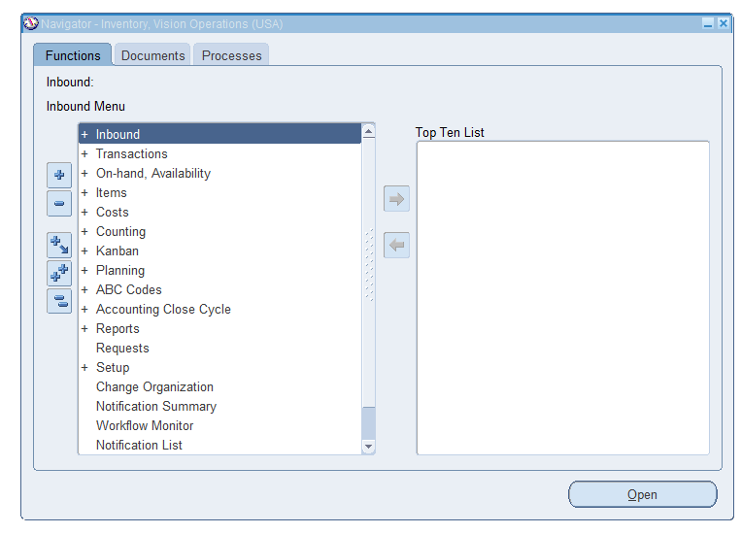

1. To find the Master Items the path is Inventory >> Items>> Master Items

Select V1 as your Org and then in Item press Ctrl + Fn + F11 to see the items for V1

1. Select the Third box on the left in the Master Items

Then select Assign All button

1. To Un assign all Press the Unassign All button at the bottom of Master Items

1. Inventory>> On-Hand Availability >> On-Hand Quantity

Then change View By: Location to View By: Item

Then click Find

1. For the Unit of Measure the path is INV >> Setup >> Units of Measure >> Units of Measure

1. Inv >> Items >> Master Items

Then fill out everything that is highlighted yellow to create a new inventory item

Then click file at the top left and Save

1. To run an Inventory Valuation Report you

Go to View>> Requests

Then submit a new request, then type All inventories value Report for the name

When the parameters pop up click on and then submit

Then you can view the output or the log

1. Change Inventory Org by the Path Inventory >> Change Organization

1. The Master Data in Inventory is very important. Master data is used to be the information to set up and manage inventory-related data in Oracle. An example of Master Data can be Supplier then under the master data supplier would be Purchasing Site and Pay Site.
2. To show the existing ORG you go to Inventory >> Setup >> Organizations >> Organization

Type Vision Operations in the name and click find

Then you get this which shows the Org structure for Vision Operations

1. Inventory >> Items >> Organization Items

Type Finished good into User Item Type and click find

Then you get these items that have Finished goods:

So, No there are many categories and item types that you can change in Oracle Inventory

1. True, you need to create the item first before performing inventory transactions.
2. False, Sub inventories are not optional in oracle you need them to hold the items in the inventory.