

School of Physics

Senior Honours Project
Computational Physics

q-state Potts Model Simulation

Richard Hanes
December 2004

Abstract

A Java™ implementation of the q-state Potts Model on a 2D square lattice is used, which confirmed analytically known results for q = 3 and q = 5. The Metropolis single spin flip and Wolff cluster flip algorithms are utilized to find phase changes, investigate Finite Size Scaling effects and calculate the Heat Capacity Critical Exponent.

Declaration

I declare that this project and report are my own work.

Signature: Date:

Supervisor: Dr. Brian Pendleton

Table of Contents

Introduction 3
Background 4
Spin Models & Magnetic Materials 4
Lattice Geometry 5
Dynamic Algorithm 5
Phase Transitions 7
Critical Exponents 8
Hysteresis Loop 9
Finite Size Effects 9
Physical Realisations of the q-state Potts Model 9
Method 10
Initialisation 10
Dynamic Algorithm 10
Observables 11
Experiments 13
Results 15
Experiment 1 - Check Analytical T_{c} Predictions 15
Experiment 2 - Investigate how the Hysteresis Loop depends on the number of sweeps at each temperature 17
Experiment 3 - Investigate how the Hysteresis Loop depends on the size of the Lattice 19
Experiment 4 - Investigate the Effects of Finite Size Scaling 20
Experiment 5 - Calculate the Critical Exponent of Heat Capacity 21
Conclusion 22
References 22
Appendix 24

Introduction

The aim of this project is to verify the known properties of the q-state Potts model by writing a computer simulation running experiments on it.

The Potts Model is an extension of the Ising Model, proposed in 1925. The Ising model was originally conceived to model a magnetic material as a number of electron ‘spins’ on a regular lattice. Each electron can take the spin value ↑ (+1) or ↓ (-1). If two adjacent electron spins point in the same direction, they reinforce each other and increase the stability of the system.

The q-state Potts Model allows each spin particle to take any value from 1…q. Each of the different values correspond to the particle spinning about a different axis of rotation.

In the low temperature regime, the particle spins tend to align to produce an overall magnetisation. At some specific temperature, the thermal fluctuations become stronger than the spin interactions, and the system tends to a paramagnetic state. Analytically solving the Ising model on an infinite lattice to find this Critical Temperature was a major breakthrough in Statistical Physics for Lars Onsager in 1944.

The computer simulation uses a Dynamic Algorithm to simulate the thermal fluctuations and update the spins in the lattice. Two Dynamic Algorithms are implemented, the Metropolis algorithm which updates a single spin at a time, and the Wolff algorithm which updates clusters of spins. Both algorithm reproduce the Critical temperature obtained from theory.

Theory predicts that the ferro- to paramagnetic phase change is second order for q≤4, and first order for q>4. By measuring the Heat Capacity of the system for the 3 state and 5 state model, the order of the transition was confirmed.

The simulator is affected by Finite Size Scaling, which change the Critical Temperature as the size of the lattice changes. By experimenting on different lattice sizes and calculating the trend, the critical temperature on an infinite lattice was confirmed to agree with the theory.

Experimentalists noticed that at temperatures close to the transition, the Heat Capacity curve obeys a simple exponential law, defined by a constant called the critical exponent. This was calculated using the program and, although the errors are large, agrees with the theoretical predictions.

Background

Spin Models & Magnetic Materials

The q-state Potts model is one of a group called spin models. The basic idea was first introduced in 1925 when G. E. Uhlenbeck and S. Goudsmit hypothesized that the electron has a ‘spin’, and so behaves like a small bar magnet.

Ising Model
Consider a regular lattice of electrons, each of which can take a spin value ↑(+1) or ↓(-1). When two adjacent electron spins are aligned, they reinforce each others magnetic field, making the system more stable and reducing its energy. When two electron spins are anti-parallel, their magnetic fields cancel out, reducing the stability and increasing the energy of the system. This can be described mathematically as:
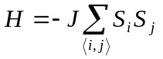
H = Hamiltonian (Energy) of the system.
J = Interaction strength.
S_{i} = Spin of the electron at site i in the lattice.
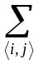= Sum over nearest neighbours in the lattice.

For example, consider a 2 spin system:

↑↑ or ↓↓ : Spins parallel, H = -2J
↑↓ or ↓↑ : Spins anti-parallel, H = +2J

The interaction strength, J, is a constant, dependant on the material being modelled.
If J > 0, the material is ferromagnetic.
If J = 0, the material is non-magnetic
If J < 0, the material is anti-ferromagnetic (most stable when all spins are anti-parallel).

Although anti-ferromagnetic materials do exist, ferromagnetic materials are much more common and will be the focus of this project.

q-state Potts Model
If the spins are allowed to take more than 2 states, the Ising model becomes the q-state Potts model named after the Australian mathematician R. B. Potts who published a study of this model in 1952. The Potts model Hamiltonian is defined by:

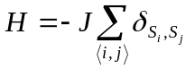
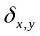is the Krönecker delta function
S_{i} can take on values 1,…,q q>2
= Sum over nearest neighbours in the lattice.

In words, if the spin at site i is the same as site j, the system is more stable. If the spin at i is different to j, the energy of the system is not changed.

There is a subtle difference between the two models. In the Ising model if two neighbouring spins are different the system energy increases, however in the Potts model, the system energy remains the same. Each of the different spin values correspond to the particle spinning about a different axis of rotation.

More Spin Models
Other spin models exist, each is an extension of the Ising model but the spin interaction energies are different.

In the p-state Clock model, each spin can take one of 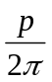values, like the hands of a clock, and the interaction energy depends on the angle between adjacent spins.

If p → ∞, the clock model turns into the XY model, where each spin can take any value between 0 and 2π.

Lattice Geometry

The layout of the lattice on which the spins are arranged has an impact on the properties of the model.

The dimensionality of the lattice, D, defines how many different orthogonal directions exist within the lattice. The simplest case is the 1D lattice which consists of a row of spins.

When the lattice has 2 or more dimensions, its shape must also be defined. Different lattice shapes include square, triangular, honeycomb etc.

It is also possible to have ‘diluted’ lattices, i.e. not every point in the lattice contains a spin or not every bond contributes to the Hamiltonian. These different lattice conditions all have different properties and relate to different physical systems.

This project will consider the 2D N by N saturated square lattice.

Dynamic Algorithm

Magnetic materials (and in fact, all physical systems) are constantly changing with time. To incorporate this into the Spin Model, a ‘Dynamic Algorithm’ is needed to simulate the random thermal fluctuations which occur in real materials.

Temperature & Thermal Equilibrium
The Potts model Hamiltonian does not have any dependence on temperature, but in real materials, the energy and magnetisation of the material do depend on the temperature. At a given temperature, the thermodynamic properties (pressure, volume, magnetisation etc) of an isolated real system will reach equilibrium values, after which they will not change with time. This is called thermal equilibrium. In order to understand thermal equilibrium a short digression into Statistical Mechanics must be made.

The Boltzmann Distribution
Consider a 3 state Potts Model with lattice size 32 by 32. Each of the 32² sites in the lattice can take the spin value 1, 2 or 3 so there are 3¹⁰²⁴ (~10⁵⁰⁰) possible ‘configurations’ or ‘states’ of the system. Boltzmann showed that, at thermal equilibrium, the probability of a system being in any state X, (P(X)) is

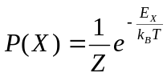
E_{x} is the energy (given by the Hamiltonian) of the state X,
k_{B} is the Boltzmann constant, 1.380658 x 10⁻²³ J/K,
T is the temperature,
Z is called the Partition Function and is defined by:
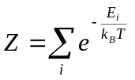
Where the sum runs over all of the configurations of the system.

Detailed Balance
In 1953 Metropolis et al. showed that if a dynamics algorithm satisfies the principle of detailed balance, it will, after time, produce thermal equilibrium in the model. The principle of detailed balance says that at thermal equilibrium the probability of a system being in a configuration A and changing to a different configuration B is equal to the probability of it being in configuration B and changing to configuration A. This principle is defined mathematically as:

P(A) is the probability of the system being in configuration A,
P(A→B) is the probability of the system changing from configuration A to configuration B (transition probability).

By using the Boltzmann probability and the definition of detailed balance:

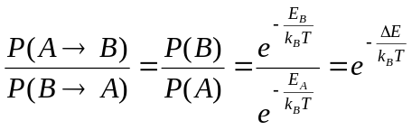
Where 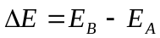

Metropolis Algorithm
In the same paper Metropolis described an algorithm which satisfies detailed balance. It works by changing the spin of a random site on the lattice and working out the difference in energy of the site due to the flip. It then allows the flip with a certain probability, based on the temperature of the system.

Call the configuration of the system before the flip A and after the flip B. The Metropolis algorithm defines the probability of accepting the flip P(A→B) as:

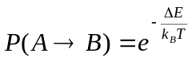 if ∆E > 0
= 1 if ∆E ≤ 0

If the flip makes the system more stable, allow it. If it makes the system less stable, check the temperature of the system and if there is enough thermal energy to de-stabilise the system, allow it, if not, flip it back.

To show that this algorithm satisfies detailed balance, consider the case where ∆E > 0 i.e. E_{B} > E_{A}:

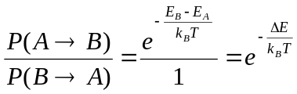
If ∆E < 0 i.e. E_{B} < E_{A}:

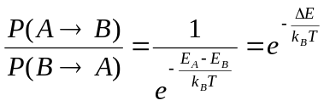

Cluster Algorithms
One of the disadvantages of the Metropolis algorithm is that for large lattice sizes it can take a large number of iterations to equilibrate the lattice. To overcome this, cluster algorithms were developed which flip more than one spin at a time, allowing the system to reach equilibrium in fewer iterations. The cluster algorithm implemented in this project is called the Wolff algorithm, developed by U. Wolff in 1989. Details of the Wolff algorithm can be found in the Method.

Phase Transitions

At low temperatures, the equilibrium state of the system is ferromagnetic, i.e. most of the spins are aligned in the same direction. At high temperatures, the thermal fluctuations become stronger than the spin interactions and the system becomes paramagnetic, i.e. the spins are orientated randomly. At some point between the ferromagnetic state and paramagnetic state, there is a phase transition. This phase change occurs at a very specific temperature in real magnetic materials, called the Curie or Critical Temperature (T_{c}). For example, the Curie Temperature of iron is 1043 K.

Not all phase transitions have the same nature. When liquid water freezes to solid ice the transition is first order, whereas in magnetic materials the paramagnetic to ferromagnetic transition is second order. First order transitions involve some form of latent heat, at the critical temperature the system either absorbs or releases a (usually large) amount of energy. The latent heat arises from a discontinuity in the first order derivative of a thermodynamic quantity (e.g. energy, magnetisation, volume). Similarly, second order transitions occur at a discontinuity in the second derivative of a thermodynamic quantity but involves no latent heat.

T_{c}

T_{c}

H
dH
dT
Fig 1a: Discontinuity in the First order Derivative of a Thermodynamic Quantity, H

H
dH
dT
d²H
dT²
T_{c}
T_{c}
T_{c}
Fig 1b: Discontinuity in the Second Order derivative of a Thermodynamic Quantity, H

The Heat Capacity (at constant volume) of the Potts model is defined to be:

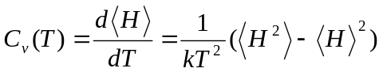
Where the 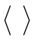 represent the expectation value and H is the system energy.
The heat capacity is a first order derivative of the energy of the system, so measuring it gives a way to detect phase changes. Furthermore, the heat capacity should show a discontinuity for first order transitions and be continuous in second order transitions.

The q-state Potts model on a 2D infinite square lattice has been solved analytically using renormalisation techniques. The theory predicts that for q values less than or equal to 4, the ferromagnetic to paramagnetic transition is second order and for q values greater than 4, the transition is first order. The predicted critical temperature of the transition is given by:
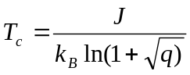
Verification of these results is one of the aims of this project.

Critical Exponents

At temperatures close to the phase transition the heat capacity is related to the system temperature by:

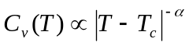
is the Heat Capacity critical exponent.
The Heat Capacity diverges at T_{c} if is positive and goes to zero if is negative. Similar exponents exist for other observables of the system including Magnetisation and Magnetic Susceptibility.

Hysteresis Loop

If the temperature of the lattice is changed quickly, it does not get time to equilibrate. In the programs this occurs because the algorithm can only flip a finite number of spins at a time. Phase transitions take many iterations of the algorithm to complete, an effect called ‘Critical Slowing Down’. This effect causes the phase change to occur at different temperatures when heating and cooling the system, creating a loop around the actual critical temperature, called the Hysteresis Loop. Cluster algorithms reduce the critical slowing down effect and the size of the Hysteresis loop.

Finite Size Effects

Finite size effects are the changes to the properties of the system due to the size of the lattice used in the simulation. Large lattices are affected less and can more accurately reproduce real systems but are computationally very expensive. For an N by N lattice, the critical temperature is related to the lattice size by:

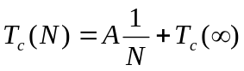
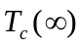 is the critical temperature for an infinite lattice.
A is a constant.
By measuring the critical temperature of the system at different lattice sizes and performing a linear fit to the data, the critical temperature of an infinite lattice can be determined.

Physical Realisations of the q-state Potts Model

q = 2 (Ising) systems
Magnetic substances that are well approximated by the Ising model are numerous, some specific examples are:
CoCs₂Br₅ in the 2D model (Wielinga et al., 1967; Mess et al., 1967)
CoCs₃Cl₅ (Wielinga et al., 1967) and DyPO₄ (Wright et al., 1971) in the 3D model.

q = 3 systems
Three state systems have been a subject of keen interest and provide a definitive test of the renormalisation solution. Examples of substances well approximated by the 3D model are:
DyAl₂ (Barbara et al., 1978)
Fluid mixture of five (suitably chosen) components such as ethylene glycol + water + lauryl alcohol + nitromethane + nitroethane (Das and Griffiths, 1979).

q = 4 systems
The four state model is a good approximation of certain adsorbed systems. For example, N₂ adsorbed on krypton-plated graphite (Domany et al., 1977) and O₂ adsorbed on the surface of nickel (Park et al., 1980) should exhibit the same critical properties of the 2D 4 state Potts model.

Method

Three versions of the simulator have been written, two experimental command line versions using the Wolff and Metropolis algorithms respectively, and one graphical version. All three can be found at:

http://www.ph.ed.ac.uk/~p0198254/Potts.html

Instructions for use and some interesting experiments can be found on this site.

Initialisation

The experimental versions of the simulator take all the initial conditions on the command line in the following format:

java BlindLatticeSimulator –SXX –QXX –TXX –FXX –GXX –WXX

-SXX Linear size of the lattice (for a 32 by 32 lattice, XX would be 32)
-QXX The q value to be used
-TXX The initial temperature of the lattice
-FXX The final temperature of the lattice
-GXX The temperature step size
-WXX The number of iterations to run at each temperature

To simplify the coding and improve the performance of the simulators J=k_{B}=1 allowing integers to be used instead of floating point numbers. The temperature in the program is in units of K²J⁻¹.

The Potts Model simulator initialises an N by N square lattice, each element of the lattice can take the value 1,2,…,q. The boundary conditions are periodic, meaning that each site on the boundary has a bond to the site on the opposite boundary. Each of the corner sites will have two of these periodic bonds. Periodic Boundary Conditions help to reduce finite size scaling effects.

If the current experiment requires the lattice to be cooled, the lattice sites are initially filled with random values between 1…q to represent disorder at high temperatures. This is called a ‘hot’ start. Conversely, if the lattice is going to be heated, all the sites will be set to the same state as though the lattice has been ‘frozen’. Since all states are equivalent in the Potts model the choice of the initial state when heating is arbitrary.

Dynamic Algorithm

Metropolis Algorithm
The version of the simulator incorporating the Metropolis algorithm is called BlindLatticeSimulator.

This is a single spin flip algorithm which works as follows:

- Pick a random site on the lattice.
- Calculate the energy of the site = U_{OLD}.
- Pick a random spin state different to that of the chosen site.
- Flip the site into the new chosen state.
- Calculate the energy of the site = U_{NEW}.
- Calculate the difference in energy due to the flip, ∆U = U_{NEW} - U_{OLD}.
- Look at the value of ∆U:
- If ∆U is less than or equal to zero, allow the flip and start again.
- If ∆U is greater than zero, pick a random number between 0 and 1 and compare it with 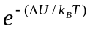.
    - If the random number is less than allow the flip and start again.
    - Otherwise flip the site back to its old state and start again.

Once through this process compromises one iteration of the Metropolis algorithm. In this report the author will use units of SPP which stand for Sweeps Per Point. 1 SPP is equivalent to running N² Metropolis iterations, where N² is the number of spins on the lattice.

Wolff Algorithm
The version of the simulator incorporating the Metropolis algorithm is called BlindWolffLatticeSimulator.

The Wolff algorithm flips clusters of spins at the same:

- Pick a random site on the lattice, call its spin state S_{OLD}.
- Pick a random spin state different to S_{OLD}, call it S_{NEW}.
- Flip the site from S_{OLD} to S_{NEW}.
- Look for nearest neighbours which have spin value S_{OLD}.
- Add them to the cluster with probability 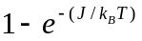.
- Repeat steps 4 & 5 for each site added.
- Once the cluster stops growing, flip all the sites it contains to S_{NEW} and start again.

This implementation uses an array of Booleans to mark each point contained in a cluster. The array is cleared after each iteration. The graphical version uses the Boolean array to decide which spins need to be redrawn.

At high temperatures, the clusters rarely contain more than one site whereas at low temperatures the clusters can fill the entire lattice. The concept of 1 SPP is not used for the Wolff algorithm, as the number of sites visited in one iteration is inversely proportional to the temperature.

ҖCoding BugҖ
The Wolff implementation used in this project uses a recursive algorithm which works faster than many other implementations. However, due to default Java™ Virtual Machine settings, if the clusters get too big, the simulation crashes with a stack overflow error. The work around for this problem is to use small lattices or temperatures which do not create large clusters.

Observables

The observables implemented in this project are:
- Energy per Lattice Point
- Magnetisation per Lattice Point
- Heat Capacity at Constant Volume

Energy
The calculateEnergy method takes the coordinates of a spin on the lattice and compares its spin to it’s 4 nearest neighbours (not diagonals). It returns then energy of the spin.

The total system energy is calculated after initialisation by going through each site in turn, calculating its energy and adding it to the total system energy. When a spin in the lattice is flipped the energy difference of that site due to the flip is ∆U. The change in energy of the nearest neighbours when a spin is flipped is also ∆U, making the total energy change of the system 2∆U.

During each experiment, whenever a spin is flipped, 2∆U is added to the system energy.

Many of the experiments involve changing the temperature of the simulation to see how the system responds. Due to the finite size of the lattice and the stochastic nature of the dynamic algorithms, the system will require a number of iterations before it reaches thermal equilibrium. If an observable is measured before the system has reached equilibrium, the results will not accurately portray the lattice at the required temperature. Further discussion of this point can be found in the Hysteresis Loop experiments.

When an experiment runs, the temperature of the system is updated and the lattice allowed to reach equilibrium. After this point, the system energy at each iteration is stored until the user defined number of iterations is reached and the temperature is updated again. These energies are averaged and divided by N² to give the system energy per site at this temperature.

Magnetisation
In the q-state Potts model, each spin state is orthogonal to all the other states. If the system was behaving paramagnetically (for example, at temperatures above T_{c}, the critical temperature) there will be approximately equal numbers of sites in each state. In the ferromagnetic phase, all the sites will have the same spin value which corresponds to the maximum magnetisation of the system. The overall system magnetisation is defined as the root mean square deviation from the paramagnetic phase:
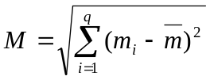
Where 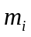 is the number of sites with spin value i and 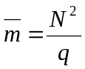, is the average number of sites in each state in the paramagnetic phase. As with the energy, this value is recorded for each iteration (after equilibrium), averaged and divided by N² (normalised) to give the magnetisation per site.

Heat Capacity
The Heat Capacity at constant volume, C_{v}, is defined to be:

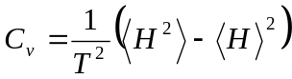
Where the represent the average over all iterations (after equilibrium has been reached) at a given temperature. The C_{v} values are calculated alongside the averaged energy values and are normalised by the number of sites in the lattice.

The output from each experiment is a log file, named by the initial conditions, containing the range of temperatures and all the observables at those temperatures.

Experiments

Five experiments were done, each investigating different properties of the model. A description of each is given below:

1. Check Analytical T_{c} Predictions
Number of Experiments: 2
Algorithm Used: Metropolis
Lattice Size: 64 by 64
States: 3, 5
Temperature Range: 2.0 to 0.0
Temperature Step: -0.001
SPP: 1000
Notes:
The point of this experiment was to obtain the Critical Temperature to a high accuracy. The first set of experiments sweeps a large temperature range to find the phase transitions for the different q values.

Number of Experiments: 2
Algorithm Used: Wolff
Lattice Size: 512
States: 3, 5
Temperature Range: Theoretical T_{c}±0.002
Temperature Step: 0.0001
Iterations: 1000000
Notes:
The second set of these experiments used a large lattice, very small step size and many iterations to find the Phase Transitions to a high accuracy.

2. Investigate how the Hysteresis Loop depends on the number of sweeps at each temperature
Number of Experiments: 16
Algorithm Used: Metropolis
Lattice Size: 64
States: 3, 5
Temperature Range: 2.0 to 0.0 (Cooling), 0.0 to 2.0 (Heating)
Temperature Step: 0.001
SPP: 1, 10, 50, 100
Notes:
For each different SPP value, heating and cooling experiments were run for the 3 and 5 state model.

3. Investigate how the Hysteresis Loop depends on Lattice size
Number of Experiments: 12
Algorithm Used: Metropolis
Lattice Size: 32, 64, 128
States: 3, 5
Temperature Range: 2.0 to 0.0 (Cooling), 0.0 to 2.0 (Heating)
Temperature Step: 0.001
SPP: 10

4 Investigate the Effects of Finite Size Scaling
Number of Experiments: 20
Algorithm Used: Wolff
Lattice Size: 32, 64, 72, 256, 512
States: 5
Temperature Range: Theoretical T_{c} ± 0.2
Temperature Step: 0.0005
Iterations: See Notes
Notes:
The number of Wolff iterations in each separate run of this experiment was determined based on computational time and accuracy of the required result. For small lattices few iterations are required to produce sharp T_{c} values but as the lattice size goes up the number of required iterations goes up exponentially.

5. Calculate the Critical Exponent of Heat Capacity
Number of Experiments: 2
Algorithm Used: Wolff
Lattice Size: 64, 128, 256
States: 3
Temperature Range: 98% of T_{c}, 99% of T_{c}
Temperature Step: See Notes
Iterations: 100000
Notes:
At temperatures close to T_{c} the Heat capacity is related to the temperature by:
Take measurements of the heat capacity at two temperatures close to T_{c}, T₁ and T₂:
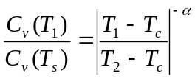
Set T₁ = 0.98T_{c} and T₂ = 0.99T_{c}
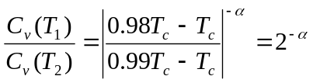

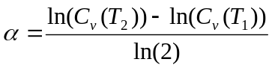
This equation was used to make an estimate of .

Results

Experiment 1 - Check Analytical T_{c} Predictions
The first run is over a large temperature range to give a rough estimate of the critical temperature:
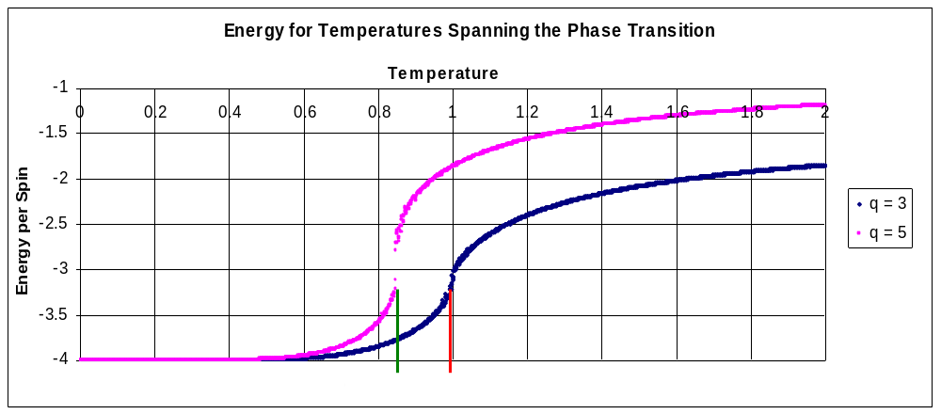
Chart 1: Energy for Temperatures Spanning the Phase Transition

The Theoretical T_{c} for the 3 and 5 state models are 0.9949 and 0.8515 respectively and have been marked on for comparison. The results in Chart 1 show a definite change in energy at the theoretical temperatures. The 5 state model shows a bigger energy change than the three state model, which suggests that they are of a different order. A graph of the magnetisation against temperature for each model has been included in the appendix (Chart 22).

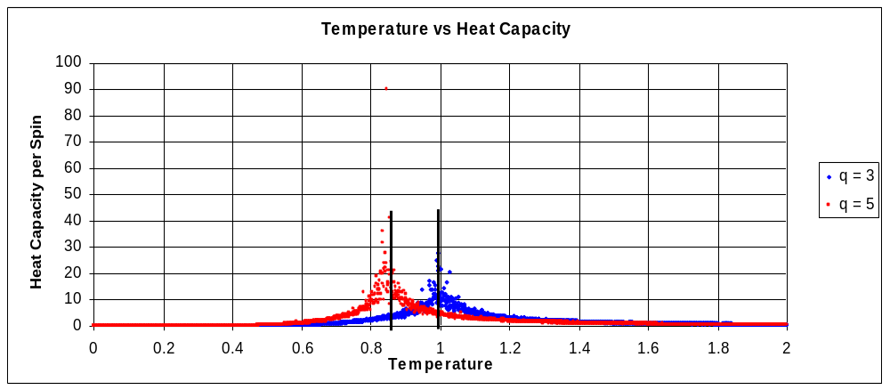
Chart 2: Heat Capacity for Temperatures Spanning the Phase Transition

Chart 2 shows the Heat Capacity from the same experiments. Both models show peaks close to the theoretical temperatures, but not exactly. The 5 state model shows a maximum C_{v} almost 5 times higher than the three state model. In a perfect simulation, the 5 state C_{v} should go to infinity (discontinuity) and the 3 state remain continuous.
The second set uses a much tighter temperature range and a lattice size of 512 by 512 to find the phase transition and its nature to a higher accuracy:
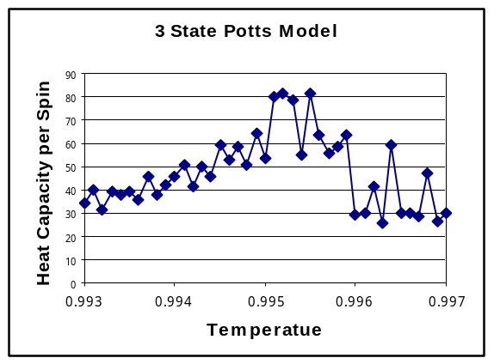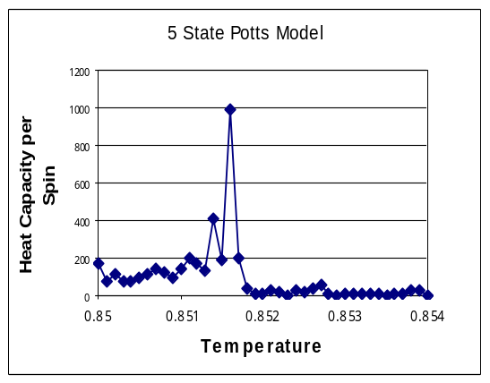
Chart 3 & 4: Heat Capacity right around the critical temperature for the 3 and 5 state model

Charts 3 & 4 show the difference between a first order and second order transition more clearly. The three state model has no definite peaks but changes smoothly at 0.995, strong evidence that a second order transition occurs at this point. The five state model has a sharp peak at 0.825 which coincides perfectly with analytical results and strongly suggests a first order transition.

No errors were taken into account during this experiment as it was a qualitative check that the simulation works and agrees with known results.

Experiment 2 - Investigate how the Hysteresis Loop depends on the number of sweeps at each temperature

3 State Model
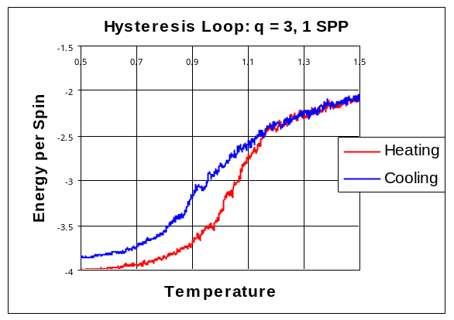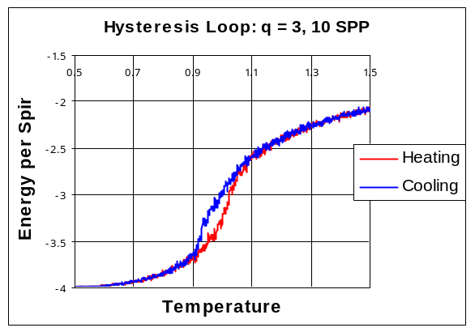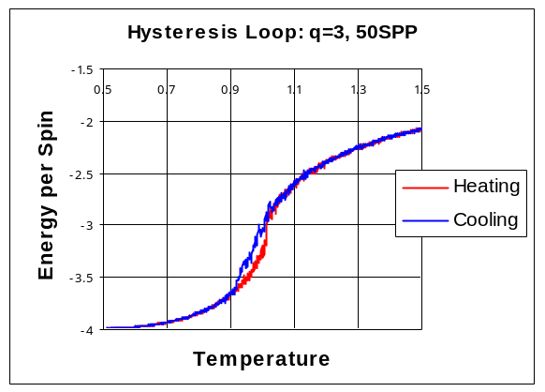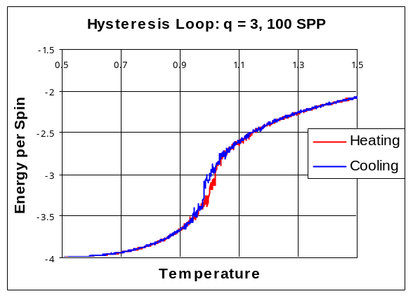
Charts 5,6,7,8: How the Hysteresis Loop changes with SPP in the 3 state Model on a 64 by 64 Lattice

The Hysteresis loop gets smaller as the number of iterations at each temperature goes up. This makes physical sense as the system has more ‘time’ to equilibrate at each temperature, reducing the difference between heating and cooling.

Chart 5 shows the Hysteresis loop for the 3 state Potts model when 1 SPP (4096) iterations are performed at each temperature. On cooling, the energy does not reach the minimum value, even at T=0. Using very few iterations like this is equivalent to cooling the lattice very quickly and stable spin clusters form:
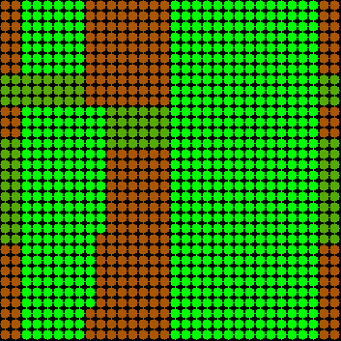
Fig 2: Screenshot from the Graphical 3 State Simulator showing Stable Clusters at T=0

The stable clusters have straight edges, as the Hamiltonian for this model does not include diagonal interactions.

5 State Model
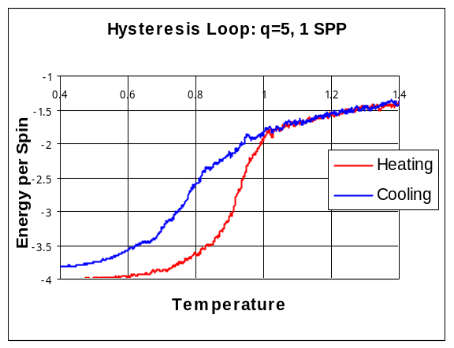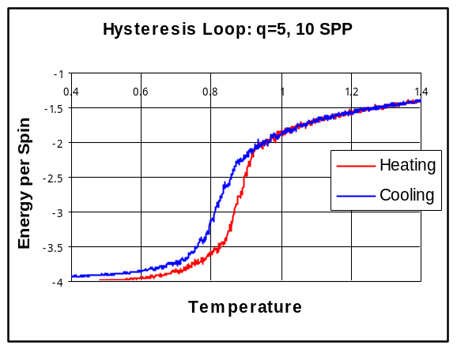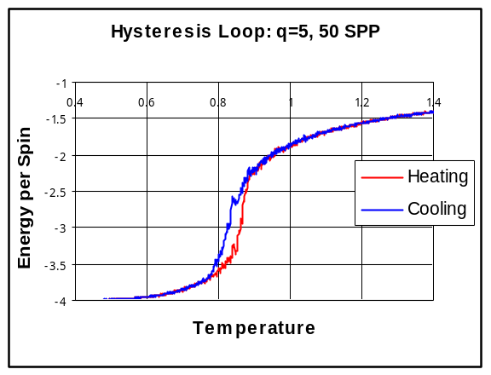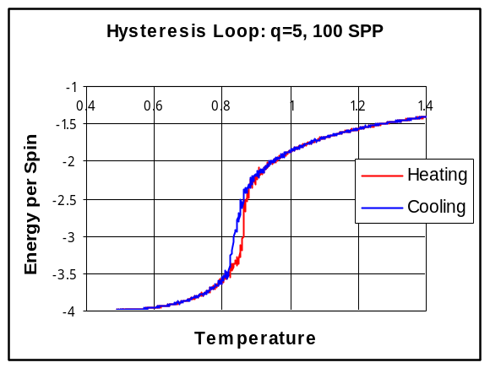
Charts 9, 10, 11, 12: How the Hysteresis Loop changes with SPP in the 5 state Model on a 64 by 64 lattice

The results for the 5 state model show a similar trend to the 3 state model, the Hysteresis loop gets smaller as the number of iterations goes up. However, the 5 state loop is bigger than the 3 state loop for the same conditions. This suggests that the 5 state model takes more iterations to reach equilibrium.

In one iteration, the simulator picks a random site and a random state for the site. As the number of states goes up, the probability of picking a state which pushes the system closer to equilibrium goes down. Therefore more iterations are needed to reach equilibrium.

Charts 8 & 12 show that when 100 SPP are performed on the lattice, the Hysteresis loop almost vanishes. These results show that performing 100 SPP on the lattice leaves it at, or very close to equilibrium. Measuring observables after equilibrium has been reached gives more accurate results. In the other experiments utilising the Metropolis Algorithm this information was used.

Experiment 3 - Investigate how the Hysteresis Loop depends on the size of the Lattice

3 State Model
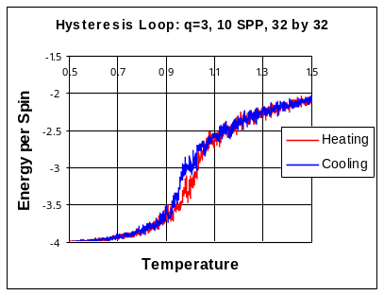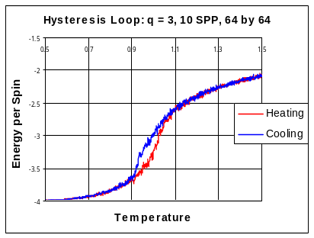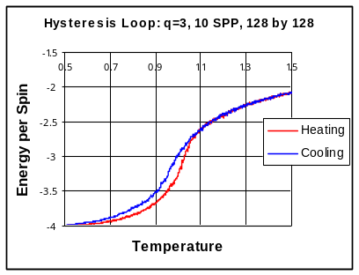
Charts 13, 14, 15: How the Hysteresis Loop changes with Lattice size in the 3 state model.

5 State Model
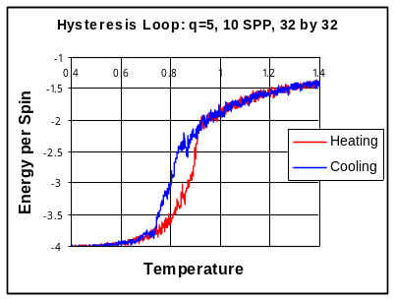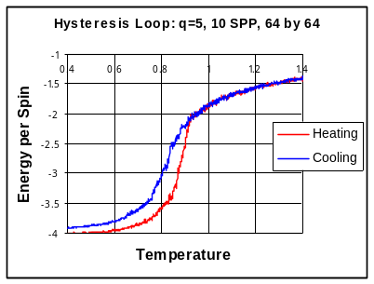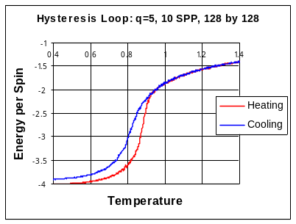
Charts 16, 17, 18: How the Hysteresis Loop changes with Lattice size in the 5 state model.

Charts 13-18 show that the Hysteresis Loop is approximately the same size for different lattice sizes. This is because the number of iterations on each lattice was scaled with the lattice size; each of these experiments ran 10 SPP so each spin was updated approximately 10 times per temperature, independent of the number of spins.

Experiment 4 - Investigate the Effects of Finite Size Scaling

The q=5 phase transition has a peak in the heat capacity at the critical temperature, but this temperature is different for different sized lattices. The first stage of the experiment was to find the phase transition for different lattice sizes:

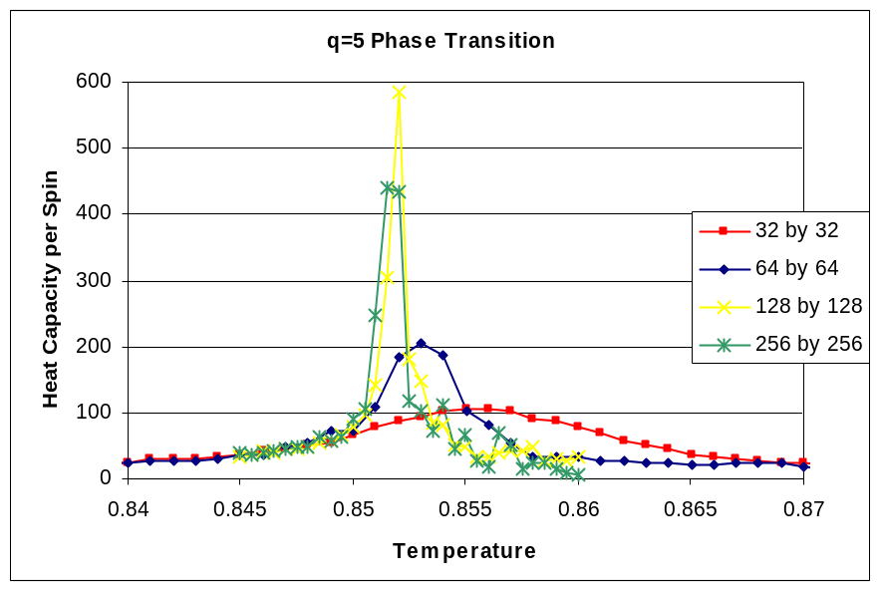
Chart 19: Finding the Phase Change on different Sized Lattices

The critical temperatures were taken at the maximum C_{v} values for each size. The temperature step size for these experiments were 0.001, so the phase transition could be within ±0.0005 of the maximum peaks.

Plotting the inverse size against the critical temperatures gives:

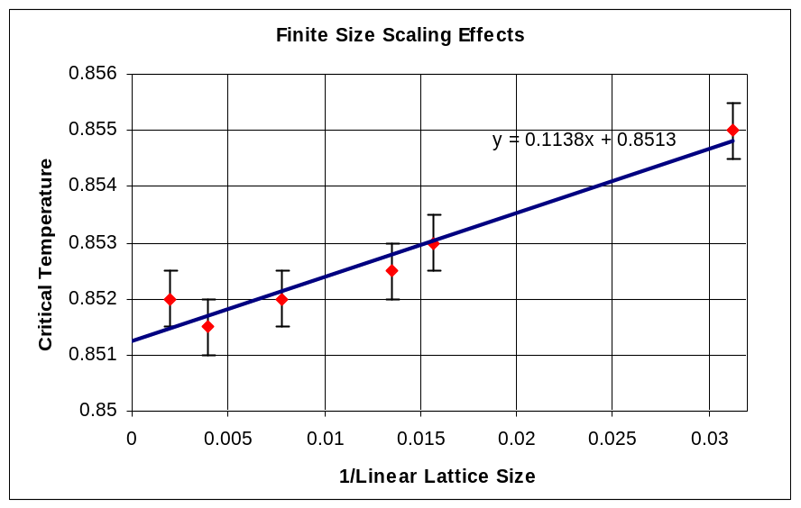
Chart 20: Critical Temperature vs. Inverse Lattice Size

By extrapolating the linear fit to zero, and using the error bars to find the upper and lower bound, the critical temperature of an infinite lattice was calculated to be 0.8513±0.0004. The theoretical value is 0.851528.

Experiment 5 - Calculate the Critical Exponent of Heat Capacity

The Heat Capacity Critical Exponent was calculated using:

Where T₁ = 0.98T_{c} = 0.9750 and T₂ = 0.99T_{c} = 0.9850

To find the required Heat Capacities for an infinite lattice, experiments were performed on lattice sizes of 64, 128 and 256 and extrapolated to infinity using the same technique as Experiment 4, Chart 20. Three experiments were done on each lattice size in order to reduce errors:

Size | Inverse Size | 98 percent T_{c} |  |  | Mean | Std Dev
64 | 0.015625 | 12.8107 | 12.5674 | 12.9195 | 12.7659 | 0.1803
128 | 0.0078125 | 13.0691 | 12.7750 | 12.5661 | 12.8034 | 0.2527
256 | 0.00390625 | 13.0134 | 12.7757 | 12.5688 | 12.7859 | 0.2224
 |  | 99 percent T_{c} |  |  | Mean | Std Dev
64 | 0.015625 | 17.9774 | 17.0702 | 18.1887 | 17.7454 | 0.5942
128 | 0.0078125 | 17.3058 | 17.4701 | 17.7981 | 17.5247 | 0.2506
256 | 0.00390625 | 16.8331 | 18.2751 | 17.9133 | 17.6738 | 0.7502
Table 1: Heat Capacity at 98% & 99% of Tc on different Sized Lattices

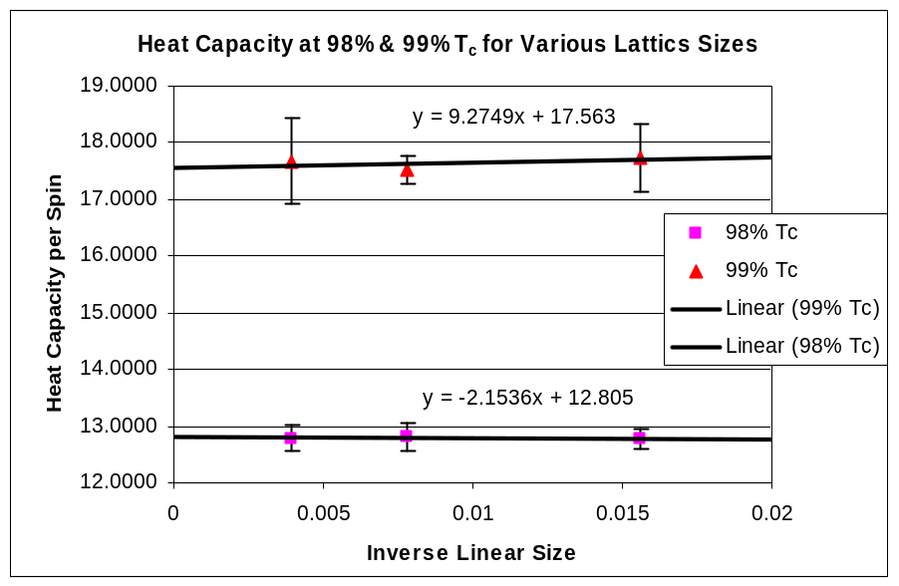
Chart 21: Calculating Heat Capacities on an Infinite Lattice (error bars are ± 1 standard deviation)

Using this data:
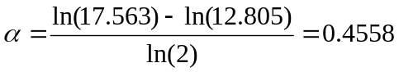
Upper and lower bounds were calculated from the graph to give the final result as 0.4558 ± 0.2381. The Critical Exponent calculated from theory is 0.296 ± 0.002.
The technique used to calculate in this experiment only considers two points on the curve and is therefore subject to large errors.
Conclusion
The results obtained from this investigation are consistent with the known theory. The simulator correctly implements the q-state Potts Model, the Metropolis algorithm and the Wolff algorithm.

Further extensions to this project could be to investigate the cluster growth at zero temperature in more depth, and experiment with different lattice geometries.

Future extensions to the simulator itself could include a built in experimental ‘lab’ where whole sets of experiments are run in a Graphical User Interface and the results automatically displayed in a variety of formats.

If the investigation was repeated, possible changes would be:
- Write the experimental versions of the simulator in C for better performance, allowing more accurate results to be obtained.
- Include a non recursive implementation of the Wolff Algorithm which does not suffer from the large cluster crash bug.
- Use a different method to estimate the Critical Exponent, incorporating more data points for higher accuracy.
- Include an error calculation algorithm in the code.
References

N. Metropolis, A.W. Rosenbluth, M.N. Rosenbluth, A.H. Teller, E. Teller, “Equation Of State Calculations By Fast Computing Machines.”, J.Chem.Phys.21:1087-1092, (1953)

Ulli Wolff, “Collective Monte Carlo Updating For Spin Systems.”, Phys.Rev.Lett.62:361, (1989)

Lars Onsager, “Crystal Statistics. I. A Two-Dimensional Model with an Order-Disorder Transition”, Phys. Rev. 65, 117–149 (1944)

F. Y. Wu, “The Potts model”, Rev.Mod.Phy., Vol. 54, No. 1, (1982)

R Zwanzig and J D Ramshaw, “Potts model specific heat critical exponents”,
J. Phys. A: Math. Gen. 10 65-69, (1977)

Glenn Elert, “Curie Temperature of Iron”, The Physics Factbook, http://hypertextbook.com/facts/2002/FeliciaLau.shtml, (2004)

Peter Meyer, “Computational Studies of Pure and Dilute Spin Models”, http://www.hermetic.ch/compsci/thesis/index.html, (July 2000)

Paul Coddington, “Monte Carlo Simulation for Statistical Physics”, http://www.npac.syr.edu/users/gcf/cps713montecarlo/p_montecarlo.html, (2004)

Appendix

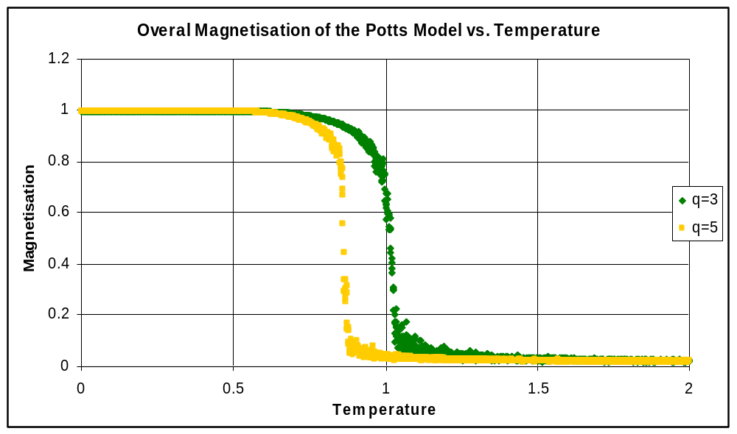
Chart 22: Magnetisation vs Temperature for the q=3 and q=5 Potts Models

This chart was left out of the body of the report as it does not give any more information than the energy-temperature chart. It is shown here for reference.

Instructions for using the Graphical Simulator:

When the program loads, it is using the Wolff algorithm on the 3 state model at the critical temperature.
The Metropolis button swaps between the Wolff and Metropolis algorithms as the simulation is running.
If any of the text fields are changed, the update button has to be pressed to read the new values into the simulator.
If the simulation is paused, the reset button changes to the update button, which allows the user to watch every step of the Dynamic algorithm.

To avoid the recursive Wolff cluster bug, use small lattices when at low temperatures.

Only the code for the graphical version is included in this appendix, the majority of the code is common to all three versions.

The Heat Capacity can be approximated by a series expansion about the critical temperature, T_{c}. At temperatures close to T_{c}, only the leading term in the expansion is significant.

