**MARYMOUNT UNIVERSITY**

**Assignment:** IT520; Enterprise Infrastructure and Networks

**Assigned:** February 6, 2018

**Instructor:** Dr. Ibrahim Waziri

**Student Name:** George Boakye

**QUESTIONS**

1. Is your browser running HTTP version 1.0 or 1.1? **ANSWER:** HTTP/1.1

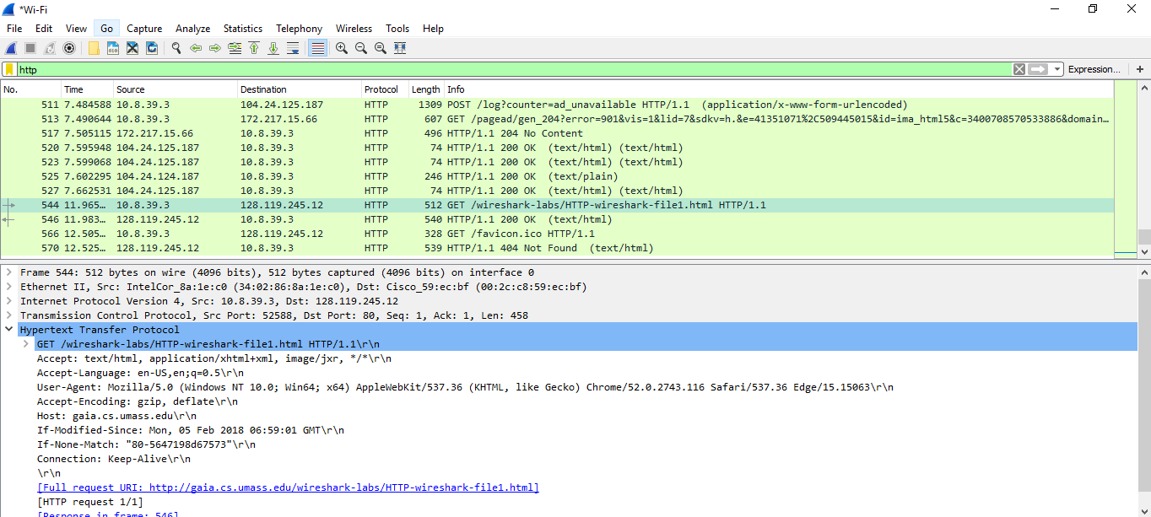

1. When was the HTML file that you are retrieving last modified at the server? Last Modified since Feb 06, 2018: 06:59:01 GMT

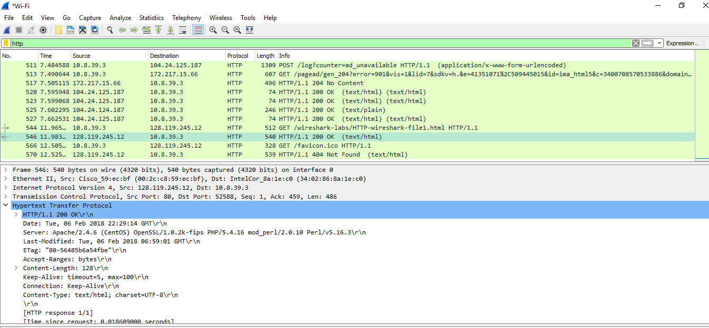

1. What is the IP address of your computer? Of the gaia.cs.umass.edu server?

**ANSWER:** Src IP: 10.8.39.3 Dst IP: 128.119.245.12­­­­­

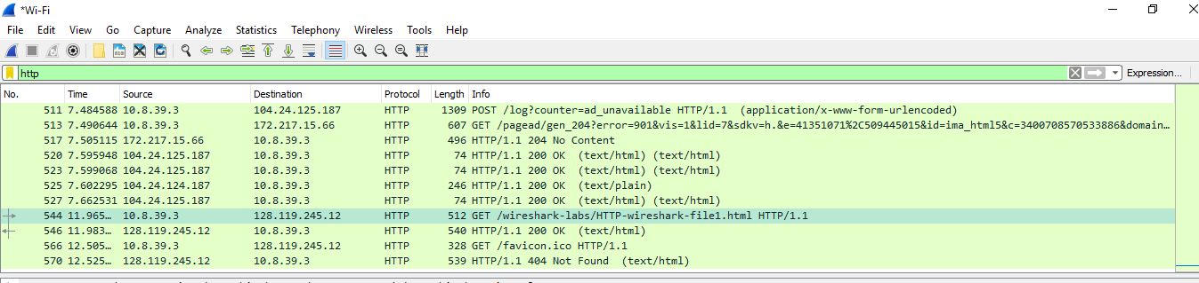

­­­­­­­

1. What languages (if any) does your browser indicate that it can accept to the server? **ANSWER:** English; US

