**MARYMOUNT UNIVERSITY**

**Assignment:** IT520; Enterprise Infrastructure and Networks

**Assigned:** February 6, 2018

**Instructor:** Dr. Ibrahim Waziri

**Student Name:** George Boakye

**QUESTIONS**

1. What is the TCP port number used by your computer to communicate with gaia.cs.umass.edu?

**ANSWER:** 56658

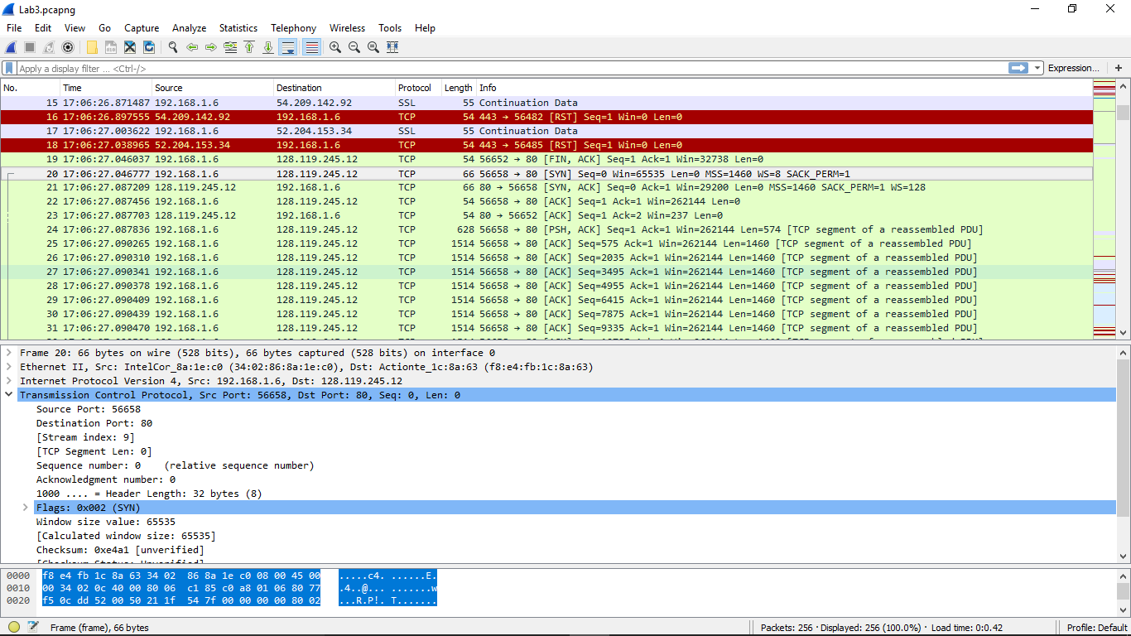

1. What is the TCP port number used by gaia.cs.umass.edu to communicate with your computer?

**ANSWER:** 80

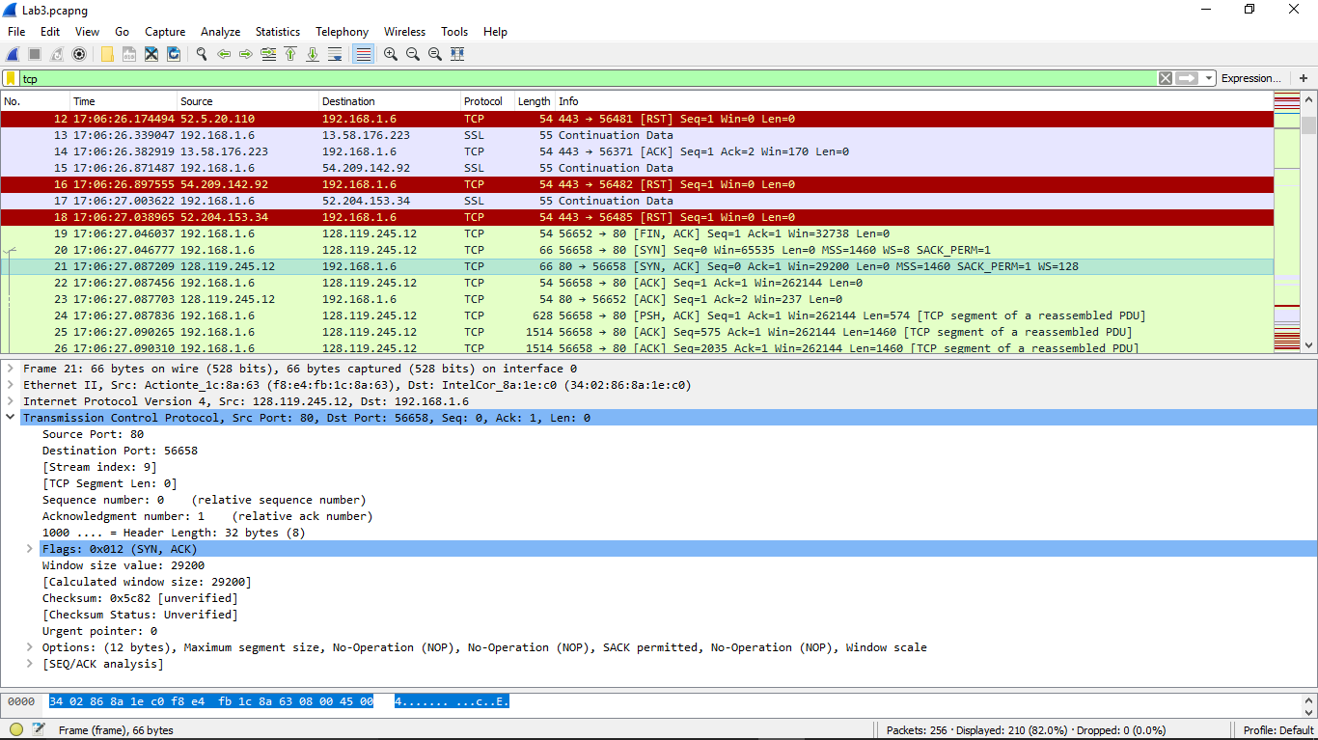

1. What is the sequence number of the TCP SYN segment that is used to initiate the TCP connection between your computer and gaia.cs.umass.edu? What is it in the segment that identifies the segment as a SYN segment?

**ANSWER:** Seq=0. This is the first byte of the data stream which is 32 bytes with ACK 0 for establishing a reliable data transfer

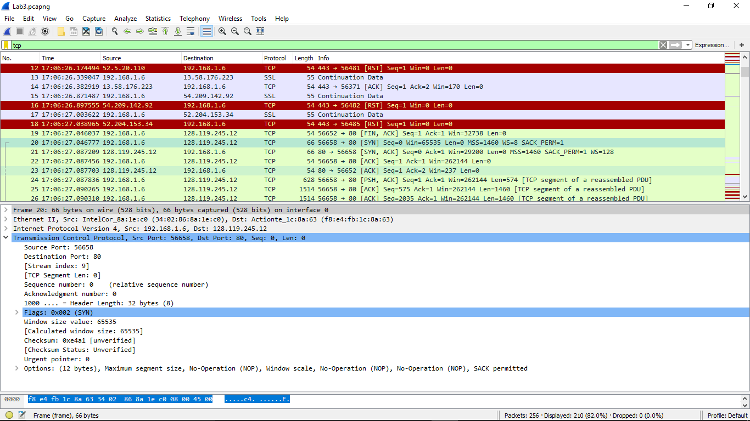

­­­­­­

1. What is the sequence number of the SYNACK segment sent by gaia.cs.umass.edu to the client computer in reply to the SYN?

**ANSWER:** Seq=0

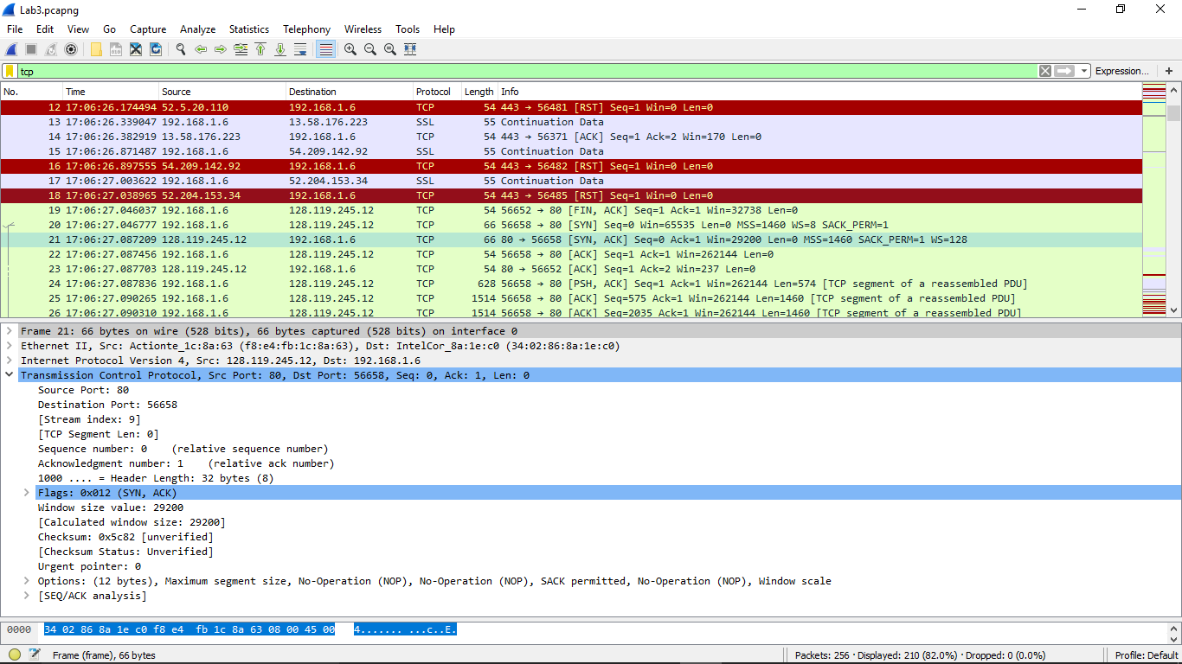

1. What is the sequence number of the TCP segment containing the HTTP POST command?

**ANSWER:** Seq=1

