**MARYMOUNT UNIVERSITY**

**Assignment:** IT520; Enterprise Infrastructure and Networks

**Assigned:** February 13, 2018

**Instructor:** Dr. Ibrahim Waziri

**Student Name:** George Boakye

**QUESTIONS**

1. What is the IP address of your computer?

**ANSWER:** 192.168.1.5

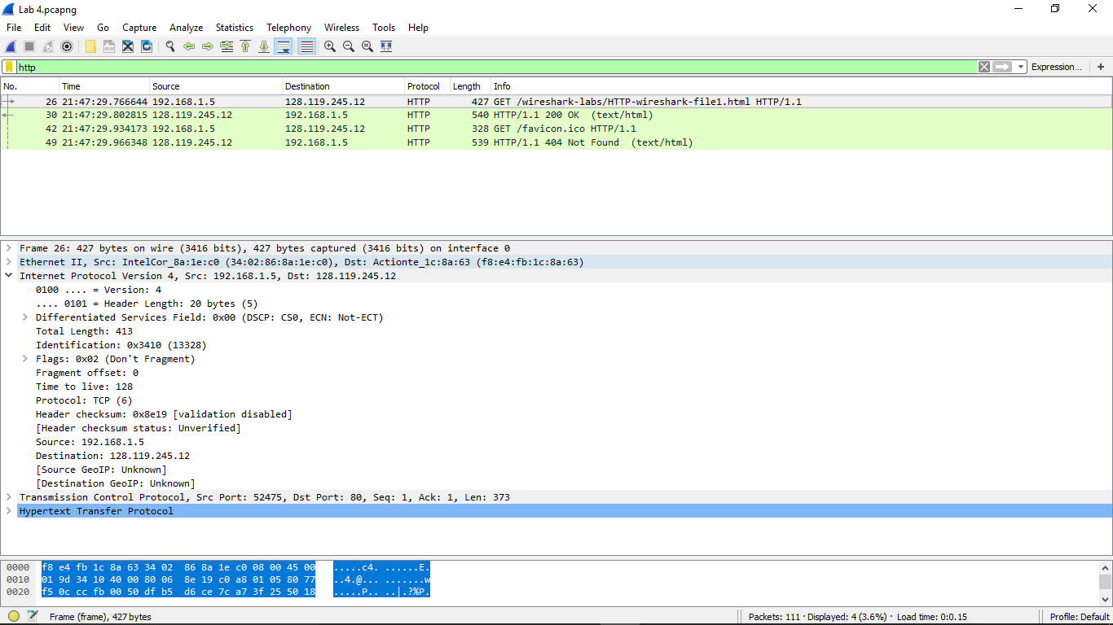

1. What is the total length of the datagram?

**ANSWER:** 413



1. Has this IP datagram been fragmented?

**ANSWER:** No. “Don’t Fragment” is set under Flags

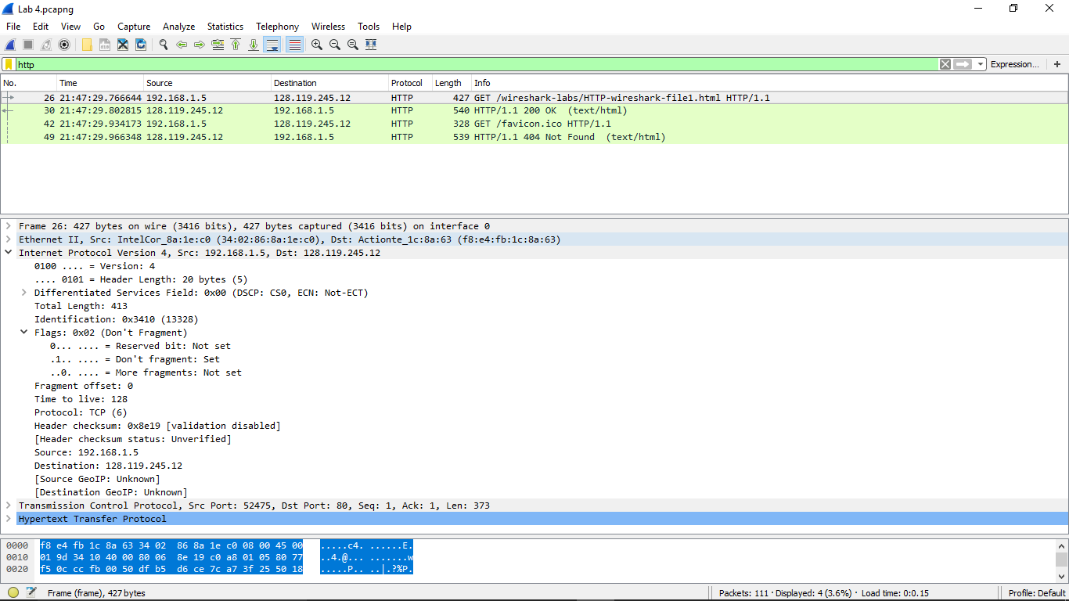

­­­­­­

1. How many bytes are in the IP header?

**ANSWER:** 20 bytes



1. How many bytes are in the payload of the IP datagram? **ANSWER:** 395 bytes

**EXPLANATION**

Because the datagram carries a TCP segment and is a nonfragmented datagram, there’s a total header of 20 bytes (i.e. TCP header [20 bytes]) that encapsulates the actual message from the application-layer.

Therefore: Total Length = 413bytes minus 20bytes (i.e. Ht), This gives 395bytes as the payload

