Contents
1. Visualisation 2
Dependency Note: 2
1.1. Kingbase chess games visualisations 2
1.1.1. Distribution of Game Outcomes 3
1.1.2. Number of yearly Games 4
1.1.3. Heat map showing the starting moves of winners 4
1.1.4. Number of Game Moves box plot 6
1.2. Bad Visualisation 6
2. Data Science 8
Dependency Note: 8
2.1. Nature of Data supplied 8
2.2. Features of Interest 10
2.3. Visualisations 12
2.3.1. Property type price Count Distribution 12
2.3.2. Property type area count Distribution 13
2.3.4. Property type – price Box Plot 14
2.3.4. Box-plot of Property Type vs. Area 15
2.3.5. Most popular localities 16
2.3.6. Geo-visualisation of the mean price 17
2.3.7. Advertisement count on Sundays and other days 17
2.3.8 Mean Price on Advertising Days 19
2.4. Statements 20
2.5. Statistical Analysis 21
2.6. Predictive Model 23
References 24

1. Visualisation

Dependency Note:
The R scripts mentioned in this section make use of the following libraries.
SQLite
stringr
RcolorBrewer
ggplot2
These packages can be installed using the following statement:
install.packages(c("RSQLite", "stringr”, ”RcolorBrewer",”ggplot2”))

1.1. Kingbase chess games visualisations

The Kingbase chess data set available on (http://www.kingbase-chess.net/) was explored through the use of a number of visualisations. The visualisations helped in getting an understanding of:
- the distribution of result outcomes (i.e. number of white wins, black wins and draws)
- the variation of the number of moves required to complete the game with time.
- The most common starting move of the winner.
- The number of games played each year

The size of the data set was larger than 1GB. This implied that the files could not be loaded and processed at one go in memory. A buffer of 10000 lines was hence iteratively used to read the file contents. The string inside this buffer (concatenated with any unparsed string left from the previous buffer) was parsed using the pgn format specification found in [1]. It was assumed that the files obeyed the pgn file format. A number of features were extracted from each parsed game, namely:
- event name
- date of game
- site
- result
- first move of the winner

Each of these features were stored in an sqllite database (task1/db/chess.db). This file was not included since it was over 120MB. This database was then queried to extract the necessary information that allowed the following visualisations to be created. Given that the *.pgn files are in task1 directory, the sqllite database can be populated again with this data by running the following statement in a bash shell. This will however take a considerable amount of time. It is advised to skip the execution of this statement and continue with the next steps to retrieve the visualisations.
cd task1
./loadChessData.sh *.pgn

The required data for this visualisation has been already extracted and stored in task1/.RData file. The number of games loaded from the pgn files amount to 1861460 rows. The visualisations described below can be generated by running the chessVisualisation.R script in an interactive R shell:
source(chessVisualisation.R)
Running the following functions will generate the visualisation that describe aspects of the loaded chess games:
plotYearlyGames()
winningMovesHeatMap()
moveInGameBoxPlot()
resultCountBarPlot()

The visualisations generated by these functions will be discussed in more detail.

1.1.1. Distribution of Game Outcomes
Chart 1: Distribution of game outcomes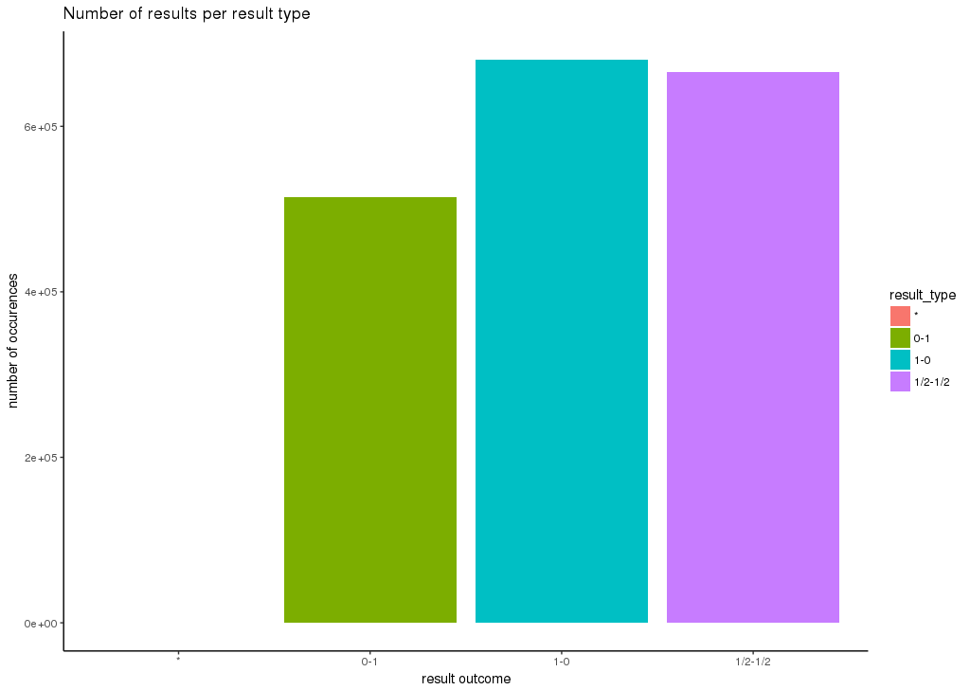

The outcome of the 1861460 games is depicted in chart 1. One can note that the number of wins and draws is considerably higher than black wins. This may suggest that a white player might have a better chance of winning the game. The number of games whose outcome is described with (*) is negligible when compared with the counts of the other result outcomes.

1.1.2. Number of yearly Games
The processed Kingston data set contains chess games ranging from 1990 to 2016 (actually 2016/02). One can note that the number of chess games increases to over 90,000 games per year between 2006 to 2014. The number of yearly games decreases drastically in 2015 and 2016.
Chart 2: Number of yearly games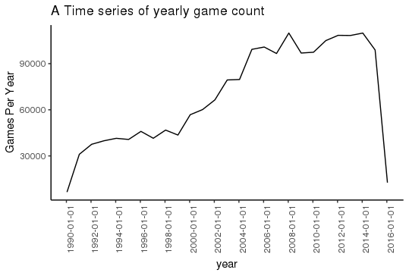

1.1.3. Heat map showing the starting moves of winners
The above heatmap allows the viewer to observe the most common starting moves that led the player to win the game. The heat map shows that the most common starting position is e4, followed by c5, d4, c4 and d5. The most common move is consistent with the previously discussed fact that white wins are higher than black wins since only the white player can start with c4.

Chart 3: Most common starting move of winners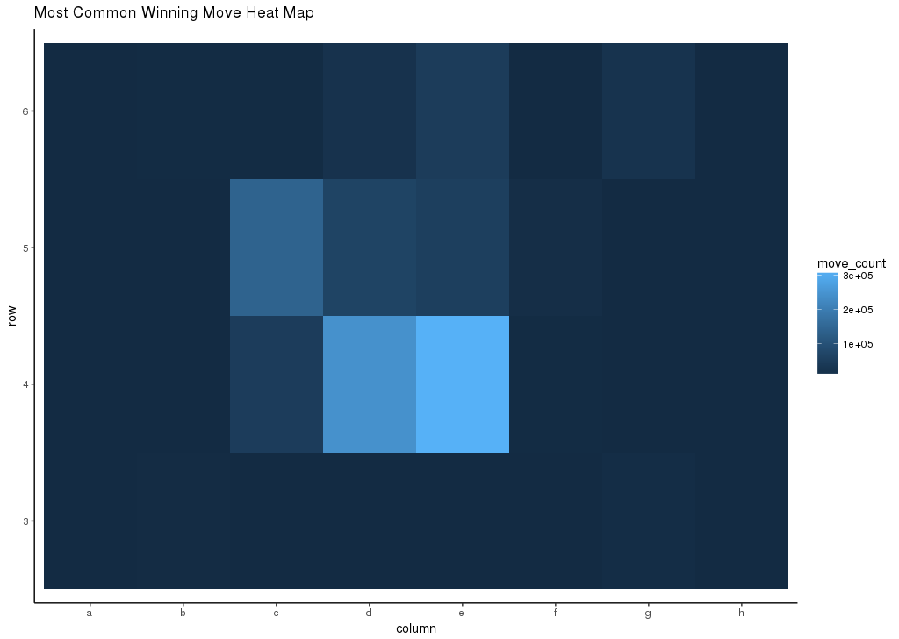

1.1.4. Number of Game Moves box plot
Chart 4 shows a box plot of the number of moves found in chess games grouped every 5 years. One can note that the mean and interquartile range are almost equal for the 5 year groups. Another interesting fact is that the outliers consist of chess games that have more than 75 moves.
Chart 4: Number of Game Moves box plot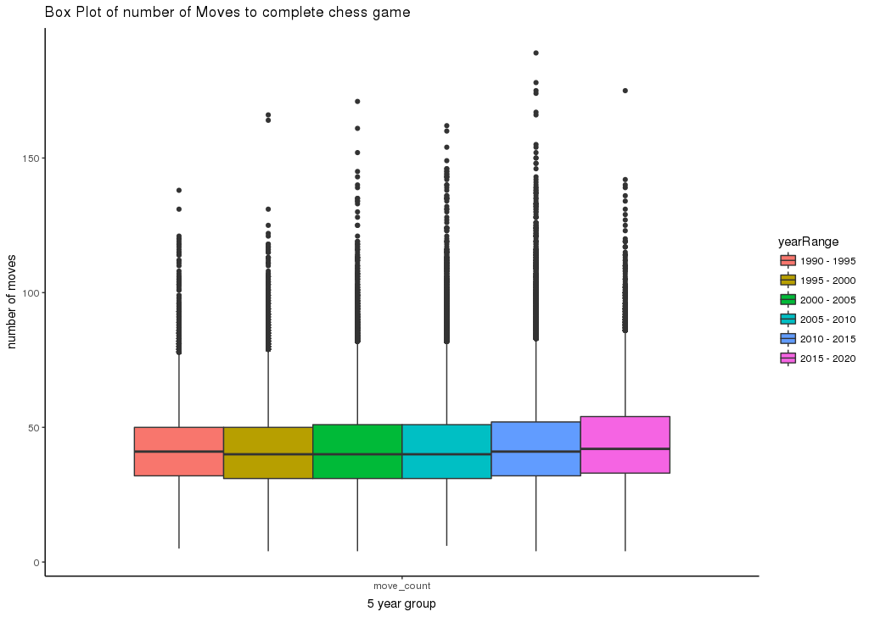

1.2. Bad Visualisation

The following visualisation (chart 5) was taken from an online Times of Malta Article 'Malta ranked second safest place in the world for natural disasters' that appeared on 4th June 2016 [4]. This article used a pie chart to compare the risk of Malta when compared with the 3 three highest natural disaster risk considered countries.
This visualisation does not help in identifying whether Philippines and Vanautu’s natural disaster risk is higher since their size is almost the same. The chart does not attach the numerical value (such as percentage risk) to the slices. Furthermore, the size are not ordered by size, making it difficult for the reader to compare.
This visualisation was re-implemented in R as a bar plot in chart 6. One can note that it is easier to compare the risk percentages for the Philippines and Vanuatu. The risk percentage can be determined easily for each graph. It is much easier to note Malta's low risk when compared to the other countries since a comparison by height is easier than by angle [2]. This visualisation was generated by the script extractPieChartInfo.R.
Chart 5: A 'terrible' visualisation

Chart 6: Re-implementation of the 'terrible' visualisation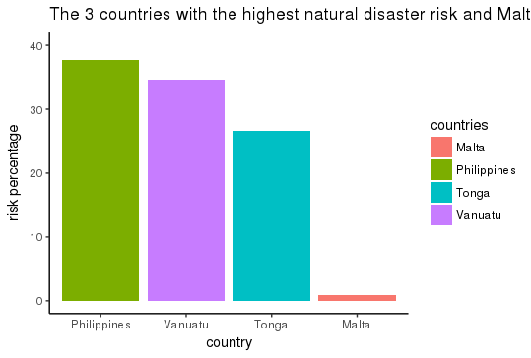

2. Data Science

Dependency Note:
The R scripts mentioned in this section make use of the following libraries.
- caret
- e1071
- ggmap
- ggplot2
- reshape2
- rvest
- stringdist
- stringi
- stringr
- tm

These packages can be installed using the following statement:
install.packages(c("caret","e1071","ggmap",
"ggplot2","reshape2","rvest",
"stringdist","stringi,
"stringr","tm"))

2.1. Nature of Data supplied
The supplied text files contain the html mark-up of the Times of Malta property advertisements published between 2015-04-16 to 2016-11-22. A word frequency analysis shows that the most frequently occurring words are 'property' and 'sale'. These advertisements feature from 539 different editions. The date range for which no advertisement was found on those days can be found in Table 1. One can note that the largest date range that for which no advertisements feature is 6 days. This information was extracted using advertismentsDates.R.
The number of advertisements on Sundays is much higher than the number of advertisements on other days. The number of such advertisements on Sunday ranges from 200 to 600. A typical week day has less than 40 advertisements. This will be discussed in more detail in the next sections.
Date from | Date To | Date Difference
2015-04-29 | 2015-05-05 | 6
2016-06-29 | 2016-07-04 | 5
2016-11-03 | 2016-11-08 | 5
2015-10-01 | 2015-10-05 | 4
2016-02-25 | 2016-02-29 | 4
2016-08-04 | 2016-08-08 | 4
2016-10-30 | 2016-11-02 | 3
2015-07-21 | 2015-07-24 | 3
2015-10-30 | 2015-11-02 | 3
2015-12-24 | 2015-12-27 | 3
2016-03-04 | 2016-03-07 | 3
2016-07-11 | 2016-07-14 | 3
2015-05-26 | 2015-05-28 | 2
2015-08-07 | 2015-08-09 | 2
2015-10-07 | 2015-10-09 | 2
2016-01-04 | 2016-01-06 | 2
2016-03-24 | 2016-03-26 | 2
2016-05-16 | 2016-05-18 | 2
2016-06-02 | 2016-06-04 | 2
2016-06-11 | 2016-06-13 | 2
2016-06-13 | 2016-06-15 | 2
2016-06-20 | 2016-06-22 | 2
2016-06-27 | 2016-06-29 | 2
2016-08-21 | 2016-08-23 | 2
2016-08-30 | 2016-09-01 | 2
2016-09-15 | 2016-09-17 | 2
2015-10-25 | 2015-10-26 | 1
Table 1: The range of days for which no advertisement was found.
A closer look at the content shows that most of the advertisements have the same structure:
- start with the locality of the property. Apart from a handful of properties found in France or Sicily (in Ragusa), most properties are located on the Maltese islands with the exception of few places. However a high number of Maltese localities were spelt incorrectly. For example, "GĦOCHARGĦOCHUR" rather than "GĦARGUR" or "BIROCHŻEBBUĠA" rather than "BIRŻEBBUĠA". In some cases, the locality was less specific than in other adverts. For example, Cottonera was used in certain adverts. On the other hand, other adverts specifically mentioned a city in Cottonera (e.g. Vittoriosa).
- mention the property type (e.g. Apartment, villa, maisonette)
- have one (or more) contact numbers
- a price given in Euro. Sometimes, the price is expressed per square meter. Large values were expressed as kilo (e.g. 20K) or as million (e.g. 2.5m). Occasionally, the price was incorrect due to a typing error (250,000 instead of 250m000).
- Area. This is expressed normally in square meters. However, in the case of fields or plots the area can be also found expressed in hectares (ha) or tumoli (especially for property located in Gozo). Occasionally, the area is expressed by length and breadth.
- An advantage that this property has due to its position (such as sea view).
- Other property features (such as pool and garages).
There are some advertisements placed by developers or real estate brokers (such as 'PROPERTIES for sale on www' or 'PRICE REDUCTIONS this week on properties'. In general, such advertisements do not contain the properties mentioned previously such as locality, area or even price and are quite vague.

2.2. Features of Interest
As previously mentioned, most of the adverts describe the property in terms of its locality, area, price as well as the type of property (such as apartment, maisonette or villa). These are in fact the features of interest that capture the reader's attention. The other features (whether the property has a garage, pool, located by the sea) strike first the attention of a smaller subset of readers (such as wealthier people). For this reason, the following attributes were selected from each advert.
- Advert Date: The date when the property was advertised.
- Contact Number: The contact number was extracted since it allows the particular property to be identified when compared to other properties. In this way, an advertisement of a 20K apartment of Sliema with contact number 123 would be considered different from an advertisement of a 20K Sliema apartment whose contact number is 456. The absence of a contact number would make these adverts equivalent and considered as duplicates.
- Area: The area in square meters (if it exists). Regular expression were used to express the area that is possibly expressed in square meters, hectares or tumoli. The value are then converted accordingly.
- Price: The property's price is extracted in euro. Any prices expressed as millions or thousands (ie. 'm' or 'k')
- Property Type: The property type. The possible types were determined after extracting the most common nouns from the entire corpus and seeing which of these describe a property type. Adverts that do not have any of these nouns are removed.
- locality: The locality is extracted from the first phrase of the advertisement. The possible correct localities were identified and placed in a text file (places.txt). The extracted locality was first passed through a locality mapper that attempts to correct (or generalise) the locality. For example, the localities 'Birgu' and 'Vittoriosa' would be mapped to Cottonera. On the other hand, 'Tower Road' is mapped to 'Sliema'. If this mapping failed, the levenshtein distance of every locality in places.txt is computed with the extract locality. The word with the least distance is selected as the locality.

The extracted features are then placed in a CSV file. This CSV file can contain duplicates since the same property could be advertised in more than one edition. Filtering only unique CSV files through a bash shell allowed duplicate adverts to be removed:

cat extracted_features.csv | sort | uniq

The feature extraction, data cleaning and duplicate removal is achieved by executing the following script. The R script invoked from this scripts reads the html text files from under a ‘data’ folder found in the same directory.

./extractPropertiesToCsv.sh
This will generate three CSV files:
- extracted_features.csv: the CSV file with the extracted features. This is the source file from where the next 2 files will be generated.
- extracted_with_date_unique.csv: the unique features with the advert date.
- unique_features.csv: the unique features without the advert date.

The last 2 files allow us to extract information related both to what has been advertised over time as well as the unique adverts (not on the date of advertisment). The visualisation, statistical analysis and model prediction will be built over these 2 csv files.

The extracted adverts in the generated CSV files contain missing information. There are instances where at least one the attributes is missing. All adverts with a missing locality are removed since it is difficult to infer the locality from the other attributes at this stage of this data science project. Furthermore, the adverts with more than one missing attributes are removed due to high uncertainty introduced when determining more than one unknown attributes based on the other features.

Adverts without a property type were assigned the 'apartment' attribute. The following imputation decisions were taken based on the assumption that the locality is the attribute that mostly affects the price type. It was further assumed that whilst the area varies with the vary property type, it does not vary with the locality (due to the small size of the Maltese islands). With these assumptions, the following imputations are performed:
- Missing prices are then imputed by taking the median price of the adverts of properties in the same locality.
- Missing areas were assigned the median area of the property type. Any property types with a missing median area (i.e. there is no advert with the property type that has a known area) is removed.

Following the imputation, box plots of the prices and areas for a given property type was visualised. The outliers were found were checked to see if there was an error in the data extraction. Some values needed to be corrected (such as in the case of the previously described ‘250m000’ price. This was initially resolved by the extraction process to 250€). The outliers found after correcting the feature extraction process were found to be in these ranges:
- Prices less than 3000€ and greater than 3 million euros.
- Areas greater than 500 square meters.
Adverts whose features were in these ranges were removed based on these decisions.

The csv loading, outlier removal, error correction and imputations were implemented in csvProcessing.R.

2.3. Visualisations

2.3.1. Property type price Count Distribution
The five most common property types are apartments, houses, maisonettes, penthouses and villas. The price - count distribution for these prices types can be found in chart 7. All distributions are skewed to the left. The villa distribution is the less skewed than the others, suggesting that in general, villas are more expensive than the other property types.
Chart 7: Price-count distribution for the 5 most common property types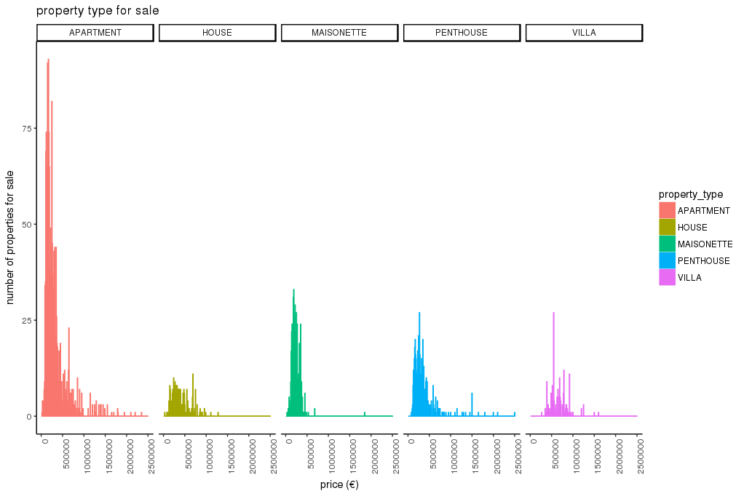

2.3.2. Property type area count Distribution

Chart 8: Property Area Count distribution for the 5 most common property types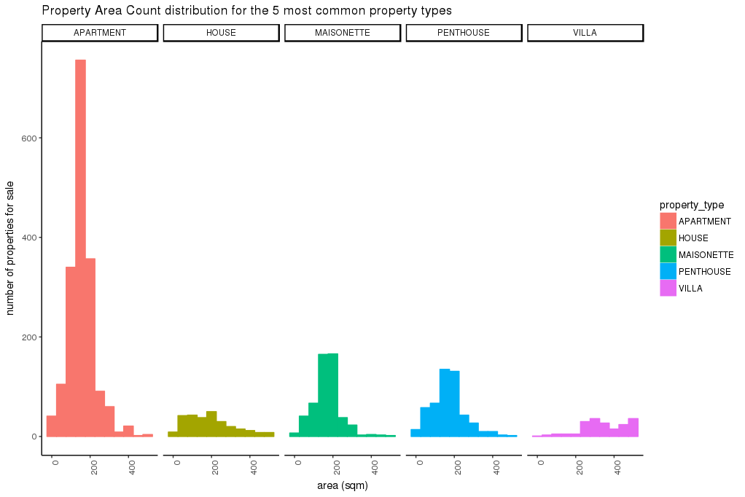

2.3.4. Property type – price Box Plot
Chart 9 depicts a property type – price box plot. This box plot helps to compare the mean, lower and upper quartile prices of the different types of property as well as the number of adverts that do not fall within these quartiles.
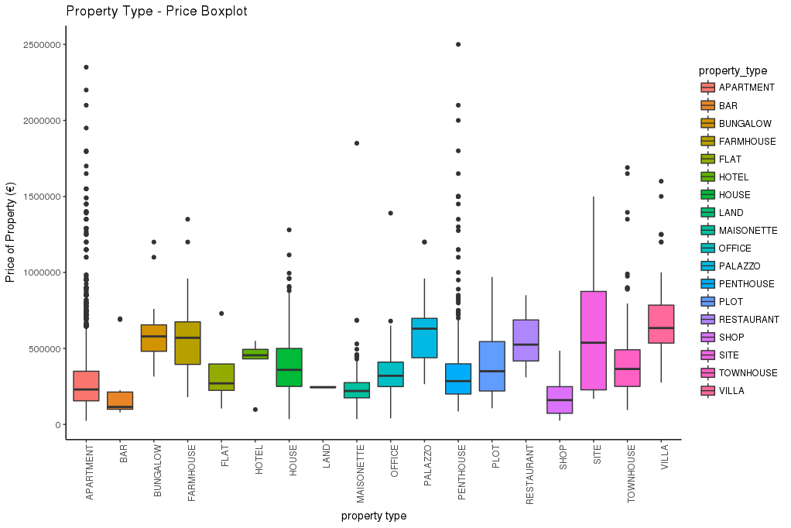

Chart 9: A property type - price box plot

2.3.4. Box-plot of Property Type vs. Area
Following the previous box plot, a box plot for the area of different property types is shown in chart 10.
Chart 10: A property - area box plot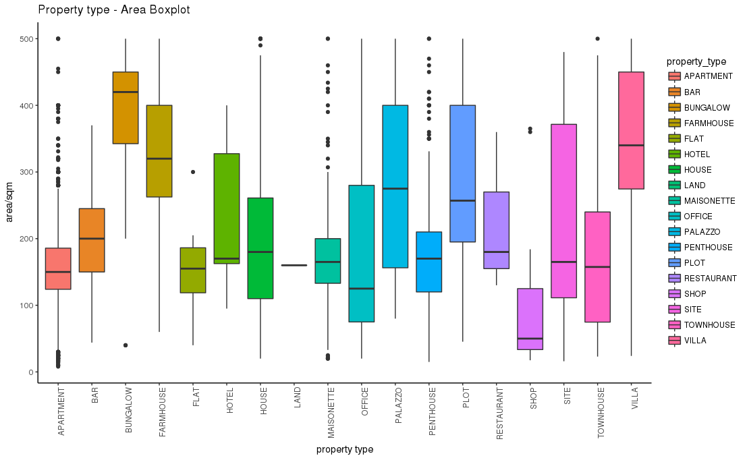

2.3.5. Most popular localities
Chart 11 shows the 10 most popular localities for the 5 most common property types.
Chart 11: The 10 most common popular locality of the 5 most common property types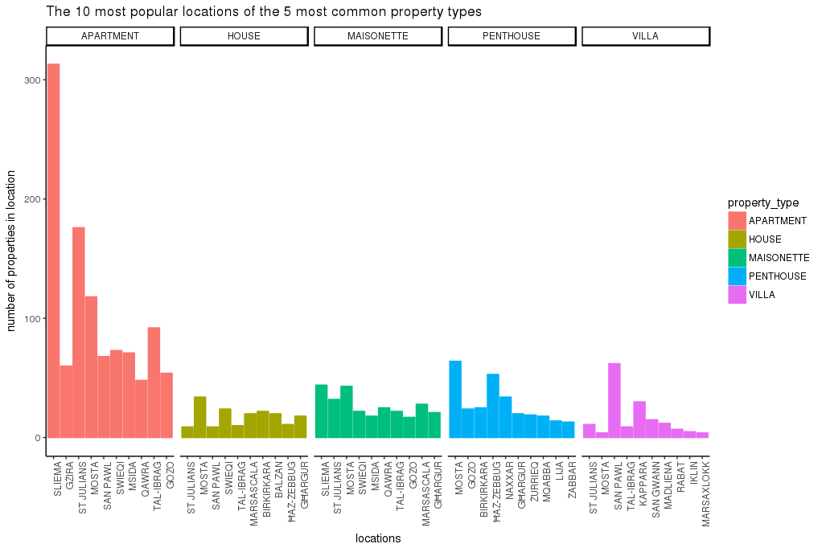

2.3.6. Geo-visualisation of the mean price
Chart 12 shows a geo-visualisation of the mean price of the ten most common localities. The size of the point is proportional to the mean price. One can note how the mean price varies with locality.
Chart 12: The 10 localities with the highest property mean price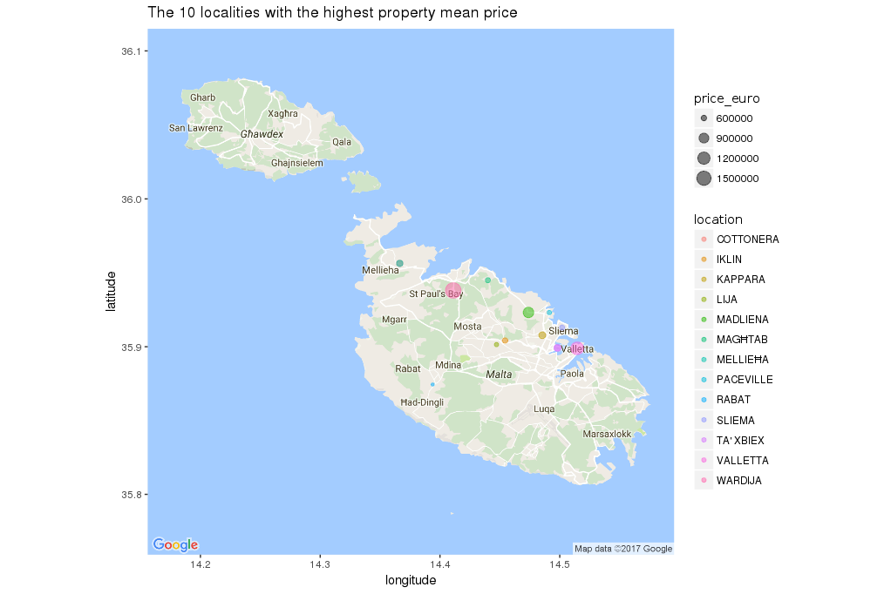

2.3.7. Advertisement count on Sundays and other days
Chart 13 shows the number of advertisements for different property types on Sundays wile chart 14 shows the total number of advertisements for days other than Sundays. The total is not given for all property types since this visualisation resulted very cluttered and difficult to read. As mentioned in section A, one can note how the number of advertisements for different property type is very consistent. On the other hand, the number of advertisements on other days varies between 20 and 40, occasionally peaking up to 60.

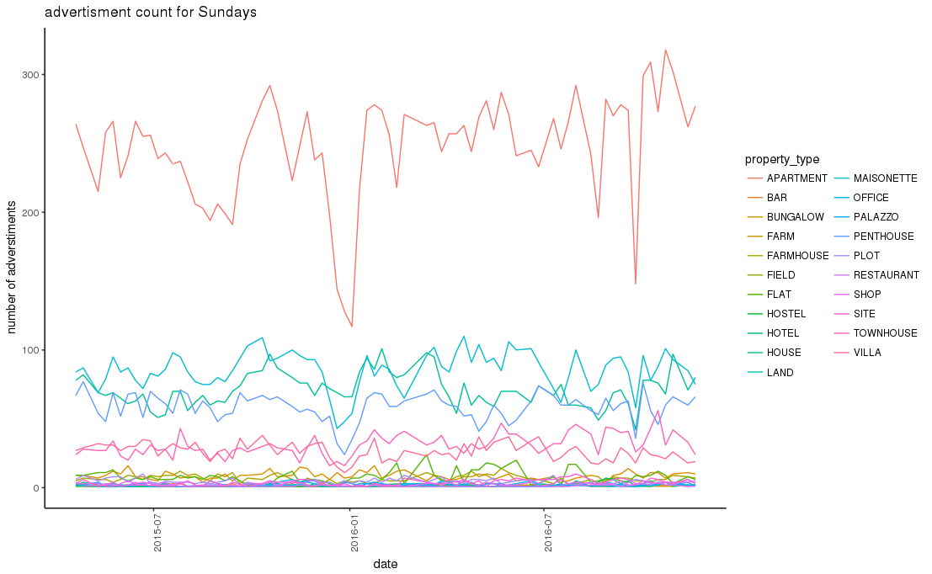
Chart 13: Number of advertisments on Sundays

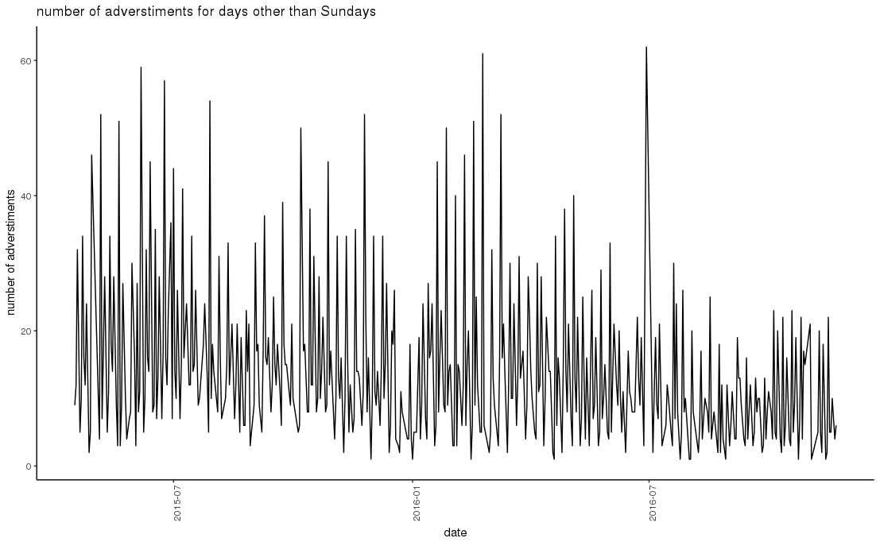
Chart 14: Number of advertisments on non-Sundays

Chart 14: Number of advertisments on days other than Sundays

2.3.8 Mean Price on Advertising Days
The mean price on every advertisement day is shown in chart 15. One can note the occasional peak, attributed to the outliers.
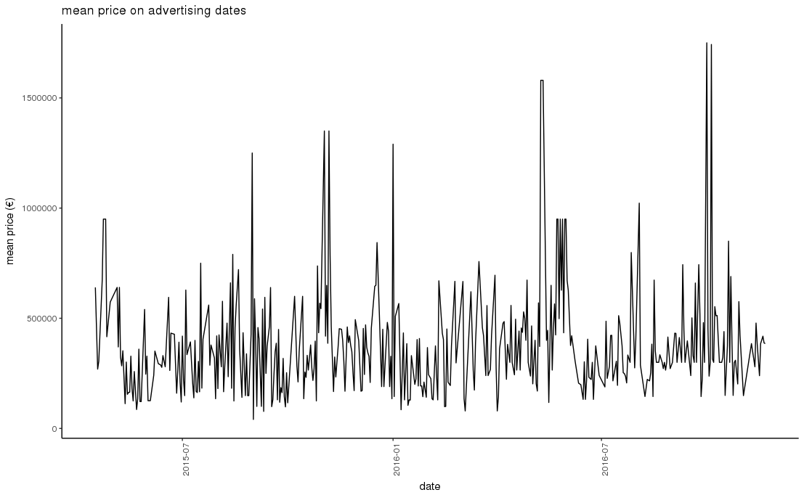

Chart 15: Advertising Day mean price

2.4. Statements
The visualisation generated in section C allows us to infer statements on the advertised property that was available for feature extraction:
Apartments are the most advertised type of property. Chart 7 gives a distribution of the different property types. One can note the striking difference of the apartment count with respect to the other counts. Most of these apartments have an area of 100-150 metres squared, as shown in Chart 8. Furthermore, the box plot in Chart 9, shows that for most property types used to live in (i.e. excluding shops, bars etc), the mean price decreases with frequency.
Chart 11 shows a high concentration of apartments for sale at Sliema. On the other hand, houses and maisonettes for sale seem to be distributed quite uniformly between their 10 most common localities. Mosta and Ħaż-Żebbuġ have a strikingly higher amount of penthouses when compared to other localities.
The geovisualisation in chart 12 shows that the Valletta and St' Paul's bay have the highest property mean price. These localities are followed by Wardija and Mellieha. The high mean price of St. Paul's Bay could be attributed to the inclusion of localities such as 'Tal-Fjuri' and 'Kennedy Grove'.
The rather uniform amount of adverts show in charts 13 and 14 both on Sundays and other days shows that there has not been any change in availability on property market. This may explain the minimal mean price fluctuation observed in chart 15.

2.5. Statistical Analysis
A statistical analysis is performed to check whether there is a significant different between the area of maisonettes and villas. The actual calculations for this check can be found in statisticalAnalysis.R.
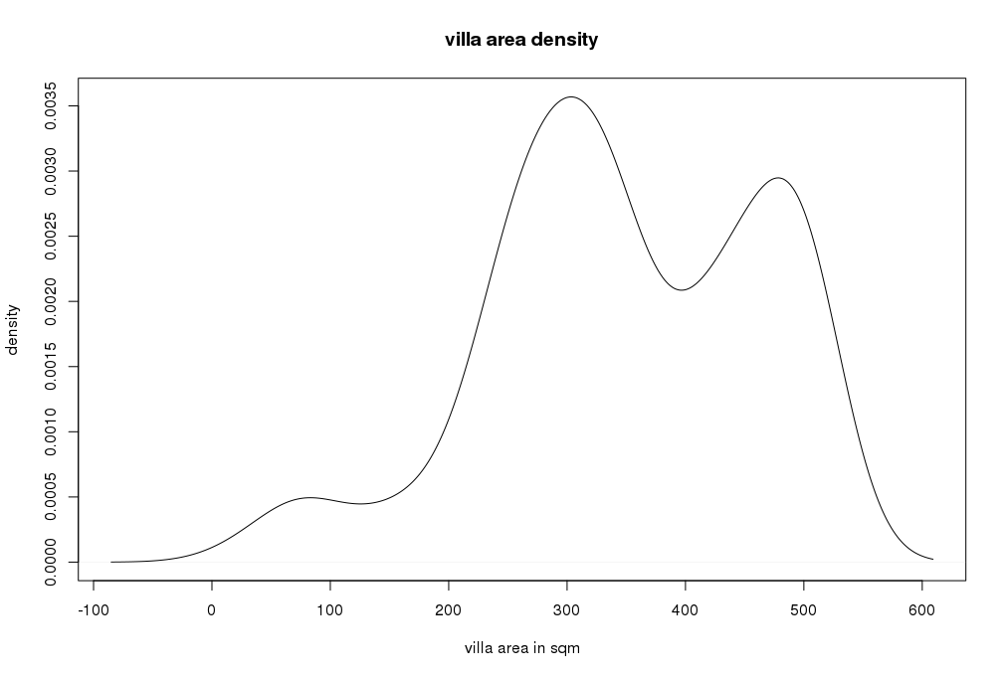
The t-test will be used to achieve this since the standard deviation is unknown. The t-test requires the samples to be normally distributed. As shown below, the fact that their distribution curve differs from the normal distribution curve will impair the validity of the result obtained from the t-test.

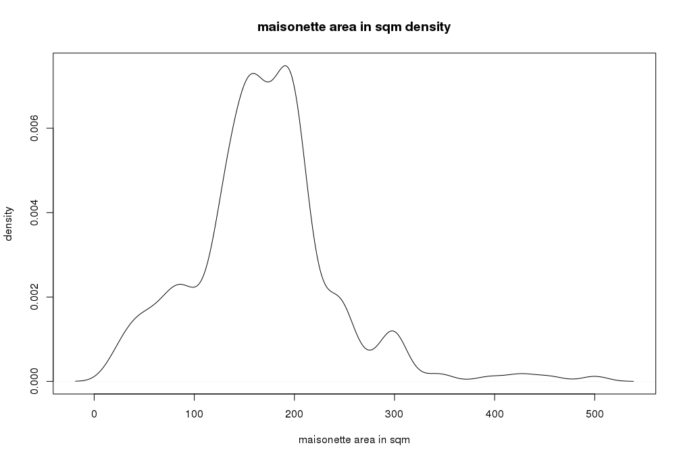

Chart 16: The density distributions of the areas of maisonettes and villas
With this in mind, we can proceed with defining the hypothesis to test:
Null hypothesis: mean area between villas and maisonettes is equal.
Alternative hypothesis: mean area between villas and maisonettes is not equal.
The F-test of these sample is used to compare the variances of these two samples (using the var.test function). In this case, the F-test value is 2.2e-16. This implies that the Welch test should be used since the samples have unequal variances. This allows us to calculate the t-test:
t.test(villas$area_sqm,maisonette$area_sqm,var.equal=FALSE, paired = FALSE)
The p-value obtained in less than 2.2e-16 which is less than 0.05. This shows that the mean of maisonette area is significantly different form the mean of area of villas.

2.6. Predictive Model
A naive-bayes classifier is used to predict the price range of a given property for sale described by the locality, property type and area. The implementation can be found in predictiveModel.R.
In this model, it is assumed that these features (locality, property type and area) independently contribute towards the probability that the property falls in a certain price range [3]. The price ranges are taken in intervals of 5000€ since it is common to speak that given property type costs 20-25K or 30-35K. The price range was hence calculated for every advertisment after finding the lowest and highest prices (maxPrice and minPrice) that are multiple of 5000:
propDetails$priceRange <- factor(cut(propDetails$price_euro,
seq(from=minPrice,to=maxPrice, by=5000),
right = TRUE))

For testing purposes, 10% of the data was removed from the training set (trainingData). This 10% was removed randomly. This sample is called priceRangesToPredict. The model was built using trainingData:
model <- naiveBayes(priceRange ~ .,data=trainingData)
The model is used to predict the price range of the advertisments in the test data to obtain predictedPriceRanges:
predictedPriceRanges <- predict(model,priceRangesToPredict)
As described in [3], a confusion matrix is used to compare the predicted price ranges with the actual price ranges:
cMat <- confusionMatrix(testData$priceRange,predictedPriceRanges)
As seen in the below confusion matrix's description, the accuracy of the training set is very low (7%).
Accuracy Kappa AccuracyLower AccuracyUpper
0.07065217 0.05709598 0.04666839 0.10181011

A reason that might this extremely poor accuracy is that the assumption stated initially does not hold.

References
[1] Portable Game Notation. URL: https://en.wikipedia.org/wiki/Portable_Game_Notation
[2] How (and why) are pie charts considered "evil" by data visualization experts? URL: https://www.quora.com/How-and-why-are-pie-charts-considered-evil-by-data-visualization-experts
[3] A gentle introduction to Naïve Bayes classification using R. URL: https://eight2late.wordpress.com/2015/11/06/a-gentle-introduction-to-naive-bayes-classification-using-r/
[4] Malta ranked second safest place in the world for natural disasters. URL: http://www.timesofmalta.com/articles/view/20160426/local/malta-ranked-second-safest-place-in-the-world-for-natural-disasters.610129

