1.

Q1:

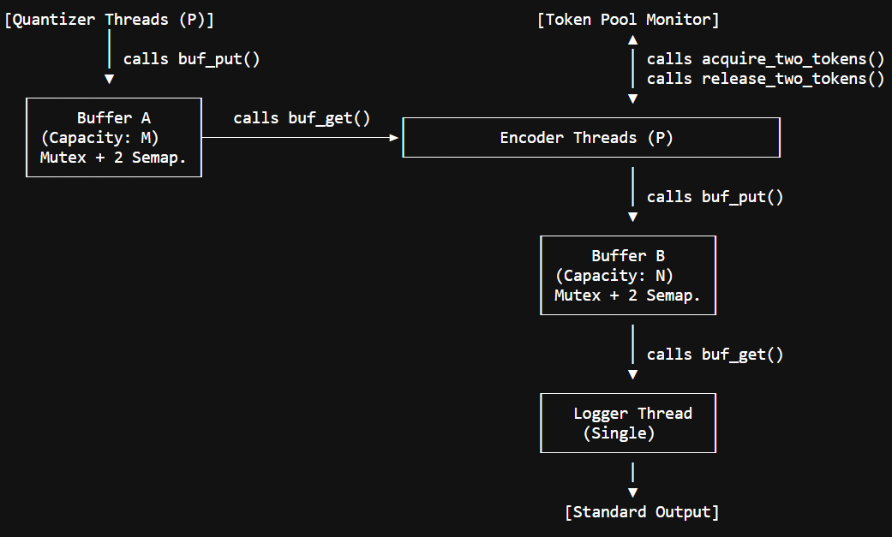

2.

Q1.1 Solution:
To achieve safe and efficient synchronization for the bounded buffers (Buffer A and Buffer B) without relying on busy-waiting, the implementation combines a POSIX Mutex with two Counting Semaphores.
Mutual Exclusion (The Mutex): A single pthread_mutex_t is used for each buffer. Whenever a thread (either a producer or a consumer) needs to access the buffer array (items) or modify the structural indices (head and tail), it must first acquire this mutex. This guarantees that only one thread can modify the buffer's internal state at any given time, preventing race conditions and data corruption.
Condition Synchronization (The Semaphores): To satisfy the strict "no busy-waiting" requirement, two counting semaphores are used: empty_slots (initialized to the buffer's capacity) and filled_slots (initialized to 0). Producers call sem_wait(&empty_slots) before locking the mutex. If the buffer is full (empty_slots == 0), the OS immediately puts the producer thread to sleep. Once space is freed and the item is inserted, the producer calls sem_post(&filled_slots) to wake up any sleeping consumers.
Consumers call sem_wait(&filled_slots) before locking the mutex. If the buffer is empty, the consumer sleeps without spinning the CPU. After extracting an item, it calls sem_post(&empty_slots) to wake up any sleeping producers. By guaranteeing that threads sleep at the OS level when resources are unavailable, this strategy ensures maximum CPU efficiency and perfect synchronization.
Q1.2
Consider the modified scenario based on test case q1/case1 where only one token of each type exists, and the requirements are:
- Encoder 0 requires tokens (0, 1)
- Encoder 1 requires tokens (1, 2)
- Encoder 2 requires tokens (0, 2)
Concrete Deadlock Interleaving:
Time T1: Encoder 0 executes sem_wait(&token_0) and successfully acquires Token 0. Time T2: Context switch. Encoder 1 executes sem_wait(&token_1) and successfully acquires Token 1.
Time T3: Context switch. Encoder 2 executes sem_wait(&token_2) and successfully acquires Token 2.
Time T4: Encoder 0 executes sem_wait(&token_1). Token 1 is held by Encoder 1, so Encoder 0 goes to sleep.
Time T5: Encoder 1 executes sem_wait(&token_2). Token 2 is held by Encoder 2, so Encoder 1 goes to sleep.Time $t_6$: Encoder 2 executes sem_wait(&token_0). Token 0 is held by Encoder 0, so Encoder 2 goes to sleep.
Result is encoder 0 is waiting on Encoder 1, Encoder 1 is waiting on Encoder 2, and Encoder 2 is waiting on Encoder 0. The pipeline is permanently frozen.
acquire_two_tokens implementation entirely breaks the Hold-and-Wait Coffman condition by using the Monitor Pattern (a single Mutex paired with a Condition Variable) to enforce an atomic, all-or-nothing allocation.
Single Pool Lock:
The entire token pool is protected by a single pool_mutex. An Encoder must lock this mutex before it can even look at the token counts.
Atomic Check:
The Encoder checks the availability of both tokens simultaneously using a while (available[tA] == 0 || available[tB] == 0) loop.
No Holding While Waiting:
If either token is missing, the Encoder calls pthread_cond_wait. Crucially, this function atomically puts the Encoder to sleep and releases the pool_mutex. Because the mutex is released, the Encoder goes to sleep empty-handed. It does not hoard its first token. This allows other Encoders to access the pool, acquire available pairs, finish their work, and return tokens via pthread_cond_broadcast.
In the exact interleaving above, under the implementation, Encoder 0 would lock the pool, see both 0 and 1 are available, take both, and unlock the pool. When Encoder 1 locks the pool, it sees token 1 is missing, so it safely goes to sleep without taking token 2, leaving token 2 available for Encoder 2. The circular wait is impossible.

Q2

Q3

5.
Function | File | Args | Return | Purpose
main | problem1.c | int argc, char *argv[] | int | Parses command-line inputs, initializes all shared structures, spawns the pipeline threads, waits for them to join, and handles teardown.
init_buffer | problem1.c | BoundedBuffer *buf, int capacity | void | Allocates memory for the buffer array and initializes the internal mutex and empty/filled semaphores based on the given capacity.
destroy_buffer | problem1.c | BoundedBuffer *buf | void | Frees the dynamically allocated buffer array and destroys the associated POSIX mutex and semaphores.
buf_put | problem1.c | BoundedBuffer *buf, Packet p | void | Producer function. Waits on the empty_slots semaphore, acquires the buffer mutex, inserts a packet at the tail, and posts to filled_slots.
buf_get | problem1.c | BoundedBuffer *buf | Packet | Consumer function. Waits on the filled_slots semaphore, acquires the buffer mutex, extracts a packet from the head, and posts to empty_slots.
init_token_pool | problem1.c | int num_types | void | Allocates the array for tracking token counts and initializes the Monitor's central mutex and condition variable.
destroy_token_pool | problem1.c | none | void | Frees the token array and destroys the Monitor's mutex and condition variable.
acquire_two_tokens | problem1.c | int tA, int tB | void | Atomically acquires both required tokens. If either is exhausted, safely sleeps the calling thread using pthread_cond_wait.
release_two_tokens | problem1.c | int tA, int tB | void | Restores both tokens to the available pool and uses pthread_cond_broadcast to wake any waiting Encoder threads.
quantizer_thread | problem1.c | void *arg | void* | Generates new order packets sequentially. Once all normal orders are generated, pushes a Sentinel packet into Buffer A and exits.
encoder_thread | problem1.c | void *arg | void* | Continuously reads from Buffer A. Acquires tokens to process normal packets, or forwards Sentinel packets directly to Buffer B and exits.
logger_thread | problem1.c | void *arg | void* | Reads from Buffer B. Prints normal encoded packets to the console. Terminates once $P$ Sentinel packets have been counted.

