Assignment 2

Zhuoyang CHEN 50005220

1. date: character (interval)

location: character (nominal)

new_cases: numerical (ratio)

new_deaths: numerical (ratio)

total_cases: numerical (ratio)

total_deaths: numerical (ratio)

weekly_cases: numerical (ratio)

weekly_deaths: numerical (ratio)

biweekly_cases: numerical (ratio)

biweekly_deaths: numerical (ratio)

1. United States has the most total_cases and total_deaths. Yeman has the highest Fatality, considering the data for North Korea is not reasonable (1 case but 6 deaths).

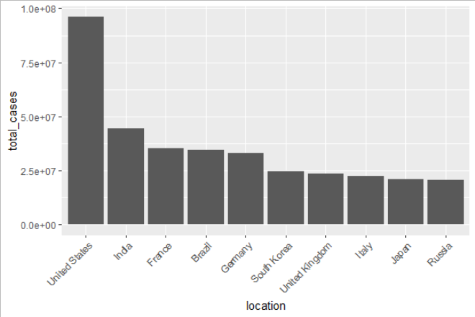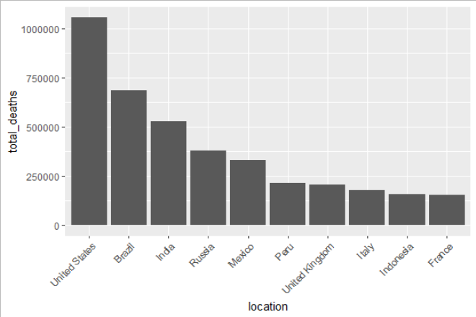

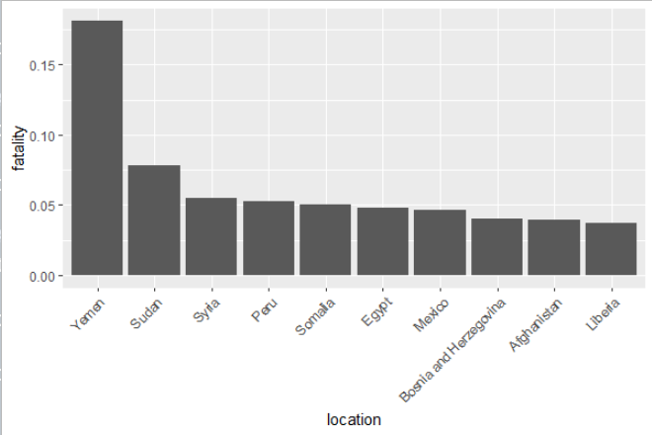

1. For population I would set each point with different radius proportional to the log scale of the total population. And I would set different colors for different continents.