This project implements a Power Converter Hardware-in-the-Loop, specifically targeted at DC-DC converters. Types of converter tested are buck, boost, buck-boost, and Cuk. The plant system (DC-DC) converters are modelled as state space equation, which then are computed in real-time by the accelerator.
Design
The accelerator design are MACs which output represents each states. At the heart of the MACs are DSP48E1, DSP slice inside FPGA that allows high frequency arithmetic operations.
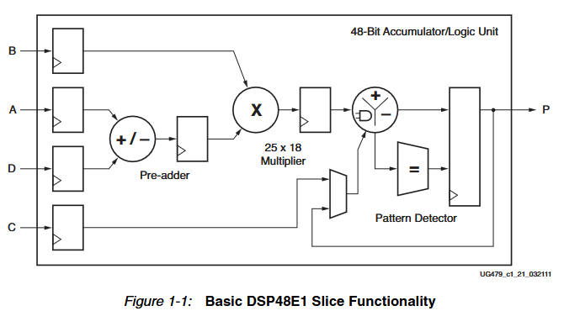
The DSP slice can be represented in this equation.
$$P=\left(A+D\right)×B+C$$
In this implementation, the DSP slices are used as two’s complement multiplier and accumulator. The DSP configuration follows the UG479 DSP48E1 Slice User Guide. Multiplier uses three-stage pipeline while accumulator uses two-stage pipeline.
To balance between precision and area, Q11.23 and Q1.23 fixed point types are used across the design. Q11.23 is used to represent the states while Q1.23 is used to represent the state space parameters. Accordingly, 36x25-multiplier are needed. This is achieved by breaking the multiplication into 2 25x18-multipliers and then summing the shifted value of the upper product with the lower product.
