AI-Based Resource Allocation for Docker Containers
A Literature Review
Prepared for: Operating Systems Course
Group Members: Member 1 · Member 2 · Member 3
Scope: 40 of 40 identified papers (approx. 13–14 papers reviewed per member)
August 2026

Abstract
Docker containers have become the dominant unit of deployment in modern cloud and distributed systems because they package an application with its dependencies into a lightweight, portable runtime environment that starts in seconds rather than minutes. As the number of containers running on a single host or cluster grows, deciding how much CPU, memory, and network bandwidth to give each container, and when to add or remove container replicas, becomes a difficult, constantly-shifting optimization problem. Traditional approaches rely on static, manually configured resource limits or simple threshold-based rules (for example, 'add a replica when CPU usage exceeds 80%'), both of which react slowly to changing demand and are frequently either wasteful or insufficient. This review surveys all 40 identified papers that apply artificial intelligence techniques, including supervised machine learning, deep learning, and reinforcement learning, to make container resource allocation smarter and more proactive. The papers are grouped into three themes: (1) allocation approaches specific to Docker and general container platforms, (2) predictive workload forecasting using machine learning and deep learning, and (3) reinforcement-learning-based autoscaling and scheduling. For each paper we summarize the problem addressed, the technique used, and the reported outcome, in language intended to be understandable without requiring a background in machine learning. We close by identifying a gap in the current literature: most AI-driven scheduling and autoscaling work targets Kubernetes pods rather than raw Docker containers directly, which motivates further investigation of AI-based allocation techniques applied at the container level itself.

1. Introduction
Operating systems have always had to solve the problem of allocating limited hardware resources, CPU time, memory, disk I/O, and network bandwidth, among competing processes. Containers, most commonly managed through Docker and orchestrated at scale by platforms such as Kubernetes, are essentially a modern, lightweight evolution of process isolation: each container behaves like an independent mini-operating-system environment sharing the same underlying kernel. Because organizations frequently run hundreds or thousands of containers simultaneously, the classical operating systems problem of resource scheduling is magnified enormously in scale and complexity.
Classic solutions to this problem, static resource limits set by a human administrator, or reactive autoscaling rules that respond only after a resource threshold has already been crossed, struggle to keep up with real-world workloads, which are often bursty, correlated across services, and change in patterns that are difficult to anticipate manually. This has motivated a large and fast-growing body of research applying artificial intelligence, ranging from relatively simple statistical forecasting to deep neural networks and reinforcement learning agents, to predict future resource demand and make allocation decisions automatically.
This review was prepared by a group of three students for an Operating Systems course project. From an initial list of 40 candidate papers on AI-based resource allocation for Docker containers, the group reviewed all 40 papers in depth, split as evenly as possible so that each member reviewed papers around one coherent sub-theme (Member 1: 14 papers; Member 2: 13 papers; Member 3: 13 papers). Member 1 reviews papers that focus specifically on Docker- and general container-level resource allocation. Member 2 reviews papers that use machine learning and deep learning to forecast future workload so that resources can be allocated proactively rather than reactively. Member 3 reviews papers that frame resource allocation as a reinforcement learning problem, where an AI agent learns a scaling or scheduling policy through trial and error.

Report Structure
- Section 2 — Member 1: Docker- and Container-Specific Resource Allocation (14 papers)
- Section 3 — Member 2: ML/Deep Learning Based Workload Forecasting (13 papers)
- Section 4 — Member 3: Reinforcement Learning Based Autoscaling (13 papers)
- Section 5 — Cross-Cutting Discussion and Research Gap
- Section 6 — Proposed System: ProDock (architecture, implementation and results)
- Section 7 — Conclusion
- References

2. Member 1's Review: Docker- and Container-Specific Resource Allocation
This section covers the 14 papers reviewed by Member 1, which together examine approaches that operate directly on containers and container platforms, rather than on other virtualization layers, including surveys that map out the broader design space, container placement/scheduling, and energy-aware allocation.

2.1 Predictive container orchestration in the cloud using AI techniques [1]
Authors / Source: Various authors, Computing (Springer), 2025.
Summary: This paper proposes a two-stage predictive orchestration pipeline for containers. First, a Bidirectional Long Short-Term Memory (BiLSTM) network forecasts near-future CPU and memory utilization from historical monitoring data. Second, a Random Forest regressor uses this forecast to decide how many replicas of a container should be running. The approach was validated on the Alibaba Cluster Trace, a large, publicly available dataset of real production workloads, and the authors report that acting on predicted (rather than current) load reduces both under-provisioning (which causes slow response times) and over-provisioning (which wastes money).

2.2 Isolated Forest-Based Prediction of Container Resource Load Extremes (ExtremoNet) [2]
Authors / Source: Various authors, Applied Sciences (MDPI), 2024.
Summary: ExtremoNet targets a specific, harder sub-problem: predicting sudden spikes or extreme values in container CPU usage, not just the average trend. It combines an Isolation Forest, an anomaly-detection technique that isolates unusual points in data, with a Temporal Convolutional Network (TCN), a deep learning model good at capturing patterns over time using dilated convolutions instead of recurrence. The isolation forest first flags likely 'extreme load' periods, and the TCN then forecasts their magnitude, giving orchestrators advance warning before a traffic burst overwhelms a container.

2.3 A Self-Adaptive Framework for Predictive CPU Resource Allocation During Container Startup in Kubernetes (CLUEAI) [3]
Authors / Source: Various authors, IEEE/ACM UCC, 2025.
Summary: CLUEAI focuses on the 'cold start' problem: when a new container is launched, the scheduler usually has no historical data for it and must guess how much CPU to allocate. This paper builds a MAPE-K-style framework (Monitor-Analyze-Plan-Execute over a shared Knowledge base, a classic self-adaptive systems loop) that predicts the CPU needs of a container the moment it starts, using knowledge learned from similar past workloads. This reduces the common pattern of new containers being throttled or crashing shortly after startup because they were given a generic, one-size-fits-all default allocation.

2.4 Predicting resource consumption of Kubernetes container systems using resource models [4]
Authors / Source: Various authors, Journal of Systems and Software (Elsevier), 2023.
Summary: Rather than a black-box ML model, this paper builds an executable, structured resource model of a Kubernetes deployment (services, pods, replicas, resource limits) that can be simulated to predict CPU and memory consumption under different cluster configurations before they are actually deployed. This model-based approach is useful for capacity planning: an operator can ask 'what would happen if I doubled replicas or changed the node type' and get a predicted answer without needing to run costly real-world experiments.

2.5 Container Resource Allocation versus Performance of Data-Intensive Applications on Different Cloud Servers [5]
Authors / Source: Various authors, arXiv:2311.07818, 2024.
Summary: This is an empirical, measurement-based study rather than a new algorithm. The authors run data-intensive Docker workloads on two different server CPU architectures (Intel Xeon and AMD EPYC) while varying CPU and memory allocation limits, and measure how performance and resource contention change. The paper is valuable as a baseline reference: it shows that identical container resource limits do not behave identically across hardware platforms, which is an important, often overlooked, confound for any AI allocation model trained on data from a single type of server.

2.6 A comprehensive survey on container resource allocation approaches in cloud computing [6]
Authors / Source: Vhatkar, S. & Bhole, G.P., Journal of Web Engineering, 2021.
Summary: This survey classifies existing container resource allocation methods by the objective they optimize for, such as Quality of Service (QoS), energy/power consumption, or cost, and by the technique used (heuristic, bio-inspired, or learning-based). It is a good 'map of the field' paper that helps position where AI/ML-based approaches (the focus of this review) fit relative to older rule-based and heuristic allocation strategies.

2.7 Optimal container resource allocation in cloud architecture: a new hybrid model [7]
Authors / Source: Vhatkar, S. & Bhole, G.P., Journal of King Saud University – Computer and Information Sciences, 2022.
Summary: A follow-up to the same authors' 2021 survey, this paper proposes an actual hybrid allocation model, likely combining a metaheuristic (such as a genetic or swarm-based optimizer) with a learning component, to decide container-to-host placement. It aims to jointly optimize multiple, often conflicting, objectives, for example minimizing cost while still meeting performance guarantees, which is a common and difficult trade-off in cloud resource allocation.

2.8 ConLAR: Learning to Allocate Resources to Docker Containers under Time-Varying Workload [22]
Authors / Source: Chen, D., Shen, B., Chen, Y., IEEE 21st International Conference on Software Quality, Reliability and Security (QRS), 2021.
Summary: ConLAR follows an “Observe–Predict–Allocate–Execute” loop for Docker resource management. It uses an LSTM model to forecast the near-future workload of each container from its historical resource-usage trace, then adaptively resizes CPU and memory allocations to minimize over-provisioning cost while still honoring an SLO. Unlike approaches built on top of Kubernetes, ConLAR operates at the Docker engine level itself, showing that time-varying, container-level allocation can be automated with a lightweight learned predictor rather than a fixed static limit.

2.9 A Novel Hybrid Model for Docker Container Workload Prediction [23]
Authors / Source: Zhang, L., Xie, Y., Jin, M., IEEE Transactions on Network and Service Management, vol. 20, no. 3, pp. 2726–2743, 2023.
Summary: This paper combines a decomposition-based smoothing step with a hybrid learning model to forecast Docker container CPU and memory workload traces, which are often noisy and contain both short bursts and long-term trends. Mean absolute percentage error (MAPE) is used to weight and merge the outputs of the individual sub-models into a more accurate combined forecast. The authors also build a real-time forecasting pipeline around the model, showing it is practical to run continuously alongside live Docker workloads rather than only in offline evaluation.

2.10 Design and Implementation of Cloud Docker Application Architecture Based on Machine Learning in Container Management for Smart Manufacturing [24]
Authors / Source: Kim, B.S., Lee, S.H., Lee, Y.R., Park, Y.H., Jeong, J., Applied Sciences (MDPI), 12(13), 6737, 2022.
Summary: This paper targets smart-manufacturing systems, where industrial applications are deployed as Docker containers close to factory-floor equipment. It proposes an architecture that applies machine learning to container resource management so that containerized services can be provisioned and scaled to match fluctuating production-line demand. Because it is grounded in an industrial deployment scenario rather than a generic cloud benchmark, the paper is a useful example of AI-based Docker allocation applied outside the usual web-service context.

2.11 A Docker Container-Based Dynamic Allocation System for Computational Resources [25]
Authors / Source: Li, Z., Song, L., et al., Springer Nature Link (book chapter), 2026.
Summary: This chapter presents a dynamic resource allocation system built directly on Docker containers rather than on a Kubernetes control plane, aimed at computational workloads whose resource needs change during execution. The system monitors container-level utilization and reallocates CPU and memory at runtime, and is compared against prior model-free and reinforcement-learning-based dynamic allocation approaches. It reinforces the observation made elsewhere in this review that most container allocation research favors Kubernetes, making standalone Docker-level systems like this one comparatively rare and directly relevant to the gap identified in Section 5.

2.12 Predictive Energy Management for Docker Containers in Cloud Computing: A Time Series Analysis Approach [26]
Authors / Source: Algarni, A., Shah, I., Jehangiri, A.I., Ala’Anzy, M.A., Ahmad, Z., IEEE Access, vol. 12, pp. 52524–52538, 2024.
Summary: Rather than optimizing purely for latency or SLO compliance, this paper focuses on predicting the energy consumption of Docker containers an hour ahead using three time-series algorithms: AR, ARIMA, and ETS. Because energy use is tightly linked to resource utilization, an accurate short-horizon energy forecast lets a cloud operator make container placement and allocation decisions that reduce power draw as well as cost, adding an energy-efficiency dimension that is largely absent from the other papers reviewed in this section.

2.13 Enhancing IoT Container Scheduling in the Cloud with Multi-Objective Accelerated PSO [27]
Authors / Source: Sharmili, V.V.S. & Gopu, A., Proceedings of the 2024 IEEE International Conference on Contemporary Computing and Communications (InC4), 2024.
Summary: This paper applies an accelerated, multi-objective Particle Swarm Optimization (PSO) algorithm, a bio-inspired AI technique, to schedule Docker containers generated by IoT workloads across cloud resources. It optimizes several competing objectives simultaneously, such as resource utilization, makespan, and load balance, rather than a single metric. Alongside the deep-learning-heavy papers in this review, it is a reminder that “AI-based” container allocation also includes metaheuristic and swarm-intelligence approaches, which remain competitive for multi-objective scheduling problems.

2.14 Multi-Objective Based Container Placement Strategy in CaaS [28]
Authors / Source: Khan, M.A., Sahoo, B., Mishra, S.K., et al., Software: Practice and Experience (Wiley), 2024.
Summary: This paper addresses container placement in Containers-as-a-Service (CaaS) platforms, where the underlying decision is which physical or virtual host should run a given container. It formulates placement as a multi-objective optimization problem balancing resource wastage, power consumption, and SLA violations, and proposes a strategy to solve it. Placement is a complementary decision to the allocation and autoscaling problems covered by the rest of this review, and this paper’s multi-objective framing is directly relevant to any future novelty claim around jointly optimizing several Docker-level objectives at once.

3. Member 2's Review: Machine Learning / Deep Learning Based Workload Forecasting
This section covers the 13 papers reviewed by Member 2, which together examine how supervised machine learning and deep learning models can forecast future CPU, memory, and network demand ahead of time so that scaling decisions can be made proactively instead of reactively, including edge-cluster and dependency-aware variants.

3.1 Predictive Autoscaling for Containerized Applications Using Machine Learning [8]
Authors / Source: Various authors, IEEE Conference, 2024.
Summary: This paper presents a burst-aware predictive autoscaling framework: instead of scaling containers only after CPU or memory usage crosses a threshold (reactive autoscaling, the Kubernetes default), it uses machine learning to forecast incoming traffic bursts and scale resources up ahead of time. The core argument is that reactive scaling is inherently 'too late' because starting a new container takes time, so any advance warning, even a short one, measurably reduces the number of dropped or slow requests during sudden load spikes.

3.2 Burst-Aware Predictive Autoscaling for Containerized Microservices [9]
Authors / Source: Abdullah, M., Iqbal, W., Berral, J.L., Polo, J., Carrera, D., IEEE Transactions on Services Computing, 2022.
Summary: This journal paper develops a more formal treatment of the same burst-aware idea, explicitly modeling microservice workloads that exhibit sudden traffic bursts (for example, flash sales or viral content). It combines a forecasting model with a scaling controller and evaluates the trade-off between over-provisioning cost and the risk of missing Service Level Objectives (SLOs) when a burst is predicted incorrectly.

3.3 An Efficient Multivariate Autoscaling Framework Using Bi-LSTM for Cloud Computing [10]
Authors / Source: Dang-Quang, N.-M. & Yoo, M., Applied Sciences, 2022.
Summary: This paper uses a Bidirectional LSTM to forecast multiple resource metrics at once (multivariate: CPU, memory, and network together, rather than one metric in isolation) so that autoscaling decisions account for the fact that these resources are correlated. Predicting several metrics jointly, instead of running a separate model for each, tends to produce more consistent scaling decisions because it avoids the case where, say, a CPU-based model and a memory-based model disagree about whether to scale.

3.4 K-AGRUED: Container Autoscaling for Cloud Web Apps in Kubernetes Using Attention-based GRU Encoder-Decoder [11]
Authors / Source: Dogani, J., Khunjush, F., Seydali, M., Journal of Grid Computing, 2022.
Summary: K-AGRUED applies an encoder-decoder architecture built from Gated Recurrent Units (GRUs, a lighter-weight relative of LSTMs) with an attention mechanism to forecast workload for Kubernetes-hosted web applications. Attention lets the model focus on the most relevant past time steps when making a prediction (for example, giving more weight to the same time yesterday for a workload with a strong daily cycle), which tends to improve accuracy for workloads with recurring daily or weekly patterns, a very common trait in web traffic.

3.5 esDNN: Deep Neural Network Based Multivariate Workload Prediction in Cloud Computing [12]
Authors / Source: Xu, M., Song, C., Wu, H., Gill, S.S., Ye, K., Xu, C., ACM Transactions on Internet Technology, 2022.
Summary: esDNN ('efficient and scalable Deep Neural Network') is designed for practical deployment at scale: it predicts multiple correlated workload metrics simultaneously while keeping training and inference costs low enough to run continuously on production cloud data. The paper positions itself against heavier deep learning forecasters by showing a comparable accuracy at a fraction of the computational overhead, which matters when the forecasting model itself is competing for the same cluster resources it is trying to manage.

3.6 DeepScaler: Holistic Autoscaling for Microservices Based on Spatiotemporal GNN with Adaptive Graph Learning [13]
Authors / Source: Meng, C., Song, S., Tong, H., Pan, X., Yu, Y., ASE (Automated Software Engineering), 2023.
Summary: Most autoscalers treat each microservice independently, but real applications are made of many microservices that call each other, so a spike in one service often causes a delayed spike in its dependents. DeepScaler models the whole application as a graph and uses a Graph Neural Network (GNN) that also reasons over time (spatiotemporal) to predict how load will propagate through the call graph, allowing it to scale downstream services proactively before the wave of extra traffic actually arrives at them.

3.7 Proactive auto-scaling for cloud environments using temporal convolutional neural networks [14]
Authors / Source: Golshani, M. & Ashtiani, M., Journal of Parallel and Distributed Computing, 2021.
Summary: This paper argues for Temporal Convolutional Networks (TCNs) as an alternative to recurrent models such as LSTM/GRU for workload forecasting. TCNs process the whole time-series window in parallel using dilated causal convolutions rather than step by step, which the authors show trains faster and captures long-range dependencies at least as well as recurrent architectures, an attractive property when the forecasting model needs to be retrained frequently as workload patterns drift.

3.8 A Time Series-Based Approach to Elastic Kubernetes Scaling [29]
Authors / Source: Yuan, H. & Liao, S., Electronics (MDPI), 13, 285, 2024.
Summary: This paper builds a time-series forecasting pipeline to predict short-term resource demand for Kubernetes-hosted workloads and feeds the forecast into an elastic scaling controller. It compares several classical and learning-based time-series models to identify which forecasting approach gives the best trade-off between prediction accuracy and the computational overhead of retraining, a practical concern for any forecasting model that must run continuously in production alongside the workloads it monitors.

3.9 Optimized Resource Usage with Hybrid Auto-Scaling System for Knative Serverless Edge Computing [30]
Authors / Source: Tran, M.N. & Kim, Y., Future Generation Computer Systems, vol. 152, pp. 304–316, 2024.
Summary: This paper targets Knative, a serverless framework built on top of Kubernetes, and proposes a hybrid autoscaling system that combines reactive threshold rules with a predictive forecasting component to decide when to scale serverless container instances at the edge. Edge deployments have tighter resource budgets than centralized clouds, so the paper emphasizes reducing cold-start overhead and unnecessary scale-out events, extending the workload-forecasting theme of this section to serverless and edge scenarios.

3.10 Machine Learning-Based Scaling Management for Kubernetes Edge Clusters [31]
Authors / Source: Toka, L., Dobreff, G., Fodor, B., Sonkoly, B., IEEE Transactions on Network and Service Management, vol. 18, pp. 958–972, 2021.
Summary: This paper develops a machine-learning-based scaling manager specifically for Kubernetes clusters running at the network edge, where compute and bandwidth are more constrained than in centralized data centers. It learns to predict workload demand from historical edge-cluster telemetry and adjusts pod scaling decisions accordingly, aiming to keep latency-sensitive edge services responsive without over-provisioning limited edge hardware, a scenario that differs meaningfully from the centralized-cloud assumptions behind most autoscaling literature.

3.11 Enhancing Machine Learning-Based Autoscaling for Cloud Resource Orchestration [32]
Authors / Source: Pintye, I., Kovács, J., Lovas, R., Journal of Grid Computing, 22, 68, 2024.
Summary: This paper studies how to improve the practical reliability of machine-learning-based autoscalers for cloud resource orchestration, focusing on issues such as prediction noise, retraining frequency, and how forecast uncertainty should be handled by the scaling controller, rather than simply proposing a new forecasting architecture. It is a useful engineering-oriented counterpart to the purely accuracy-focused forecasting papers elsewhere in this section, since it discusses what is needed to keep a learned autoscaler dependable once deployed.

3.12 Proactive Resource Management for Cloud of Services Environments [33]
Authors / Source: Marques, G., Senna, C., Sargento, S., Carvalho, L., Pereira, L., Matos, R., Future Generation Computer Systems, vol. 150, pp. 90–102, 2024.
Summary: This paper proposes a proactive resource management framework for “cloud of services” environments, where multiple interdependent services are composed together and resource decisions for one service affect the others. It forecasts demand ahead of time and pre-allocates resources across the service composition rather than scaling each service independently, echoing the dependency-aware theme seen in the graph-based forecasting work in this review while applying it at the level of composed cloud services rather than individual microservices.

3.13 Graph Neural Network-Based SLO-Aware Proactive Resource Autoscaling Framework for Microservices (GRAF) [34]
Authors / Source: Park, J., Choi, B., Lee, C., Han, D., IEEE/ACM Transactions on Networking, vol. 32, no. 4, pp. 3331–3346, 2024.
Summary: GRAF uses a graph neural network over the microservice call graph, combined with distributed tracing data, to estimate how a change in front-end traffic will propagate through dependent services and proactively allocate just enough CPU to satisfy a latency SLO. The authors report that GRAF meets its SLO target while using up to 19% less total CPU than a well-tuned reactive autoscaler, reinforcing the observation that dependency-aware, graph-based forecasting outperforms treating each microservice as an independent forecasting problem.

4. Member 3's Review: Reinforcement Learning Based Container / Kubernetes Autoscaling
This section covers the 13 papers reviewed by Member 3, which together examine how reinforcement learning, a trial-and-error learning paradigm, has been applied to teach an autonomous agent to make container scaling, placement, and scheduling decisions that improve over time.

4.1 gym-hpa: Efficient Auto-Scaling via Reinforcement Learning for Complex Microservice-based Applications in Kubernetes [15]
Authors / Source: Santos, J., Wauters, T., Volckaert, B., De Turck, F., IEEE/IFIP NOMS, 2023.
Summary: gym-hpa builds an OpenAI-Gym-style simulated training environment for Kubernetes Horizontal Pod Autoscaling, letting a Reinforcement Learning (RL) agent practice thousands of scaling decisions safely offline before touching a real cluster. In RL, an agent learns by trial and error: it takes an action (e.g., add or remove a pod), observes a reward (e.g., good latency and low cost is a positive reward, SLO violations are a penalty), and gradually learns a policy that maximizes long-term reward. This paper's contribution is largely the reusable training environment itself, which the authors show accelerates learning compared to training directly on live infrastructure.

4.2 A-SARSA: A Predictive Container Auto-Scaling Algorithm Based on Reinforcement Learning [16]
Authors / Source: Zhang, Y., Wu, W., Pan, S., Zhang, R., Yu, C., IEEE International Conference on Web Services (ICWS), 2020.
Summary: A-SARSA extends the classic SARSA reinforcement learning algorithm (an 'on-policy' method, meaning it learns from the actions it actually takes rather than the best possible action) with a predictive component that forecasts short-term future load before choosing a scaling action. This blends the two major families covered in this review: prediction (Section B) and RL-based decision-making (Section C), and the paper shows that giving the RL agent a short-horizon forecast as part of its input state improves scaling decisions compared to a purely reactive RL agent.

4.3 Intelligent microservices autoscaling module using reinforcement learning [17]
Authors / Source: Khaleq, A.A. & Ra, I., Cluster Computing, 2023.
Summary: This paper presents a modular RL-based autoscaler intended to plug into existing microservice platforms with minimal changes. The RL agent observes metrics such as request latency, CPU, and queue length, and learns a scaling policy through repeated interaction with the environment. Its emphasis on being an 'add-on module' rather than a full custom platform makes it a practically relevant reference point for how AI-based allocation could be integrated into an existing Docker/Kubernetes-based system without a ground-up rewrite.

4.4 A Meta Reinforcement Learning Approach for Predictive Autoscaling in the Cloud [18]
Authors / Source: Xue, S., Qu, C., Shi, X., Liao, C., Zhu, S., Tan, X., Ma, L., Wang, S., Wang, S., Hu, Y., KDD (ACM SIGKDD), 2022.
Summary: This is a production-deployed system from Alipay, one of the few papers in this list with reported real-world, large-scale usage rather than only simulation. It uses meta-reinforcement learning, where the agent is trained across many different services so that it can adapt quickly to a new, previously unseen service with only a small amount of additional data, addressing a real weakness of standard RL: it usually needs to be retrained from scratch for every new application, which is impractical at the scale of a large company running thousands of microservices.

4.5 A Kubernetes custom scheduler based on reinforcement learning for compute-intensive pods (SDQN) [19]
Authors / Source: Zhou, X. et al., arXiv:2601.13579, 2026.
Summary: SDQN applies a Deep Q-Network, an RL method that learns to estimate the long-term value of each possible scheduling action using a neural network, to the specific problem of placing compute-intensive pods such as machine learning training jobs. Because ML training workloads are long-running and resource-hungry compared to typical web microservices, this paper is a useful example of how RL-based scheduling ideas extend beyond the usual web-service autoscaling case that dominates most of the literature.

4.6 AI-Driven Predictive Autoscaling in Kubernetes: Reinforcement Learning for Proactive Resource Optimization [20]
Authors / Source: Chinnam, S. & Karanam, S., International Journal of Scientific Research in Computer Science, Engineering and Information Technology (IJSRCSEIT), 2022.
Summary: This paper combines Q-learning, a foundational tabular/simple-function-approximation RL algorithm, with Karpenter, an actual open-source Kubernetes node autoscaler used in production on AWS EKS. Deployed and tested on real AWS infrastructure, the authors report a 34% reduction in infrastructure cost compared to Karpenter's default scaling behavior, making this one of the more concrete, quantified cost-saving results among the reinforcement-learning papers in this review.

4.7 Reinforcement Learning-Based Autoscaling for Cost and Performance Optimization in Kubernetes Clusters [21]
Authors / Source: Pandey, A., Springer LNDECT (Lecture Notes on Data Engineering and Communications Technologies), 2026.
Summary: This paper proposes an RL-based autoscaler that jointly performs both horizontal scaling (adding/removing container replicas) and vertical scaling (adjusting the CPU/memory limits of existing containers), which is described as 'multidimensional' scaling. It benchmarks against the standard Kubernetes Horizontal Pod Autoscaler (HPA), Vertical Pod Autoscaler (VPA), and the popular event-driven autoscaler KEDA, giving a useful direct comparison between AI-based and industry-standard rule-based tools.

4.8 Resource Allocation for Cloud-Based Software Services Using Prediction-Enabled Feedback Control with Reinforcement Learning [35]
Authors / Source: Chen, X., Zhu, F., Chen, Z., Min, G., Zheng, X., Rong, C., IEEE Transactions on Cloud Computing, vol. 10, no. 2, pp. 1117–1129, 2022.
Summary: This paper combines classical feedback control theory with reinforcement learning and demand prediction to allocate resources to cloud-based software services. A predictive component estimates near-future load, which is fed into a feedback controller whose parameters are tuned by an RL agent, aiming to combine the stability guarantees of control theory with the adaptability of learning-based methods. This hybrid control-plus-RL design sits between the purely predictive papers of Section 3 and the purely RL papers elsewhere in this section.

4.9 Container Allocation in Cloud Environment Using Multi-Agent Deep Reinforcement Learning [36]
Authors / Source: Danino, T., Ben-Shimol, Y., Greenberg, S., Electronics (MDPI), 12(12), 2614, 2023.
Summary: This paper frames container allocation as a multi-agent reinforcement learning problem, where multiple RL agents, each responsible for a subset of containers or hosts, learn a joint allocation policy rather than relying on a single centralized agent. Multi-agent RL is presented as a way to make the learning problem more scalable as cluster size grows, since a single agent’s action space becomes unwieldy at scale, and the paper reports allocation quality competitive with centralized baselines while distributing the decision-making load.

4.10 Gwydion: Efficient Auto-Scaling for Complex Containerized Applications in Kubernetes Through Reinforcement Learning [37]
Authors / Source: Santos, J., Reppas, E., Wauters, T., Volckaert, B., De Turck, F., Journal of Network and Computer Applications, vol. 234, 104067, 2025.
Summary: Gwydion is an OpenAI-Gym-based RL autoscaling framework, similar in spirit to gym-hpa (Section 4.1), but specifically designed to model inter-dependencies between microservices in a complex containerized application. It trains RL agents under two opposing reward strategies, cost-aware and latency-aware, and shows that accounting for how a scaling decision in one microservice ripples through to its dependents produces better autoscaling outcomes than treating each microservice as an isolated scaling problem.

4.11 DeepScaling: Autoscaling Microservices With Stable CPU Utilization for Large Scale Production Cloud Systems [38]
Authors / Source: Wang, Z., Zhu, S., Li, J., Jiang, W., Ramakrishnan, K.K., Zheng, Y., Yan, M., Zhang, X., Liu, A.X., IEEE/ACM Transactions on Networking, vol. 32, no. 5, pp. 3961–3976, 2024.
Summary: DeepScaling is a production-oriented autoscaler that aims to keep CPU utilization stable, avoiding the oscillation (“thrashing”) between scale-up and scale-down that can occur when an autoscaler reacts too aggressively to noisy metrics. It reports deployment experience at large scale in a production cloud system, making it, alongside the Alipay and Karpenter papers already covered, one of the few papers in this review with genuine production-scale evidence rather than only simulation or small testbed results.

4.12 An RL-Based Model for Optimized Kubernetes Scheduling [39]
Authors / Source: Rothman, J. & Chamanara, J., 2023 IEEE 31st International Conference on Network Protocols (ICNP), 2023.
Summary: This paper replaces the default Kubernetes scheduler’s scoring heuristics with a learned reinforcement learning policy that decides which node should host a newly created pod. Instead of scaling the number of replicas after the fact, the RL agent optimizes the initial placement decision itself, learning from cluster state and past placement outcomes to reduce resource fragmentation and improve overall cluster utilization compared to the default bin-packing-style scheduler.

4.13 Management of Autoscaling Serverless Functions in Edge Computing via Q-Learning [40]
Authors / Source: Benedetti, P., Femminella, M., Reali, G., Future Generation Computer Systems, vol. 175, 108112, 2026.
Summary: This paper applies Q-learning, the same foundational tabular RL algorithm used in Section 4.6, to autoscaling serverless functions deployed at the network edge rather than containers in a centralized cloud. It learns a scaling policy under the tighter resource and latency constraints typical of edge nodes, extending the RL-based autoscaling theme of this section to the serverless and edge computing settings that are becoming increasingly common alongside traditional container orchestration.

5. Cross-Cutting Discussion and Research Gap

5.1 Common Themes
Across all three sub-sections, a clear progression emerges from reactive to proactive to adaptive resource management. Early and simpler approaches, largely threshold-based, react only once a resource metric has already crossed a set boundary. The machine learning and deep learning papers reviewed by Member 2 move the decision earlier in time by forecasting demand before it happens, typically using recurrent architectures (LSTM, GRU, BiLSTM), convolutional architectures (TCN), or graph-based models (GNN) that account for dependencies between microservices. The reinforcement learning papers reviewed by Member 3 go a step further by having the system learn an allocation policy directly from experience, optimizing for long-term reward (for example, balancing cost against SLO violations) rather than simply predicting a single number and reacting to it.

5.2 A Real Gap: Docker vs. Kubernetes Pods
A notable pattern across the papers surveyed, and one worth highlighting explicitly for a novelty claim in further coursework or research, is that the large majority of AI-driven scheduling and autoscaling papers (essentially all of Section 4, and most of Section 3) actually target Kubernetes pods rather than raw Docker containers directly. Kubernetes is built on top of container runtimes such as Docker/containerd, but a pod-level decision (adding or removing a pod) is a coarser-grained action than a container-level decision (adjusting the resource limits or count of individual containers, which may be more numerous than pods and, in many self-managed or edge deployments, run without any orchestration layer at all). Only the papers reviewed in Section 2 by Member 1 focus specifically at the Docker/container layer. This suggests an underexplored area: AI-based allocation techniques designed and evaluated for standalone Docker environments (such as small business deployments, edge computing devices, or developer environments) rather than assuming a full Kubernetes control plane is always present.

5.3 Practical Considerations
A second observation is that few of the papers report deployment in real, large-scale production settings; most are validated on simulations, public traces such as the Alibaba Cluster Trace, or small experimental testbeds. The Alipay meta-RL paper (Section 4) and the Karpenter/Q-learning paper (Section 4) are notable exceptions that report real production or real cloud infrastructure results. This gap between simulated and production evidence is a recurring caveat that should be kept in mind when evaluating how ready these AI-based allocation techniques are for real-world adoption.

5.4 Note on Documentation for Possible Future Patent Filing
Because the group may pursue a patent on a novel allocation technique arising from this project, it is worth recording two points here rather than leaving them implicit. First, everything surveyed in Sections 2–4 is prior art: any future patent claim would need to be clearly distinguished from all 40 papers listed here, so the specific technical gap chosen for further work (Section 5.2) should be stated as precisely as possible. Second, most patent offices, including the Indian Patent Office, apply an absolute novelty standard with no general grace period for the inventors' own prior disclosure; publicly presenting, publishing, or submitting a detailed description of a genuinely novel method (for example, as a conference paper, public GitHub repository, or openly accessible course submission) before a patent application is filed can itself count against novelty. If a patent is a realistic possibility, it is advisable to keep implementation details of the novel contribution confidential, maintain dated records of the design process, and consult the institution's IPR/patent cell or a registered patent agent before any public disclosure. This paragraph is informational and not legal advice.

6. Proposed System: ProDock
Section 5.2 showed that almost all AI-driven allocation work targets Kubernetes pods, and very little addresses standalone Docker hosts. To act on that gap, we built ProDock, a proactive resource allocator that runs directly against the Docker engine with no orchestration layer. ProDock follows the Observe, Predict, Allocate, Execute loop of ConLAR [22], our base paper, and extends it in three ways: an unsupervised burst detector inspired by ExtremoNet [2], burst-aware safety headroom, and scale-down rules that prevent the oscillation described in DeepScaling [38]. The implementation is written in Python, and the forecasting model is a small LSTM implemented directly in NumPy.

6.1 System Architecture
Figure 1 shows the complete pipeline. Data flows down the left column, is passed across by the orange relay, and continues down the right column until a new limit is applied to the container. The new limit takes effect on the next tick, which closes the loop. Components drawn with red dashed borders are part of the design but were not built for this review.
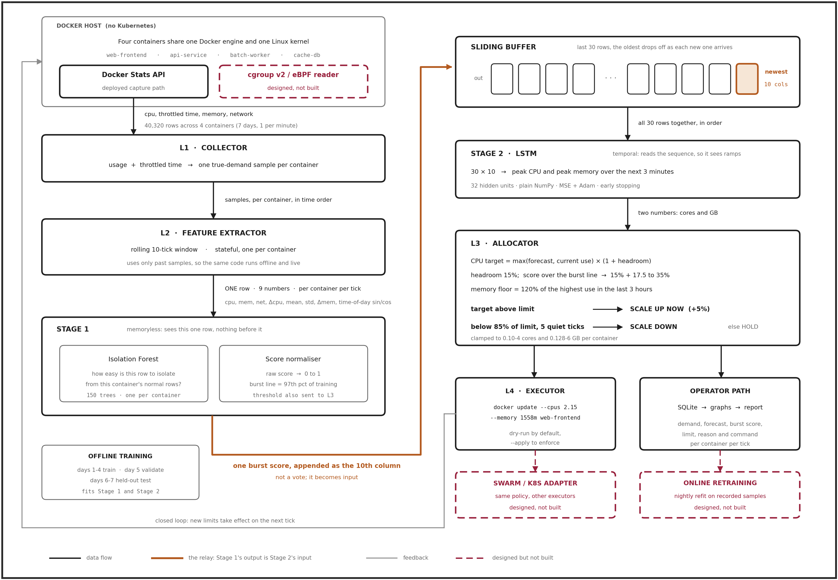
Figure 1: ProDock architecture. Solid boxes are implemented; red dashed boxes are designed but not built.

6.2 Components at a Glance
- Docker host: four containers (web-frontend, api-service, batch-worker, cache-db) share one Docker engine. There is no Kubernetes, which is the setting identified as underexplored in Section 5.2.
- L1 Collector: reads docker stats for every container each tick. It adds CPU throttled time to CPU usage, so it can estimate the true demand of a container even when its current limit is holding it back.
- L2 Feature extractor: turns each sample into one row of 9 numbers: CPU, memory, network, change in CPU, the 10-tick average and spread of CPU, change in memory, and the time of day. It only uses past data, so the same code runs in training and in live operation.
- Stage 1, Burst detector: an Isolation Forest, trained separately for each container, scores how unusual the current row is on a 0 to 1 scale. A score above the 97th percentile of training scores counts as a likely burst.
- The relay: the burst score is not used as a vote. It is appended to the row as a 10th column, so the forecaster can learn what an unusual row tends to lead to.
- Sliding buffer: keeps the 30 most recent rows (30 minutes). Each new row pushes out the oldest.
- Stage 2, LSTM forecaster: reads the 30 rows in order and predicts the peak CPU and peak memory over the next 3 minutes. The peak is predicted, rather than the average, because a limit has to cover the highest point.
- L3 Allocator: sets the CPU limit to the forecast (or current use, if higher) plus 15% headroom, and adds up to 35% more when a burst is flagged. Memory is never set below 120% of the highest use in the last 3 hours, because running out of memory kills a container. Limits grow immediately but only shrink after 5 quiet ticks and when the new target is under 85% of the current limit.
- L4 Executor: applies the decision with docker update --cpus and --memory. This changes the container’s cgroup limits without a restart. It runs in dry-run mode unless explicitly enabled.
- Operator path: every decision (demand, forecast, burst score, new limits, reason and command) is written to a SQLite log, which is also the source of the graphs in this section.
- Designed, not built: a direct cgroup v2 or eBPF reader, nightly retraining on recorded data, and adapters for Docker Swarm or Kubernetes.

6.3 Experimental Setup
Because no production cluster was available, we generated a realistic week of per-minute demand for the four containers (40,320 rows). web-frontend has an evening peak and random flash crowds; api-service peaks at lunchtime and is quieter at weekends; batch-worker runs a heavy job every two hours; cache-db has steady CPU while its memory grows and is compacted nightly. Days 1 to 4 were used for training, day 5 for validation and early stopping, and days 6 and 7 as an unseen test set.
On the test days we compared four allocation policies: Static (a fixed limit, as set by hand), Reactive (grow the limit by 50% above 80% utilisation and shrink it by 25% below 30%), Predictive (the ConLAR-style approach: LSTM forecast plus 15% headroom, applied every minute) and ProDock. A minute counts as an SLO violation when a container demands more than 2% above its CPU limit.

6.4 Results
Stage 1 in action. Figure 2 checks whether the burst detector does its job before we look at the full system.
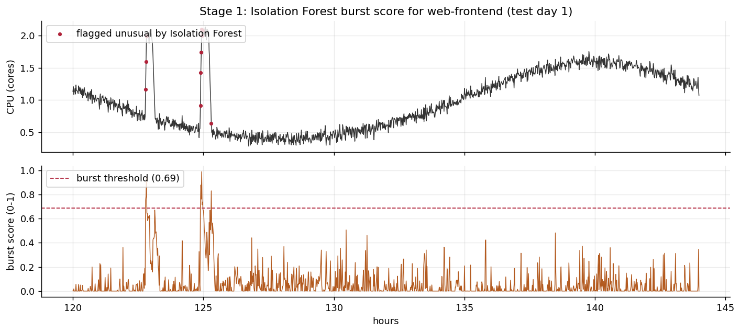
Figure 2: Burst score for web-frontend on the first test day. Top: CPU demand, with red dots where the score crossed the burst threshold. Bottom: the score itself and the threshold (dashed line).
What it shows: the score stays low during normal daily variation, including the slow evening rise, and spikes at the start of each flash crowd. Why it matters: the flags land on the first minutes of each burst, which is exactly when extra headroom does the most good.
Table 1: Forecast error for peak CPU over the next 3 minutes (test days, all containers).
Model | Mean abs. error (cores) | Error on peak minutes | Predicted too low
Naive (last value) | 0.080 | 0.154 | 74%
Moving average | 0.130 | 0.404 | 82%
Linear (Ridge) | 0.059 | 0.098 | 42%
LSTM without burst score | 0.053 | 0.105 | 54%
ProDock (Isolation Forest + LSTM) | 0.061 | 0.102 | 30%

Adding the burst score does not give the lowest average error; the plain LSTM is slightly more accurate on that measure. Its value is that the model predicts too low far less often (30% of the time against 54%). For resource limits, under-prediction is the costly mistake because it is what causes throttling, so this shift matters more than a small change in average error.
Table 2: Allocation results on the two test days (all four containers).
Policy | SLO violations | Wasted CPU (core-h) | Avg CPU util. | OOM kills | Limit changes
Static | 1.28% | 246.5 | 41.6% | 0 | 0
Reactive | 2.14% | 122.8 | 50.7% | 24 | 1,206
Predictive (ConLAR-style) | 2.48% | 34.9 | 73.0% | 93 | 11,473
ProDock | 0.70% | 54.3 | 65.4% | 1 | 1,966

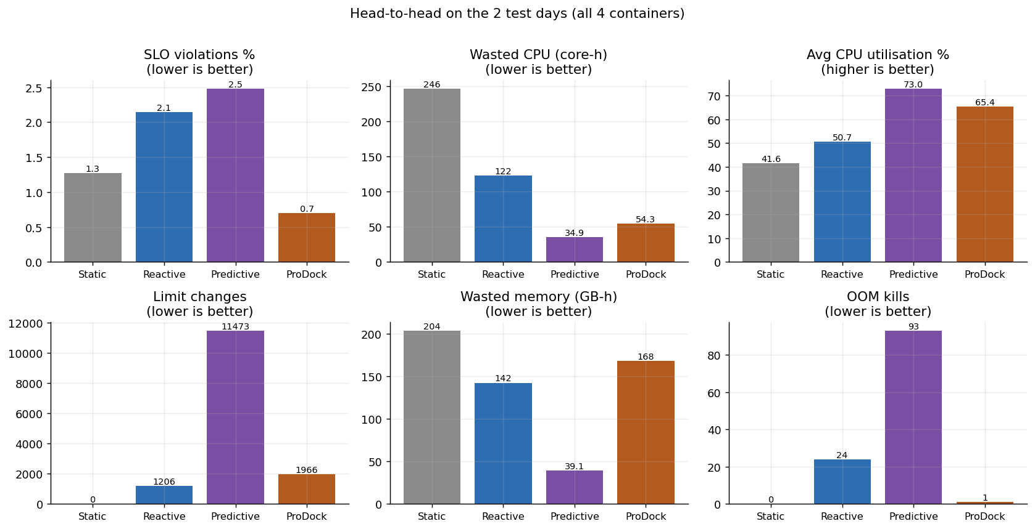
Figure 3: Head-to-head comparison of the four policies on six measures.
What it shows: each bar chart is one column of Table 2. Key takeaway: ProDock has the fewest SLO violations of all four policies while wasting 78% less CPU than static limits and 56% less than reactive rules. Compared with the ConLAR-style predictor it makes 5.8 times fewer limit changes and has 1 OOM kill instead of 93. The trade-off is that the ConLAR-style predictor wastes less CPU and memory, but only by cutting limits so fine that it violates the SLO 3.5 times as often.
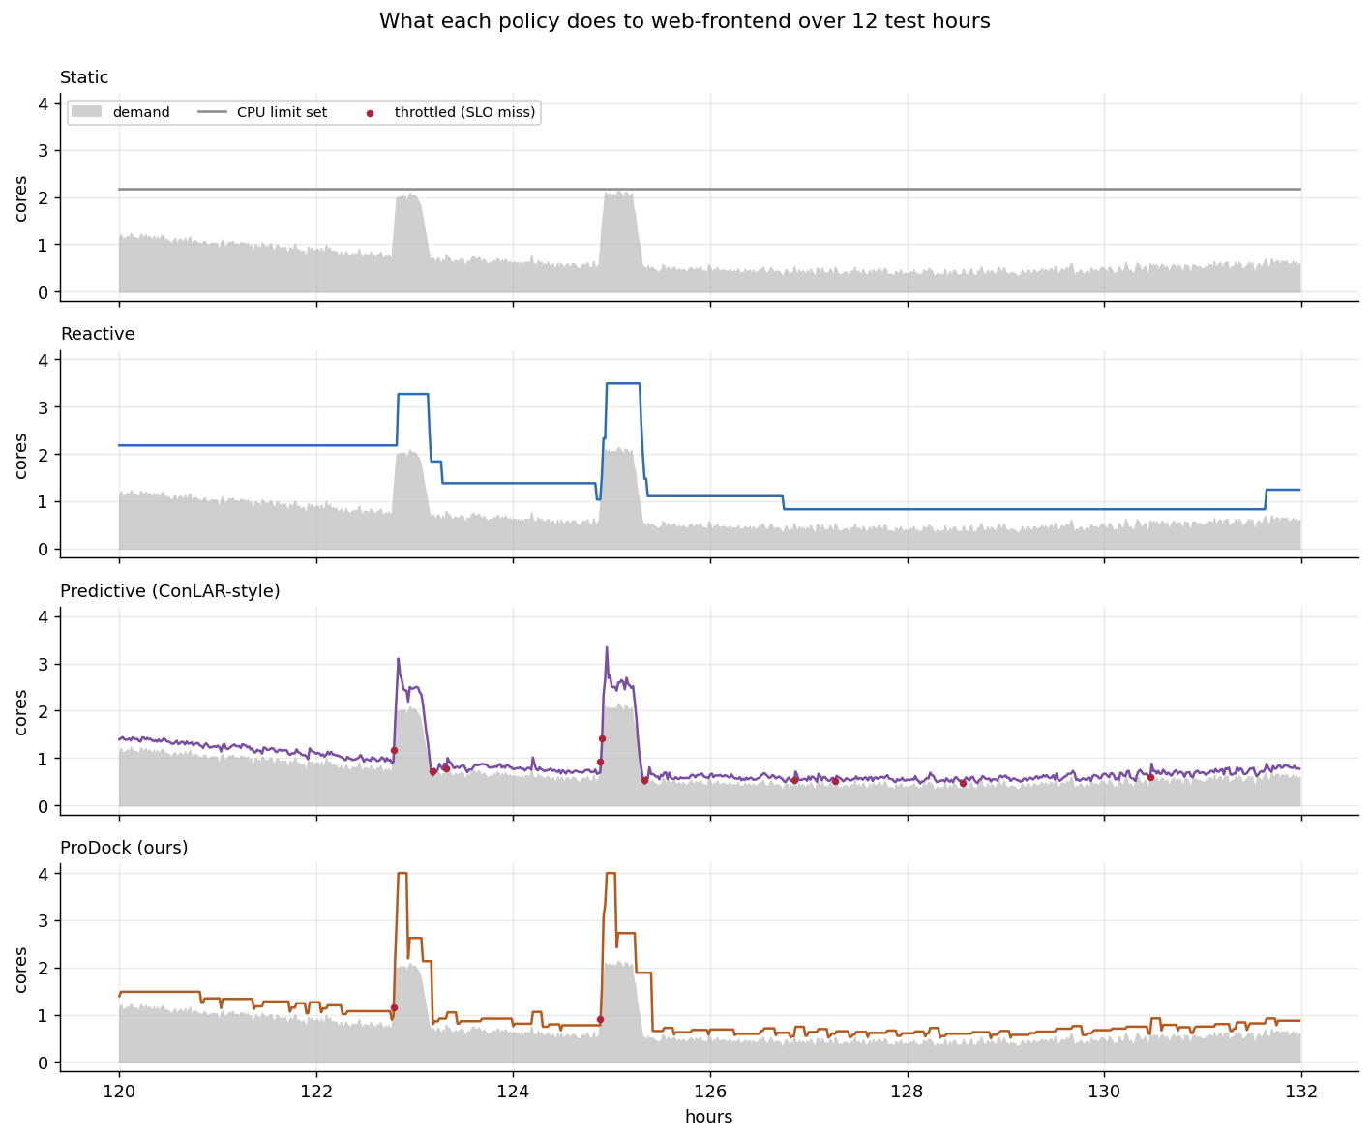
Figure 4: CPU limit (coloured line) against demand (grey) for web-frontend over 12 test hours under each policy. Red dots mark throttled minutes.
What it shows: how each policy behaves over time on the same traffic. Static reserves a large band of unused CPU. Reactive jumps late and then stays too high for hours. The ConLAR-style predictor tracks demand closely but is caught at the start of each spike. Key takeaway: ProDock raises the limit as soon as the burst score fires and settles back down once the spike passes.
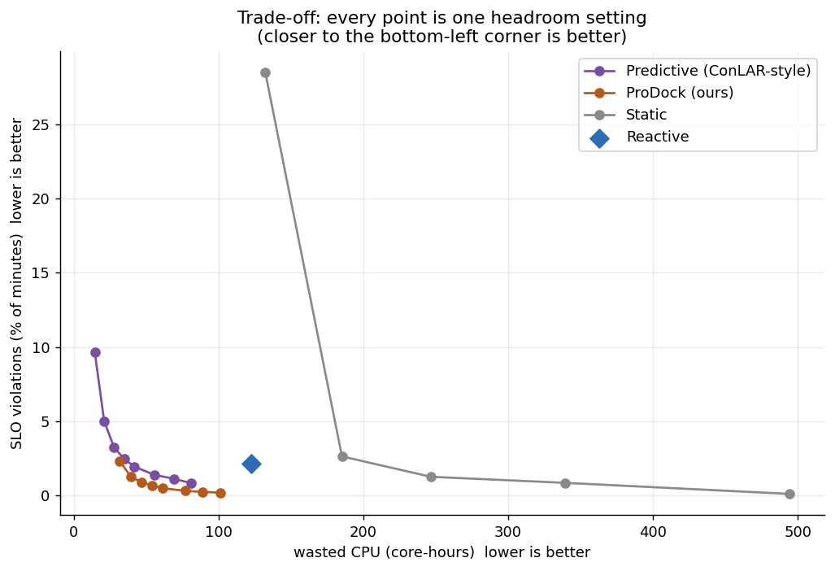
Figure 5: SLO violations against wasted CPU. Each point is one headroom setting; points nearer the bottom-left corner are better.
What it shows: we re-ran the predictive policies at eight headroom levels and the static policy at five limit levels. Key takeaway: ProDock’s curve sits below the ConLAR-style curve across the range, so for any given amount of waste ProDock has fewer violations. This indicates that the improvement comes from the method itself rather than from choosing one favourable setting.
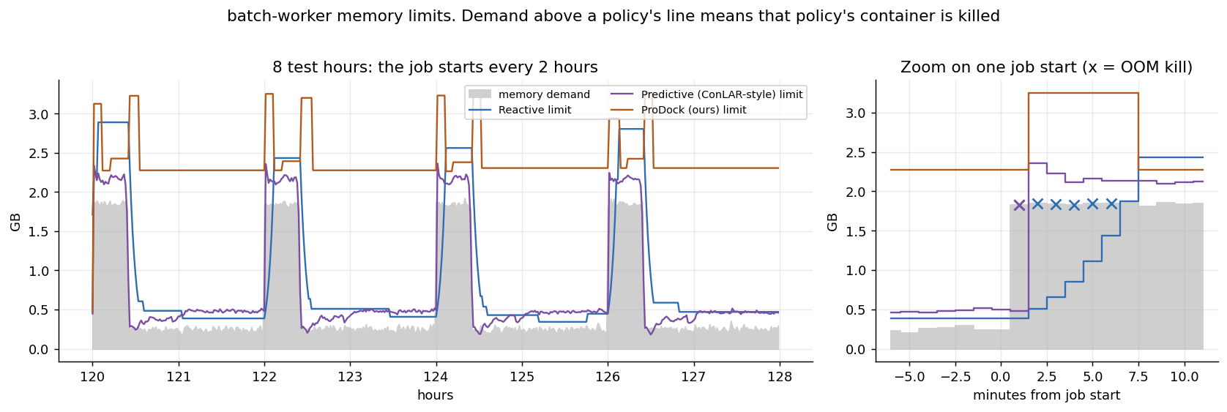
Figure 6: Memory limits for batch-worker. Left: 8 test hours. Right: one job start, where a cross marks a minute in which that policy’s container would be killed for exceeding its memory limit.
What it shows: batch-worker’s memory jumps sharply each time its scheduled job starts. Key takeaway: the reactive policy grows its limit too slowly and is killed for five consecutive minutes; the ConLAR-style limit is caught on the first minute. ProDock stays above demand throughout, because its memory floor remembers the previous job.

6.5 Limitations
- Simulated data: the results show the method behaves as designed, but they do not establish production performance, a limitation shared by most of the papers reviewed (Section 5.3).
- Scheduled jobs: the LSTM looks back only 30 minutes, so the first minute of batch-worker’s two-hourly job is hard to anticipate. A same-time-yesterday feature is a natural next step.
- Memory cost: ProDock reserves more memory than the ConLAR-style predictor. This is the price of avoiding OOM kills.
- Live deployment: the model was trained on the simulated host; real use requires recording a few days of data on the target machine and retraining.

7. Conclusion
This review examined all 40 identified papers spanning three complementary approaches to AI-based resource allocation for Docker containers: container-specific allocation and survey work, machine-learning-based workload forecasting, and reinforcement-learning-based autoscaling and scheduling. Taken together, the literature shows a clear trend away from static, manually configured, or purely reactive resource management and toward predictive and adaptive systems that use historical data to anticipate demand or learn an optimal allocation policy over time. At the same time, the review surfaced a genuine gap: most AI-driven work operates at the Kubernetes pod level rather than the Docker container level, and most evaluation is done in simulation rather than production. These observations point to concrete directions for further study, including AI-based allocation for standalone or lightweight Docker deployments and more extensive real-world validation of the techniques proposed in the literature.
Building on the gap identified in this review, Section 6 presented ProDock, a working prototype of proactive, AI-based allocation for standalone Docker hosts. On the held-out test days it produced the fewest SLO violations of the four policies compared, cut wasted CPU by 78% relative to static limits, and almost eliminated out-of-memory kills. Validating it on real, non-simulated workloads is the clearest direction for further work.

References
[1] Various authors, "Predictive container orchestration in the cloud using AI techniques," Computing (Springer), 2025. Available: https://link.springer.com/article/10.1007/s00607-025-01505-z
[2] Various authors, "Isolated Forest-Based Prediction of Container Resource Load Extremes (ExtremoNet)," Applied Sciences (MDPI), 2024. Available: https://doi.org/10.3390/app14072911
[3] Various authors, "A Self-Adaptive Framework for Predictive CPU Resource Allocation During Container Startup in Kubernetes (CLUEAI)," IEEE/ACM UCC, 2025. Available: https://dl.acm.org/doi/10.1145/3773274.3774262
[4] Various authors, "Predicting resource consumption of Kubernetes container systems using resource models," Journal of Systems and Software (Elsevier), 2023. Available: https://www.sciencedirect.com/science/article/pii/S0164121223001450
[5] Various authors, "Container Resource Allocation versus Performance of Data-Intensive Applications on Different Cloud Servers," arXiv:2311.07818, 2024. Available: https://arxiv.org/abs/2311.07818
[6] Vhatkar, S. & Bhole, G.P., "A comprehensive survey on container resource allocation approaches in cloud computing," Journal of Web Engineering, 2021. Available: https://journals.sagepub.com/doi/full/10.3233/WEB-210474
[7] Vhatkar, S. & Bhole, G.P., "Optimal container resource allocation in cloud architecture: a new hybrid model," Journal of King Saud University – Computer and Information Sciences, 2022. Available: https://doi.org/10.1016/j.jksuci.2022.02.017
[8] Various authors, "Predictive Autoscaling for Containerized Applications Using Machine Learning," IEEE Conference, 2024. Available: https://ieeexplore.ieee.org/document/10530773/
[9] Abdullah, M., Iqbal, W., Berral, J.L., Polo, J., Carrera, D., "Burst-Aware Predictive Autoscaling for Containerized Microservices," IEEE Transactions on Services Computing, 2022. Available: https://doi.org/10.1109/tsc.2020.2995937
[10] Dang-Quang, N.-M. & Yoo, M., "An Efficient Multivariate Autoscaling Framework Using Bi-LSTM for Cloud Computing," Applied Sciences, 2022. Available: https://doi.org/10.3390/app12073523
[11] Dogani, J., Khunjush, F., Seydali, M., "K-AGRUED: Container Autoscaling for Cloud Web Apps in Kubernetes Using Attention-based GRU Encoder-Decoder," Journal of Grid Computing, 2022.
[12] Xu, M., Song, C., Wu, H., Gill, S.S., Ye, K., Xu, C., "esDNN: Deep Neural Network Based Multivariate Workload Prediction in Cloud Computing," ACM Transactions on Internet Technology, 2022.
[13] Meng, C., Song, S., Tong, H., Pan, X., Yu, Y., "DeepScaler: Holistic Autoscaling for Microservices Based on Spatiotemporal GNN with Adaptive Graph Learning," ASE (Automated Software Engineering), 2023. Available: https://doi.org/10.1109/ase56229.2023.00038
[14] Golshani, M. & Ashtiani, M., "Proactive auto-scaling for cloud environments using temporal convolutional neural networks," Journal of Parallel and Distributed Computing, 2021.
[15] Santos, J., Wauters, T., Volckaert, B., De Turck, F., "gym-hpa: Efficient Auto-Scaling via Reinforcement Learning for Complex Microservice-based Applications in Kubernetes," IEEE/IFIP NOMS, 2023. Available: https://doi.org/10.1109/noms56928.2023.10154298
[16] Zhang, Y., Wu, W., Pan, S., Zhang, R., Yu, C., "A-SARSA: A Predictive Container Auto-Scaling Algorithm Based on Reinforcement Learning," IEEE International Conference on Web Services (ICWS), 2020. Available: https://doi.org/10.1109/icws49710.2020.00072
[17] Khaleq, A.A. & Ra, I., "Intelligent microservices autoscaling module using reinforcement learning," Cluster Computing, 2023. Available: https://doi.org/10.1007/s10586-023-03999-8
[18] Xue, S., Qu, C., Shi, X., Liao, C., Zhu, S., Tan, X., Ma, L., Wang, S., Wang, S., Hu, Y., "A Meta Reinforcement Learning Approach for Predictive Autoscaling in the Cloud," KDD (ACM SIGKDD), 2022.
[19] Zhou, X. et al., "A Kubernetes custom scheduler based on reinforcement learning for compute-intensive pods (SDQN)," arXiv:2601.13579, 2026. Available: https://arxiv.org/abs/2601.13579
[20] Chinnam, S. & Karanam, S., "AI-Driven Predictive Autoscaling in Kubernetes: Reinforcement Learning for Proactive Resource Optimization," International Journal of Scientific Research in Computer Science, Engineering and Information Technology (IJSRCSEIT), 2022. Available: https://doi.org/10.32628/CSEIT22548
[21] Pandey, A., "Reinforcement Learning-Based Autoscaling for Cost and Performance Optimization in Kubernetes Clusters," Springer LNDECT (Lecture Notes on Data Engineering and Communications Technologies), 2026. Available: https://doi.org/10.1007/978-3-032-10344-4_3
[22] Chen, D., Shen, B., Chen, Y., "ConLAR: Learning to Allocate Resources to Docker Containers under Time-Varying Workload," 2021 IEEE 21st International Conference on Software Quality, Reliability and Security (QRS), 2021, pp. 458–469. Available: https://ieeexplore.ieee.org/document/9724894
[23] Zhang, L., Xie, Y., Jin, M., "A Novel Hybrid Model for Docker Container Workload Prediction," IEEE Transactions on Network and Service Management, vol. 20, no. 3, pp. 2726–2743, Sep. 2023.
[24] Kim, B.S., Lee, S.H., Lee, Y.R., Park, Y.H., Jeong, J., "Design and Implementation of Cloud Docker Application Architecture Based on Machine Learning in Container Management for Smart Manufacturing," Applied Sciences (MDPI), 12(13), 6737, 2022.
[25] Li, Z., Song, L., et al., "A Docker Container-Based Dynamic Allocation System for Computational Resources," Springer Nature Link, 2026. Available: https://doi.org/10.1007/978-981-95-9299-9_11
[26] Algarni, A., Shah, I., Jehangiri, A.I., Ala’Anzy, M.A., Ahmad, Z., "Predictive Energy Management for Docker Containers in Cloud Computing: A Time Series Analysis Approach," IEEE Access, vol. 12, pp. 52524–52538, 2024. Available: https://doi.org/10.1109/ACCESS.2024.3387436
[27] Sharmili, V.V.S. & Gopu, A., "Enhancing IoT Container Scheduling in the Cloud with Multi-Objective Accelerated PSO," Proceedings of the 2024 IEEE International Conference on Contemporary Computing and Communications (InC4), pp. 1–6, 2024.
[28] Khan, M.A., Sahoo, B., Mishra, S.K., et al., "Multi-Objective Based Container Placement Strategy in CaaS," Software: Practice and Experience, 2024.
[29] Yuan, H. & Liao, S., "A Time Series-Based Approach to Elastic Kubernetes Scaling," Electronics (MDPI), 13, 285, 2024.
[30] Tran, M.N. & Kim, Y., "Optimized Resource Usage with Hybrid Auto-Scaling System for Knative Serverless Edge Computing," Future Generation Computer Systems, vol. 152, pp. 304–316, 2024.
[31] Toka, L., Dobreff, G., Fodor, B., Sonkoly, B., "Machine Learning-Based Scaling Management for Kubernetes Edge Clusters," IEEE Transactions on Network and Service Management, vol. 18, pp. 958–972, 2021. Available: https://doi.org/10.1109/TNSM.2021.3052837
[32] Pintye, I., Kovács, J., Lovas, R., "Enhancing Machine Learning-Based Autoscaling for Cloud Resource Orchestration," Journal of Grid Computing, 22, 68, 2024. Available: https://doi.org/10.1007/s10723-024-09783-1
[33] Marques, G., Senna, C., Sargento, S., Carvalho, L., Pereira, L., Matos, R., "Proactive Resource Management for Cloud of Services Environments," Future Generation Computer Systems, vol. 150, pp. 90–102, 2024.
[34] Park, J., Choi, B., Lee, C., Han, D., "Graph Neural Network-Based SLO-Aware Proactive Resource Autoscaling Framework for Microservices," IEEE/ACM Transactions on Networking, vol. 32, no. 4, pp. 3331–3346, 2024. Available: https://doi.org/10.1109/TNET.2024.3393427
[35] Chen, X., Zhu, F., Chen, Z., Min, G., Zheng, X., Rong, C., "Resource Allocation for Cloud-Based Software Services Using Prediction-Enabled Feedback Control with Reinforcement Learning," IEEE Transactions on Cloud Computing, vol. 10, no. 2, pp. 1117–1129, 2022. Available: https://doi.org/10.1109/TCC.2020.2992537
[36] Danino, T., Ben-Shimol, Y., Greenberg, S., "Container Allocation in Cloud Environment Using Multi-Agent Deep Reinforcement Learning," Electronics (MDPI), 12(12), 2614, 2023. Available: https://doi.org/10.3390/electronics12122614
[37] Santos, J., Reppas, E., Wauters, T., Volckaert, B., De Turck, F., "Gwydion: Efficient Auto-Scaling for Complex Containerized Applications in Kubernetes Through Reinforcement Learning," Journal of Network and Computer Applications, vol. 234, 104067, 2025. Available: https://doi.org/10.1016/j.jnca.2024.104067
[38] Wang, Z., Zhu, S., Li, J., Jiang, W., Ramakrishnan, K.K., Zheng, Y., Yan, M., Zhang, X., Liu, A.X., "DeepScaling: Autoscaling Microservices With Stable CPU Utilization for Large Scale Production Cloud Systems," IEEE/ACM Transactions on Networking, vol. 32, no. 5, pp. 3961–3976, 2024.
[39] Rothman, J. & Chamanara, J., "An RL-Based Model for Optimized Kubernetes Scheduling," 2023 IEEE 31st International Conference on Network Protocols (ICNP), 2023. Available: https://doi.org/10.1109/ICNP59255.2023.10355623
[40] Benedetti, P., Femminella, M., Reali, G., "Management of Autoscaling Serverless Functions in Edge Computing via Q-Learning," Future Generation Computer Systems, vol. 175, 108112, 2026.

