BUSINESS PROPOSAL
Modular "Plug-and-Play" AI-Agent Platform for Enterprise Onboarding
Activate a fully working AI customer-support and CRM agent for any Egyptian business in hours, not weeks, simply by uploading its policies, knowledge documents and customer data structures.
Hours | Arabic-first | -60%+ | PDPL-ready
to first working agent, not weeks | Egyptian dialect + English | service cost vs. a manual team | Egypt-hosted data option

Prepared for: prospective pilot customers and enterprise partners in Egypt
Market focus: Egypt (telecom & subscription services, e-commerce, fintech, hospitality & travel, airlines)
Version 1.0 | September 2026 | All figures in EGP with USD equivalents at 51.5 EGP/USD
Confidential. Market figures are drawn from public sources listed in the Appendix; forecasts are management estimates and design targets, not guarantees.
Contents
Refreshed automatically when the document is opened or exported in Microsoft Word.
1. Title and One-line Value Proposition 3
2. Executive Summary / The Big Idea 4
3. Problem Statement 5
4. Current Situation / Root Causes 6
5. Target Customer Segments 7
6. Customer Journey and Pain Points 8
7. Market Opportunity 9
8. Solution Overview 10
9. How the Solution Works (business-friendly) 11
10. Value Proposition 12
11. Unique Selling Points / Competitive Advantages 13
12. Competitive Analysis 14
13. Business Model Canvas 15
14. Revenue Model and Pricing 16
15. Go-to-Market Strategy 17
16. Marketing and Sales Funnel 18
17. Operations / Delivery Model 19
18. High-level Technology Overview 20
19. Validation / Traction Approach 21
20. Key Performance Indicators 22
21. Financial Assumptions 23
22. Revenue Forecast 24
23. Cost Structure 25
24. Profitability Projection 26
25. Break-even Analysis 27
26. Unit Economics 28
27. Funding Requirements 29
28. Roadmap 30
29. Risks and Mitigation 31
30. Team and Capabilities 32
31. Strategic Vision / Future Expansion 33
32. The Ask / Next Steps 34
33. Closing Statement 35
Appendix: Sources 36

1. Title and One-line Value Proposition
Modular "Plug-and-Play" AI-Agent Platform for Enterprise Onboarding
In short: One sentence: a new business uploads its policies, documents and customer-data structure, and within hours it has a working AI agent that answers customers in Arabic and English, takes real actions on its data (orders, tickets, bookings, accounts), and hands anything risky to a human.

The value proposition in one line
"Plug in your business, and a safe, action-taking AI support agent is live within hours, with only light adjustments and no development project."

Why this matters now in Egypt
- Customers already live on chat. Egypt has 98.2 million internet users (82.7% penetration) and roughly 57 million WhatsApp users; over 90% of Egyptian businesses use WhatsApp to talk to customers.
- Human support is the bottleneck. An Arabic-speaking agent costs EGP 7,000-14,000 per month before employer costs, cannot cover 24/7 alone, and takes weeks to train on a company's policies.
- AI is ready, but deployment is not. Existing tools either give fast FAQ bots that cannot act on business data, or powerful platforms that need developers and weeks of integration.
- The market is growing fast. Egypt's conversational-AI market is estimated at USD 200 million in 2025, growing 23.1% a year to USD 696 million by 2030.
Sources: DataReportal Digital 2026: Egypt; ChatDaddy WhatsApp in Egypt 2026; WUZZUF call-center salary guide 2026; MarketsandMarkets Egypt Conversational AI Market.

2. Executive Summary / The Big Idea
In short: We are building the fastest way for an Egyptian business to get a trustworthy AI support and CRM agent. Instead of a months-long chatbot project, the business drops in its documents and data structure, the platform builds the knowledge base and the action tools automatically, and a business owner adjusts the agent in plain language from a Control Center. We will prove this with paid pilots in five verticals in 2027.

USD 200M | EGP 22.8M | ~88 | 9:1
Egypt conversational-AI market 2025, 23.1% CAGR | Revenue target 2029 (~300 SMB + 4 enterprise) | paying customers to break even (2028 cost base) | LTV to CAC ratio (base case)

What we are proposing
- The product: a multi-tenant platform with two faces. A customer-facing agent (WhatsApp, website, Messenger, Instagram; voice later) that answers from the business's own policies and executes approved actions on its data. And a Business Owner Control Center where a non-technical owner uploads documents, reviews what the agent can do, adjusts rules in plain language and audits every action.
- The onboarding promise: low developer involvement. Knowledge ingestion and tool creation are automated from uploaded documents, spreadsheets, database schemas or API specifications. Light adjustments replace heavy integration work.
- The safety promise: every action is bounded by the business's own policies and confidence thresholds; anything ambiguous, sensitive or out of scope is escalated to a human with full context.
- The business model: flat monthly subscription tiers in EGP (Starter EGP 2,500, Growth EGP 7,500, Business EGP 20,000, Enterprise from EGP 60,000) with conversation allowances, plus paid 60-day pilots at EGP 5,000.
- The ask: 5-8 founding pilot customers across telecom/ISP, e-commerce, fintech, hospitality/travel and airlines, starting Q1 2027.

Why we will win
Local bot builders (Hulul/WideBot) are fast but stop at scripted FAQs; global platforms (Intercom, Zendesk) act on data but are priced in dollars, need integration work and are not built for Egyptian Arabic or Egypt's data-protection regime. We sit in the empty quadrant: fast to onboard and able to act on business data, priced in EGP, Arabic-first and PDPL-aware.

3. Problem Statement
In short: Egyptian businesses are drowning in repetitive customer conversations on WhatsApp and social media, but the two ways to fix it, hiring more agents or building a chatbot, are both slow, expensive and unreliable for a small or mid-sized company.

Who suffers, how often, and what it costs
Stakeholder | What happens today | Evidence / scale
Business owner / operations manager | Pays a growing team to answer the same 30-50 questions; still misses messages at night and on weekends; cannot see what was promised to customers. | Arabic agent EGP 7,000-14,000/month; English EGP 12,000-21,000/month; fully loaded ~x1.3.
Customer | Waits hours for an answer, repeats information across channels, escalates to a hotline or a regulator. | NTRA received 141,224 telecom complaints in H1 2026; fixed-broadband complaint rate 336 per 100,000 subscribers.
Support agent | Copy-pastes policy text, switches between CRM, order system and WhatsApp; burns out; leaves within months. | High churn is structural in Egyptian BPO; entry pay near the EGP 7,000 minimum wage.
IT / developers | Asked to 'build a bot' on top of daily work; each new policy or product change requires code changes. | Mid-level backend developer EGP 21,000-44,000/month; projects take weeks to months.
Travellers & subscribers (airlines, telecom) | Baggage, refund, delay and billing enquiries go unanswered; brand damage is public. | EgyptAir averaged ~20 complaints per 100 flights (Canadian Transportation Agency, 2023-24).

The core problem, stated plainly
A business cannot get an AI agent that (a) knows its own policies, (b) can actually do things on its systems, (c) is safe enough to trust with customers, and (d) can be set up and changed by non-technical staff. Today you can have two or three of these four, never all four, and never quickly.
Sources: WUZZUF and Ta3Heed 2026 salary data; NTRA H1 2026 complaint statistics via Business Tech News; CV Pro Maker Egypt tech salaries 2026; AirAdvisor citing the Canadian Transportation Agency.

4. Current Situation / Root Causes
In short: The problem persists because every current option pushes the hard work onto people: agents memorise policies, developers hand-code integrations, and bot builders make owners draw flowcharts. Nothing turns a company's existing documents and data into a working agent automatically.

Five whys
1. Why do businesses still answer most messages manually? Because their chatbots cannot answer policy questions accurately or take actions.
2. Why can't the chatbots do that? Because they are built from scripted flows and FAQs, not from the company's real documents and systems.
3. Why aren't they connected to real documents and systems? Because connecting them requires developers to write and maintain integrations.
4. Why is developer work the blocker? Because in Egypt mid-level developers cost EGP 21,000-44,000/month and are scarce; SMEs cannot dedicate one to support tooling.
5. Why has nobody automated the integration step? Because until recently, models could not reliably read a schema or API spec and generate safe, bounded tools; that is now possible, and it is the core of this platform.

Why current methods fall short
Current approach | Strength | Why it is insufficient
Hire more agents | Flexible, human judgement | Linear cost growth, 8-hour coverage, inconsistent answers, weeks of training per hire.
Flow-builder chatbots (drag-and-drop) | Fast, cheap, Arabic support | Break on any question outside the script; cannot look up an order or change a booking; owner must maintain flows.
Global AI helpdesks (Intercom, Zendesk, Freshdesk) | Strong AI, integrations | Priced in USD per seat and per resolution; integrations still need developer work; weak on Egyptian dialect; data hosted abroad.
Custom in-house build | Fully tailored | 3-6 months, EGP 300,000+ in developer time, then permanent maintenance; every policy change is a code change.
Outsourced call centre (BPO) | Scales quickly | Same per-agent economics, less knowledge of the business, quality risk.

What changed
Three shifts make the automated approach viable now: (1) budget-tier language models cost about USD 0.20-0.25 per million input tokens, so a full conversation costs a fraction of an Egyptian pound; (2) models can reliably generate structured tool definitions from schemas and API documents; (3) Meta's WhatsApp Business Platform and Egypt's fibre and 4G/5G roll-out have made chat the default channel for both consumers and businesses.
Sources: CV Pro Maker Egypt tech salaries 2026; OpenAI, Google and Anthropic public API price lists (Sept 2026); Meta WhatsApp Business Platform pricing.

5. Target Customer Segments
In short: We target Egyptian businesses that already handle high volumes of customer conversations and have written policies and structured customer data: telecom and subscription services, e-commerce, fintech, hospitality and travel, and airlines. The platform is horizontal by design; these five are where the pain and the willingness to pay are highest today.

Segmentation matrix
Segment | Typical customer profile | Conversation drivers | Buyer / decision maker | Egypt scale
Telecom, ISPs and subscription services | Mobile operators, ISPs and resellers, streaming, SaaS and membership businesses | Billing questions, outages, plan changes, cancellations | Head of customer care / COO | 4 mobile operators, 12.7M fixed-broadband lines; WE alone 15.3M mobile + 11.2M data subscribers
E-commerce and online retail | Brands and stores selling via web, Instagram and WhatsApp | Order status, returns, delivery, payment | Founder / e-commerce manager | Market USD 11.5B in 2026; 35M+ online shoppers; 72% of value on smartphones
Fintech and lending | Wallets, BNPL, microfinance, payment providers | KYC status, transaction disputes, limits, fees | Head of operations / compliance | 227 active fintech companies; sector USD 765M (2024) growing ~15.8%/yr
Hospitality and travel | Hotels, tour operators, restaurants, travel agencies | Bookings, changes, multilingual enquiries, complaints | GM / revenue manager | 19M tourists in 2025 (+21%); ~1,300 hotels; 2,240 tourism companies; 1,620 tourist restaurants
Airlines and air-travel services | National, low-cost and charter carriers; GSAs; ground handlers | Flight status, baggage, refunds, rebooking | VP customer experience / CIO | Enterprise-tier accounts; charter traffic +32% in 2025; arrivals from 193 cities

Primary vs secondary focus
- Primary (self-serve tiers, 2027): e-commerce brands and hospitality/travel SMEs with 500-20,000 conversations a month. Fast decisions, clear ROI, WhatsApp-native.
- Primary (enterprise tier, from 2028): telecom/ISP resellers, subscription services, fintechs and airlines with complex policies and strict escalation needs.
- Secondary (any domain): clinics, education, real estate, logistics. The same ingestion and tool-generation engine applies with light adjustments; we will serve inbound demand but not market to these verticals until 2028.

Persona: the business owner we serve first
Mariam runs an online fashion brand in Cairo with 4 support staff answering 6,000 WhatsApp and Instagram messages a month. She has a return policy PDF, a Shopify export of orders and a Google Sheet of customers. She is not technical, has no developer, and loses sales every evening after her team logs off. She will pay for something that works in Arabic, respects her policies, and that she can change herself.
Sources: TelecomLead Best ISPs in Egypt 2026; Telecom Egypt Q1 2026 results; Mordor Intelligence Egypt E-commerce 2026; Tracxn Egypt FinTech (May 2026); ICLG Fintech Egypt 2026; Xinhua and Zawya/IDSC tourism 2025; Ministry of Tourism statements.

6. Customer Journey and Pain Points
In short: Today the journey from 'we need better support' to 'it works' is long and frustrating for the business owner, and the end customer's journey is full of waiting and repetition. The platform collapses the owner's journey to hours and gives the end customer an instant, consistent answer.

The business owner's journey today (before)
Stage | What the owner does | Pain | Typical time / cost
1. Realise | Notices missed messages, lost sales, complaints | No data on what customers ask | Months of leakage
2. Search | Compares bot builders, agencies, freelancers | Confusing, mostly USD pricing, unclear Arabic quality | 2-4 weeks
3. Decide | Picks a flow-builder bot or an agency | Has to write scripts or a requirements document | 1-2 weeks
4. Build | Draws flows or waits for developers to integrate | Every policy change is rework; integrations slip | 4-12 weeks; EGP 50,000-300,000+
5. Launch | Bot goes live, breaks on real questions | Customers say 'I want a human'; staff switch it off | Days to abandonment
6. Maintain | Nobody owns updates | Bot drifts out of date; ROI never measured | Ongoing

The business owner's journey with the platform (after)
1. Sign up and pick a plan in EGP (minutes).
2. Upload policies, FAQs, product documents and a data source (spreadsheet, CRM export, database schema or API spec).
3. Review the auto-generated knowledge base and the proposed action tools ('look up order', 'open ticket', 'change booking date') and switch on the ones you want.
4. Test-chat with the agent in Arabic and English; adjust tone and rules in plain language in the Control Center.
5. Connect WhatsApp, website widget or Instagram and go live; a human inbox receives escalations.
6. Watch the dashboard: resolution rate, escalations, top unanswered questions; update a policy by uploading the new document.
Design target: first working agent within one hour for a business with documents and a standard data source; complex or custom integrations typically 1-3 days with light developer adjustment. These are targets to be validated in the pilots, not guarantees.

The end customer's journey
Moment | Before | After
Asks 'where is my order?' at 10 pm on WhatsApp | Auto-reply 'we will get back to you'; answer next morning | Instant answer with tracking status pulled from the order system
Wants to change a booking date | Back-and-forth over 5 messages; agent checks a system manually | Agent checks availability, applies the change policy, confirms in one exchange
Disputes a charge | Repeats details on hotline, then email | Agent verifies identity per policy, records the dispute, escalates to a human with full context
Asks something unusual or sensitive | Bot loops or gives a wrong answer | Agent says it will bring in a colleague and hands over immediately

7. Market Opportunity
In short: The problem is commercially worth solving. Egypt's conversational-AI market is USD 200 million today and heading to nearly USD 700 million by 2030, on top of a digital base of 98 million internet users and the largest WhatsApp audience in the Arab world.

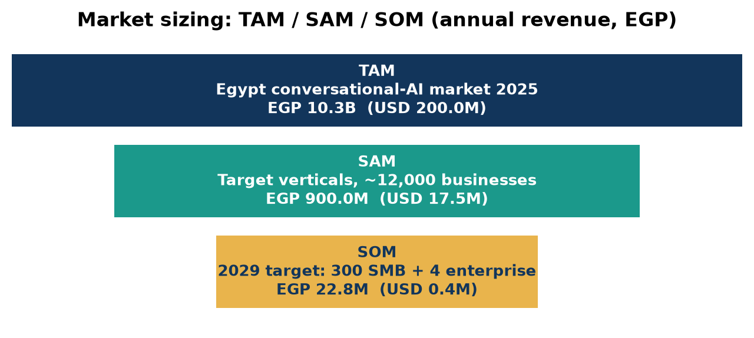

How we size the market
Layer | Definition | Size (annual) | Basis
TAM | Spending on conversational AI (chatbots, virtual assistants, platforms, services) in Egypt | USD 200M (2025) = EGP 10300.0M; USD 696M by 2030 | MarketsandMarkets, Egypt Conversational AI Market, 23.1% CAGR
SAM | Egyptian businesses in our five verticals (plus medium enterprises) with high conversation volumes and written policies: ~12,000 organisations | ~EGP 900M (USD 17M) | Bottom-up: ~12,000 businesses x blended ~EGP 75,000/year
SOM | Planned by end-2029: ~300 SMB subscriptions and 4 enterprise contracts | EGP 22.8M (USD 443K) | ~2.5% of SAM; forecast in Section 22

Growth and trends
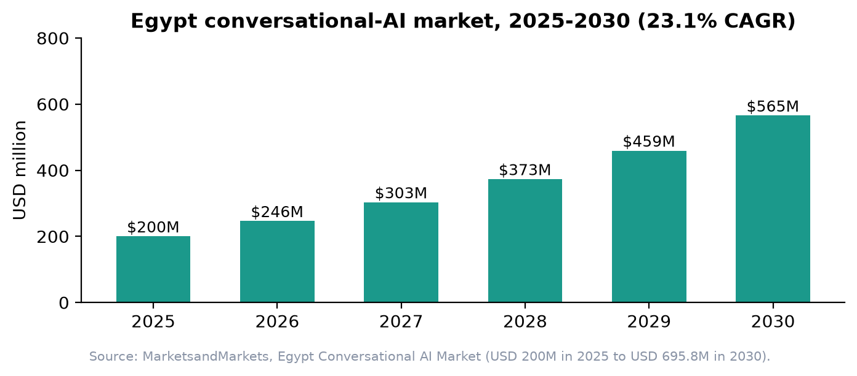
- Digital demand: 98.2M internet users (82.7%), ~57M WhatsApp users, 35M+ online shoppers.
- Verticals growing faster than GDP: e-commerce USD 11.5B in 2026 (11.9% CAGR); fintech ~15.8% CAGR; tourism arrivals +21% in 2025, 30M target.
- Regional path: MEA conversational-AI market USD 1.2B (2024) to USD 3.5B (2030), 19.7% CAGR; Arabic-first capability travels to the GCC.
- Policy tailwind: Digital Egypt, the national AI strategy and Cashless Egypt push businesses toward digital service channels.
Sources: MarketsandMarkets; Grand View Research; DataReportal Digital 2026: Egypt; Mordor Intelligence; AmCham Egypt / IMARC; Xinhua (Jan 2026). SAM organisation count is a management estimate built from CAPMAS, CBE FinTech Egypt, Ministry of Tourism and NTRA figures.

8. Solution Overview
In short: A single platform with two interfaces: a customer-facing AI agent that answers and acts, and a Business Owner Control Center that lets a non-technical owner set it up, adjust it and audit it. The platform does the heavy lifting of turning documents and data structures into knowledge and tools automatically.

What the business gets
Component | What it does for the business
Customer-facing agent | Answers questions grounded in the business's own policies, in Egyptian Arabic and English; executes approved actions (look up, create, update) on the business's data; works on WhatsApp, website chat, Messenger and Instagram; voice in a later phase.
Business Owner Control Center | Upload and version documents; see and switch on/off the auto-generated action tools; set rules and tone in plain language; review every action the agent took; manage the human escalation inbox; see KPIs.
Automated knowledge ingestion | PDF, Word, spreadsheets, web pages and FAQs are parsed, chunked and indexed into a tenant-isolated knowledge base within minutes of upload.
Automated tool generation | From a customer-data schema, spreadsheet, CRM export or API specification, the platform proposes bounded action tools (e.g., get_order_status, update_delivery_address, create_ticket) with validation and permissions; the owner approves them.
Safety and escalation | Policy-derived guardrails, confidence thresholds, identity verification steps and automatic hand-over to a human with the full transcript and context.
Compliance layer | Tenant isolation, audit log of every answer and action, data-retention controls and an Egypt-hosted data option aligned with the PDPL.

Before and after, at a glance
 | Before (typical Egyptian SME) | After (with the platform)
Time to a working agent | 4-12 weeks project | Hours to a few days (design target)
Who sets it up | Developers or an agency | The business owner, with light adjustments
What the agent can do | Answer scripted FAQs | Answer from real policies and act on real data
Coverage | Business hours | 24/7 with human escalation
Language | Formal Arabic or English | Egyptian dialect, Arabic and English, auto-detected
Changing a policy | Ticket to IT | Upload the new document
Cost basis | Per agent salary | Flat EGP subscription

9. How the Solution Works (business-friendly)
In short: Three steps for the business: upload, review, go live. Behind the scenes, the platform reads what you uploaded, builds a private knowledge base, drafts the tools the agent may use on your data, and wraps everything in your policies and an escalation path.

Step-by-step
Step | The business does | The platform does | Typical time
1. Drop and load | Uploads policies, FAQs, product documents; connects a data source (spreadsheet, CRM export, database schema or API spec). | Parses documents; detects languages; indexes knowledge into an isolated tenant workspace; reads the data structure. | 10-30 minutes
2. Auto-generate | Nothing yet. | Proposes action tools (read/create/update) with field validation and permission levels; derives guardrails from the policy text (e.g., 'refunds only within 14 days'). | Minutes
3. Review and adjust | Approves or disables tools; sets tone; adds rules in plain language ('never promise delivery dates'); test-chats. | Applies changes instantly; shows sample answers with the source passage highlighted. | 30-60 minutes
4. Go live | Connects WhatsApp, web widget, Messenger/Instagram; names the humans who receive escalations. | Routes conversations; executes approved actions; escalates out-of-scope or low-confidence cases with context. | Same day
5. Operate and improve | Reviews the dashboard and unanswered questions weekly; uploads updated documents. | Re-indexes; suggests new tools when new data fields appear; reports resolution, escalation and satisfaction. | Ongoing, minutes/week

Runtime: what happens in a conversation
1. A customer writes on WhatsApp in Egyptian Arabic: 'the internet has been down since morning, and my bill went up'.
2. The agent verifies the customer per the business's rule (e.g., registered number plus account ID) and retrieves the relevant policy passages (outage compensation, billing cycle).
3. It calls approved tools (get_account_status, get_last_invoice), explains the bill change with the actual line items, and opens a technical ticket via create_ticket with a reference number.
4. If the customer asks for a refund beyond policy, or frustration rises above a threshold, it hands over to a human with the full transcript and the data already gathered.
5. Everything is logged; the owner sees it in the Control Center audit trail.

Worked examples across five industries
Industry | Uploaded by the business | Auto-generated tools (examples) | Always escalated to a human
Telecom / ISP / subscriptions | Tariff sheet, outage policy, subscriber export or billing API | get_account_status, get_invoice, change_plan, create_ticket | Contract termination, disputed charges above a set amount
E-commerce | Return and shipping policy, product catalogue, order export or store API | get_order_status, update_address, create_return, apply_voucher | Fraud signals, refunds outside policy
Fintech / lending | Fees schedule, KYC FAQ, transaction API (read-only by default) | get_kyc_status, get_transaction, create_dispute | Any account change, suspected fraud, complaints to the regulator
Hospitality / travel | Booking terms, hotel/tour information, reservation system export | get_booking, change_dates (within policy), request_service | Overbooking, refunds, medical or safety issues
Airlines | Fare rules, baggage policy, PNR/booking API, flight status feed | get_flight_status, get_booking, open_baggage_claim (PIR), rebook_within_rules | Compensation claims, irregular operations, special-assistance needs

10. Value Proposition
In short: Businesses pay because the platform cuts the monthly cost of service by more than half, answers customers around the clock, protects the business with policy-bound actions, and removes the developer dependency that has killed previous chatbot projects.

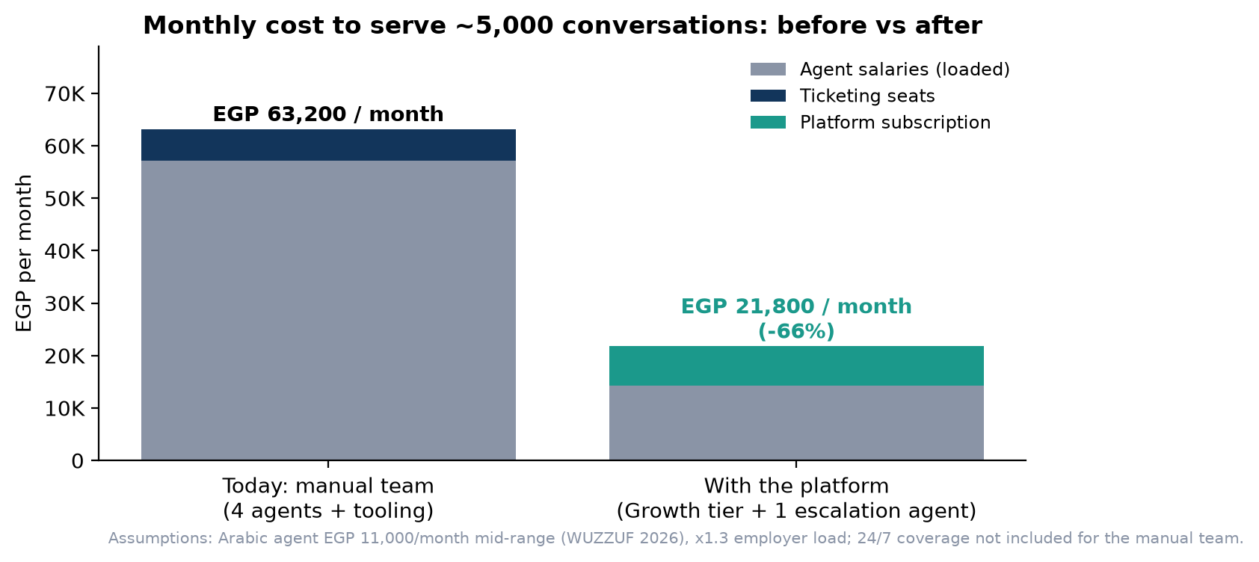

Measurable benefits
Benefit | What it means | Indicative measure
Lower cost to serve | Replace 3-4 shifts of repetitive answering with a flat subscription plus one escalation agent | -60% or more on monthly support cost for ~5,000 conversations (chart above)
Faster answers, 24/7 | Median first response in seconds instead of hours; night and weekend coverage without overtime | First-response time from hours to under 1 minute
More revenue captured | Answers pre-purchase questions and completes order or booking changes at any hour | Pilot KPI: conversion of pre-sale chats, recovered after-hours enquiries
Fewer errors and disputes | Answers come from the policy text, actions are validated and logged | Reduction in complaint volume and NTRA/regulator escalations
Speed to value | Hours to a working agent instead of a 4-12 week project | Time-to-first-resolution measured in every pilot
Control without code | Owner changes tone, rules and documents in plain language | Zero developer tickets for policy changes
Compliance comfort | Tenant isolation, audit trail, Egypt-hosted option, retention controls | Supports PDPL obligations; breach-notification readiness

Value proposition canvas (summary)
Customer jobs | Pains we relieve | Gains we create
Answer customers fast and correctly; keep policies consistent; keep costs predictable; stay compliant | Missed messages, agent churn, developer dependency, bots that break, USD pricing, data abroad | 24/7 coverage, EGP flat pricing, owner-controlled agent, real actions on data, audit trail, Arabic that sounds Egyptian

Sources: Cost comparison assumptions: Arabic agent EGP 11,000/month (mid-range of WUZZUF 2026 EGP 7,000-14,000), employer load x1.3, EGP 1,500/seat ticketing tool, Growth tier EGP 7,500/month.

11. Unique Selling Points / Competitive Advantages
In short: Five pillars make the offer hard to copy quickly: automated tool generation, plug-and-play onboarding, Egyptian Arabic, built-in safety with escalation, and EGP pricing with Egypt-hosted data.

Pillar | What it is | Why it is hard to replace
1. Automated tool generation | Action tools are generated from the business's own schemas, exports or API specs, then approved by the owner | Competitors either script flows (no actions) or require developer-built integrations; our engine turns integration into configuration.
2. Plug-and-play onboarding | Documents in, working agent out, with light adjustments in a Control Center | Speed compounds: every onboarding teaches the engine new document and schema patterns; industry packs accumulate.
3. Egyptian Arabic first | Dialect-aware understanding and replies, seamless Arabic/English switching, tone controls | Global vendors optimise for English and Modern Standard Arabic; local nuance is our home ground.
4. Safety and human escalation by design | Policy-derived guardrails, confidence thresholds, identity checks, full-context hand-over, audit log | Trust is the buying criterion for fintech, telecom and airlines; safety architecture is not a feature that can be bolted on later.
5. EGP pricing and Egypt-hosted data | Flat tiers in Egyptian pounds; option to keep tenant data in Egypt; PDPL-aware processing | USD pricing exposes Egyptian SMEs to FX risk; cross-border transfers need PDPC permits from 31 Oct 2026; local hosting is a real advantage.

Defensibility over time
- Data network effect: anonymised patterns of what customers ask in each vertical improve default tools and guardrails for the next customer.
- Industry packs: pre-built policy templates and tool sets for telecom, e-commerce, fintech, hospitality and airlines shorten onboarding further.
- Switching cost: once the audit trail, escalation workflows and tuned rules live in the Control Center, moving is costly for the business.

12. Competitive Analysis
In short: We compete with local flow-builder bots, global AI helpdesks and in-house builds. None combines fast self-onboarding with real action-taking on business data in Egyptian Arabic at EGP prices. That is the gap we occupy.

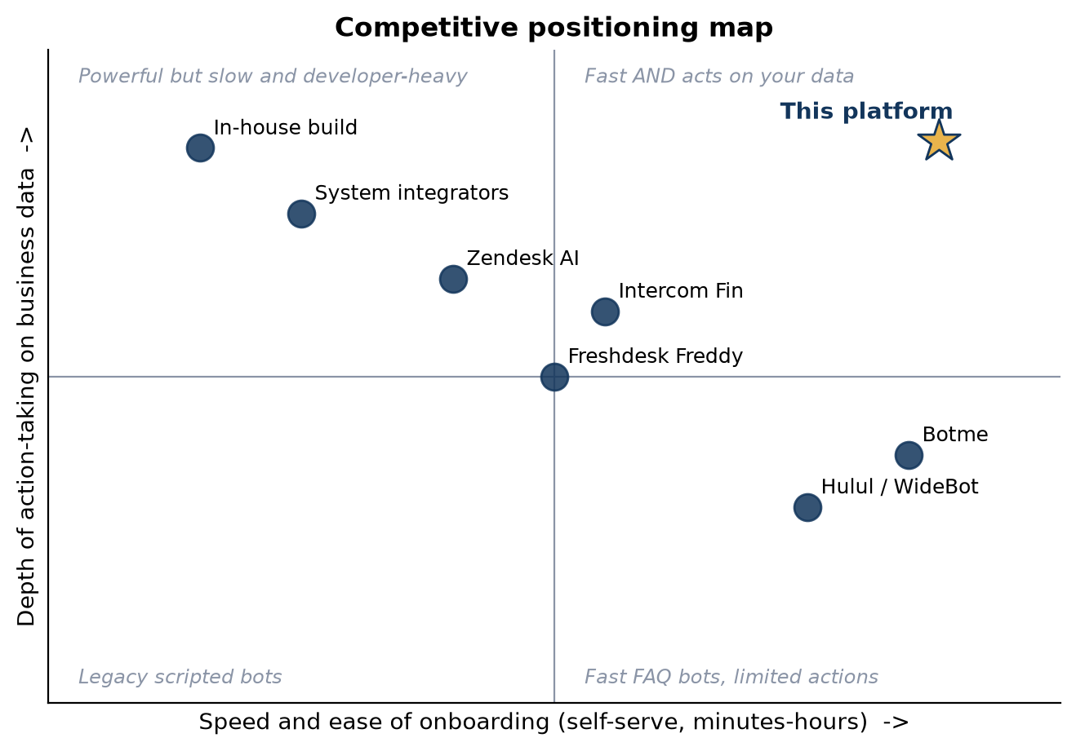

Competitor matrix
 | Hulul / WideBot (Egypt) | Botme | Intercom Fin | Zendesk AI | Freshdesk Freddy | In-house build | This platform
Public pricing | EGP 700 / 1,400 / 3,500 per month | Tiered, messages-based | USD 0.99 per resolution + USD 29-132 per seat | USD 55-169 per seat; ~USD 1.50-2.00 per resolution (est.) | USD 19-89 per seat; USD 0.49 per AI session | EGP 300,000+ build, ongoing dev cost | EGP 2,500 / 7,500 / 20,000; enterprise from 60,000
Arabic / Egyptian dialect | Strong (Arabic-first, 12 dialects) | Multilingual | Basic | Basic | Basic | Depends | Egyptian-first + English
Answers from own documents | Partly (generative add-on) | Yes | Yes | Yes | Yes | Yes | Yes
Acts on business data | Limited, via integrations | Limited (calendar, forms) | Yes, with developer setup | Yes, with developer setup | Partly | Yes | Yes, auto-generated tools
Self-serve onboarding | Yes (flow builder) | Yes (5 minutes, docs only) | Partly | No | Partly | No | Yes, documents + data
Human escalation | Yes | Lead form | Yes | Yes | Yes | Custom | Yes, with context
Owner Control Center (plain language) | Flow editor | Basic | Admin console | Admin console | Admin console | None | Yes
Egypt-hosted data / PDPL | On-prem available (enterprise) | No | No | No | No | Yes | Optional Egypt hosting
Voice | Yes (voicebot) | No | Yes (usage-based) | Yes | Limited | Custom | Roadmap 2028

How we position against each
- vs Hulul / WideBot: the local benchmark (40,000+ brands, strong Arabic). We do not compete on cheap FAQ bots; we win where the agent must act on data safely.
- vs Intercom / Zendesk / Freshdesk: strong products priced in USD per seat and per resolution for English-first teams with developers. We win on EGP pricing, Egyptian Arabic, onboarding speed and local hosting.
- vs in-house build: days instead of months, and kept current as policies change.
Sources: hulul.net pricing page; widebot.ai; botme.io; intercom.com/pricing; freshworks.com/freshdesk/pricing; Zendesk per-resolution figures are third-party estimates (GetMacha, eesel AI, 2026). Retrieved September 2026.

13. Business Model Canvas
In short: A subscription software business: we sell flat monthly plans in EGP to Egyptian businesses, delivered through self-serve onboarding and a partner channel, built on cloud AI infrastructure and a small expert team.

Key Partners  - Meta Business Solution Provider for WhatsApp  - Cloud & LLM providers (multi-vendor)  - Egyptian data-centre / hosting partner  - E-commerce platforms & agencies (Salla, Shopify partners)  - Telecom & fintech system integrators  - ITIDA / NTI ecosystem | Key Activities  - Ingestion & tool-generation engine R&D  - Arabic dialect quality & evaluation  - Safety, guardrails, audit  - Pilot delivery & customer success  - Industry pack development | Value Propositions  - Working AI support + CRM agent in hours  - Acts on your data, bounded by your policies  - Egyptian Arabic + English  - Owner-controlled, no developers needed  - Built-in human escalation  - EGP pricing, Egypt-hosted option | Customer Relationships  - Self-serve onboarding + guided pilot  - Customer success for Growth+ tiers  - Dedicated manager for Enterprise  - Community & templates library | Customer Segments  - Telecom / ISP / subscription services  - E-commerce & online retail  - Fintech & lending  - Hospitality & travel  - Airlines  - Any domain (secondary)
 | Key Resources  - AI/backend engineering team  - Proprietary ingestion & tool-generation pipeline  - Evaluation datasets (Egyptian Arabic)  - Industry packs  - PDPC licence & compliance posture |  | Channels  - WhatsApp/LinkedIn founder-led outreach  - Partner agencies & integrators  - Content & webinars (Arabic)  - Events (RiseUp, Cairo ICT, Techne)  - Referrals from pilots
Cost Structure  - Salaries (largest, ~65% of fixed)  - Cloud & AI inference (variable, ~EGP 0.5/conversation)  - Marketing & events  - Legal, PDPL licensing, accounting  - Tools, BSP fees, co-working |  |  | Revenue Streams  - Monthly subscriptions: Starter EGP 2,500 / Growth 7,500 / Business 20,000  - Enterprise contracts from EGP 60,000/month  - Paid 60-day pilots EGP 5,000  - Overage EGP 2 per conversation  - Add-ons: voice, extra seats, industry packs

14. Revenue Model and Pricing
In short: Money enters as flat monthly subscriptions in EGP, sized by conversation volume and features, plus paid pilots and enterprise contracts. Flat tiers keep budgets predictable for Egyptian SMEs; Meta's WhatsApp per-message fees are passed through at cost, as is standard.

Plans
 | Starter | Growth | Business | Enterprise
Monthly price | EGP 2,500 (USD 49) | EGP 7,500 (USD 146) | EGP 20,000 (USD 388) | from EGP 60,000 (USD 1,165)
Included conversations / month | 1,000 | 5,000 | 20,000 | Custom
Channels | 1 (WhatsApp or web) | WhatsApp, web, Messenger, Instagram | All text channels + voice add-on | All + IVR / call deflection
Auto-generated action tools | Up to 3 | Up to 10 | Unlimited | Unlimited + custom connectors
Knowledge base | Up to 50 documents | Up to 500 documents | Unlimited | Unlimited, multi-brand
Human escalation inbox seats | 1 | 3 | 10 | Custom
Control Center | Basic | Full | Full + roles | Full + SSO
Data hosting | Shared cloud | Shared cloud | Egypt-hosted option | Private cloud or on-premises
Support & SLA | Email | Chat, next business day | Priority, 99.5% uptime SLA | Dedicated success manager, custom SLA
Best for | Small shops, single channel | Growing brands, hotels, agencies | High-volume retailers, ISPs, fintechs | Telecom operators, airlines, banks

Other revenue lines
- Paid pilot: EGP 5,000 for 60 days with Growth features and hands-on onboarding; the fee is credited against the first annual contract.
- Overage: EGP 2 per conversation above the plan allowance, with alerts at 80% and 100%.
- Add-ons: voice channel, extra inbox seats, industry packs, custom connectors (enterprise).
- Pass-through: Meta WhatsApp per-message fees (Egypt: USD 0.0036 per utility/service message plus 14% VAT from 1 Oct 2026) are billed at cost.

Pricing logic
Growth at EGP 7,500 sits 2x above Hulul's top tier (EGP 3,500) and about half of what a single Arabic-speaking agent costs fully loaded. For a business handling 5,000 conversations a month, Intercom Fin would cost roughly USD 0.99 x resolved conversations plus seats, i.e. well above EGP 100,000 a month at 60% resolution; our flat EGP 7,500 is an order of magnitude cheaper and predictable. Blended ARPU in the model is EGP 6,250 in 2027 rising to EGP 7,375 in 2029 as the mix shifts to Growth and Business.
Sources: hulul.net pricing; intercom.com/pricing; Meta WhatsApp Business Platform pricing (Egypt rate card, July 2026 update, chatmaxima.com summary).

15. Go-to-Market Strategy
In short: We launch with founder-led, paid pilots in five verticals, turn those pilots into public case studies, then scale through partner agencies and integrators who already serve Egyptian SMEs, supported by Arabic content and industry events.

Phased approach
Phase | Timing | Objective | Motion
0. Discovery | Oct-Nov 2026 | 30+ structured interviews across the five verticals; validate willingness to pay and onboarding assumptions | Founder network, NTI/ITIDA ecosystem, LinkedIn
1. Founding pilots | Q1-Q2 2027 | 5-8 paid pilots, 3 public case studies with measured results | Direct, founder-led selling; hands-on onboarding
2. Self-serve launch | Q3 2027 | Starter and Growth tiers open; 40 paying customers by year-end | Arabic content, webinars, referral programme, WhatsApp-native demos
3. Partner channel | 2028 | Agencies, e-commerce platform partners and integrators resell or refer; 150 customers; first 2 enterprise contracts | Partner programme with 15-20% referral commission; co-marketing
4. Enterprise & regional | 2029 | Industry packs for telecom, airlines, fintech; 300 customers; 4 enterprise contracts; GCC groundwork | Enterprise sales, RFP responses, system-integrator alliances

Acquisition channels
- Founder-led direct sales: the primary channel in 2027; every pilot is a reference.
- Partners: e-commerce agencies, WhatsApp BSPs, telecom and fintech integrators who lack an AI-agent layer.
- Content in Arabic: practical guides ('how to write a return policy an AI can follow'), demo videos on WhatsApp, LinkedIn thought leadership.
- Events: RiseUp Summit, Cairo ICT, Techne Summit, fintech and tourism trade gatherings.
- Ecosystem: NTI, ITIDA and incubator networks for credibility and introductions, not funding.

Sales model
Starter and Growth are self-serve with optional guided onboarding. Business is sold through a short consultative process (demo, pilot, contract). Enterprise follows a 3-6 month cycle with security review, PDPL documentation, private hosting and a dedicated success manager.

16. Marketing and Sales Funnel
In short: In 2028 we need about 125 new paying customers. Working back through realistic conversion rates, that means reaching roughly 6,000 target businesses, engaging 600, qualifying 240, running 100 paid pilots and converting 65 of them, plus ~60 direct self-serve sign-ups.

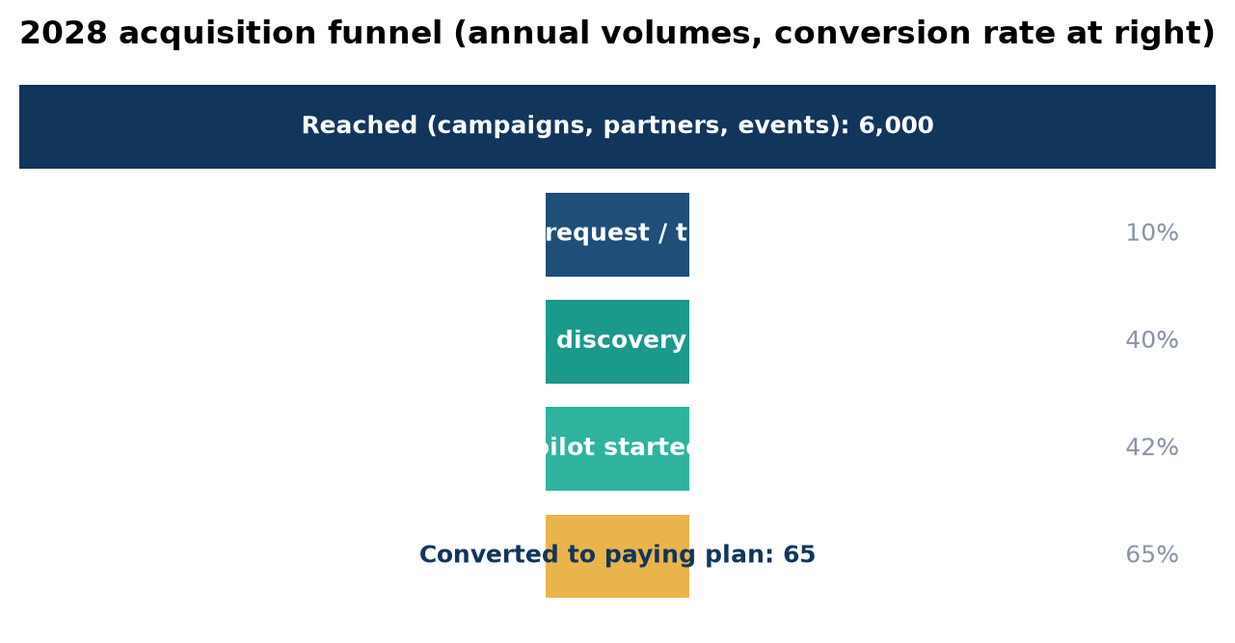
Stage | 2028 volume | Conversion to next stage | Main levers
Reached (campaigns, partners, events) | 6,000 | 10% | Arabic content, partner lists, event follow-ups
Engaged (demo request or trial signup) | 600 | 40% | WhatsApp-native demo, instant sandbox with sample documents
Qualified discovery call | 240 | 42% | Fit criteria: volume 500+ conversations/month, written policies, data source available
Paid pilot started (EGP 5,000) | 100 | 65% | Defined success criteria, hands-on onboarding, weekly review
Converted to paying plan | 65 (+~60 direct self-serve) | - | Pilot fee credited; founding-customer pricing lock for 12 months

Funnel volumes are planning assumptions to be calibrated during the 2027 pilots. Pilot-to-paid conversion of 65% is the single most important rate in the model; Section 20 tracks it as a headline KPI.

17. Operations / Delivery Model
In short: Delivery is mostly software, so operations centre on three things: keeping the platform reliable, onboarding customers well, and handling escalations and compliance. A lean team of five runs this in 2027, growing to about eleven by 2029.

Operating model
Function | What it covers | Who (2027) | Tools / partners
Platform engineering | Ingestion, tool generation, agent runtime, channels, Control Center, security | 2 AI/backend engineers, 1 full-stack engineer | Cloud provider, LLM APIs (multi-vendor), vector database, monitoring
Customer onboarding & success | Guided pilots, data-source connection, tool approval sessions, weekly reviews | Product & operations lead, sales & customer success | Control Center, onboarding checklist, shared WhatsApp groups
Sales & partnerships | Pipeline, pilots, partner programme | Sales & customer success (founder support) | CRM, partner portal (2028)
Quality & safety | Arabic evaluation sets, red-teaming of tools, escalation review, incident response | AI engineers + product lead | Evaluation harness, audit log, incident playbook
Compliance & finance | PDPC registration/licence, DPO role, contracts, invoicing in EGP, VAT | Product & operations lead + external counsel/accountant | Law firm, accountant, e-invoicing

Service delivery flow
1. Sign-up or pilot agreement; success criteria agreed in writing (resolution rate, first-response time, escalation quality).
2. Onboarding session (60-90 minutes for SMEs): upload, tool approval, tone and rule setting, channel connection.
3. Go-live with 'shadow mode' for the first days if the customer prefers: the agent drafts, a human approves, then autonomy is switched on per tool.
4. Weekly review in the pilot period; monthly afterwards for Growth+; quarterly business review for Enterprise.
5. Continuous: uptime monitoring, model-quality monitoring, cost monitoring per tenant, PDPL record-keeping.

Key suppliers and dependencies
- Language-model providers: multi-vendor routing (OpenAI, Google, Anthropic or open-weight models) to control cost and avoid lock-in.
- Meta WhatsApp Business Platform via a Business Solution Provider; Messenger and Instagram via the same Meta stack.
- Cloud hosting with an Egyptian data-centre partner for the Egypt-hosted option (Telecom Egypt and others operate local data centres).
- Legal counsel for PDPL licensing and contracts; accountant for VAT and e-invoicing.

18. High-level Technology Overview
In short: Think of the platform as four layers: an intake layer that reads your documents and data structure, a generation layer that builds knowledge and tools, an agent layer that talks to customers and acts safely, and a control layer for the owner. Each business lives in its own isolated workspace.

Layer | Business purpose | Main components (plain language)
1. Intake | Accept what the business already has | Document parsers (PDF, Word, spreadsheets, web pages); schema and API readers; language detection; tenant workspace creation
2. Generation | Turn inputs into a working configuration | Knowledge indexing (retrieval-augmented generation); automatic tool generation from schemas/APIs using a standard tool protocol; policy-to-guardrail extraction
3. Agent runtime | Serve customers safely on every channel | Conversation engine; retrieval; tool execution with validation and permissions; confidence scoring; escalation router; channel connectors (WhatsApp, web, Messenger, Instagram; voice later)
4. Control & trust | Give the owner control and evidence | Business Owner Control Center; plain-language rule editor; audit log of answers and actions; dashboards; data-retention and export controls

Design principles that matter to the business
- Isolation: one workspace, knowledge index and tool set per business; no cross-tenant data access.
- Bounded actions: tools are generated with explicit fields, validations and permission levels; the owner approves each one; high-risk tools default to 'ask a human'.
- Grounded answers: the agent cites the policy passage it relied on; if nothing relevant is found, it escalates instead of guessing.
- Model independence: budget-tier models handle routine turns (about USD 0.20-0.25 per million input tokens), stronger models are used only where needed; providers can be swapped.
- Egypt-ready: Egypt-hosted storage option, encryption at rest and in transit, 72-hour breach-notification readiness as required by the PDPL executive regulations.
- Observability: per-tenant cost, quality and escalation metrics feed both the customer dashboard and our own KPIs.

What we deliberately do not build
We do not train our own foundation models, build our own messaging infrastructure or run our own data centres. We integrate best-in-class components and focus engineering effort on the two things that differentiate: automated tool generation and safe, Egyptian-Arabic-first agent behaviour.
Sources: OpenAI, Google and Anthropic API pricing pages (Sept 2026); PDPL Executive Regulations (Decree 816/2025) summaries by Clyde & Co and ICLG.

19. Validation / Traction Approach
In short: The platform is at concept stage: no code has been written and there are no customers yet. This section therefore sets out how we will prove the idea in stages, what evidence each stage must produce, and what would make us stop or change course.

Stage | Timing | What we test | Evidence required to proceed
1. Problem interviews | Oct-Nov 2026 | 30+ interviews with owners and support leads across the five verticals | At least 60% rank support cost/coverage as a top-3 problem; at least 15 agree to see a prototype
2. Concierge prototype | Dec 2026-Feb 2027 | Manually onboard 3 businesses using off-the-shelf components; measure time, answer quality, escalations | Onboarding under 1 day; >70% of test questions answered correctly from documents; owners willing to pay a pilot fee
3. MVP + paid pilots wave 1 | Mar-Jun 2027 | Self-serve ingestion, generated tools, Control Center, WhatsApp + web; 5-8 paid pilots | Pilot fee paid by 5+ businesses; >60% autonomous resolution; <5% escalation failures; 3 case studies
4. Conversion & retention | Jul-Dec 2027 | Pilot-to-paid conversion, monthly churn, self-serve onboarding without our help | >=60% pilot conversion; monthly churn <=5%; >=10 self-serve onboardings completed without assistance
5. Enterprise proof | 2028 | One telecom/ISP or airline pilot with API-based tools and Egypt hosting | Signed enterprise contract; security and PDPL review passed

Pilot success criteria (agreed with each pilot customer)
- Time from documents received to first live conversation.
- Share of conversations resolved without a human (target 60%+ by week 4).
- Median first-response time (target under 1 minute).
- Escalation quality: share of hand-overs where the human had everything needed (target 90%+).
- Customer satisfaction on resolved chats (thumbs-up rate, target 80%+).
- Owner effort: hours spent per week maintaining the agent (target under 1 hour).

Kill or pivot signals
If fewer than half of interviewed businesses see the problem as urgent, if pilots cannot exceed 50% autonomous resolution after tuning, or if pilot conversion is below 40%, we will revisit the segment focus, the pricing or the product scope before spending further.

20. Key Performance Indicators
In short: We will manage the business with a small dashboard: customer and revenue growth, unit economics, product quality, and onboarding speed. Targets below are for end-2027 and end-2028.

Area | KPI | Definition | End-2027 target | End-2028 target
Growth | Paying customers | Active SMB subscriptions | 40 | 150 (+2 enterprise)
Growth | Monthly recurring revenue (MRR) | Sum of active monthly subscriptions | EGP 250K | EGP 1,151K
Funnel | Pilot-to-paid conversion | Pilots converting within 30 days of pilot end | >= 60% | >= 65%
Retention | Monthly logo churn | Cancelled subscriptions / active at start of month | <= 5% | <= 4%
Retention | Net revenue retention | MRR from existing customers vs 12 months earlier | >= 95% | >= 105%
Unit economics | CAC and LTV:CAC | Fully loaded acquisition cost; lifetime gross profit / CAC | CAC <= EGP 20,000; LTV:CAC >= 4 | CAC <= EGP 15,000; LTV:CAC >= 9
Unit economics | Gross margin | (Revenue - AI compute, infra, payment fees) / revenue | >= 70% | >= 75%
Product | Autonomous resolution rate | Conversations closed without a human | >= 60% | >= 70%
Product | Escalation quality | Hand-overs with complete context (human rating) | >= 90% | >= 95%
Product | Customer satisfaction | Thumbs-up rate on resolved chats | >= 80% | >= 85%
Onboarding | Time to first live conversation | Median, from sign-up | < 1 day | < 2 hours
Onboarding | Owner maintenance effort | Hours per week in the Control Center | < 1 hour | < 30 minutes
Reliability | Platform uptime | Monthly availability of agent runtime | 99.5% | 99.9%

21. Financial Assumptions
In short: The forecast rests on a handful of drivers: how many customers we win each year, what they pay, what each conversation costs us, and what the team costs. All are listed here so they can be challenged and updated.

Driver | Assumption | Basis
Exchange rate | 51.5 EGP per USD | CBE mid-rate September 2026 (51.3-51.8)
Plan prices | Starter 2,500 / Growth 7,500 / Business 20,000 / Enterprise from 60,000 EGP per month | Section 14; benchmarked against Hulul (EGP 700-3,500) and Intercom/Zendesk (USD)
Tier mix (Starter/Growth/Business) | 2027: 50/40/10; 2028: 45/42/13; 2029: 40/45/15 | Shift toward higher tiers as case studies and industry packs mature
Blended ARPU | EGP 6,250 (2027), EGP 6,875 (2028), EGP 7,375 (2029) per month | Derived from prices and mix
Paying customers (end of year) | 40 / 150 / 300 | Pilot conversion 65%; funnel in Section 16
Enterprise contracts | 0 / 2 (from mid-2028) / 4 (2 full-year + 2 from mid-2029) | One telecom/ISP and one travel/airline pilot in 2028
Paid pilots | 60 / 100 / 150 per year at EGP 5,000 | Pilot fee credited against first annual contract (treated as revenue when earned)
Conversation usage | 50% of plan allowance on average | Typical SaaS utilisation; overage revenue not counted (upside)
Variable cost per conversation | EGP 0.50 (LLM tokens, embeddings, vector search, compute) | Budget-tier model at USD 0.20-0.25 per 1M input tokens; ~6 turns per conversation; prompt caching
Payment processing | 2.5% of revenue | Card / wallet gateway fees in Egypt
WhatsApp fees | Passed through at cost; not in our revenue or cost | Meta Egypt rate USD 0.0036 per utility/service message + 14% VAT from 1 Oct 2026
Team | 5 people (2027), 8 (2028), 11 (2029) | Section 23; salaries at Egyptian mid-level market rates
Salary inflation and employer load | 15% per year; 20% employer social insurance and benefits | Egyptian wage inflation 2024-2026; social insurance law
Monthly churn | 4% (base), 6% (stress) | SMB SaaS benchmarks; validated in pilots
CAC | EGP 15,000 (base), EGP 25,000 (stress) | 2028 sales and marketing spend / new customers, fully loaded
Taxes and financing | Not modelled (EBITDA level) | Corporate tax 22.5%; no debt assumed

Sources: Fexant CBE USD/EGP history; OpenAI/Google/Anthropic pricing; Meta WhatsApp pricing; CV Pro Maker and WUZZUF salary data; management estimates.

22. Revenue Forecast
In short: Revenue grows from EGP 1.8M in 2027 to EGP 9.1M in 2028 and EGP 22.8M in 2029 (about USD 443K), driven by customer count, a shift to higher tiers and the first enterprise contracts.

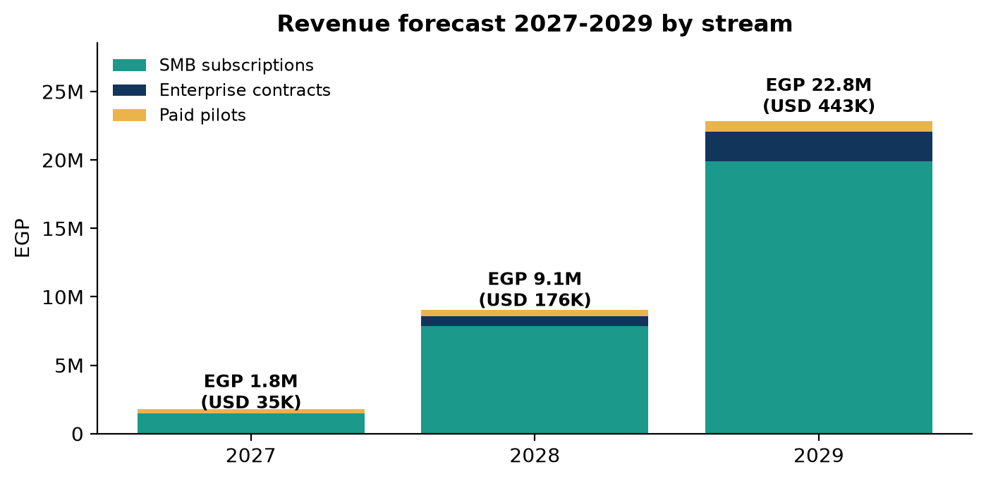

Year 1 in detail (quarterly)
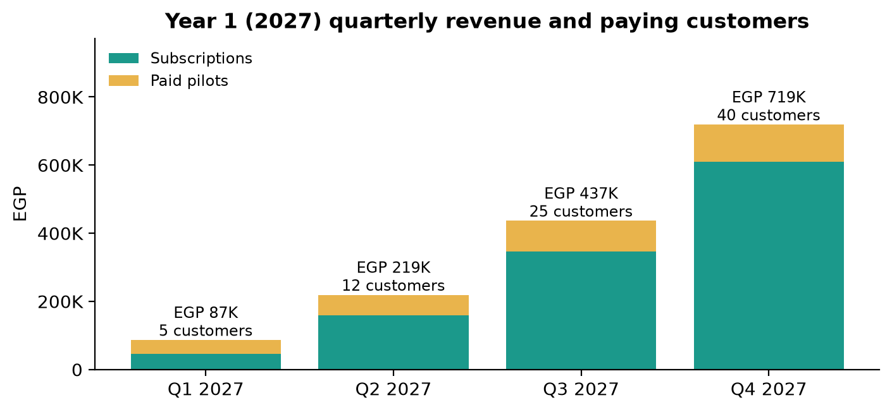
 | Q1 2027 | Q2 2027 | Q3 2027 | Q4 2027 | FY 2027
Paying customers (end of quarter) | 5 | 12 | 25 | 40 | 40
Paid pilots started | 8 | 12 | 18 | 22 | 60
Revenue | EGP 87K | EGP 219K | EGP 437K | EGP 719K | EGP 1.8M

Three-year view
 | 2027 | 2028 | 2029
Paying SMB customers (end of year) | 40 | 150 | 300
Enterprise contracts (active at year end) | 0 | 2 | 4
Blended ARPU (EGP / month) | 6,250 | 6,875 | 7,375
SMB subscription revenue | EGP 1.5M | EGP 7.8M | EGP 19.9M
Enterprise revenue | EGP 0.0M | EGP 0.7M | EGP 2.2M
Paid pilot revenue | EGP 0.3M | EGP 0.5M | EGP 0.8M
Total revenue | EGP 1.8M | EGP 9.1M | EGP 22.8M
Total revenue (USD) | USD 35K | USD 176K | USD 443K

Growth drivers: pilot conversion (Section 16), partner channel from 2028, tier upgrades as customers grow, and enterprise contracts from mid-2028. Overage revenue and add-ons are excluded and represent upside.

23. Cost Structure
In short: People are the largest cost at roughly two-thirds of fixed spend. Variable costs (AI compute, infrastructure, payment fees) stay near a quarter of revenue thanks to budget-tier models and flat pricing. Total costs rise from EGP 3.7M in 2027 to EGP 14.5M in 2029.

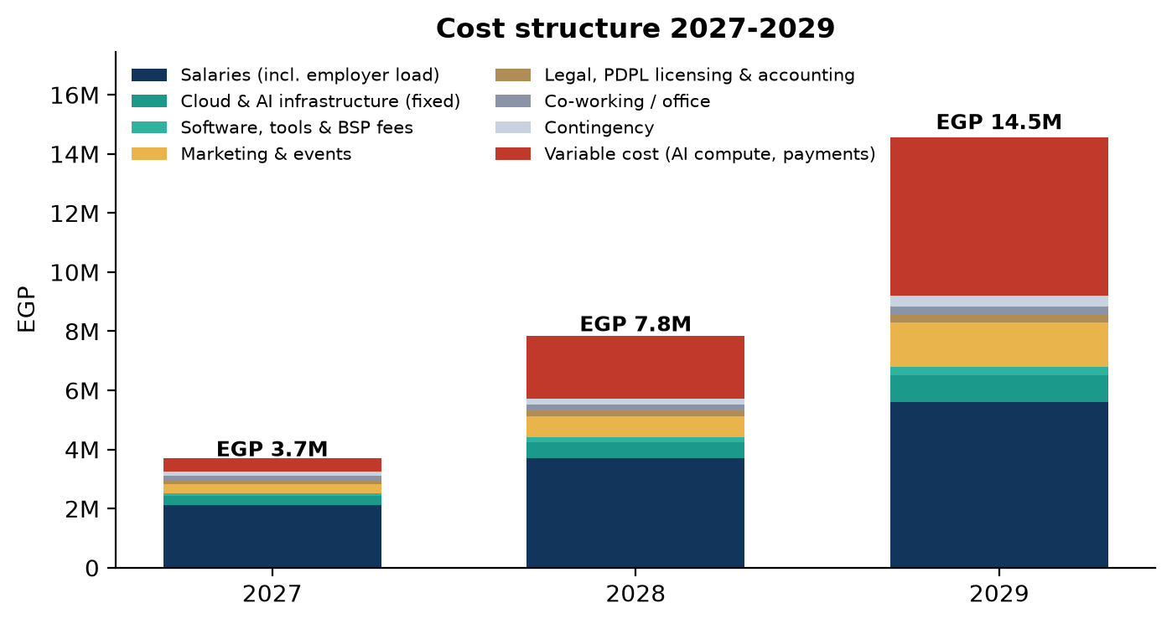
Cost line (EGP) | 2027 | 2028 | 2029
Salaries (incl. employer load) | EGP 2.1M | EGP 3.7M | EGP 5.6M
Cloud & AI infrastructure (fixed) | EGP 0.3M | EGP 0.5M | EGP 0.9M
Software, tools & BSP fees | EGP 0.1M | EGP 0.2M | EGP 0.3M
Marketing & events | EGP 0.3M | EGP 0.7M | EGP 1.5M
Legal, PDPL licensing & accounting | EGP 0.1M | EGP 0.2M | EGP 0.2M
Co-working / office | EGP 0.1M | EGP 0.2M | EGP 0.3M
Contingency | EGP 0.1M | EGP 0.2M | EGP 0.3M
Total fixed costs | EGP 3.2M | EGP 5.7M | EGP 9.2M
Variable costs (AI compute, infra, payment fees) | EGP 0.5M | EGP 2.1M | EGP 5.3M
Total costs | EGP 3.7M | EGP 7.8M | EGP 14.5M
Headcount (end of year) | 5 | 8 | 11

Team plan and salary basis (2027 monthly gross, EGP)
Role | 2027 | 2028 | 2029 | Monthly gross (2027 base)
AI / backend engineer | 2 | 3 | 3 | 35,000
Full-stack engineer | 1 | 1 | 2 | 28,000
Product & operations lead | 1 | 1 | 1 | 30,000
Sales & customer success | 1 | 1 | 1 | 20,000 + commission
Sales executive | - | 1 | 1 | 22,000 + commission
Partner & channel manager | - | - | 1 | 25,000
Onboarding & support specialist | - | 1 | 2 | 18,000

Salaries sit in the mid-level local range for Egyptian tech roles (software engineers EGP 18,000-42,000 mid-level; AI/ML EGP 30,000-55,000). Employer load of 20% and 15% annual wage inflation are applied on top.
Sources: CV Pro Maker Egypt tech salaries 2026 (egytech.fyi survey); mafeshsho8l Egypt salary guide 2026; WUZZUF.

24. Profitability Projection
In short: The business loses EGP 1.9M in 2027 while building and piloting, turns EBITDA-positive during 2028 (EGP 1.2M for the year) and reaches EGP 8.3M EBITDA in 2029, a 36% margin.

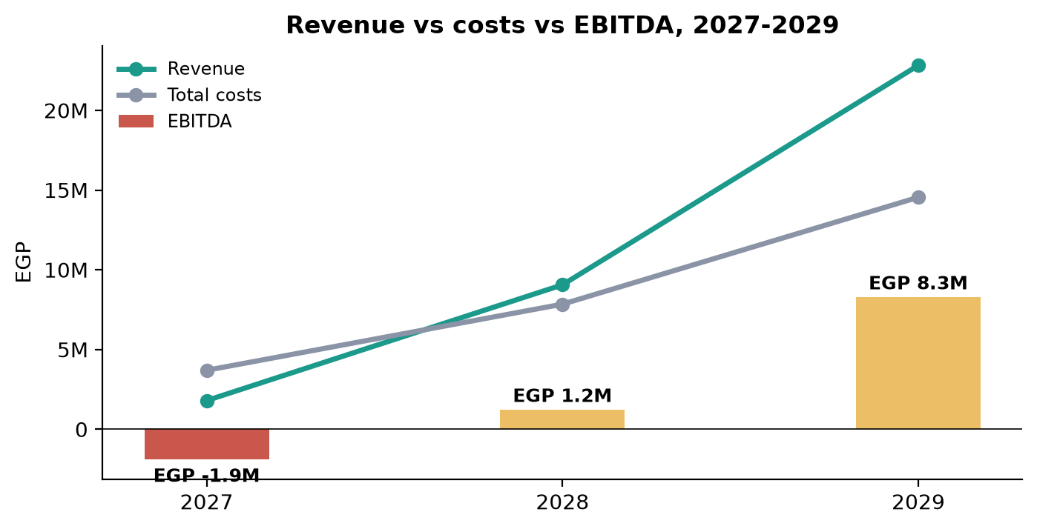
EGP | 2027 | 2028 | 2029
Revenue | EGP 1.8M | EGP 9.1M | EGP 22.8M
Variable costs | (EGP 0.5M) | (EGP 2.1M) | (EGP 5.3M)
Gross profit | EGP 1.4M | EGP 6.9M | EGP 17.5M
Gross margin | 75% | 76% | 77%
Fixed costs | (EGP 3.2M) | (EGP 5.7M) | (EGP 9.2M)
EBITDA | EGP -1.9M | EGP 1.2M | EGP 8.3M
EBITDA margin | -105% | 13% | 36%

Reading the numbers
- 2027 is an investment year: five salaries and the pilot programme against a small but growing customer base.
- Monthly break-even arrives around June 2028: when paying customers pass roughly 88 on the 2028 cost base (Section 25).
- 2029 margins reflect software economics: fixed costs grow with headcount, revenue grows with customers; each additional customer adds ~79% gross margin.
- Not included: corporate tax (22.5%), overage and add-on revenue (upside), any external financing.

25. Break-even Analysis
In short: On the 2028 cost base we cover all fixed costs with about 88 paying SMB customers, which the plan reaches around June 2028. On the leaner 2027 cost base the figure is about 54 customers.

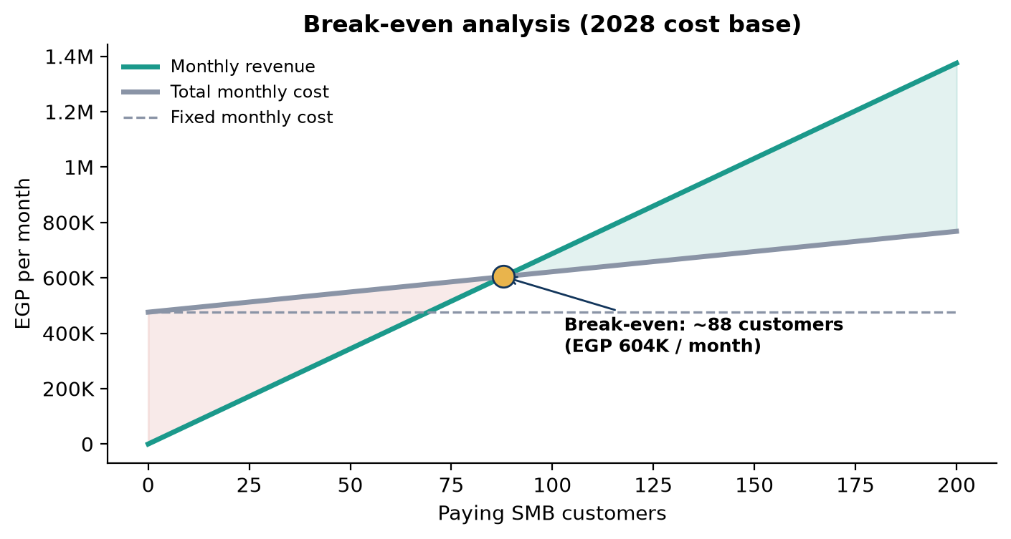

Calculation
 | 2027 cost base | 2028 cost base
Monthly fixed costs | EGP 270,600 | EGP 476,073
Blended ARPU per customer / month | EGP 6,250 | EGP 6,875
Variable cost per customer / month | EGP 1,281 | EGP 1,459
Contribution per customer / month | EGP 4,969 | EGP 5,416
Break-even customers = fixed / contribution | 54 | 88
Break-even monthly revenue | EGP 340,377 | EGP 604,363

Enterprise contracts shorten the path: one EGP 60,000 contract replaces roughly nine SMB customers in contribution terms. The break-even count is sensitive to ARPU; a 20% lower blended ARPU raises the 2028 figure to about 110 customers.

26. Unit Economics
In short: Each customer is worth acquiring: a customer costing EGP 15,000 to win generates about EGP 135K of gross profit over an expected 25-month life, an LTV:CAC of 9:1 with payback in about 3 months. Even under stress (CAC EGP 25,000, churn 6%) the ratio stays at 3.6:1.

EGP 15,000 | EGP 135K | 9:1 | 2.8 mo | 79%
Customer acquisition cost (fully loaded) | Lifetime value (gross profit) | LTV : CAC | CAC payback | Gross margin per customer

Metric | Base case | Stress case | How it is calculated
Blended ARPU (2028) | EGP 6,875 | EGP 6,875 | Prices x tier mix
Gross margin | 79% | 79% | 1 - (variable cost per conversation x conversations) / ARPU - payment fees
Monthly gross profit per customer | EGP 5,416 | EGP 5,416 | ARPU x gross margin
Monthly churn | 4% | 6% | Cancelled / active
Expected lifetime | 25 months | 17 months | 1 / monthly churn
LTV | EGP 135,391 | EGP 90,260 | Monthly gross profit x lifetime
CAC | EGP 15,000 | EGP 25,000 | Sales + marketing spend / new customers
LTV : CAC | 9.0 | 3.6 | Healthy SaaS benchmark >= 3
Payback period | 2.8 months | 4.6 months | CAC / monthly gross profit

Base-case CAC reflects founder-led and partner-referred sales with modest paid marketing; it will be recalculated from actual 2027 spend. Churn is the assumption with the least evidence today and is the first thing the pilots must measure.

27. Funding Requirements
In short: We are not raising external equity. The plan is self-funded by the founders and by paid pilots. The cumulative cash gap peaks at about EGP 2.7M (USD 53K) in early 2028 before the business funds itself.

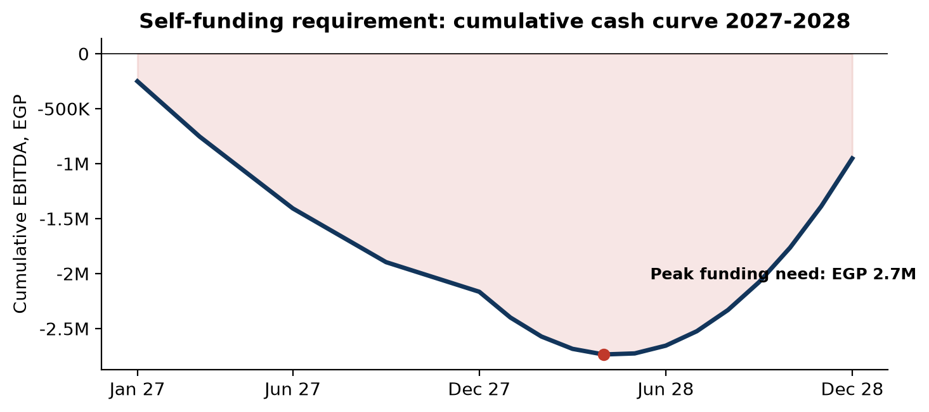

How the gap is covered
Source | Amount / mechanism | Notes
Founders' contribution (cash and reduced salaries) | ~EGP 2.2M | Founding engineers and product lead draw below-market pay in 2027; difference treated as sweat equity
Paid pilots | EGP 0.3M in 2027 | 60 pilots x EGP 5,000; also funds onboarding effort
Annual prepayment discount | 10% discount for annual plans | Pulls cash forward; not modelled in revenue timing (upside to cash)
Ecosystem support (non-dilutive) | In-kind: cloud credits, mentoring, workspace | NTI / ITIDA / incubator programmes; cloud provider startup credits typically USD 5,000-25,000

Use of funds 2027 (EGP)
Category | Amount | Share
Salaries (incl. employer load) | EGP 2.1M | 66%
Cloud & AI infrastructure (fixed) | EGP 0.3M | 9%
Software, tools & BSP fees | EGP 0.1M | 3%
Marketing & events | EGP 0.3M | 9%
Legal, PDPL licensing & accounting | EGP 0.1M | 5%
Co-working / office | EGP 0.1M | 4%
Contingency | EGP 0.1M | 5%
Total 2027 fixed spend | EGP 3.2M | 100%

If growth outpaces the plan (for example, an enterprise contract in 2027) we may consider a small strategic round to accelerate hiring; this is optional, not required for the base case.

28. Roadmap
In short: From discovery in late 2026 to founding pilots in H1 2027, public launch in late 2027, voice and industry packs in 2028, and an enterprise offering plus GCC groundwork in 2029.

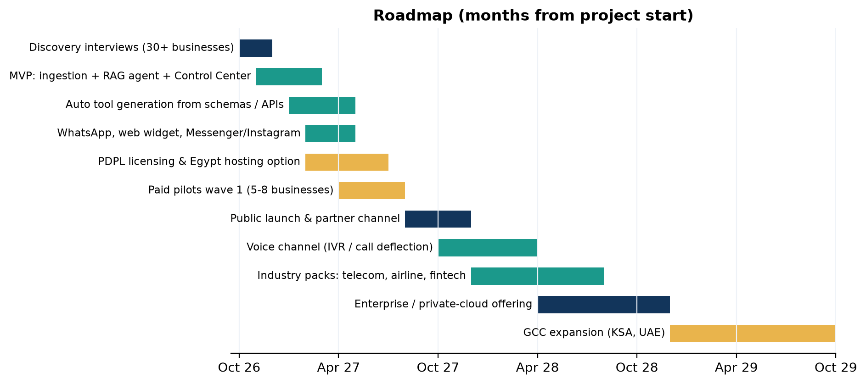
Milestone | Target date | Definition of done
Discovery complete | Nov 2026 | 30+ interviews; 15 prototype commitments; pricing validated
Concierge prototype | Feb 2027 | 3 businesses served with manual onboarding; quality baseline measured
MVP live | Apr 2027 | Self-serve ingestion, tool generation, Control Center, WhatsApp + web widget
Founding pilots wave 1 | Jun 2027 | 5-8 paid pilots running; 3 case studies drafted
PDPC registration / licence | Sep 2027 | Controller/processor registration filed; Egypt-hosted option available
Public self-serve launch | Q4 2027 | Starter and Growth open; 40 paying customers
Partner programme | Q1 2028 | 10 active partners; referral commission live
Voice channel | Q3 2028 | IVR / call deflection in Arabic for Business and Enterprise tiers
First enterprise contracts | H2 2028 | Two signed (telecom/ISP, travel or airline)
Industry packs | 2028-2029 | Telecom, airline, fintech, e-commerce, hospitality templates and tool sets
Enterprise / private cloud | H1 2029 | On-premises or private-cloud deployment option
GCC groundwork | H2 2029 | Saudi/UAE partner and hosting assessment; first regional pilot

29. Risks and Mitigation
In short: The main risks are AI mistakes, data-protection compliance, slow SME adoption, and dependence on a small team and on third-party platforms. Each has a concrete mitigation built into the product or the plan.

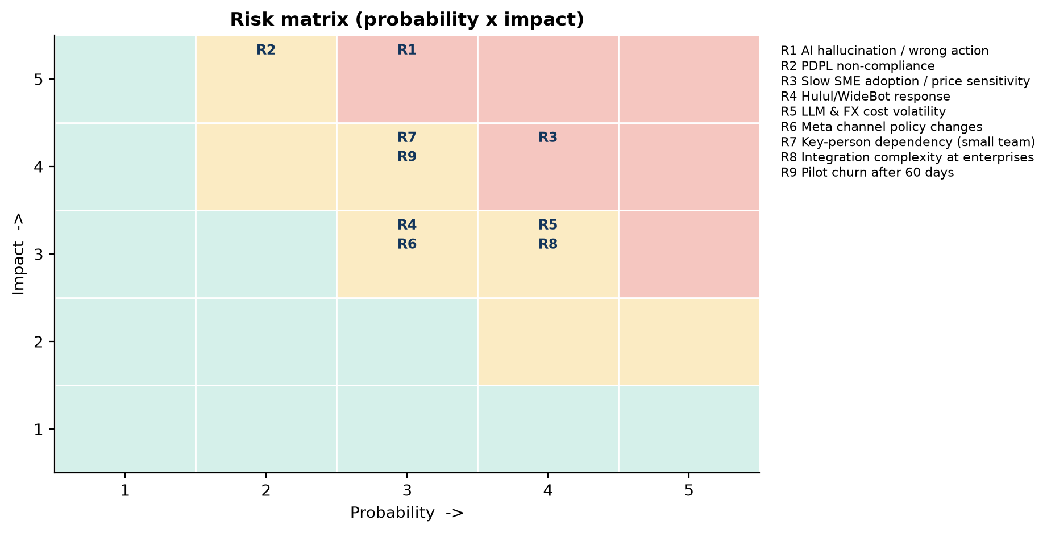
# | Risk | P | I | Mitigation
R1 | AI gives a wrong answer or takes a wrong action, damaging a customer relationship | 3 | 5 | Grounded answers with cited policy passages; tools with validation and permission levels; high-risk tools default to human approval; shadow mode at launch; audit log; incident playbook
R2 | Non-compliance with PDPL (licensing, cross-border transfer, breach notification) after 31 Oct 2026 | 2 | 5 | PDPC registration in 2027; Egypt-hosted option; DPO role assigned; 72-hour breach process; data-processing agreements with every customer; external counsel
R3 | Egyptian SMEs adopt slowly or resist the price | 4 | 4 | Paid pilots with written success criteria; EGP flat pricing; Starter tier; case studies in Arabic; ROI calculator; annual-plan discount
R4 | Hulul/WideBot or a global vendor adds similar automated tool generation | 3 | 3 | Speed and focus; industry packs; Egyptian-Arabic evaluation data; switching costs via Control Center and audit history
R5 | LLM prices or the EGP/USD rate move against us | 4 | 3 | Multi-vendor model routing; budget-tier models for routine turns; prompt caching; price-review clause; hedging by pricing in EGP with annual review
R6 | Meta changes WhatsApp policies or fees (e.g., per-message service charges from Oct 2026) | 3 | 3 | Fees passed through at cost; multi-channel design (web, Messenger, Instagram, voice) so no single channel is critical
R7 | Key-person dependency in a five-person team | 3 | 4 | Documentation, code reviews, shared ownership; early hire of a third engineer in 2028; advisor bench
R8 | Enterprise integrations prove more complex than 'light adjustment' | 4 | 3 | Enterprise tier priced for services; API-first connectors; system-integrator partners; honest scoping in pilots
R9 | Pilots do not convert after 60 days | 3 | 4 | Success criteria agreed upfront; weekly reviews; pilot fee credited on conversion; founding-customer price lock

P = probability, I = impact, each scored 1 (low) to 5 (high).
Sources: PDPL Executive Regulations (Decree 816/2025) summaries by Clyde & Co, CMS and ICLG; Meta WhatsApp Business Platform pricing updates.

30. Team and Capabilities
In short: Execution needs four capabilities: applied AI engineering, product and operations discipline, Egyptian-market sales, and compliance. The founding team covers the first two; the plan hires the rest and adds advisors for the industries we serve.

Role | Responsibilities | Capabilities required | Status
Founder / technical lead (AI & backend) | Architecture, ingestion and tool-generation engine, model routing, safety | Applied LLM engineering, retrieval systems, API design, security | Founding team
Founder / product & operations lead | Product scope, Control Center UX, pilots, PDPL programme, finance | Product management, customer discovery, operations, compliance coordination | Founding team
AI / backend engineer | Channel connectors, evaluation harness, Arabic quality | Python, NLP evaluation, Egyptian Arabic fluency | Hire Q1 2027
Full-stack engineer | Control Center, dashboards, onboarding flows | Web front-end, APIs, usability | Hire Q1 2027
Sales & customer success | Pipeline, pilots, onboarding sessions, renewals | B2B selling to Egyptian SMEs, WhatsApp-native communication | Hire Q2 2027
Advisors (part-time) | Telecom, airline, fintech and e-commerce domain input; legal (PDPL) | Senior operators from target industries; data-protection counsel | Recruit 2026-2027

Why this team can execute
- Technical depth in retrieval-augmented generation and tool-using agents, the two components that make the product different.
- Product discipline: every feature in this proposal maps to a pilot success criterion or a KPI.
- Local advantage: native understanding of Egyptian Arabic, Egyptian business practice and the WhatsApp-first market.
- Cost discipline: a five-person plan that reaches monthly break-even in 2028 without external capital.
Names and biographies are available on request and will be added for specific pilot discussions.

31. Strategic Vision / Future Expansion
In short: Stage one proves the plug-and-play agent in Egypt. Stage two makes it the operating layer for customer operations, with voice, proactive outreach and deeper CRM. Stage three carries the Arabic-first platform into the GCC and adjacent domains.

Stage | Horizon | What we add | Why it matters
1. Prove it in Egypt | 2027-2028 | Text channels, automated tools, Control Center, industry packs for five verticals, PDPL posture | Establish the category locally; 150+ customers; enterprise references
2. Become the customer-operations layer | 2028-2029 | Voice (IVR, call deflection), proactive notifications (delivery, renewals, payment reminders), CRM enrichment, agent-assist for human teams, analytics | Higher ARPU; deeper switching costs; the agent becomes the front door of the business
3. Expand regionally and across domains | 2029-2030 | Saudi Arabia and UAE via partners and local hosting; packs for healthcare, education, real estate, logistics; marketplace for connectors and templates | MEA conversational-AI market USD 3.5B by 2030; Arabic-first capability is the wedge

Long-term positioning
Every business in the region should be able to switch on a safe, knowledgeable, action-taking agent the way it switches on a phone line. We aim to be the default way that happens in Arabic-speaking markets, starting with Egypt.
Sources: Grand View Research MEA Conversational AI Market outlook.

32. The Ask / Next Steps
In short: We are asking for 5-8 founding pilot customers across telecom/ISP and subscription services, e-commerce, fintech, hospitality/travel and airlines, starting in Q1 2027, on paid 60-day pilots with agreed success criteria and founding-customer pricing.

What we ask of a founding pilot customer
- A paid 60-day pilot at EGP 5,000 (credited in full against the first annual contract).
- Your policies and a data source: policy documents, FAQs, and a customer or order data export, schema or API for one use case.
- A named business owner and one escalation agent for a 90-minute onboarding session and a weekly 30-minute review.
- Permission to publish an anonymised or named case study if the agreed success criteria are met.

What a founding pilot customer receives
- Growth-tier features during the pilot, with hands-on onboarding by the founding team.
- A written success scorecard: time to go-live, autonomous resolution rate, first-response time, escalation quality, customer satisfaction, owner effort.
- Founding-customer pricing locked for 12 months after conversion, and priority input into the industry pack for your sector.
- A clear exit: if success criteria are not met, the pilot ends with no further obligation.

Next steps
Step | Owner | When
Discovery call (45 minutes): your volumes, channels, policies, data sources | Us + your operations lead | Within 2 weeks
Pilot scope and success criteria agreed in writing | Both | Week 3
Onboarding session and go-live (shadow mode if preferred) | Us + your business owner | Q1 2027, week 1 of pilot
Weekly reviews; final scorecard and conversion decision | Both | Weeks 2-9

Contact: [founder name], [email], [WhatsApp number]. Placeholders to be completed before distribution.

33. Closing Statement

Egyptian businesses do not lack customers, questions or goodwill. They lack a way to answer at scale, safely, in their own voice, without hiring another shift or launching another IT project.
This platform turns the documents and data a business already has into a working AI agent in hours, keeps a human one tap away, and prices it in Egyptian pounds. The market is growing at 23% a year, the technology is finally ready, and the first movers who prove it with real customers will define the category.
Plug in your business. Let your customers feel the difference this quarter.

Modular "Plug-and-Play" AI-Agent Platform for Enterprise Onboarding
Business Proposal, Version 1.0, September 2026. Contact details: [to be completed].

Appendix: Sources
All external figures in this proposal were retrieved in September 2026 from the following public sources. Market-size estimates differ between research houses; where ranges exist we used the most conservative widely cited figure and flagged it in the text.
Topic | Source | Location
Egypt conversational-AI market | MarketsandMarkets, Egypt Conversational AI Market (USD 200M 2025, USD 695.8M 2030, 23.1% CAGR) | marketsandmarkets.com/Market-Reports/geography/conversational-ai-market/egypt
MEA conversational-AI market | Grand View Research, Middle East & Africa Conversational AI Market Outlook (USD 1.2B 2024, USD 3.53B 2030) | grandviewresearch.com/horizon/outlook/conversational-ai-market/mea
Egypt chatbot market growth | 6Wresearch, Egypt Chatbot Market 2025-2031 (14.9% CAGR) | 6wresearch.com/industry-report/egypt-chatbot-market
Egypt e-commerce | Mordor Intelligence, Egypt E-commerce Market (USD 11.49B 2026, 11.89% CAGR to 2031) | mordorintelligence.com/industry-reports/egypt-ecommerce-market
Egypt fintech | FinTech Egypt (CBE) Landscape Report 2023; Tracxn Egypt FinTech (May 2026); ICLG Fintech Laws Egypt 2026; AmCham Egypt / IMARC | fintech-egypt.com; tracxn.com; iclg.com; amcham.org.eg
Egypt tourism | Xinhua (Jan 2026) and Zawya/IDSC (FY2024/25) on arrivals, revenues, hotels and tourism companies; Egypt Independent (Oct 2025) on hotel rooms | english.news.cn; zawya.com; egyptindependent.com
Egypt telecom | Telecom Egypt Q1 2026 Earnings Release; TelecomLead Best ISPs in Egypt 2026; NTRA H1 2026 complaints via Business Tech News | ir.te.eg; telecomlead.com; businesstec.news/23568
Egyptian enterprises | CAPMAS Economic Census 2017/18 via Egypt Today (3.653M MSMEs; 216,900 small; 2,181 medium) | egypttoday.com/Article/3/85024
Digital adoption | DataReportal Digital 2026: Egypt (98.2M internet users, 82.7%); ChatDaddy WhatsApp in Egypt 2026 (57M users, 90%+ businesses); World Population Review | datareportal.com/reports/digital-2026-egypt; chatdaddy.tech
Airline service complaints | AirAdvisor citing Canadian Transportation Agency (EgyptAir ~20 complaints per 100 flights, 2023-24); Trustpilot reviews | airadvisor.com; trustpilot.com
Customer-service salaries | WUZZUF Careers, Call Center Agent Salary in Egypt 2026; Ta3Heed BPO agent cost in Egypt 2026 | wuzzuf.net/careers; ta3heed.com
Tech salaries | CV Pro Maker, Tech & Developer Salaries in Egypt 2026 (egytech.fyi survey); mafeshsho8l Egypt Salary Guide 2026 | cvpromaker.com/salaries/egypt; mafeshsho8l.com
Local competitors | Hulul pricing and product pages; WideBot; Botme | hulul.net/our-pricing; hulul.ai; widebot.ai; botme.io
Global competitors | Intercom pricing; Freshdesk pricing; Zendesk AI pricing analyses by GetMacha and eesel AI (third-party estimates) | intercom.com/pricing; freshworks.com/freshdesk/pricing; getmacha.com; eesel.ai
WhatsApp fees | Meta WhatsApp Business Platform pricing documentation; Gupshup USD rate card Jan 2026; ChatMaxima Egypt rate summary; SleekFlow | developers.facebook.com; gupshup.ai; chatmaxima.com; sleekflow.io
LLM pricing | OpenAI API pricing; Google Gemini API pricing; Anthropic Claude pricing (Sept 2026) | developers.openai.com/api/docs/pricing; ai.google.dev/gemini-api/docs/pricing; platform.claude.com
Data protection | PDPL Law 151/2020 and Executive Regulations (Decree 816/2025): ICLG Data Protection Egypt 2026; Chambers Data Protection Egypt 2026; Clyde & Co (Jan 2026); CMS | iclg.com; practiceguides.chambers.com; clydeco.com; cms.law
Exchange rate | Central Bank of Egypt USD/EGP via Fexant; FxConverter September 2026 | fexant.com/currency-pair/CBE/USD-EGP

Forecasts, targets, funnel rates, pricing and cost assumptions are management estimates and design targets. They will be updated with pilot data.

