Track: AI for Accounting
Topic: An Explainable Artificial Intelligence Based Conceptual Model for Financial Auditing to Enhance Audit Transparency and Quality
Name: George Samy 58-21333
Supervisor: Dr. Gamal Kassem

Contents
Project Features 2
Business Process 1: Audit Explanation & Narrative Generation Pipeline 2
System Structure: Class Diagram 2
System Behaviour: Sequence Diagram 3
User Stories 4
Field Requirements / Business Rules 6
Interface (Demonstration UI) 7
Audit Input Selection 7
ISA Retrieval Results & Narrative Output 7
UI after Refinement (Error Handling) 9
Test Cases 10
Retrieval Accuracy — Confusion Matrices 12
Sequence Diagram — After Refinement 13

Project Features
AI Audit Intelligence : XAI-Based Audit Pipeline (Steps 19–25)

This feature implements the explainability and narrative generation layer of a 27-step XAI-driven financial audit pipeline. The system integrates Retrieval-Augmented Generation (RAG) with a locally hosted Large Language Model to produce transparent, standards-grounded audit findings. Each flagged General Ledger entry is explained through three complementary layers: SHAP-based feature attribution, ERP control failure identification, and ISA standard paragraph retrieval culminating in an auditor-ready narrative that is traceable, modular, and aligned with professional auditing requirements.

Business Process 1: Audit Explanation & Narrative Generation Pipeline
The core business process begins at the handoff boundary of the full 27-step conceptual pipeline (Step 18), where a MergedExplanation object carrying a SHAP feature column name and an ERP control attribution is received. The process then executes ISA standard retrieval via semantic similarity search (Steps 19–22), passes enriched explanations to a locally hosted language model for narrative generation (Steps 23–24), and renders the final audit observation to the auditor through an interactive dashboard (Step 25). All processing occurs locally to ensure financial data never leaves the organisation's infrastructure.

System Structure: Class Diagram
The class diagram below presents the structural perspective of the XAI audit pipeline, showing all system components, their attributes, methods, and inter-component relationships as defined in the conceptual model.

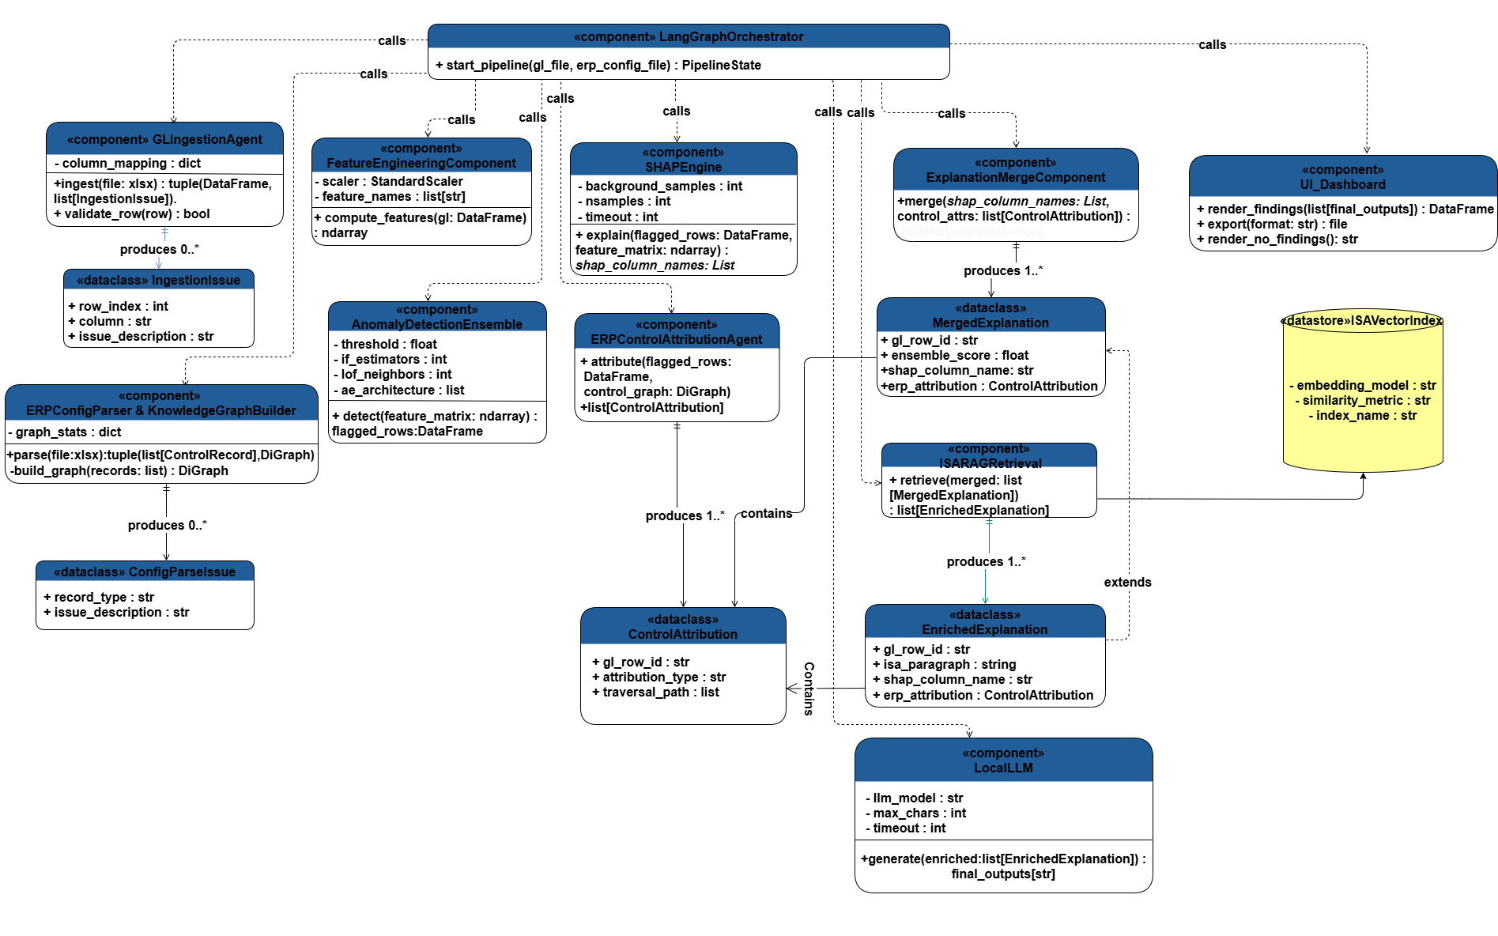

System Behaviour: Sequence Diagram
The sequence diagram below presents the behavioural perspective of the pipeline, showing the 27-step end-to-end message flow between all system components. The diagram includes the ALT branch for zero anomalies detected (Steps 11–12) and the error-handling ALT fragment for LLM unavailability (Steps 23–24), added following expert review.

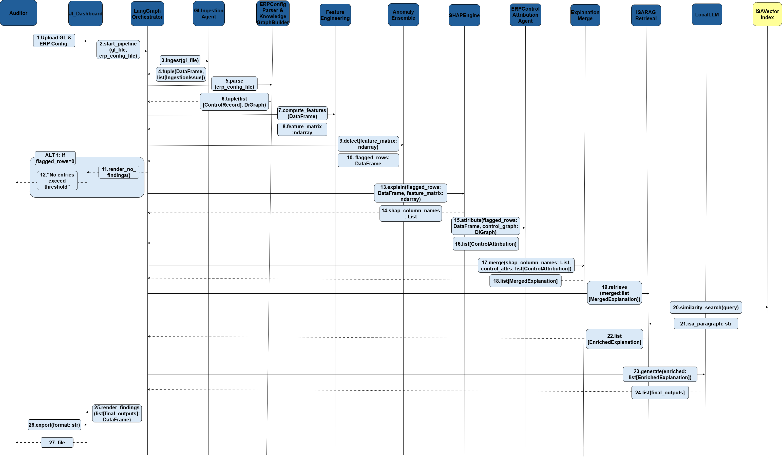

User Stories
The following user stories are derived from the functional requirements (FR-1 through FR-10) defined in the conceptual model. Each story is scoped to the auditor as the primary actor.

Req ID | Epic | User Story Summary
FR-1 | Audit Pipeline Entry | As an auditor, I want to upload a General Ledger file and ERP configuration file through a UI so that the audit pipeline is triggered automatically with a single controlled entry point.
FR-2 (Novel) | Data Ingestion & Validation | As an auditor, I want the system to ingest and validate the GL file row by row so that I can trace and correct data quality issues before analysis begins.
FR-3 (Novel) | ERP Control Graph | As an auditor, I want the system to parse the ERP configuration and build a knowledge graph so that downstream control attribution can traverse precise ERP relationships.
FR-4 | Feature Engineering | As an auditor, I want the system to compute domain-specific financial features from the GL data so that anomaly detection captures financial behavior patterns that generic features would miss.
FR-5 | Anomaly Detection Ensemble | As an auditor, I want the system to run a multi-model ensemble (Isolation Forest, LOF, Autoencoder) so that GL entries with the highest averaged anomaly scores are flagged for review.
FR-6 | SHAP Explainability | As an auditor, I want SHAP contribution values computed for every flagged entry so that I can understand which financial features drove each anomaly detection decision.
FR-7 (Novel) | ERP Control Attribution | As an auditor, I want the system to traverse the ERP control graph per flagged entry so that I can pinpoint exactly which ERP control failed rather than relying on generic anomaly flags.
FR-8 (Novel) | ISA Standard Retrieval | As an auditor, I want the most semantically relevant ISA paragraph retrieved for each flagged entry so that every finding is grounded in an officially recognized auditing standard.
FR-9 | Audit Narrative Generation | As an auditor, I want the system to generate readable prose for each flagged entry so that pre-determined SHAP values, ERP attributions, and ISA citations are formatted into an auditor-ready narrative.
FR-10 | Dashboard & Export | As an auditor, I want an interactive dashboard showing ranked anomalies with expandable narratives so that I can export the complete audit report as PDF or Excel for documentation.

Field Requirements / Business Rules
The following table defines the interface fields exposed to the auditor and the system parameters that govern pipeline behaviour. Business rules are derived from the non-functional requirements (NFR-1 through NFR-7) of the conceptual model.

Field / Parameter | Description | Business Rule / Constraint
ERP Control Attribute | Dropdown — auditor selects the ERP control type that failed (e.g., Management Override of Controls, Missing Approval, SoD Violation) | NFR-1: Must not be transmitted to any external server; all processing stays local.
SHAP Feature Column | Dropdown — auditor selects the top SHAP feature name for the flagged GL entry (e.g., posting_hour, amount_ratio) | NFR-1: Must not be transmitted externally. Field must match a feature in the pre-indexed ISA corpus query.
ISA Vector Index | Pre-built ChromaDB collection. Embedding model: BAAI/bge-large-en-v1.5. Similarity metric: cosine. Index name: isa_corpus. | NFR-7: Index must be pre-indexed with a fixed embedding model and version-controlled for reproducible retrieval across audit runs.
LLM Model | Locally hosted: llama3.1:8b-instruct-q4_K_M via Ollama runtime on localhost:11434 | NFR-5: Model role is strictly text rendering only — no independent reasoning. Output capped by max_chars; generation bounded by timeout parameter.
max_chars | Maximum character count for ISA paragraph input passed to LLM | NFR-5: Caps ISA paragraph input at 4000 characters to minimise hallucination risk.
timeout | Maximum seconds allowed for LLM generation per request | NFR-5: Bounds generation time. On timeout or connection failure, pipeline surfaces error to auditor and halts cleanly (NFR-6).
Anomaly Threshold | Configurable minimum ensemble score required to flag a GL entry | NFR-3: System prioritises recall over precision — threshold must be set conservatively to minimise missed fraud signals.
Export Format | PDF or Excel — selected by auditor at export step | FR-10: Dashboard must provide both export options. Generated file is delivered directly to auditor.
No External Transmission | All pipeline stages — ingestion, detection, SHAP, attribution, retrieval, generation | NFR-1: Absolute constraint — financial audit data must never leave the organisation's infrastructure under any circumstance.

Interface (Demonstration UI)
The following screenshots present the actual demonstration interface built with Streamlit, covering the audit input selection panel, the dual ISA retrieval results, and the generated audit narrative observation.

Audit Input Selection
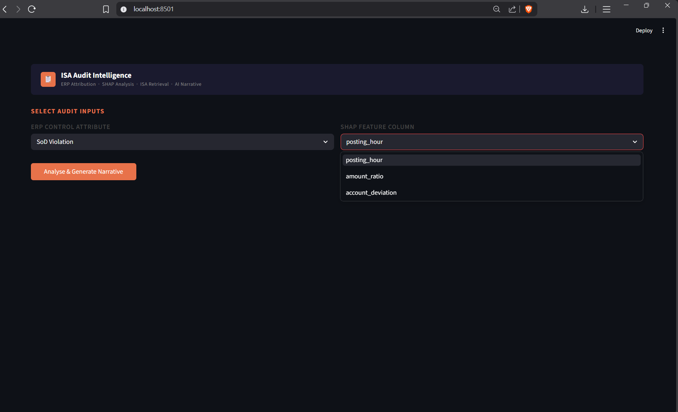

ISA Retrieval Results & Narrative Output
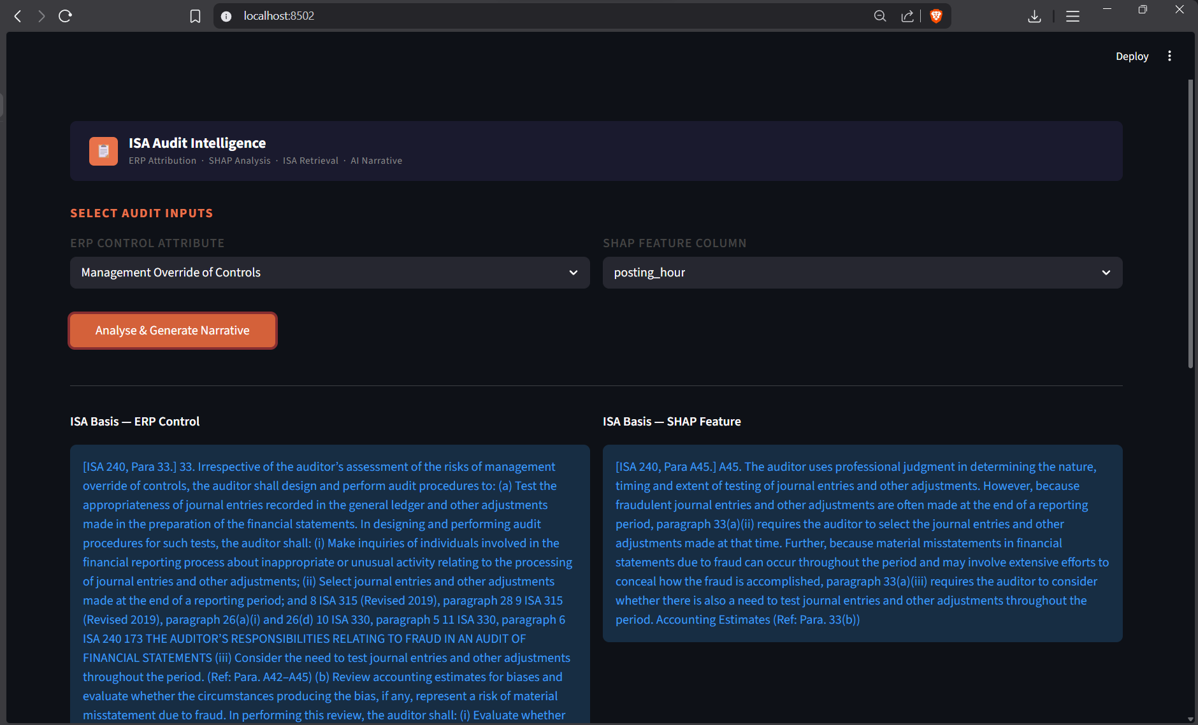

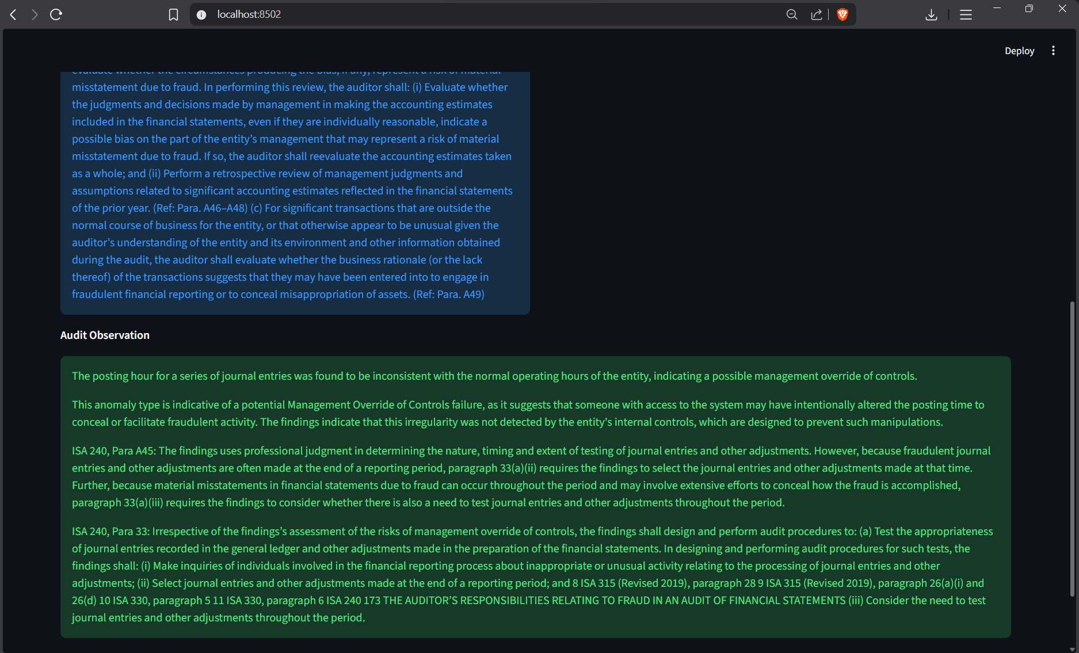

UI after Refinement (Error Handling)
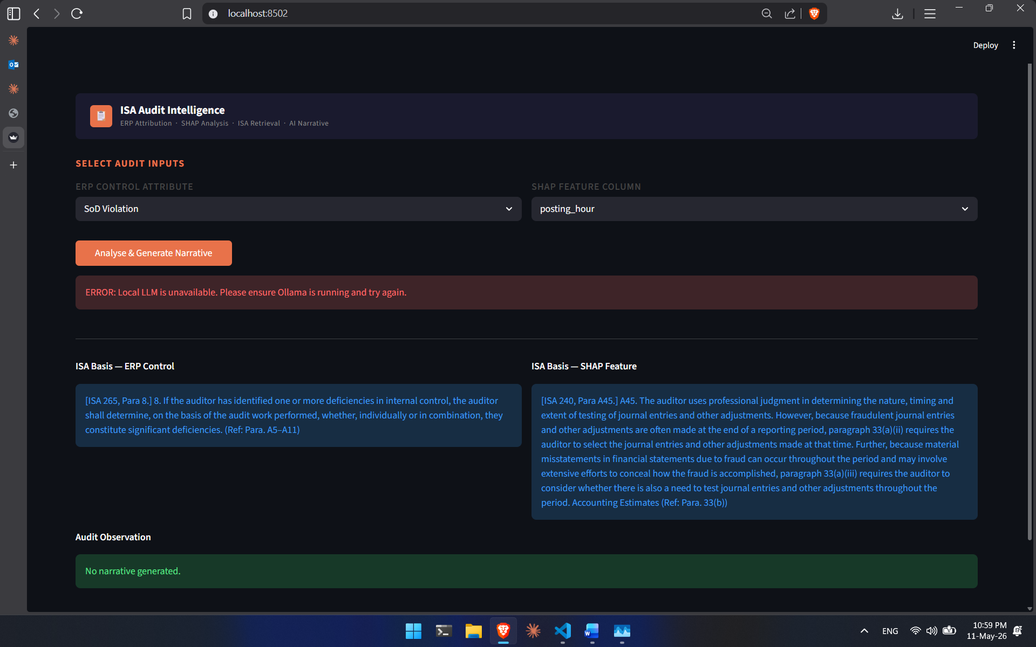

Test Cases
Test cases are drawn from three evaluation activities: Verification (Ver-1 through Ver-5), Validation (Val-FR9 and NFR tests), and Retrieval Accuracy analysis via confusion matrix (Ret-SHAP, Ret-ERP). All tests are scoped to the demonstration prototype covering Steps 19–25.

Test Case ID | Test Scenario | Test Steps / Evidence | Expected / Actual Result
Ver-1 | LangGraph Orchestrator design conformance | Inspected build_graph(): StateGraph(PipelineState) created; retrieve_isa and generate_narrative nodes registered with directed edge; compiled graph exposed via start_pipeline() as sole entry point. | PASS — Component matches class diagram and sequence diagram specification exactly.
Ver-2 | ISA corpus chunker boundary detection | Inspected chunk_isa_document(): line-by-line pdfplumber scan; regex detects numbered paragraph identifiers (e.g., 33., A42.) as boundaries; all subsequent lines merged into one chunk until next boundary. | PASS — Each chunk corresponds to exactly one ISA paragraph unit, preserving semantic granularity required for retrieval.
Ver-3 | LocalLLM text-renderer constraint | Inspected generate(): prompt explicitly instructs model to format pre-determined facts without independent reasoning; ISA inputs truncated to max_chars; timeout passed to Ollama HTTP request; response parsed from JSON and appended to output list. | PASS — Model acts as text renderer only; output capped and bounded as specified in NFR-5.
Ver-4 | ISAVectorIndex configuration and persistence | Inspected ISAVectorIndex.__init__(): ChromaDB PersistentClient points to local chroma_db/; collection configured with BAAI/bge-large-en-v1.5 and cosine distance; two independent queries each return one paragraph string. | PASS — Index persists across restarts; retrieval configuration matches class diagram attributes.
Ver-5 | ISARAGRetrieval dual-query design | Inspected retrieve_node(): auditor-selected ERP type and SHAP feature passed directly; two separate similarity_search() calls issued against ChromaDB collection — one per input dimension. | PASS — Faithfully simulates dual-query design; results packaged into EnrichedExplanation as specified.
Val-FR9 | Narrative generation requirement (FR-9) | LocalLLM.generate_node() sends structured prompt to Ollama (llama3.1:8b-instruct-q4_K_M); prompt constrains model to formatting role; narrative string returned and rendered on dashboard. | PASS — Requirement satisfied: LLM generates standards-grounded prose from pre-determined inputs.
Val-NFR1 | Data locality requirement (NFR-1) | Ollama serves model locally via localhost HTTP; ChromaDB persists to local disk; sentence-transformer runs locally via PyTorch; no external API calls made throughout pipeline. | PASS — All audit data remains within local infrastructure at every pipeline stage.
Val-NFR4 | Modularity requirement (NFR-4) | LangGraph StateGraph decouples each node; ISARAGRetrieval, LocalLLM, and UI_Dashboard injected as dependencies into LangGraphOrchestrator; swapping any one component does not require modifying others. | PASS — Each component is independently replaceable without disrupting pipeline.
Val-NFR5 | LLM renderer constraint (NFR-5) | Prompt explicitly instructs model to act as text renderer only; ISA inputs truncated to max_chars; timeout passed to Ollama HTTP request; no independent reasoning prompted. | PASS — Hallucination risk minimised; model operates strictly as a formatting tool.
Val-NFR7 | Vector index reproducibility (NFR-7) | ChromaDB collection configured with fixed embedding_model (BAAI/bge-large-en-v1.5), similarity_metric (cosine), and index_name; index persisted to disk and reused across restarts. | PASS — Retrieval results are reproducible and consistent across audit runs.
Ret-SHAP | SHAP Feature Retrieval Accuracy (FR-8) | Ground truth set constructed via expert annotation. Each SHAP feature name queried 3 times. ISA 330 Para 18: 3/3 correct. ISA 240 Para A45: 3/3 correct. ISA 240 Para 23: 1/3 correct (2 misrouted to ISA 315 Para A27 due to semantic overlap). See Figure 26. | Overall retrieval accuracy = 7/9 = 77.78%. Two misroutes acknowledged as limitation due to vector space semantic overlap.
Ret-ERP | ERP Attribution Retrieval Accuracy (FR-8) | ISA 265 Para 8, ISA 330 Para 8, and ISA 240 Para 33 each achieved 2/3 correct retrievals across all associated inputs. See Figure 27. | Overall retrieval accuracy = 6/9 = 66.67%. Narrative output excluded from evaluation as model acts strictly as text renderer.

Retrieval Accuracy — Confusion Matrices
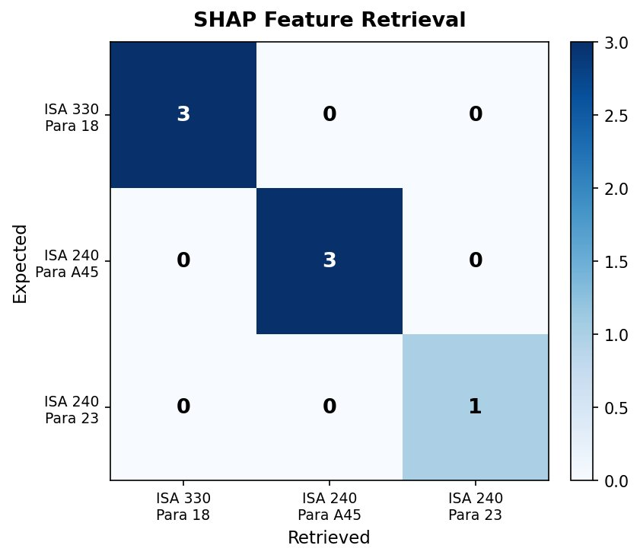

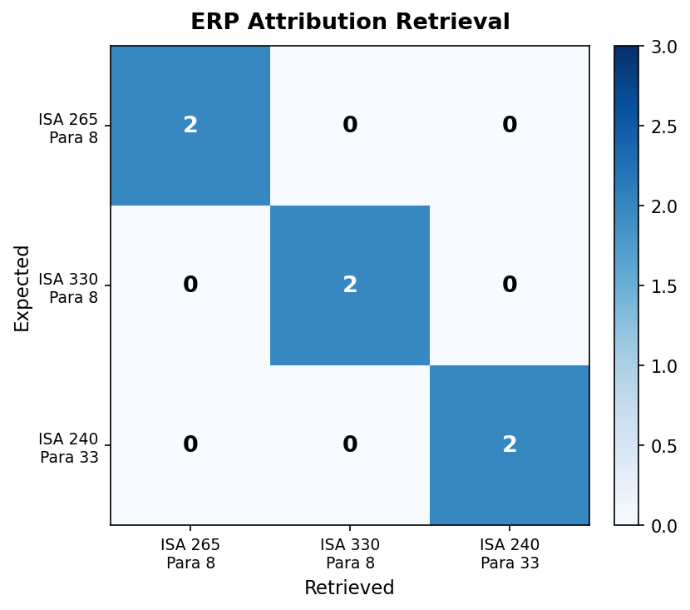

Sequence Diagram — After Refinement
