**Table of Contents**

### Page No.

### Chapter 1. Introduction

1. Introduction to the System 4
2. Problem Definition 4
3. Aim 5
4. Objective 5
5. Goal 6
6. Need of System 6

### Chapter 2. Hardware and Software requirement

1. Introduction 8
2. System environment 8
3. Software requirement 9
4. Hardware requirements 10

### Chapter 3. System Analysis

1. Purpose 12
2. Project Scope 12
3. Existing System 13
4. Proposed System 14
5. System Description 15

### [Chapter 4.Implementation issues](#chap 8)

1. Python 17
2. HTML 18
3. Cascading style sheet(CSS) 19
4. Sqlite 20

**Chapter 5. System Design**

1. Introduction 21
2. Conceptual Design 22
3. ER-Diagram 23
4. Logical Design 24
5. Physical Design 25
6. Data Flow Diagram of **“Employee Management System”** 26

### [Chapter 6.User Screens](#chap 8) 27-45

### [Chapter 7.Coding](#chap 8) 46-100

[**Chapter 8. Conclusion**](#chap 9)

1. Features of “**Employee Management System**” 101
2. Benefits Accrued from “**Employee Management System**” 102
3. Limitations of “**Employee Management System**” 103

Bibliography

**CHAPTER # 1**

**Introduction**

*Contents:*

* Introduction
* Problem Definition
* Aim
* Objective
* Goal
* Need of System

**Introduction to the System:**

Employee Record Management system is a database which keeps the record of all the details pertaining to employees in an organization.

Organizations have always had to collect and use personal information from and about employees to comply with tax and other laws, to administer benefits, to operate their businesses.

**Problem Definition:**

* No use of Web Services and Remoting.
* Risk of mismanagement and of data when the project is under development.
* Less Security.
* No proper coordination between different Applications and Users.

**Objective:**

The main objective of developing this web based Record Management system is to to manage the data of the employees such as personal details, education details, work exp etc. This project will reduce the paper work of the company. Through this project company can manage all data online.

**Need of the System:**

There is always a need of a system that will provide easy interface for managing all details of employee. This system will reduce the manual operation required to maintain all the records of employee education and experience detail. And also generates the various reports for analysis.

Thus, there is a big need of an online employee record management system, which provides all the above- mentioned facilities and many more.

**CHAPTER # 2**

**Hardware and Software Requirements**

*Contents:*

##### Introduction

* System environment
* Software requirement
* Hardware requirements

**Introduction:**

In this chapter we mentioned the software and hardware requirements, which are necessary for successfully running this system. The major element in building systems is selecting compatible hardware and software. The system analyst has to determine what software package is best for the **“Employee Record Management System”** and, where software is not an issue, the kind of hardware and peripherals needed for the final conversion.

**System Environment:**

After analysis, some resources are required to convert the abstract system into the real one.

The hardware and software selection begins with requirement analysis, followed by a request for proposal and vendor evaluation.

Software and real system are identified. According to the provided functional specification all the technologies and its capacities are identified. Basic functions and procedures and methodologies are prepared to implement. Some of the Basic requirements such as hardware and software are described as follows: -

**Hardware and Software Specification**

**Software Requirements:**

* Technology: Python Django
* IDE : Pycharm/Atom
* Client Side Technologies: HTML, CSS, JavaScript , Bootstrap
* Server Side Technologies: Python
* Data Base Server: Sqlite
* Operating System: Microsoft Windows/Linux

**Hardware Requirements:**

* Processor: Pentium-III (or) Higher
* Ram: 64MB (or) Higher
* Hard disk: 80GB (or) Higher

**CHAPTER # 3**

**System Analysis**

*Contents:*

##### Purpose

* Project Scope
* Existing System
* Proposed System
* System Overview

### Purpose:

1. This project is aimed at developing a web based Record Management Tool, which is of importance to any organization. This is an Intranet based application that can be accessed throughout the organization or a specified group/Dept. This system can be used to manage the employee education and experience details. There are features like updation, deletion, report generation etc. in this Tool.

**Project Scope:**

The scope of the project is to store and access the database consisting of employee’s personal details and the database can be shared with the concerned department to complete joining formalities.

We can also store and access the database consisting of program details.

The project has a wide scope, as it is not intended to a particular organization. This project is going to develop generic software, which can be applied by any businesses organization. More over it provides facility to its users. Also the software is going to provide a huge amount of summary data.

**Proposed System:**

The development of the new system contains the following activities, which try to automate the entire process keeping in view of the database integration approach.

1. User friendliness is provided in the application with various controls.
2. The system makes the overall project management much easier and flexible.
3. There is no risk of data mismanagement at any level while the project development is under process.
4. It provides high level of security with different level of authentication.

**System Overview:**

Employee record management system (ERMS) divided in two modules:

1. **Employee module**
2. **Admin module**

### **Admin Module details**

* Admin Login
* Admin can manage all employee records.
* Admin can update / edit user personal details/ work exp. details / Education.
* Change password
* Logout

### User Module

* User can register himself.
* User login
* User can add / edit own work experience details
* User can add / edit own education details.
* User can edit own profile.
* User can update own password.
* Logout

**CHAPTER # 4**

**Implementation issues**

**Python**

Python is a widely used general-purpose, high level programming language. It was initially designed by Guido van Rossum in 1991 and developed by Python Software Foundation. It was mainly developed for emphasis on code readability, and its syntax allows programmers to express concepts in fewer lines of code.

Python is a programming language that lets you work quickly and integrate systems more efficiently.

Python is dynamically typed and garbage-collected. It supports multiple programming paradigms, including procedural, object-oriented, and functional programming. Python is often described as a "batteries included" language due to its comprehensive standard library.

**HTML**

HTML (Hypertext Markup Language) is the set of markup symbols or codes inserted in a file intended for display on a World Wide Web browser page. The markup tells the Web browser how to display a Web page's words and images for the user. Each individual markup code is referred to as an element (but many people also refer to it as a tag). Some elements come in pairs that indicate when some display effect is to begin and when it is to end.

**CASCADING STYLE SHEET (CSS)**

Cascading Style Sheets (CSS) are a collection of rules we use to define and modify web pages. CSS are similar to styles in Word. CSS allow Web designers to have much more control over their pages look and layout. For instance, you could create a style that defines the body text to be Verdana, 10 point. Later on, you may easily change the body text to Times New Roman, 12 point by just changing the rule in the CSS. Instead of having to change the font on each page of your website, all you need to do is redefine the style on the style sheet, and it will instantly change on all of the pages that the style sheet has been applied to. With HTML styles, the font change would be applied to each instance of that font and have to be changed in each spot.

CSS can control the placement of text and objects on your pages as well as the look of those objects.

HTML information creates the objects (or gives objects meaning), but styles describe how the objects should appear. The HTML gives your page structure, while the CSS creates the “presentation”. An external CSS is really just a text file with a .css extension. These files can be created with Dreamweaver, a CSS editor, or even Notepad.

The best practice is to design your web page on paper first so you know where you will want to use styles on your page. Then you can create the styles and apply them to your page.

**Javascript**

JavaScript is a programming language commonly used in web development. It was originally developed by Netscape as a means to add dynamic and interactive elements to websites. While JavaScript is influenced byJava, the syntax is more similar to C and is based on ECMAScript, a scripting language developed by Sun Microsystems.

JavaScript is a client-side scripting language, which means the source code is processed by the client's web browser rather than on the web server. This means JavaScript functions can run after a webpage has loaded without COMMUNICATING with the server. For example, a JavaScript function may check a web form before it is submitted to make sure all the required fields have been filled out. The JavaScript code can produce an error message before any information is actually transmitted to the server.

Like server-side scripting languages, such as PHP and ASP, JavaScript code can be inserted anywhere within the HTML of a webpage. However, only the output of server-side code is displayed in the HTML, while JavaScript code remains fully visible in the source of the webpage. It can also be referenced in a separate .JS file, which may also be viewed in a browser.

**Django**

Django is a web application framework written in Python programming language. It is based on MVT (Model View Template) design pattern. The Django is very demanding due to its rapid development feature. It takes less time to build application after collecting client requirement.

This framework uses a famous tag line: **The web framework for perfectionists with deadlines.**

**CHAPTER # 5**

**System Design**

*Contents:*

* Use case diagram
* Class Diagram
* Sequence Diagram
* Data flow diagram

**Use Case Diagram:**

* Use case diagram consists of use cases and actors and shows the interaction between them. The key points are:
* The main purpose is to show the interaction between the use cases and the actor.
* To represent the system requirement from user’s perspective.
* The use cases are the functions that are to be performed in the module.

**Use Case Diagram Admin**

### Use Case Diagrams Employee

**FLOW CHART**

**User flow chart**

**ERMS**

**EmployeeSign in**

**After Sign in**

**Edit Profile**

**Edit Education Detail Deatail**

**Edit Experience Detail**

**Admin flow chart**

**ELMS**

**Admin Sign in**

**After Sign in**

**Manage Employee Detail**

**(Edit Profile, Education and Experience)**

**Requests accepts/ in process / finished**

**Requests accepts/ in process / finished**

**DFD (Data Flow Diagram)**

**DFD Level 1**

Employeee

Administrator

**DFD Level 2**

Administrator

Administrator

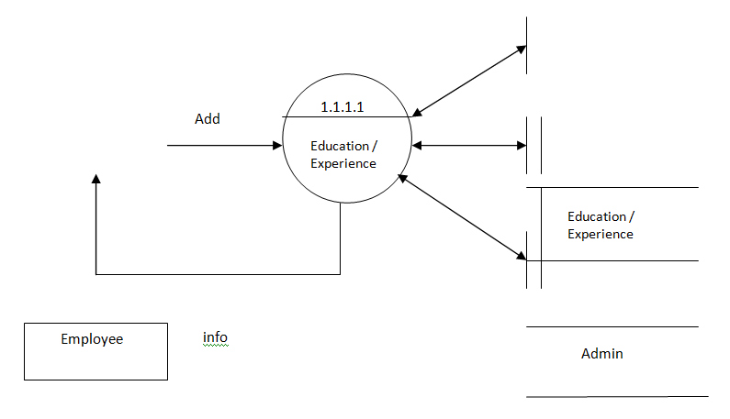

**ER DIAGRAM**

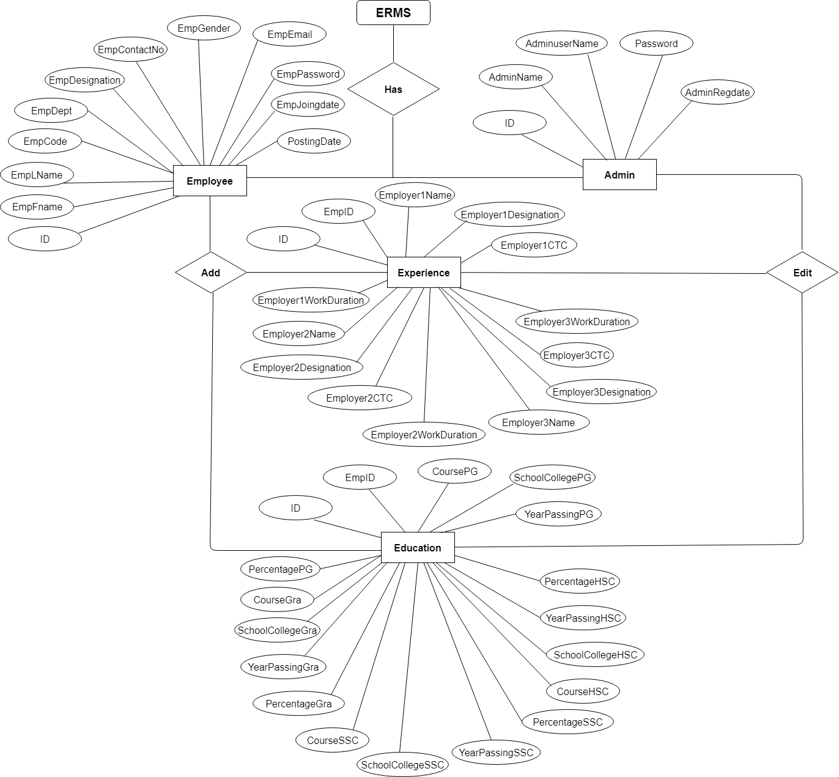

**Sequence Diagram For Administrator:-**

**Administrator**

**Success:hide()**

**Login**

**Application**

**Database**

**Login**

**:Request**

**:Validate()**

**:executeQuery()**

**Response**

**Show Result**

**Failed:show()**

Fig.5.4

**Sequence Diagram For User:-**

**User**

**Success:hide()**

**Login**

**Application**

**Database**

**Login**

**:Request**

**:Validate()**

**:executeQuery()**

**Response**

**Show Result**

**Failed:show()**

**:**

Fig.5.5

# Databse Design

The data in the system has to be stored and retrieved from database. Designing the database is part of system design. Data elements and data structures to be stored have been identified at analysis stage. They are structured and put together to design the data storage and retrieval system.

A database is a collection of interrelated data stored with minimum redundancy to serve many users quickly and efficiently. The general objective is to make database access easy, quick, inexpensive and flexible for the user. Relationships are established between the data items and unnecessary data items are removed. Normalization is done to get an internal consistency of data and to have minimum redundancy and maximum stability. This ensures minimizing data storage required, minimizing chances of data inconsistencies and optimizing for updates. The MS Access database has been chosen for developing the relevant databases.

**Employee Record Management System (erms) contains 4 Sqlite tables :**

**tbladmin table Structure :** This table store the login details of admin.

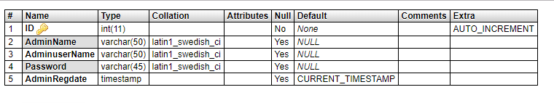

**employeedetail table Structure :** This table store the personal details of the employee.

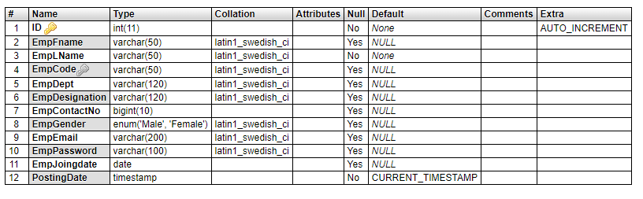

**empeducation table Structure :** This table store the education details of the employee.

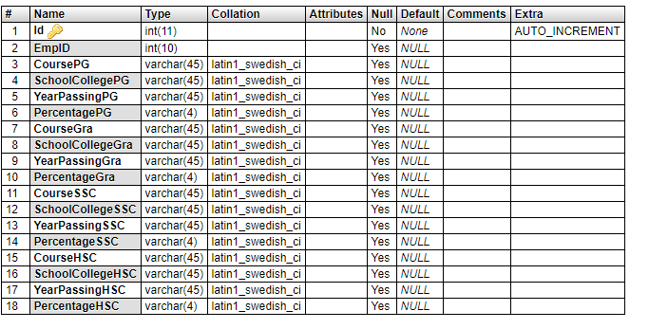

**empexpireince table Structure :** This table store the experience details of the employee.

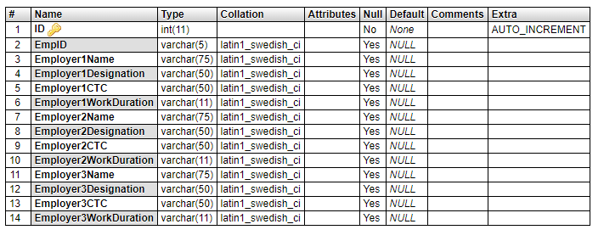

**Class Diagram:**

The class diagram shows a set of classes, interfaces, collaborations and their relationships.

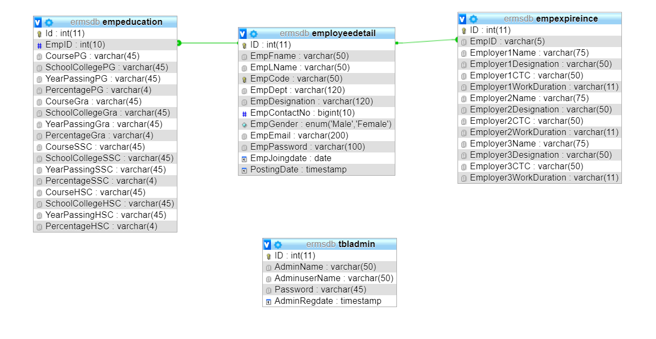

**CHAPTER # 6**

**Output screens**

**HOME PAGE**



**EMPLOYEE SIGNUP PAGE**

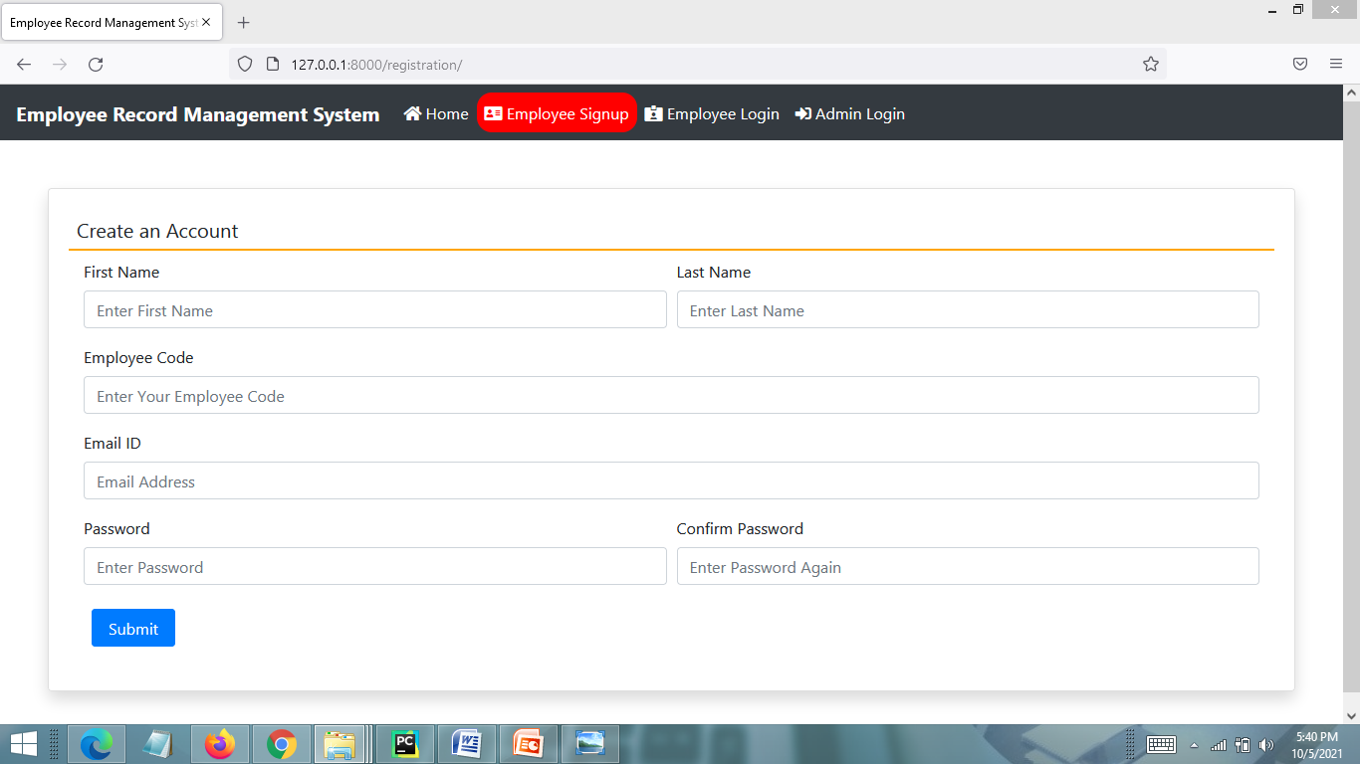

**LOGIN PAGE**

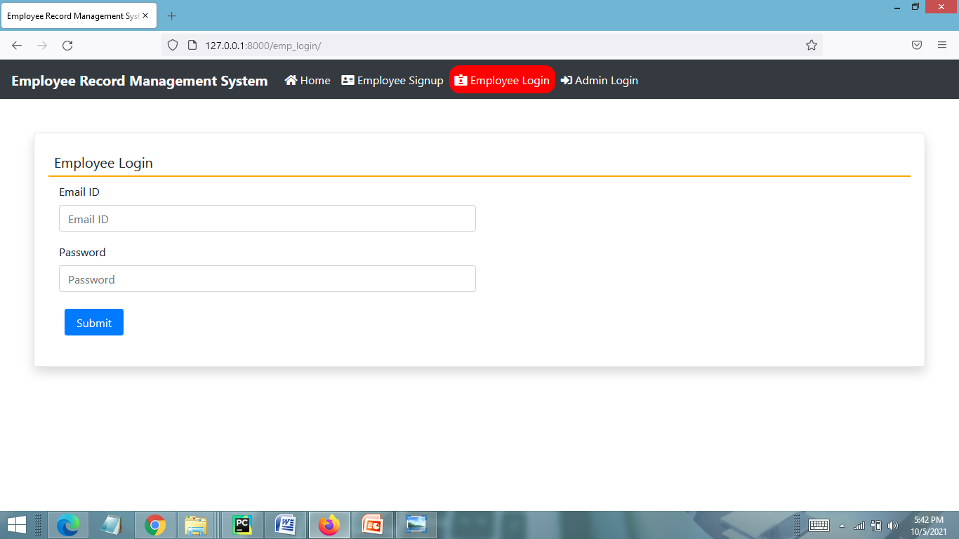

**EMPLOYEE DASHBOARD PAGE**

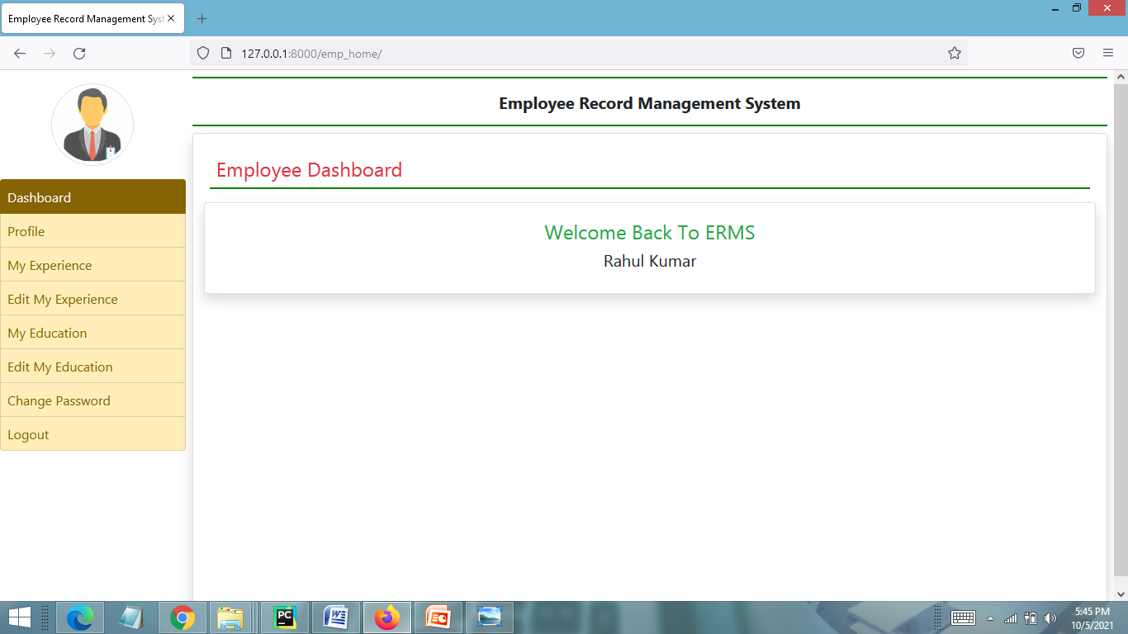

**MY PROFILE PAGE**

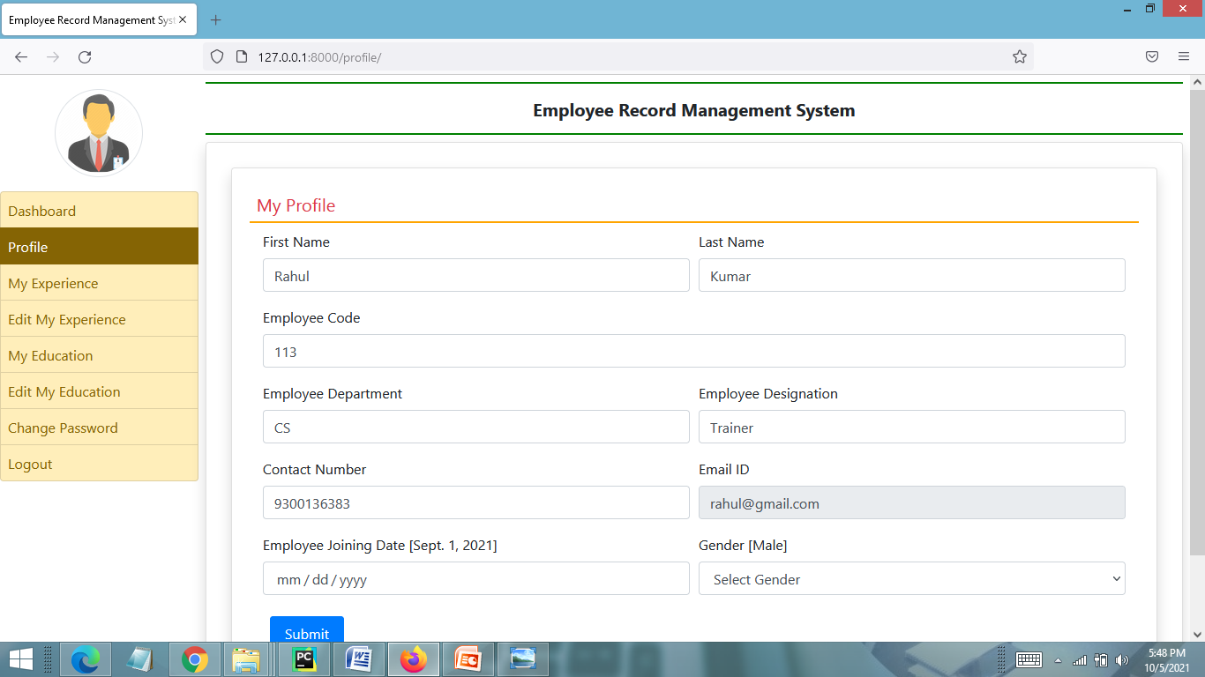

**VIEW MY WORK EXPERIENCE PAGE**

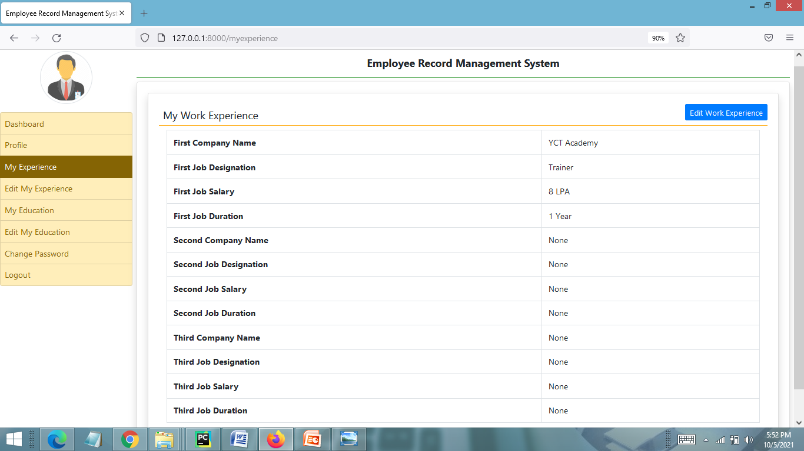

**EDIT MY WORK EXPERIENCE PAGE**

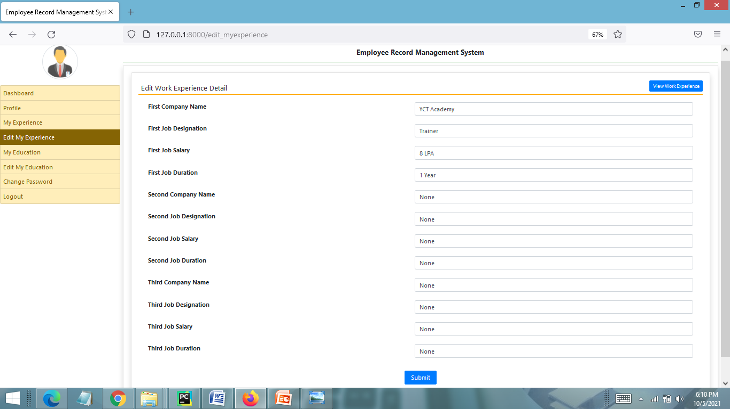

**VIEW MY EDUCATION DETAIL PAGE**

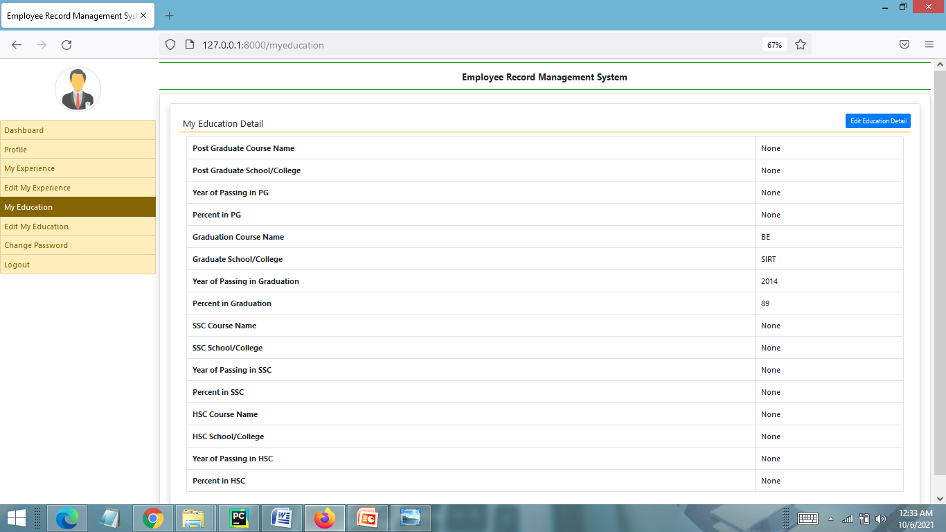

**EDIT EDUCATION DETAIL PAGE**

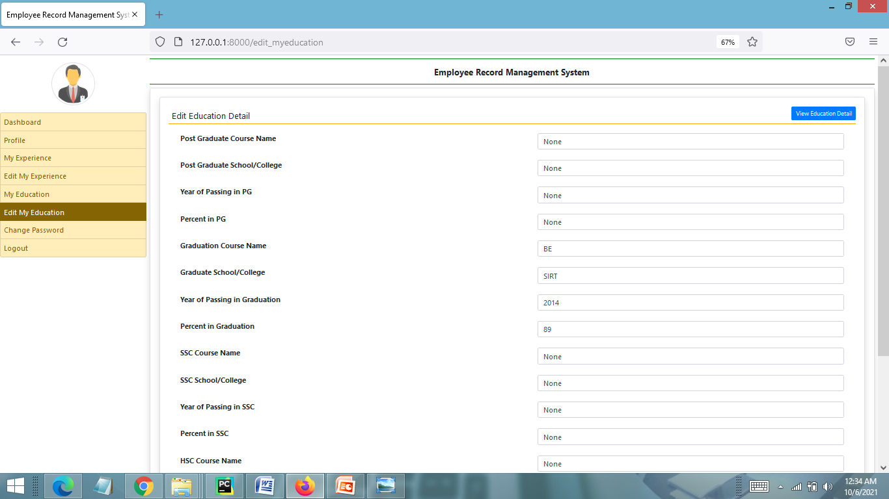

**CHANGE PASSWORD PAGE**

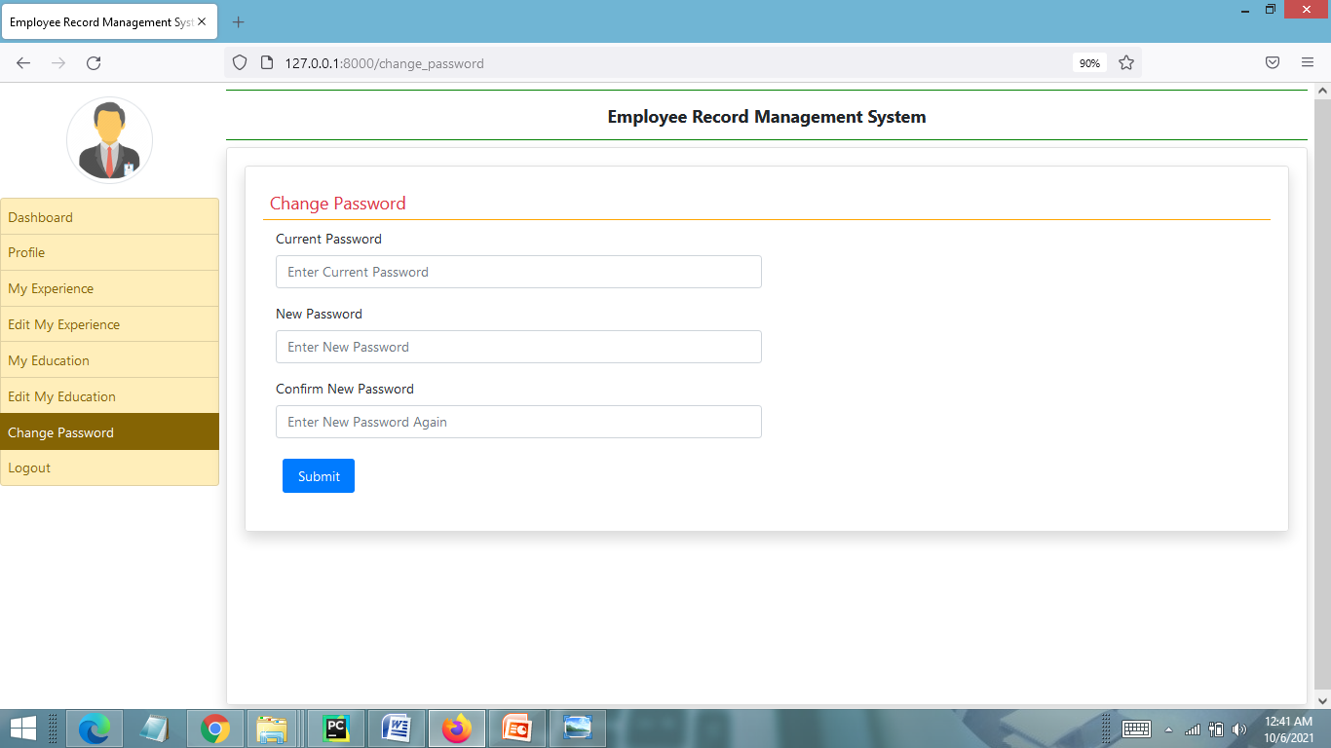

**ADMIN LOGIN PAGE**

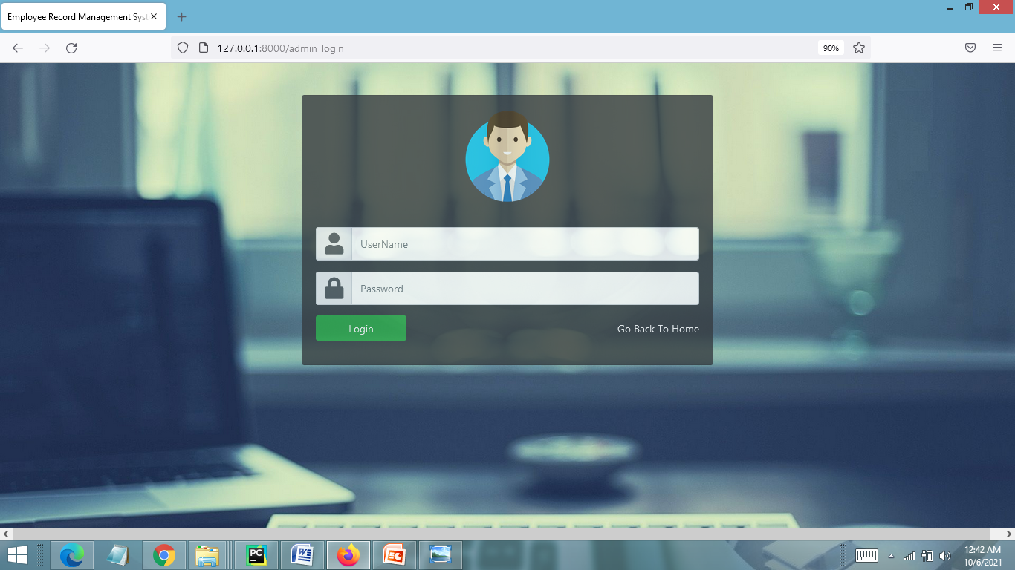

**ADMIN HOME PAGE**

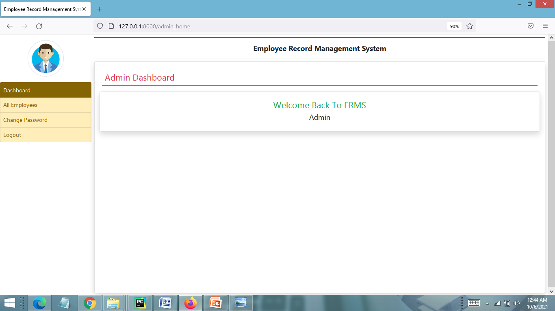

**MANAGE EMPLOYEE DETAIL PAGE**

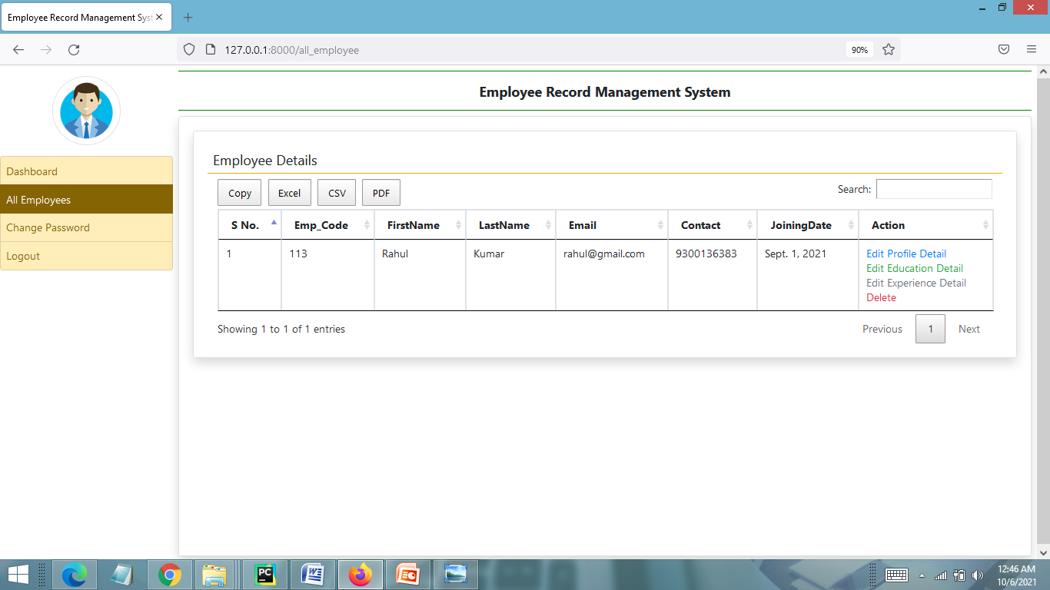

**CHAPTER # 7**

***Coding***

**HOME PAGE CODING**

**{% load static %}**

**<html>**

**<head>**

**{% include 'header.html' %}**

**<style>**

**.headingfour:hover{**

**color : lightblue;**

**</style>**

**</head>**

**<body>**

**{% include 'navigation.html' %}**

**<!-- carousel start-->**

**<div id="demo" class="carousel slide" data-ride="carousel" style = "margin-top : 1px">**

**<!-- Indicators -->**

**<ul class="carousel-indicators">**

**<li data-target="#demo" data-slide-to="0" class="active"></li>**

**<li data-target="#demo" data-slide-to="1"></li>**

**</ul>**

**<!-- The slideshow -->**

**<div class="carousel-inner">**

**<div class="carousel-item">**

**<img src="{% static 'images/2.gif' %}" width="100%" height="500">**

**</div>**

**<div class="carousel-item active">**

**<img src="{% static 'images/1.jpg' %}" width="100%" height="500">**

**</div>**

**</div>**

**<!-- Left and right controls -->**

**<a class="carousel-control-prev" href="#demo" data-slide="prev">**

**<span class="carousel-control-prev-icon"></span>**

**</a>**

**<a class="carousel-control-next" href="#demo" data-slide="next">**

**<span class="carousel-control-next-icon"></span>**

**</a>**

**</div>**

**<!--carousel end-->**

**<div class="container-fluid" style = " height : 150px ; background-color : black">**

**<br><br>**

**<h4 class="text-center text-white">Employee Record Management System</h4>**

**<p class="text-center text-primary">&copy; PanjwaniSoftwares</p>**

**</div>**

**</body>**

**</html>**

**EMPLOYEE SIGNUP PAGE CODING**

**{% load static %}**

**{% include 'header.html' %}**

**{% include 'navigation.html' %}**

**<script>**

**function checkpass()**

**{**

**if(document.signup.pwd.value!=document.signup.cpwd.value)**

**{**

**alert('Password and Repeat Password field does not match');**

**document.signup.cpwd.focus();**

**return false;**

**}**

**return true;**

**}**

**</script>**

**<div class="card shadow m-5">**

**<div class="card-body">**

**<h5 class="p-2" style="border-bottom: 2px solid orange;">Create an Account</h5>**

**<div class="container-fluid">**

**<form method="POST" name = "signup" onsubmit="return checkpass();">**

**{% csrf_token %}**

**<div class="form-row">**

**<div class="col-sm-6">**

**<div class="form-group">**

**<label>First Name</label>**

**<input type="text" name="firstname" placeholder="Enter First Name" class="form-control" pattern="[A-Za-z]+">**

**</div>**

**</div>**

**<div class="col-sm-6">**

**<div class="form-group">**

**<label>Last Name</label>**

**<input type="text" name="lastname" placeholder="Enter Last Name" class="form-control" pattern="[A-Za-z]+">**

**</div>**

**</div>**

**<div class="col-sm-12">**

**<div class="form-group">**

**<label>Employee Code</label>**

**<input type="text" name="empcode" placeholder="Enter Your Employee Code" required class="form-control" pattern="[0-9]+">**

**</div>**

**</div>**

**<div class="col-sm-12">**

**<div class="form-group">**

**<label>Email ID</label>**

**<input type="email" name="email" placeholder="Email Address" required class="form-control">**

**</div>**

**</div>**

**<div class="col-sm-6">**

**<div class="form-group">**

**<label>Password</label>**

**<input type="password" name="pwd" placeholder="Enter Password" class="form-control">**

**</div>**

**</div>**

**<div class="col-sm-6">**

**<div class="form-group">**

**<label>Confirm Password</label>**

**<input type="password" name="cpwd" placeholder="Enter Password Again" class="form-control">**

**</div>**

**</div>**

**</div>**

**<input type="submit" value="Submit" class="m-2 px-3 btn btn-primary">**

**</form>**

**</div>**

**</div>**

**</div>**

**{% ifequal error "no" %}**

**<script>**

**alert('Signup Successfully');**

**window.location=("/emp_login");**

**</script>**

**{% endifequal %}**

**{% ifequal error "yes" %}**

**<script>**

**alert('Something went wrong,Try Again...');**

**</script>**

**{% endifequal %}**

**EMPLOYEE LOGIN PAGE CODING**

**{% load static %}**

**{% include 'header.html' %}**

**{% include 'navigation.html' %}**

**<div class="card shadow m-5">**

**<div class="card-body">**

**<h5 class="p-2" style="border-bottom: 2px solid orange;">Employee Login</h5>**

**<div class="container-fluid">**

**<form method="POST">**

**{% csrf_token %}**

**<div class="form-row">**

**<div class="col-sm-6">**

**<div class="form-group">**

**<label>Email ID</label>**

**<input type="email" name="emailid" placeholder="Email ID" class="form-control" >**

**</div>**

**</div>**

**</div>**

**<div class="form-row">**

**<div class="col-sm-6">**

**<div class="form-group">**

**<label>Password</label>**

**<input type="password" name="password" placeholder="Password" class="form-control">**

**</div>**

**</div>**

**</div>**

**<input type="submit" value="Submit" class="m-2 px-3 btn btn-primary">**

**</form>**

**</div>**

**</div>**

**</div>**

**{% ifequal error "no" %}**

**<script>**

**alert('logged in successfully');**

**window.location=("/emp_home");**

**</script>**

**{% endifequal %}**

**{% ifequal error "yes" %}**

**<script>**

**alert('Invalid Login Credentials,Try Again...');**

**</script>**

**{% endifequal %}**

**EMPLOYEE HOME PAGE CODING**

**{% extends 'emp_base.html' %}**

**{% block main %}**

**<h4 class="p-2 text-danger" style="border-bottom: 2px solid green;">Employee Dashboard</h4>**

**<div class="row text-center">**

**<div class="col-sm-12 p-2">**

**<div class="card shadow">**

**<div class="card-body">**

**<h4 class="text-success">Welcome Back To ERMS</h4>**

**<h5 class="text-capitalize">{{request.user.first_name}} {{request.user.last_name}}</h5>**

**</div>**

**</div>**

**</div>**

**</div>**

**{% endblock %}**

**VIEW PROFILE PAGE CODING**

**{% extends 'emp_base.html' %}**

**{% block main %}**

**<div class="card shadow m-2">**

**<div class="card-body">**

**<h5 class="p-2 text-danger" style="border-bottom: 2px solid orange;">My Profile</h5>**

**<div class="container-fluid">**

**<form method="POST" name = "signup" onsubmit="return checkpass();">**

**{% csrf_token %}**

**<div class="form-row">**

**<div class="col-sm-6">**

**<div class="form-group">**

**<label>First Name</label>**

**<input type="text" name="firstname" placeholder="Enter First Name" class="form-control" value="{{employee.user.first_name}}" pattern="[A-Za-z]+">**

**</div>**

**</div>**

**<div class="col-sm-6">**

**<div class="form-group">**

**<label>Last Name</label>**

**<input type="text" name="lastname" placeholder="Enter Last Name" class="form-control" value="{{employee.user.last_name}}" pattern="[A-Za-z]+">**

**</div>**

**</div>**

**<div class="col-sm-12">**

**<div class="form-group">**

**<label>Employee Code</label>**

**<input type="text" name="empcode" value="{{employee.empcode}}" placeholder="Employee Code" required class="form-control" pattern="[0-9]+">**

**</div>**

**</div>**

**<div class="col-sm-6">**

**<div class="form-group">**

**<label>Employee Department</label>**

**<input type="text" name="department" value="{{employee.empdept}}" placeholder="Department" required class="form-control">**

**</div>**

**</div>**

**<div class="col-sm-6">**

**<div class="form-group">**

**<label>Employee Designation</label>**

**<input type="text" name="designation" value="{{employee.designation}}" placeholder="Designation" class="form-control">**

**</div>**

**</div>**

**<div class="col-sm-6">**

**<div class="form-group">**

**<label>Contact Number</label>**

**<input type="text" name="contact" placeholder="Contact Number" value="{{employee.contact}}" class="form-control">**

**</div>**

**</div>**

**<div class="col-sm-6">**

**<div class="form-group">**

**<label>Email ID</label>**

**<input type="email" name="emailid" value = "{{employee.user.username}}" placeholder="Email ID" class="form-control" readonly>**

**</div>**

**</div>**

**<div class="col-sm-6">**

**<div class="form-group">**

**<label>Employee Joining Date [{{employee.joiningdate}}]</label>**

**<input type="date" name="jdate" class="form-control">**

**</div>**

**</div>**

**<div class="col-sm-6">**

**<div class="form-group">**

**<label>Gender [{{employee.gender}}]</label>**

**<select name="gender" class="form-control">**

**<option value="None">Select Gender</option>**

**<option value="Male">Male</option>**

**<option value="Female">Female</option>**

**</select>**

**</div>**

**</div>**

**</div>**

**<input type="submit" value="Submit" class="m-2 px-3 btn btn-primary">**

**</form>**

**</div>**

**</div>**

**</div>**

**{% ifequal error "no" %}**

**<script>**

**alert('Profile Updated Successfully.');**

**window.location=("/profile");**

**</script>**

**{% endifequal %}**

**{% ifequal error "yes" %}**

**<script>**

**alert('Something went wrong,Try Again...');**

**</script>**

**{% endifequal %}**

**{% endblock %}**

**EDIT MY EDUCATION DETAIL PAGE CODING**

**{% extends 'emp_base.html' %}**

**{% block main %}**

**<style>**

**</style>**

**<div class="card shadow">**

**<div class="card-body">**

**<a href="{% url 'myeducation' %}" class="btn btn-primary btn-sm float-right">View Education Detail</a>**

**<h5 class="p-2" style="border-bottom: 2px solid orange;">Edit Education Detail</h5>**

**<div class="container-fluid">**

**<form method="post">**

**{% csrf_token %}**

**<table class="table table-borderless">**

**<tr>**

**<th>Post Graduate Course Name</th>**

**<td><input type = "text" name = "coursepg" class="form-control" value ="{{education.coursepg}}"></td>**

**</tr>**

**<tr>**

**<th>Post Graduate School/College</th>**

**<td><input type = "text" name = "schoolclgpg" class="form-control" value ="{{education.schoolclgpg}}"></td>**

**</tr>**

**<tr>**

**<th>Year of Passing in PG</th>**

**<td><input type = "text" name = "yearpassingpg" class="form-control" value ="{{education.yearpassingpg}}"></td>**

**</tr>**

**<tr>**

**<th>Percent in PG</th>**

**<td><input type = "text" name = "percentagepg" class="form-control" value ="{{education.percentagepg}}"></td>**

**</tr>**

**<tr>**

**<th>Graduation Course Name</th>**

**<td><input type = "text" name = "coursegra" class="form-control" value ="{{education.coursegra}}"></td>**

**</tr>**

**<tr>**

**<th>Graduate School/College</th>**

**<td><input type = "text" name = "schoolclggra" class="form-control" value ="{{education.schoolclggra}}"></td>**

**</tr>**

**<tr>**

**<th>Year of Passing in Graduation</th>**

**<td><input type = "text" name = "yearpassinggra" class="form-control" value ="{{education.yearpassinggra}}"></td>**

**</tr>**

**<tr>**

**<th>Percent in Graduation</th>**

**<td><input type = "text" name = "percentagegra" class="form-control" value ="{{education.percentagegra}}"></td>**

**</tr>**

**<tr>**

**<th>SSC Course Name</th>**

**<td><input type = "text" name = "coursessc" class="form-control" value ="{{education.coursessc}}"></td>**

**</tr>**

**<tr>**

**<th>SSC School/College</th>**

**<td><input type = "text" name = "schoolclgssc" class="form-control" value ="{{education.schoolclgssc}}"></td>**

**</tr>**

**<tr>**

**<th>Year of Passing in SSC</th>**

**<td><input type = "text" name = "yearpassingssc" class="form-control" value ="{{education.yearpassingssc}}"></td>**

**</tr>**

**<tr>**

**<tr>**

**<th>Percent in SSC</th>**

**<td><input type = "text" name = "percentagessc" class="form-control" value ="{{education.percentagessc}}"></td>**

**</tr>**

**<tr>**

**<th>HSC Course Name</th>**

**<td><input type = "text" name = "coursehsc" class="form-control" value ="{{education.coursehsc}}"></td>**

**</tr>**

**<tr>**

**<th>HSC School/College</th>**

**<td><input type = "text" name = "schoolclghsc" class="form-control" value ="{{education.schoolclghsc}}"></td>**

**</tr>**

**<tr>**

**<th>Year of Passing in HSC</th>**

**<td><input type = "text" name = "yearpassinghsc" class="form-control" value ="{{education.yearpassinghsc}}"></td>**

**</tr>**

**<tr>**

**<th>Percent in HSC</th>**

**<td><input type = "text" name = "percentagehsc" class="form-control" value ="{{education.percentagehsc}}"></td>**

**</tr>**

**</table>**

**<center><input type="submit" value="Submit" class="m-2 px-3 btn btn-primary"></center>**

**</form>**

**</div>**

**</div>**

**</div>**

**{% ifequal error "no" %}**

**<script>**

**alert('Education Detail has been updated.');**

**window.location=("{% url 'myeducation' %}");**

**</script>**

**{% endifequal %}**

**{% ifequal error "yes" %}**

**<script>**

**alert('Something went wrong,Try Again...');**

**</script>**

**{% endifequal %}**

**{% endblock %}**

**EDIT MY EXPERIENCE PAGE CODING**

**{% extends 'emp_base.html' %}**

**{% block main %}**

**<style>**

**</style>**

**<div class="card shadow">**

**<div class="card-body">**

**<a href="{% url 'myexperience' %}" class="btn btn-primary btn-sm float-right">View Work Experience</a>**

**<h5 class="p-2" style="border-bottom: 2px solid orange;">Edit Work Experience Detail</h5>**

**<div class="container-fluid">**

**<form method="post">**

**{% csrf_token %}**

**<table class="table table-borderless">**

**<tr>**

**<th>First Company Name</th>**

**<td><input type = "text" name = "company1name" class="form-control" value ="{{experience.company1name}}"></td>**

**</tr>**

**<tr>**

**<th>First Job Designation</th>**

**<td><input type = "text" name = "company1desig" class="form-control" value ="{{experience.company1desig}}"></td>**

**</tr>**

**<tr>**

**<th>First Job Salary</th>**

**<td><input type = "text" name = "company1salary" class="form-control" value ="{{experience.company1salary}}"></td>**

**</tr>**

**<tr>**

**<th>First Job Duration</th>**

**<td><input type = "text" name = "company1duration" class="form-control" value ="{{experience.company1duration}}"></td>**

**</tr>**

**<tr>**

**<th>Second Company Name</th>**

**<td><input type = "text" name = "company2name" class="form-control" value ="{{experience.company2name}}"></td>**

**</tr>**

**<tr>**

**<th>Second Job Designation</th>**

**<td><input type = "text" name = "company2desig" class="form-control" value ="{{experience.company2desig}}"></td>**

**</tr>**

**<tr>**

**<th>Second Job Salary</th>**

**<td><input type = "text" name = "company2salary" class="form-control" value ="{{experience.company2salary}}"></td>**

**</tr>**

**<tr>**

**<th>Second Job Duration</th>**

**<td><input type = "text" name = "company2duration" class="form-control" value ="{{experience.company2duration}}"></td>**

**</tr>**

**<tr>**

**<th>Third Company Name</th>**

**<td><input type = "text" name = "company3name" class="form-control" value ="{{experience.company3name}}"></td>**

**</tr>**

**<tr>**

**<th>Third Job Designation</th>**

**<td><input type = "text" name = "company3desig" class="form-control" value ="{{experience.company3desig}}"></td>**

**</tr>**

**<tr>**

**<th>Third Job Salary</th>**

**<td><input type = "text" name = "company3salary" class="form-control" value ="{{experience.company3salary}}"></td>**

**</tr>**

**<tr>**

**<th>Third Job Duration</th>**

**<td><input type = "text" name = "company3duration" class="form-control" value ="{{experience.company3duration}}"></td>**

**</tr>**

**</table>**

**<center><input type="submit" value="Submit" class="m-2 px-3 btn btn-primary"></center>**

**</form>**

**</div>**

**</div>**

**</div>**

**{% ifequal error "no" %}**

**<script>**

**alert('Expirence Detail has been updated.');**

**window.location=("{% url 'myexperience' %}");**

**</script>**

**{% endifequal %}**

**{% ifequal error "yes" %}**

**<script>**

**alert('Something went wrong,Try Again...');**

**</script>**

**{% endifequal %}**

**{% endblock %}**

**ADMIN LOGIN PAGE CODING**

**{% load static %}**

**<head>**

**<title>Employee Record Management System - Admin Login</title>**

**<meta charset="utf-8">**

**<meta name="viewport" content="width=device-width, initial-scale=1">**

**<link rel="stylesheet" href="https://maxcdn.bootstrapcdn.com/bootstrap/4.4.1/css/bootstrap.min.css">**

**<script src="https://ajax.googleapis.com/ajax/libs/jquery/3.4.1/jquery.min.js"></script>**

**<script src="https://cdnjs.cloudflare.com/ajax/libs/popper.js/1.16.0/umd/popper.min.js"></script>**

**<script src="https://maxcdn.bootstrapcdn.com/bootstrap/4.4.1/js/bootstrap.min.js"></script>**

**<link rel="stylesheet" href="https://use.fontawesome.com/releases/v5.7.0/css/all.css" integrity="sha384-lZN37f5QGtY3VHgisS14W3ExzMWZxybE1SJSEsQp9S+oqd12jhcu+A56Ebc1zFSJ" crossorigin="anonymous">**

**<link rel="stylesheet" type = "text/css" href="{% static 'css/login.css' %}">**

**</head>**

**<body style = "background-image : url({% static 'images/bg.jpg' %})">**

**<div class="row">**

**<div class="col-lg-5 m-auto">**

**<div class="card mt-5 bg-dark">**

**<div class="card-title text-center mt-3">**

**<img src="{% static 'images/adminlogin.png' %}" width="150" height="150">**

**</div>**

**<div class="card-body">**

**<form method="post">**

**{% csrf_token %}**

**<div class="input-group mb-3">**

**<div class="input-group-prepend">**

**<span class="input-group-text">**

**<i class="fa fa-user fa-2x"></i>**

**</span>**

**</div>**

**<input type="text" name="username" class="form-control py-4" placeholder="UserName">**

**</div>**

**<div class="input-group mb-3">**

**<div class="input-group-prepend">**

**<span class="input-group-text">**

**<i class="fa fa-lock fa-2x"></i>**

**</span>**

**</div>**

**<input type="password" name="pwd" class="form-control py-4" placeholder="Password">**

**</div>**

**<input type="submit" value="Login" class="btn btn-success px-5">**

**<a href="/" class="float-right mt-2 text-white">Go Back To Home</a>**

**</form>**

**</div>**

**</div>**

**</div>**

**</div>**

**</body>**

**{% ifequal error "no" %}**

**<script>**

**alert('logged in successfully');**

**window.location=('{% url 'admin_home' %}');**

**</script>**

**{% endifequal %}**

**{% ifequal error "yes" %}**

**<script>**

**alert('Invalid Login Credentials,Try Again...');**

**</script>**

**{% endifequal %}**

**ADMIN HOME PAGE CODING**

**{% extends 'admin_base.html' %}**

**{% block main %}**

**<h4 class="p-2 text-danger" style="border-bottom: 2px solid green;">Admin Dashboard</h4>**

**<div class="row text-center">**

**<div class="col-sm-12 p-2">**

**<div class="card shadow">**

**<div class="card-body">**

**<h4 class="text-success">Welcome Back To ERMS</h4>**

**<h5 class="text-capitalize">Admin</h5>**

**</div>**

**</div>**

**</div>**

**</div>**

**{% endblock %}**

**MANAGE EMPLOYEE DETAIL PAGE CODING**

**{% extends 'admin_base.html' %}**

**{% block main %}**

**<div class="card shadow">**

**<div class="card-body">**

**<h5 class="p-2" style="border-bottom: 2px solid orange;">Employee Details</h5>**

**<div class="container-fluid">**

**<table class="table table-bordered table-sm" id="example">**

**<thead>**

**<tr>**

**<th>S No.</th>**

**<th>Emp_Code</th>**

**<th>FirstName</th>**

**<th>LastName</th>**

**<th>Email</th>**

**<th>Contact</th>**

**<th>JoiningDate</th>**

**<th>Action</th>**

**</tr>**

**</thead>**

**<tbody>**

**{% for i in employee %}**

**<tr>**

**<td>{{forloop.counter}}</td>**

**<td>{{i.empcode}}</td>**

**<td>{{i.user.first_name}}</td>**

**<td>{{i.user.last_name}}</td>**

**<td>{{i.user.username}}</td>**

**<td>{{i.contact}}</td>**

**<td>{{i.joiningdate}}</td>**

**<td><a href="{% url 'edit_profile' i.id %}" class="text-primary">Edit Profile Detail</a>**

**<br><a href="{% url 'edit_education' i.user.id %}" class="text-success">Edit Education Detail</a>**

**<br><a href="{% url 'edit_experience' i.user.id %}" class="text-secondary">Edit Experience Detail</a>**

**<br><a href="{% url 'delete_employee' i.user.id %}" class="text-danger" onclick="return confirm('Are You Sure?')">Delete</a>**

**</td>**

**</tr>**

**{% endfor %}**

**</tbody>**

**</table>**

**</div>**

**</div>**

**</div>**

**{% endblock %}**

**CHAPTER # 8**

**Advantages & Limitations**

**Advantages of “Employee Record Management System”:**

“Employee Record Management System” provides various features, which complement the information system and increase the productivity of the system. These features make the system easily usable and convenient. Some of the important features included are listed as follows:

* Intelligent User Forms Design
  + - Data access and manipulation through same forms
    - Access to most required information
* Data Security
* Restrictive data access, as per login assigned only.
* Organized and structured storage of facts.
* Strategic Planning made easy.
* No decay of old Records.
* Exact financial position of the business.

**Limitations of “Employee Record Management System”:**

Besides the above achievements and the successful completion of the project, we still feel the project has some limitations, listed as below:

* + It is not a large scale system.
  + Only limited information provided by this system.
  + Since it is an online project, user needs internet connection to use the software.
  + People who are not familiar with computers can’t use this software.

**CHAPTER # 8**

**Future Scope**

**FUTURE SCOPE**

Thisweb application involves almost all the basic features of the online employee record management system. The future implementation will be online help for the employees and chatting with website administrator.

**CONCLUSION**

It has been a great pleasure for me to work on this exciting and challenging project. This project proved good for me as it provided practical knowledge of not only programming in Python and Sqlite web based application. It also provides knowledge about the latest technology used in developing web enabled application and client server technology that will be great demand in future. This will provide better opportunities and guidance in future in developing projects independently.

Employee record management system is used for daily operations in any organization to maintain or access employee related information for internal administration purposes.

**Bibliography**

**BIBLIOGRAPHY**

* Wikipedia
* <https://www.geeksforgeeks.org/python-django/>
* <https://www.javatpoint.com>
* <https://www.python.org/>
* <https://www.tutorialspoint/>
* **REFERENCE BOOKS**

### Two scoops of Django for 1.11 by Daniel Greenfeld’s and Audrey Greenfield

### Lightweight Django by Elman and Mark Lavin