georjohn@ - body of work

Item | Title | Description | Outcome | Artifacts
1 | EKS Provisioned Control plane | Allow customers to set a higher baseline of performance for EKS clusters and scale beyond Kubernetes tested limits. This feature will help customers achieve predictable performance for large scale clusters. | Our control plane vertical auto scaling covers 90%+ of customer use cases. But certain customers with bursty traffic, or XL+ cluster use cases, still require custom scaling. This will provide better customer UX, reduce pre-scaling tickets, and introduce new revenue stream as we support larger and larger cluster sizes. | Provisioned Control plane PR/FAQ - linkProvisioned control plane Pricing doc - linkAWS Field messaging - wikiAWS Launch blog - link
2 | EKS GenAI experience for deveopers | Launch general availability of Holodeck, a Model Context Protocol (MCP) server with EKS and Kubernetes specific context. Integrate with AWS Next Gen DevX (NGDE) experiences in AWS Console and Integrated Development Environment, as well as 3p industry tools like Cursor. | EKS offerings today help customers create and manage Kubernetes clusters, maintain them at scale, and optimize their infrastructure and resource usage. To build and ship software with their clusters, customers often spend weeks navigating complex tooling, infrastructure design decisions, and deployment mechanisms to navigate from idea to production with Kubernetes. This complexity impacts innovation and agility, often leaving customers frustrated and hindering their ability to quickly bring new ideas to market. By simplifying this experience with expert GenAI models and integrated context assistance, that leverage upcoming EKS platform services features including Deployments and Cloud Resource Orchestration, we can help customers focus on building (and troubleshooting) their differentiated applications rather than wrestling with infrastructure and tooling. WIth the delivery of EKS MCP server, AWS and EKS demonstrated its innovation leadership by being the first major Kubernetes provider to implement Model Context Protocol (MCP) server support, delivering this capability just 6 months after MCP's initial release. This swift adoption set a new standard in the industry, with other leading providers like Google Kubernetes Engine (GKE) and Azure Kubernetes Service (AKS) following EKS's lead several months later. By pioneering MCP server integration, EKS strengthened its position as a thought leader in the Kubernetes ecosystem and reinforced AWS's commitment to rapid innovation in container orchestration. The launch is succesfully with 851 customers using EKS MCP server since its launch two months ago. | EKS GenAI PR/FAQ - linkEKS GenAI product experience - link EKS GenAI strategy update - linkEKS MCP server launch blog - link(aws-labs), link(fully managed)
3 | EKS 100K node cluster (project Titan) | Launch Amazon EKS cluster capable of supporting up to 100K nodes in GA, enabling frontier model builders to efficiently train and run large-scale AI models on EKS | Led the product execution and strategic launch messaging for EKS 100K node cluster (Project Titan). Orchestrated alignment across Engineering, Marketing, Legal, and account teams. Worked closely with AI innovator - Anthropic, that played a key part in securing them as a launch partner. Secured L10 leadership (cooksbar@) signoff on launch messaging while driving customer reference with Anthropic and Amazon AGI stakeholders. Developed nuanced messaging (doc here and field session here) that highlighted EKS cutting edge innovation while clearly communicating onboarding criteria since 100K node clusters was meant for a very niche set of AI/ML customers. The messaging was complex since EKS wanted to highlight its though leadership and innovation but land the messsaging that this is not for all customers but specifically for ultra scale AI/ML workloads. Created comprehensive field enablement materials that equipped AWS teams to have the right conversations with customers about the capability. The launch positioned EKS as an innovation leader in the Kubernetes space since it supports the worlds largest Kubernetes clusters and has created a lot of customer excitement which included reachouts from JP morgan chase , Aribnb, Adobe, Poolside.ai, Grammarly, NovaProspect, Motional, CoStar Inc, etc, who wants to onboard since launch 2 weeks ago. | Launch Blog - linkWhat's new post - linkAWS Field messaging - linkAWS field enablement - link
4 | EKS observability strategy | Defined the business opportunity, product strategy, and long term roadmap and vision for improving observability experience for Amazon EKS customers. to deliver a differentiatiing experience for customers | Defined a multi-year strategic vision document, build a long-term roadmap, and drove teams to execute on that vision (see Item #2 and Item #3 in this table). Partnered effectively with other leaders across AWS orgs including AIO team that is responsible for AWS observability services like CloudWatch, Managed Prometheus, etc. Was able to influence their roadmap priorities and reach consensus on approach/prioritization. | Strategy doc - linkEstablished and leads the monthly PM leadership syncup between EKS and AMO team - link
5 | Control plane insights | One of the major themes of opportunites identified in the EKS observabiilty strategy doc [Item #1 in this table] was to deliver control plane insights to enable customers to more effectively run their workloads on EKS. This is a win-win for both customers ane AWS since it helps customers to get the needed insights to quickly root cause and remediate issues, and heps AWS by reducing the number of tickets cut by customers to AWS Support and EKS service team. | Delivered clarity on a complex and ambigous product opportunity with complete indepedence. This product initiative will result in signficant and increased valute to the customers (performance improvements, improved operational posture, customer innovation), and enables EKS to maintain a competitive advantage over competition. Identified an proactively managed areas of business importance including engagement with other AWS service teams (Amazon Managed Prometheus and Container insights) AWS partner teams (DataDog, NewRelic, etc) to ensure the right go to market messaging and allignment. | Control plane insights PR/FAQ - link, Customer interview questionnaire - linkAllignment with AWS Partner solutions - linkAllignement with AMP team - linkCP o11y blog - link
6 | Eventing service | One of the major themes of opportunites identified in the EKS observabiilty strategy doc [Item #1 in this table] was to deliver near real-time updates from EKS clusters and Kubernetes resources on the channels where customers are (slack, email, MS teams, etc). Notifications into the health and performance of EKS cluster and K8s resources is one of the most asked feature request from EKS customers. | Defined the business opportunity and strategy for a area that was technically complex and not defined. Anticipated future growth opportunities and turns these signals into viable business opportunities by defining the product experience that involved collaboration and integration with other AWS service (Amazon EventBridge). Demonstrated deep knowledge of the core systems and broad understanding of systems/technologies in multiple domains. | Eventing service PR/FAQ - link Other AWS service team engagements - Amazon Inspector team (here), EKS Hybrid Nodes (here), ECR (here), ACO (Cost and usage team here), EMR on EKS (here)Customer interview questionnaire - link
7 | Project obelisk | Rearchitect EKS control plane by leveraging the internal Journal services as the consensus layer for etcd (replacing raft), along with colocation of API server and etcd on a single instance. This will not help us deliver predictable performance, higher durability, and higher availability to EKS customers, but also signficantly improve EKS cost model and operating margin by elliminating the etcd fleet (~ approx 1 million instances). This is expected to result in ~$87.1MM in CapEx savings in 2025. | Impacted long-term business and service profitability. Obelisk is game-changing, and could have industry impact by enabling EKS to gain a competitive advantage. Demonstrated deep product management expertise at the next level, by handling significantly complex problems, evaluating risks, navigating roadblocks, and getting allignment from varios stakeholders. | Working backwards (PR/FAQ) doc - linkCustomer facing doc - link
8 | Defined and launched brand new AWS service (AWS CodeArtifact) | As the lead and sole Product Manager, I was responsible for defining the requirements, designing the user experience, and overseeing the development and launch of a brand new AWS service called AWS CodeArtifact, which was released in June 2020. CodeArtifact is fully managed artifact repository service that makes it easy for organizations of any size to securely store, publish, and share packages used in their software development process. CodeArtifact eliminates the need for you to set up, operate, and scale the infrastructure required for artifact management so you can focus on software development | Demonstrated abiilty to single handedly lead all facets of a defining and launching a new AWS service. Partnered effectively with all leaders and stakeholders involved in the design, development, marketing, compliance, ISV partners, and sales of an AWS service. Demonstrated innovation by not following the pack (JFrog Artifactory, Sonatype Nexus, Azure Artifacts, GCP Artifact registry, etc), but coming up with a customer focussed, service cost following pricing model, that recieved postive feedback | Pricing and naming doc - linkcode.aws user stories - linkPrivate beta - linkNaming alternatives - link Decision doc pricing options - link Public repos engagement plan - link and link Launch plan - link CodeArtifact roadmap - link Business metrics/feature requests - link
9 | EKS performance and scale strategy | Defined the business opportunity, product strategy, and long term roadmap and vision for delivering a truly differentiating cluster performance and scalability experience for Amazon EKS customers. Own strategic scalability engagement with Anthropic to ensure they are successful in going above the upstream K8s limites (> 5k nodes per cluster) | Proactively identified and managed an area of business that was important, including maintaing ongoing relationship with Anthropic. Brought clarity to the complex problem area and defined the user journey to probe assumptions, illuminate pitfalls, and foster shared understanding. Defined a multi-year strategic vision document and build a long-term roadmap to execute on that vision (see Item #2 and Item #3 in this table). | Strategy doc - linkUX narrative - docAnthropic engagement - doc
10 | EKS Core and Performance roadmap | Owns the overall roadmap for EKS core and performance (7 sub-teams) along with L7 engg: counterpart (@sabhayav) | Owned the long term roadmap and execution for a major suite of sub-teams (known as EKS core and performance) within EKS in the cloud team. | EKS core and perf 2025 Q1 roadmap - linkEKS core and perf 2024 Q4 roadmap - linkEKS core and per 2024 Q3 roadmap - link EKS core and perf 2024 Q2 roadmap - link
11 | EKS control plane positioning | Define the value proposition and external communications on the fully managed control plane offered by Amazon EKS to control external messaging. Develop content that evangelizes the benefits that customers get, drives the desired customer behavior, and establishes EKS as a thought leader in the containerized workloads space. | Drove strategic communications both internally and externally. Developed technical position papers for large technical audiences and for internal teams (support, BD, Sales, etc.). Content created enabled AWS sales team to drives strategic conversations with customer technical decision makers and technical executive teams through pre-sales and post-sales engagements and briefings. | Co-authored blog:: Deep dive into Amazon EKS scalability testing - linkCo-authored blog: Managing etcd at scale - linkInitiated and drove Control plane scaling blog - link, linkLed “Scalability” best practices section in EKS best practices guide - linkMegaCluster private beta - doc
12 | EKS IPv6/dual stack support | IPv6 support for EKS service management API and API server endpoints | Launched (what's new post) this cross functional, AWS-level customer commit successfully. Navingated through various launch blocking conerns, by taking ownership, bringing clarity, and driving decision making across teams. | FAQs - doc
13 | EKS Security opportunity | Defined the product requirements to deliver a truly differentiating security experience for EKS customers. | Drove clarity by defined the user journey and identifying product opportunities and requirements | Security narrative - link2023 reInvent breakout security session - link2024 reInvent security breakout session - link
14 | EKS Pod Identity | Pod Identity (aka IRSAv2) makes it easier for customers to securely access AWS services in Kubernetes applications. This was a STEAM goal (link). | Demonstrated ability to independently own the product definition, delivery of a deeply complex and technical solution, which was a STEAM goal for EKS. Showed ability to build consensus and partner effectively with stakholders and leaders to allign teams towards common goals. Exhibited deep knowledge of the systems and fluency in technical alternatives to guide engineering decisions. | PR/FAQ - linkFeature naming doc - linkCross account UX proposal - linkAWS Field enablement session - linkPod identity post launch analysis - linkPod identity launch blog - linkPod Identity cross account launch blog - linkeksctl + IRSAv2 eksctl experience - linkUser story definition - linkDecision doc: Pod identity agent deployment option - link
15 | Led Prodcut management for AWS Lambda@Edge | Was the lead PM to drive all the go to market, evangelization, and roadmap definition of a new launched AWS featre (Lambda@Edge). | Manages the strategic direction (business and technology), development, and business aspects of a major feature that was just launched (another PM launched this feature but left soon after launch). | Body of work - doc
16 | Strategic decisions | Drives strategic product decisions including decision to scale down zero node clusters, EKS response to upstream APF behaviour changes, and the change in Beta API behaviour | Demonstrated ability to distinguish between one-way and two-way doors. Exhibited high judgment that has led to smart decisions with two-way doors. | Decision doc: Scale down zero node clusters - linkDecision doc: Upstream APF behavior change - linkDecision doc: Beta API change - link
17 | Critical customer communications | Drive strategic customer communications | Identified and proactively manage customer communications related to importance areas of the product | Customer comm: EBS CSI migration - docCustomer comm: Registry freeze - docCustomer comm: Skylens issue - docCustomer comm: HPA controller issue - docCustomer comm: EKS Console secret retrieval failure - linkInternal comm: Obelisk VP status update doc - link
18 | EKS old cluster deprecation campaign | Move customers off deprecated EKS versions | Drove alignment and defined mechanisms to ensure EKS customers move off deprecated versions. Created predictable process paths for engagement between EKS and AWS field teams. | EKS old cluster migration campaign - doc
19 | EKS compliance program | Be the point of contact and lead the engagement with AWS compliance team to ensure EKS continue to be compliant and receieves new compliance attestation | Drove clarity, allignment across various EKS sub teams and GEAR to ensure EKS audit readiness. | Created EKS High level architecture diagram for GEAR - docLed the compliance engagement with GEAR team - link
20 | Data on EKS roundatable | Co-led (wtih @raghat) the EKS service team roadmap engagement with strategic customers who are trying to modernize their data architectures on Amazon EKS | Had a highly successful Data on EKS Open Source roundtable on June 25th at SJC18, featuring presentations from Fruitstand ACS, Intuit, Pinterest, and Capital One. Autodesk, Airbnb, Fruitstand Ads platform, and F5 were also present, with a total of 26 customer attendees. Drove strategic conversations with customer technical decision makers and technical executive | Event details link
21 | Integration with CUR for granular EKS cost reporting | AWS Cost and Usage Reports (CUR), enabling customers to analyze, optimize, and chargeback cost and usage for their Kubernetes applications. With AWS Split Cost Allocation Data (SCAD) for Amazon EKS, customers can now allocate application costs to individual business units and teams based on how Kubernetes applications consume shared EC2 CPU and memory resources. | Partnered effectively with AWS CUR team in the design, development, marketing, and launch of this feature. | Container cost allocation twitch session - link
22 | Hiring | Partcipate in hiring and development of Amazonians | Actively recruited for AWS, as well as participated in the hiring/interview process. Played a significant role in the career development of other PMTs, including actively mentoring PMT intern (Spyros Angelopoulos), and performing PMT skills review request | Recently interviewed 3 internal SDM candidates for EKS control plane SDM positionCompleted 30 external candidate interviewPerformed PMT-ES Skills review/ assessmentMentored 2024 EKS PMT intern (Spyros Angelopoulos) who was made an offer to return
23 | Field enablement | Delivered EKS roadmap session to container TFC and wrote white paper on blue/green deployments | Delievered EKS roamdap session on 5/11 as part of container TFC hours hours. Recieved CSAT score of 4.67 https://amzn-aws.slack.com/archives/C056UKH8KKJ/p1684168866073889 | Feedback - linkBlue/Green white paper - link

Accolades & Feedback

Barry’s feedback on Mercedes Benz win
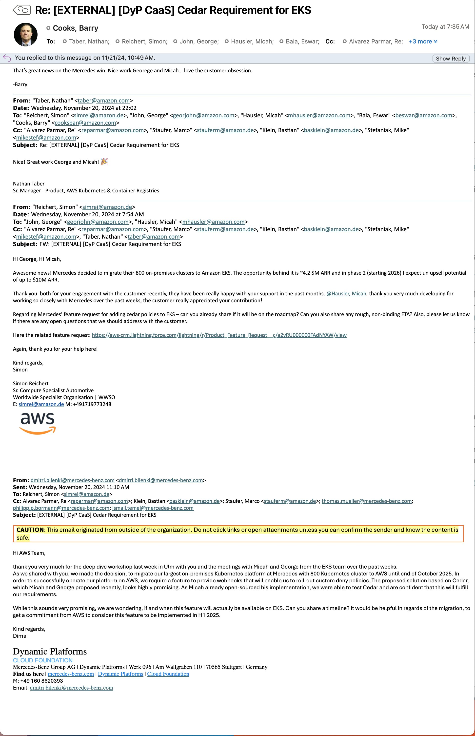

Barry’s feedback on meeting Obelisk’s goal for 2024
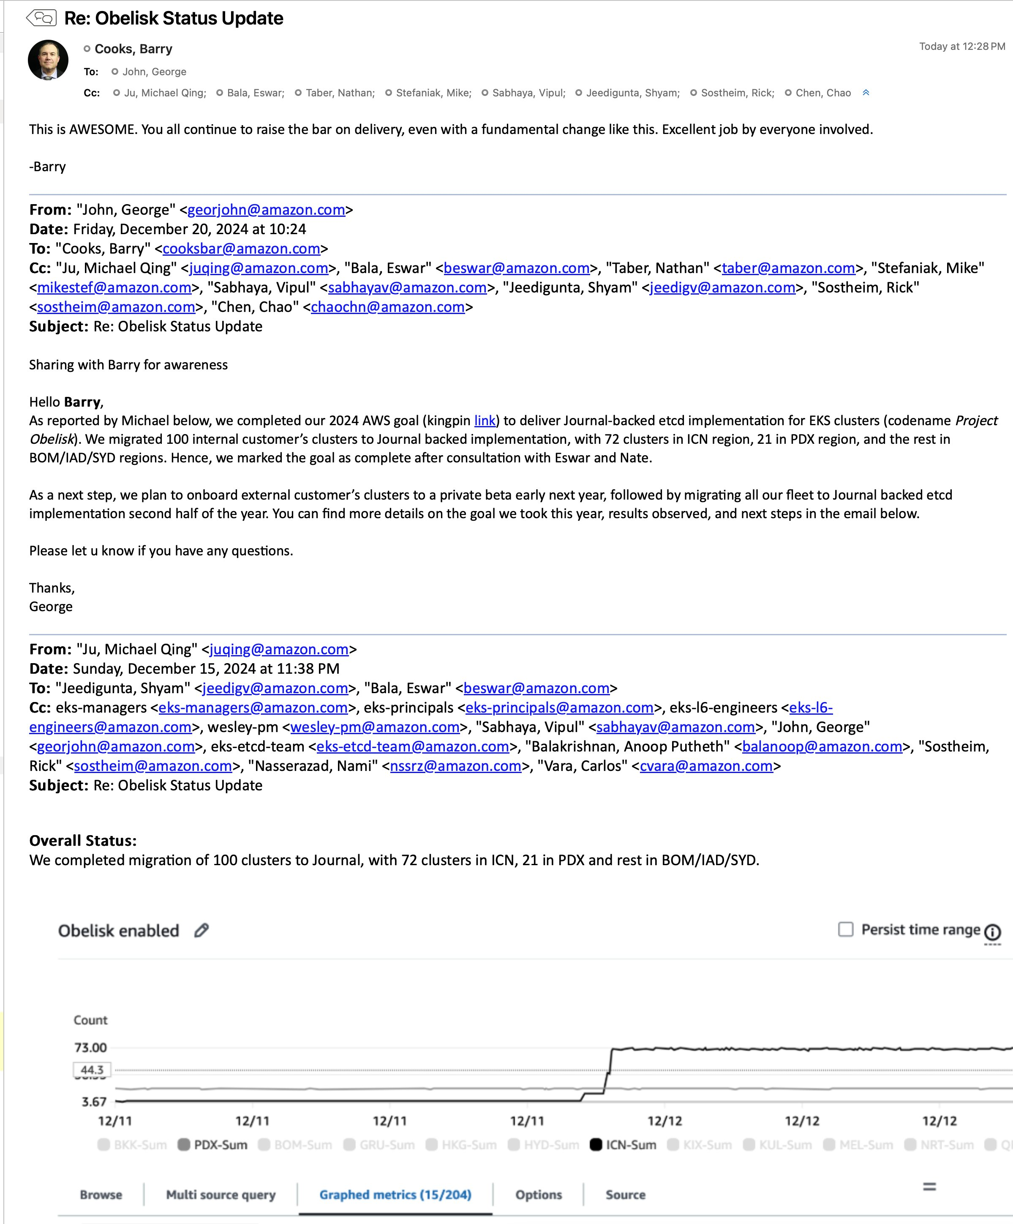

Barry’s feedback on Snap engagement
  - Email subject “FW: Snap Priority Request”
  - Tuesday, January 31, 2023 at 4:02 PM
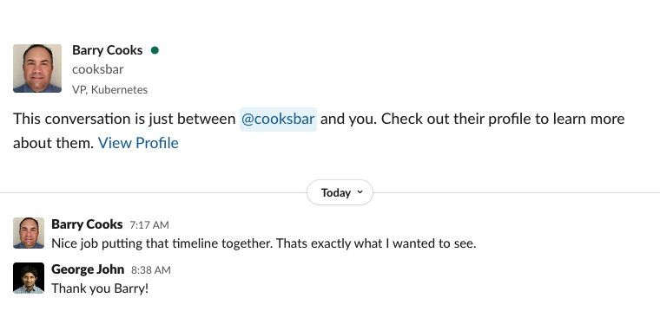

Barry’s feedback on EKS MCP server launch
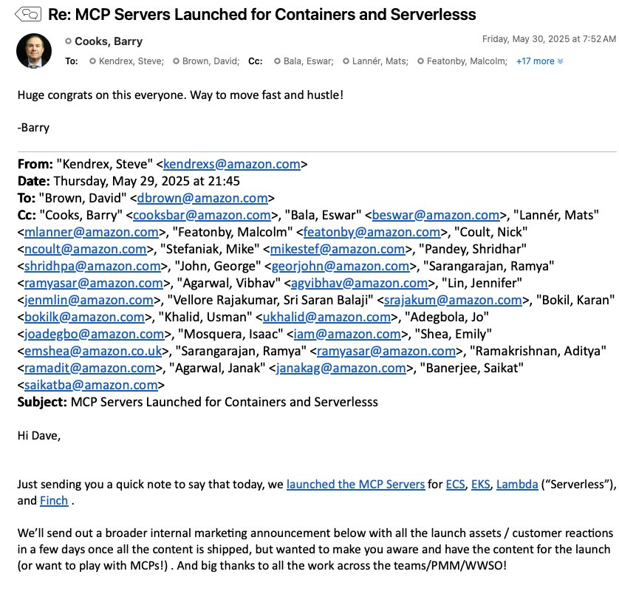

Airbnb Win
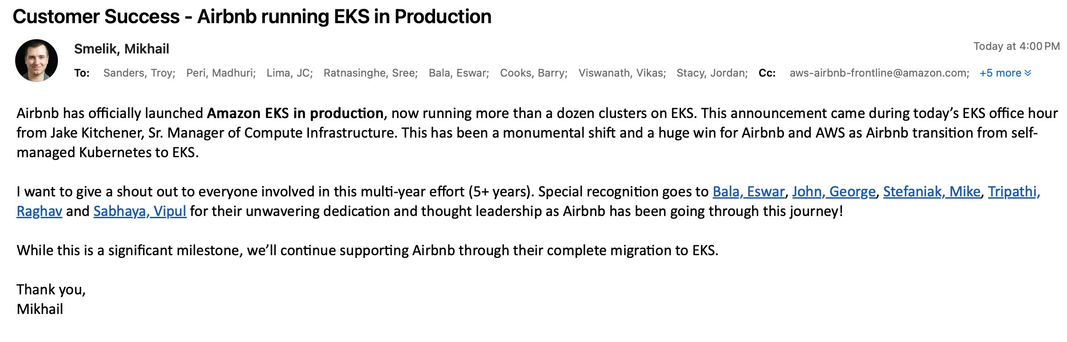

HSBC TAM
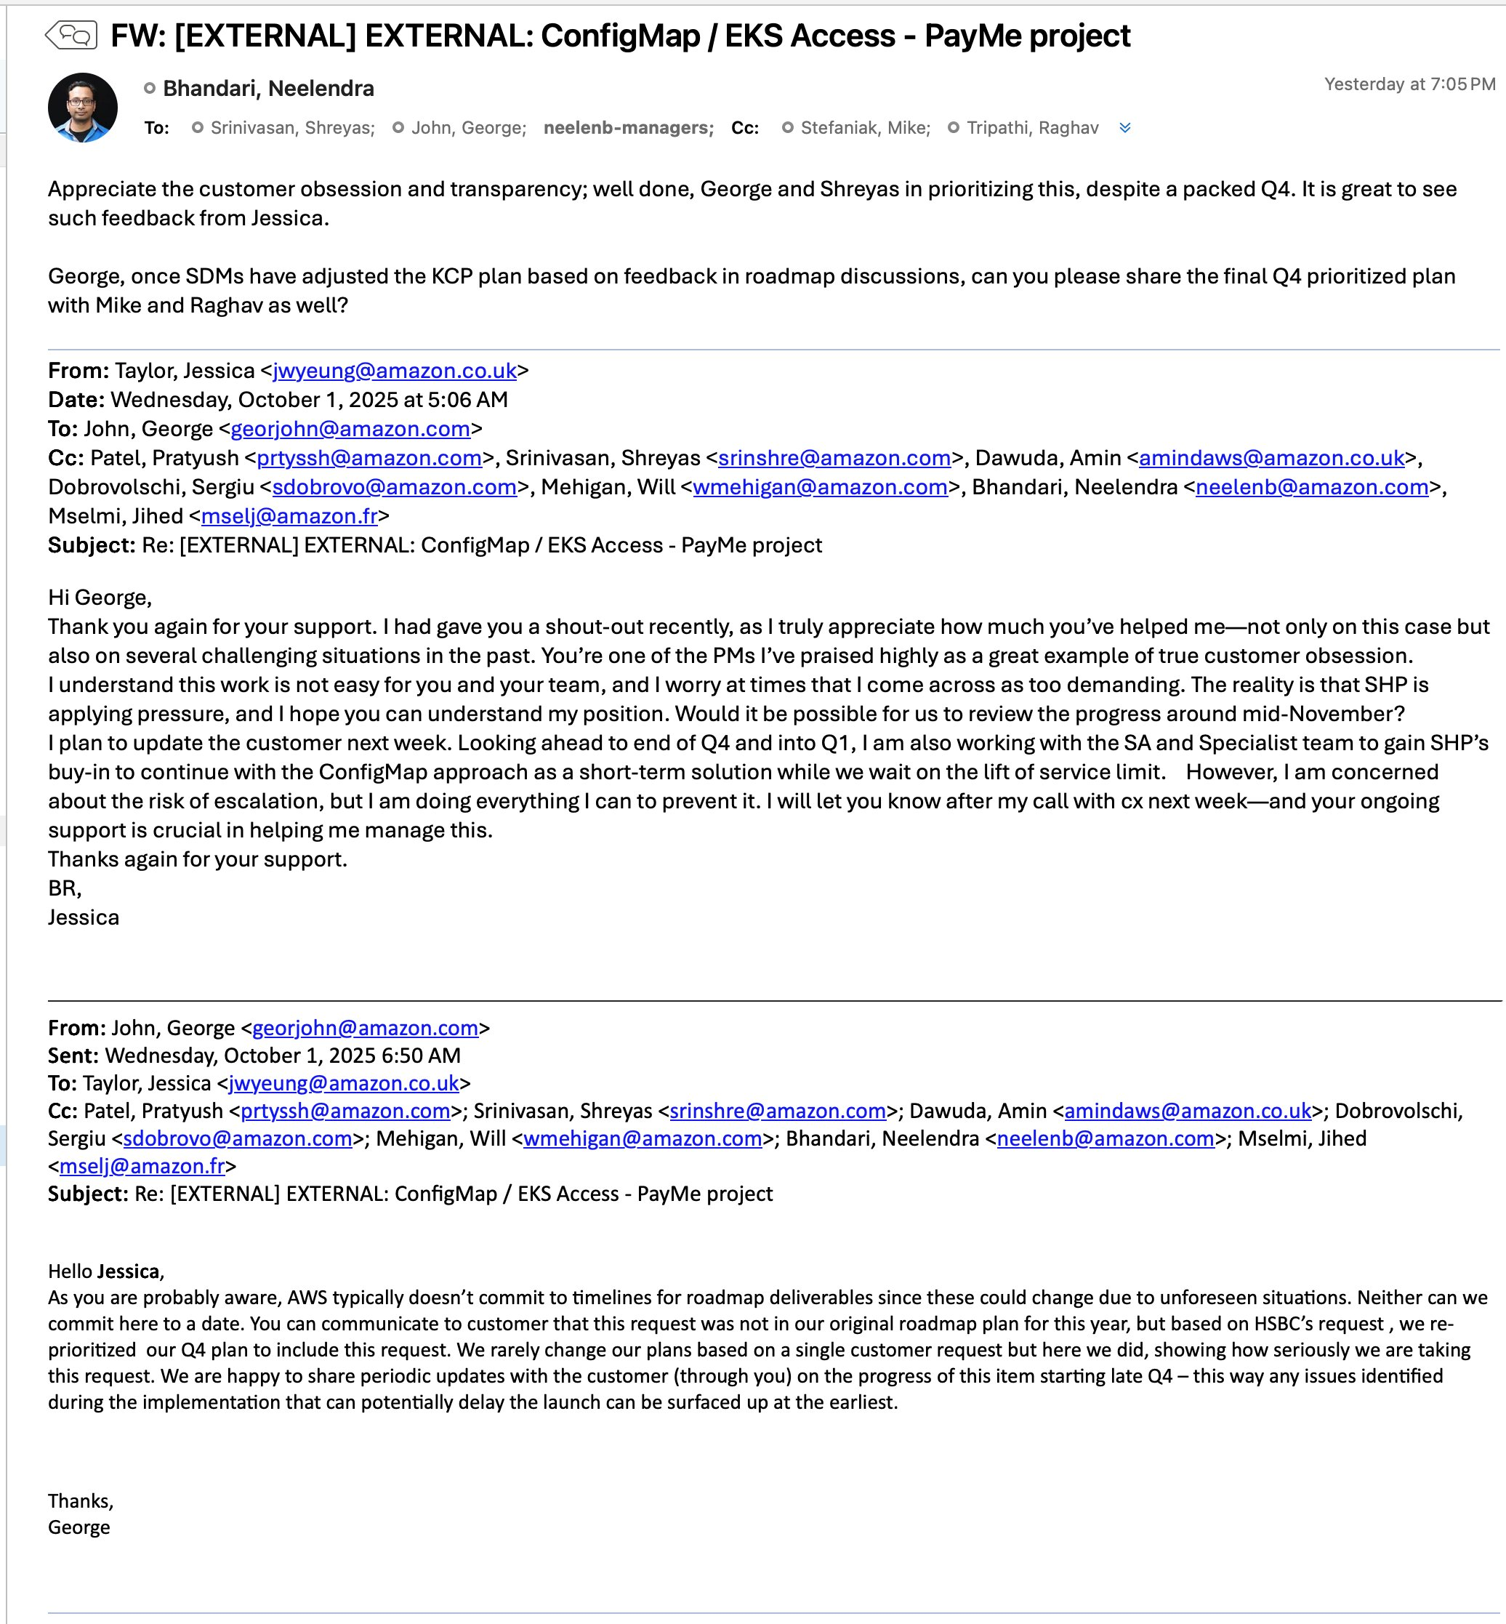
Shout-out link

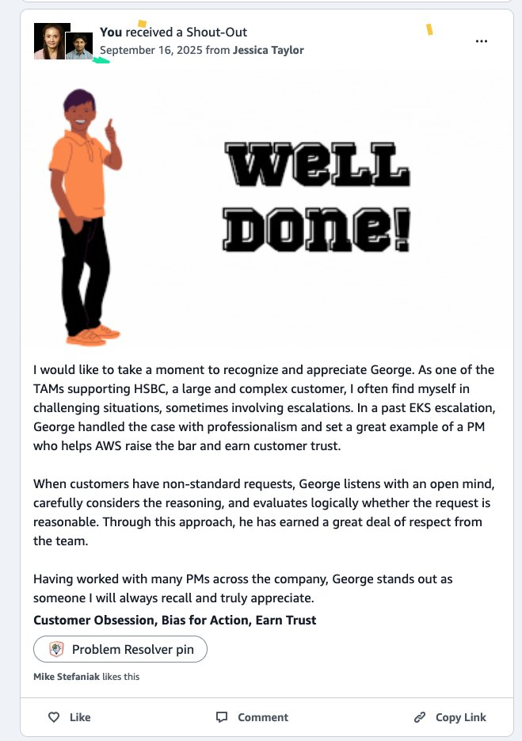

From Aaron Schwam L7 PMM on CodeArtifact launch
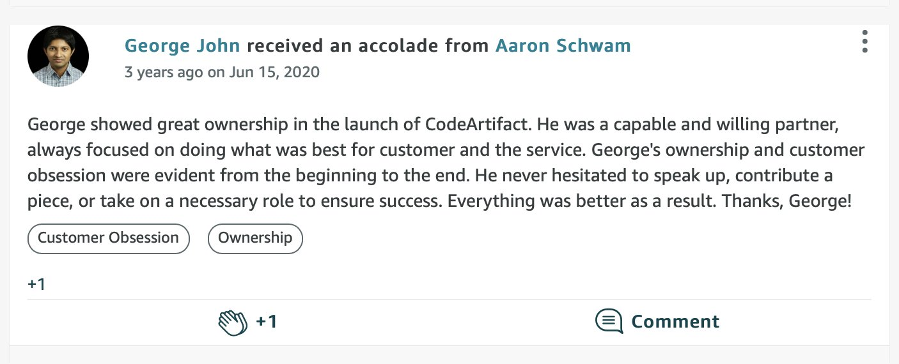

From Linden Labs (link)
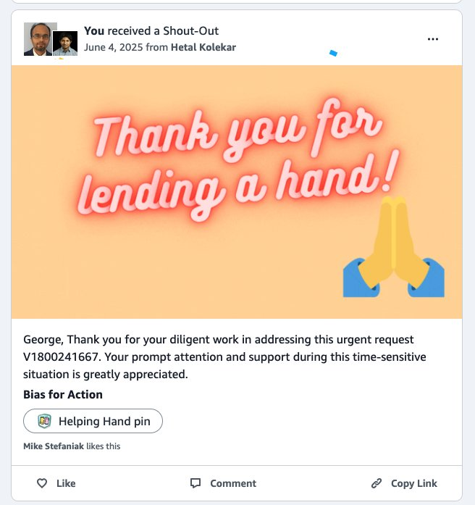

From Adevinta’s SA on engagement with customer
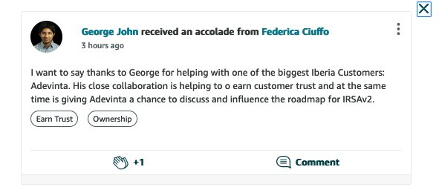

From Shein’s SA specialist (link)
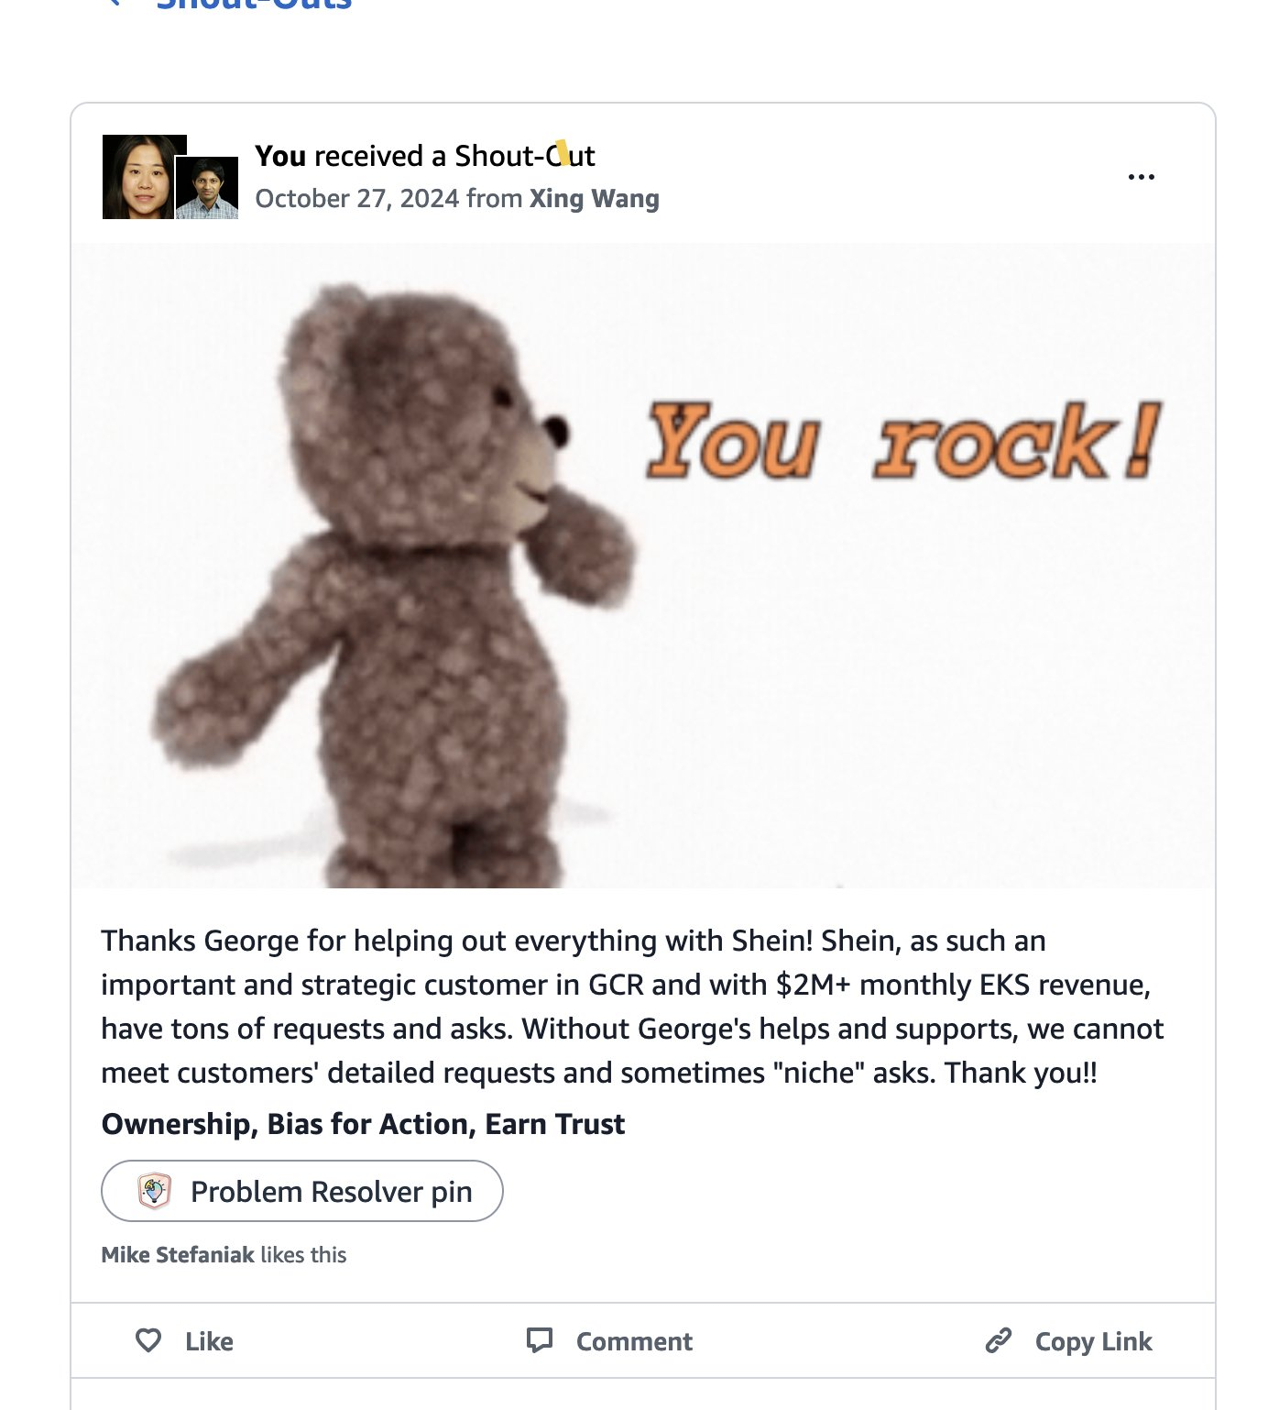

From Coalition’s account manager (Link)
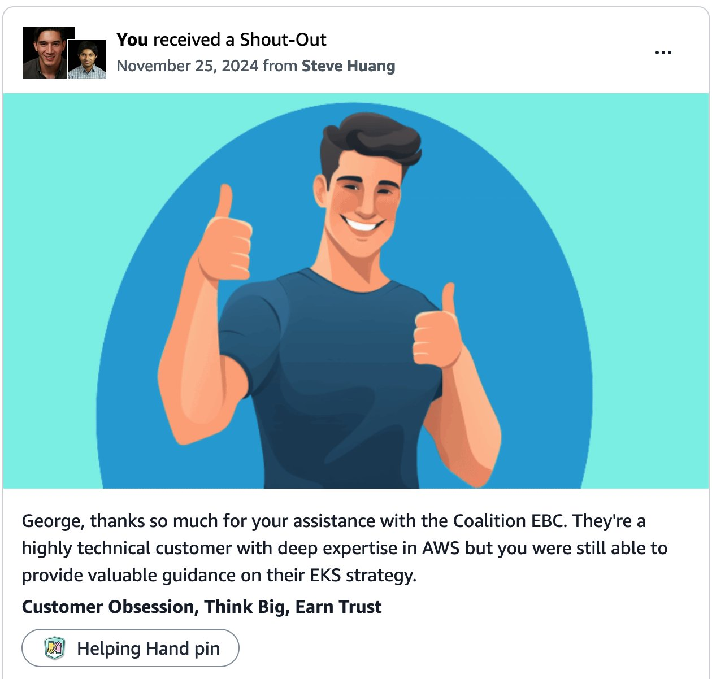

From Airbnb for launching Pod Identity Cross account support
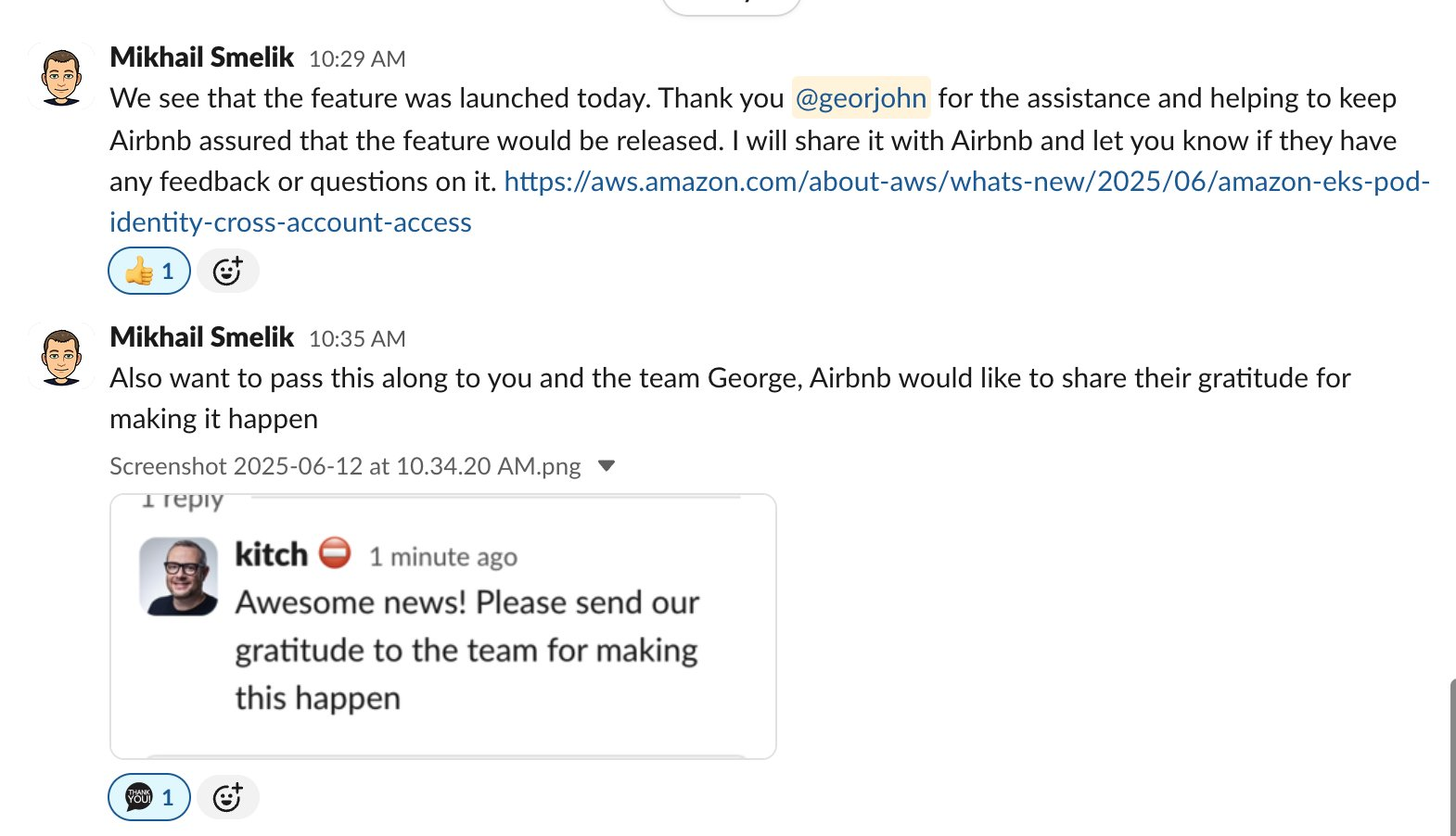

Ticket support shoutout

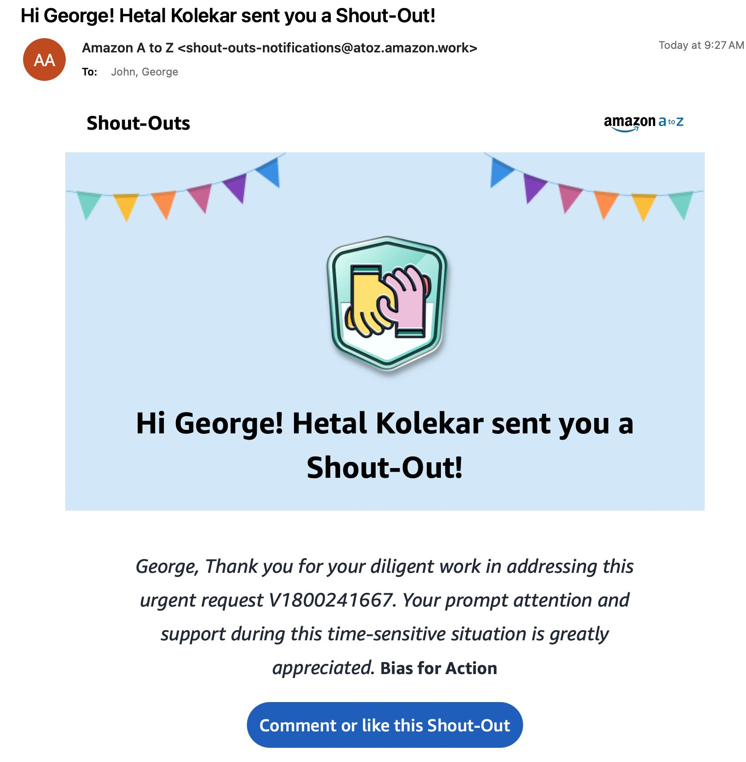

EKS UX shoutout (link)
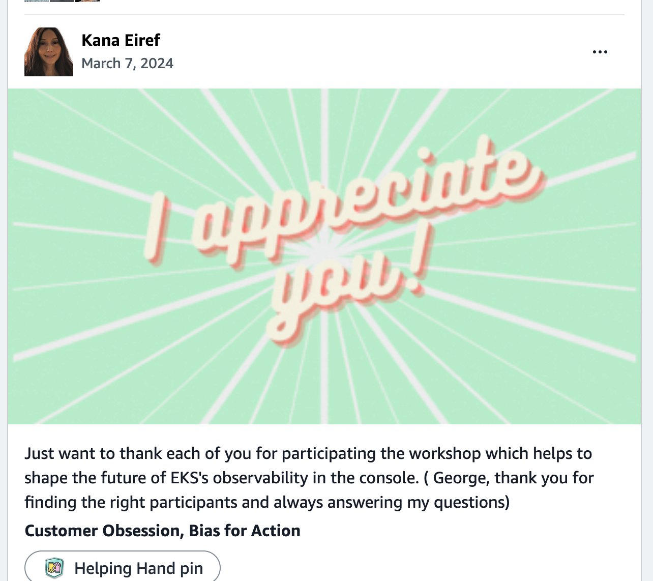

Adobe MegaCluster engagement
From: "Cooks, Barry" <cooksbar@amazon.com>
Date: Tuesday, April 11, 2023 at 5:32 PM
To: "Widhani, Gaurav" <gwidhani@amazon.com>, "Bender, Cathy" <bencathy@amazon.com>, "Sajjadpour, Mahdi" <mahdis@amazon.com>, "Chaurasiya, BK" <bchauras@amazon.com>, "Bala, Eswar" <beswar@amazon.com>, "Taber, Nathan" <taber@amazon.com>, "Srinivasan, Shreyas" <srinshre@amazon.com>, "John, George" <georjohn@amazon.com>, "Gogia, Prateek" <pgogia@amazon.com>, "Kuna, Harish" <hakuna@amazon.com>, "Lele, Abhijit" <abhijitl@amazon.com>, "Miller, Aaron" <millrfz@amazon.com>, "Sathaye, Praseeda" <sathayep@amazon.com>, "Lee, Chance" <changsul@amazon.com>, "Liu, Jeffrey" <jfliu@amazon.com>, "Corbett, Shane" <shancor@amazon.com>, "Ponnuswami, Rama Prasanna" <ponrama@amazon.com>, AWS Account Team <aws-adobe-notify@amazon.com>
Cc: "Otis, Julie" <juliotis@amazon.com>, "Dhamija, Gaurav" <dhamijag@amazon.com>, "Dey, Sujoy" <sujoyde@amazon.com>, "Pillai, Kunal" <kunpil@amazon.com>
Subject: Re: Adobe I/O Runtime successfully migrated from Azure to AWS

Made my week! Excellent to see all the hard work of so many (both at AWS and Adobe) complete its first major migration for Ethos on EKS. Onwards an upwards for our partnership with Adobe and the Ethos team.

-Barry

From: "Widhani, Gaurav" <gwidhani@amazon.com>
Date: Tuesday, April 11, 2023 at 5:22 PM
To: "Bender, Cathy" <bencathy@amazon.com>, "Sajjadpour, Mahdi" <mahdis@amazon.com>, "Chaurasiya, BK" <bchauras@amazon.com>, "Bala, Eswar" <beswar@amazon.com>, "Taber, Nathan" <taber@amazon.com>, "Srinivasan, Shreyas" <srinshre@amazon.com>, "John, George" <georjohn@amazon.com>, "Gogia, Prateek" <pgogia@amazon.com>, "Kuna, Harish" <hakuna@amazon.com>, "Lele, Abhijit" <abhijitl@amazon.com>, "Miller, Aaron" <millrfz@amazon.com>, "Sathaye, Praseeda" <sathayep@amazon.com>, "Lee, Chance" <changsul@amazon.com>, "Liu, Jeffrey" <jfliu@amazon.com>, "Corbett, Shane" <shancor@amazon.com>, "Ponnuswami, Rama Prasanna" <ponrama@amazon.com>, AWS Account Team <aws-adobe-notify@amazon.com>
Cc: "Cooks, Barry" <cooksbar@amazon.com>, "Otis, Julie" <juliotis@amazon.com>, "Dhamija, Gaurav" <dhamijag@amazon.com>, "Dey, Sujoy" <sujoyde@amazon.com>, "Pillai, Kunal" <kunpil@amazon.com>
Subject: Adobe I/O Runtime successfully migrated from Azure to AWS

Exciting news from Adobe!
After more than 14 months of effort, multiple deep dives, brainstorming and war rooms, Adobe has successfully migrated their I/O Runtime workload from Azure to AWS; and decommissioned Azure environment. ARR $2.5MM with upside of $5MM in 2024.

What is Adobe I/O Runtime and how did we win? It is a Serverless platform based on Apache OpenWhisk and is used by Adobe’s customers and partners to host their Function as a Service (FaaS) workloads as Kubernetes pods. Due to the nature of workload, it experiences high pod churn rate and relies on EKS cluster elasticity to ensure efficient usage of EC2 resources. Adobe was facing resiliency and scale challenges on Azure impacting experience for their end customers. AWS team introduced EKS to Adobe to demonstrate a pod churn rate of 100 pods/second, which was 5x the scale I/O Runtime could achieve on Azure. On 03/29, Adobe migrated 100% of I/O Runtime traffic to AWS. This is also first major production workload running on Adobe Ethos (Kubernetes based platform) to be moved to Amazon EKS, and will lead the way for migrating 60 additional clusters from self-managed to EKS. This project has been a remarkable example of cross-team collaboration between multiple customer teams (I/O, Ethos & AEM), Amazon EKS service team and WWSO team.

Customer quote – “The Adobe I/O Runtime team has been focused for over a year on moving to EKS. This project is a critical part of improving I/O Runtime reliability and performance, as well as an excellent case study for other Adobe services considering EKS. The AWS team has been an amazing partner from the beginning, supporting both I/O Runtime and Ethos to make the project successful. Now that the move to EKS is complete, we’re already seeing the positive impact in production on performance, throughput, and stability for our customers. Thank you for all your help, and we’re looking forward to future collaboration.” – Nick Halbakken, Sr. Manager, Adobe

A huge thank you to everyone. We could not have done it without your amazing support.
Amazon EKS Team: Eswar Bala, Nathan Taber, Shreyas Srinivasan, George John, Pratik Gogia, Harish Kuna
Container Specialists: Abhijit Lele, Aaron Miller, Praseeda Sathaye, Chance Lee, Jeffrey Liu, Shane Corbett, Rama Prasanna Ponnuswami
Adobe Account Team: Gaurav Widhani, Renee LeBaron, Gaurav Dhamija, Sujoy Dey, Maciej Torbus, Kunal Pillai
Big thanks to Barry Cooks who helped us build trust and relationship with Bob Wulff, Adobe SVP of Developer Platforms and Dave Weinstein, Adobe VP of Developer Productivity.
Thank you,
Gaurav Widhani
Strategic Account Manager, Adobe
Amazon Web Services (AWS)

EKS SCAD launch email
Subject: [🚀 Launch Announcement 🚀] AWS launches Split Cost Allocation Data for Amazon EKS

What did we launch?
On April 16th 2024, we launched granular cost visibility for Amazon Elastic Kubernetes Service (Amazon EKS) in the AWS Cost and Usage Reports (CUR), enabling customers to analyze, optimize, and chargeback cost and usage for their Kubernetes applications. In joint collaboration with the Cloud Intelligence Dashboards team, we also launched a new Containers Cost Allocation dashboard to visualize EKS costs in Amazon QuickSight and CUR query library to query EKS costs using Amazon Athena. With AWS Split Cost Allocation Data (SCAD) for Amazon EKS, customers can now allocate application costs to individual business units and teams based on how Kubernetes applications consume shared EC2 CPU and memory resources. The launch also supports customers that configure their AWS Batch workloads to run on EKS clusters.
Why is this important?
Kubernetes helps customers automate the management, scaling, and deployment of containerized applications. With Amazon EKS, customers get a managed service that eliminates the need to install, operate, and maintain their own Kubernetes control plane on AWS. However, getting fine grained visibility into Kubernetes costs is not easy. This is because you can’t simply allocate the cost of a resource, such as EC2 instance to a tag or label, because the EC2 instance may be running multiple containers, with each supporting a different application. The resources also may be attached to different cost centers around the organization. Customers have requested for finer-grained visibility into the cost allocation of applications running on Amazon EKS that share AWS resources like Amazon EC2 instances. Nearly half (49%) of those surveyed in CNCF’s latest microsurvey report on Cloud Native and Kubernetes FinOps saw an increase in cloud spend driven by Kubernetes usage. The report also identified a gap in the level of cost monitoring customers have in place with 40% respondents said they estimated their Kubernetes costs and there was no monitoring in place for 38%. Additionally, the report also identified a gap in the level of cost monitoring customers have in place with only 19% doing accurate showback and 2% for chargeback, and 38% with no monitoring mechanisms in place at all.
What are customers initial reactions to the launch ?
As of April 30th 2024, 400 customers (XXL: 75, XL:140, L: 99) have opted into the service.

https://www.itpro.com/infrastructure/aws-ups-its-cost-visibility-game-with-free-to-use-offering-for-kubernetes-clusters
Launch Content
What's New
Blog
Marketing Web Page
User Documentation
Containers Cost Allocation Dashboard
Containers CUR Query Library
What’s next?
The next phase in the Split Cost Allocation Data (SCAD) roadmap is to 1/ Expand Split Cost Allocation Data for EKS to ZHY, 2/ Integrate with Cost Explorer, 3/ Expand to support Kubernetes Labels, GPU, Networking, EBS and Load Balancer 4/ Expand to other service integrations i.e. S3, EC2 dedicated hosts etc. The full roadmap for the feature is available here
Who should I reach out to for questions?
For feedback on Split Cost Allocation Data or questions on how the product works, please reach out to Shubir Kapoor (@shubirk). If you have a customer inquiry related to the product please file a ticket using AWS customer success and technology enablement (ACT) SIM intake (CTI: AWS / Insights Reporting / Split Cost Allocation Data) with the Split Cost Allocation Data team.
Acknowledgements
Split Cost Allocation Data: Steven Sadowski, Rob Cooper, Brijen Ved, Mihir Surani, Miao Yu, Abhijit Jathar, Bolun Yan, Tobias Stodieck, Sam Fleischer, Adarsh Telkur, Albert Yih, Andrew Drennan, Bill Leidy, Bill Zhang, Mahsood Ebrahim, Michael Rallo, Pooja Nagaraja, Kirubel Moses, Ran Zhou, Mervyn Badiang
AWS Compute Optimizer (ACO): Ge Liang, Hamrit Sidhu, Tao Liu, Matthew Kelsey, Abhigna Reddy Manda,
AIO Optimizations Nexus: Ran Zhou, Jigar Patel, Albert Yih
EKS: Sri Saran Balaji Velore Rajakumar, Eric Kwete, Sushil Shrestha, Liyuan Zhou, Mike Stefaniak, Amine Hilaly, Zach Dorame-Barajas, Chloe Yang, Paul Pollack
Atlas: Mervyn Badiang, Andrew Drennan, Matt Brown
Cloud Intelligence Dashboard: Yuriy Prykhodko, Iakov Gan, Udi Dahan
UX: David Yun
AppSec: Ayodele Owolabi, Dieu Pham, Richard Thally
Technical Documentation: Mike Lucey, Ami Gregory-Ito, Geoffrey Cline, Nathan Bigman, Daniel Afolabi
CP Legal: Melissa Giger
Marketing: Bowen Wang, Erica Lien
Business Intelligence: Priyanka Pachori
Insights and Optimization Leadership: John Phillips, Bina Khimani, Shawn Swistak, Les Lamprecht, Mohit Gupta
AWS Organizations: Bradie Loeffel, Praveen Kumar Singh, Simar Kalra, Nivedita Tripathi
EKS Leadership: Barry Cooks, Nate Taber, Eswar Bala
PM: Shubir Kapoor (Insights), Vipin Mohan (EKS), George John (EKS), Mike Stefaniak (EKS)

EKS roadmap session on 5/11 with container specialist TFC
Feedback below:
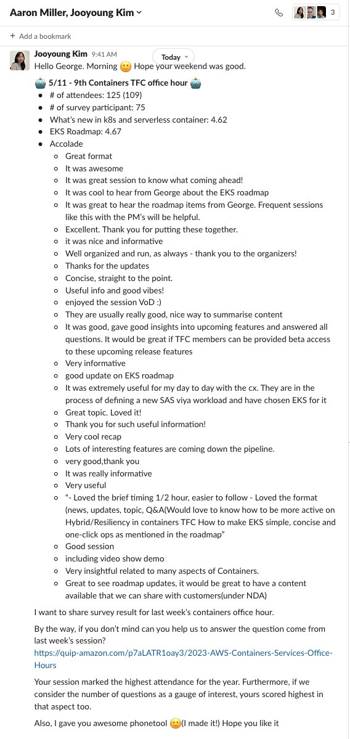

EKS UX shout-out (link)

