1. **Introduction**

With the continuous advancement of technology, the applications and benefits to using technology are now more evident in our daily lives. In the field of education, technology has revolutionized the way students are taught. Teachers and professors now make use of projectors as their main visual aid tool instead of using traditional Manila paper. The library is no longer the only source of references, as a wide array of resources and information are now accessible online. Professors are now even able to create virtual classrooms in websites where they are able to make announcements, set up extensive online discussions, and create assignments for students to submit. The online classroom setting not only provides convenience to both parties, but also allows the students to interact with both the professor or teacher and the entire classroom, which provides a better avenue for learning in an unobstructed environment. The concept of an online classroom was used as a basis for the development of the CT Thesis Management System, whose aim is to create a portal where students are able to search for topic specific resources more quickly, allow simultaneous checking and development of revisions for both the panel and the students, and to allow for students to consult with faculty online regarding their thesis project. (Bates, Poole, 2003).

* 1. **Background of the Study**

The study will focus on the Thesis management of the CT department for the entire thesis series. *The Computer Technology department in De La Salle University is a world class academic center, for robotics, digital signal processing, networking and data security, with a track record for innovation and commerce. It is a part of a vibrant community that holds service to the people, God and country as an all encompassing goals.*  The portal will be made by the group using web applications tools in creating the portal. These tools will include MySQL for the database, PHP for the back-end part of the portal, HTML & CSS for the front end of the portal and XXAMP as a server to run the web application. A business process model was used to illustrate the current business process of the department.

**Thesis preparation**

This phase is done at the start of a new term. The thesis coordinator creates an account for all new users, which provides them access to the system under a given username and default password. All users are then required to indicate their given schedules for the term, which will allow the thesis coordinator to schedule defenses later on. The thesis coordinator then groups users in a thesis group in order for easier navigation and for the system to recognize group submissions. In case a grouping is changed, the thesis coordinator is notified and will edit accordingly.

**Thesis Development**

During thesis development, the thesis coordinator will schedule defense schedules for each group. The coordinator will look through each schedule of all the participants of a defense and identify a common time between all. If no common time can be found, the coordinator will notify them personally or via email.

**Post Thesis**

After the defense schedule, once the verdict of the group is ‘passed’, then the group is required to upload their thesis document. Else, the panelists will indicate their comments on a revisions list, which will be handed to the students on a later date. Once received by the students, they are given a set time to apply the revisions given. (G. Franco, personal communication, February, 2017)

C:\Users\ralphcbk\AppData\Local\Microsoft\Windows\INetCache\Content.Word\Untitled Diagram.png

**Figure 1**: Legacy System Business Process Model

**1.2 Statement of the Problem**

Upon consultation with the client, the main purpose of the system is to allow students who are taking their thesis to be able to monitor the processing of their revisions list, so that students are able to review and apply the comments of the other panelists whilst the revisions list is being reviewed by another panelist. The group however, found that the current system is unable to do this as most of the time the website is down. Further, the current system is only able to confirm which panelist is in possession of the revisions list, however does not show the actual comments.

The group performed the GAP problem analysis technique to identify the problem areas that need to be addressed within the current system. The group believes that the GAP technique is the most effective method of highlighting the current problems of the system, as the current system is unable to perform its main function effectively. The GAP technique requires analysts to list down the current functions/features or lack thereof, as well as ideal functions/features that the system is expected to have; this is based on the insights of the system’s current users as well as a review on related systems, which is discussed further in chapter 2. This is done in an effort to be able to clearly visualize a gap between the current and ideal, and in turn assist analysts in formulating a solution to reach the ideal state of the system.

|  |  |  |
| --- | --- | --- |
| **Users Affected** | **Current** | **Ideal** |
| Students | Unable to review revisions list content during panel deliberation | Panelists are able to review thesis documents online and upload their comments. Students are able to view uploaded comments. |
| Website is constantly down | Website is accessible at any time of the day |
| Unable to reupload document in case of change | Students are able to reupload documents before the deadline is passed. |
| All Users | Announcements and communication is done through email | All users are able to communicate through a home/stream page within the system. |
| Interface is outdated and arduous to navigate through | A more modern user interface design, along with navigation tools such as search functions, filtering and sorting capabilities. |
| Thesis Coordinator | System is only accessible by the thesis coordinator within campus | System can be accessed even outside the campus |
| Defense schedule is generated through manually checking each individual schedule of all participating members | System is able to identify a common time for all participating members. Else, system is able to identify conflicts with scheduling. |

**Figure 3**: GAP Analysis Table

* 1. **Conceptual Framework**

The framework outlines the given users, the thesis coordinator with an orange background; the thesis adviser with a green background; and the students with a blue background. The problems and solutions listed correspond with each users’ reflected background; such as problems and solutions associated with an orange background correspond to the thesis coordinator, and so forth with other users.

The problems are outlined with a number that is also reflected in the solutions; entries with the same number indicate the corresponding solution/problem. The input portion of the diagram outlines what data the system will take in, and the output outlines what will be generated with the given inputs. The technology shows what software will be used to develop the system, and the architecture reflects the design of the software in processing inputs and outputs

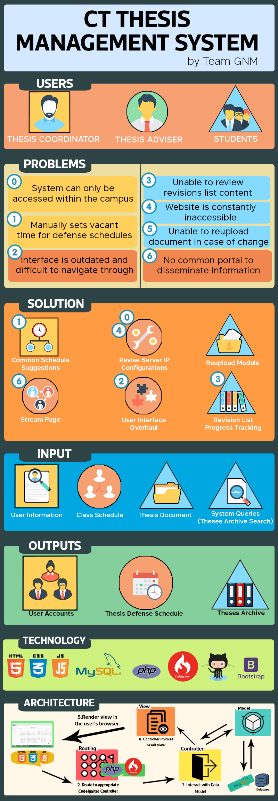**Figure 3**: Conceptual Framework Design

**1.4 Objective of the study**

**1.4.1 Main Objective**

The main objective of thesis project is to develop a Thesis portal for the Computer Technology Department of De La Salle University.

**1.4.2 Specific Objectives**

To evaluate and study the current process of the thesis management system of the Computer Technology Department of De La Salle University.

To study related systems and concepts to be able to identify how the current process can be improved upon.

To design a solution based on the related systems and concepts researched upon.

To develop and integrate the designed modules based on the gathered requirements and system designs.

To implement a fully functional system that is able to meet user requirements and provide innovative improvements.

**1.5 Scope and Limitations**

The scope of the project will only cover the development and implementation of a thesis management website for the Computer Technology Department. The modules are limited to the thesis preparation, thesis development, and post thesis, which reflect their current business process cycle. The general scope consists of updating the network server protocols, which cause the current system to constantly be inaccessible. The scope also covers a complete overhaul of the user interface and functionalities of the current system, which will make the interface more navigable with the use of search and filters.

**1.6 Significance of the Study**

The study is meant to assist the CT department in handling the thesis projects done by the students under the CT department. It will allow the CT department to have a much easier time in passing important comments and suggestions to the work of the students, and also allows the students to ask questions from their advisers virtually and also allow them to work on the comments of the panelist when the other panelist are still reviewing their work.